**Temperature detection and remote monitoring using Deep learning and IoT**

**Anirudh E R1, Sai Viswanth1, Monica Subashini2, Geetha Mani3**

1Student, School of electronics engineering, VIT University, TamilNadu, India

2Associate Professor, School of electrical engineering, VIT University, TamilNadu, India

3 Associate Professor, School of electrical engineering, VIT University, TamilNadu, India

**ABSTRACT**

In the light of COVID-19 outbreak, it's highly important to screen the people based on their temperature abnormalities. The government has informed people to stay safe and to keep social distancing in order to break the chain of coronavirus spread. Until now there is not any automation tool designed to detect Covid-19 symptoms in patients. The thermal images also offer an advantage in human detection, especially in dim lighting conditions. In dim light conditions, the surroundings emit less infrared radiation compared to humans, and this marginal difference in heat allows us to identify the subject from the external environment. We aim to solve this issue by providing a portable, compatible and accurate thermal human scanner. The project is a real-time application of a neural network programmed by Raspberry Pi with a thermal camera (MLX90600). The CNN face detection approach employed here is able to predict the human face from the thermal image and further extract the temperature thus helping in effective screening.

**Keywords:** Convolution Neural Network [CNN], Haar cascade classifier, Thermal images, Raspberry pi, Internet of Things

1. **INTRODUCTION**

Thermal images depict an image based on the relative differences in the infrared radiation emitted by the objects from their surroundings. Thermal images depict an image based on the relative differences in the infrared radiation emitted by the objects from their surroundings. This characteristic feature of thermal cameras to detect heat in the form of infrared radiation is currently used for calculating the human temperature because the heat emitted by the human and another object in the frame is quite different. Thermal images are to be profound in conditions where colour images fail miserable such as in bad lighting conditions. Humans give an edge over the other objects to the cameras since they are warmer. Thermal cameras are capable enough to detect the intensity of the infrared radiation which has been emitted by the object. The intensity of Infrared radiation emitted by the objects varies since it depends on mainly three factors - Emissivity, reflectance, and transmittance coefficient. For instance, if we compare emissivity values between human beings and steel it could be interpreted those human beings have more chance of emitting infrared radiation than the former. Each pixel in the thermal image represents the corresponding color in RGB format, so in order to get directly the temperature values of the frame, there is necessary to use a thermal camera. There is enough evidence to conclude that the red color signifies elevation in temperature whereas the blue colour represents low temperature. However, using only temperature data is not sufficient to detect and classify a person from other objects. One of the difficult issues to tackle in thermal imaging is that there could be sudden changes in temperature in the outdoor environment. The raw data from a low-cost thermal sensor may often be unstable as well which often requires image processing techniques to make it refined for further analysis. Face detection is an imperative research area for many commercial as well as medical purposes. Recent studies have presented high detection accuracy. During the nighttime, thermal images are much better to use as they capture heat waves of the objects without any need for an illumination source. In order to suffice our scalable needs such as low-cost and easy-to-implement components, we have went with a thermal camera that is interfaced with the most renowned miniaturized computer, the Raspberry Pi (RPi). The RPi was selected because of its processing capability at such a low cost. In this paper, a Raspberry pi camera module is used to capture the image, main advantages are that modules are highly compatible with the Raspberry pi.During the covid outbreak, there arose a situation to take preventive measures to control the spread of covid. One such initiative was to screen the persons based on their body temperature. The real challenge lies in deploying this concept in crowded places. It's a cumbersome process to screen people based on temperature and record it manually. This whole screening process has to be automated and should maintain the safe social distancing criteria. The proposed solution discussed in the paper evolves the idea of screening and monitoring humans based on their temperature. The idea involves integrating a thermal camera with Raspberry Pi which captures the images which are further processed to analyze based on the significant deviation from the preset threshold of temperature. The CNN face detection algorithm detects the region of interest[ROI] from the thermal image obtained from the acquisition unit. If the face is detected then the haar cascading algorithm helps to get the coordinates of the face. The coordinates are used to get the average RGB values of the pixels enclosed between the facial region detected. The average absolute temperature is obtained from this ROI region and further compared with the preset threshold to determine whether a person is normal or abnormal. The live monitoring can be visualized by sending the data to an IoT platform called thingspeak.This paper tries to improve the accuracy of people with abnormal rises in temperature by identifying them using facial and forehead thermal characteristics.

1. **METHODOLOGY**

The proposed methodology’s main contribution is the use of facial thermal characteristics of persons to distinguish them based on their body heat. The flow chart of our proposed method is shown in Figure. 1

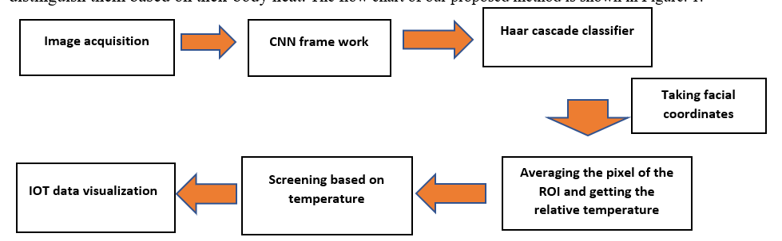

**Figure 1:** block diagram of the process

**2.1 Image Acquisition system**

The thermal camera is a 32×24 pixels, 55° fov, IR array thermal imaging camera and it communicates via I2C interface. It operates in a voltage range of 3.3V/5V operating voltage. Raspberry pi 4 is the core component of our proposed system and it is built based on the ARM Cortex-A53 processor, which functions as the brain of our proposed system. Since the thermal camera is integrated with the raspberry pi all the actions which are to be done by the camera will be controlled by the master controller (raspberry pi). The logic could be executed with the programming language python which is supported by Raspberry pi OS. Due to its uncomplicated interfacing with the external components, low cost and ease of configuration, it is used widely in the development and prototyping stages of a variety of medium complexity embedded systems. The image acquisition system comprises the hardware circuit with the thermal image capturing unit. The thermal camera MLX90640 is interfaced with the raspberry pi-4.The Thermal camera captures and streams the image data to the raspberry pi-4 where its programmed for further analysis. The thermal image has pixels which corresponds to the intensity of heat at a particular point with respect to the outer environment. This system provides a non-invasive temperature detection and monitoring which is comfortable and the most desired choice in recent times.

* 1. **CNN Architecture**

A Convolutional Neural Network [CNN] is one of the deep learning algorithms which is mostly applied to images. This algorithm follows a structured model which works on building a model like a funnel and finally gives out a fully-connected layer where all the neurons are connected to each other and the output is processed. Before passing the image into the model we have to flatten the image from a three-dimensional image into a single column vector. This step is required to reduce the dimensionality, consequently, standardization of values needs to be done for us to get the values under 0-1.Every CNN model comprises two basic layers - convolution and pooling layers. Convolution layer which contains an input image matrix and a filter matrix, a basic convolution operation is applied between the input matrix and the filter matrix. The filter matrix is also called a kernel whose dimensions are nxn where n is most likely to be odd. The next layer after the convolution layer is the max-pooling layer; it often turns out that the max-pooling layer is used to reduce the dimensionality and highlight the significant features in the image. The core principle of the max-pooling layer is that it calculates the largest value in the sub-matrix of the matrix. It usually is in the dimension of 2x2. In our CNN model, the general convolutional layer has 16 kernels with the size of 3x3 and the max-pooling layer consists of a 2x2 matrix. The reason why we have used CNNs is that they have the ability to learn these characteristics in a more efficient way. The CNN model is used here to distinguish the human face from other objects.

**Table 1**: CNN architecture

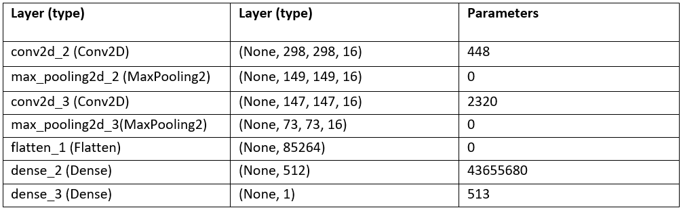

* 1. **HaarCascade classifier**

The proposed method uses Haar Cascade classifiers to detect face along with their coordinates from the thermal image acquired from the thermal camera. This algorithm uses edge or line detection features to distinguish the pixels in the image. The algorithm requires a good amount of both positive images (images with faces) and negative images (images without faces) to train our classifier model. The output of the Haar cascade classifiers applied to the thermal image will yield the four coordinates of the face. The complexity of running the model is minimum as it’s a pretrained model.

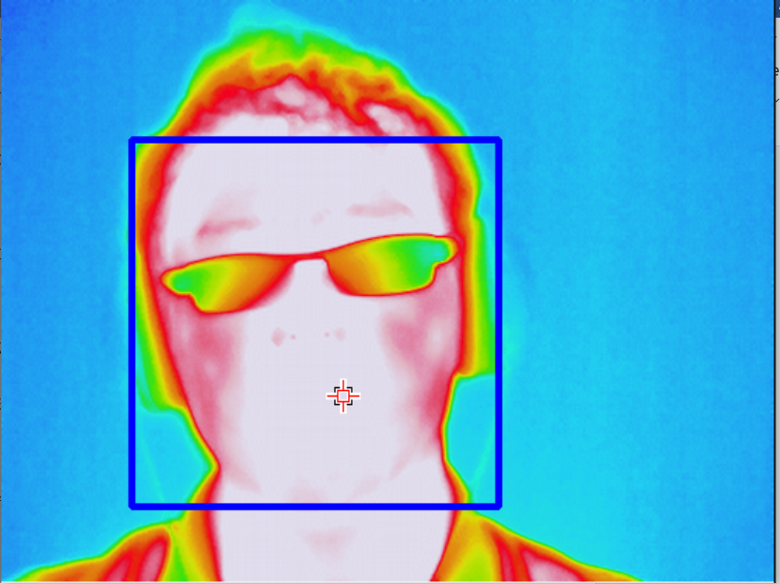

**Figure 2:** Face detected from the thermal image.

* 1. **Temperature detection**

The coordinates obtained from the haar cascade locates the face of the person in the thermal image and it helps us to localize the region to be considered for taking the temperature reading. as mentioned earlier each individual pixel in the thermal image represents the intensity of heat/relative temperature at that point with respect to the surrounding. Now the average of these pixel values of the region of interest is taken into account for further analysis. The average of these values obtained is compared to the present threshold values. If the temperature of the person surpasses the threshold value i.e.,37°C it detects the abnormality and highlights the subject from other people, thus helping in spotting the people with elevated body temperature.

* 1. **IOT Visualization**

The absolute temperature values obtained from each entry are sent to an IoT cloud platform. it helps in visualizing and recording the data entries and enables remote monitoring. The data trends help to identify the abnormal deviations that exist if any.Fig.4 shows the temperature values in graphs with 0 corresponding to abnormal temperature and 1 meaning normal temperature. The number of data points shows the number of people screened over time.



**Figure 3:** Thing speak dashboard visualization

1. **EXPERIMENTS**

In our experiments, we have used a Raspberry Pi 4 Model B with 1.2 GHz quad-core processors, and 1 GB memory using Raspbian buster software. Our proposed methods were implemented using OpenCV and Python.

* 1. **Dataset**

For dataset which we have used here constitutes 1074 thermal images with the same dimensions of 553x417. The thermal image dataset was obtained from Kaggle (an open-source repository). This dataset has thermal images of different people which gives us a wide variety of thermal thresholding scales for further choosing the best threshold for distinguishing abnormal and normal patients based on thermal intensity.

The RGB value of the thermal image corresponding to 37 degrees Celsius was taken from the standard temperature colour coding chart which was taken for the thresholding. After detecting the face, the average of the pixels is taken into consideration for comparison with the preset threshold. Trials were conducted to check the performance of thresholding with respect to the dataset images and the thermal images with average pixel values higher than the threshold were identified as abnormal because of their relative deviation from the normal body temperature.

**4. RESULTS AND DISCUSSION**

In this section, we first present some example results showing the reason to perform normalization. Then, the performance measures have been evaluated for our CNN model by the performance metrics.

* 1. **Normalization**

Thermal images taken here is in RGB format where the pixel values range from 0 to 255.In order for the CNN model to perform well, there is a need to use normalization. Normalization is a rescaling technique where it reduces the values within the range 0 and 1. This method allows the model not to concentrate on higher pixel values.

* 1. **Dataset**

Our proposed method for human detection that uses thermal images and its performance analysis gives the accuracy for detecting the face near 100%. The validation accuracy was 97%.

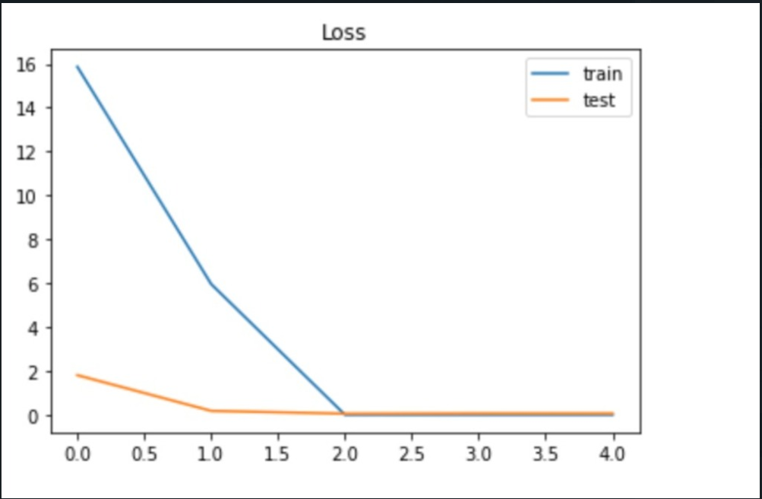

**Figure 4:** loss at each epoch for test and train datasets

figure 4 shows that the loss has decreased linearly for the training dataset, but for the test dataset the loss was minimal from the beginning which concludes that the model is not overfitting as both train and test have same loss. Figure 5 describes both the test and train datasets have attained an accuracy of about 97%.

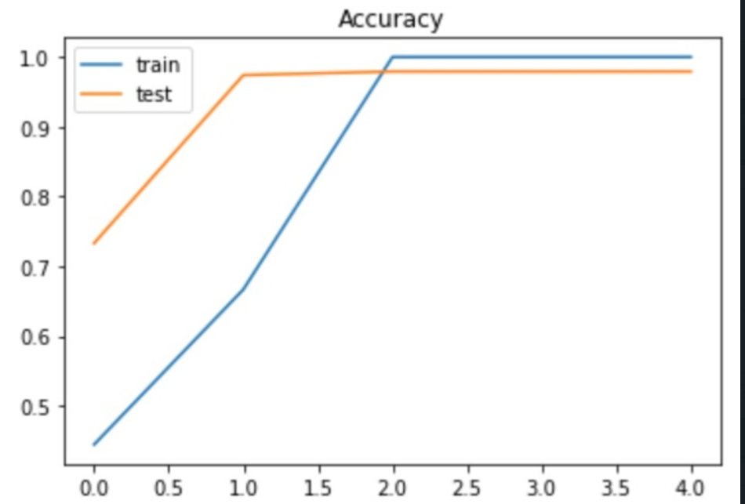

**Figure 5:** Test and train dataset accuracy

**Table 2:** Test and train dataset accuracy

|  |  |
| --- | --- |
| **Dataset** | **Accuracy(percentage)** |
| Train dataset | 98.99 |
| Test dataset | 98.73 |

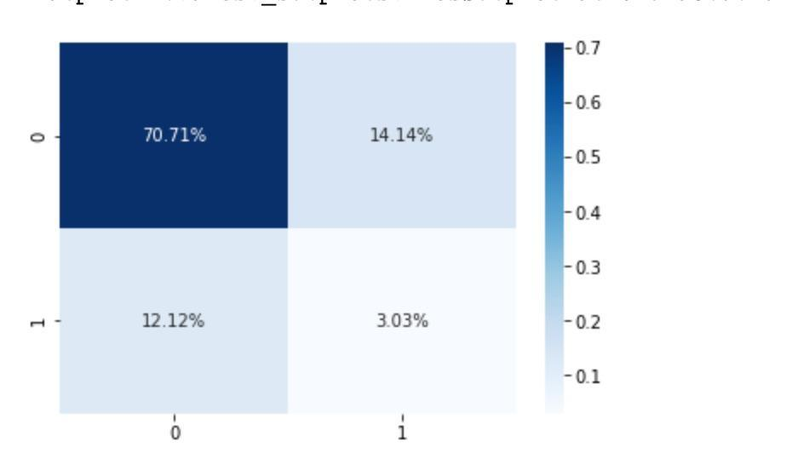

**Figure 7:** Confusion metrics (0-face detected,1-face not detected)

To interpret this confusion matrix here is the key: face detected is set to 0 while face not detected is set to 1. With this key, we can decipher that it has a 70.71 % chance of detecting the face and a 3.03% chance of detecting the face not detected. Approximately a 34% chance of detecting a face wrongly and a 34% chance of not detecting the face incorrectly. Having a high FN score is very essential as the device shouldn't fail to recognize the face.

**5. CONCLUSION**

In this paper we have proposed a novel system to overcome the temperature screening of people during this pandemic. The system was built around raspberry pi which has been configured with a thermal camera. The customized CNN model has been implemented to detect the face. The experimental results showed that the model detection rate was over 97%(test). Then the haar cascade classifier will return the four coordinates of the face. The threshold for detecting abnormal temperature is analyzed from the thermal palette. The whole system performs reliably in static and closed environments. In the future, we hope to establish a more practical temperature detection system by providing scalable features - screening multiple people at the same time and making it available in public places.

**6. REFERENCES**

1. Patel, H., Upla, K.P: Night Vision Surveillance: Object Detection using Thermal and Visible Images. 2020 International Conference for Emerging Technology (INCET) pp. 1-6 (2020).
2. Dang, K., Sharma, S.: Review and comparison of face detection algorithms.2017 7th International Conference on Cloud Computing pp. 629-633 (2017).
3. Yamanoor, N.S., Yamanoor, S.: High-quality, low-cost education with the Raspberry Pi. IEEE Global Humanitarian Technology Conference (GHTC) pp. 1-5 (2017).
4. Jones, B.F.: A reappraisal of the use of infrared thermal image analysis in medicine. IEEE Transactions on Medical imaging 17(6), 1019-1027 (1998).
5. Tokunaga, T.: A method for accurate temperature measurement using infrared thermal camera. in Microscopy 61(4), 223-227 (2012).
6. Alkhayat, A.H, Bagheri, N., Ayub, M.N., Noor, N.F.M.: Fever detection & classroom temperature adjustment: Using infrared cameras. 2015 IEEE International Conference on Consumer Electronics - Taiwan pp. 240-241 (2015).
7. . Lee, P., Bui, T., Lo, C.: Temperature Model and Human Detection in Thermal Image. 2018 IEEE 7th Global Conference on Consumer Electronics (GCCE) pp. 57-59 (2018)
8. Lin, J., Lu, M., Lin, Y.: A Thermal Camera Based Continuous Body Temperature Measurement System. 2019 IEEE CVF International Conference on Computer Vision Workshop (ICCVW) pp. 1681-1687 (2019)
9. Ghose, D., Desai, S.M., Bhattacharya, S., Chakraborty, D. Fiterau, M.,Rahman, T. Pedestrian Detection in Thermal Images Using Saliency Maps. 2019 IEEE/CVF Conference on Computer Vision and Pattern Recognition Workshops pp. 988-997 (2019)
10. Rujilietgumjorn, S., Watcharapinchai, N.: Real-Time HOG-based pedestrian detection in thermal images for an embedded system. 14th IEEE International Conference on Advanced Video and Signal Based Surveillance (AVSS) pp, 1-6 (2017)
11. Devaguptapu, C., Akolekar, N., Sharma, M.M, Balasubramanian, V.N. Borrow Prom Anywhere: Pseudo Multi-Modal Object Detection in Thermal Imagery. 2019 IEEE/CVF Conference on Computer Vision and Pattern Recognition Workshops pp. 1029-1038 (2019)
12. Kantara, A., Ekenel, H.K.: Thermal to Visible Face Recognition Using Deep Autoencoders.2019 International Conference of the Biometrics Special Interest Group (BIOSIG) pp. 1-5 (2019).
13. Bhuyan, M.K., Dhawle, S., Sasmal, P., Koukiou, G. Intoxicated Person Identification Using Thermal Infrared Images and Gait. 2018 International Conference on Wireless Communications, Signal Processing and Networking (WiSPNET) pp. 1-3 (2018).
14. V, lonescu, M., Enescu, F.M.: Low cost thermal sensor array for wide area monitoring. 2020 12th International Conference on Electronics, Computers and Artificial Intelligence (ECAI) pp. 1-4 (2020)
15. Zhong, C., Ng. W.W.Y., Zhang. S., Nugent, C.D., Shewell, C., Medina Quero, J.: Multi-Occupancy Fall Detection Using-Non-Invasive Thermal Vision Sensor. IEEE Sensors Journal 21(1), 5377-5388 (2021)
16. Cakiroglu, O., Ozer, C., Gunsel, B.: Design of a Deep Face Detector by Mask R-CNN. 27th Signal Processing and Communications Applications Conference (SIU) pp. 1-4 (2019)
17. Nwafor, E., Olufowobi, H.: "Towards an Interactive Visualization Framework for lot Device Data Flow. 2019 IEEE International Conference on Big Data (Big Data) pp. 4175-4178 (2019)
18. Krikto, M., Ivakié-Kos, M.: Thermal Imaging Dataset for Person Detection.2019 42nd International Convention on Information and Communication Technology, Electronics and Microelectronies (MIPRO) pp. 1126-1131 (2019).