The Impact of a Secure Intelligent Access Control System in Manufacturing Industries

Bernard Obino Ongere1, Livingstone1 Ngoo Henry Kiragu1

Department of Electrical and Communication Engineering

Multimedia university of Kenya Nairobi, KENYA.

Obino03@gmail.com, [ingoo@](mailto:ingoo@) mmu.ac.ke, hkiragu@mmu.ac.ke

# ***ABSTRACT*-Most industrial security systems are not automated which leads to rampant theft and loss of finished products and materials. The theft takes place due to lack of security checks on people and vehicles leaving the premises, however the theft may also be aggravated by workers in management position who develop cartels whose main aim is to facilitate movement of unauthorized goods and materials.**

**In this paper, the problem of theft is solved using the internet of things that uses a raspberry PI microcontroller. The paper presents an industrial set up that gives access when the vehicle number plate and facial recognition are positively identified by the developed system from the database. When there is a forced entry or intrusion into the premises, a buzzer system goes on to alert the authorities. The database of the faces of the drivers and the vehicle number plates are stored in a secure area and only accessible to authorized personnel. A high resolution infrared camera for image scanning and high identification rate is also installed for easy identification of Vehicle details**

**Keywords: Raspberry PI; Rampant theft; Security system; Access control ;Database; IoT; image resolution**

# INTRODUCTION

The improvement of industrial security system in areas of access are aimed at solving theft and vandalism through the elimination of unauthorized entries.

The proposed system comprising of Raspberry PI processor is the heart of this work. This onboard computer is able to effectively and efficiently communicate with the output and input modules that are interfaced. The operating system is installed in external Secure Digital card for booting and storage purposes. The storage has a facial records of each driver as well as the vehicles details. The facial captured is recorded in a flash memory [1]. The system also uses a camera circuit that is interfaced to a raspberry PI. The camera captures the faces of the driver and the number plate of vehicles. Once the face of the driver is positively identified from the database, the system will proceed to identify number plates of vehicles. The number plate of vehicle shall be captured by the camera as the vehicle moves towards the gate. On positive identification of faces of the driver and vehicle number plate, the gate to the premises opens automatically however if the face of the driver or the vehicle number plate don’t match, entry is denied and a buzzer will sound.

1. LITERATURE REVIEW

## *An Overview of Smart Industrial Gate Access Systems*

This chapter aims to provide a brief summary of smart industrial gate access, particularly by discussing their enabling technologies, architectures, structures, and application areas. The goal highlights the basic principles, review the subject, and analyzes the literature associated with the subject of security management using artificial intelligence (AI).

## *Enabling Technologies for Smart Gate Access*

Recent advancements in information and communication technologies (ICT) related to artificial intelligence, embedded systems, and computer networks have resulted in an era where smart industrial automation is technically possible. By incorporating new smart functions in traditional industrial Automation Systems, smart home environments can now leverage different types of AI. In particular, smart industrial technology entails using networking to merge technology and services thereby resulting in improved life quality. Concerning the smart gate access system, it requires several enabling technologies including AI, Wireless Fidelity (Wi-Fi), Internet Protocol (IP), Bluetooth, Wireless Sensor Networks (WSN), Barcode, Radio Frequency Identification (RFID), Electronic Product Code (EPC), Actuators, ZigBee and Near Filed Communication (NFC) [2].

Many remote systems now exist to achieve academic or business purposes. To start with, ZigBee Technology [3] now has a system that is equipped with a human detection module, which can detect when there is a person at the door. The system succeeds in doing so via a camera module, which processes video and the image. Essentially, items that are captured are passed through a verification tag that is located for each user before access is granted and if one is not verified, the alert system is activated. However, this system is not secure and is prone to attack besides its coverage being limited thus limiting its use to indoor settings. Secondly, [4] proposed a system that relies on RFID technology, and access is only granted once an RFID card reader is used. Nonetheless, an intrusion is possible thus the system is not secure.

Thirdly, GSM [5] proposed a system, which necessitates a password for one to be granted access. Nevertheless, this system is insecure since intrusion is possible once a person learns the password. Fourthly, [6] proposes a system for face recognition, and the system first scans the face of any person entering and compares it with those in the database. If no match is detected, the system concludes an intrusion is ongoing thereby sending an alert to the owner and proper authorities for further action. This system is, nonetheless, suboptimal since variation in illumination may lead to a specific face appearing differently. As such, one may be granted access at times and denied access at other times. Also, [7] proposed a fingerprint-based biometric system, which automatically records the driver’s entry. This entry system is based on Raspberry-PI, and it confirms the driver’s identification using the fingerprint sensor. The use of Raspberry PI to ascertain fingerprints for verification [8] creates a management system using barcodes and

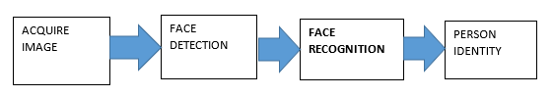

Fig2.1: Block diagram for face recognition

Raspberry PI.

There has been a shift toward face recognition systems, and their numerous applications have resulted in increased attention from researchers. These systems rely on people’s facial information thus making them easily applicable compared to relying on people’s signatures, iris, or fingerprints. The use of these systems is especially preferred in metropolitan areas as they are instrumental in person verification, video surveillance, and crime prevention among many other security uses [6].

A face recognition system solves the image-processing problem via intricate effects of imaging conditions, occlusion, and illumination on live images. It merges face recognition and detection when analyzing an image. The detection application locates the face’s position in a given image while the recognition algorithm checks the structural properties of the identified face. Face recognition systems thus use standard images to detect a face and extract those that have facial features including the mouth, nose, eyebrows, and eyes. This way of doing things makes them more intricate than single detection or recognition systems. A face recognition system follows certain steps (see Fig 2.1). Firstly, it acquires an image captured by a camera. Secondly, it detects a face from the image. Thirdly, it undertakes face recognition. Finally, it outputs a person’s identity.

The proposed system is more secure since it grants entry only after facial and vehicular details have been positively identified.

### *Convolutional Neural Networks (CNNs*)

Convolutional Neural Network mirrors the method used in describing the characters that are on segmented License plates (LP).

This system’s design is highlighted in Fig 2.2, and it consists of an array of layers, namely conv, pooling and fully connected (FC) layers [12]. In [13], CNN was used in creating a system for automatically recognizing LPs and it was based on the self-synthesized feature, which identifies a

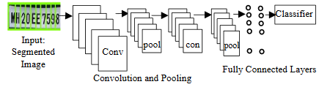

Fig 2.2: *The design of CNN for Character recognition [12]*

Vehicle from its corresponding plate. This system had at least a 90% precision rate. However, the system fails to recognize vehicle license plate when shade or direct sunlight is present.

### *Deep Learning (DL) based Approaches*

In [15], a system for vehicle license plate recognition in complex environments using a deep learning approach is suggested. First, more sophisticated algorithms for key issues such as skewing of the license plate, image noise and blurring of license plate was implemented. The deep learning algorithms are listed as algorithms for direct detection and indirect detection, where the detection and recognition of license plates and algorithms are analyzed. Besides, contrasts is made between the variations in data sets, workstations (special computers that provide higher performance, graphics, memory space, and multitasking capabilities), precision, and time complexity of various license plate recognition systems. Finally, the existing public datasets of license plates was compared and illustrated based on set of images, the resolution, and the sophistication of the area. The model achieved a segmentation rate of 82.6% and recognition precision of 87.3%. The approach is limited for blurred images

### *Optical Character Recognition (OCR***)**

In [17] an innovative vehicle number plate recognition method using OCR and template matching strategies for the Pakistani language has been suggested. Several real-time images from different formats of number plates used in Pakistan were evaluated by the proposed Automatic License Plate Recognition (ANPR) system. For law enforcement agencies and private organizations to enhance home security, the ANPR model has both time and money-saving benefit of 93 % accuracy of the proposed ANPR approach. This system can be further expanded to identify the number plate of the crashed vehicle in an accident and warn the nearest hospital and police station about the accident, thereby protecting the number plate of the accident. This system is limited if the vehicle license plate is nonexistence or not clear and finally its blurred

# RESEARCH METHODOLOGY

### *Facial database creation*

The facial storage is made possible by use of a Raspberry PI which is capable of capturing and storing faces for various drivers in the cloud using a camera. The graphical user interface facilitates communications with hardware by carrying pixel data to the processor. The block diagram designed to store facial data is shown in Fig 3.1:

### *Design of a face recognition system*

Many approaches can be used in the development of a face including merging knowledge-based techniques to detect a face and a neural network mechanism to recognize a face as shown in Fig 3.2.

The input section is essential to the facial recognition system, and it revolves around image acquisition. Essentially, images must be modified into digital data to facilitate processing. To do so, the images are forwarded to the face detection algorithm.

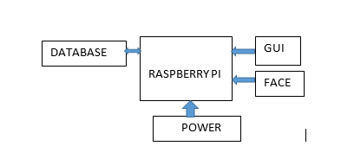

Fig 3.1: Block diagram of face storage

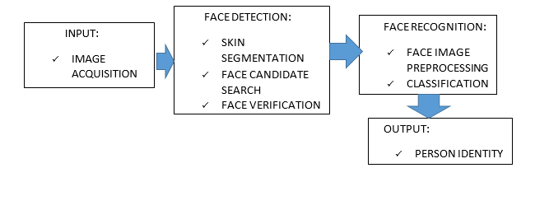

Fig 3.2: *Face recognition*

Once in the face detection process, several image operations are conducted as shown in Fig 3.3. Once an image is acquired, it undergoes skin segmentation, which lowers computational time spent when the whole image is being searched. RGB color space is also utilized to define skin color [18]. The white balance of images tends to be divergent owing to variations in lighting conditions of an environment, which could bring about some skin objects being deemed to be non-skin objects. It is for this reason that white balance correction is necessary, and it should be done before segmentation is done.

Once the AND operation is done on images that have undergone segmenting, morphological operations are conducted on the final image to facilitate a face search. Here, noise is eliminated in addition to closing operations being eliminated. Then, there is a selection of face candidates, which is dependent upon two conditions, namely, the ratio of the candidate’s bounding box and the covering of some gaps. In particular, the former should range between 0.3 and 1.5. With the help of these two conditions, an extraction of face candidates is done from the input image in addition to a modified bounding box from the original one. The face candidates are then sent to the next stage for validation.

During the facial feature extraction process, the facial feature is concentrated on since it is one of the leading features of a face in terms of

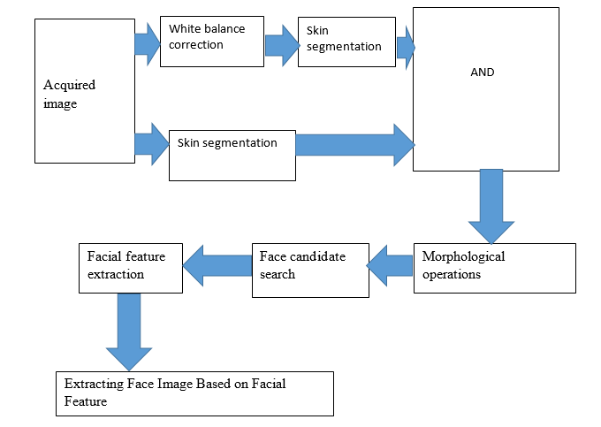

Fig 3.3: Face detection process

Significance. Facial features include the cheek, nose, nose tip, eyes, eyebrows, and mouth. To extract these features, the Laplacian of Gaussian (LoG) filter and other operations are undertaken. Once a filtered image is obtained, labeling follows to foster the determination of the labels that are likely to be facial features. Once the corner points of a face cover are computerized, extraction of a face image is possible

Where the face recognition system outputs a transformed face image, which classifies the process geared toward identifying the person. The face recognition phase is made up of several steps as well (figure 3.4).

To start with, the image is preprocessed, and this step involves the grayscale of the facial image undergoing histogram equalizing, the pixels being resized to 30-by-30, and the matrix image being vectorized. Next, the preprocessed image is taken through a classifier where a Feedforward Neural Network (FFNN) is utilized, particularly because it is the optimized structure. Once the generation of the structure is completed, the neural network may be trained to undertake the classification of the given images relating to a face database. As such, a face database must be created prior to any testing and back-propagation can be used in training the network.

### *Automatic license plate recognition (ALPR) system*

The capturing of the vehicle number plate is enhanced by a camera which plays and important role. The characters on the vehicle number plate are recognized by a technique known as ALPR using OCR which reads the license plate under all weather conditions. The verification of the number plate is done once it’s detected by the Raspberry PI connected to the cloud. Once this process of verification of the vehicle number plate is complete, the driver face is scanned and matched with that of the vehicle number plate for Verification, if it matches, gate will open while contrary a buzzer sets ON .This setup is shown in Fig3.5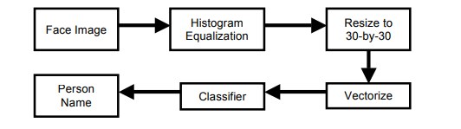

Fig3.4: *Face recognition algorithm*

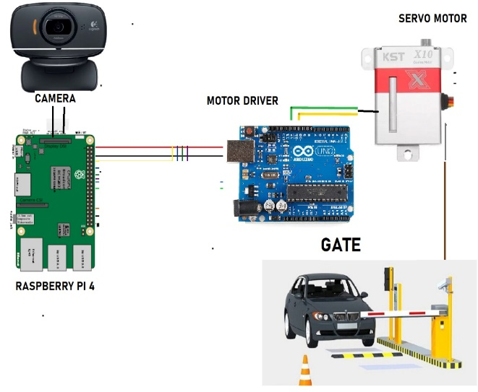

Fig 3.5: ALPR system

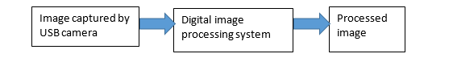

Fig3.6: Image processing

### *Concept of image processing*

Fig 3.6 shows an image processing hardware, the input consist of a camera while the processor works on the pixel of the image. The output is the facial image.

As shown in the Fig 3.7, the raspberry PI plays a key role in image processing. The main part of the processor connected in the input section consist of: SD card memory, mouse, keyboard power supply and camera while the output section consist of display, gate, and Buzzer.

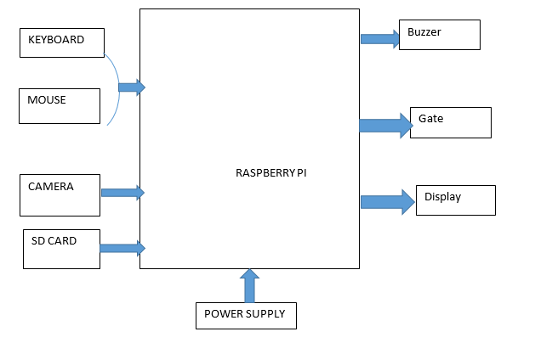

Fig 3.7: Image processing hardware design

The keyboard and mouse are helpful especially during the creation of database as it helps in registration of vehicle number plate as well as storage of faces. The camera helps in the capturing of vehicle details as well as faces of the driver and finally in the input section the SD card will help in storage purposes as well as booting .On the output section, if the records of vehicle details and faces of driver exists in the database access is granted and the gate opens. On the contrary a buzzer sounds to alert authorities.

Broadcom 2835 700MHz is the main processing chip present in Raspberry PI.it has a CPU core of 32bit ARM1176JZF-S RISC processor which connects a camera and display. The raspberry Pi uses SD card for booting and storage and does not have a solid state driver nor a built in hard disk. The board is designed to run Linux Debian operating systems and contains a micro SD card preloaded with New out of Box Software (NOOBS) package

Camera serial interface connects the camera and Raspberry PI and it carries pixel data to BCM2835 processor as well as facilitating a high data rates. The camera has a 5MP resolution image, HD video recording at 60Fps and 720p.The camera is interfaced into the PI by a Universal Serial Bus (USB) port .

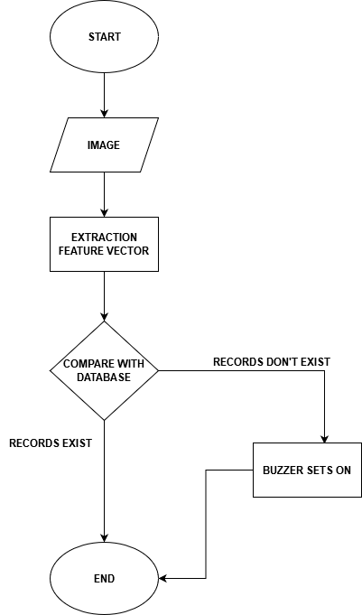

Fig 3.8: Face recognition system

### *Face recognition algorithm*

The working principle is indicated in fig 3.8 of identifying existing users using a camera to capture the faces as well as a Raspberry PI to process the image. If the facial records do match with that in the database, the camera proceeds to scan the vehicle number plate. If the facial record do not exist buzzer goes on to alert the authorities of intrusion and if it does, *License plate detection algorithm*

As the vehicle approaches the gate, the camera and the number plate program turns on. The camera image is analyzed frame by frame while the program scans the number plate. The procedure is done by applying a grayscale filter on the frame and then contouring it. The program then proceeds to search rectangular contour which represents the number plate. The program further runs optical character recognition to extract the characters from the number plate. The number plate is then mapped to the database and if it exists, access is granted otherwise, access is denied and the buzzer sets ON as shown in Fig 3.9.

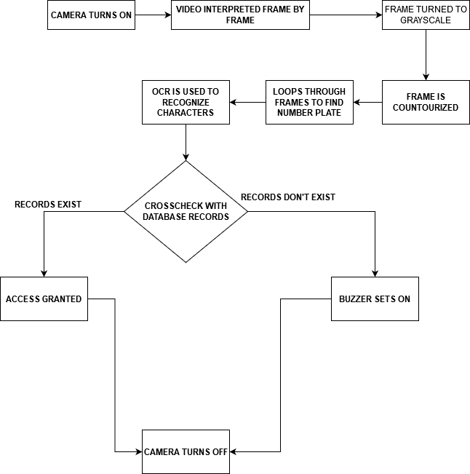

Fig3.9: *license plate detection algorithm*

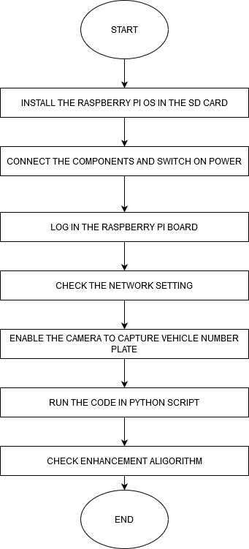

Fig 3.10: Image processing to obtain vehicle number plate

### *Image processing algorithm*

The flowchart in Fig 3.10 is used to enhance the image of the vehicle plate captured by removing noise.

.

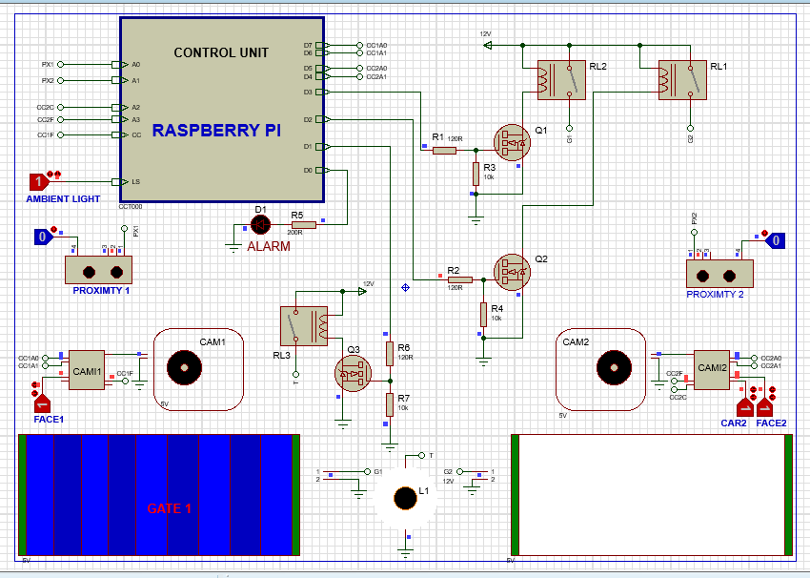

Fig 4.1: Opening of second gate

# RESULTS AND DISCUSSION

## *SIMULATIONS*

As the driver approaches the gate, the camera takes the image of the driver and the vehicle. If the face and vehicle details exist in the database, its sets Face2 “1” and Car2 “1”. Once they are verified by the scanner, the gate opens and hence access is enabled as shown in Fig 4.2 .Contrary a buzzer sets ON.

## *DEMONSTRATION OF OPEN GATE AND CLOSED GATE*

As the driver approaches the gate, the camera takes the image of the face and processes it, if the facial records exist in the database, it then proceeds to take the images of the vehicle number plate and processes it and if the details exist in the database access is granted and the gate opens as shown in Fig 4.2 on the contrary, the gate remains closed and the buzzer sounds as shown in Fig 4.3.

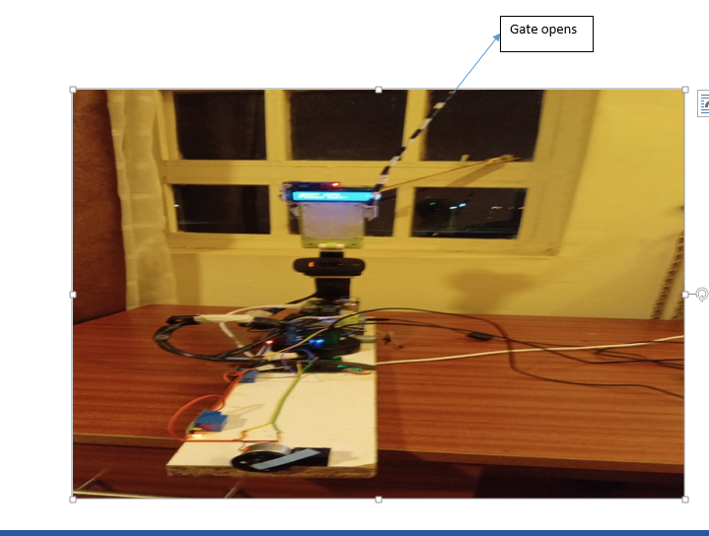

Fig 4.2: Demonstration of an opens

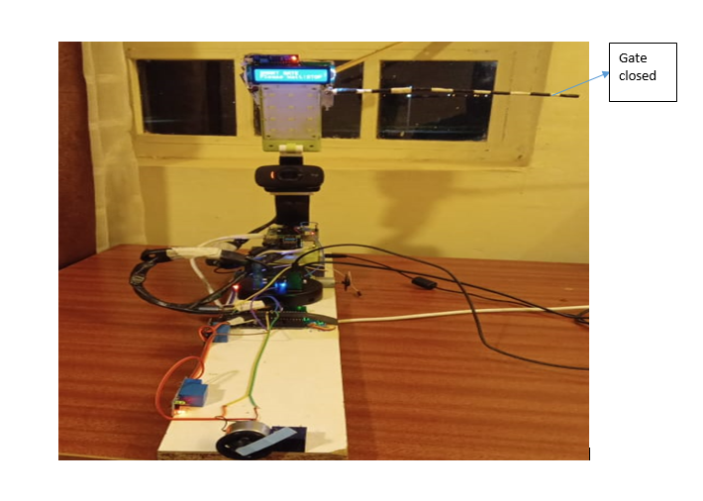

Fig 4.3: Demonstration of a closed gate

### CONCLUSION

The industrial security system developed using internet of things has demonstrated that the face and vehicle number plate may be used to minimize the theft of goods and materials in industries and other sensitive institutions. The principle of using both the face and the vehicle number plate to open the gate will greatly improve the security in vital institution in developing countries

1. ACKNOWLEDGMENT

I would like to pass my appreciation to Multimedia University of Kenya for the provision of a conducive environment which enabled me to conduct and complete my research on time

# **REFRENCES**

|  |  |
| --- | --- |
| [1] | R. Mishra, "Student Attendance System Based On Fingerprint Recognition and One-toMany Matching", Orissa, : National Institute of Technology Rourkela, May 2011. |
| [2] | N. K. Suryadevara and M. S. C., "Smart Homes: Design, Implementation and issues," Springer, vol. 14, 2015. |
| [3] | I. -K. Hwan and J. -w. Baek, "Wireless access monitoring and control system based on digital door lock," IEEE Transactions on Consumer Electronics, vol. 53, 2007. |
| [4] | Y. .. Park and J. -Y. Pyun, "Smart digital door lock for the home automation," in TENCON 2009-2009 IEEE Region 10 Conference, pp. 1-6, 2009. |
| [5] | A. Ibrahim, A. Paravath, P. Aswan, S. M. Iqbal and S. U. Abdulla, "GSM based digital door lock security system,," in Power, Instrumentation, Control and Computing (PICC), International Conference, pp. 1-6, 2015. |
| [6] | C. Gurel, "design of a face recognition system," in The 15th International Conference on Machine Design and Production, Pamukkale, Denizli, Turkey, 2012. |
| [7] | S. .. H. Sadikot, " Biometric Attendance Monitoring System Using Raspberry Pi and Finger Print. In International Journal of Scientific Development and Research(IJSDR)," vol. 3, no. 11, pp. 88-94, 2018. |
| [8] | S. Shetty and S. Raut, "Automated Biometric Attendance Management System," In International Journal of Recent Trends in Engineering & Research. , vol. 04, no. 02, pp. 116-121, 2018. |
| [9] | D. P. J. R. D. G. A. K. K. S. C. S. G. J. I.V. Pustokhina, “Automatic Vehicle License Plate Recognition Using Optimal K-Means with Convolutional Neural Network for Intelligent Transportation Systems," IEEE Access, 2020, pp. 92907–92917. |
| [10] | P. M. N. S. P. C. M. Mondal, "Automatic number plate recognition using CNN based self synthesized feature learning," IEEE Calcutta Conference, 2018, pp. 378–381,. |
| [11] | W. Weihong and T. Jiaoyang, "Research on Licence Plate Recognition Aligorithmn Based On Deep Learning In a Complex Enviroment"," IEEE Access, vol. 8, pp. 91661-91675, 2020. |
| [12] | S. U. Rehman, M. Ahmad, A. Nawaz and T. Ali, "An Efficient Approach for Vehicle Number Plate Recognition in Pakistan," The Open Artificial Intelligence Journal, vol. 6, no. 1, pp. 12-21, 2020. |
| [13] | J. K. a. F. S. 2. P. Peer, "Robust Human Face Detection in Complicated Color," vol. 2nd, Chengdu, China, The 2nd IEEE International Conference on Information Management , Proc. 2010, pp. 218 – 221,. |
| [14] | M. P. R. Boliwala, "Automatic number plate detection for varying illumination conditions," International Conference on Communication and Signal Processing, ICCSP 2016, , pp. 658–661,, 2016. |
| [15] | Saghaei, “Proposal for Automatic License and Number Plate Recognition System for Vehicle Identification,” International Conference on New Research Achievements in Electrical and Computer Engineering Proposal, 2016. |
| [16] | A. Bajpai, "A Survey On Automatic Vehicle Number Plate Detection System," International Journal of Computer Science Trends and Technology (IJCST), , vol. 5, no. 2, pp. 290-300, 2017. |
| [17] | S.U. Rehman, M. Ahmad, A. Nawaz, T. Ali, “An Efficient Approach for Vehicle Number Plate Recognition in Pakistan,” The Open Artificial Intelligence Journal, 6(1), 12–21, 2020, doi:10.2174/1874061802006010012. |
| [18] | B. B. B. A. Y. A. Elihos, " Deep learning based segmentation free license plate recognition using roadway surveillance camera images," ArXiv, , 2019. |
| [19] | P. A. V. Kumthekar, "Identification and detection of vehicle number plate using Raspberry pi2," International Research Journal of Engineering and Technology (IRJET), vol. volume 5 , no. issue 4,, 21th April 2018. |
| [20] | K. Türkyilmaz and K. Kaçan, "License plate recognition system using artificial neural networks,," ETRI Journal, vol. 39, no. 2, pp. 163–172, 2017. |