**IoT Based Smart Mine Safety System Using Arduino**

**Prof. BASAMMA R, KRATIK, SYED ZEESHAN, VARUNKUMAR, MOHD AZHAR**

1.Prof. BASAMMA R, Assistant Professor, Department of Electrical and Electronics Engineering,

Guru Nanak Dev Engineering College, Bidar, Karnataka, India

KRATIK,UG SCHOLAR,Department of Electrical and Electronics Engineering,

SYED ZEESHAN,UG SCHOLAR,Department of Electrical and Electronics Engineering

VARUNKUMAR,UG SCHOLAR,Department of Electrical and Electronics Engineering,

MOHD AZHAR,UG SCHOLAR,Department of Electrical and Electronics Engineering,,

Guru Nanak Dev Engineering College, Bidar, Karnataka, India.

**ABSTRACT**

Now a day’s due to global warming and climate changes there are challenging situation in field of coal mine. To reduce the cost and improve the productivity along with product quality the atomization in the field of coal mine is indeed necessary, which will also reduce the mine workers efforts. This paper proposes a design of a Wireless Sensor Network (WSN) with the help of controller which is able to monitor the temperature, humidity, gas, LDR, IR sensors in an underground mine. This system also controls the ventilation demand to mine workers depending upon present climate conditions within the mine field. This system utilizes the low power, cost effective controller a temperature sensor LM35, humidity sensor, IR sensors, gas sensor, LDR sensor for sensing the mine climate parameters and Wi-Fi for remote logging of data at central location to control the climate state with the help of motor and value control circuitry.

Keywords— Internet of things, Thing speak, Arduino, Mine Safety System, Wireless Sensor Network

1. **INTRODUCTION**

The Internet of Things (IoT), which is just a network of interconnected machines, does not exist. IoT is used for a wide range of purposes. The European Internet of Things Research Cluster lists smart buildings, smart transportation, smart energy, smart business, smart health, and smart environment as crucial IoT technologies. These are all significant IoT application areas. Cloud-based All sensor data collected by IoT is stored in the cloud and is accessible from any web-enabled device. Coal is the most important commodity in the planet. The Earth's natural resources, like petroleum products, enable the production of energy and the satisfaction of specific needs. Coal cannot be widely substituted by people as a source of energy since it is not sustainable, and miners risk their lives working in coal mines where accidents routinely occur. It is tragic that occasionally diggers working in coal mines lose their lives. Accidents in coal mines are primarily caused by out-of-date machinery and wiring, which result in handling errors and the release of hazardous gases. The coalmine safety system was developed as a response to address this problem. All of the data gathered by the sensors we used in our research was fully analysed using the Thinger system. Control may be automated or manually applied.

1. **METHODOLOGY**

In this proposed system, including the sensor modules and the light-dependent resistor (LDR sensor). All of the sensors are connected to the Arduino Uno via Internet of Things (IoT). The most important parts of this system are the monitoring and regulatory systems. There is a buzzer that goes off whenever the gas level in a coal mine environment increases above a certain threshold. For future analysis and usage, sensor data is sent to the cloud on an ongoing basis. The temperature and humidity of the coal mine are also monitored. The resistance value of an LDR sensor is varied to determine the light's intensity. The led turns on automatically if the LDR sensor detects an obstruction. People are being counted by the infrared sensor. A fire alert notification will appear on the IoT page immediately in the event of a fire. The IoT platform is used to control the entire system. Our widgets in the Internet of Things platform allow us to manually control the buzzer and the led.

1. **MODELING AND ANALYSIS**

**3.1 Arduino UNO**

It is an ATmega328P-based microcontroller board. 14 digital input/output pins, six analogue inputs, a 16 MHz ceramic resonator, a reset button and USB connectivity are only some of the features of this device. It comes with everything you need to run the microcontroller, including a USB cord and an AC-to-DC adapter or battery, so you can get started right away.

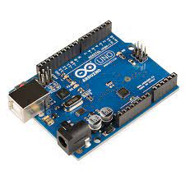

Fig 3.1: Arduino Uno

**3.2 Humidity And Temperature Sensor (DHT 11)**

All of the sensors of the DHT11 sensor, including the capacitive humidity and thermistor temperature sensors, work together. When a humidity sensor has moisture-holding substrate as its dielectric, the result is a moisture-resistant capacitor. A change in the humidity level affects capacitance. Changes in resistance are measured and processed by the integrated circuit (IC).Using a Negative Temperature Coefficient Thermistor, this sensor is able to sense temperature by decreasing its resistance value as the temperature rises This sensor often uses semiconductor ceramics or polymers in order to achieve a greater resistance value even at the smallest temperature change.

The DHT11's temperature measuring range, from 0 to 50 degrees Celsius, is accurate to within two degrees. This sensor's humidity range has a 5-percent accuracy. A single reading is taken every second by this sensor, which has a sampling rate of 1 Hz. There are numerous uses for the DHT11's 3 to 5 volt power range. Up to 2.5mA of current can be drawn by measuring instruments.

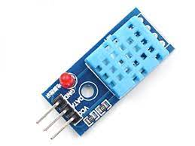

Fig 3.2: DHT 11 Sensor

**3.3 LDR Sensor (LIGHT DEPENDENT SENSOR)**

It is nothing more than a simple optical phenomenon that underlies photoconductivity in LDRs. When a material is able to absorb light, its conductivity increases. When the LDR is lighted, the electrons in the material's valence band are ready to join the conduction band. Photons with energy larger than the band gap of the material must be able to excite electrons, allowing them to hop across bands (valance to conduction).

When enough light energy is available to drive electrons into the conduction band, a large number of charge carriers can be created. Because of this method, when current flow increases, resistance decreases.

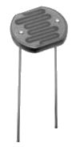

Fig 3.3: LDR Sensor

**3.4 Gas Sensor**

A gas detector checks to see if there are any toxic gases present when integrated into a safety system. In the event of a gas detector alarm, operators in the immediate proximity of the leak can leave. This type of equipment is vital since there are gases that can be harmful to organic life, such as humans or animals.

Gas detectors can pick up on things like oxygen depletion and the presence of combustible, flammable, and dangerous gases. Oil rigs use it to monitor manufacturing operations and cutting-edge technology like solar power. They could be used in the event of a fire.

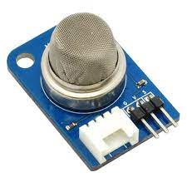

Fig 3.4: Gas Sensor

**3.5 MEMS**

A MEMS device is a micro-electro-mechanical system (MEMS). The small size and the design method of these devices can be used to characterise them as a group. These sensors can be designed using components with a diameter of 1–100 micrometres. These devices can range from simple mechanical constructions to complex electromechanical systems with many moving parts under the control of integrated micro-electronics.

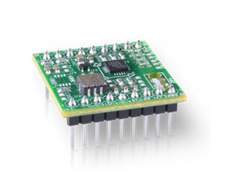

Fig 3.5: MEMS

**3.6 ESP WiFi Module**

An SOC with an inbuilt TCP/IP protocol stack can be used by any microcontroller to connect to your WiFi network. A variety of applications allow the ESP8266 to either host an application or offload all WiFi networking functions to a different processor altogether. You don't need a WiFi Shield to use an ESP8266 module on your Arduino to obtain the same WiFi capabilities as a WiFi Shield (and that's just out of the box). As one of the most affordable boards on the market, this one has a steadily increasing number of users.

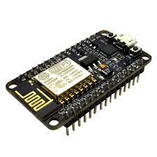

Fig 3.6: WiFi Module

**3.7 Buzzer**

A mechanical, electromechanical, or piezoelectric buzzer or beeper is a device that emits audible sound to alert the user to something. Buzzers and beepers can be used for a variety of purposes, including alarms, timers, and confirmation of human input. By applying a direct current (DC) voltage, it produces a stable single-tone sound. Large sound volumes can be achieved with this type of system by using a properly constructed resonant one. The most common types are available at Future Electronics, sorted by Type, Sound Level, Frequency, Rated Voltage and Dimension.

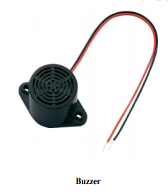

Fig 3.7: Buzzer

1. **RESULTS AND DISCUSSION**

Temperature, humidity, flame intensity, and gas molecule concentration are all measured in the mining environment and saved in the cloud. The thing Speak website offers a plot of these findings, which can be studied at a later time. If there is any doubt, action can be taken immediately.

As shown in Fig. 3.2 a mining unit is detected by numerous sensors. The x axis shows the time and the y axis shows the measurements in this graph, which shows the sensors' readings over time. When the mechanism is functioning normally, the plot stays straight. Any time a value is increased or lowered, a curve is formed in the graph's plot.

Thing speak is a Matlab-based IoT Analytics tool. Using this free web service, you may create IoT apps by storing sensor data in the cloud. There are predefined fields that can be seen in the graphs of the findings. Toxic gas concentrations and light intensity are both stored in these four fields. Thing speak's sensed values are synchronised with its cloud database through the internet. Using this, you can see when and where the system is being used.

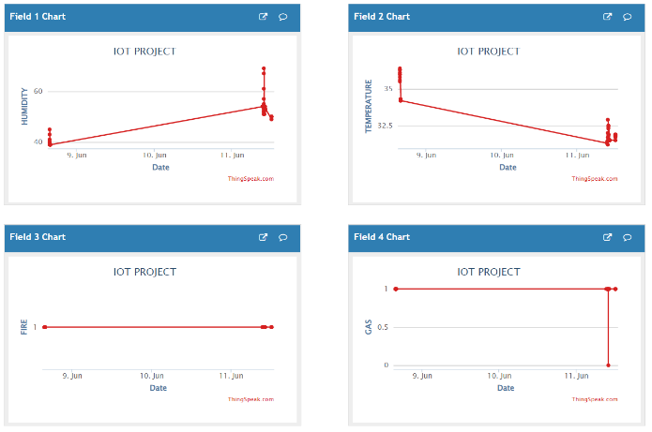

Fig 4.1: Displays Of Sensors Output as a plots

1. **CONCLUSION**

Arduino microcontrollers are used to build a mine safety system prototype in this manner. The components of this system include both hardware and software. An Android-based app is used to communicate with the Arduino board and other hardware components via the Internet of Things, while the hardware comprises of various sensors (IoT). The use of micro controllers, gas sensors, fall sensors, temperature and humidity sensors, and IR sensors to monitor the safety of mining continues to be developed and updated to the Internet of Things site. The safety of our employees is ensured thanks to the use of this equipment.

1. **ACKNOWLEDGEMENTS**

We thankful to Vision Group on Science and Technology for sanctioning grant under Scheme RGSF, GRD.No. 977.

1. **REFERENCES**

[1]. Kumarsagar “Design of Monitoring system for Coal mine safety based on MSP430”, International Journal of Engineering Science Invention(IJESI) Volume2,Issue 7, July 2013

[2]. LiHui “Design of Monitoring system for Coal mine safety based on Wireless sensor Networks” 2008 International Conference on Mechatronic and Embedded systems and Applications(ASME).

[3]. Kumar “Design and Implementation of Portable health monitoring system using PSOC mixed signal Array chip”. IJESC, October 2019 23934 http://ijesc.org/ International Journal of Recent Technology and Engineering (IJRTE), ISSN, 2277-3878,2012

[4]. Madhu Coalmine safety monitoring system”, International journal of Mechanical Engineering and Technology (IJMET) Volume 8,Issue 12 ,December 2017

[5]. Ashish “Coalmine safety monitoring using Wireless sensor Networks”,International Journal of Scientific Engineering and Technology (IJSET) Volume 2,Issue 10,October 2013

[6]. Wakode “Coalmine safety monitoring and Alerting system”, International research journal on Engineering and Technology (IRJET) Volume 4,Issue 3,March 2017

[7]. Aarthi “Coal Mine safety Monitoring system using ARM 9”,International Journal of Science and Research (IJSR), Volume- 3,Issue-11,November 2014

[8]. R. S. Nutter and M. D. Aldridge, “Status of mine monitoring and communications,” IEEE Trans. on Industry Applications, vol. 24, no. 5, pp. 820-826, Sep./Oct. 1998.

[9]. S. Wei, L. Li-li, “Multi-parameter Monitoring System for Coal Mine based on Wireless Sensor Network Technology”, Proc. International IEEE Conference on Industrial Mechatronics and Automation, pp 225-27, 2009.

[10]. Y.P. Zhang, G. X. Zheng, J. H. Sheng, “Radio Propagation at 900 MHz in Underground Coal