**An Investigation of the Behavior of Box Girder Bridges Determined by Experiments**

**Vineet Kumar Singh1, Jyoti Yadav2**

1M.Tech Scholar, Dept. Of Civil Engineering, Sarvepalli Radhakrishnan University, Bhopal, M.P, India

2Assistant Professor, Dept. Of Civil Engineering, Sarvepalli Radhakrishnan University, Bhopal, M.P, India

**Abstract-**The Bhopal Metro or Bhoj Metro is an under construction rapid transit system intended to serve the city of Bhopal, India, the capital of the Indian state of Madhya Pradesh. The total system consists of 6 corridors covering a distance of 104.87 kilometres. Metro Rail Transport has been implemented in order to handle the traffic needs. Various structural components make up a conventional box girder bridge. The current work focuses on the parametric analysis of curved single cell box girder bridges. Five box girder bridge models with varied curvatures and constant span lengths were used for the parametric research. A box girder bridge example is chosen from the literature for a validation study of the finite element modelling technique. The example box girder is modelled and examined in SAP 2000, and it is discovered that the findings are reasonably consistent with those mentioned in the literature. The five box girder bridges are modelled in SAP2000 for the parametric research. Cross-section, material quality, and span length are unaffected. The radius of curvature is the only variable that changes. The box girder bridge's superstructure is made up of a single cell box in cross section. Only the horizontal direction is variable in the bridges' curvature. Each model is put through a self-weight and moving load test using an IRC class A tracked vehicle. Both a modal analysis and a static analysis of moving and dead loads are carried out. Recorded are the longitudinal stress, bending moment, torsion, deflection, and fundamental frequency at the top and bottom of cross sections. In comparison to a straight bridge, the reactions of a box girder bridge with a curved design are studied. A parameter is used to indicate the response ratio. According to the replies, the characteristics such as torsion, bending moment, and deflection are growing as bridge curvature increases.

**Keywords- Metro Rail Corporation, IRC, SAP2000 etc.**

**1. INTRODUCTION**

The Bhopal Metro or Bhoj Metro is an under construction rapid transit system intended to serve the city of Bhopal, India, the capital of the Indian state of Madhya Pradesh. The total system consists of 6 corridors covering a distance of 104.87 kilometers. Metro Rail Transport has been implemented in order to handle the traffic needs to meet the traffic demands, Metro Rail Transport has been started. Some part of the Metrorail is elevated one, known as viaduct. The viaduct has trapezoidal box girders of single cell. There are different structural elements for a typical box girder bridge. Box girders, have gained wide acceptance in freeway and bridge systems due to their structural efficiency, better stability, serviceability, economy of construction and pleasing aesthetics. Analysis and design of box-girder bridges are very complex because of its three dimensional behaviours consisting of torsion, distortion and bending in longitudinal and transverse directions. A typical box girder bridge constructed in Bhopal Metro Rail Project is shown in Figure.1 Box girders can be classified in so many ways according to their method of construction, use, and shapes. Box girders can be constructed as single cell, double cell or multicellular. It may be monolithically constructed with the deck, called closed box girder or the deck can be separately constructed afterwards called open box girder or box girders may be rectangular, trapezoidal and circular.

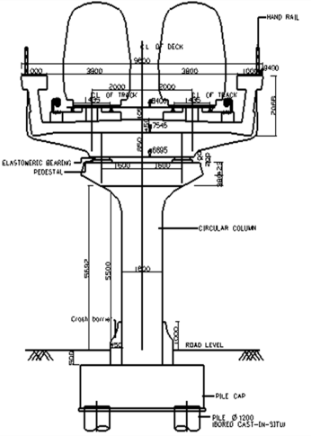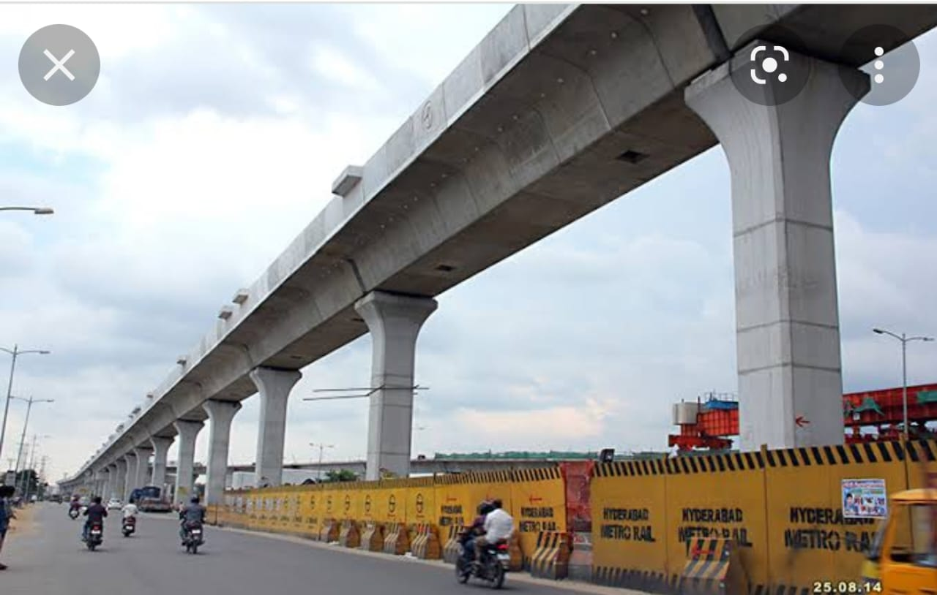

Fig-1 Viaduct for metro rail.

**2. OBJECTIVES**

The objectives of the present study are:

* A study of the relevant literature about the analytical methodologies, prior experimental and theoretical research work, and the overall behavior of curved box girder bridges
* To investigate the differences in performance between curved box girders and straight bridges.

**3. METHODOLOGY**

Five box girder bridge models are considered with constant span length and varying curvature. In order to validate the finite element modelling method, an example of box Girder Bridge is selected from literature to conduct a validation study. The example of box girder is modelled and analyzed in SAP 2000 and the responses are found to be fairly matching. For the purpose of the parametric study, the five box girder bridges are modelled in SAP2000. The span length, cross-section and material property remains unchanged. The only parameter that changes is the radius of curvature in plan. The cross section of the superstructure of the box girder bridge consists of single cell box. All the models are subjected to self-weight and moving load of IRC class A tracked vehicle. A static analysis for dead load and moving load, and a modal analysis are performed. The longitudinal stress at top and bottom of cross sections, bending moment, torsion, deflection and fundamental frequency are recorded. The responses of a box girder curved in plan and straight are compared. The ratio of responses is expressed in terms of a parameter.

|  |  |  |  |  |
| --- | --- | --- | --- | --- |
| **Parameters** | **Location** | **Present Study** | **Previous Study** | **%Error** |
| Bending Moment (KN-m) | L/4th of  span | 0.16 | 0.16 | 0 |
| Mid  span | 0.32 | 0.32 | 0 |
| Shear Force (KN) | L/4th of  span | 0.8 | 0.8 | 0 |
| Mid  span | 0.8 | 0.8 | 0 |
| Deflection  (mm) | Mid-  span | 4.35 | 4.91 | 12.87 |

Table 1: Comparison of responses obtained in present study

**3.1 Types of design loads**

The loads that are to be considered on the superstructure of a typical box girder bridges are listed below;

**1. Permanent Loads**

* Dead Loads
* Superimposed Dead Loads
* Pressures (earth, water, ice, etc.)

**2. Temporary Loads:**

* Vehicle Live Loads
* Earthquake Forces
* Wind Forces
* Channel Forces
* Longitudinal Forces

**3. Centrifugal Forces**

* Impact Forces
* Construction Loads

**4. Deformation and Response Loads**

* Creep
* Shrinkage
* Settlement
* Uplift
* Thermal Forces



Figure -2: Curved 3D Model of Box Girder

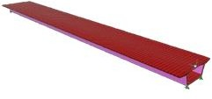

Figure -3: Straight girder 3D Model

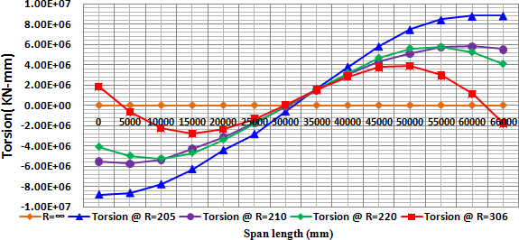

Figure 4: Details of cross-section at mid span

|  |  |  |
| --- | --- | --- |
| **Parameters** | **Notation** | **(m)** |
| Length span | L | 66 |
| Depth box girder | H | 2.31 |
| Width of top flange | btf | 9.6 |
| Thickness of top flange | ttf | 0.381 |
| Width web | bw | 0.381 |
| Width bottom flange | bbf | 4 |
| Thickness bottom flange | tbf | 0.381 |
| Width box top side | bboxts | 5.445 |
| Cantilever length top flange | L cant | 2.080 |
| Depth webs | H box | 1.547 |
| Parameters | Notation | (m) |
| Length span | L | 66 |
| Depth box girder | H | 2.31 |
| Width of top flange | btf | 9.6 |
| Thickness of top flange | ttf | 0.381 |
| Width web | bw | 0.381 |
| Width bottom flange | bbf | 4 |
| Thickness bottom flange | tbf | 0.381 |
| Width box top side | bboxts | 5.445 |
| Cantilever length flange | L cant | 2.080 |
| Depth webs | H box | 1.547 |
| Parameters | Notation | (m) |
| Length span | L | 66 |
| Depth box girder | H | 2.31 |
| Width of top flange | btf | 9.6 |
| Thickness of top flange | ttf | 0.381 |
| Width web | bw | 0.381 |
| Width bottom flange | bbf | 4 |
| Thickness bottom flange | tbf | 0.381 |
| Width box top side | bboxts | 5.445 |
| Cantilever length flange | L cant | 2.080 |
| Depth webs | H box | 1.547 |

Table-2: Cross-sectional dimensions

**4. ANALYSIS & RESULT**

Both static and dynamic evaluations of the moving and dead loads have been performed on the models of the straight and curved box girder bridges. Every analysis preserves a record of the responses, which may include torsion, bending moment, longitudinal stress, and deflections. It is hypothesized that the non-dimensional parameter (L/R) might be utilized to visualize variations in the bridges' maximum responses' curvature. The influence of the span length in relation to the radius of curvature has almost little effect for straight bridges with L/R = 0. In the case of curved bridges, the ratio improves with increasing span length while the radius of curvature remains the same. On the other hand, the ratio deteriorates when the radius of curvature is raised while the span length remains the same.



Figure 5: Variation of Torsion along the span under self-weight

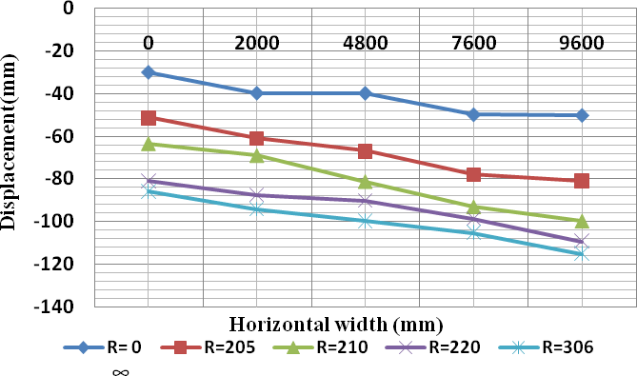

Figure 6:Mid-span vertical displacement along the width of box girder

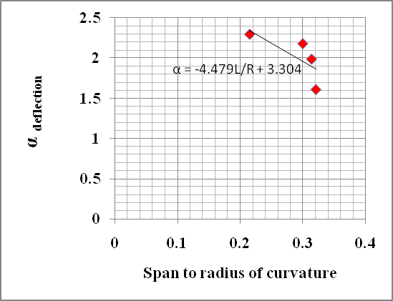

Figure-7: α deflection along transverse direction to span to radius of curvature.

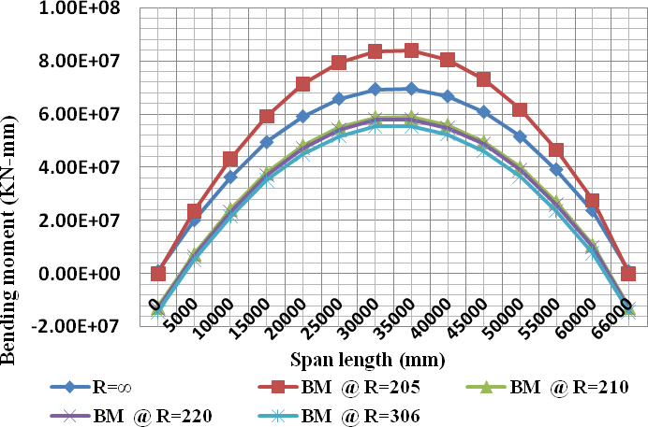

Figure 8: Bending Moment along the span of girder in their self-weight

**5. CONCLUSIONS**

1. As the span to radius of curvature increases the value of α (for all cases) increases. The range of α is in between 1 to 6 except for the torsion. This means that the forces or deflections in the curved bridge can be obtained by multiplying the straight bridge with the corresponding values of α.Under dead load; it is recorded that, there is a 33% decrease in maximum torsion is observed when the radius of curvature is increased from 205m to 210m, 210m to 220m and 220m to 306m.
2. Under IRC class A loading; it shows that as radius of curvature is increased from 205m to 210m, the maximum torsion in the cross section decreased by 20.5%. An increase in maximum torsion of 7% is observed for in the increase in radius from 210m to 220m. When the radius of curvature increased from 220m to 306m, the maximum torsion is decreased by 16%.
3. For relation of torsional moment to the L/R ratio, it showed that with decrease in span to radius of curvature, the dimensionless value α for maximum torsion is increasing.
4. Under dead load, the bending moment decreases by almost 29% as the radius of curvature decreases from 205m to 210m, 210m to 220m, and 220m to 306m.
5. Under IRC Class A loading, the bending moment decreases by almost 18.75% as the radius of curvature decreases from 205m to 210m, 210m to 220m, and 220m to 306m

**REFERENCES**

1. AASHTO (2004) AASHTO LRFD "Bridge Design Specification" 2nd Edition with Interims, American Association of State Highway and Transportation Officials Washington D.C.
2. Bhaskar Sengar (2005) "Load Distribution Factors for Composite Multi-Cell Box-Girder Bridges" Master in Engineering. Delhi College of Engineering.
3. Cagri Ozgur (2007) "Behaviour and Analysis of a Horizontally Curved and Skewed I-girder bridge" for MSc, School of Civil and Environmental Engineering
4. D. Linzell, D. Hall, and D. White (2004) "Historical Perspective on Horizontally Curved I Girder Bridge Design" Journal Bridge Engineering 9 (3), 218-229.
5. IRC: 6-2000, Standard Specifications and Code of Practice for Road Bridges, Section II, Loads and Stresses, the Indian Roads Congress, 2000.
6. James S. Davidson, Ramy S. Abdalla and Mahendra Madhavan (2004). "Stability of Curved Bridges during Construction" University of Transportation Centre for Alabama.
7. Liu Fangping (2012) "The Deformation Analysis of the Curved Box Girder Bridges under Different Radius" School of Civil Engineering & Architecture, Chongqing Jiao tong University.
8. M. A. Memberg, J. A. Yura, K. H. Frank, and E. B. Williamson (2002). "A Design Procedure for Intermediate External Diaphragms on Curved Steel Trapezoidal Box Girder Bridges" University of Texas at Austin. Centre for Transportation Research, United States.