**Demographic factors impact on the employee engagement of employees working from home or on Hybrid model in IT companies (Bangalore) – Research Paper**

**--V V Sushmita R P (Research Scholar)**

**Abstract:** The hybrid and work from home has been explored to its maximum during the covid – 19 times. These were the times employees got accustomed to the advantages they explored while working with flexible times. There have been many factors the employees were not able to balance while working from home and during these times they were able to balance and perform better than ever. There are many factors that have helped the employees to improve their performance. The employee performance has also affected the retention percentage of the employees in the organization. Few of the factors have been identified in this paper. The demographic factors that have been identified have been tested to see if they have significant influence on employee engagement. The area identified is Bangalore IT companies.

**Keyworks:** Employee engagement, Employee, Hybrid model, employer, manager, work from home, employee performance, employee retention.

**Introduction:**

Work from home and the hybrid model of organization work had been needed for many years. This need became a requirement during the covid times. Work from home model is defined as complete remote working which happens when the employer or founder is in one country and the office is established in another. Work from home is also applied to employees with medical issues. Hybrid model is the type of work where employee works at office two or three days a week and rest of the days the employee reports in the office. These two models have been gaining a lot of importance from the time of Covid. Initially employees were a little uncomfortable and found it difficult to adjust to the new style of working but as they understood the whole model employees found it more convenient and have shown great interest in the new style of working. From the recent 2023 Industrial survey (PHILLIPS, 2021)conducted there have been few findings on the work from home and hybrid model impact on the organization employees, few are stated as below,

* The number of salaried workers working from home is expected to rise from 10% (pre-pandemic levels) to 30%.
* **Remote work is more productive. When workers work remotely, their productivity increases by 13%. Employees also feel happier and tend to stay longer at their current workplaces**.
* 63% of high-growth companies have implemented productivity anywhere workforce models.
* Hybrid workplaces can have a big impact on the economy. Work-from-home could increase productivity in the US by 5%.
* It seems that employers are taking note. 68% of executives are planning on implementing some kind of hybrid workplace model.
* **83% of employers say that remote work has been productive for them.**
* **At the same time, 83% of workers prefer a hybrid model**.
* 55% want to work remotely at least 3 days a week.
* Only 20.3% of workers never want to work from home.

Highlight of the study shows that after the covid -19 era employees mostly prefer to work in flexible timing. The preference of the work from home/ hybrid model is preferred for the employees to maintain the work balance.

It is observed that employee engagement has drastically increased during this era. It has also been observed that there has been an increase in demand for work from home or the hybrid option by the employees. During a recent study by Deloitte, it’s been observed that men respondents were as likely as women to prefer flexible or hybrid arrangements. They were twice as likely to prefer one to two days in office per week (27%) than three to four days (13%). Generationally, millennials and Gen X, who made up 91% of the survey population, were closely aligned in their workplace preferences. More than 30% chose flexible arrangements, followed by almost 25 % choosing one to two days and about 10% choosing fully in office. Survey shown that the respondents who said they could leave in the next 12 months said they would do so for a job with more flexibility (35%), better payor benefits (34%) and alignment with life goals (32%). Therefore, FSI’s mandating strict return – to -office arrangement could face dual talent challenges. They could run the risk of losing their pipeline of leaders and have difficulty recruiting fresh talent. (Hazuria, 2023)

Another survey reaffirms the widespread suspicion that the pandemic has had an indelible global impact on working locations and hours. The average worker has experiences a sharp increase in location and time flexibility during the pandemic, which they expect to moderate only slightly once we enter the “post pandemic” era Consider that over 70% of respondents worked fully in person before the pandemic. Of those who did, a large majority (72%) have now shifted to remote work at least one day a week. Only a third of all respondents expect to be working fully in person once the pandemic is over. This increase in location flexibility is broad- based, although not as prevalent for junior employees and workers in the education and health care sectors. (Yuxin Lin, 2021)

There are many reasons due to which the employees are more interested in opting for the work from home option and hybrid working model. Employees find working from home and the hybrid model helps in completing their job effectively along with having a good work – life balance. Employees believe that their wellbeing is positively affected when they work from home or are on hybrid model. Employees, when working from home feel more confident in a few areas and in technology which helps them being more focused and oriented. This builds their confidence in the technology and work, and this also improves their leadership skills. As per the study there is an observation of productivity and innovation in an organization (Grant, 2013). During and post Covid there a study revealed that the number of working days and the time a person spent teleworking also has an impact on work- family conflict. In addition to individual factors, family factors also have influence in WFH. For example, Household Characteristics such as size of the living area, number of family members sharing the same accommodation and the number and age of children in the household are considered as family factors influencing WFH. More WFH can also be influenced by the individual working space available in the house and the number of people present when working at home. The study highlighted the health benefits of WFH, with over 80% of workers feeling mentally relaxed while working at home. This study also highlighted workers favoring and supporting WFH measures (73%), Flextime (83%), and Compressed working hours (77%) (Butakhieo, 2020)

Many factors affecting the employee engagement of the employee working from home and on hybrid model has been researched and studied from past two years post covid times. Work from home and the hybrid model has opened doors to many facilities for example flexibility timing and flexible location. This came into existence due to the appointment of efficient employees from distant places by the company during the covid times. During these times employees worked from their respective homes and communicated through Zoom or other platforms for better connectivity. Companies started integrating policies and practices that incorporated physical, mental, emotional, spiritual, and financial wellbeing of the employees. H R leaders observed that people were dissatisfied by the managers more than the jobs in an organization. Many employees opting for the hybrid options, many companies like Facebook, Google, and Apple wanted employees to report to the office at least sometime each week. Other organizations have gone remote or are at least giving employees the choice to work exclusively from their homes. Engaging employees across geographies, time zones and computer screens added another layer of challenges for the HR leaders. This also opened great platforms of communication within the organization. Surveys, focus groups and one – on -one meetings between the managers and the employee’s helped opportunities for active listening. It’s been observed that there has been a great improvement in employee engagement when managers communicate every day and give the right feedback rather than feedback given once in a month or year. (Team, 2021)

**Findings:**

To understand the employee engagement and the impact of the demographic factors on the employees, A survey has been conducted for 20 employees through questionnaire. They employees are working on hybrid and work from model for IT companies located in Bangalore. The questionnaire given to the employees were dependent on three “P” categories i.e., Professional, Psychological, Personal. Where Professional factors are the general factors affecting the employee engagement of the employee. Psychological factors are the factors affecting the employees’ mental condition or stability. Personal factors are the factors relating to the family factors affecting the employees. From the three P’s of the data collection, Few of the data which gives the insight of impact of the demographic factors affecting the work engagement of the employee is been explored and analyzed. The questionnaire used is as follows:

1. Do you think your performance has improved by working from home?
2. Do you think you feel more engaged when you are home than when you are at the office?
3. Do you feel the location of work affects your performance?
4. Do you feel family responsibilities affect your performance when working at home than working at the office?
5. Do you feel that your health improves when working at the office than working at home?
6. Do you want to go back to the office soon?
7. Do you feel your work environment helps in improving your performance?
8. Do you feel your work engagement will increase if you go back to the office?

The data has been collected from three companies from 20 employees which is as follows.

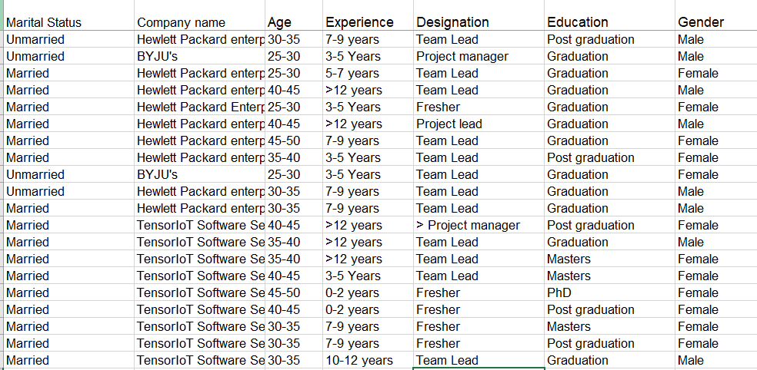

**Analysis:**

From the data collected the variables impact that have been identified for this paper are the demographic factors. The demographic factor studied and analyzed for the employee engagement of the work from home and hybrid model employees for this paper are.

1. Age
2. Designation
3. Experience
4. Marital status
5. Family income
6. Education

From the data collected we have

Demographic factors impact on the engagement of the employees of the work from home and hybrid model working employees:

Age Impact:

Experience:

Designation:

Education:

Gender:

Family income:

Marital Status:

2. Demographic factors effecting the performance of the working from home and hybrid model working employees:

Age:

Marital Status:

Experience:

Designation:

Education:

Gender:

Family Income:

Few forecasts: 1. Impact of Family responsibilities on employee engagement:

1. Impact of health on employee engagement:

**Results and Conclusions:**

The data collected reflects that increase in engagement through demographic factors when employee works from home or on hybrid model. There are many outcomes due to this work model which are.

1. Improved performance
2. Increased Family time and connectivity
3. Increased work Life balance
4. Increased work engagement

During the data collection, when the employee was asked if they intended to go back to the office, maximum of the employee replied that they were not intended to go back to the office and they are happy with the work from home and hybrid model employee’s option.

References:

* utakhieo, L. V. (2020, August 29). The impact of working from home during COVID-19 on work and life domains: an exploratory study on Hong Kong. *https://www.tandfonline.com/doi/full/10.1080/25741292.2020.1863560*.
* Grant, C. A. (2013). An exploration of the psychological factors affecting remote e-worker's job effectiveness, well-being and work-life balance. *Reserch Gate*.
* Hazuria, A. R. (2023, August 01). *Deloitte Insights* . Retrieved from https://www2.deloitte.com/xe/en/insights/industry/financial-services/improve-employee-engagement.html: https://www2.deloitte.com/xe/en/insights/industry/financial-services/improve-employee-engagement.html
* PHILLIPS, T. (2021, NOV 1). *https://codesubmit.io/blog/hybrid-workplace-statistics/*. Retrieved from https://codesubmit.io: https://codesubmit.io/blog/hybrid-workplace-statistics
* Team, I. E. (2021, April 10). *Employee Engagement And Experience For The Post-Covid World.* Retrieved from https://www.hrexchangenetwork.com: https://www.hrexchangenetwork.com/employee-engagement/articles/employee-engagement-and-experience-for-the-post-covid-world-2
* Yuxin Lin, p. m. (2021). *MAKING HYBRID WORK HUMAN 2021 GLOBAL SURVEY REPORT.* Economist Impact - google workplace.
* Monica R , 2020,” Identifying the determinants and its impact on employee engagement in IT sector Coimbatore, <http://hdl.handle.net/10603/345203>.
* Rakesh Ranjan, 2021,” Impact of Employee Engagement on Career Development A Study in Manufacturing Industries”, <http://hdl.handle.net/10603/363205>
* Suhasini Tatiparti,2019 “Employee Engagement s Moderating Impact over the Antecedents of Job Satisfaction and Employee Loyalty Empirical Evidence from Indian IT Sector”, <http://hdl.handle.net/10603/289880>
* Bhargavi V R , 2015,” A Study on Employee Engagement and Its Impact on Organizational Effectiveness In Select Global Companies In Bangalore City, <http://hdl.handle.net/10603/85984>
* S. Sangeetha,2020,” Employee retention strategies in IT industry – A study of select IT companies in Chennai city”, <http://hdl.handle.net/10603/278071>
* Anantha gowda K, 2018, “A study on employee engagement practices with special reference to I T and manufacturing industries , Bangalore and Mysore regions, <http://hdl.handle.net/10603/264046>
* Philcy Philip, 2018,” Factors influencing employee engagement and its impact on three components of organizational commitment in IT Organizations, Bengaluru, [http://hdl.handle.net/10603/314074](http://hdl.handle.net/10603/314074" \t "_blank).
* Rao, Geeta Kalyankar, 2018,”Impact of employee engagement on retention of employees a study of selected information technology and Information technology enabled services IT and ITES in Pune City. <http://hdl.handle.net/10603/375976>.
* Priyadhasini nihdan,2016,”A study of impact of organization culture of employee engagement in selected firms in India, <http://hdl.handle.net/10603/175975>
* Kumar,K R Kishore, 2018,”Employee engagement strategies adopted in IT companies Chennai, <http://hdl.handle.net/10603/280053>
* Mr P V Muthu Perumal and Dr P Umarani ,2021,” Models of Employee engagement”, IJCRT,Volume -6 , Issue – 8 , ISSN – 2320-2882
* Dr Sasmita Choudhury, Dr Manoj Kumar Mohanty,July 2018,”A Conceptual Model of employee engagement from the perspective of manufacturing Industry”, Research review international journal of multidisciplinary , Volume – 3 Issue- 07 ,ISSN – 2455-3085
* Swathi Jha, 2019 ,”Impact of employee welfare programs on employee engagement in IT sector of Rajasthan, <http://hdl.handle.net/10603/338367>, (Jha, 2019)
* Sharma, Praveen Kumar,2016,”Employee engagement and retention: a study of software professionals , <http://hdl.handle.net/10603/124704> , (praveen kumar, 2016)
* Shailashri V T ,2018,”Assessment of employee engagement practices in service sector in Mangalore , Karnataka, <http://hdl.handle.net/10603/267598>, (Shailashri V, 2018)
* Suganthiya M S,2020, Organizational Climate and employee engagement a study with reference to selected employees from information technology organizations, <http://hdl.handle.net/10603/350881>, (Suganthiya, 2020)
* Indhira .N,2017,”A empirical study of factors contributing to employee happiness among millennials in Information technology industry, <http://hdl.handle.net/10603/232155>, (N, 2017)
* Batra G S, 2013,Employees Engagement and Family initiatives – A study of selected corporate enterprises in India, <http://hdl.handle.net/10603/32454>, (G S, 2013)
* Pawar Avinash Vilas,2016,A study on analysis and evaluation of employee value proposition of IT companies in Pune, <http://hdl.handle.net/10603/190592>, (Pawar, 2016)
* 20. Nancy Kumari,2018,Factors influencing the retention of employees in the IT services Industry in Bengaluru, <http://hdl.handle.net/10603/208142>, (Kumari, 2018)
* 21. Jagdeep Singh ,2013,Employees engagement and family friendly initiatives – A study of selected corporate enterprises in India, http://hdl.handle.net/10603/32454. (Singh, 2013)