**TO CHECK VIABILITY OF PROBIOTICS WITH DIFFERENT FRUITS & VEGETABLE FLAVOURS**.

Honde Bharat S.1*, Sonawane Akshay

1. *Department of Pharmaceutical Chemistry S.V.N.H.T.’S College of B.Pharmacy, Shrishivajinagar (Rahuri factory), Tal-Rahuri, Dist-Ahmednagar, MS, India-413706.*

*Corresponding author

**\*Address for correspondence**

**Dr. Honde Bharat Shivaji**

Head, Department of Pharmaceutical Chemistry

S.V.N.H.T'S College of B.Pharmacy,

Shrishivajinagar (Rahuri factory), Tal-Rahuri,

Dist-Ahmednagar, MS, India-413706.

E.mail[I.D.-bharat_honde11@rediffmail.com](mailto:I.D.-bharat_honde11@rediffmail.com)

**Abstract**:-

Probiotics (for life) can be described as a live microorganism which when ingested with or without food improves the intestinal microbial balance and,consequently, the health and functioning of the large intestine.probiotics or friendly bacteria present in the dairy food,is another area of functional foods. Probiotic bacteria promotes good health. Microbial cultures have been used for thousands of years in food & alcoholic fermentation, & in the past century have undergone scientific scrutiny for their ability to prevent & cure a variety of diseases. This has led to coining of the term probiotics. Good probiotic should be nonpathogenic, nontoxic, and resistant to gastric acid, adhere to gut epithelial tissue & produce antibacterial substances and should persist albeit for short periods in the gastro-intestinal tract influencing metabolic activities like cholesterol assimilation, lactose activity & vitamin production.

**KEYWORDS**- cholesterol assimilation, albeit, scrutiny.

**INTRODUCTION**

**Objectives:-**

* Isolation & identification of probiotics organism from curd & sachet.
* To check probiotic organism’s viability in different fruits & vegetables.
* To check probiotic organism’s health beneficial affects on testing it’s antimicrobial affects to pathogenic microorganism.

**Introduction:-**

Microbial cultures have been used for thousands of years in food & alcoholic fermentation, & in the past century have undergone scientific scrutiny for their ability to prevent & cure a variety of diseases. This has led to coining of the term probiotics. Today Probiotics are available in a variety of food products & supplements have got wide application in the control of cholesterol, cancer, allergies etc.

A good probiotic agent need to be nonpathogenic ,non toxic, resistant to gastric acid, adhere to gut epithelial tissue & produce antibacterial substances .It should persist albeit for short periods in the gastro-intestinal tract influencing metabolic activities like cholesterol assimilation, lactose activity & vitamin production.

Probiotics have been used as growth promoters, for lactose intolerance, antitumor &anticholestrolaemic effects. Probiotics have been extensively studied under in vitro & in vivo condition. The use of probiotics resulting in alleviation of lactose intolerance due to increase concentration of β-galactosidase in the small intestine.

Composition of probiotics –probiotics can be bacteria, molds, yeast, but most probiotics are bacteria. Amoung bacteria lactic acid bacteria are more popular. *Lactobacillus acidophillus, L.casei, L.lactis,L.helviticus,L.salivarius,L.plantrum,L.bulgarius,L.rhamnsus,L.johnsonii,L.reuteri,L.fermentum, L.delbrueckii, Streptococcus thermophilus, Enterococcus faecium, E.faecalis,Bifidobacterium s bifidium , B. breve , B. longum & Saccharomyces boulardii* are commonly used bacterial probiotics

In India , probiotics are often used as animal feed supplement for cattle, poultry , & piggery. This requirement is also met by importing probiotics from other countries. It is rarely used for human being – sporolac, Saccaromycesboulardii& yogurt are the most common ones. Sporolac is manufactured using sporolactobacillus. Lactobacillus solution is an example of probiotics, usually gives to pediatric patient in India. The latest addition to the list of probiotics in India is ViBact which act as an alternative to B-complex capsules.

* **Materials and methods**
* Isolation & identification of LAB from curd & probiotic sachet.
* Purification of LAB strain.
* Inoculation of LAB on nutrient agar supplemented with fruits & vegetables
* Quantitate the growth on media
* Compare the fruit extract for optimal growth

**RESULT & DISCATION**

|  |  |  |  |  |  |  |  |
| --- | --- | --- | --- | --- | --- | --- | --- |
|  | Fruit | Pomegranate | | Apple | | NB | |
| Dilution |  | 10-4 | 10-3 | 10-4 | 10-3 | 10-4 | 10-3 |
| Colony form | Big | 800 | 650 | 14 | 2 | 6 | 14 |
| Colony form | Small | 100 | 200 | 40 | 4 | 450 | 600 |

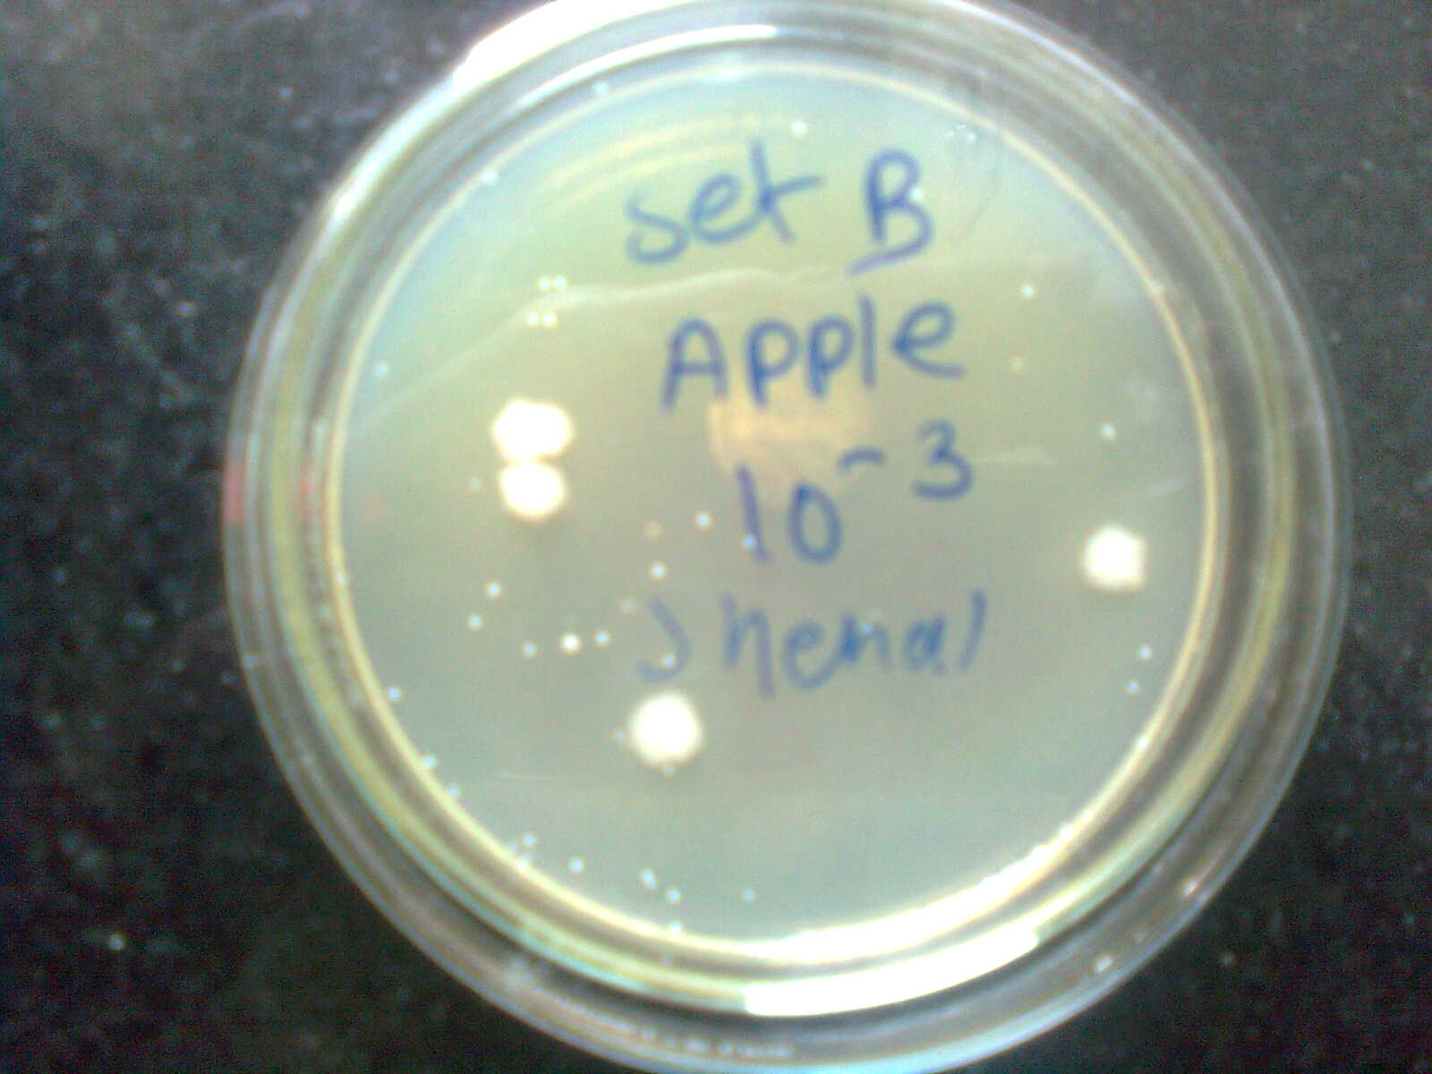

Apple (10-3dilution)

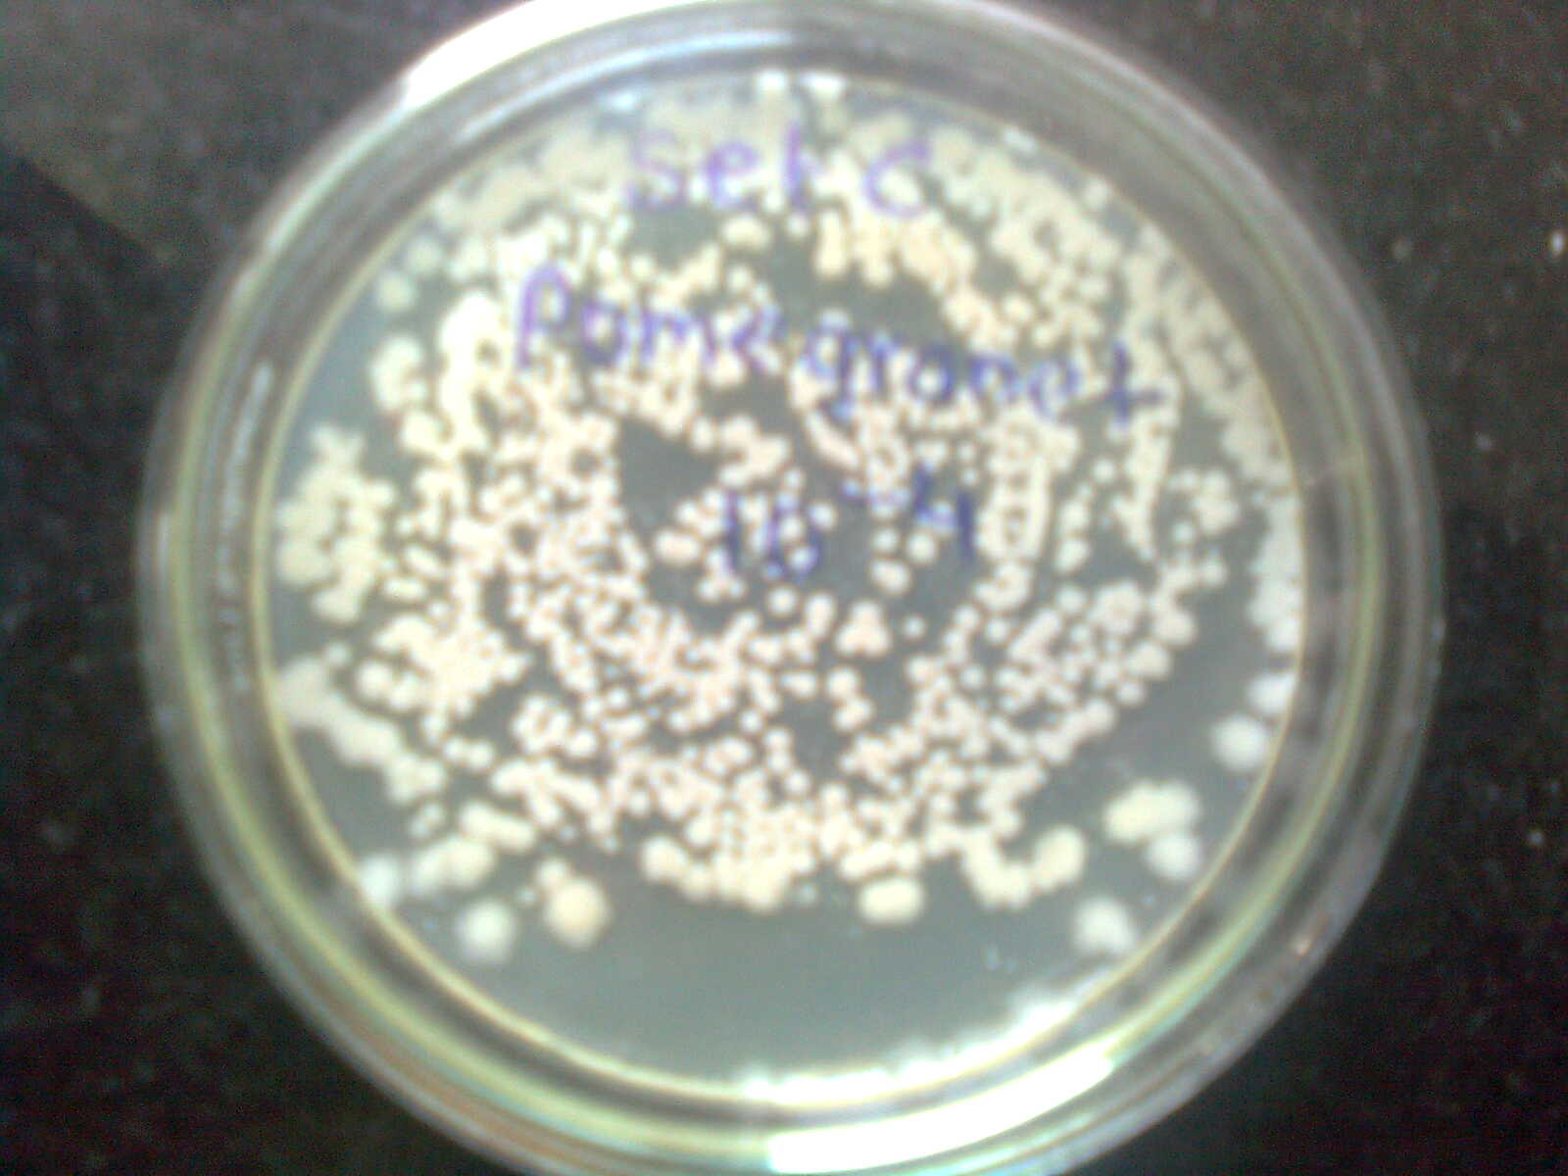

Pomegranate (10-4 dilution)

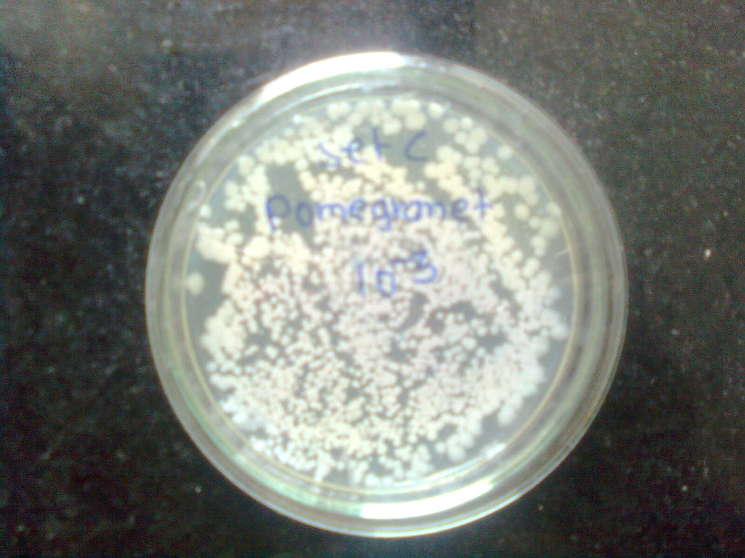

Pomegranate (10-3dilution)

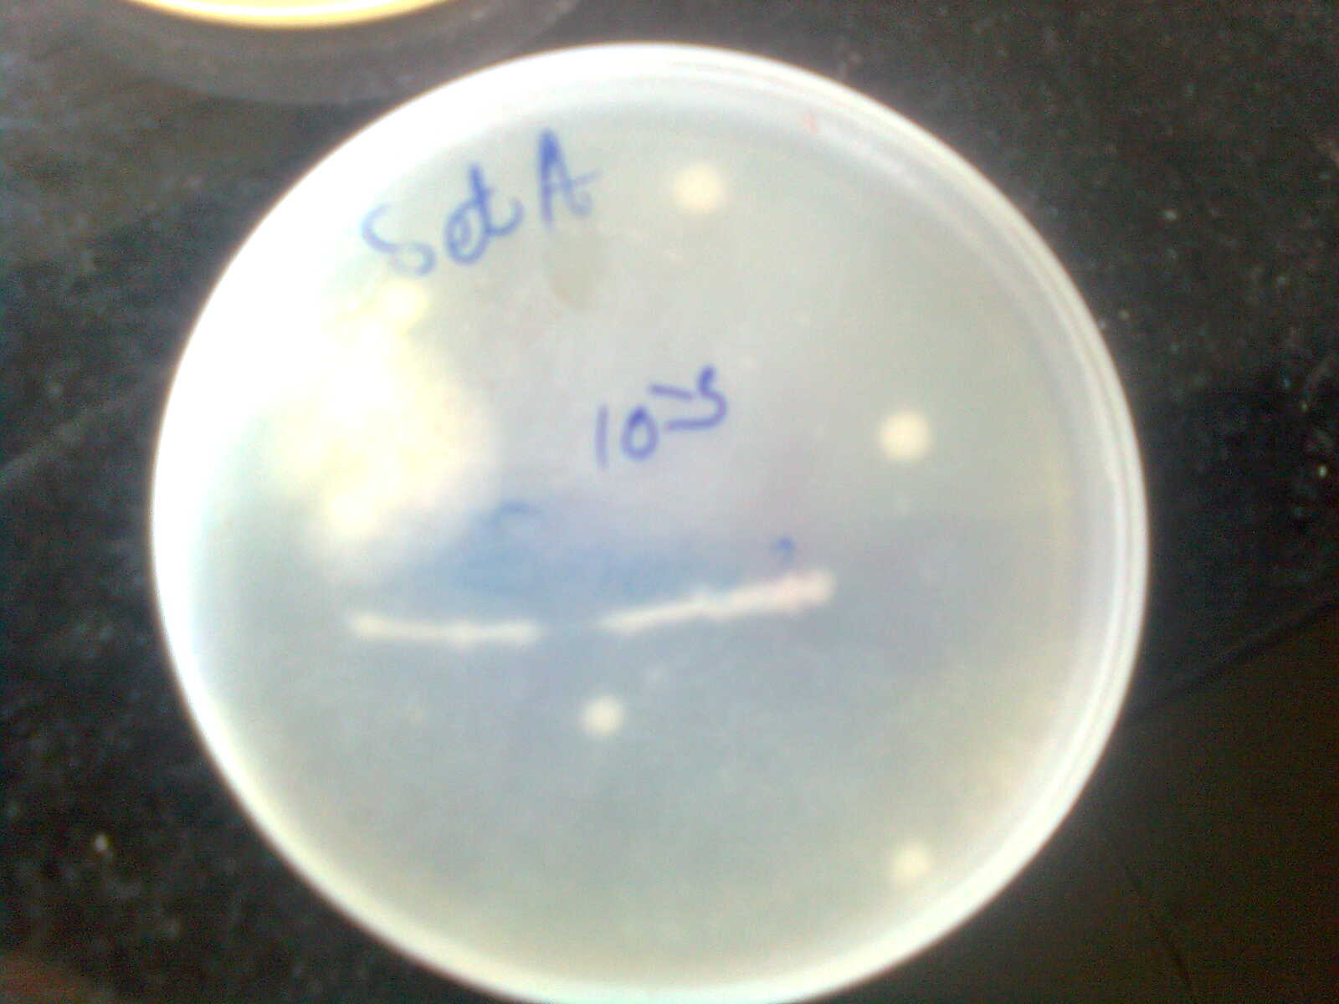

**Lacto Bacillus in Nutrient Broth (10-3dilution)**

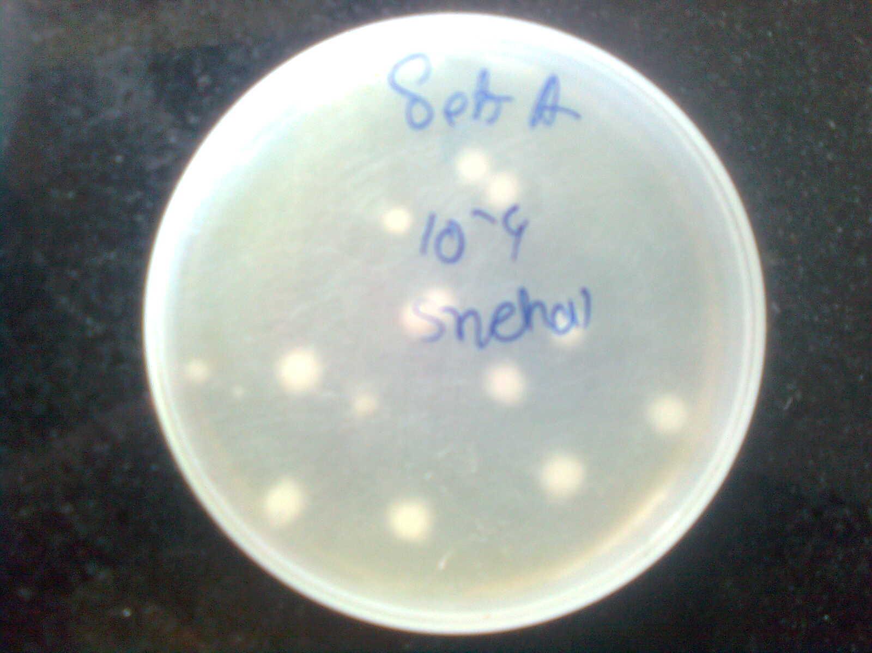

**Lacto Bacillus in Nutrient Broth (10-4dilution)**

Per ml conc. of each bacteria

Pomegranate = 650 × dilution factor

=650× 10-4

=6.5 × 10-4

Pomegranate contain big size colonies i.e. Lactobacillus are 6.5 × 106

Pomegranate = 200 × dilution factor

=2 × 106

Small size colonies i.e. Streptococci are 2 × 106

Apple = 1 × dilution factor

=1 × 10-4

Apple contain 10-4 dilution contain

Big size colonies 1× 104

Apple = 4 × dilution factor

= 4 × 10-4

Apple contain10-4 dilution contain

Small size colonies 4 × 104

Nutrient broth =14× dilution factor

= 14× 10-3

Nutrient broth contain × 10-3 dilution contain

Big size colonies 1.4× 104

Nutrient broth = 600 × dilution factor

=600× 10-3

=6× 105

Nutrient broth contain × 10-3 dilution contain

Small size colonies 600× 105

**Conclusion:-**

**1.**From above observation we found that there is an optimum growth of microorganism in pomegranate sample.

2.The number of colony count was found to be more in given dilution of pomegranate than that of apple.

3.The well separated and distinct colonies are obtained in pomegranate sample than that of apple and nutrient broth.

4.So,pomegranate sample contains more amounts of probiotic bacteria.

5.Since,we can conclude that pomegranate sample(fruits) improves metabolic activity of intestine by improving intestinal microbial balance by acting as a good health promoters.

**Result:-**

From comparative study of pomegranate sample and apple sample and nutrient broth sample,it was came into existence that pomegranate sample having more viability than that of apple and nutrient broth sample,as well as it is also a good health promoter.

**Acknowledgement**

The authors are thankful Department of Chemistry, University, and President, Principal

S.V.N.H.T'S College of B.Pharmacy, Shrishivajinagar (Rahuri factory), Tal –

Rahuri, Dist-Ahmednagar for providing laboratory facilities.

***referances:-***

1. Body .U.V & Suvarna .V.C 2005 probiotic in human health: a current assesment, current science88, no.11,10
2. Karovicova.J&Kohajdova.Z 2005 Lactic acid fermented vegetable juices potable & wholesome foods, Slovak Univresity of technology, Bratislava143-148
3. BleoancaLunia ,Moraru Dana & Segal Rodica 2007 Probiotic vegetable juices , faculty of Da de Jos university Galati, Romania