## Artificial Blood [Hemoglobin-Based Blood Substitutes] A Solution to Blood Deficiency.

Abstract:

Blood is a fluid composed of living cells suspended in a non-cellular fluid matrix. Cellular components of blood are responsible for fuel exchange (red blood cells), immunity (white blood cells), and hemostatic responses (platelets), while non-cellular components (salt, protein, etc.) provide nutrients to various tissues. body. Blood transfusion is one of the most common procedures performed on patients in the hospital. Artificial blood is a product used to replace red blood cells. Although blood has many different functions, its main purpose is to carry oxygen and carbon dioxide throughout the body. The initial development of blood transfusion dates to the early 1600s, and the search for effective blood transfusion continues. Malfunction and deficiency of these blood products cause tissue damage and death. Therefore, transfusion of whole blood or its components is an important clinical point in the treatment of trauma, surgery, myelosuppression and congenital hematological disorders. Nanotechnology offers an exciting way to achieve this goal by using material engineering techniques to create synthetic and semi-synthetic red blood cell replacement for oxygen transport, platelet replacement for hemostasis, and white blood cells for the immune system. Therefore, there is a need to develop alternative methods that can transfer blood reliably and safely. This article will provide a comprehensive review of various methods for generating artificial hemocytes and a critical discussion of the successes and challenges of the current state-of-the-art in this field. However, a recently developed hemoglobin-based oxygen carrier has been promising in early clinical trials and has been granted "orphan drug" status by the FDA.  
  
  
  
Keywords: *artificial blood, nanotechnology, nanomedicine, synthetic blood, red blood cells, white blood cells, platelets, plasma expanders, heme, perfluorocarbons, heme-based oxygen carrier, oxygen therapeutics agent*

## Introduction:

Although research on the safety and effectiveness of blood transfusions (often referred to as "artificial blood" but more scientifically known as "oxygen treatments" (for reasons explained later in this article)) has been ongoing for many years, real success has yet to occur. Blood transfusion is still one of the most common procedures performed on patients in hospitals today, and the safety of blood products has improved for the following reasons: 1. Improved health care and risk assessment of blood donors, 2. Increased infection in blood donors. For example, testing for human immunodeficiency virus (HIV) and hepatitis viruses (hepatitis B and C) also includes recent testing. This confirms the spread of infectious diseases (such as the Zika virus and, in some cases, Brazil). Baylosis is a parasite. Diseases are usually transmitted through bites that can be transmitted through ticks, bites, and blood transfusions) and 3. Improvements in blood products (for example, universal leukapheresis, which filters out disease and the potential danger of white blood cells) 1 ,2,3. However, the risk of blood transfusion cannot be eliminated. Additionally, some well-established risks, such as iron overload (due to changes in red blood cells (RBCs) containing 200-250 mg of iron) and infectious lung disease (TRALI), have proven difficult to prevent or reduce. A comorbid disease in which pulmonary edema (pulmonary edema) is often caused by antibodies to donor leukocyte antigens (HLA) in patients, but other methods (such as infusion of bioactive response modifiers or BRMs) are also applied. defined, collected when collecting blood cell products (e.g., red blood cells and platelets) 4.5. There are also infectious diseases that are undiagnosed or undiagnosed; these include malaria transmission, human granulocytic anaplasmosis (formerly ehrlichiosis) disease, and prion disease (e.g., Klebsiella pneumoniae variant). Bovine spongiform encephalopathy and the spread of CJD, also known as the virus, that causes rabies, are just a few risks.[1] Risks exist but are not recognized. A major concern with the use of blood is risk.  
  
**1.The Availability and Quality of Blood:**

Products create additional challenges in practice. Seasonal shortages are not uncommon in the United States, especially during summer and winter holidays, and sometimes result in delayed selection. It can also be very difficult to find blood for patients with weakened immune systems (for example, those who have developed many antibodies against small red blood cells, such as those found in people with type 2 diabetes) or patients with rare diseases. Blood types (including the Bombay type, also known as Oh, which covers less than 1% of the world's population.[2]  
 However, despite many attempts to overcome blood type problems, the development of such products has proven difficult. to go forward. Although the authors try to cover all known products, it must be said that some products are not covered in this article.[3]   
  
  
**2. Blood and Transfusions:**

Not the Same. Of course, blood is important in providing oxygen and nutrients to tissues and removing waste products. However, circulating white blood cells (granulocytes and lymphocytes [B cells and T cells]) play an important role in the immune system, and platelets, plasma coagulation, and fibrinolytic factors are important components suitable for the balance and lysis of blood vessels.[4]  
  
**4.Artificial blood Function:**

Another important function of blood is the transportation of hormones. What is perhaps less well known is that it also plays an important role in pH buffering of the blood, as blood pH should be around pH 7,409. Blood transfusions, on the other hand, do not actually replace the blood as the name suggests, because these workers are designed to support only one treatment of the blood, that is, the delivery of oxygen to the tissues. Therefore, blood transfusions are better known as “oxygen therapeutic agents” (OTAs) 1 .  
  
[5]  
  
**5. Perfluorocarbon-based blood transfusion**  
  
  
  
3.1 Description Perfluorocarbons were first described by Clark and Gollan in 196610 (PFC) Can act as an oxygen-carrying agent. Their studies proved that mice could survive in the oxygenated PFC. The interaction between these atoms forms a long, strong bond that protects it from chemical degradation, and the fluoride ions form a negative barrier around the molecule, as shown in Figure 1. Due to its hydrophobic nature, complex processes are required to stabilize emulsions for intravenous use. When converted into this emulsion, PFC can dissolve gases better than most liquids. This is due to the low polarizability of fluorine, which reduces van der Waals interactions between PFC molecules. These interactions are known to hold nonpolar molecules together.  
[6]  
PFCs have strong intramolecular bonds, making them stable, but their intermolecular bonds are not very strong, causing them to behave like fat and easily dissolve other substances. -viscosity chemicals (e.g., oxygen [O2], carbon dioxide [CO2], etc.). The amount that PFC absorbs and releases O2 is independent of temperature and environment. Unlike hemoglobin, which relies on local chemical reactions to dissolve O2, PFC obeys Henry's Law, which states that at equilibrium temperature the concentration of dissolved O2 is proportional to the Half pressure of oxygen, allowing O2 to be rapidly released when needed. The reason why PFCs are good candidates for in vivo use is due to the combination of their poor properties in dissolved gases, their O2/CO2 solubility, and their molecular stability. Liquid PFCs have different intramolecular binding strengths and are less complex, thus providing special properties that distinguish them from other organic compounds.[7]

**Materials & Methods:**

**Hemoglobin-based products:**

Hemoglobin carries oxygen from the lungs to other tissues in the body. Hemoglobin-based artificial blood takes advantage of these functions. Oxygen binds to hemoglobin, unlike PFC products where insulation is the main component. This hemoglobin product eliminates blood problems because it is not present in the membrane, unlike whole blood. However, raw hemoglobin cannot be used because it is broken down into smaller toxic substances in the body. There are also problems with the stability of heme in solution. The challenge in making hemoglobin-based blood products is to modify the hemoglobin molecule to solve these problems. Many strategies are used to stabilize hemes. This includes adding compounds or using DNA sequencing technology to produce modified proteins. Such as liposome-encapsulated hemoglobin modified with polyethylene glycol, nanoparticles and polymer Somes-encapsulated hemoglobin, stabilized hemoglobin solution, polymerized hemoglobin solution, conjugated hemoglobin solution.[8]  
  
  
  
Conjugation with hemoglobin effectively increases its molecular size and reduces its antigenicity, causing a slowdown in circulation and reducing the "visibility" of the reticuloendothelial system. Special properties of binding hemoglobin are its high colloid osmotic pressure (which makes it very effective as a blood volume expander) and its viscosity.  
[9]  
Intramolecular cross-linking of hemoglobin does not increase its molecular weight, but there are chemical connections between polypeptide chains that prevent separation into dimers or monomers.  
  
These modified hemes are stable and soluble in solution. In theory, these modifications should make the product more capable of carrying oxygen than our red blood cells. The first products will be available in one to two years.[10]  
  
**Table 1: Perfluorocarbon Products:**

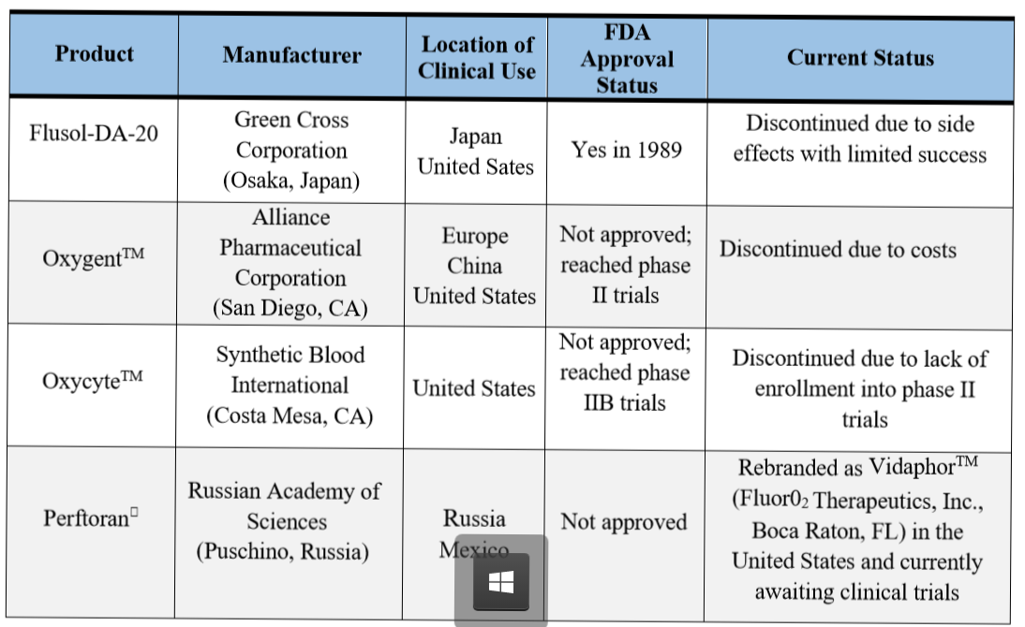[11]

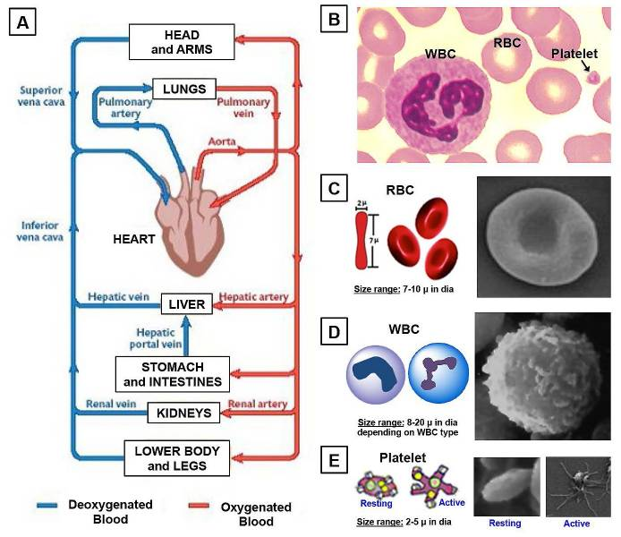[12]

**Design:**

The best blood products have the following features. First, it must be safe to use and consistent in the human body. This means that different blood types do not matter when blood is used. This also means that blood can be produced to eliminate all disease-causing pathogens such as bacteria and viruses. Secondly, it must be able to carry oxygen throughout the body and release it when necessary. Third, it must be stable. Unlike donated blood, blood can be stored for more than a year or more. This contrasts with natural blood, which can be stored for a month before breaking. There are two types of blood changes in development. Their main difference is the way they transport oxygen. One is a PFC-based product and the other is a hemoglobin product.[13]

**Raw Materials:**  
Various raw materials are used depending on the type of blood produced. Hemoglobin products may use isolated hemoglobin or synthetic hemoglobin.  
To produce hemoglobin synthetically, manufacturers use compounds called amino acids. These are chemicals used by plants and animals to make proteins necessary for life. There are 20 amino acid formations used in the production of hemoglobin. All amino acid molecules share some chemical properties. It has amino groups, carboxyl groups and side chains. The nature of the chain varies between amino acids. Hemoglobin synthesis also requires a specific organism and all the information necessary for its growth. This includes warm water, molasses, glucose, acetic acid, alcohol, urea and liquid ammonia.  
Like other hemoglobin-based blood products, hemoglobin is isolated from human blood. It is usually obtained from donated blood that has expired before use. Another source of hemoglobin is animal blood. This heme is slightly different from human heme and must be replaced before use.[14]

### Table: Clinical applications of Tablet Oxygen carrying solutions 1. Treatment (a) Blood transfusion: hemorrhagic shock; bleeding (obesity, surgery); anemia. (b) Whole body washed: acute poisoning; heart failure. (c) Ischemia: Acute myocardial infarction; Staged MI; Heart failure; Cerebral infarction; Acute arterial thrombosis and embolism; Coronary PTCA. (d) Global ischemia: gas embolism; carbon monoxide poisoning; HACO; HACO. (e) Physical therapy: renal failure; hard work; acute pancreatitis. (f) Bacteria: anaerobic and aerobic; (g) Complementary therapy: tumor radiation; chemotherapy 2. Maintaining perfusion during surgery - cardiopulmonary bypass, deep hypothermia, circulatory arrest, cardioplegi 3. Protection of organ donation. 4. Drug carrier – drug-conjugated hemoglobin and perfluorochemicals. 5. Contrast agent – (Perfluoro-octyl bromide) Non-Clinical Applications 1. Culture medium 2. Chemical analysis - oxygen sensor; oxygen calibrator standard solution 3. Bioreactor Use of Paradox (High Oxygen Affinity) 1. Oxygen absorber 2. Oxygen pulse therapy is combined with radiation or chemotherapy to treat malignant tumors.

[15]

**Process:**

Here it is mixed with water and other electrolytes to create artificial blood [Figure 2]. The blood can then be pasteurized and placed in the appropriate container. Check the quality of your compounds regularly throughout the process. It is especially important to check for bacterial infections frequently. Additionally, the finished products' pH value, melting point, moisture content, etc. Many physical and chemical properties such as are also controlled. This production method has been proven to produce up to 2,640 gallons (10,000 liters).

[16]

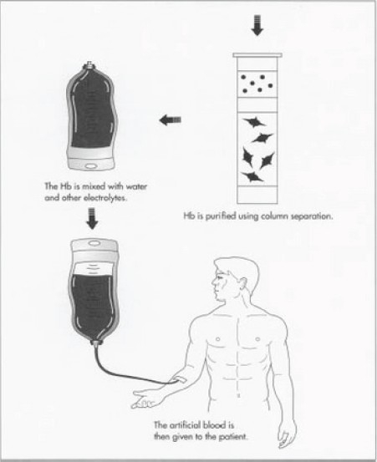[17]

Future:  
  
Currently there are many companies working to produce high quality and useful electronic products. Many blood transfusions have certain limitations. For example, most hemoglobin products do not last more than 20-30 hours in the body. Compared to all blood transfusions over 34 days. Additionally, these blood transfusions do not mimic blood's ability to protect against infection and blood clotting. Therefore, current blood technology will be limited to short-term blood transfusion applications. He hopes to find new products that carry oxygen throughout the body in the future. Long-term supplies as well as blood processing equipment should also be produced.[18]

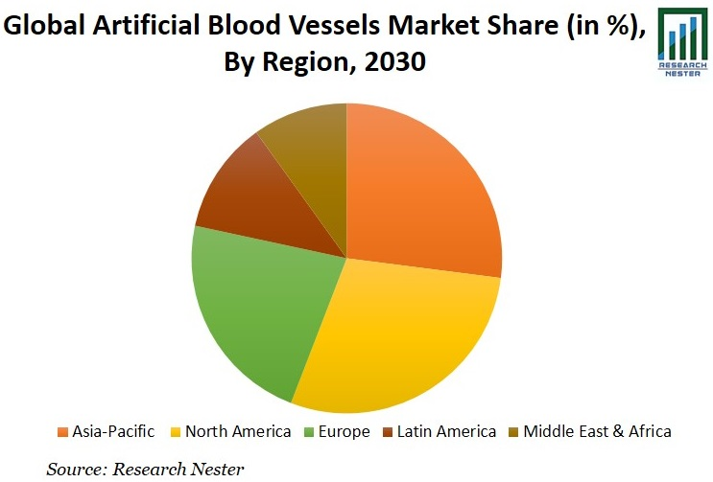[19]

*Global Estimate Artificial Blood Share In 2030 Market*

**Conclusion:**

Many oxygen devices have failed in terms of effectiveness and safety and have therefore been withdrawn from the market or did not enter the market in the first place. Other  
products are still in the early stages of development and may hold promise for future medical advances. The most promising products in the current emerging market are hemoglobin-based oxygen carriers from Polypheme and Hemasure. The safety and effectiveness of both products have been proven in clinical trials and Hemasure is approved for commercial use in South Africa. There are currently no randomized controlled trials directly comparing different products. Additionally, there is no evidence of effects from long-term follow-up, long-term use, or reusing the product after it has been prescribed. Currently, the dose of Hemasure is limited by the manufacturer to 7 units, which, together with its short lifespan, makes its use in the removal of allogeneic red blood cells Limited, but very rare. Essentially, because it is ready to use, it is more universally available than products that can survive the absence of blood.  
The results of the Polypheme pre-hospital trauma trial  
and the planned Hemasure RESUS trial will prove to be important research in making treatment more general where oxygen equipment can be used.[20]

1. Khan, F., Singh, K., & Friedman, M. T. (2020). Artificial blood: the history and current perspectives of blood substitutes. Discoveries, 8(1). [PMC free article] [PubMed] [Google Scholar] [Ref list]
2. Khan, F., Singh, K., & Friedman, M. T. (2020). Artificial blood: the history and current perspectives of blood substitutes. Discoveries, 8(1). [PubMed] [Google Scholar]
3. Squires, J. E. (2002). Artificial blood. Science, 295(5557), 1002-1005. [Google Scholar] [Ref list]
4. Khan, F., Singh, K., & Friedman, M. T. (2020). Artificial blood: the history and current perspectives of blood substitutes. Discoveries, 8(1). [Google Scholar]
5. Khan, F., Singh, K., & Friedman, M. T. (2020). Artificial blood: the history and current perspectives of blood substitutes. Discoveries, 8(1). [Google Scholar] [Ref list]
6. Khan, F., Singh, K., & Friedman, M. T. (2020). Artificial blood: the history and current perspectives of blood substitutes. Discoveries, 8(1). [PMC free article] [PubMed]
7. Khan, F., Singh, K., & Friedman, M. T. (2020). Artificial blood: the history and current perspectives of blood substitutes. Discoveries, 8(1). [PubMed] [Google Scholar] [Ref list]
8. Sarkar S. (2008). Artificial blood. *Indian journal of critical care medicine : peer-reviewed, official publication of Indian Society of Critical Care Medicine*, *12*(3), 140–144. [https://doi.org/10.4103/0972-5229.43685 [PubMed] [Google Scholar] [Ref list]](https://doi.org/10.4103/0972-5229.43685)
9. Sarkar S. (2008). Artificial blood. *Indian journal of critical care medicine : peer-reviewed, official publication of Indian Society of Critical Care Medicine*, *12*(3), 140–144. https://doi.org/10.4103/0972-5229.43685 [PubMed] [Google Scholar] [Ref list]
10. Sarkar S. (2008). Artificial blood. *Indian journal of critical care medicine : peer-reviewed, official publication of Indian Society of Critical Care Medicine*, *12*(3), 140–144. https://doi.org/10.4103/0972-5229.43685 [PubMed] [Google Scholar] [Ref list]
11. Khan, F., Singh, K., & Friedman, M. T. (2020). Artificial blood: the history and current perspectives of blood substitutes. Discoveries, 8(1).

    [PMC free article] [PubMed] [Google Scholar] [Ref list]
12. https://www.ncbi.nlm.nih.gov/corecgi/tileshop/tileshop.fcgi?p=PMC3&id=391065&s=71&r=1&c=1 [PubMed] [Google Scholar] [Ref list]
13. Cabrales, P., & Intagliata, M. (2013). Blood substitutes: evolution from nonmarrying to oxygen- and gas-carrying fluids. ASAIO journal (American Society for Artificial Internal Organs: 1992), 59(4), 337–354. https://doi.org/10.1097/MAT.0b013e318291fbaa [PubMed] [Google Scholar]
14. Cabrales, P., & Intagliata, M. (2013). Blood substitutes: evolution from nonmarrying to oxygen- and gas-carrying fluids. ASAIO journal (American Society for Artificial Internal Organs: 1992), 59(4), 337–354. https://doi.org/10.1097/MAT.0b013e318291fbaa [PubMed] [Google Scholar]
15. Goorha, Y. K., Deb, P., Chatterjee, T., Dhot, P. S., & Prasad, R. S. (2003). Artifical Blood. *Medical journal, Armed Forces India*, *59*(1), 45–50. https://doi.org/10.1016/S0377-1237(03)80107-7 [PMC free article] [PubMed] [Google Scholar] [Ref list]
16. Khan, F., Singh, K., & Friedman, M. T. (2020). Artificial blood: the history and current perspectives of blood substitutes. Discoveries, 8(1). [PMC free article] [PubMed] [Google Scholar] [Ref list]
17. [Indian J Crit Care Med. 2008 Jul-Sep; 12(3): 140–144. [Google Scholar] [Ref list]](https://www.ncbi.nlm.nih.gov/pmc/articles/PMC2738310/)
18. Squires, J. E. (2002). Artificial blood. Science, 295(5557), 1002-1005. [PubMed] [Google Scholar]
19. <https://images.app.goo.gl/hoKoBUMBG7FptvEv9> {Google Images}
20. Tappenden, J. (2007). Artificial blood substitutes. *JOURNAL-ROYAL ARMY MEDICAL CORPS*, *153*(1), 3. [PubMed] [Google Scholar]