Design and Implementation of Unidirectional
Flushing in Water Distribution Pipe System
at Emily Homes Cabantian, Davao City
May Ann P. Baron^{#1}
¹Professional Schools, Master in Engineering
University of Mindanao, Matina, Davao City, Philippines
¹mayann_baron@umindanao.edu.ph

Abstract— Design and implementation of Unidirectional Flushing (UDF) using WaterGEMS software was conducted in the Cabantian Water Supply System (WSS) of Davao City Water District (DCWD), specifically at Emily Homes Cabantian (EHC) in Davao City. The objective is to evaluate the effectiveness of the UDF design in terms of volume reduction and time optimization. Data on pipe network layout, pipe materials, hydraulic parameters (flow rates and pressures), and water demand patterns were collected from Quantum Geographic Information System (QGIS) and Non-Revenue Water Management Division (NRWMD) under Pipeline and Appurtenances Maintenance Department (PAMD) of DCWD used for the UDF design. The implementation flushing process was monitored and recorded for volume and time analysis. The analysis of the UDF implementation revealed a significant reduction in volume, with a recommended volume of 5.1 cubic meters compared to the existing data of 15.68 cubic meters from DCWD. Additionally, the flushing time was minimized to 2.6 minutes, showcasing the effectiveness of the UDF design in optimizing water usage and reducing flushing duration. The implementation of the UDF design using WaterGEMS software at Emily Homes Cabantian successfully achieved the objectives of volume reduction and time optimization. The findings demonstrate the effectiveness of the UDF approach in minimizing water usage, and operational improvements.

Index Terms— Water Distribution Pipe System, Unidirectional Flushing, WaterGEMS, QGIS
- Introduction
Drinking water supply and distribution systems are critical infrastructure that has to be protected for the safety of public health [4]. A water distribution system (WDS) is the physical network of pipes that delivers water from the water source to the intended users [9]. Nowadays, WDS pipe network is essential in population growing city and in large villages because of the need for WDS to provide good quality of water that can minimize health problems of people [18]. Good water quality must be freed from particles which are deposited in water pipes. Flushing of the WDS is one way to get rid of these deposited particles [9]. Traditionally, conventional flushing consists of opening hydrants in specific locations to let the water flow out of the pipe, this action doesn’t usually include the activation of isolation valves [4].
A water distribution network is an essential hydraulic infrastructure that is part of the water supply system composed of a different set of pipes, hydraulic devices, and storage reservoirs [16]. Considering the complexity and the widespread coverage, it is very hard to maintain the distribution network that will meet the desired water quality level. One important tools in the maintenance of WDS is flushing [4]. Performing flushing sequences requires time, skills, and equipment [10]. There are several cleaning methods developed to prevent particle accumulation and incrustation growth. The method selected is UDF [13]. In conventional flushing, all the contaminated water is discharged into the environment, causing damage to it [4]. The UDF is a widely used method to remove sediments from WDS. A section of the pipe system is isolated by closing key valves with the objective of creating a single directional flow with a velocity of at least 1.5 m/s [4].
The network system is modeled, analyzed, and its performance is evaluated under the various physical and hydraulic parameters or conditions. The process is simulated using WaterGEMS. There are various supporting analyses required to be carried out using various software and tools such as MS Excel, QGIS, and WaterGEMS [19]. WaterGEMS is a software that performs extended-period simulation of hydraulic and water quality behavior within pressurized pipe networks [16]. This software is applied to find the optimal pipe diameter to supply an adequate quantity of water at satisfactory pressures to the end users [17]. Watergems can perform any function effectively, including flushing [21]. Also, QGISRed is a freeware QGis plugin developed to assist in building and analyzing hydraulic models of water distribution networks of any complexity, up to the level of detail required by Digital Twins [23]. Google Earth Pro is a freeware that is able to display a picture of the earth's surface both in two dimensions (2D) and three dimensions (3D) [20].
The main objective of this study was to create a hydraulic model design of UDF using WaterGEMS software. The created design will then be implemented at (EHC), Davao City specifically under Cabantian WSS of DCWD. Specifically, this study aims to determine the flushing report in terms of volume and time. The obtained data will be compared against the existing data from DCWD flushing record. These will be the basis in determining the effectiveness of the design and implementation of UDF.
The study will be beneficial to DCWD as it will improve the operation for flushing by reducing volume and minimizing time during maintenance activities through optimized flushing parameters and schedules. If the design is utilized and implemented, the customers of EHC will experience a shortened time of water service interruption. Other water utilities like DCWD as their reference in reducing the volume and time of water flush after maintenance activity. Future research researchers would benefit from this study since it provides reference information and understanding for the creation of new technologies and approaches for analyzing and monitoring flushing during maintenance activities.
The study covered only the designing and implementing of a UDF system specifically for the water distribution pipe system at EHC, Davao City under Cabantian WSS of DCWD. The goal of the study is to improve the operation of flushing by reducing volume and minimizing time during maintenance activities through optimized flushing parameters and schedules. The study utilizes WaterGEMS software for hydraulic modeling design. The impact of the implemented UDF system will be assessed through measurements of volume and time. However, the study does not specifically address the color and taste of the current water in the study area. It focuses primarily on operational improvements. The study does not include sampling and testing of the water after the implementation of the flushing system for microbiological, physical, and chemical analysis. The focus is on assessing operational improvements rather than conducting detailed water quality analyses.
- Materials and Methods
- Conceptual Framework
Input
Water Distribution System Data (Pipe Network Layout, Hydraulic Parameters, Water Demand Patterns)

Process
Hydraulic Modeling Design
Flushing Zone Identification
Implementation of UDF Design
Output
UDF Design Result
Evaluation of the Operational UDF Effectiveness

Figure 1. Conceptual Framework

In Figure 1, data from WDS at EHC, Davao City such as pipe network layout, pipe materials, hydraulic parameters (flow rates and pressures), and water demand patterns are collected. The collected data was used for Hydraulic Modeling Design with WaterGEMS software, as well as flushing Zone identification and flushing system implementation. Evaluation of the UDF design and implementation effectiveness by comparing the UDF design result to the existing DCWD flushing activity.
- Materials and Resources
B.1 QGIS Map
QGIS Map was used to obtain operational data including pipe diameter, pipe length, valve locations, and hydrant placements to facilitate the design of UDF using WaterGEMS modeling.

B.2 WaterGEMS Software
The utilized data gathered from multiple sources, including the operational data obtained from the QGIS map, as well as pressure and flow information from NRWMD of DCWD under the PAMD of DCWD was utilized to create a hydraulic model design for UDF using WaterGEMS software.

B.3 Google Earth Pro
Google Earth Pro was used to acquire elevation data that was utilized in the modeling and design of a UDF. This elevation data was crucial for understanding the hydraulic behavior of the WDS, as it provided insights into the natural flow patterns and potential areas of concern within the network.
- Methods and Procedures
C.1 Description of the Study Area
Emily Homes Cabantian lies in Barangay Cabantian, Davao City. The geographic position of EHC is found within its latitude of 7°7’38.28” N and longitude of 125°36’55.08” E. The study area is under the Cabantian WSS of DCWD. The total active service connection of the study area is 2,132 as of June 2023. WDS of the study area was examined as a typically branched and looped network made of a mixture of Mortar Line Cement Steel Pipe and Polyvinyl Chloride pipe materials with sizes ranging from 50 mm diameter to 250 mm diameter. The total number of gate valves in the study area is forty-four (44) with ten (10) fire hydrants and nine (9) blow-off valves, as shown in Fig. 2.
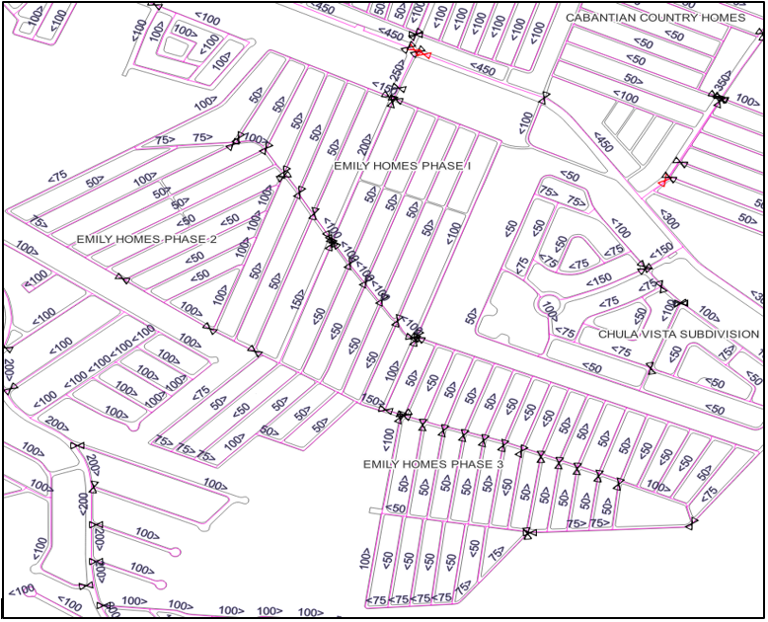
Figure 2. Location of the study area using QGIS Software
C.2 Data Entry
Maps are prepared for the various elements of the WDS of EHC from the gathered data obtained from NRWMD and QGIS software. After validating the maps, hydraulic modeling is done. The data is checked and verified for details such as supply pattern (psi), flow in Million Litres per Day (MLD), and water pressure (psi) through each pipe. The data stored in the attribute table is in the form of diameter, material, head pattern, and flow.

C.3 WaterGEMS Modeling Design
The input data requirements for the hydraulic model analysis are classified as pipe data, node data, and reservoir data. Pipe data are the assigned pipe number for the following pipe properties: diameter (mm), length (m), and materials. Node data are assigned node number for elevation (m), and water demand (psi). The assigned head (m) and flow (psi) are reservoir data. Fig. 3 show the calculation summary of the WaterGEMS simulation process. The simulation was successful and did not encounter any technical errors.

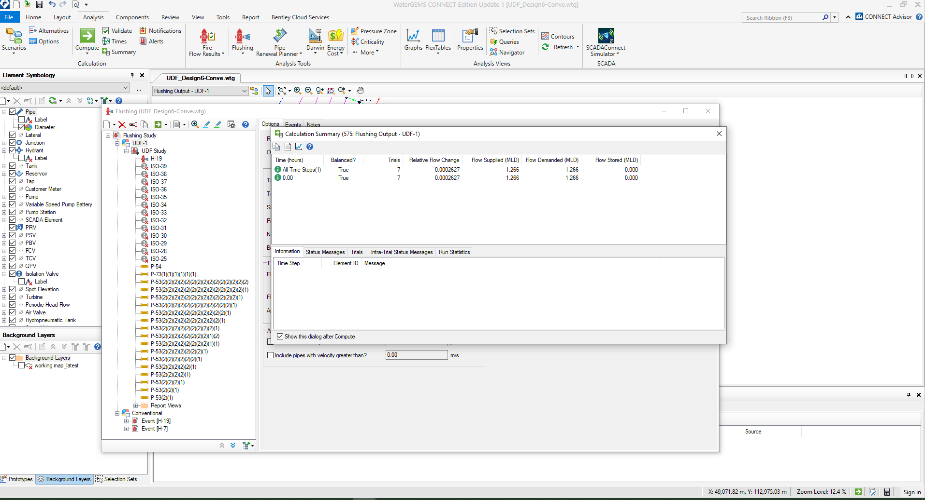
Figure 3. Simulation Process in WaterGEMS

C.4 Design Process of Unidirectional Flushing
The UDF design starts with establishing the UDF event by highlighting the Flushing Study and then adding a new area and renaming it UDF-1. In the Options pane, the Base was set for a Representative Scenario and set the Emitter coefficient to eleven (11). A pipe set was then created. After selecting the pipe set, the operational elements buttons such as valves and one (1) hydrant were then selected. Next, the Pipe to Flush was then selected. Finally, after all the elements were identified, the Compute button was selected to generate a UDF result.

C.5 Implementation Process for Flushing Operations
The generated report that includes a map of the area and the tabular description of the event of which elements to operate such as valves and hydrants were reviewed. Then, prepared the map with valves and hydrants to operate and instructed the maintenance crew for asset assessment. After the asset assessment, the maintenance crew gathered and prepared the necessary equipment for the UDF process. On the scheduled day of the implementation of the hydraulic model design of UDF, the maintenance crew closed the valves indicated in the generated map. Then, start the flushing process by opening the designated hydrant. Flow rates, pressure levels, and time during the flushing process were monitored and recorded to evaluate the effectiveness of the flushing and identify any issues that may require further attention by utilizing the data from NRWMD of DCWD. Using the recorded time (min), diameter (m) of the hydrant, and the result of the flow (gpm) from NRWMD of DCWD on the scheduled implementation, the volume can now be computed using the formula specified in equation 1 below.

Volume = Qt - - - - - - - - (1)

Where Volume is in cubic meters, t is the time (min) and Q is the flowrate (gpm). This calculation allowed for an estimation of the volume of water used during the implementation.

After completing the flushing activity, the maintenance crew reopen the necessary valves and closed the designated hydrant gradually to avoid sudden pressure surges or water hammer. The flushed area was inspected to ensure proper functioning and identify any problems.

C.6 Evaluation of Operational UDF Effectiveness
The effectiveness of the design and implementation of the UDF was comprehensively evaluated. The collected existing data of the flushing operations from DCWD, including the volume and time information was utilized. These data were compared and analysed to the design results of UDF.
- Results and Discussions
This chapter presents the result and discussion of the hydraulic model design of UDF and its implementation focusing on reducing the volume and minimizing the time.

- Hydraulic Model Design for UDF using WaterGEMS Software Result
After collecting the data for the hydraulic model design for UDF at EHC, Davao City, and by following the methods and procedures presented, outputs by WaterGEMS Software are obtained. Fig. 4 presents the results browser of the UDF hydraulic model design. The analysis indicates that the flushing operation achieved the 833 meters of pipe length target. The cumulative pipe length flushed during the operation was precisely 833 meters, and the minimum flushing time recorded was 2.632 minutes, aligning with the recommended flushing time. The volume of water used during the minimum flushing duration was determined to be 5.1 cubic meters, which also matches the recommended volume for flushing. The hydrant discharge during the operation was measured at 509.733 gallons per minute. Additionally, the design result highlights the valves that need to be closed and the specific hydrant that should be used for flushing. This detailed information assists in directing the flushing process by pinpointing the exact pipes and elements involved.

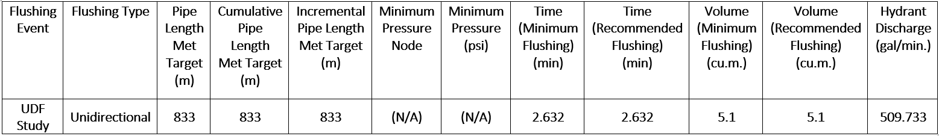
Figure 4. Unidirectional Flushing Result Browser
The results of the UDF analysis, provide detailed information about the pipes involved in the flushing event. The result displays the pipe labels, lengths, and diameters, allowing for easy identification and reference. In addition, the result includes the Velocity results for the maximum flushing scenario, expressed in meters per second. This velocity value indicates the flow rate at which the flushing event occurred. The analysis also assesses whether the flushing target velocity was achieved. If the velocity meets the specified target, it indicates that the flushing process was carried out at the desired flow rate to effectively remove sediments and stagnant water. Furthermore, the figure presents the Shear Stress results for the maximum flushing scenario, measured in pascals. Shear stress refers to the force exerted by the flowing water against the pipe walls. The analysis evaluates whether the obtained shear stress satisfies the target shear stress specified for the flushing operation. If the shear stress value aligns with the target, it suggests that the flushing process generated sufficient hydraulic forces to dislodge and remove sediments effectively. With the objective of creating a single directional flow with a velocity of at least 1.5 m/s. [4], these parameters serve as indicators of the effectiveness of the flushing process in terms of achieving the desired flow velocity and hydraulic forces required for efficient sediment removal.
Among the listed results, twenty-two (22) of pipe ID numbers satisfied both the flushing target and the target shear stress requirements. This indicates that the flushing events associated with these pipe IDs successfully achieved the desired flow velocity and generated sufficient hydraulic forces to effectively remove sediments, aligning with the specified targets. On the other hand, twenty-four (24) of pipe ID numbers did not satisfy the flushing target requirement. It implies that the flow velocity during the flushing events for these pipes did not meet the specified target. However, despite not meeting the flushing target, these pipes satisfied the target shear stress requirement. This indicates that although the flow velocity was not at the desired level, the generated hydraulic forces were still sufficient to remove sediments effectively based on the specified shear stress criteria.
The flushing field result provides a comprehensive overview of the elements involved in the flushing operation. It includes a legend that explains the symbols or labels used to represent different elements, such as valves and hydrants. This map highlights the specific valves that need to be closed and the designated hydrant that should be used for flushing as shown in Fig.5.

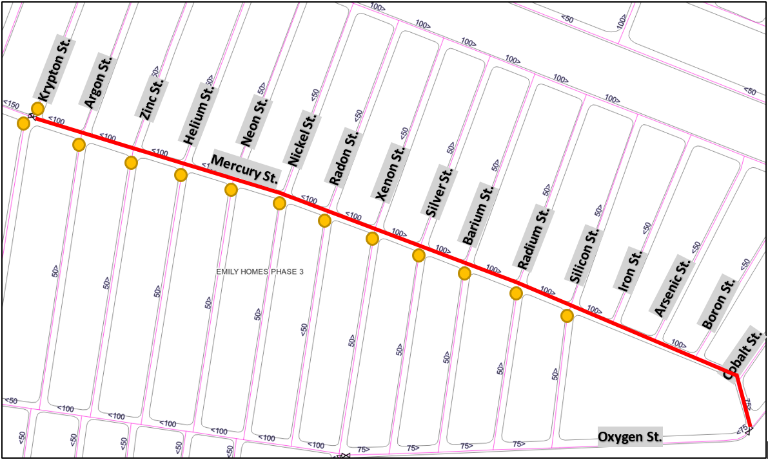
Figure 5. Flushing Field Report Map

The report within the flushing field result indicates key details related to the flushing operation. It specifies that the designated hydrant for flushing is located at Oxygen St., while valves along Mercury St. corner Krypton St., Argon St., Zinc St., Helium St., Neon St., Nickel St., Radon St., Xenon St., Silver St., Barium St., and Silicon St. are identified as the valves that need to be operated and closed during the flushing process. The report further provides information on the minimum flushing time required, which is recorded as 2.6 minutes, and the recommended flushing time, also set at 2.6 minutes. In terms of volume, the flushing report states that both the minimum flushing volume and the recommended flushing volume are recorded as 5.1 cubic meters. This volume represents the amount of water required for the flushing operation, ensuring effective cleaning of the system. Additionally, the report highlights the specific pipe run that needs to be cleaned, specifically along Mercury St. from corner Krypton St. to Cobalt St. These pipes are identified as the sections of the network that require targeted flushing to remove sediments and improve water quality. The result report indicates the final actions taken during the flushing process. According to the report, the final actions involved reopening of valves along Mercury St. corner Krypton St., Argon St., Zinc St., Helium St., Neon St., Nickel St., Radon St., Xenon St., Silver St., Barium St., and Silicon St.
- Unidirectional Flushing Design Implementation Result
After reviewing the generated map, it was verified that along the Mercury St. corner Krypton St., Argon St., Zinc St., Helium St., Neon St., Nickel St., Radon St., Xenon St., Silver St., Barium St., and Silicon St. valves were visible and the hydrant located at Oxygen St. was operational. However, it was observed that some of the valves were difficult to open, which posed a challenge during the implementation process. Despite this difficulty, the implementation followed the recommended time of 2.6 minutes as specified in the design. The average flow rate during flushing was 189.87 gallons per minute (gpm) using data from NRWMD-PAMD-DCWD (Table 1), the volume of water used during the implementation was calculated using the formula specified in the methods and procedures. The calculated volume was determined to be 1.87 cubic meters.
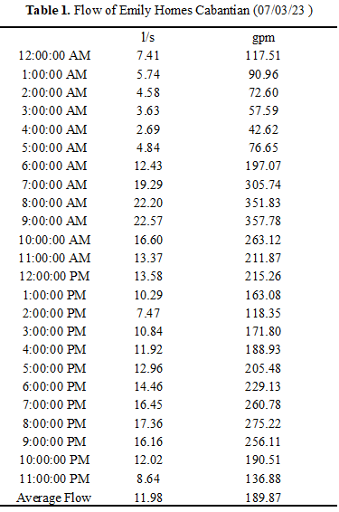
Table 1. Flow Result during Implementation from NRWMD-PAMD-DCWD
- Effectiveness of UDF Design and Implementation
Table 2 presents the existing data from DCWD flushing operations in Cabantian WSS, specifically at EHC, as of June 2023. The data reveals that repetitive flushing activities have been conducted by DCWD. This information has important implications for the operational effectiveness of DCWD, particularly in terms of volume and time. Flushing the networks (routinely performed for cleaning purposes) to examine its effect on the water [8] suggests a recurring issue in the WDS, such as sediment accumulation or water quality concerns, which necessitates frequent flushing to maintain system performance.
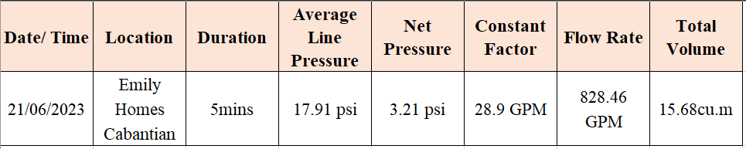
Table 2. DCWD Flushing Report as of June 2023 in Cabantian WSS

Volume Analysis: UDF Design Results vs. Existing Data of DCWD Flushing Activity
The UDF design recommended volume of 5.1 cubic meters and the existing data of 15.68 cubic meters from DCWD reveals a significant difference in water usage for flushing operations as shown in Fig. 6. The UDF Design lower recommended volume signifies a more effective approach to flushing, as it requires significantly less water compared to the existing practices of DCWD. This reduction in volume reflects a commitment to water conservation, resource optimization, and sustainable management within the WDS. The notable difference in volume highlights the possibility for improvements and cost-effectiveness through the adoption of optimized flushing strategies.

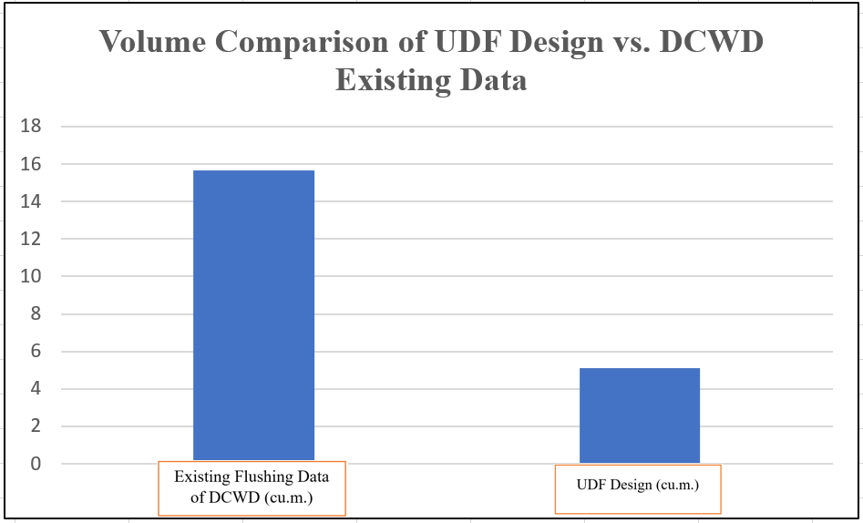
Figure 6. Volume Comparison of UDF Design vs. DCWD Existing Data

Time Analysis: UDF Design Results vs. Existing Data of DCWD Flushing Activity
The UDF Design recommended a time was 2.6 minutes and the existing data of DCWD was 5 minutes that reveals a notable difference in the duration of the flushing operations shown in Fig. 7. The UDF design shorter recommended time signifies a more time-effective approach to flushing compared to the existing practices of DCWD. The reduced time duration indicates optimized flushing sequences, unidirectional flow patterns, and targeted cleaning, resulting in quicker completion of the flushing process which enhances the flushing effectiveness [15]. The significant difference in time highlights the potential for improved resource utilization, cost savings, and customer satisfaction through the adoption of the UDF approach. Further analysis and evaluation of the UDF Design's impact on system performance and water quality will provide valuable insights for streamlining flushing practices and maximizing operational effectiveness within the water distribution network.
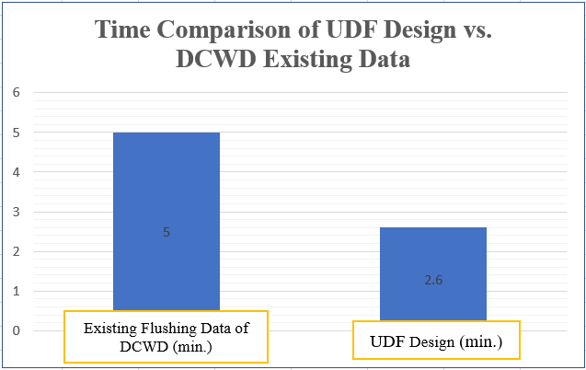Figure 7. Time Comparison of UDF Design vs. DCWD Existing Data

Evaluation of the Operational UDF Effectiveness
Understanding the extent and occurrence of these flushing events enables DCWD to assess the impact on water usage, operational costs, and customer satisfaction. By analyzing this data, the UDF Design’s ability to save approximately 67% of the volume compared to the conventional or traditional flushing methods of DCWD is a clear statement of its effectiveness in conserving water resources. Substantial reduction in volume indicates a remarkable improvement in the operation of DCWD. Cleaning the distribution system using flushing [11] leads to improved customer satisfaction due to the minimized time duration. DCWD can identify patterns, optimize flushing strategies, and implement proactive measures to address the underlying issues, ultimately improving its operations of flushing in the Cabantian WSS. Further analysis and evaluation of the UDF design impact on system performance and water quality will provide valuable insights for streamlining flushing practices and maximizing operational effectiveness within the water distribution network
- Conclusions and Future Works
Based on the results, the volume analysis revealed a significant reduction in the volume of water required for flushing compared to existing data of DCWD, indicating the effectiveness and water conservation benefits of the implemented design. Similarly, the time analysis indicated minimizing the flushing duration, minimizing disruptions to the water supply, and achieving operational effectiveness. The effectiveness of the design and implementation was further supported by the comparison with existing flushing data. The study's findings provide important insights for water utilities in improving their flushing activities. This study contributes to the understanding and implementation of UDF as an effective technique for water quality improvement. It highlights the importance of hydraulic modeling and careful planning in achieving significant reductions in water volume and flushing duration.
The findings can serve as a basis for utilities such as DCWD to enhance their flushing strategies, optimize system performance, and provide improved service to their customers. Future works can be done from the study, such as continuous monitoring, refinement of the hydraulic model design, optimization of the flushing strategy, collaboration with stakeholders, and knowledge sharing will contribute to the long-term success and sustainability of the flushing program.
Acknowledgment
The researcher would like to extend her deepest gratitude to the following persons who, in one way or another, helped in making this study possible: To the Thesis Adviser, Dr. Charlito Cañesares who has been very supportive and understanding of the efforts of the researcher, and for his valuable suggestions and guidance throughout the conduct of the study; To the Management of the DCWD who unselfishly gave their authority for the researcher to use DCWD official data and for their support and encouragement to pursue this undertaking; To her colleagues Engineers James T. Gonida, Zandra Heramis, Bernadine Fajardo, Rodina Niño, Jonalei Bermudez, Charity Farase, Elmer Dimalanta, Kimberly Muaña, and Hevi Angelo Tadena who provided the necessary information, technical support, and critical reviews, and for raising the challenge for her to complete this study; To her family, especially her husband Engr. Kevin Danrell Batoy, daughter Melody Kalliste Batoy, mother Ammic Baron , father Ferdinand Baron, sister and brother-in-law Stephanie, and Melmar Ledres, and mother and father-in-law Gerlie and Danilo Batoy for constantly inspiring her to have the courage and persistence to complete this part of her life’s journey; And to God Almighty whose blessing and guidance got her through this once in a lifetime adventure in her adult life.
References
[1] | J. B. Jensen, "Automated flushing gives water savings," Filtration+Separation, pp. 22-24, 2019.
[2] | A. W. W. Association, "Addressing Question Posed in Federalism Consultation Long-Term Lead and Copper Rule Federalism Consultation," pp. 1-37, 2018.
[3] | Amanda Mussared, Rolando Fabris, Jan Vreeburg, Jenny Jelbart and Mary Drikas, "The origin and risks associated with loose deposits in a drinking water distribution system," Water Supply, pp. 291-302, 2019.
[4] | Margarita Rebolledo, Sowmya Chandrasekaran, and Thomas Bartz-Beielstein, "Technical Report: Flushing Strategies in Drinking Water Systems," Open Water Open Source (OWOS), TH Koln. Germany, 2020.
[5] | Jingpeng Wang, Youming Xiong, Baocheng Wu, Zongyu Lu, Xiaoxiao Li, and Zheng Zhang, "Study on Reasonable Amount of Flushing Fluid and Flushing Time," Energies, pp. 1-22, 2020.
[6] | Zhaozhao Tang, Wenyan Wu, Xiaoxi Han, Ming Zhao, Jingting Luo, Chen Fu and Ran Tao, "Numerical Modelling and Simulation of Two-Phase Flow Flushing Method for Pipeline Cleaning in Water Distribution Systems," Water, pp. 1-11, 2020.
[7] | Mostafa Shoorangiz, Mohammad Reza Nikko, Jirka Šimůnek , Amir H. Gandomi, Jan Franklin Adamowski, Malik Al-Wardy, "Multi-Objective optimization of hydrant flushing in a water distribution system using a fast hybrid technique," Journal of Environmental Management, vol. 334, 2023.
[8] | Joline El-Chakhtoura, Pascal E. Saikaly, Mark C. M. van Loosdrecht and Johannes S. Vrouwenvelder, "Impact of Distribution and Network Flushing on the Drinking Water Microbiome," Front Microbiol, pp. 1-13, 2018.
[9] | Darud E. Sheefa and Brian D. Barkdoll, "Feasibility of an environmentally friendly method of contaminant flushing in water distribution systems using containment ponds," Water Supply, vol. 22, pp. 3745-3755, 2022.
[10] | Florent Pourcel, Sophie Duchesne and Maxim Ouellet, "Evolution of the relationship between total suspended solids concentration and turbidity during flushing sequences of water pipes," Journal of Water Supply:Research and Technology-AQUA, pp. 376-386, 2020.
[11] | Nikki van Bel, Luc M. Hornstra, Anita van der Veen and Gertjan Medema, "Efficacy of Flushing and Chlorination in Removing Microorganisms from a Pilot Drinking Water Distribution Systems," Water, pp. 1-18, 2019.
[12] | Petra Jurek Vidláˇrová and Silvie Heviánková, "Comparison of Modern Drinking Water Network Maintenance Methods: Evaluation of Removed Deposits in the Form of Total Suspended Solids (TSS)," International Journal of Environmental Research and Public Health, pp. 1-16, 2021.
[13] | Florent Pourcel and Sophie Duchesne, "Comparative analysis of air scouring and unidirectional flushing of water distribution sysytems," Journal of Water Supply:Research and Technology - IQUA, pp. 1-13, 2020.
[14] | Guiwei Li, Yuanxun Ding, Hongfu Xu, Junwei Jin, Baoyou Shi, "Characterization and release profile of (Mn, Al)-bearing deposits in drinking water distribution systems," Chemosphere, pp. 73-80, 2018.
[15] | Mohammad Ali Khaksar Fasaee, Mohammad Reza Nikko, Parnian Hashempour Bakhtiari, Shahryar Monghasemi and Mojtaba Sadegh, "A novel dynamic hydrant flushing framework facilitated by categorizing contamination events," Urban Water Journal, pp. 1-13, 2020.
[16] | Pravinkumar Shinde, Prashant Patil, Rahul Hodage, "Design and Analysis of Water Distribution Network Using Water GEMS," International Journal of Advance Research in Science and Engineering, vol. 7, no. 3, pp. 545-552, April 2018.
[17] | Tewelde Gebremedhin Berhane and Tamru Tesseme Aregaw, "Optimization of Water Distribution System Using WaterGEMS: Optimization of Water Distribution System Using WaterGEMS:," Civil and Environmental Research, vol. 12, no. 6, 2020.
[18] | Mr. Prashant Machhindra Darunte, Prof. Shankar C. Wadne, Dr. P.A. Hangargekar, "WATER SUPPLY DISTRIBUTION SYSTEM BY USING WATERGEMS SOFTWARE AT SAIGAON VILLAGE," International Research Journal of Engineering and Technology (IRJET), vol. 9, no. 12, pp. 395-403, December 2022.
[19] | Laxman Netaji Kawathe, Akshay Rajan Thorvat, "Analysis and Design of Continuous Water Distribution System against Existing Intermittent Distribution System for Selected Area in Pandharpur, M.S., INDIA," AQUADEMIA, vol. 4(2), no. ep20028, pp. 1-8, 2020.
[20] | Erni Suharini, Muhammad Hasim Ariyadi, and Edi Kurniawan, "Google Earth Pro as a Learning Media for Mitigation and Adaptation of Landslide Disaster," International Journal of Information and Education Technology, vol. 10, no. 11, pp. 820-825, November 2020.
[21] | Nikita Adhav, Vishal Zerikunthe, Aishwarya Sasane, Arpan Deshmukh, "Analysis and Redesign of 24/7 Water Distribution Network using Watergem Software," International Journal for Research in Applied Science & Engineering Technology (IJRASET), vol. 10, no. VI, pp. 2054-2065, June 2022.
[22] | Darshan J. Mehta, Vipin Yadav, Sahita I. Waikhom, Keyur Prajapat, "Design Of Optimal Water Distribution Systems Using Watergems: A Case Study Of Surat City," E-Proceedings Of The 37th Iahr World Congress, August 2017.
[23] | N. Lerma, "QGIS Plugin to Build and Analyze Advanced Water Distribution Network Models and Digital Twins," QGISRed v. 0.16, pp. 1-47, July 2022.

