**ROLE AND IMPACT OF AI IN FINTECH INDUSTRY**

**1Vanshika Wadhwa, 2Dr. D. Sathish Kumar**

1Student, Maharaja Agrasen Institute of Technology

2Assistant Professor, Department of MBA, Sree Chaitanya College of Engineering, Karimnagar, India

**Abstract**

[Fintech](https://101blockchains.com/what-is-fintech/) is an example of how innovation can transform financial services. As artificial intelligence platforms gain popularity on a massive scale, it is important to look for applications of AI in the domain of fintech. The support of AI in fintech can help in creating faster and more resilient workflows alongside reducing operational costs. AI can help in completing certain tasks at a faster rate while ensuring minimal errors, which fits perfectly with the requirements in fintech. Financial technology (FinTech) and artificial intelligence (AI) are two cutting-edge innovations that have recently altered the financial sector. AI can boost economic growth by 26% and [financial services revenue by 34%](https://blog.gitnux.com/ai-use-in-financial-services-statistics/). It is pivotal for FinTech’s rapid advancements, enabling financial institutions and businesses to analyze vast amounts of data, identify patterns, and make data-driven decisions efficiently.

Artificial intelligence has carved a niche for itself in the world of fintech, leveraging its prowess to perform tasks like crunching financial data, enhancing customer service, streamlining supply chain management, dispensing shrewd trading counsel, and much more. When it comes to best practices in applying AI within the banking sector, looking at case studies is a smart move. Among these examples, it’s evident that chatbots are at the forefront, holding the reins on the customer-facing front. The arrival of automated solutions in the domain of finance introduced plausible improvements over the years. Now, the discussions about the role of AI in fintech have been gaining traction, as financial services and solutions could become more cost-efficient and accessible. This paper find the answer by reviewing the applications and challenges for artificial intelligence in fintech.

**Keywords :** Artificial Intelligence, Fintech, customer, finance, security.

**Introduction**

The first thing about fintech is that it implies a paradigm shift in the design of financial services. You might come across questions like “Is AI needed in fintech?” when you think about technological advancements required for finance. Interestingly, the importance of artificial intelligence in fintech has developed beyond expectations.

Market research reports have pointed out that the market for[artificial intelligence](https://101blockchains.com/blockchain-and-ai/) in fintech can grow up to almost $31 billion by 2027. What factors could drive such favourable trends for adopting artificial intelligence in fintech? You can find a reliable answer with references to possibilities for coming up with a personalized approach to the target audience in fintech. The benefits of AI in fintech would emerge from the outcomes of the advanced algorithms, which help in developing an in-depth understanding of user behaviour. Fintech companies have the best chances of leveraging AI and its comprehensive insights into consumer behaviour for defining their strategies.

For example, AI can help fintech companies identify suspicious behaviours which can lead to loan fraud. AI can also help fintech businesses expand their service offerings and reduce financial risks. Artificial intelligence works to detect fraud and improves safeguards against unauthorized or anonymous access through advanced methods.

The solution segment dominates the market, accounting for [77.5% of the global revenue](https://www.grandviewresearch.com/industry-analysis/artificial-intelligence-in-fintech-market-report). These include applications for mobile banking, digital loans, insurance, credit scores, buying and selling activities, and asset management. [North America leads the market for AI in the Fintech](https://www.mordorintelligence.com/industry-reports/ai-in-fintech-market) due to prominent AI software and system vendors, combined financial institution investment in AI projects, and widespread adoption of AI in FinTech solutions.

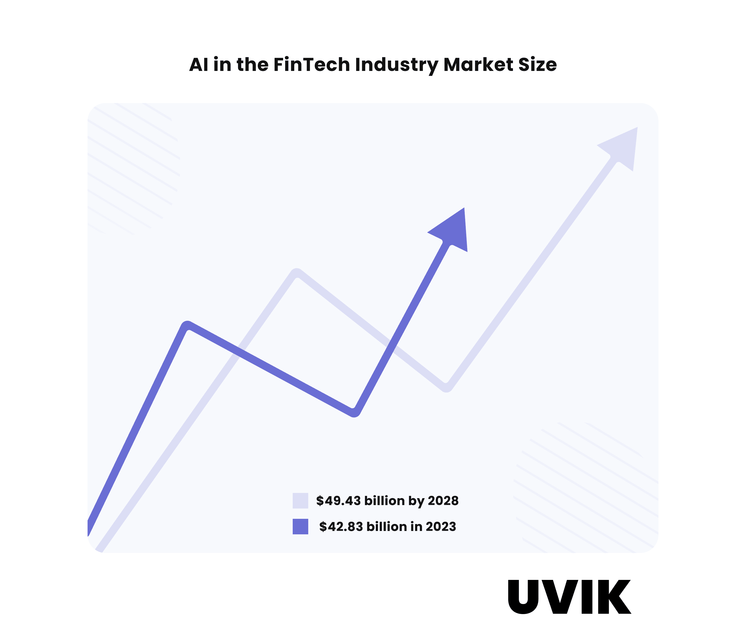

## AI is Revolutionizing the FinTech Industry

Artificial intelligence in FinTech redefines the industry, revolutionizing traditional financial practices and paving the way for innovative advancements. AI’s integration in FinTech reshapes the sector, creating a more efficient, secure, and inclusive financial landscape for businesses and customers. This section will highlight seven ways AI will disrupt FinTech in 2023.

### **AI-Driven Customer Service and Engagement**

AI-driven chatbots and virtual assistants have become game-changers in the financial industry, improving customer engagement and satisfaction. They provide instant and personalized customer support, handle routine inquiries, offer product recommendations, and assist with account management. AI-powered client service is available 24/7, allowing customers to access support anytime.



AI systems also analyze customer data to understand preferences and behaviors. AI-powered chatbots and virtual assistants enable FinTech companies to provide personalized advice and aid customers in making crucial financial decisions. This level of customized attention dramatically enhances the client experience and fosters business growth.

ChatGPT is one of the most potent chatbot technologies. Debuting in 2022, it soon gained popularity for its natural conversational flow and well-structured responses to user prompts. The company that developed ChatGPT, OpenAI, expects the technology to generate [$1 billion in revenue by the end of 2023](https://www.zdnet.com/article/what-is-chatgpt-and-why-does-it-matter-heres-everything-you-need-to-know/). ChatGPT runs on a “pre-trained transformer language model” that uses a “[reinforcement learning from human feedback](https://www.marktechpost.com/2023/03/04/what-is-chatgpt-technology-behind-chatgpt/)” (RLHF) method to produce human-like interactions.

### **Strengthening Cybersecurity and Fraud Detection**

The rise of digital transactions and online financial services has increased the number of cyber threats and fraud attempts. AI in payments & FinTech promotes cybersecurity and fraud detection efforts. Businesses will save more than [$10.4 billion by 2027](https://www.juniperresearch.com/pressreleases/ai-enabled-financial-fraud-detection-spend) due to the use of AI-powered fraud detection and prevention systems, according to a Juniper Research analysis.

AI algorithms can analyze vast amounts of data in real time, continuously monitoring transactions to recognize patterns and identify anomalies, potential security threats, and vulnerabilities. These sophisticated systems distinguish legitimate customer behaviors from fraudulent activities, preventing unauthorized access and financial loss.



AI enhances security procedures to protect financial institutions, secure client data, and increase customer trust. By integrating AI-driven predictive analytics into their fraud detection systems, financial businesses can significantly lower the number of false positives (transactions that are mistakenly flagged as fraudulent).

Financial service providers can better detect and prevent fraud by having more control over the data. AI-powered large language models (LLMs) also process delicate or private information within their infrastructure. It decreases dependency on third-party systems, lowers privacy issues, and guarantees the security of sensitive data.

### **Predictive Analysis**

Financial organizations’ success relies mainly on their ability to forecast future issues and assess existing business trends. Traditional predictive analysis models often have limitations due to the complexity and volatility of financial markets. Predictive forecasting [requires more adaptable technologies](https://www2.deloitte.com/us/en/pages/advisory/articles/leveraging-more-predictive-analytics-in-finance.html) for data consolidation, planning, budgeting, and scenario evaluation.

AI-driven predictive analytics uses machine learning algorithms to identify patterns and trends in historical data and make more accurate forecasts. By employing AI in predictive analysis, financial institutions can make informed decisions on investments, risk management, and market trends, leading to improved portfolio performance and better risk mitigation.

AI-powered large language models help analyze financial data and forecast future investment patterns, empowering investors to make well-informed choices that maximize ROIs. An LLM can undergo specialized training to serve a particular subject or sector. Customization modifies the model to produce precise results based on a domain, offering effectively targeted information.

### **Data-Driven Decision-Making**

Data-driven decision-making implies using facts, metrics, and statistics to make strategic business decisions that align with your company’s objectives and initiatives. It has several benefits over traditional decision-making processes:

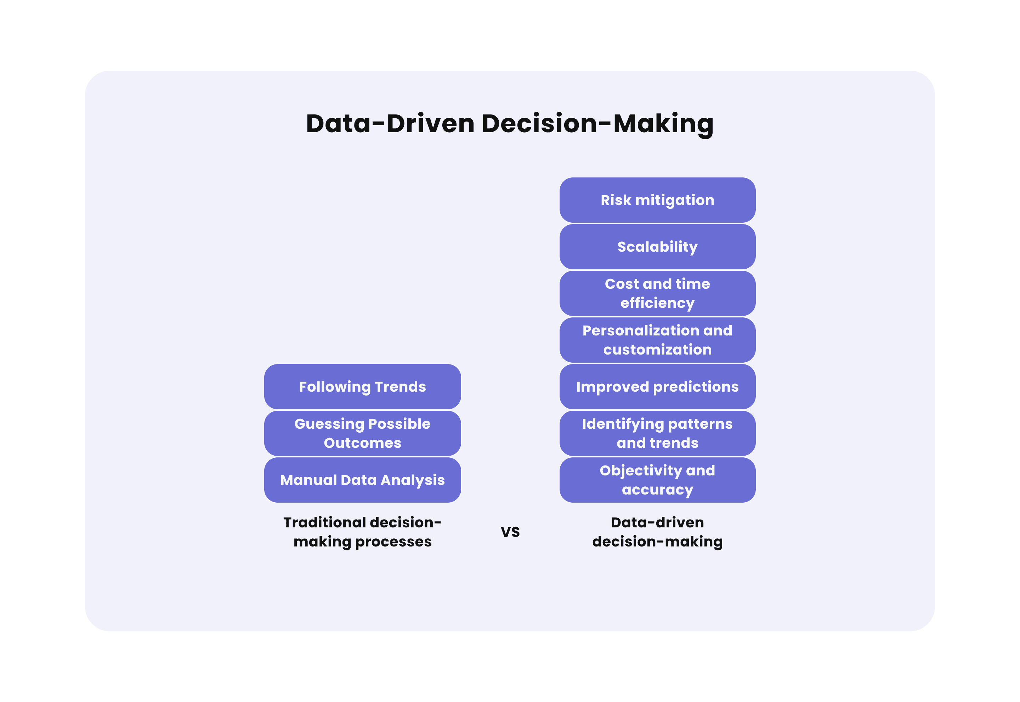

* **Objectivity and accuracy**: Data-driven decision-making relies on specific data and facts. It eliminates biases and subjectivity in human decision-making;
* **Identifying patterns and trends**: It excels at identifying patterns within large datasets, unveiling valuable correlations that might go unnoticed through traditional means;
* **Improved predictions**: It leverages historical data and advanced algorithms to make more accurate predictions about future events;
* **Personalization and customization**: It can access individuals’ data to enable personalized experiences and enhance customer satisfaction and loyalty.
* **Cost and time efficiency**: Streamlined decision-making reduces the time and effort required for analysis and enhances efficiency, leading to cost savings and resource optimization.
* **Scalability**: It can be scaled effectively to handle large datasets and complex scenarios and is adaptable to different business sizes and industries.
* **Risk mitigation**: It identifies potential risks and vulnerabilities, allowing businesses to proactively address challenges before they escalate.

AI technologies facilitate data extraction, analysis, and utilization for informed decision-making, enhancing efficiency and reducing the time and effort required for traditional manual analysis. AI-powered systems analyze enormous volumes of data from multiple sources, such as social media, market trends, and consumer behavior, to find relevant insights and opportunities.

For instance, LLMs can analyze news and social media information to determine public opinion on financial products. An LLM can be taught using a dataset specific to FinTech to foster a thorough understanding of specialized topics. Compared to general-purpose language models, responses based on domain-specific knowledge are more accurate and contextually appropriate.

FinTech companies can leverage AI-driven insights to improve their marketing and business decisions. They can provide individualized products and services, optimize marketing plans, and create cutting-edge solutions that cater to the unique demands of their customers thanks to data-driven decision-making enabled by AI technologies.

### **Automated Virtual Personal Assistants**

AI technology in finance has paved the way for the development of automated virtual personal assistants, providing an enhanced customer experience. These assistants can handle a wide range of tasks, from providing real-time financial updates to executing transactions on behalf of customers. AI-powered assistance systems can track bond and stock price trends and provide instantaneous advice to traders.

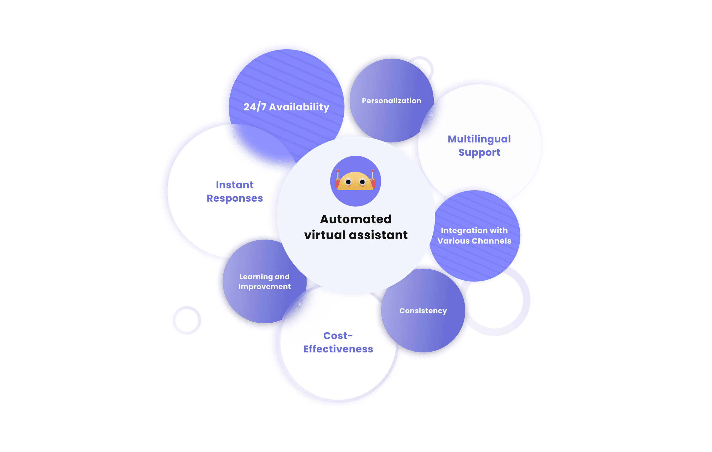

AI-enabled robo-advisors offer game-changing trading methods to novice and experienced stock market participants. Financial assistants’ AI capabilities expand beyond trading. LLMs can also enhance financial literacy, assist in developing tailored financial plans for clients based on their spending patterns and financial goals, and promote better financial decision-making.

Automated virtual assistants powered by AI and natural language processing (NLP) transform how businesses interact with clients and enhance overall customer experiences. They offer several significant advantages over traditional customer service approaches:

* **24/7 Availability**: Automated virtual assistants operate round-the-clock without human intervention, ensuring customers receive prompt responses to their queries outside regular business hours.
* **Instant Responses**: Virtual assistants handle multiple customer queries simultaneously and respond instantly, reducing wait times and providing quick resolutions.
* **Cost-Effectiveness**: Automated virtual assistants are a cost-effective solution compared to maintaining large customer service teams. Once set up, they require minimal maintenance and handle numerous interactions simultaneously.
* **Consistency**: Virtual assistants provide consistent responses and service quality, ensuring all customers receive the same level of support regardless of the time of day or the agent handling the query. It helps build trust and credibility with customers.
* **Multilingual Support**: Virtual assistants can be programmed to understand and respond in multiple languages, eliminating the need for language-specific agents.
* **Personalization**: Advanced virtual assistants analyze customer data and preferences to provide personalized recommendations and responses. It makes customers feel valued and understood.
* **Learning and Improvement**: AI-powered virtual assistants continuously learn from interactions, improving their responses and problem-solving capabilities. The iterative learning process ensures they become more efficient in addressing customer needs.
* **Integration with Various Channels**: Virtual assistants can seamlessly integrate with multiple communication channels, such as websites, mobile apps, and social media platforms.

### **AI-Driven Process Automation**

Based on Mordor Intelligence data, process automation is [one of the main drivers of AI across financial institutions](https://www.mordorintelligence.com/industry-reports/ai-in-fintech-market). FinTech players use AI technologies to automate repetitive corporate procedures, replace manual labor, and increase effectiveness. Automation powered by AI streamlines operations and reduces manual effort.

Automation of customer onboarding, document verification, and loan processing leads to significant time and cost savings for financial institutions. AI-driven automation ensures greater accuracy and compliance with regulatory requirements. As a result, financial institutions can allocate their human resources more effectively to manage higher-value tasks that require human expertise.

AI-powered chatbots like ChatGPT facilitate business processes, creating outlines that teams can use to develop comprehensive solutions. It can offer a financial investment structure based on goals and priorities, analyze service feedback to better understand client feelings, or recommend new financial instruments and investment vehicles.

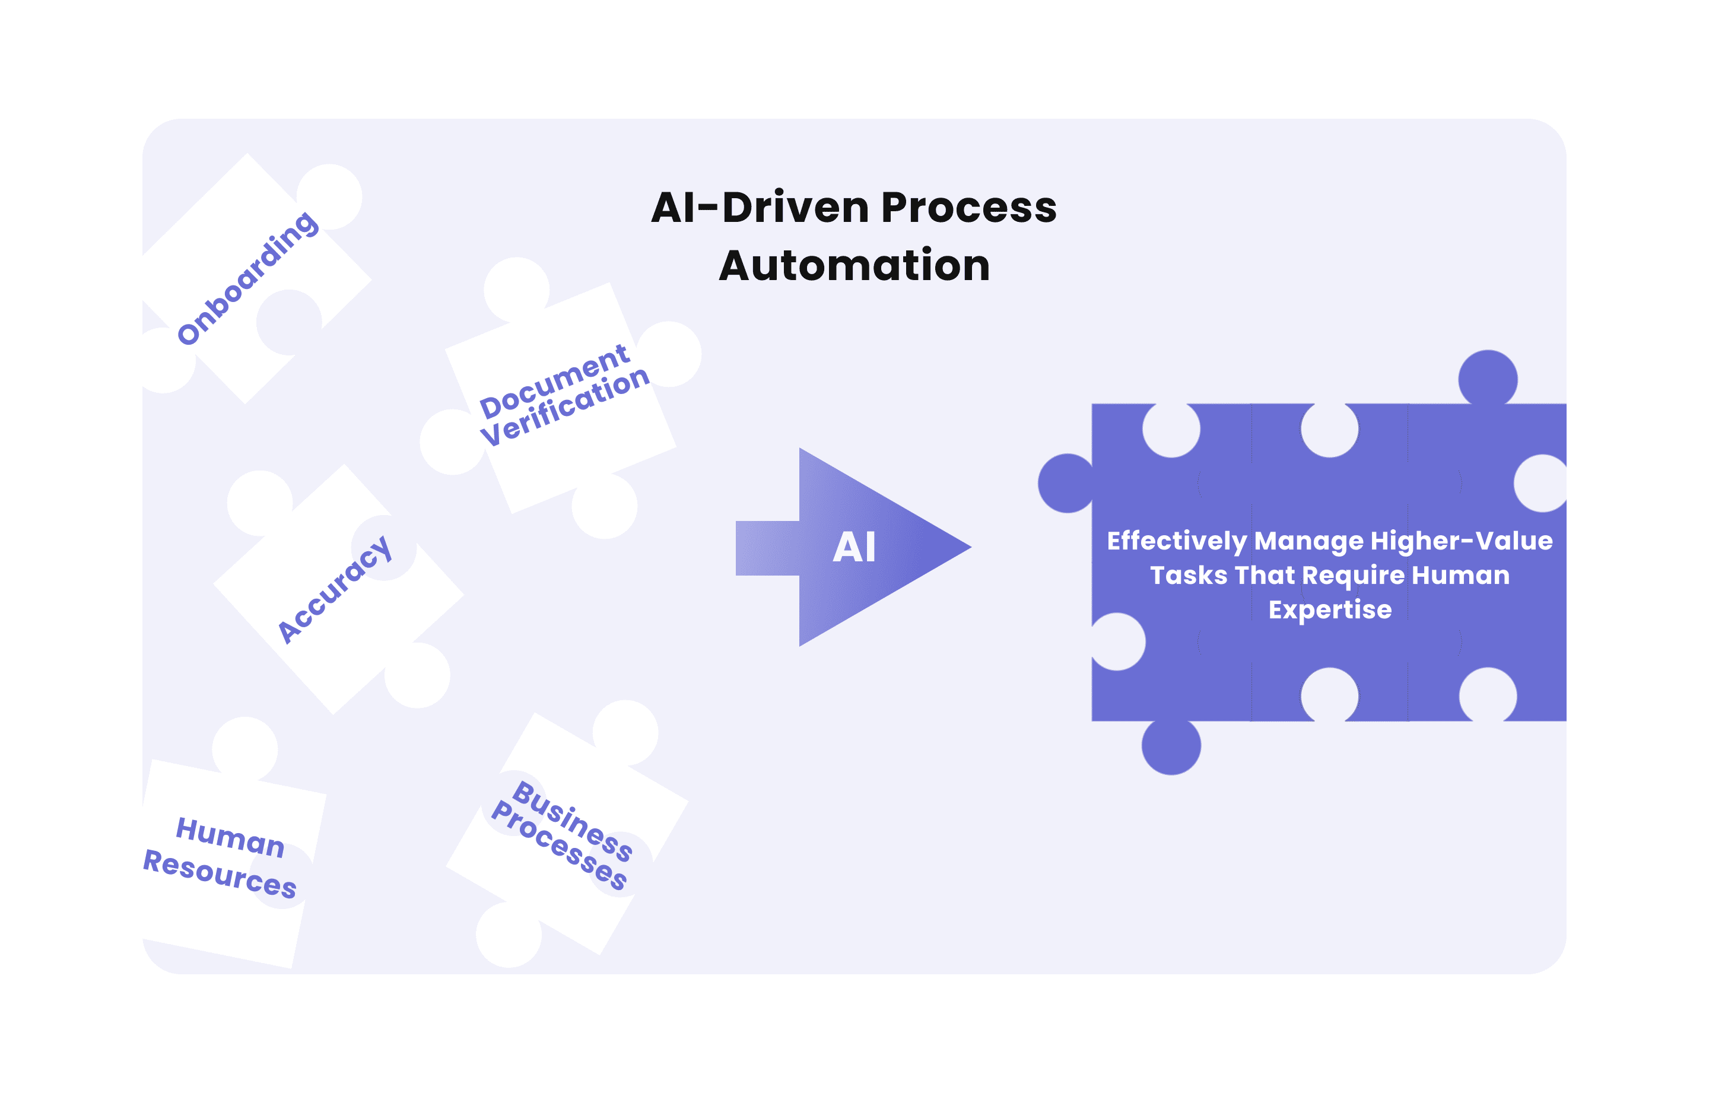

Additionally, large language models can save time and effort by summarizing lengthy financial papers, such as financial reports and contracts. LLMs can be trained to follow specifications for responses in a specific format. AI-powered process automation is used in many areas, including sales, call centers, accounting, and learning and development.

### **Analysis of Credit Worthiness**

Traditional creditworthiness analysis relies primarily on historical financial data, determining a credit risk only partially. On the other hand, AI-driven creditworthiness analysis considers a broader set of factors, including social behavior, online presence, and transaction history. It offers a more holistic and accurate credit risk assessment.

Financial companies can efficiently analyze enormous amounts of consumer data using AI for precise credit evaluations. Today’s AI systems can assess clients’ investment, cash, and credit accounts to assess their financial health. By analyzing customer data, AI can expedite account support and help banks keep up with real-time developments.

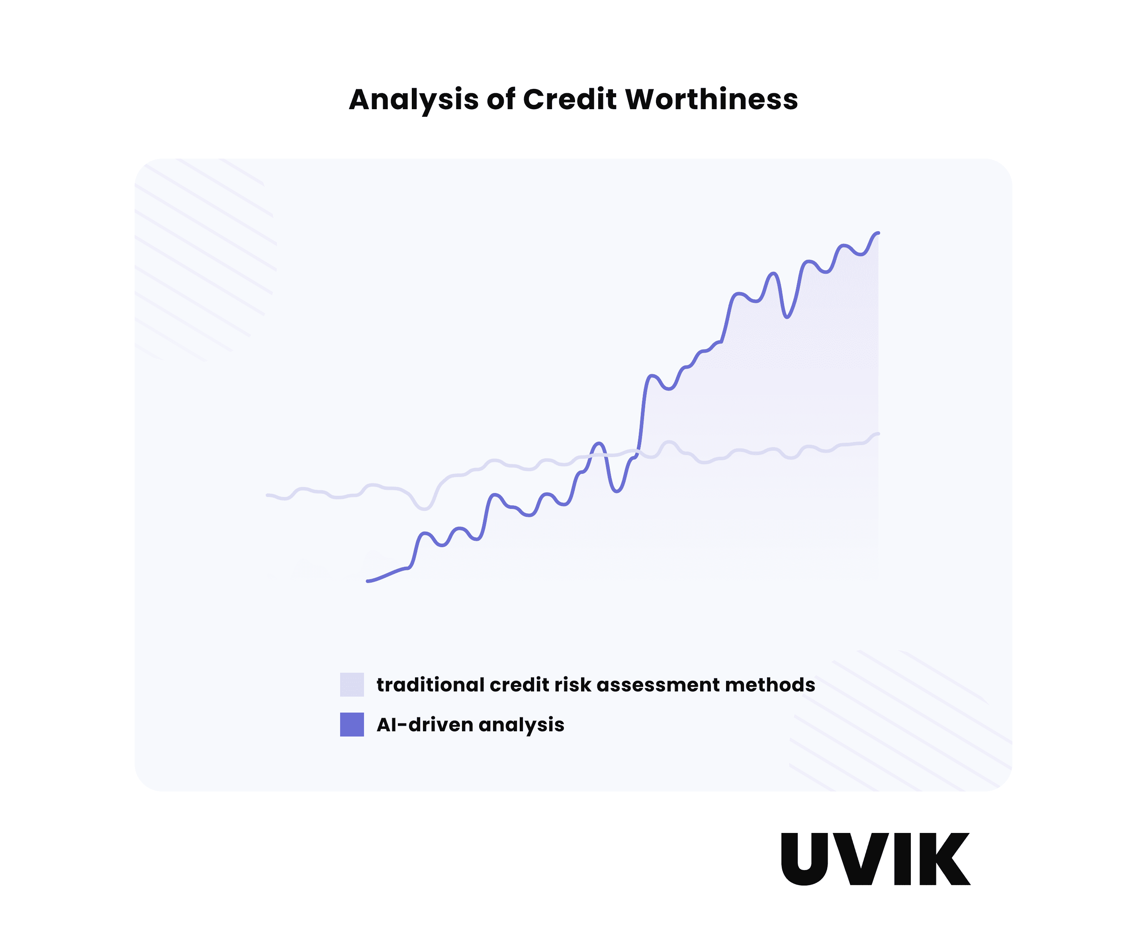

AI compares and analyzes data to assess if a customer is eligible for the products or services. Banking organizations can use a large language model (LLM) to analyze client data and determine risk factors. FinTech firms can also customize loans and insurance policies depending on client profiles and demands.

The role and impact of artificial intelligence (AI) in the fintech (financial technology) industry have been significant and continue to evolve rapidly. AI has revolutionized the way financial services are delivered and consumed, offering numerous benefits and challenges. Here are some key aspects of AI in the fintech industry:

**Improved Customer Experience:**

Chatbots and virtual assistants powered by AI provide real-time customer support and enhance user experience.

Personalized financial recommendations and advice can be offered based on user data and behavior.

**Fraud Detection and Prevention:**

AI algorithms can analyze transaction data in real-time to detect and prevent fraudulent activities.

Machine learning models can adapt and evolve to identify new types of fraud.

**Risk Assessment:**

AI enables more accurate risk assessment for lending and insurance by analyzing a wider range of data sources.

This helps in making more informed lending and underwriting decisions.

**Algorithmic Trading:**

AI-driven algorithms are used for high-frequency trading, making rapid decisions based on market data and historical trends.

They can exploit small price differences and execute trades at a speed and accuracy that is difficult for humans to achieve.

**Credit Scoring and Underwriting:**

AI models can assess a borrower's creditworthiness by considering a broader set of variables, beyond traditional credit scores.

This expands access to credit for individuals and businesses with limited credit history.

**Automation of Back-Office Tasks:**

AI streamlines administrative and repetitive tasks, such as data entry, document verification, and compliance checks, reducing operational costs.

**Regulatory Compliance:**

AI helps fintech companies stay compliant with changing regulations by monitoring and analyzing vast amounts of data for potential violations.

**Wealth Management and Robo-Advisors:**

AI-powered robo-advisors can manage investment portfolios, providing automated and cost-effective financial planning services.

**Data Analysis and Predictive Analytics:**

AI and machine learning can analyze large datasets to identify patterns, trends, and make predictions about market movements and customer behavior.

**Enhanced Security:** - AI is used for biometric authentication, such as facial recognition and fingerprint scans, enhancing the security of financial transactions and account access.

**Impact of AI in the Fintech Industry:**

**Efficiency:** AI automates many manual processes, reducing operational costs and allowing financial institutions to handle tasks more efficiently.

**Accuracy:** AI-driven algorithms can make decisions and predictions with a high level of accuracy, reducing errors and improving risk management.

**Access to Financial Services:** AI enables the provision of financial services to underserved and underbanked populations, as it can assess risk and make lending decisions using non-traditional data.

**Innovation:** Fintech companies are constantly innovating with AI, leading to the development of new products and services that cater to evolving customer needs.

**Challenges:** AI in fintech also poses challenges, including data privacy concerns, algorithm bias, and the need for robust cybersecurity measures to protect sensitive financial data.

**Conclusion**

AI is already transforming the fintech industry, and its influence will keep growing exponentially. AI-powered tools improve efficiency and accuracy, enhance predictive power, and democratize financial services. Therefore, integrating AI in fintech is a game-changer. In summary, AI has transformed the fintech industry by enhancing customer experiences, improving operational efficiency, and expanding the range of financial services offered. While it brings numerous advantages, the industry also faces challenges in terms of regulation, security, and ethical use of AI technologies. The role and impact of AI in fintech will continue to evolve as technology and regulatory landscapes change.

**Reference**

1. Milana, C., & Ashta, A. (2021). Artificial intelligence techniques in finance and financial markets: a survey of the literature. Strategic Change, 30(3), 189-209.
2. Lu, Y. (2019). Artificial intelligence: a survey on evolution, models, applications and future trends. Journal of Management Analytics, 6(1), 1-29.
3. Rana, N. P., Chatterjee, S., Dwivedi, Y. K., & Akter, S. (2022). Understanding dark side of artificial intelligence (AI) integrated business analytics: assessing firm’s operational inefficiency and competitiveness. European Journal of Information Systems, 31(3), 364-387.
4. Pan, Y., & Zhang, L. (2021). Roles of artificial intelligence in construction engineering and management: A critical review and future trends. Automation in Construction, 122, 103517.
5. Villar, A. S., & Khan, N. (2021). Robotic process automation in banking industry: a case study on Deutsche Bank. Journal of Banking and Financial Technology, 5(1), 71-86.
6. Milana, C., & Ashta, A. (2021). Artificial intelligence techniques in finance and financial markets: a survey of the literature. Strategic Change, 30(3), 189-209.
7. Fedyk, A., Hodson, J., Khimich, N., & Fedyk, T. (2022). Is artificial intelligence improving the audit process?. Review of Accounting Studies, 27(3), 938-985
8. Gregory, R. W., Henfridsson, O., Kaganer, E., & Kyriakou, H. (2021). The role of artificial intelligence and data network effects for creating user value. Academy of management review, 46(3), 534-551.
9. Martínez-Plumed, F., Gómez, E., & Hernández-Orallo, J. (2021). Futures of artificial intelligence through technology readiness levels. Telematics and Informatics, 58, 101525.