**Formulation and evaluation of ornidazole loaded ethosomes for antibacterial activity**

Rahul Kumar, Avinash K. Kondalkar, Deepak Tripathi, Manvendra Kaurav*, Muraree Lal

Sun Institute of Pharmaceutical Education and Research, Lahar, Madhya Pradesh, India

*Corresponding Author

Email id – manvendra@siper.ac.in

**Abstract**

Ethosomes entrapping ornidazole were prepared using cold method and the effect of varying concentration of ethanol was considered for obtaining an optimized formulation. Lecithin (2%w/w) was used as the phospholipid to provide the structure to vesicles and propylene glycol (10%) was used as the permeating agent. The vesicles were found to be of spherical to irregular shape ranged from 3.596 ± 0.855 µm to 6.496 ± 2.576 µm in size. The drug entrapment in the ethosomes was studied by analyzing the amount of drug after breaking the vesicles with Triton X100 and it was found that the maximum entrapment efficiency was found to 94.11% for formulation F5 and minimum 87.18% for formulation F1, respectively. The *in vitro* release study suggested that the maximum amount of drug released from the ethosome was 98.1% for F1 while the least release was 89.7% from F5 in 12 h. It was observed that only about 1.18% degradation occurred at 25°C and the formulation was almost stable at 4°C with only 0.89% loss of the entrapped ornidazole thereby proving the stability of the developed system.

**Keywods**

Ornidazole, ethosome, stability, controlled release, antibacterial

**Introduction**

Transdermal drug delivery offers many advantages as compared to traditional drug delivery systems, including oral and parenteral drug delivery system (Vyas and Khar, 2022). Ethosomes are non-invasive delivery carriers that enable drugs to reach the deep skin layers and/or the systemic circulation. These are soft, malleable vesicles tailored for enhanced delivery of active agents (Pandey et al, 2015; Gangwar et al., 2010; Kumar et al., 2010; Bhalaria et al., 2009). The literature revealed that vesicle encapsulated ornidazole combination formulations have been a topic of wide interest among the researchers and helps in improving the antibacterial efficacy and storage stability of the drug. It was further witnessed that ethosomes offered a higher advantage over the liposomes for transdermal delivery of drugs. The method of preparation of the ethosomes influences the physicochemical characteristics of and hence the release kinetics and clinical efficacy of the drug.

Ornidazole (ODZ) chemically known as 1-chloro-3-(2-methyl-5-nitroimidazole-1-yl) propan-2-ol, is a third generation 5 nitroimidazole derivatives that is commonly used in the treatments of infections caused by the bacterial and protozoa. The half-life of ornidazole is 12-14 hours and it is usually administered orally in dose of 500 mg twice a day (Indian Pharmacopoeia, 2010). Hence it was envisioned to formulate ornidazole as ethosome in order to reduce the dosage and even help in topical delivery. The objective of this project is to develop, optimize and characterize ornidazole loaded ethosomes and to determine its topical applicability.

**Material and Methods**

**Preformulation Studies** (Shukla et al., 2022)

The preformulation studies of the drug and excipient provides a preliminary picture of the methodologies that could be adopted for any formulation. Organoleptic features, solubility and melting point of the drug was observed.

**Preparation of Calibration Curve in methanol**

A stock solution of ornidazole (100 mg/100 ml) was prepared in methanol. Diluted ornidazole solution (10 mg / 100 ml) in methanol was prepared from the stock solution. Then, serial dilutions were prepared from that diluted solution in methanol to obtain different concentrations ranging from 10 to 50 µg/ml. The absorbance of these serial dilutions was determined spectrophotometrically at λmax 311 nm, using ethanol as a reference. The measured absorbance was plotted against the corresponding concentrations to obtain the standard calibration curve.

**Drug-excipient compatibility study**

FT-IR spectra matching approach was used for detection of any possible chemical interaction between drug and excipients. A physical mixture (1:1:1) of drug and lecithin was prepared. It was scanned from 4000 to 400 cm-1 in FT-IR spectrometer. The IR spectrum of the physical mixture was compared with that of pure drug to detect any appearance or disappearance of peaks.

**Preparation of ethosomes** (Paliwal et al., 2019; Kumar and Jain, 2021)

Ethosomes were prepared by cold method. In brief the lecithin (3% w/v) was taken in a small round bottom flask and solubilized using ethanol (10-50% v/v) and propylene glycol (10 %v/v) containing drug under mixing with a magnetic stirrer. The round bottom flask was covered to avoid ethanol evaporation. Distilled water was added slowly with continuous stirring to obtain the ethosomal colloidal suspensions. The final suspension of ethosomes was kept at room temperature for 30 min under continuous stirring. Formulations were stored in the refrigerator and evaluated for vesicle size, vesicular shape, surface morphology, entrapment efficiency, in vitro drug permeation study and stability study.

**Table 1 Composition of ethosomal formulations**

|  |  |  |  |
| --- | --- | --- | --- |
| **Formulation code** | **Lecithin concentration (%)** | **Ethanol concentration (%)** | **Propylene glycol concentration (%)** |
| F1 | 3 | 10 | 10 |
| F2 | 3 | 20 | 10 |
| F3 | 3 | 30 | 10 |
| F4 | 3 | 40 | 10 |
| F5 | 3 | 50 | 10 |

**Evaluation of ethosomes**

**Shape and size**

An optical microscope (Magnus) with a camera attachment was used to observe the shape of the prepared ethosomes formulation. Size and size distribution were determined by dynamic light scattering (DLS) using a computerized inspection system (Malvern Zetamaster ZEM 5002, Malvern, UK).

**Entrapment efficiency**

Aliquots of ethosomal dispersion were subjected to centrifugation using cooling ultracentrifuge (Remi) at 12000 rpm. The clear supernatant was siphoned off carefully to separate the unentrapped ornidazole. The sediment was treated with 1 ml of 0.1% Triton X 100 to lyse the vesicles and then diluted to 100 ml with methanol and ornidazole was analyzed by UV spectrometry. Amount of ornidazole in sediment was calculated using calibration curve. The percent entrapment was calculated using the formula,

% entrapment= amount of ornidazole in sediment/amount of ornidazole added ×100

***In vitro* drug permeation study**

The *in vitro* permeation study was carried out by using modified Franz diffusion cell with egg membrane. The study was performed with phosphate buffer saline (pH 7.4). The formulation (centrifuged sediment) was placed (equivalent to 2.5 mg of drug) on the upper side of egg membrane in donor compartment. The temperature of the assembly was maintained at 37±2ºC. Samples were withdrawn after every hour from the receptor media through the sampling tube and at the same time, same amount of fresh receptor media was added to make sink condition. Withdrawn samples were analyzed for ornidazole content by suitable dilution with methanol using UV Visible spectrophotometer.

**Stability study**

Optimized ethosomal formulations were selected for stability study. Formulations were stored at 4°C/60 ± 5% relative humidity and 25°C/60 ± 5% relative humidity for a period of three months. Percent drug entrapment was determined at different time intervals.

**Antibacterial activity of ZNP loaded with ornidazole**

The microorganisms used for the antimicrobial study were procured from Institute of Microbial Technology, Chandigarh (MTCC). *Escherichia coli* (MTCC 40), and *Staphylococcus* *aureus* (MTCC 3160) were used for the present investigation.

**Revival of cultures**

The lyophilized cultures were revived by adding 0.3 mL of nutrient broth to the culture ampoules to obtain a suspension of the bacteria. Revival of the fungal culture was done using 0.3 mL of water.

**Screening Procedure**

About 3 mm thick pre-poured nutrient agar plates were inoculated with a few drops of the bacterial suspension by swabbing on the surface of agar. The antimicrobial action was screened using disc diffusion method (Mishra and Jain, 2013).

Wells were bored into the agar plate at equal distances using cork borer (10mm) and 200µL of the ZNPs (50, 75, 100 & 150 µg/mL) were placed in each hole. The plates were incubated for 24h at 37 ± 0.1°C to allow for microbial growth. The zone of inhibition in each plate was measured in millimeters.

**Results and Discussion**

**Preformulation studies**

The pure drug (active pharmaceutical ingredient) ornidazole was purchased from Yarrow Pharmaceuticals, Mumbai and the sample was observed for its organoleptic characters. The organoleptic characters are the first step towards evaluating the identity and purity of the drug samples (Table 2).

**Table 2 Preformulation studies on ornidazole**

|  |  |  |
| --- | --- | --- |
| **S.No** | **Test** | **Observation** |
| 1 | Appearance | Powder, crystalline |
| 2 | Color | White |
| 3 | Odor | Odorless |
| 4 | Taste | Bitter |
| 5 | Solubility | Soluble in organic solvents like ethanol and DMSO |
| 6 | Melting Point | 78-80°C |

**Calibration curve of ornidazole**

The standard calibration curve of ornidazole was constructed in ethanol to obtain different concentrations ranging from 10 to 50 µg/ml, for which the absorbance readings were determined spectrophotometrically at λmax 311 nm (Figure 1). The standard calibration curve was linear over the concentration range studied and obeys Beer-Lambert’s law with a correlation coefficient (r2) 0.998. The corresponding regression equation was found to be Y = 0.0177X-0.0058.

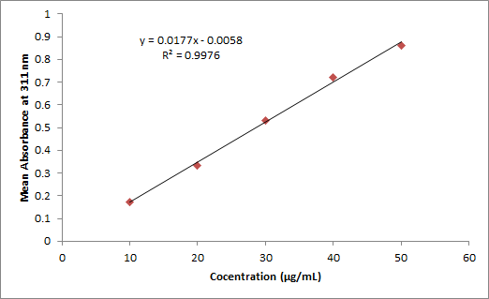

**Figure 1 Standard calibration curve of ornidazole in methanol**

**Drug-Excipient Compatibility Study**

In order to confirm the compatibility of the drug and the excipients, a physical mixture of lecithin and ornidazole was subjected to FT-IR analysis. No peak of the pure drug was removed though the position of the peak changed marginally due to the vibrations of the functional groups of the excipients (Figure 2).

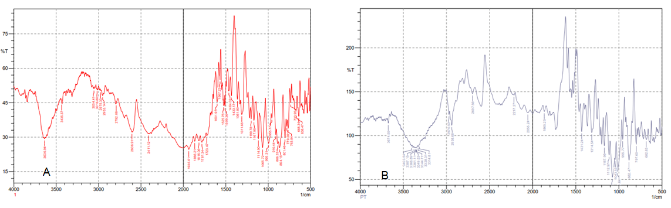

**Figure 2 FT-IR spectrum of (A) ornidazole (B) physical mixture of ornidazole and lecithin**

**Vesicle shape and size**

The vesicles were found to be of spherical to irregular shape ranged from 3.596 ± 0.855 µm to 6.496 ± 2.576 µm in size (Table 3). The smallest particle size was found to be the formulation F5 whereas the largest size was found to be of F1. The vesicles were visualized under optical microscope and were found to be spherical in F2 and F3 whereas irregular in F1, F4 and F5 (Figure 3).

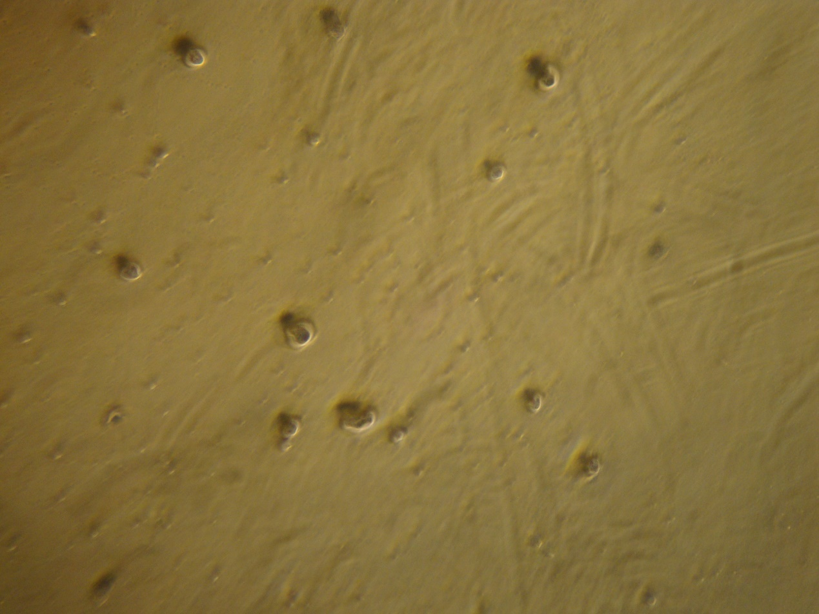

**Figure 3 Spherical particles (F3) visible under microscope (500 X magnification)**

**Table 3 Particle size and shape of ethosomes**

|  |  |  |  |
| --- | --- | --- | --- |
| **Formulation Code** | **Vesicle Size (µm) ± SD** | **Shape** | **Drug Entrapment (%)** |
| F1 | 6.496 ± 2.576 | Irregular | 87.18 |
| F2 | 5.684 ± 1.388 | Spherical | 89.84 |
| F3 | 4.176 ± 1.246 | Spherical | 92.86 |
| F4 | 3.712 ± 1.198 | Irregular | 93.78 |
| F5 | 3.596 ± 0.855 | Irregular | 94.11 |

**Entrapment Efficiency**

The entrapment efficiency of ethosomes was determined for all formulations. Effect of ethanol concentration was observed on percent drug entrapment of ethosomes. The maximum entrapment efficiency was found to be 94.11% for formulation F5 and minimum 87.18% for formulation F1, respectively. An increase in percent drug entrapment was observed with an increase in ethanol concentration. Improvement in aqueous solubility of ornidazole was achieved with higher concentration of ethanol, which could be due to its co-solvent effect. Therefore, the more drug amount could be accommodated in the aqueous core of the vesicles.

***In vitro* drug release**

The amount of drug released from the ethosome was determined using Franz diffusion cell method employing egg-membrane as the barrier imitating skin. It was found that all the formulations were able to control the release of ornidazole up to 12 h of the study. It was seen that that highest amount of ornidazole released from F1 (98.1%) while the least amount of released was from F5 (89.7%) at the 12th hour of study. The drug released at a steady rate from the vesicles suggesting an erosion in vesicle over time leading to the release of the drug (Figure 4).

**Figure 4 *In vitro* release of ornidazole from ethosomes**

**Stability study**

The best formulation (F3) with spherical shape and higher entrapment efficiency was selected for stability study at various temperatures. The formulation was stored in amber glass container at different temperature. The drug content after treatment with triton X100 and % residue of ornidazole was calculated. It was observed that only about 1.18% degradation occurred at 25°C and the formulation was almost stable at 4°C with only 0.89% loss of the entrapped ornidazole thereby proving the stability of the developed system (Table 4).

**Table 4 Stability of the ethosome formulation (F3) on storage**

|  |  |  |
| --- | --- | --- |
| **Time (d)** | **Drug entrapment (%)** | |
| **4°C/60 ± 5RH** | **25°C/60 ± 5RH** |
| 30 | 92.74 ± 0.065 | 92.60 ± 0.083 |
| 60 | 92.58 ± 0.036 | 92.41 ± 0.06 |
| 90 | 92.03 ± 0.124 | 91.76 ± 0.087 |

**Antibacterial activity**

The antibacterial action of ethosome F3 loaded with ornidazole was studied using disc diffusion method. The zone of inhibition obtained was taken as a measure of antibacterial activity. The ethosome F3 was found to show activity against both gram positive and gram negative bacteria.

**Conclusion**

The use of ethosomal flexible carriers has gained popularity as promising approach for transdermal drug delivery. Incorporation of ornidazole in the ethosomal carrier enhances the topical applicability of the drug as ethosomes can be easily incorporated into gel base and formulated as topical gels. The stability of the ethosomes and its controlled release up to 12 h make the carrier system suitable for formulation as a topical delivery system.

**References**

1. Vyas SP, Khar RK, Vyas S. Introduction to Novel Drug Delivery Systems. CBS Publishers, New Delhi, 2022.
2. Pandey V, Golhani D, Shukla R. Ethosomes: versatile vesicular carriers for efficient transdermal delivery of therapeutic agents. Drug Delivery. 2015; 22(8): 988-1002. Doi: 10.3109/10717544.2014.889777
3. Gangwar S, Singh S, Garg G. Ethosomes: A novel tool for drug delivery through the skin. J Pharm Res. 2010; 3 (4), 688-691.
4. Kumar KP, Radhika PR, Sivakumar T. Ethosomes-A Priority in Transdermal Drug Delivery. Int J Advances Pharm Sci. 2010; 1: 111-121.
5. Bhalaria MK, Naik S, Misra AN. Ethosomes: A novel delivery system for antifungal drugs in the treatment of topical fungal diseases. Indian J Exper Biol. 2009; 47:368-375.
6. Ornidazole. In: Indian pharmacopoeia, Indian Pharmacopoeial Commission, New Delhi, 2010, pp. 1823-1824
7. Shukla SK, Dangi S, Ghatuary SK, Prasad S, Shende R. Formulation and evaluation of Repaglinide loaded Nanoparticles. Journal of Pharmacology and Biomedicine. 2022; 6(4): 537-543.
8. Paliwal S, Tilak A, Sharma J, Dave V, Sharma S, Yadav R, Patel S, Verma K, Tak K. Flurbiprofen loaded ethosomes -transdermal delivery of anti-inflammatory effect in rat model. Lipids in Health and Disease. 2019; 18: 133. Doi: 10.1186/s12944-019-1064-x
9. Kumar R, Jain A. Formulation and evaluation of salicylic acid loaded ethosomes. Journal of Pharmacology and Biomedicine. 2021; 5(3): 334-341.
10. Mishra R, Jain S. Investigation of antimicrobial potential of some thiazolyl chalcone derivatives. PharmacologyOnLine. 2013; 1: 190-193