Performance Analysis of Draft Tube for Variation in Diffuser Angle

Sunita Mohanty1 , Prof. Akshay Anand2

1M.Tech. Scholar, Millennium Institute of Technology, Bhopal

2Assistant Professor (M.E.), Millennium Institute of Technology, Bhopal

ABSTRACT

Energy is abundantly available in various forms in nature. Flowing water contains kinetic energy and it can be easily harnessed with the help of reaction turbines for lower and medium heads. Water leaving the turbine still has lot of energy, that energy can be further extracted using draft tubes. Design of draft tubes is important as its performance will affect the overall efficiency of hydel power plant. In the present work, the performance of conical draft tube for variation in diffuser angle has been carried out using Computational Fluid Dynamics technique. The analysis has been carried out for draft tube with diffuser angle of 4.0°, 4.5°, 5.0°, 5.5°, 6.0° for a fixed height of draft tube. Uisng CFD it has been found that head loss coefficient is low for newly designed geometry. For 5.5° diffuser angle draft tube, both head recovered and efficiency are found to be on higher side as compared to draft tube with diffuser angle of 5°

**Introduction**

A number of blades are attached to the spinning shaft in hydraulic turbines. Water in motion striking the turbine blades as it travels through a hydraulic turbine causes the shaft to turn. While flowing through turbines, water's velocity and pressure vary. This causes the turbine shaft to rotate and create torque. Different types of hydraulic turbines are in use based on the needs that need to be met. A certain kind of turbine is employed for a particular need.

Prasad, V.et al. 2009 numerically carried out 3D viscous turbulent flow analysis of an elbow type draft tube using ANSYS CFX. Rahul Bajaj et al. 2014 found that the geometry of draft tube had large impact on the performance of reaction turbine. Ruchi Khare et al. 2012 carried out 3D viscous flow simulation in the complete flow passage of Francis turbine for three different runner solidities at different rotational speeds. Lekha Mourya et al. 2017 has emphasized on redesigning of the existing draft tube by changing their shapes has been worked upon. Ruchi Khare et al. 2012 has stated that because conical draft tubes recover more of the vortex flow leaving the runner than elbow draught tubes, they perform more efficiently. Chakrabarty, S. et al. 2016 used the ANSYS Fluent CFD code to optimise the design of the draft tube. McNabb, J., et al. 2014 described a complete set of design parameters is used to define the precise geometry of the draft tube. Ruchi Khare et al. 2015 explored how the amount and direction of swirl originating from the runner affects how the flow is distributed inside the draft tube. Gupta et al. 2015 studied that hydraulic turbines are made to operate as efficiently as possible. Each component of the hydraulic electric power plant must operate at close to 100% efficiency in order to achieve the best efficiency feasible.

Efficiency of draft tube plays a very important role in the overall performance of reaction turbines. Numerical methods can be used to predict the performance of hydraulic components in design stage only. ANSYS CFX is one of the promising software packages for simulating flow and performing the detailed analysis of hydraulic components. There is direct effect of length and divergent angle of draft tube on the overall performance of hydro electric power plant having reaction type turbine.

Computational Fluid Dynamics (CFD) is a branch of fluid mechanics that deals with the numerical analysis of fluid flow and heat transfer phenomena. It involves using mathematical algorithms and computational methods to simulate and solve the governing equations that describe fluid flow and heat transfer processes.

**Modeling**

Straight divergent type draft tube has been used for present simulation. Geometry given by Ruchi et.al. (2012) has been used as reference work and validation has been done.

The 3D-view of the modeled draft tubes for variation in diffuser angle have been shown in Fig. 1, Fig.2, Fig. 3 and Fig. 4

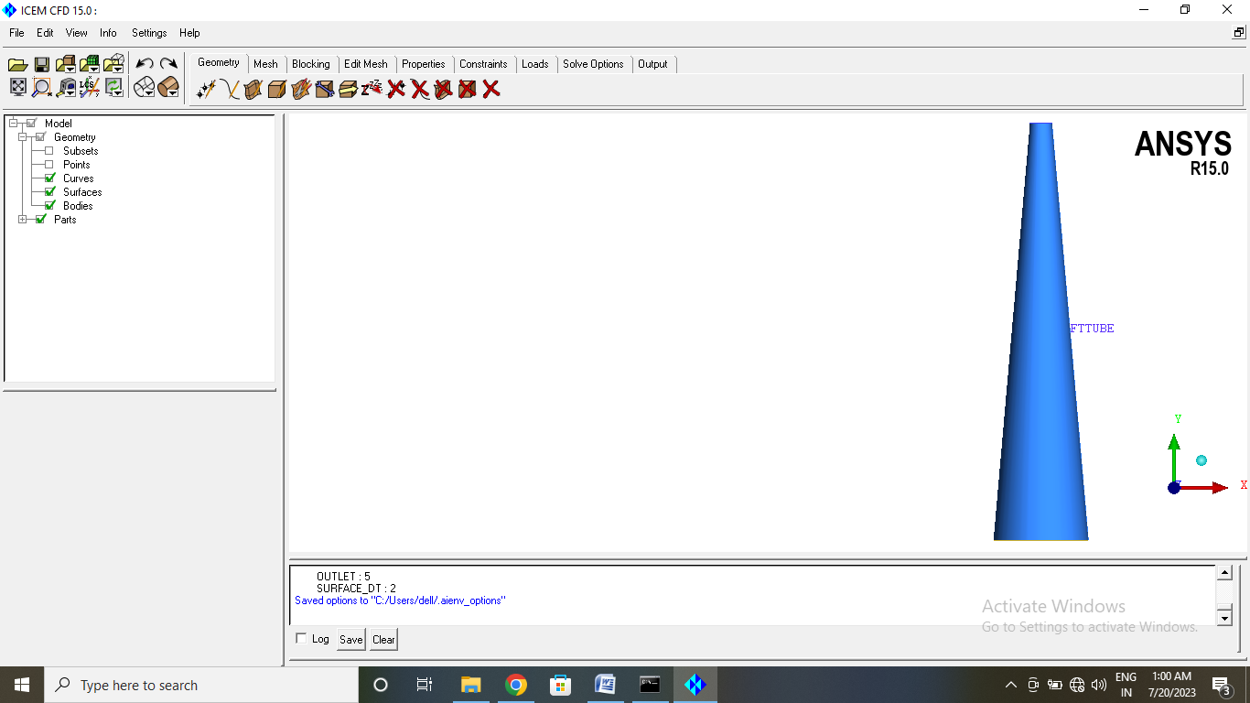

Fig 1: 3-D view of draft tube with divergent angle of 5° and height 30.4 m

Inlet diameter of the draft tube is 1.6 meter and the height is 30.4 meter. The diffuser angle is 5°. This geometry has been used for validation of results.

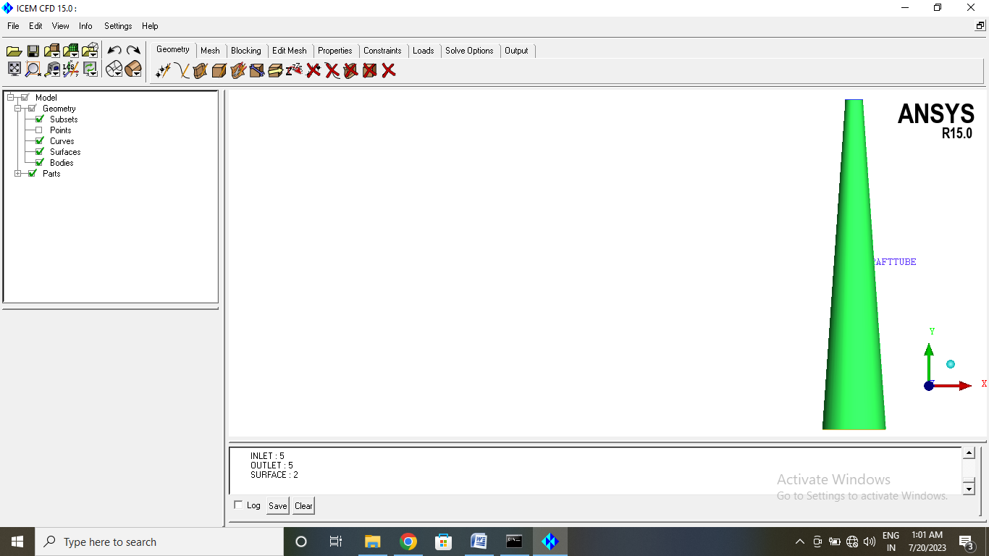

Fig 2: 3-D view of Draft Tube with changed divergent angle (4°)

The geometry has been modified by changing its divergent angle. Due to this the outlet area varied.

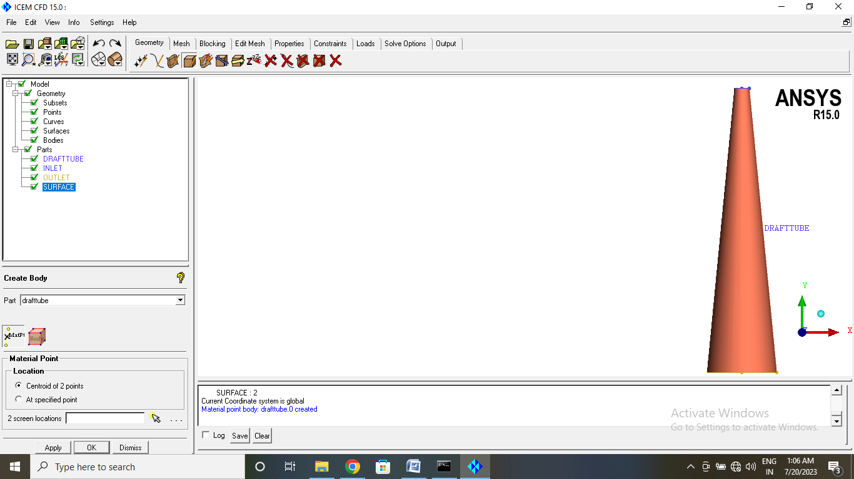

Fig 3: 3-D view of Draft Tube with changed divergent angle (5.5°)

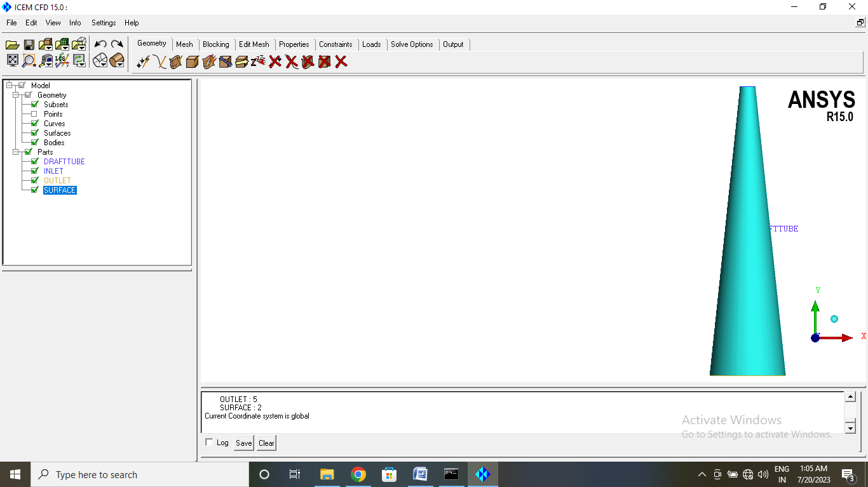

Fig 4: 3-D view of Draft Tube with changed divergent angle (6.0°)

**Meshing**

Draft tube domain is enclosed by inlet and outlet surfaces. The velocity components specified by Ruchi et.al. (2012) have been specified at inlet to draft tube. The outlet of draft tube is kept open to atmosphere. Triangular elements have been used for 2 D surface and tetrahedral elements have been used for 3D fluid flow region for the mesh generation.

Table - 1: Data for Meshing of Draft Tube

|  |  |  |
| --- | --- | --- |
| **Part name** | **No. of Elements** | **Element Type** |
| Inlet | 350 | Triangle |
| Outlet | 3796 | Triangle |
| Surface | 64494 | Triangle |
| Draft Tube | 2453044 | Tetrahedral |

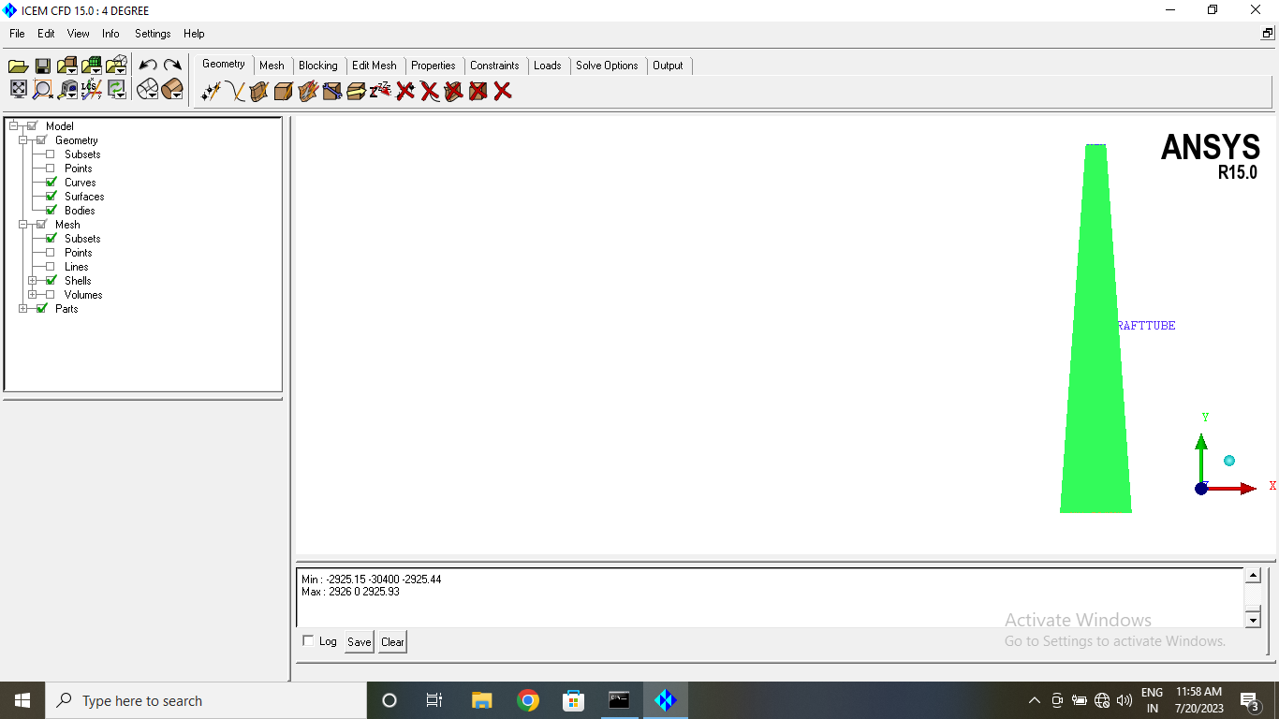

Fig. 5: Mesh of Draft Tube with Divergent Angle 5°

Table - 2: Mesh Data for Draft Tube with Divergent Angle 4.5°

|  |  |  |
| --- | --- | --- |
| **Part name** | **No. of Elements** | **Element Type** |
| Inlet | 4385 | Triangle |
| Outlet | 4524 | Triangle |
| Surface | 70474 | Triangle |
| Draft Tube | 2885431 | Tetrahedral |

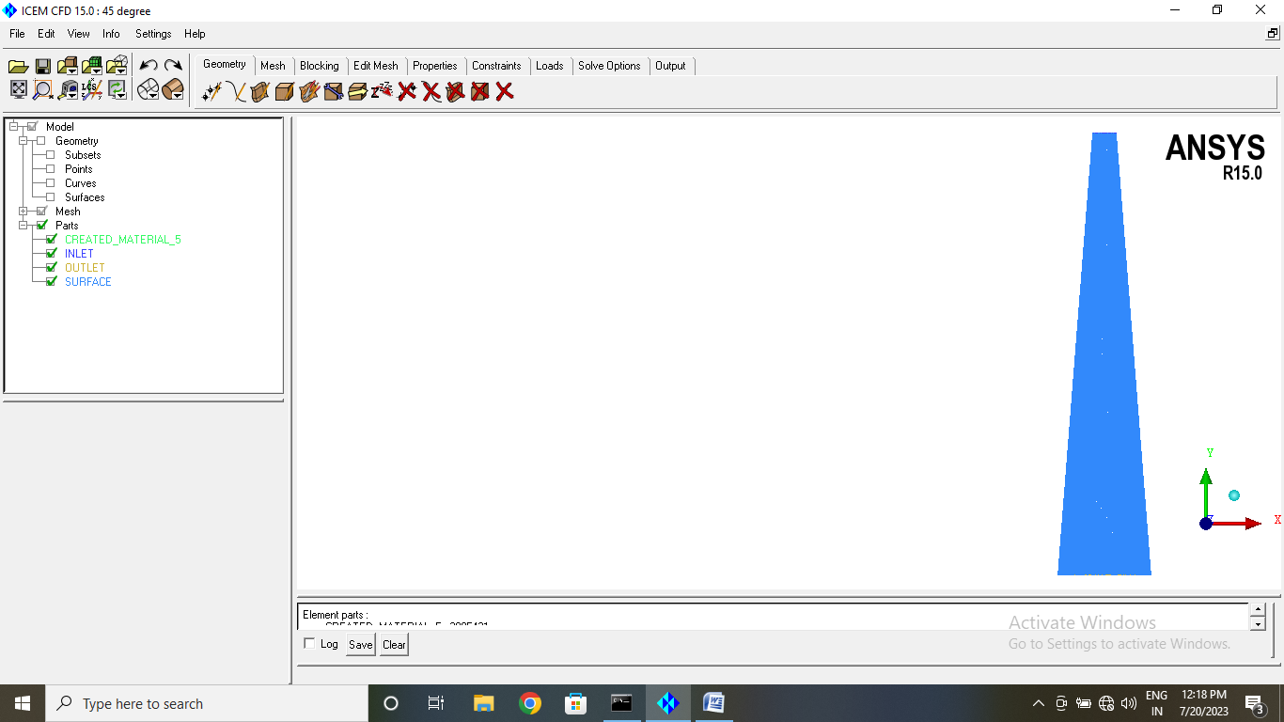

Fig 6: Mesh of Draft Tube with Divergent Angle 4.5°

**Boundary Conditions**

The boundary conditions are applied at the inlet and outlet surfaces of the domains.

**Inlet Boundary Condition:** The water velocity in axial, tangential and radial direction is specified at inlet of draft tube. Turbulence is set to medium intensity with value of 5%.

**Outlet Boundary Condition:** The pressure at the outlet of draft tube domain is set equal to 1 atmospheric.

**Wall Conditions:** The surface of draft tube is assumed to be smooth wall with no slip condition.

**Turbulence Model:** SST turbulence model with automatic wall function is applied as SST model can capture boundary layer better.

**Results and Discussion: Graphical Plots**

**Results for Diffuser Angle 4°**

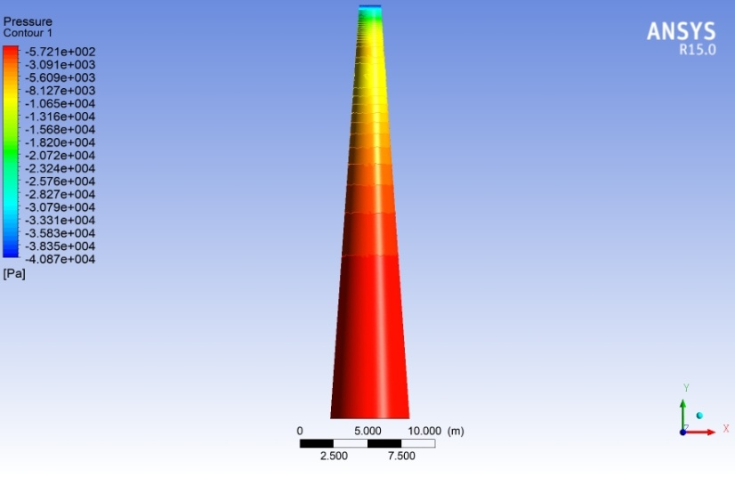

Fig 7: Pressure contour

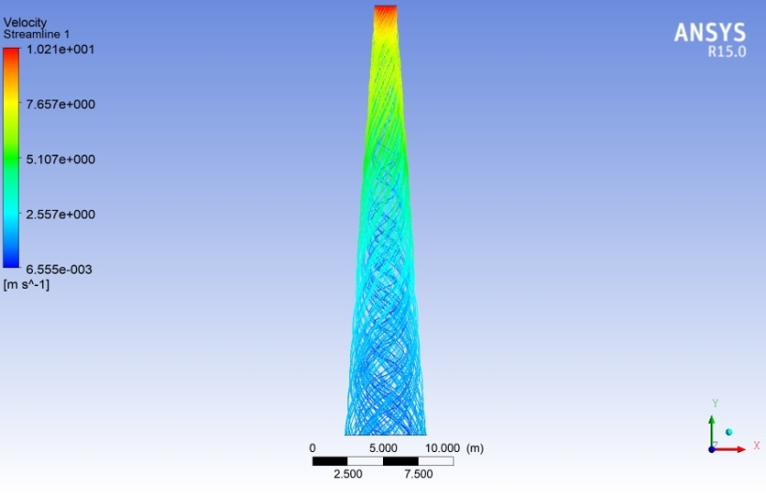

Fig 8: Streamlines showing the velocity distribution

**Draft tube with Diffuser Angle 5.5°**

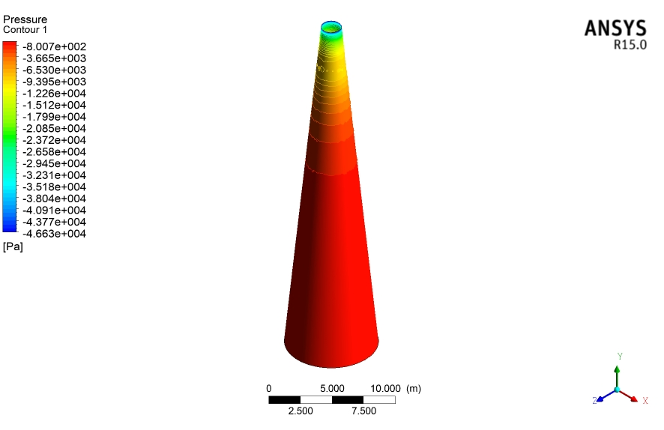

Fig 9: Pressure contour

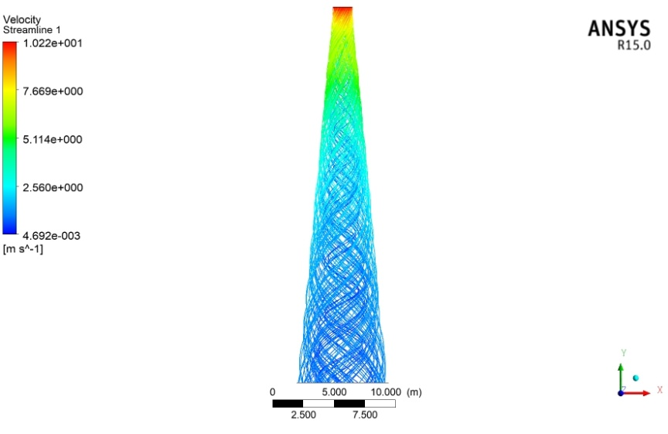

Fig 10: Streamlines showing the velocity distribution

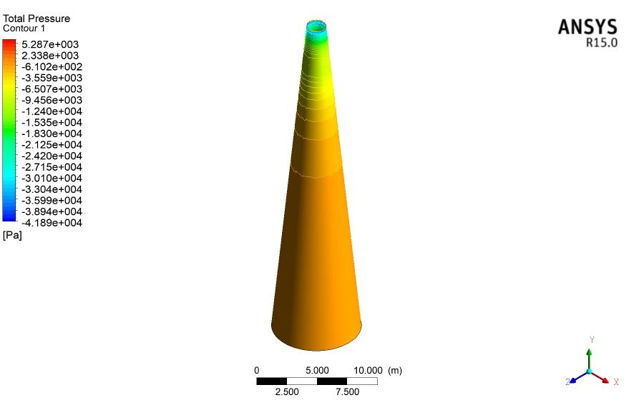

Fig 11: Variation in total pressure

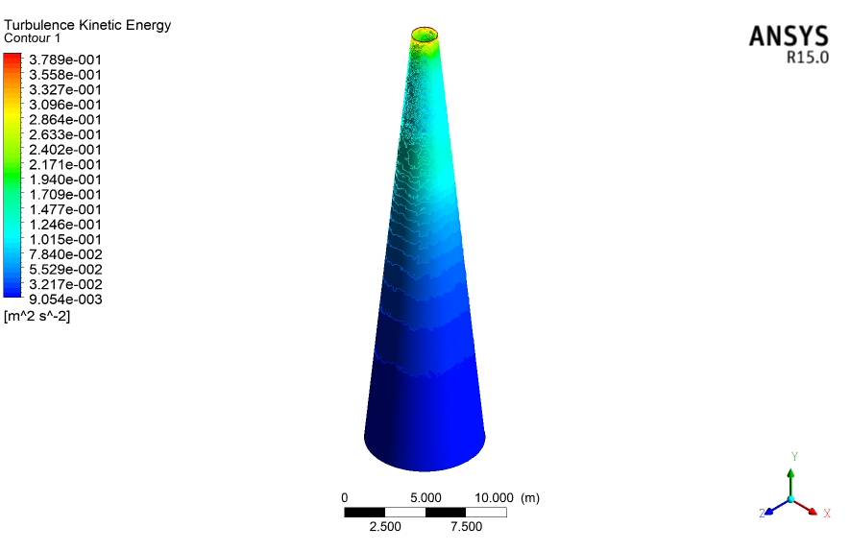

Fig 12: Variation in turbulent kinetic energy

**Draft Tube with Diffuser Angle 6.0°**

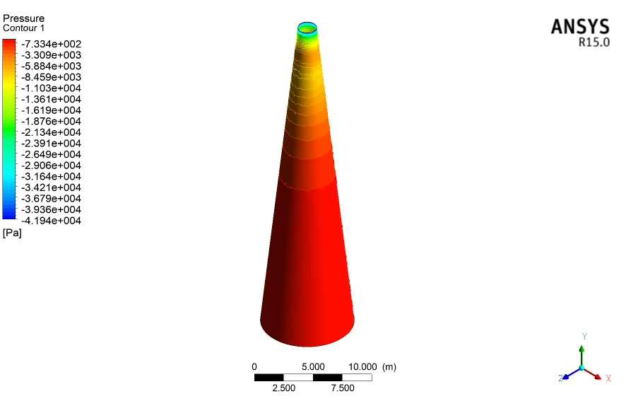

Fig 13: Pressure contour

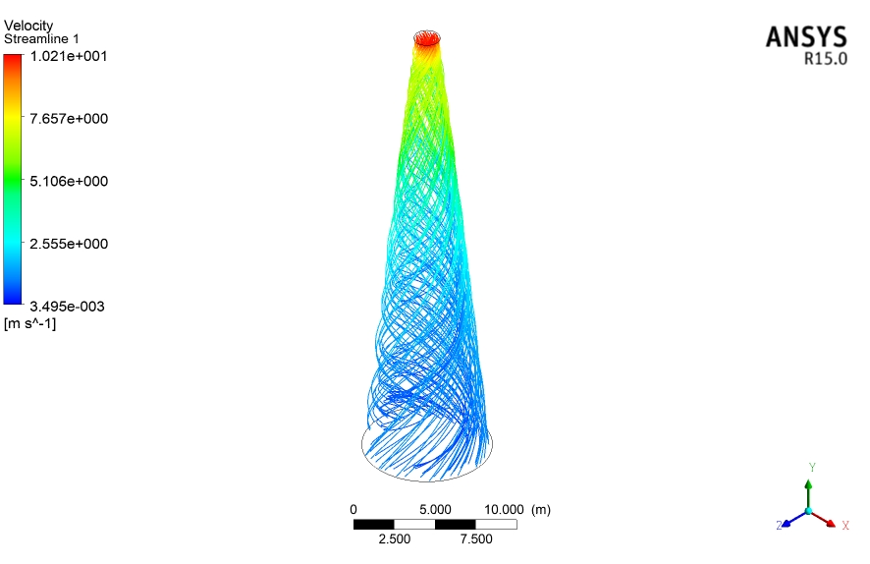

Fig 14: Streamlines showing the velocity distribution

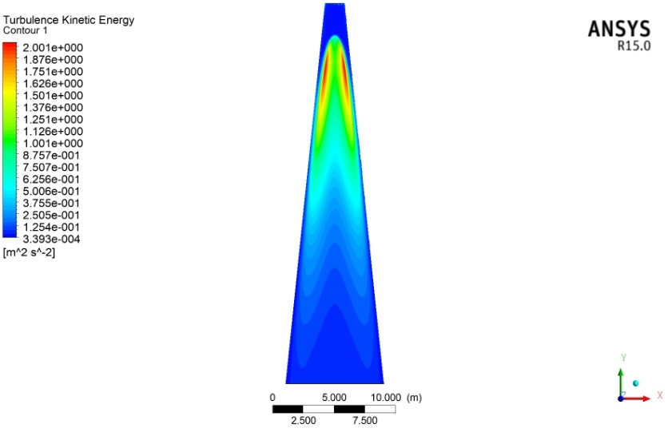

Fig 15: Turbulent kinetic energy contour at mid section of draft tube

**Head loss**

This is the loss in energy per unit volume of fluid. Fig.16 shows the head loss

Fig. 16: Head loss for all the geometries

**Head loss coefficient**

Ratio of head loss to the inlet total pressure head is called head loss coefficient. It is non dimensional parameter. Head loss coefficient is also low for newly designed geometry.

Fig. 17: Variation in head loss coefficient for all the geometries

Fig. 18: Variation in head recovered for all the geometries

Fig. 19: Variation in efficiency for all the geometries

**Head recovered and Efficiency**

Head loss is inversely proportional to head recovered. And recovered head is directly related to the efficiency of the draft tube. So for draft tube with diffuser angle of 5.5°, both head recovered and efficiency are found to be on higher side as compared to other geometries.

**Conclusions**

On increasing the diffuser angle upto 5.5° of the draft tube, the performance increases and then it decreases. Pressure from inlet to outlet of draft tube increases. Velocity decreases from inlet to outlet of the draft tube. Lowest velocity is observed in mid section of exit of draft tube. There is much variation in total pressure at inlet of draft tube as compared to outlet region. From graphical plots, highest turbulent kinetic energy is observed at mid volume of the draft tube. Ratio of head loss to the inlet total pressure head is called head loss coefficient. It is non dimensional parameter. Head loss coefficient is also low for newly designed geometry. For 5.5° diffuser angle draft tube, both head recovered and efficiency are found to be on higher side as compared to draft tube with diffuser angle of 5°.

REFERENCES

1. Kubota, T., and S. Yamada. "Effect of Cone Angle at Draft Tube Inlet on Hydraulic Characteristic of Francis Turbine." Proc. IAHR 11th Symp., Amsterdam, Netherlands. No. 53. 1982.
2. Prasad, V., Khare, R., & Chincholikar, A. (2009). Numerical Simulation for Performance of Elbow Draft Tube at Different Geometric Configurations. J. Continuum Mechanics, Fluids, Heat, ISSN, 5095.
3. Khare, Ruchi., V. Prasad, and S. Kumar. "CFD approach for flow characteristics of hydraulic francis turbine." International Journal of Engineering Science and Technology 2.8 (2010): 3824-3831.
4. Susan-Resiga, Romeo, et al. "Analysis and prevention of vortex breakdown in the simplified discharge cone of a Francis turbine." Journal of Fluids Engineering 132.5 (2010): 051102.
5. Soni, Vishal, et al. "Design development of optimum draft tube for high head Francis turbine using CFD." Proceedings of the 37th International and 4th National Conference on Fluid Mechanics And Fluid Power. 2010.
6. Khare, R., Prasad, V., & Verma, M. (2012). Design Optimisation of conical draft tube of hydraulic turbine. IJAEST International Journal of Advances in Engineering, Science and Technology, 2(1), 22-26.
7. Khan, M. H., Tiwari, M. K., & Gupta, V. Prediction of Efficiency of Conical Draft Tube Using Numerical Method.
8. Gupta, V., Prasad, V., & Khare, R. Numerical Simulation For Visualising Effect Of Jet Shape On Various Parameters Of Multi Jet Pelton Turbine Model.
9. Gupta, V., Prasad, V., & Khare, R. (2016). Numerical simulation of six jet Pelton turbine model. Energy, 104, 24-32.
10. ANSYS CFX 15 software manuals.