**An Overview of Probiotics' Impact on Skin Health**

**Shivani Fotedar1, Anshul Namdev2 , Shreesh Tiwari 3 , Priyanka Gupta4**

1Assistant Professor, Department of Pharmaceutics, Chameli Devi Institute of Pharmacy, Indore, Madhya Pradesh, India

2Assistant Professor, Department of Pharmacology, Chameli Devi Institute of Pharmacy, Indore, Madhya Pradesh, India

3Assistant Professor, Department of Pharmaceutical Chemistry, Chameli Devi Institute of Pharmacy, Indore, Madhya Pradesh, India

4Associate Professor, Department of Pharmacognosy, Chameli Devi Institute of Pharmacy, Indore, Madhya Pradesh, India

__________________________________________________________________________________

**ABSTRACT**

People suffer from aging skin, wrinkles, pigmentation, and dryness; researchers are trying to find solutions for these issues. There is a gut-skin axis, as evidenced by recent studies that indicate intestinal microbiota homeostasis can affect skin health. Micro-ecological skin care is gaining popularity, and probiotic interventions have been suggested to improve skin health. Probiotics are well known to be beneficial for certain illnesses, and numerous clinical studies have shown that they can have unique effects on the cutaneous apparatus, either directly or indirectly, that can be significant from a variety of angles. Probiotic bacteriotherapy has a lot of promise for the prevention and treatment of skin conditions like eczema, atopic dermatitis, acne, and allergic inflammation, as well as for skin hypersensitivity, wound healing, UV-induced skin damage, and cosmetic purposes.

**Keywords:** Skin, Probiotics, Atopic Dermatitis, Eczema

**INTRODUCTION:**

The body's surface acts as an environmental interface. The skin is an immunogenic organ that serves as the body's first line of defense and a biologic sensor against environmental allergens. It also forms a crucial structural boundary and a perceptual interface for humans. Current studies aimed at comprehending the regulation of skin barrier functions indicate a strong correlation between the skin's microflora and its physical, immunological, and cell biological properties. Improving the skin barrier may be crucial, especially in cases of aging, atopic dermatitis, and other inflammatory illnesses where the barrier is compromised. Every day, environmental, chemical, or physical factors (such as UV radiation, pollution, hot and cold temperatures, air conditioning, low humidity, etc.) as well as psychological stress and/or dietary deficiencies put barrier function to the test. Seeking beauty is an endless pursuit. Knowing whether skin problems, such as pigmentation, wrinkles, aging, and dehydration, are caused by internal or external factors can be challenging. There are many different reasons why people get skin problems, and scientists are always looking for safe and effective skin care products to solve these problems. Many cosmetic products on the market today contain chemicals, such as titanium dioxide, which can be somewhat toxic and detrimental to one's health.

A thorough investigation revealed that probiotics are "live microorganisms, which confer a health benefit to the host when administered in adequate amounts." Individual characteristics of intestinal microflora are determined by diet variations in relation to factors such as age, feeding habits, lifestyle, interactions among various constituents of the same flora, and pathologic conditions. An emerging field in skin health is probiotic formulations, which are becoming more widely available for the purpose of healthy skin care, the prevention and treatment of skin diseases, and antiaging benefits. Probiotics have generally been studied primarily for their potential to mitigate digestive tract disorders. Nonetheless, extensive meta-analyses have also shown that probiotics can lower the frequency of infections and the requirement for antibiotic treatment. The applications of probiotics in skin care, including skin whitening, skin moisturizing, skin anti-aging, skin anti-wrinkle, and body odor removal, are reviewed in this paper along with their mechanisms. This provides a theoretical foundation for future probiotic applications in skin care.

**PROBIOTICS:**

Some definitions are necessary to facilitate the discussion of probiotics. Probiotics are defined as "live microorganisms which when administered in adequate amounts confer a health benefit on the host" by the Expert Panel, which was commissioned by the Food and Agriculture Organization of the United Nations and supported by the World Health Organization in 2001.Postbiotics are effector molecules derived from probiotics that are secreted by bacteria or released after lysis. They possess properties that are like those of their parent probiotics. This is not the same as what this is Probiotics, then, seek to replicate the advantageous effects of probiotics without posing the danger of delivering live microorganisms. For instance, several commensal bacteria produce butyrate, a postbiotic that is essential to the colon's energy metabolism and plays a key role in the development, differentiation, and regulation of the intestines' inflammatory response. Probiotics that have been heat-killed may also serve as probiotics. Probiotics are indigestible food products that support intestinal health by fostering the growth of commensal bacteria.

**THE SKIN'S MICROORGANISMS AND THE PROBIOTICS' POSITION**

The skin microbiota is important for the processing of skin proteins, free fatty acids, and sebum as well as for the competitive exclusion of pathogens that are aggressive and cause skin infections. The microbiota of the skin is normal. The competitive exclusion of pathogens is likely facilitated by the skin's normal microbiota, and using probiotics may strengthen this process. Skin homeostasis can be maintained by certain probiotics by helping to regulate the lipid barrier, cutaneous microbiota, and skin immune system. For a "normal, healthy" host, the resident microbiota might be considered "beneficial," but for a host with compromised skin integrity, it could become dangerous. There is evidence that the immune system is activated by the skin microbiota, not the non-adaptive immune system. In this sense, it has been demonstrated that skin microorganisms are coated with immunoglobulins, which are most likely derived from eccrine gland secretions.

**PROBIOTICS'S BENEFITS FOR SKIN HEALTH**

Probiotic microorganisms can be applied topically (in vitro) or taken orally (in vivo) to enhance skin health. Recent years have seen many studies focused on oral consumption. Probiotics may have therapeutic or preventive effects on the skin. Research has shown that taking probiotic bacteria orally could be a novel way to shield the skin's immune system from ultraviolet radiation (UVR).

1. Integrity of the Skin Barrier
2. Anti-Aging
3. Skin Moisturization
4. Skin Whiting
5. Anti-Chronological Aging
6. Anti-Photoaging
7. Anti-Wrinkle

**Probiotics-Mediate Intestinal Microbiota to Improve Skin Disorders**

1. **Acne:** Acne pathogenesis has been associated with dysregulation of the innate and adaptive immune systems. It has been demonstrated that localized overexpression of inflammatory cytokines, including TNF-α, IL-1B, and IL-8, contributes to the development of acne lesions by activating CD14 and toll-like receptors through the action of lipopolysaccharides and Propionibacterium. Propionibacterium can also activate Th1 cells and humoral immunity, which in turn can activate the adaptive immune system.Antibiotics can be used to treat acne, but not all patients respond well to this kind of treatment, and there may be negative side effects. When topical probiotics were used to treat acne, the number of lesions, erythema, and pathogenic bacteria were reduced, and the skin barrier was improved. Probiotics that were examined included cell-free supernatant from E. faecelis and L. plantarum. Thus, inter-study comparison is not possible, in line with research on AD that investigated various probiotics and postbiotics and analyzed a range of endpoints. Without causing adverse effects on the body, topical probiotics may help reduce acne lesions by reestablishing a more desirable microflora.
2. **Atopic Dermatitis:** Atopic dermatitis (AD) is a common skin condition that is believed to be associated with immune dysregulation and defects in the epidermal barrier. Pruritus, erythema, and dermatitis plaques that may weep, crust, or scale are all experienced by people with AD. Despite the complicated pathophysiology of AD, it is believed to arise in people who are genetically predisposed and are impacted by external factors. The pathophysiology of AD is frequently associated with changes in the skin barrier and the loss of filament grin. AD patients exhibit reduced expression of specific AMPs, including β-defensins and cathelicidins. Nonetheless, additional research has shown elevated AMP expression in AD. For atopic dermatitis and seborrheic dermatitis, topical pro biotics have demonstrated the ability to increase skin ceramides, improve erythema, scaling, and pruritus, and decrease the con centration of pathogenic *S aureus.*
3. Psoriasis
4. Seborrheic Dermatitis
5. Rosacea

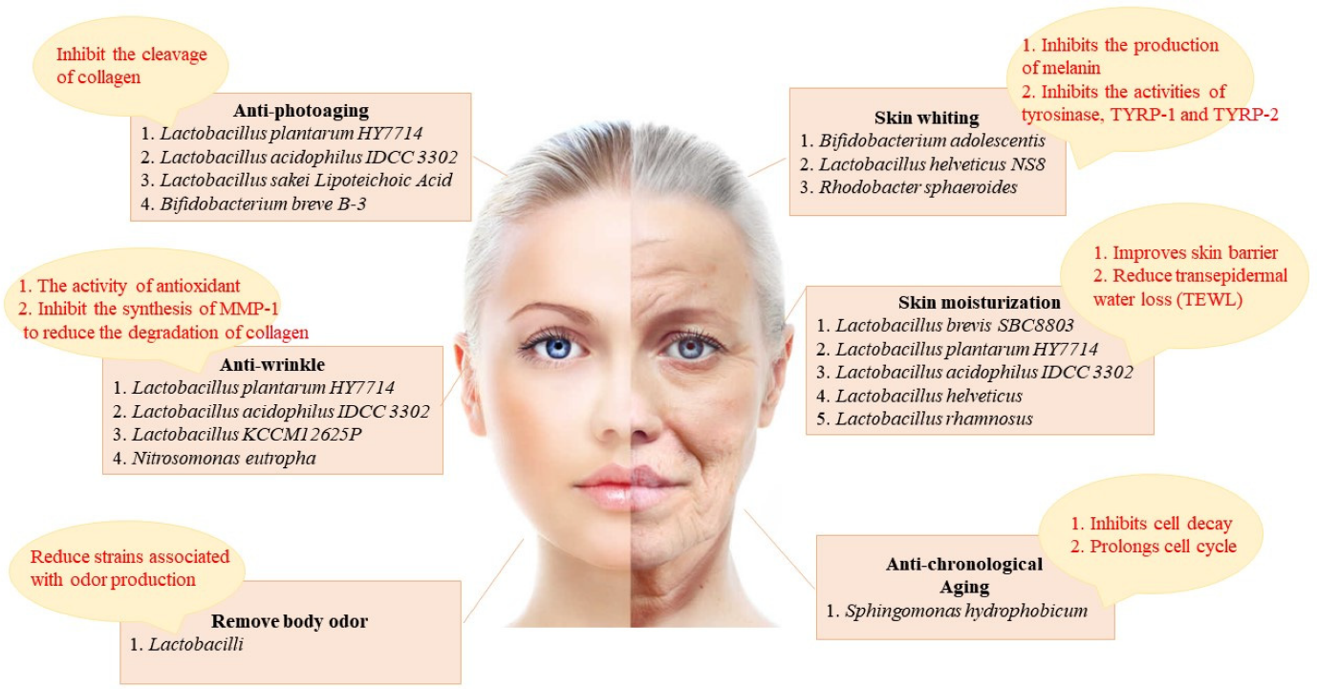**Figure 1: The skin improvement effect of probiotics and its related mechanism**

**Anti-Allergic and Anti-Inflammatory Effects of Probiotics on the Skin**

Probiotics may help prevent allergic diseases, but this is still up for debate. Probiotics have been demonstrated to have antiallergic effects on immune cells and epithelial cells. When allergens enter the body through the skin, the intestinal mucosa may become sensitized throughout the body. Additionally, it has been noted that inflammation contributes significantly to the in vivo photoaging of human skin. By taking probiotics orally, intervention strategies have been developed to balance the gut microbiota. The primary factor in allergic diseases is the makeup of the intestinal microflora, and certain probiotic species may contribute to enteric microecology, the development of a healthy immune response, the prevention of allergic diseases, and even their treatment.

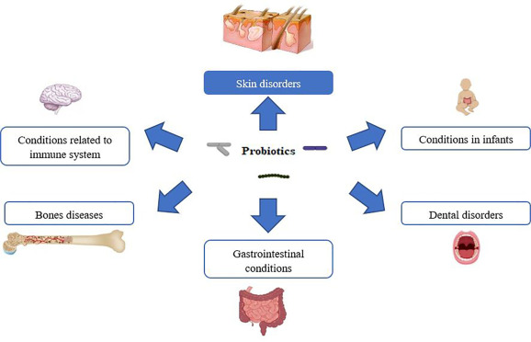**Figure 2: Health benefits of probiotics**

**CONCLUSION**

The interactions between pathogenic and beneficial topial skin bacteria and their downstream mediators are intricate and not entirely understood. The skin microbiome is unique to each individual and is constantly changing due to both endogenous and exogenous factors. The reason behind certain people's susceptibility to unwanted changes in their skin microbiome remains unknown. But for some skin disorders, like atopic dermatitis or psoriasis, it is not always clear what injury caused pathogenic bacteria to predominate and then set off a vicious cycle of inflammation and illness. It is too early to tell exactly how topical probiotics will affect skin conditions. Topical probiotics have shown promise in treating a variety of skin conditions in both human and animal models, and oral probiotics have also shown promise in treating topical disease states. Still, there are a lot of unsolved questions. Since each patient's microbiome is unique, not every patient will benefit from every probiotic or intervention.

**REFERENCE**

1. E. M. Quigley, Gastroenterol. Hepatol. 2013, 9, 560.
2. F. Guarner, J. R. Malagelada, Lancet 2003, 361, 512.
3. J. L. Round, S. K. Mazmanian, Nat. Rev. Immunol. 2009, 9, 313.
4. I. Spadoni, E. Zagato, A. Bertocchi, R. Paolinelli, E. Hot, A. Di Sabatino, F. Caprioli, L. Bottiglieri, A. Oldani, G. Viale, G. Penna, E. Dejana, M. Rescigno, Science 2015, 350, 830.
5. J. A. Foster, L. Rinaman, J. F. Cryan, Neurobiol. Stress 2017, 7, 124.
6. J. L. Sonnenburg, F. Backhed, Nature 2016, 535, 56.
7. L. A. David, A. C. Materna, J. Friedman, M. I. Campos‐Baptista, M. C. Blackburn, A. Perrotta, S. E. Erdman, E. J. Alm, Genome Biol. 2014, 15, R89.
8. K. Shimizu, H. Ogura, T. Asahara, K. Nomoto, A. Matsushima, K. Hayakawa, H. Ikegawa, O. Tasaki, Y. Kuwagata, T. Shimazu, Burns 2015, 41, e28.
9. Z. M. Earley, S. Akhtar, S. J. Green, A. Naqib, O. Khan, A. R. Cannon, A. M. Hammer, N. L. Morris, X. Li, J. M. Eberhardt, R. L. Gamelli, R. H. Kennedy, M. A. Choudhry, PLoS One 2015, 10, e0129996.
10. F. Wang, Q. Li, Q. He, Y. Geng, C. Tang, C. Wang, J. Li, Shock 2013, 39, 96