WIRELESS DIGITAL NOTICE BOARD USING IOT
Aditya Engineering College, Surampalem, A.P, India

 | Guide: M. Phani Sridhar ,M. Tech.,(Ph.D)
 | Authors:
Sk Ayesha¹ | Tarun dev² | Varanasi Sai Aseesh³
(19A91A0552), | (19A91A0555), | (19A91A0561),
CSE, B.Tech, | CSE, B.Tech, | CSE, B.Tech,
Aditya Engineering College, | Aditya Engineering College, | Aditya Engineering College,
Surampalem | Surampalem | Surampalem

ABSTRACT: Notice board plays a major role in providing information in different fields, but changing the notice boards manually is a big task which can be solved by replacing these with the wireless digital notice boards using IOT. So this paper mainly includes the digital Notice boards which are wireless connected using IOT technology. Internet of Things (IOT) is the brand new era that connects the complete world. It establishes connectivity (via net) with most of the numerous gadgets or offerings or structures for you to step by step make automation improvement in all areas..The key concept of this proposed system is to mainly send the information from the user to the receiver’s side through the web based application. When a person needs to send the information to the receiver’s side then he will give the private IP address of the receiver the in the web based application. At receiver’s end a low cost micro-controller board is programmed to receive and display messages through internet. In this way, the information can be shared wireless through digital notice board, which mainly helps in saving the time and cost for paper and printing hardware.

Keywords: Internet of Things, Wireless Notice Board, Micro-controller.

1. INTRODUCTION
In today's environment, notice boards are crucial for providinginformation.It is essential to any business or institution.However, replacing the manual notice boards with wireless digital notice boards using IOT will eliminate the laborious effort of doing so.On the campus, this gadget can be put up in a number of locations.This will facilitate rapid information transmission.The Internet of Things (IOT), which is a term used to describe a network of physical items or "things" that are implanted with sensors, software, and other technologies for the purpose of connecting to and exchanging data with other devices and systems over the internet, is the major topic of this article.
IOT can be used to share and collect data with minimal human intervention. IOT can be used to share and collect data with minimal human intervention.

By choosing the recipient's IP address from the web-based application, notice boards are used to transmit messages wirelessly from the sender to the recipient. The requirement for gathering information and disseminating it inside institutions and organisations predominates in this situation. Notice boards are one way to accomplish this. But it's a big work to make it simple. This paper introduces the notice board which are connected wirelessly and the notice board is digital in order to make the announcements and passing of information easier.
This notice boards also includes the networking concept as the IP address of the receiver is put in the application here. In addition to designing, building, and using a network, networking also includes managing, maintaining, and running the network's hardware,software,andpolicies.A device can be identified by its IP address on the internet or a local network. IP stands for "Internet Protocol" which is the set of rules governing the format of data sent via the internet or local network. So in this way we use networking and IOT concepts in this system to ensure the information to be passed to receiver’s side.

2. LITERATURE REVIEW
The concept of a wireless digital notice board using GSM technology has been put out in this suggestedsystem.So, cutting down on paperwork and time is our key goal.In this work, we attempt to design our system in such a way that it can show messages sent to the notice board's GSM module by authorised users.In summary, the GSM module at the digital notice board receives the message from the authorised user and displays it on the distant notice board while simultaneously sending the message to various users' mobile devices numbers that are stored in microcontroller memory.
Therefore, vital messages or notices will reach the appropriate mobile numbers in a very short period of time. This indicates that a user or registered individual can send a message from any location, and the message will be shown on an LCD screen.[1]
The notice board is the most typical and essential piece of equipment at any institution, company, or location that provides a public service like a bus stop, train station, or park. However, it is a challenging task to adhere different alerts every day. The wireless notice board is the subject of this project. The project's primary goal is to create a wireless notice board that shows messages submitted from a user's mobile device. When a user sends a message, a SIM installed in IOT at the receiving unit receives it.[2]
Every commercial in today's world will be digital. Currently, computerised moving displays are used in large stores and shopping malls. Everything, including ticket details, registration numbers, and more, is displayed on a computerised moving display in the bus and train stations. However, in order to modify the message or design on these displays, users must go there and connect the display to a PC or laptop.
If someone wanted to display the same message throughout the city's main squares, he would need to travel there with his laptop and connect it to a computer to alter it.In light of this, a novel remote-accessible display system that uses GSM to connect mobile devices and microcontrollers has been developed.[3]
In this paper the work is based on designing and development of advertisement. These techniques are used mostly in the shopping centres or malls where digital displays are used.
This project mainly focuses on digital noticeboard. Its application is both Educational and Market sector, wherever it can be used. In this paper LED display are used for displaying messages. For displaying large data P10 LED is used in this work is preferred because it a scrolling display. In this work a model is formed for displaying notices at places those require real time noticing by sending message through SMS using mobile phone through GSM modem. The heart of this system is Arduino board using ATmega 328.This system can be used by any kind of person such as educational or businessmen both can send message by SMS to the system so that system can display it on the digital notice board.[4]
In this project, we suggest using an Android application built on a Raspberry Pi card to remotely deliver a notice to Digital Monitor. First step of notice board recall has been completed. An application built on the Android operating system has been created in the second stage. The many diagrams have been shown. Data transfer is done over Wi-Fi. Anytime we want, we can add, remove, or change the wording to suit our needs. A notice is sent using an authorised PC at the transmitter. Raspberry Pi is connected to Wi-Fi at the receiving end. A notice is received by the receiver when it is sent from the system by an authorised user. An electronic device can transmit data wirelessly through a computer network, including through high-speed wireless connections, thanks to the widely used wireless technology. The information comes from a verified user.[5]

3. PROPOSED SYSTEM
The key concept of this proposed system is to mainly send the information from the user to the receiver’s side through the web based application. The web based application consists of the user login and password.
Here the user mainly uses the web based application to access the IP address of the receiver to whom the message need to be sent which is provided in the web based application. when user is in need to send message or pass the information then the user can use the web based application through the login user and password being entered in the web based application. when the user access it then user can select the required receivers IP address in the application which are used to send the information.
So, when the IP address of the receiver is used then the information is received through the Node MCU that is used to get information on the receiver’s side. In this way the message can be displayed on the receiver side and also message can be read in speaker if necessary for announcements. The proposed system is simply useful to connect the notice boards wirelessly without any manual work when compared to notice boards used in the past to display information through the papers. The main difference in the existing and proposed system is using the web based application in which we use IP address for reference which are generated to send the information to the receiver whereas in existing system mainly uses android application to convey information which may fail if there is no Wi-Fi or if uses bluetooth which is not in range for the connection.

Hardware requirements:
- Breadboard
- ESP8266Wi-Fi Module
- LCD Display
- Jumper Wires
- Adapter
- L2C module
- Potentiometer

Software requirements:
- Arduino IDE
- VS CODE

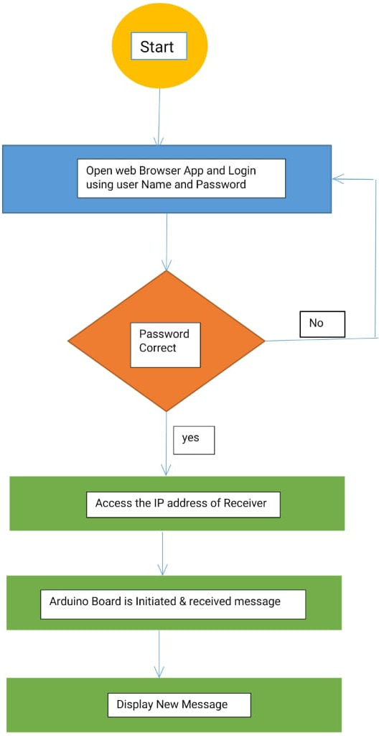
4.ALGORITHMS USED
- Component Interfacing:
- Node MCU and LCD display interfaced hrough the Arduino code.Here, IP Address is generated.
- Interfacing with the Firebase Real-time Database(RTDB) using the FirebaseESP8266 library
- Initialize the LCD I2C library to communicate with a 16x2 character LCD.
- IP Configuration:
The IP Address which is generated in previous module is pasted in the web browser. After pasting, web page will be opened.
- Web-page Design:
In the opened web page we can observe the message box. So, we can write the required message to be send in the message box and send it.
- Troubleshooting:
If code execution is failed then we need to recheck the code and execute it.

The Internet of Things (IOT), which describes a network of actual physical objects or "things" that have been integrated with sensors, software, and other technologies for the purpose of communicating and exchanging data with other devices, has been employed in this suggested system. IOT can be used to share and collect data with minimal human intervention.

IOT enables data sharing and collection with a minimum of human involvement.
Due to the IP address of the receiver being entered in the programme, this notice board also incorporates the networking notion. Networking includes managing, maintaining, and running the network infrastructure, software, and rules in addition to designing, building, and using the network.

5. FLOWCHART
6. EXPERIMENTAL RESULTS

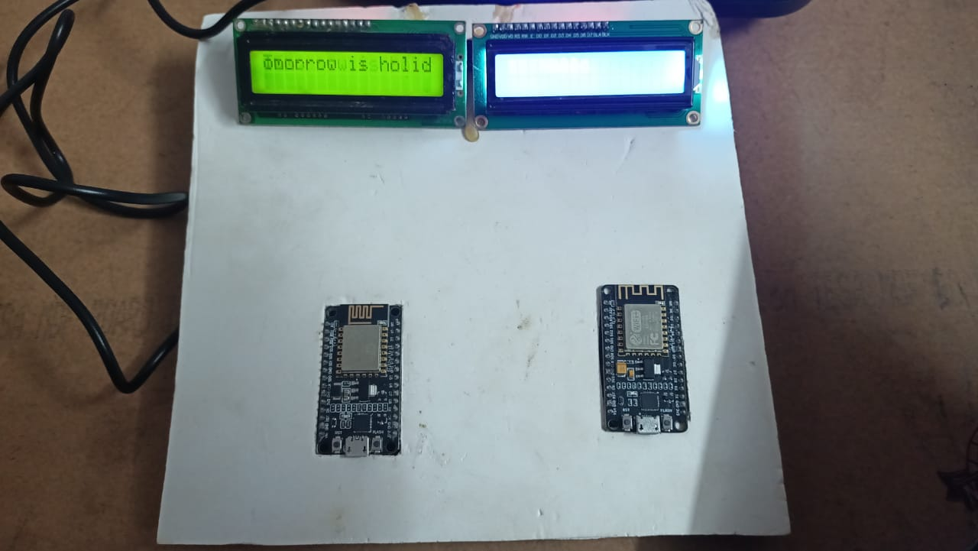

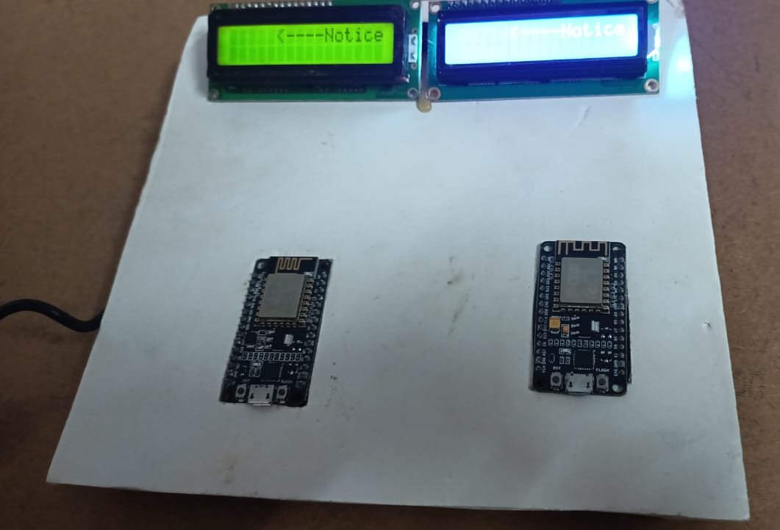

    - ADVANTAGES
- Notice boards can be connected wireless and are digital notice boards.
- Information can be displayed accurately as we are using the IP address of the digital notice boards.

- It reduces the manual work.
- It decreases the waste of paper and printing costs of paper

- CONCLUSION AND FUTURE SCOPE

The major purpose of the suggested method is to disseminate information via wireless digital notice boards while minimising human work. The project can be used as a college notice board where a professor can post a message for the department's immediate gathering of students. As a result, the suggested system is primarily employed in colleges and also has the ability to show the appropriate message just by accessing the receiver's IP address.
By including the concept of wireless skill in the message field, we can enhance the organisation, promptness, and competence of our communication.
Some modules can be added to the proposed system such as
- Temperature and time (RTC) display during periods when no messages are to be displayed.
- Storing a message initially and displaying it on the required time.
For use with the suggested system in train stations, airports, or bus terminals, the voice calling feature can be included.

  - REFERENCES
- Kalpana seelam, K. Prasanti,” A NOVEL APPROACH TO PROVIDE PROTECTION FOR WOMEN BY USING SMART SECURITY DEVICE”, IEEE International Conference on Inventive Systems and Control (ICISC 2018), ISBN:978-1-5386-0806-7.

- AkshayR,N K Sachin, Prasanna K R, Chithra M N Dept. Of Ece, Vviet, Mysuru, Rohith M N Asst. Prof. Dept. Of Ece, Vviet, Mysuru,”SMART SHIELD FOR WOMEN SAFETY”,International Journal of Engineering Research & Technology (IJERT),Volume: 08 Issue:11,Special Issue .

- NitiShree, “A REVIEW ON IOT BASED SMART GPS DEVICE FOR CHILD AND WOMEN SAFETY APPLICATIONS”, International Journal of Engineering Research and General Science, ISSN 2091-2730, Volume 4, Issue 3, May-June.

- A Jyothi, Alapati Srimaithri, Anusha P, AvulaSindura S, Santhosh Kumar S, “DEVELOPMENT OF WEARABLE DEVICE FOR THE SAFETY AND SECURITY OF WOMEN AND CHILDREN”, International Journal of Scientific Research in Computer Science, Engineering and Information Technology, Volume 4, Issue 6, ISSN: 2456-3307.

- T.Gopperundevi, R. Manimozhi and R. Nivetha, “HIGH ACCURACY SENSOR BASED WOMEN AND CHILD SAFETY BY USING GSM”, International Journal of Advanced Scientific Research & Development, Vol. 05, Spl. Iss. 01, Ver. III, pp. 264 – 273, Mar 2018, ISSN: 2395-6089.

- R. Pavithra, P. S. Sangeetha, “DESIGN AND IMPLEMENTATION OF A RESCUE SYSTEM FOR THE SAFETY OF WOMEN BY USING ARDUINO CONTROLLER”, International Journal of Advance Research, Ideas and Innovations in Technology, ISSN: 2454- 132X, Volume 4, Issue 2.

- B. Meenakshi1 , P.Harish2 Assistant Professor1,2 “Web Based Wireless Notice Board(Real-Time)” Volume 06, Issue 04, Apr 2016 ISSN 2581 – 4575

- ] Dr.S.Surendiran1, M. Mathumathi2, S. Nivetha3, A. Pon Lucina4 “IOT BASED MESSAGE SCROLLING LED DISPLAY” ISO 9001:2008 Certified Journal Volume: 07 Issue: 05

- Arun Agarwal1 , Kishan Ray2 , Biplab Kumar Pradhan3 , Vishaka Kumari4 “GSM Based Smart Digital Wireless Electronic Notice Board” Journal of Information Technology and Digital World, September 2022, Volume 4, Issue 3

- Vinod B. Jadhav1, Tejas S. Nagwanshi2, Yogesh P. Patil 3, Deepak R. Patil4. “Digital Notice Board Using Raspberry PI” Volume: 03 Issue: 05.

