**DONATIONS USING ANDROID APPLICATION**

|  |  |  |
| --- | --- | --- |
| B.Yaswanth (19A91A0502),  CSE, B.Tech,  Aditya Engineering College, Surampalem | Authors: T.Y.PhaniKumar (19A91A0556), CSE, B.Tech,  Aditya Engineering College, Surampalem | P.Sai Srinivas (19A91A0540), CSE, B.Tech,  Aditya Engineering College, Surampalem |

Guide: Dr. K. Vydehi, M.Tech

Senior Assistant Professor

Aditya Engineering College

**ABSTRACT:**The donation project's major objective is to develop an Android app for the aged care facility and the orphanage that will assess their current needs and schedule the contributors.

Waste of food, clothing, and books is a serious issue in countries with dense populations like India. The streets, dumpsters, and landfills are all full of proof of this. At weddings, canteens, restaurants, social gatherings, and family celebrations, a lot of food is wasted. In addition to poverty, food waste is an indicator of other economic problems. Food, clothing, and other supplies are being wasted as a result of rapid changes in lifestyle and habits brought on by the high standard of living. In order to prevent them from going to waste, we might put these goods to use by donating them to organisations like old age homes and orphanages.

There is an increasing amount of waste of food, clothing, books, and other commodities, which makes charitable giving necessary. With this initiative, a fresh web-based application is unveiled that provides a platform for distributing used goods and food scraps to all worthy people and organisations. It explains the current contribution system, the motivation behind creating such an app, and how the suggested product advances society. The programme is shown to be a practical way to donate money online to charity and other causes. It shows that it is possible to stop the waste of food, clothing, books, and other things.

**1. INTRODUCTION**

This idea comes under. Now a days world is running around technologies, So we make use of technology in order to overcome the difficulties faced by the orphanage's for the donations. Here we make use of Android Development technology and designed an app such that donor is able to donate with at most satisfaction. The purpose of this project is to use Android Development to identify where the orphanage is and what it requires to make the donors contact the nearby orphanage easily. Because they are fed inadequate or inappropriate food, the majority of children in orphanages are malnourished. Parents' lack of concern and unwillingness to provide for their children has resulted in a linear growth in the number of children living in orphanages. Despite the rise in orphans, less money is often donated to orphanages. You can utilise our OHS website to help you easily fix or decrease this problem. To enhance or increase the charitable contributions made to old age homes and orphanages, donation software was developed. With this programme, development is easy. In addition to hundreds of pre-made layouts, this software offers incredible customization features for building your own app layouts from scratch.

**2. LITERATURE REVIEW**

As we know, the pandemic has been tough on a lot of people. According to the International Labour Organization, the coronavirus crisis is having a devastating effect on orphanages & old age homes worldwide, with more orphanage homes and old age homes at risk to have good meals and clothes and they unable to find the donors due to the situation of pandemic. Charities are losing their donors, thus seeing plummeting revenue and disruptions to their services. Some old age homes struggle to meet their basic needs such as food, clothing, and even a mask but are unable to receive help from any sources. More than 4 in 10 orphanage homes and old age homes face serious financial problems amid this pandemic. On the other end of the spectrum, we have some potential donors who are either clueless about how and where they can help, or maybe they are shy about the fact that they can only afford little.

We thought, why not make the donation process easier so that one can donate as little as a rupee, any moment they want, within just a few clicks. We all love using apps that make our life easier on a day to day basis, and that's what we did with the donation app. We made an app. Anyone can enter the app and donate some pre-built care packages (a care-package contains some necessary items specific individuals need daily) or any amount of money they want within seconds.

**3.METHODOLOGY**

•With the aid of our suggested system, we hope to link those who are willing to donate to those who want to support orphanages and nursing homes.

•The primary barrier to people helping orphanages and nursing homes is that they don't know how to go about doing so.

•Each orphanage or nursing home has different requirements, including those for supplies of food, cash, clothing, and medicine. Through our proposed approach, the contributors can truly select the category they want to support.

•This application is built with React Native, Nodejs, MongoDB in it. It consists of two modules namely Orphanage Maintainer and Donor. Orphanage Maintainer can manage and update the requirements and can chat with the donor. The donor will be able to login and check the requirement's and can be able to contact using chat window or call.

•As map is provided in the application in order to locate the orphanages nearby and get the directions to it which makes the donation easy. This application is very interactive and user-friendly, it can also accept more traffic and can load pages fast. Each module of the application is highly secured.

•Through the offered chat box on this application, donors can speak with the orphanages directly.

•By including a chat box in the application, we can ensure that donations made by donors are genuine.The given map can be used by the donors to find the closest orphanages or the orphanages they'd want to support easily.

**Hardware requirements:**

* Processor – I5 , Rygen 5000 series or above
* SSD – 128 GB
* RAM - 8GB or Above
* GPU - optional

**Software requirements:**

* Famework – Express, Flutter
* Database - Mongo
* Language – Javascript , Dart
* Editor – VS Code, Android SDK

**4. EXPERIMENTAL RESULTS**

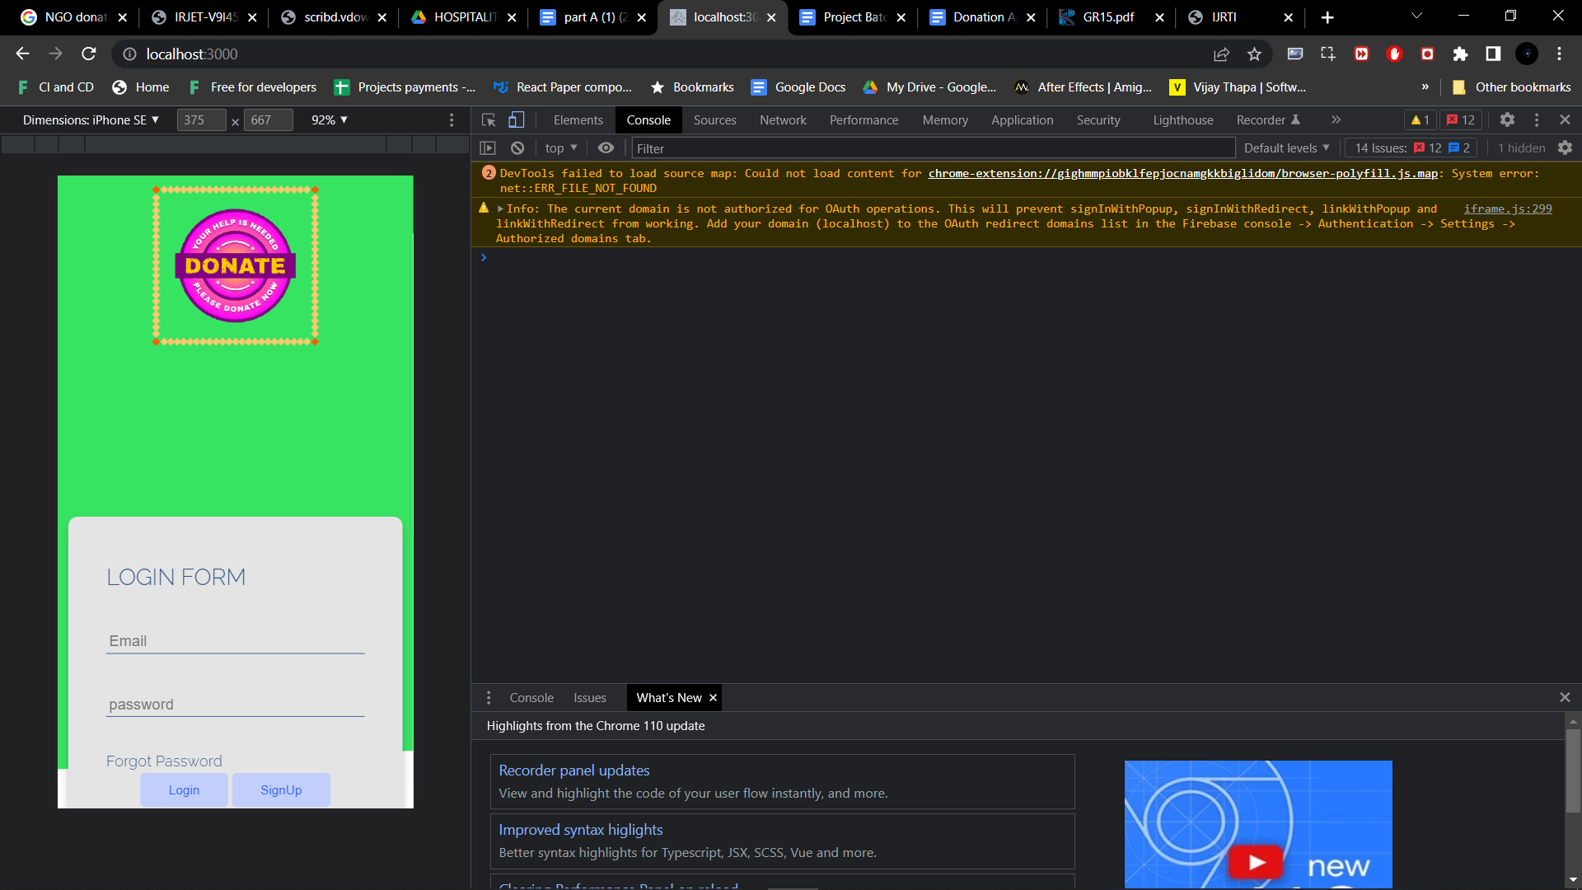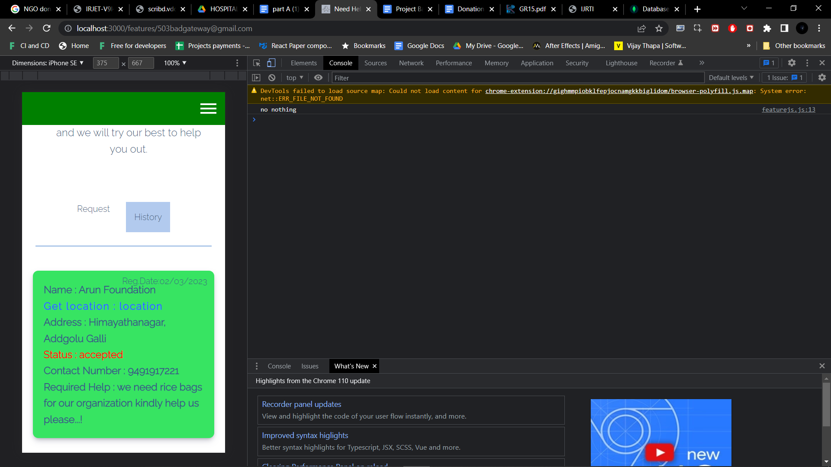

**5. TECHNOLOGIES USED**

Firebase Auth :- A service called Firebase Auth enables user validation to be done entirely with client-side JavaScript. It supports Google (and Google Play Games) as well as Facebook, GitHub, Twitter, and other social login services. A user management system is further made available, allowing programmers to implement user authentication using emails and passwords kept in Firebase.

MongoDB:- MongoDB is a well-known open-source document store and NoSQL database. MongoDB is written in C++. This session will provide you with a full overview of the MongoDB concepts needed to design and deploy a highly scalable and performance-driven database.

Android Studio:- The official integrated development environment (IDE) for Google's Android platform, Android Studio, is based on JetBrains' IntelliJ IDEA software and designed specifically for Android development.Android Studio was introduced on May 16, 2013, during the Google I/O conference. It reached version 0.1 of the early access preview stage in May 2013.The most recent stable version is 3.1, which was released in March 2018.

Flutter:-A free and open-source UI software development kit from Google called Flutter makes it simple for developers to create cross-platform mobile apps.

Express:- A node js web application framework called Express provides a wide range of functionality for creating both web and mobile applications.

**6. FLOWCHART**

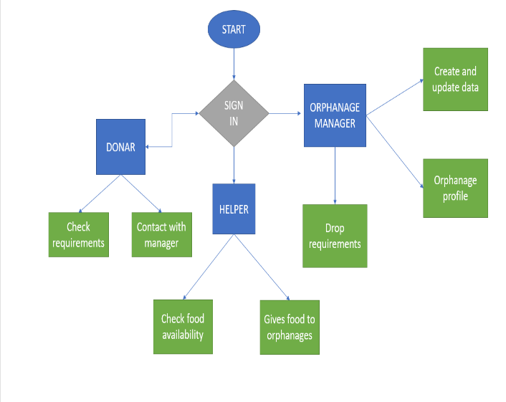

**7. ADVANTAGES**

•In this application the donors can directly contact the orphanages by using the chat box provided.

•By introducing the chat box in the application we can assure the donor's fraud free donation.

•The donors can use the map provided to get easy access to the nearby or their desired orphanages with the shortest directions to it.

**8. CONCLUSION**

A study by a global children's charity for abandoned and orphaned children estimates that 20 million children in India, or 4% of the total number of children in the nation, are orphans. Most children and elderly residents of orphanages and nursing homes have been left behind by their families. Only 0.3% of these orphans truly had parents who have passed away, according to estimates. Because the orphanages cannot support them all, people should take action to better their lives. Every penny counts. Additionally, the elderly who had been abandoned by their offspring needed housing assistance.

**9. FUTURE SCOPE**

The following are ideas for OH & OAH's potential future improvements:

•All Indian orphanages and nursing facilities can receive real-time data.

•Information about the children's education and health may be added to the orphanage information.

• Old age homes and orphans can receive SMS notifications alerting them to the need for donations and supplies.

**10. REFERENCES**

[1] Chen, H., Chiang, Y. Chang, F., H. Wang, H. (2010). Toward Real-Time Precise Point Positioning: Differential GPS Based on IGS Ultra Rapid Product,SICE Annual Conference, The Grand Hotel, Taipei, Taiwan August 18-21.

[2] Asaad M. J. Al-Hindawi, Ibraheem Talib, “Experimentally Evaluation of GPS/GSM Based System Design”, Journal of Electronic Systems Volume 2 Number 2 June 2012

[3] Chen Peijiang, Jiang Xuehua, “Design and Implementation of Remote monitoring system based on GSM,” vol.42, pp.167-175. 2008.

[4] V.Ramya, B. Palaniappan, K. Karthick, “Embedded Controller for Vehicle In-Front Obstacle Detection and Cabin Safety Alert System”, International Journal of Computer Science & Information Technology (IJCSIT) Vol 4, No 2, April 2012.