**Expense Tracker App**

1. **Author name: Shruti Bhavsar**

Student, Department of Computer Science Thakur Shivkumar Singh Memorial Engineering College, Burhanpur, Madhya Pradesh, India

E-mail: bhavsarshruti088[@gmail.com](mailto:patilnikam813@gmail.com)

1. **Author name: Yogesh Patil**

Student, Department of Computer Science Thakur Shivkumar Singh Memorial Engineering College, Burhanpur, Madhya Pradesh, India

E-mail: [patilyogeshr75@gmail.com](mailto:patilyogeshr75@gmail.com)

**Guide name: Prof. Pragati Lokhande**

Assistant professor, Department of Computer Science Thakur Shivkumar Singh Memorial Engineering College, Burhanpur, Madhya Pradesh, India

E-mail: pslokhande13[@gmail.com](mailto:patilnikam813@gmail.com)

# ABSTRACT

Monetary information refers to the process of monitoring and planning the use of capital by an individual or group. In personal and business finance, money management typically involves budgeting, spending, saving, and investing. financial management is a comprehensive concept. Refers to the strategies and techniques for determining the use of capital by a person, company, or institution. The 50-20-30 budgeting rules imply that a person spends 50% of their after-tax income on essential expenses. Major ones include mortgage or rent, transportation, groceries, utilities, etc. 30% of their income should be used for the things the person wants. It can include spending on parties with friends, movie tickets, and vacations. The remaining 20% ​​should be set aside or invested for future financial purposes. Money Management with intuitive planning and budgeting helps reduce unnecessary expenses. These expenses do not contribute to a person's standard of living. They can be kept or invested for better use in the future. Money management also reduces the risk of running out of money. It helps a person achieve a long-term financial goal.

# INTRODUCTION

# Expense Tracker App - Money Information refers to the process of tracking and planning the use of funds by an individual or group. In personal and business finance, money management typically involves budgeting, spending, saving, and investing. Money management is a broad concept. Refers to the strategies and techniques used to determine the use of capital by a person, company, or institution.

# The 50-20-30 budgeting rules imply that a person spends 50% of their after-tax income on basic expenses. The essentials include house mortgages or rent, transportation, groceries,

# utilities and so on. 30% of their income should be spent on the things that the person wants. It can include expenses on partying with friends, movies tickets, and vacations. The remaining 20% should be saved or invested for future financial goals. Money management with intuitive planning and budgeting helps to reduce inessential expenditures. These expenses do not contribute to a person's standard of living. They can be kept or invested for better use in the future. Money management also reduces the risk of running out of money. It helps a person achieve a long-term financial goal. The "money information" was developed to replace the manual system that is prevalent in practice. This is argued to eliminate and, in some cases, reduce the difficulties faced by this existing system. In addition, this system is tailored to the specific needs of the company in terms of effective and efficient business operations.

# EXPLANATION

Before creating any website, one has to go through the various processes involved in it. The multiple processes combined together to form a model which is used by every software developer to maintain the flow of cycle which creating any kind of application.

The Software Life Cycle Model (**SDLC**) is a conceptual framework that describes all activities of a software development project from planning to maintenance. This process is linked to several models, each with different tasks and activities. SDLC provides a set of steps that must be followed in order to design and develop software effectively.

**Iterative Waterfall Model: -**

The Iterative in the Iterative model, iterative process starts with a simple implementation of a small set of the software requirements An iterative life cycle model does not attempt to start with a full specification of requirements.

**Characteristics of Iterative waterfall model: -**

• This process is then repeated, producing a new version of the software at the end of each iteration of the model.

• An iterative life cycle model does not attempt to start with a full specification of requirements. It is very easy to understand and use. In the iterative waterfall model.

The flow of our project can be seen in the following diagram which gives a quick introduction of how our project will flow through multiple stages and what all functionality it will include and how the processes are related to each other through multiple stages.

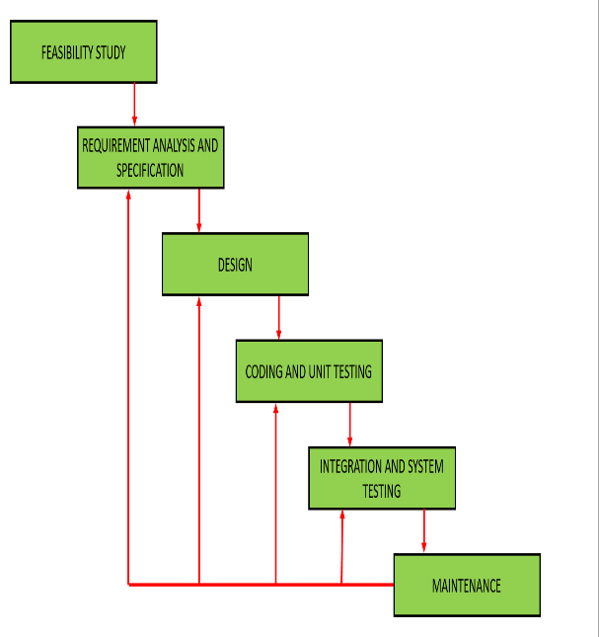

**Objective of Project**

The objectives of the project are: • Management of all information on expenses, payments, registration, expenses

. • The aim of the project is to develop an application to reduce the manual work related to expense management.

• Tracks all details related to user, registration, expenses.

• Effective financial management, like all financial planning, is a process, not a product.

• Manage expense details.

The main goal of the Money Info. project is to manage the details of expenses, categories, typologies, users, and subscriptions. Manages all information about expenses, payments, membership, expenses. The project is built entirely on the administration side, so only the administrator is granted access. The goal of the project is to create a program that reduces the manual work involved in managing expense, category, payment, and type. Tracks all types, users, registration details**.**

Putting focuses on the designing perspective we have created a choosing a mobile application, these TrackerApp easily loads on the user’s devices without consuming memory. We have designed our TrackerApp in such manner that it is compatible to almost all devices including the laptops of different brands, mobile phone, tablets and many more.

The multiple pages in our TrackerApp are home page, category page, dashboard page, sign in and login page.

**Home Page|** It includes the short description of the different categories of renting including with the button of the sign in, login page, trending trade and category.

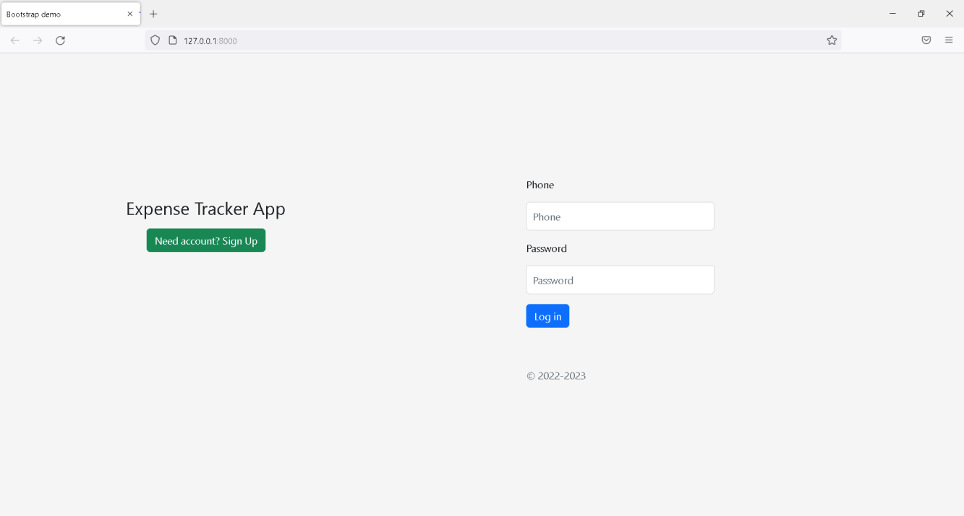

**Sign in page|** This page is maintained for maintaining the track of users who have visited on our website, using their name, email-id, DOB, and password they can register their account on **Renting website.**

**Login page|** This page will allow registered user to access on the system by using the Phone number and password they can login to the system. We have kept an option of forgot password if a user forgot their password, then by using their Phone number they will get their password.

**Category page|** It will contain multiple categories and by clicking on them user can see a wide variety of cloths available in that kind of category, but for viewing the cloths present in different category user first have to login on these app.

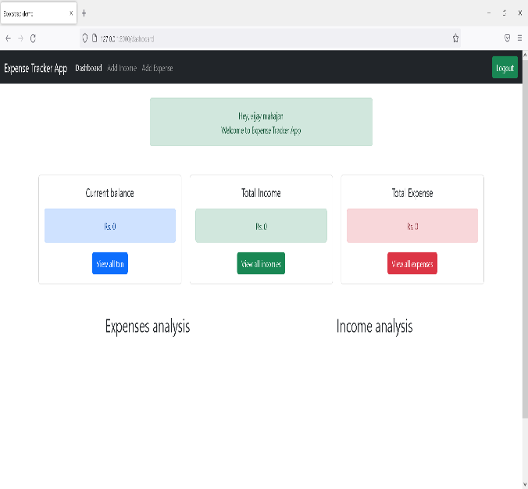

# CONCLUSION

In Our project we discuss how to invest in project as a whole with eye on creating for the company.one of the purposes of this chapter was to establish that projects are unique and bear different levels of risk than the risk of the company as a whole. In regard to value, it is all about how much cash you can generate.

Once the tools for understanding how to derive cash flow were introduced, the concept of capital budgeting was introduced.

# FUTURE SCOPE

# • A money transfer system will be added.

# • The system allows the member to verify their bank account and/or change account options.

# • Chat online with many users of the service.

# REFRENCES

1. [www.w3school.com](http://www.w3school.com/)
2. [www.scribd.com](http://www.scribd.com/)
3. [www.google.com](http://www.google.com/)
4. [www.wikipedia.com](http://www.wikipedia.com/)
5. [WWW.stackoverflow.com](http://www.stackoverflow.com/)
6. [WWW.jssor.com](http://www.jssor.com/)
7. [WWW.youtube.com](http://www.youtube.com/)
8. [WWW.gfg.com](http://www.gfg.com/)
9. [WWW.javatpoint.com](http://www.javatpoint.com/)

10. [WWW.Boostrap.com](http://WWW.Boostrap.com)