**A REVIEW PAPER ON BACTERIOLOGICAL SOLUTION FOR CONCRETE CRACKS**

**MD SHAHID1, MD. ANZAR RABBANI2, SONAM KUMARI3**

1 M.Tech Scholar, Ganga Institute Of Tech. & Management, Jhajjar, India

Mdshahid8581816064[@gmail.com](mailto:refazgitm@gmail.com)

2 Assistant Professor, Ganga Institute Of Tech. & Management, Jhajjar, India

[rabbanianzar1@gmail.com](mailto:rabbanianzar1@gmail.com)

3 Assistant Professor, Ganga Institute Of Tech. & Management, Jhajjar, India

sljakhar06@gmail.com

ABSTRACT

Concrete that can naturally cure itself without maintenance is known as self-healing concrete. When concrete fissures are exposed to moisture, air, and water, bacteria become active and produce lime, which causes the cracks to seal themselves. Buildings need less upkeep, more durability, and corrosion resistance, which bacterial concrete provides. As a difficult composition for self-repairing and increasing the compressive strength of the concrete, bacterial concrete is now accepted in the building sector.

## *Key Words*: Bacterial concrete, Bacillus subtilis, Calcium lactate

1. **INTRODUCTION:**

Due to shrinkage reactions of setting concrete and tensile strains present in set structures, cracks in concrete may barely be completely prevented. These fissures reduce the durability of concrete because they offer a simple route for the passage of liquids and gases that may contain hazardous materials. The reinforcement will corrode if microcracks spread to it, which could result in damage to both the concrete and the reinforcement. It is quite creative to use bacteria-induced carbonate precipitation to seal the fissures. The amount of dissolved inorganic carbon, pH, calcium ion concentration, and the existence of nucleation sites are some of the variables that affect the microbial precipitation. Additionally, the high alkaline environment of concrete, which limits bacterial development, is a key barrier when using bacteria to repair fractures in concrete. Therefore, the appropriate steps must be performed to safeguard microorganisms in concrete. Concrete is in touch with air, water, and moisture when fractures form. When water or moisture interacts with bacteria, the bacteria become active and produce lime, which causes fissures to close on their own. Bacterial concrete offers greater compressive strength in a similar manner. A concrete building or component's durability can be improved by using Bacillus Subtilis to repair fractures in the concrete surface. Buildings made of bacterial concrete require less maintenance and have greater durability and corrosion resistance, which bacterial concrete provides. As a difficult composition for self-repairing and increasing the compressive strength of the concrete, bacterial concrete is now accepted in the building sector. In a seismic zone, bacterial concrete also contributes in the early stages.

## THE BACTERIA-BACILLUS SUBTILIS:

* First of all, Vibrio subtilis, often known as bacillus subtilis, was identified in 1835 by Christian Gottfried Ehrenberg. Ferdinand Cohn gave it a new name in 1872. The bacteria Bacillus subtilis (B. subtilis) is an aerobic, gram-positive species. It resembles a rod.
* A non-pathogenic and non-toxicogenic microbe is Bacillus Subtilis.
* The Bacillus Subtilis bacteria are added to a concrete matrix during mixing to give it the self-healing capability.
* A fracture in the concrete surface causes infiltration water to react with bacteria, producing calcium carbonate (caco3), the primary component of lime.
* We choose calcium lactate as a chemical precursor because bacteria need nourishment to survive.

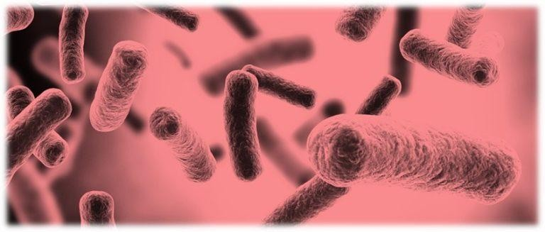

## LITERATURE REVIEW:

S. Sanjay, S. Neha, and R. Jasvir (2016), In order to improve the strength of bio concrete and shed light on the steps involved in making bacterial concrete, this publication presented experimental research on the subject. Analysis of the microstructure has been carried out to learn how the calcite crystals created in the bacterial concrete are employed for the potential to repair the cracks in the concrete as well as to learn about the biological reaction in the concrete. As a result, the bio concrete's nutrient broth medium, which was shown to be more adaptable than urea medium, achieved greater strength after 28 days.

**Thakur, A. Phogat, K. Singh (2016),** This publication provided a summary of several papers published in recent years that discussed the use of bio concrete to enhance the mechanical qualities, durability, and permeability characteristics of conventional concrete. They have investigated the examination of bio concrete using XRD and SEM tests, as well as a number of bacterial species, their isolation techniques, various methods for incorporating bacterial species into concrete, and the effects of these on compressive strength and water absorption. Finally, they came to the conclusion that some bacterial types, such as B. cereus and S. pasteurii, caused an extreme increase in compressive strength and a maximal decrease in water absorption over the specimen's 28-day curing period, respectively. Bacillus sphaericus, B. pasteurii, and Bacillus flexus are bacterial that do not affect humans and have the ability to precipitate calcite, while some other bacterial species are harmful to people's health.

**N. Amudhavalli, K. Keerthana and A. Ranjani (2015),** The state-of-the-art outcomes in all experiments demonstrate that the material was developed as self-healing agents. This study has provided an overview of bacterial concrete. Some bacteria, such as B. Pasteuri, B. megaterium, and B. subtilis, have limitations that prevent them from being directly useful in buildings like homes and offices. Finally, due to their benefits over other bacteria like B. sphaericus and Eschericheria coli, they are able to produce that bacterium that has been employed in concrete in a better method.

**N. Chahal and R.Siddique (2008)** According to this study, Sporosarcina pasteurii can be used to make a wound self-healing. They noticed that the presence of bacteria caused recently created fissures to mend. Using a bacterial solution with 103, 105, and 107 cells/ml, 10%, 20%, and 30% of the cement was replaced with fly ash, silica fume, and dosages of 5% and 10%, respectively. They used up to 91 days of age to conduct experiments on the compressive strength, chloride permeability, and water absorption and porosity. They came to the conclusion that S. pasteruii increases compressive strength and decreases the permeability and porosity of fly ash and silica fume concrete.

**V Srinivasa Reddy, M V SeshagiriRaoand S Sushma,** have written a study about the viability of using bacterial concrete as a novel self-repairing technology. By measuring the compressive strength of standard cement mortar cubes of various classes that have been mixed with various bacterial cell concentrations, this research discusses the impact of Bacillus subtilis JC3 bacterial cell concentration on strength. This demonstrates that at a cell concentration of roughly 105/ml, the improvement in compressive strength reaches its maximum. It is also examined how much more expensive utilising microbial concrete is compared to using regular concrete, which is important in establishing the viability of the technique from an economic standpoint. The cost investigation revealed that as grade dropped, microbial concrete cost increased by 2.3 to 3.9 times more than conventional concrete. Additionally, nutrients like cheap, high-protein industrial wastes like corn steep liquor (CSL) or lactose mother liquor (LML) effluent from the starch sector can be employed, which drastically lowers the whole process cost. The accumulation of these crystals within the gel matrix also greatly increases the toughness of concrete. In addition, this analysis revealed that when compared to traditional concrete, the cost of production increased but the carbon footprint significantly decreased.

**Ramakrishnan et al, (2001)** developed a novel method of microbiologically generating calcite precipitation to repair cracks and fractures in concrete. A technique known as microbiologically induced calcite precipitation falls under the more general branch of research known as biomineralization. A typical soil bacteria called Bacillus pasteurii has the ability to cause calcite to precipitate. Calcite demonstrated its favourable potential as a microbiological sealer by consolidating sand and selectively consolidating simulated fractures and surface fissures in granites. Since calcite precipitation is caused by microbial activity, MICP is a highly desired chemical process. The method can be used to increase the specimens of cracked concrete's compressive strength and stiffness. He looked examined the durability of bacteria-treated concrete beams that were also exposed to alkaline, sulphate, and freeze-thaw conditions. He also looked into how varying bacterial concentrations affected how long concrete would last. It was discovered that all of the bacterium-filled beams outperformed the control beams (which were devoid of bacteria). As the amount of bacteria increased, so did the durability performance. X-ray diffraction (XRD) analysis was used to measure the amount of microbial calcite precipitation and SEM was used to see it. The existence of calcite precipitation inside cracks, rod-shaped bacterial imprints, and a fresh layer of calcite on the surface of concrete were all confirmed by the SEM's distinctive imaging and microanalysis capabilities. This calcite coating strengthens the specimen's impermeability, boosting its defence against alkaline, sulphate, and freeze-thaw damage .

## SCOPE AND OBJECTIVES OF WORK:

**FROM DETAILED LITERATURE REVIEW THE FOLLOWING POINTS ARE EVIDENCE**:

• Create bacterial concrete by adding members of the bacillus family of bacteria.

• To determine the ideal bacterial dosage needed for bacterial concrete.

• To boost concrete's compressive strength.

• To repair concrete cracks that have appeared.

• To investigate concrete's resistance to various types of weathering. to conduct a durability test to evaluate the performance of Bacillus subtilis.

• To assess how well Bacillus subtilis performs with cracks that are 15mm, 20mm, 25mm, and 30mm deep and 1mm and 2mm wide.

## CRACK COMPARISON BETWEEN BACTERIAL CONCRETE AND CONVENTIONL CONCRETE

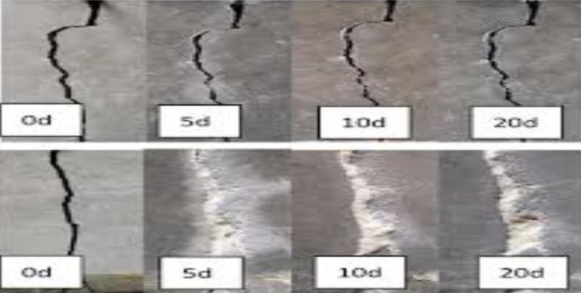

**IMPORTANCE:**

It gets automatically activated and heals the crack :-

Concrete cracks that come into touch with moisture, water, and air cause bacteria to become active and produce lime, which causes the fissures to self-heal. The right environment allows the bacteria to proliferate.

## Reduces the corrosion :-

Bacterial concrete does not allow the corrosive agent to reach the reinforcement, before that it heals itself and avoid or reduce the corrosion.

## Reduces the maintenance :-

Whenever the cracks gets form the Bacterial concrete heals the cracks automatically and reduce the maintenance and cost.

## WORKING PROCESS:

* **Culture of Bacteria:**

First of all, Vibrio subtilis, often known as bacillus subtilis, was identified in 1835 by Christian Gottfried Ehrenberg. Ferdinand Cohn changed the name of the place in 1872. The bacteria Bacillus subtilis (B. subtilis) is an aerobic, gram-positive species. It resembles a rod.

## Mix design:

With the goal of manufacturing concrete with the needed minimum strength, workability, and durability as economically as possible, acceptable elements of concrete (M25) such as cement, aggregates, and water are chosen, and their relative proportions are determined.

## Mixing, Casting and Curing: Mixing:

Mixing is done with the cement, sand and aggregate in the proportion of 1:2:2 (M25 Grade) with respective proportion of bacteria.

## Casting:

For the purposes of testing the compressive strength and tensile strength of concrete with and without bacteria, a total of 18 cubes and 18 cylinders were cast.

## Curing:

The cubes and cylinders are kept immersed in water for curing at the intervals of 7 days, 14 days and 28 days.

## Preliminary test of the concrete using Bacteria:

**Compression test: -**

The compressive strength of a total of 18 cubes, comprising concrete that contained and lacked microorganisms, was examined. Tests for compression strength will be conducted after 7, 14, and 28 days.

Tension test :- The split tensile strength of 18 cylinders, comprising samples with and without bacteria, was examined. A

tension test will be conducted after 7, 14, and 28 days.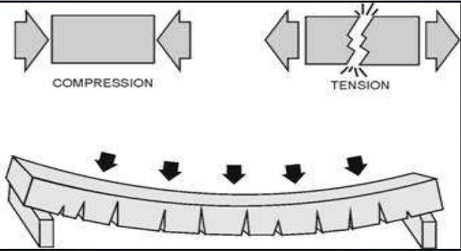

1. **APPLICATIONS:**

• Building construction to increase durability.

• Building construction in an earthquake-prone area.

• The construction of low-maintenance buildings.

## ADVANTAGES:

• Self-repair of cracks without outside assistance.

• A notable improvement in flexural and compression strength.

• Lessen steel's corrosiveness.

## DISADVANTAGES:

* Cost of the Bacteria is more.
* Bacteria needs proper atmosphere for growth.

## CONCLUSIONS

1) The properties of ordinary concrete are improved by bacteria, such as an increase in strength of 13.75% in 3 days, 14.28% in 7 days, and 18.35% in 28 days.

2) Eco-friendly self-healing concrete is available.

3) Make the material more compressible and less permeable.

4) Lessen steel's corrosion.

5) Bacterial concrete technology has shown to be superior to many established ones.

6) Bio concrete extends a structure's life by a greater amount than was anticipated.

## ACKNOWLEDGEMENT:

For their genuine efforts in completing the project work to bring up this study, we would like to extend our gratitude to Prof. Manish Bhatkar, Department of Civil Engineering, Jagadambha College of Engineering and Technology, Yavatmal.

## REFERENCES:

* H.M. Jonkers, A. Thijssen, Bacteria mediated remediation of concrete structures, in Proceedings of the Second International Symposium On Service Life Design for Infrastructures (Delft, The Netherlands, 2010)
* J.Y. Wang, K. Van Tittelboom, N. De Belie, W. Verstraete, Potential of applying bacteria to heal cracks in concrete, in Proceedings of the Second International Conference on Sustainable Construction Materials and Technologies, (Ancona, Italy 2010)
* H.M. Jonkers, Development of self-healing concrete: towards full scale application, in 3rd Internatinal Conference on Self-Healing Materials, (Bath, UK, 2011), p. 27
* S.K. Ramachandran, Venkataswamy Ramakrishnan S.S. Bang
* Willem De Muynck,Dieter Debrouwer,Nele De Belie,Willy Verstraete,P. GhoSh, Saroj Mandal, Brajadulal Chattopadhyay, Shri Lal Pal
* K. Van Tittelboom, N. De Belie, W. De Muynck, and W. Verstraete (2010). The use of bacteria to repair concrete cracks. 157-166 in Cement and Concrete Research, 40(1).
* H. M. Jonkers, A. Thijssen, G. Muyzer, O. Copuroglu, and E. Schlangen (2010). Bacteria as a self-remedial agent in the development of sustainable concrete. 230-235 in Ecological Engineering.
* W. De Muynck, N. De Belie, and W. Verstraete (2010). A review of microbial carbonate precipitation in building materials. 118-136 in Ecological Engineering, 36(2).
* Williams, A. E., Warmington, J. R., and Bang, S. S., together with Bachmeier, K. L. (2002). Urease activity in the precipitation of calcite brought on by microbes. 93(2), 171–181 in Journal of Biotechnology.
* W. De Muynck, K. Cox, N. De Belie, & W. Verstraete (2008). An alternative concrete surface treatment is bacterial carbonate precipitation. Building and Construction Materials, 22(5), 875-885.
* Rajor, A., Corinaldesi, V., Singh, K., and M. Singh (2016). properties of rice husk ash concrete made with microorganisms. 112-119. Construction and Building Materials, 121.
* 3.N. Chahal, R. Siddique, & A. Rajor (2012). bacteria's effects on fly ash concrete's compressive strength, water absorption, and fast chloride permeability. 28(1), 351-356, Construction & Building Materials.
* Majid, M. Z. A., Andalib, R., and Hussin, M. W. (2016). Bacillus megaterium at its ideal concentration for fortifying structural concrete. 180–193 in Construction and Building Materials, 118.
* H. K. Kim, S. J. Park, J. I. Han, and H. K. Lee (2013). Calcium carbonate precipitation mediated by microbes on normal and lightweight concrete. 1073-1082 in Construction and Building Materials.
* Vijay, K., Murmu, M., and S. V. Deo (2017). A review of bacteria-based self-remedial concrete. 1008-1014 in Construction and Building Materials..