**DEVELOPMENT OF A LPG MONITORING AND AUTOMATIC CYLINDER BOOKING SYSTEM BASED ON WIRELESS SENSOR NETWORK**

BYREDDY YASHASWINI1, REGATI RAJITHA2, MAADINENI GOWTHAMI3, EJJE DHAKSHAYANI4, NANDYALA VINNILA REDDY5, N. SREENIVASA RAO6

1,2,3,4,5UG students, Department of ECE, SREC, Nandyal

19x51a0477@srecnandyal.edu.in

6Asst. Prof., Department of ECE, SREC, Nandyal

**ABSTARCT**

LPG is widely used for cooking in many countries for economic reasons, for convenience or because it is the preferred fuel source. This paper focuses on the application of the IoT which is used for measuring and displaying the gasoline content present in household LPG cylinder and this is helpful in automatic booking of new LPG cylinder and also detect the gas leakage. Usually the capacity of LPG in Cylinder is not determined, so we are going to display the level of LPG. The level of LPG is measured using load sensor (SEN-10245). The output of the sensor is connected with Arduino R3.By use of GSM Module, the information is sent to user by SMS (short messaging service) and also automatic booking is done by dialing the registered gas booking number. Then the gas leakage is detected by gas sensor (MQ-6). By using this, we can detect the current LPG level and it is continuously displayed on the LCD. We can know the validity of LPG usage from the date of initialization. By use of IOT the user is alerted by giving the message to their mobile phone when the LPG level is critically low(below 20%).Automatic booking of new LPG by auto dialing of gas booking number and by this we prevent pre-booking and late booking. Then by detecting the gas leakage we can prevent the LPG gas burst accidents in the home.

**INTORDUCTION**

In our day to day life, LPG cylinder plays a major role. The main application of the LPG is that it is used in the place of chlorofluro carbon which cause great damage to the ozone layer. Though it's one in all the foremost normally used fuels, it's associate explosive vary of one.8%–9.5% volume of gas in air. it's packed into three classes per the burden of the LPG within the cylinder: social unit, business and Industrial. The social unit class of LPG cylinder contains 14.2 kilo LPG within the cylinder. Similarly, the business and Industrial classes of LPG cylinders contain nineteen and thirty five kilo of LPG severally. With the rising demand for LPG, users have to be compelled to pre book their LPG cylinder a minimum of a month before the delivery of the new LPG cylinder. Most of the days, users find it difficult to figure out what quantity of LPG is left at intervals the cylinder and this causes tons of bother to them. In such a state of affairs, associate degree efficient technique to watch the amount of LPG within the cylinder is needed, so the users are tuned in to the LPG level at intervals the cylinder. This paper deals with the detection of the gas leakage and the level of gas in the cylinder and automatic booking of the new LPG cylinder. The sensor used in this has the high sensitivity and fast response time. The gas sensor detects other gases including cigarette smoke. When the gas is detected the output of the sensor is send to the microcontroller and the buzzer is turned on and when the weight measured using load sensor becomes critically low, the alert is send to the user and the new LPG cylinder is booked. The main application of this proposed system is to overcome the shortcomings such as delay and pre-booking of the LPG cylinder by the consumers.

**LITERATURE REVIEW:**

T. Machappa, M. Sasikala, and M. V. N. Ambika Prasad exhibited a framework that electrical obstruction increments with increment at intervals the grouping of the gas. The variation of resistance depends on the dopents of the polyaniline, like metal oxides, bimetal oxides (ceramics), etc. conduction, the variation of resistance of the sensing material is either by activity of atmospherically substance on the sensing surface and/or by direct reaction of lattice substance or gap substance with the check gases unit the gas sensing mechanism. throughout this the gas sensing behavior of polyaniline and polyaniline salt composites unit given.

Fabien Chraim, Yusuf Bugra Erol, Kris Pister had explained the gas leakage solution for industrial places. Since the leakage of gas in the industries are unknown, the gas sensors are kept around the places where the gas leakage is possible. The information from these sensors are then send to the single system. The two techniques used are fixed instrumentation and mobile sensing. The mobile sensors are placed in the suspective sources and the readings are evaluated in that spot. These readings are then transmitted to the users or workers through wireless connection. But the main drawback is that the localization accuracy is under 5m.

L.P.Deshmukh, T.H.Mujawar, M.S.Kasbe, S.S.Mule, J.Akhtar and N.N.Maldar provides the abstract design so as to watch the outpouring of LPG within the atmosphere.The LabVIEW programming environment is developed to connect large area. The leakage level of a gas concentration is done using the LabVIEW GUI. The nodes and network are configured in this program. The measurements which is taken by the sensor nodes through the coordinator node using USB and ZigBee interface are also captured in this program. When the system detects the gas leakage, it sends a SMS alert to the user and also it activates the alarm. The gas flow emission is also controlled by using the solenoid valve. The output of the system is supervised using the personal computer or laptop.

**EXISTING SYSTEM:**

The basic principle behind this technique is that the modification in concentration of the LPG is detected associated it activates an audio visual alarm once it exceeds an explicit threshold worth. Further, it sends another alarm message through a radiofrequency (RF) system to the receiver module .The receiver module can be a mobile unit that will be placed anywhere among the premises of the house therefore the alarm area unit typically detected and detected at a distance from the place of gas outflow. The microcontroller reads the voltage from the detector and uses it to calculate modification in concentration. The gas detector is sensitive to many gases and actually gas kind can't be determined. Instead, during this work, it absolutely was assumed that the gas sensing element has the identical sensitivity for LPG and CH4, which may be thought-about a sound assumption.

**PROPOSED SYSTEM:**

Gas level detection and automatic booking is designed with various features which is implemented using Arduino R3 and this device will be a single system with multiple applications for LPG consumers. The device monitors the load if the gas level and displays it within the alphanumeric display incessantly. It also detects the gas leakage by gas senor. This includes an additional feature of booking a new LPG cylinder when the gas level becomes critically low. Then its sends an alert to the registered mobile number by a call with the help of GSM module and the alert database are displayed in the system monitor.

**Methodology:**

One-part deals with the percentage of gas remaining in the cylinder which is found using a sensor called load cell and it is updated continuously to the mobile that is being used by the user when the gas level is less than the threshold value then the notification will be given to the user through the LCD, and booking is done automatically through the mobile device. The second part deals with leakage detection. When the leakage is detected by the gad sensor, it switches the relay connected to the solenoid valve and turns off the valve. Then the message is sent to the user.

**BLOCK DIAGRAM:**

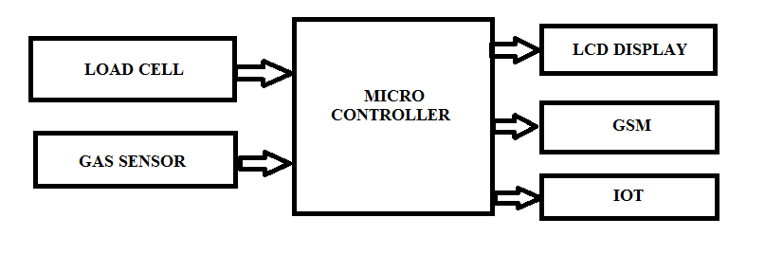

Figure Block diagram

**GSM:**

GSM (Global System for Mobile communication) is a digital mobile network that is widely used by mobile phone users in Europe and other parts of the world.

The GSM is a circuit-switched type of network. The GPRS is a packet-switched type of network. The GSM technology provides a data rate of about 9.6 kbps (kilobytes per second) for all of its users. The GPRS technology provides a data rate of about 14.4 kbps to 115.2 (kilobytes per second) for all of its users.

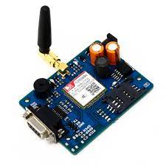

Figure GSM module

**LOAD CELL:**

Load cells are used to measure weight. They are an integral part of our daily life. "In your car or at the cheese counter in the supermarket – we encounter load cells everywhere," says HBM Product Manager Stefan Schmidt. Of course they are usually not immediately recognizable, because they are hidden in the inner workings of instruments.

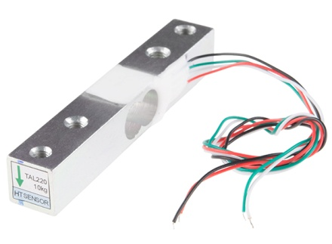

Figure Load cell

[Load cells](https://www.hbm.com/en/0013/load-cells-and-load-sensors/) generally consist of a spring element on which [strain gauges](https://www.hbm.com/en/0014/strain-gauges/) have been placed. The spring element is usually made of steel or aluminum. That means it is very sturdy, but also minimally elastic. As the name "spring element" suggests, the steel is slightly deformed under load, but then returns to its starting position, responding elastically to every load. These extremely small changes can be acquired with strain gauges. Then finally the deformation of the strain gauge is interpreted by analysis electronics to determine the weight.

**Gas Sensor:**

Gas sensors (also known as gas detectors) are electronic devices that detect and identify different types of gasses. They are commonly used to detect toxic or explosive gasses and measure gas concentration. Gas sensors are employed in factories and manufacturing facilities to identify gas leaks, and to detect smoke and carbon monoxide in homes. Gas sensors vary widely in size (portable and fixed), range, and sensing ability. They are often part of a larger [embedded system](https://www.fierceelectronics.com/embedded/what-embedded-computer), such as hazmat and security systems, and they are normally connected to an audible alarm or interface. Because gas sensors are constantly interacting with air and other gasses, they have to be calibrated more often than many other types of sensors.

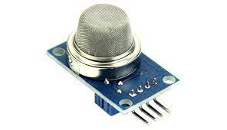

Figure Gas Sensor

**LCD:**

Depending on how many lines are used for connection to the microcontroller, there are 8-bit and 4-bit LCD modes. The appropriate mode is determined at the beginning of the process in a phase called “initialization”. In the first case, the data are transferred through outputs D0-D7 as it has been already explained. In case of 4-bit LED mode, for the sake of saving valuable I/O pins of the microcontroller, there are only 4 higher bits (D4-D7) used for communication, while other may be left unconnected.

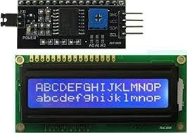

Figure LCD module

Consequently, each data is sent to LCD in two steps: four higher bits are sent first (that normally would be sent through lines D4-D7), four lower bits are sent afterwards. With the help of initialization, LCD will correctly connect and interpret each data received. Besides, with regards to the fact that data are rarely read from LCD (data mainly are transferred from microcontroller to LCD) one more I/O pin may be saved by simple connecting R/W pin to the Ground. Such saving has its price. EvenEven though message displaying will be normally performed, it will not be possible to read from busy flag since it is not possible to read from display.

**Result:**

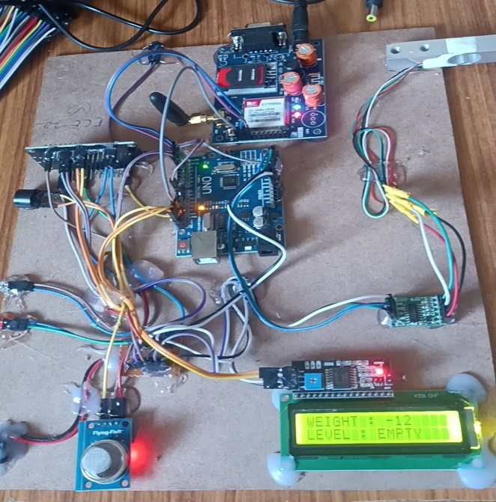

Figure Project Hardware connections

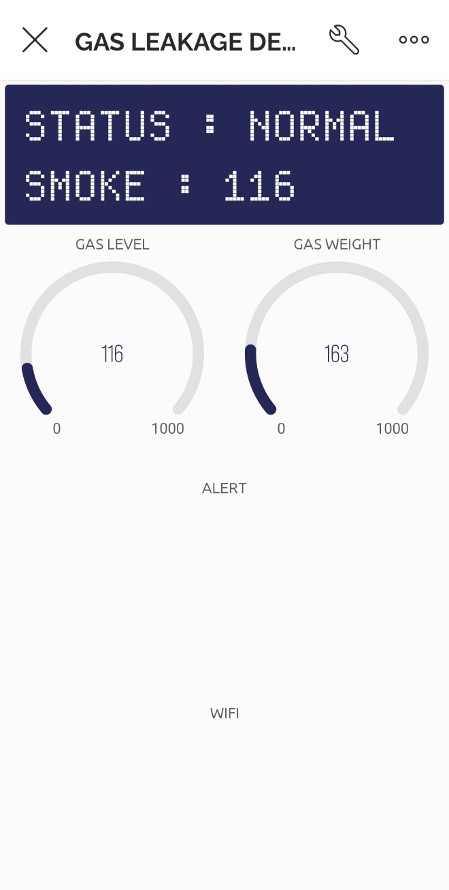

Figure Gas level indication

**CONCLUSION:**

This paper consists of two sections transmitter section and receiver section. In this the automated booking of latest LPG cylinder is enforced. With the assistance of the gas device and cargo device ready to} able to observe the amount of the gas and also the gas leak. And at last with the application of IoT, new LPG cylinder can be booked by the user. By this system, the users can be aware of their gas level and it also avoids the prior and delay booking of the cylinder. And also the components used here are commercially cheap when compared to other gas detectors. Hence this concept can also be widely used in the industries according to their requirements.

**REFERENCES:**

[1] S., Koushanfar, F., Kosterev, A., Tittel, F., “LaserSPECks: Laser SPECtroscopic Trace-Gas Sensor Networks - Sensor Integration and Applications”, Information Processing in Sensor Networks, 2007. IPSN 2007. 6th International Symposium on, April 2007, p. 226 - 235, ISBN 978-1-59593-638-7

[2] P. M. Vidya, S. Abinaya, G. G. Rajeswari, and N. Guna, “Automatic lpg leakage detection and hazard prevention for home security,” in Proceeding of 5th National Conference on VLSI, Embedded and Communication & Networks on April, vol. 7, 2014.

[3] N. S. G. B. D. Jolhe and P. A. Potdukhe, “Automatic lpg booking, leakage detection and real time gas measurement monitoring system,” International Journal of Engineering Research & Technology (IJERT), vol. 2, April-2013.

[4] Brush, A. J., Lee, B., Mahajan, R., Agarwal, S., Saroiu, S., & Dixon, C. (2011, May). Home automation in the wild: challenges and opportunities. In Proceedings of the SIGCHI Conference on Human Factors in Computing Systems (pp. 2115-2124). ACM.

[5] F. Chraim, Y. Erol, and K. Pister, “Wireless gas leak detection and localization,” IEEE Trans. Ind. Inf., pp. 1–13, 2015.

[6] M.S.Kasar, Rupali Dhaygude, Snehal Godse and Sneha Gurgule,”Automatic LPG Gas Booking and Detection System”, International Journal of Advanced Research in Electrical, Electronics and Instrumentation Engineering, ISSN 2278-8875, Vol. 5, Issue 3, pp. 1250-1253, March 2016.

[7] S.Sivajothi Kavitha and S. Senthilkumar, "A Wireless Gas Leakage & Level Detection with Auto Renewal System ", International Journal of Advanced Research in Electrical, Electronics and Instrumentation Engineering, ISSN 2278-8875, Vol. 4, Issue 4, pp. 2095-2100, April 2015.

[8] M.S.Kasar, Rupali Dhaygude, Snehal Godse and Sneha Gurgule,”Automatic LPG Gas Booking and Detection System”, International Journal of Advanced Research in Electrical, Electronics and Instrumentation Engineering, ISSN 2278-8875, Vol. 5, Issue 3, pp. 1250-1253, March 2016.

[9] G. B. C. V. K. G. S. V. H., B. N. V. Abhishek, P. Bharath, “Automation of lpg cylinder booking and leakage monitoring system,” International Journal of Combined Research and Development (IJCRD), pp. 693–695, 2016.

[10] Ankit Sood, Babalu Sonkar, Atul Ranjan, Ameer Faisal, “Microcontroller Based LPG Gas Leakage DetectorUsinbg GSM Module, International Journal of Electrical and Electronics Research, Vol.3, Issue.2, pp: (264-269), Month: April- June 2015.

[11] N. Sreenivasa Rao, G. Sowmya and S. Munawwar, Lab VIEW BASED TEXT DETECTION AND OBJECT RECOGNITION PROTOTYPE FOR THE BLIND AND THE DUMB PEOPLE in JETIR , Vol. 6, Issue. 5, May 2019

[12] N. Sreenivasa Rao and Dr. P. Thimmaiah published a journal on A HIGHLY SECURED SYSTEM FOR HOME APPLIANCESEMBEDDED WITH ELECTRONICS, SOFTWARE AND SENSORS in IJEIR, Vol. 6, Issue. 5, ICEMS-2017, September 2017

[13] **“Temperature and Humidity Sensor Based Air Blower Controller For Food Drying”,** JOURNAL OF ALGEBRAIC STATISTICS, Volume 13, No. 1, 2022, p. 869 – 876, ISSN: 1309-3452.

[14] “TEMPERATURE AND HUMIDITY SENSOR BASED AIR BLOWER CONTROLLER FOR FOOD DRYING”JOURNAL OF ALGEBRAIC STATISTICS VOLUME 13, NO. 1, 2022, P. 869 - 876 HTTPS://PUBLISHOA.COM ISSN: 1309-3452

[15] Multiple Sensor Data Fusion Based Top-Down Embedded System for Automatic Plant Pot Watering,B Saraswati, MV Subramanyam, Journal of Algebraic Statistics 13 (1), 884-891,2022

[15] V.Jyothi, Dr.M. V. Subramanyam “ An Enhanced technique to improve the Network Lifetime of Cognitive Sensor Networks ’, International Journal of Wireless Personal Communications’ pp. 12757 – 12763, May-2021 DOI <https://doi.org/10.1007/s11277-021-08575-0>[SCI].