**CAR COLLISION DETECTION USING IOT**

|  |  |  |
| --- | --- | --- |
|  | Ms.Velvizhi, M.E.  Dept. of Computer Science and Engineering  Sathyabama Institute of Science and Technology  Chennai, India  velvizhi.cse@sathyabama.ac.in |  |

|  |  |  |
| --- | --- | --- |
| T. Krishna Vamsi  Dept. of Computer Science and Engineering  Sathyabama Institute of Science and Technology  Chennai, India  Vamsi9182161788@gmail.com |  | K. Venkata Balaji Kumar  Dept. of Computer Science and Engineering  Sathyabama Institute of Science and Technology  Chennai, India  baluyadav7400@gmail.com |

**Abstract**

# This device is used to hit upon car collisions and send collision facts to the closest emergency services such as ambulances and police stations. When a traffic accident happens in far flung regions, the accident can motive the driver and passenger to a situation in which they can't call for assist. In those instances, the subsequent hospitalization function of this application appears. When an twist of fate happens, this application determines the intensity of the collision in which the auto is worried within the accident, and if it exceeds a certain threshold, then the application is activated and waits for the person's response. This leads to the subsequent two situations: if the driving force movements and confirms his fame via the application, the application does now not take action, otherwise the utility is in close touch with the closest emergency services, consisting of the ambulance and the police.

# Keywords: ArduinoUNO microcontroller, pace, distance, L293D motor driving force, Mems sensor, LCD display;

# Introduction:

# This device is used to stumble on car collisions and ship collision information to the nearest emergency offerings together with ambulances and police stations. When a visitors coincidence occurs in faraway regions, the accident can cause the driving force and passenger to a state of affairs wherein they cannot call for assist. In those instances, the next hospitalization characteristic of this software seems. When an twist of fate happens, this software determines the depth of the collision wherein the automobile is concerned inside the coincidence, and if it exceeds a positive threshold, then the utility is activated and waits for the person's reaction. This leads to the following conditions: if the motive force movements and confirms his repute thru the utility, the utility does not take movement, in any other case the software is in close touch with the nearest emergency offerings, including the ambulance and the police.

# Literature survey

# Title-1Automatic Traffic Accident Detection and Notification with Smartphones

# Author-JulesWhite, Chris Thompson, Hamilton Turner, Brian Dougherty, and Douglas C. SchmidtRoad visitors accidents are one of the leading reasons of demise in the United States.

# An crucial component in survival after an accident is the time between twist of fate and an ambulance changed into despatched to the scene. Reducing the time between the incident and rescuers on the scene reduces mortality by 6%. An technique to get rid of the delay among the prevalence of an accident and the velocity of emergency response is to use on-board automobile detectors and notification systems that hit upon whilst an coincidence occurs and notify emergency employees without delay.However, these car systems aren't to be had in all automobiles and retrofitting them for older automobiles is luxurious. This paper describes how smartphones consisting of the iPhone and Google Android structures can robotically detect traffic injuries the usage of accelerometers and acoustic facts, without delay notify a important device server after an twist of fate, and provide situational cognizance with photographs, GPS coordinates and VOIP. Communication channels and occasion registration data. This article makes the subsequent contributions to the examine of traffic coincidence detection with smartphones: (1) we gift a formal version for traffic detection that integrates sensors and contextual records, (2) we show how we provide sensors, community connections, and web offerings. Ought to be used to offer situational awareness to first responders, and (three) we provide empirical effects demonstrating the effectiveness of diverse approaches used in crash detection systems to save you false alarms.

# Title-2 A Comprehensive Study on IoT Based Accident Detection Systems for Smart Vehicles

**Author- UNAIZA ALVI1 , MUAZZAM A. KHAN KHATTAK 2 , (Senior Member, IEEE), BALAWAL SHABIR 1 , ASAD WAQAR MALIK 1 , (Senior Member, IEEE), AND SHER RAMZAN MUHAMMAD**

With the growth in populace, the call for for motors has risen sharply, which has created a dire scenario in phrases of visitors situations and traffic accidents. The percent of avenue traffic injuries will increase exponentially, as does the quantity of deaths due to injuries. However, the primary reason for the growth in deaths is because of the delay of the emergency. Many lives can be saved with effective rescue services. There is a delay due to traffic congestion or unstable communications with medical devices. Implementing automotive anti-robbery detection systems offer important strategic support. Many solutions had been proposed in the sizable literature of fault detection. Collision prediction strategies include the usage of smartphones, vehicle-specific networks, GPS/GSM-primarily based structures and diverse device gaining knowledge of techniques. With such a lot of deaths related to avenue site visitors crashes, street protection is the maximum important location that needs severe interest. In this article, we present a important evaluation of the various current methodologies that are expecting and save you street visitors crashes, highlighting their strengths, obstacles, and challenges that want to be addressed to protect road safety and save treasured lives.

**Title-3 Real Time Detection and Reporting of Vehicle Collision**

**Author-Parag Parmar, Ashok M. Sapkal**

Road visitors injuries are the main cause of demise in India. In India, the number one loss of life turned into because of accidents. This is important and steps ought to be taken to keep the sufferer's existence. A sufferer's lifestyles may be saved if proper medical care is furnished in time. Statistics display that during many instances, in which the twist of fate is critical, the witnesses of the accident or the bystanders do now not need to face up to because of the lengthy system in reporting to the police and accomplishing an research. This makes us a thinking gadget in which we do not have to depend on others to assist the sufferer. In addition, in lots of instances, victims, if aware, can not inform emergency scientific providers their precise vicinity, close by limitations, and many others. Because of injury or because they may be strange with the region. Therefore, it's far essential that the item is right now transferred to the use of the item. This challenge aims to broaden a machine which could stumble on the occasion of an twist of fate, report the incident to the sufferer's circle of relatives in predetermined numbers, locate the closest health center, and tell them of the twist of fate if you want to immediately ship scientific help. This prototype uses gyroscope, accelerometer, GPS, GSM and automated dialer. The MPU6050 MEMS sensor detects the accident occasion using a three-axis gyroscope and a 3-axis accelerometer. The circle of relatives of the sufferer has been notified via the dialing feature. The GPS module reads the precise location of the accident website online and this information is despatched to the emergency services. This gadget has helped to reduce the response time of the twist of fate to successfully report to the hospital. This was essential to store the lives of these affected.

**Title-4Developing a forward collision warning system simulation**

**Author-Collision Warning System Simulation Shih-Ken Chen Jayendra S. Parikh**

This research challenge turned into accomplished to expand an engineering device to assess the technical and practical overall performance of an automobile front radar sensor and hazard evaluation algorithms to develop a pre-collision warning gadget. The tool includes three main elements: 1) an interactive riding simulator, 2) a radar sensor simulator, and three) a danger assessment subsystem. The standard shape of the gadget is decided and the medium between the main components is determined. Car accidents claim more than forty,000 lives every yr and bring about billions of bucks in social expenses. Rear affects account for about 12% of those crashes. Technologies are getting to be had which can reduce the impact of the rear and be effective. The Forward Collision Warning System (FCWS) Simulation was evolved as a tool to assess the technical and practical performance of a forward looking radar sensor and improve overall device performance for automobile applications. The selected simulation consists of street geometry, traffic eventualities and a radar sensor version for analysis and presentation. In addition, it affords a tool to analyze numerous pre-collision caution algorithms evolved in regular and crash eventualities. Threat assessment algorithms can be evaluated in reproducible simulated situations to determine the performance and sensitivity of device parameters and sensors.

**EXISTING SYSTEM**

In the modes of car collision detection and cylinder detection the usage of RNS and satellite tv for pc module. Satellites for monitoring devices. Send alerts to the satellite tv for pc with the help of RNS modules. If the following collisions are very extreme and the driving force can not confirm his condition, then the tool (located in the car) sends a signal to the satellite tv for pc and immediately contacts the nearest emergency center, sending the exact place of the accident the use of pre-recorded audio or text. This machine will assist many vacationers, whose recent encounter with extreme injuries can cause lack of cognizance on the road, in faraway regions, or in any moderately populated areas.

**Proposed system**

Vehicle-to-automobile communique plays an important function in coincidence prevention and detection, as car collisions can handiest be prevented through right car-to-automobile verbal exchange on the road. A LiFi-primarily based system has been brought to display the driving force's physical parameters and the space between motors to reduce the chance of injuries. This system saves the lives of many by means of overcoming all system failures earlier than implementation, determining the technical purpose of injuries and preventing accidents by means of caution the driver. , affords a better security mechanism. The whole device is controlled by means of an Arduino Uno microcontroller. The block diagram of the module includes an Arduino Uno microcontroller.

**Advantages**

The fundamental benefits of this machine are fee effectiveness, guaranteed safety, the capacity to quickly shop the victim's lifestyles, low energy intake, better accuracy, green time intake, and reduced probability of human blunders.

**Block Diagram**

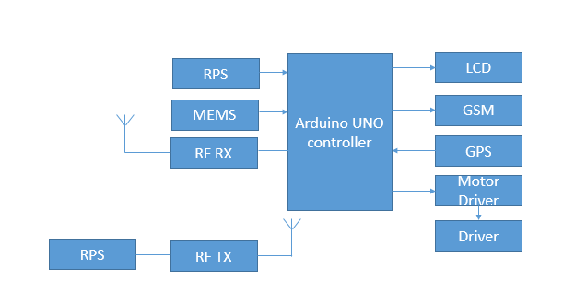

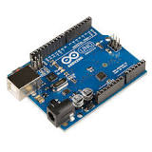**Arduino UNO Controller**

Arduino Uno - microcontroller boards from ATmega328P (datasheet). It has 14 virtual input/output pins (6 of which can be used as PWM outputs), 6 analog inputs, a 16MHz ceramic resonator (CSTCE16M0V53-R0), a USB connection, a strength connector, an ICSP connector, and a reset button. . Most Arduino boards encompass an 8-bit Atmel AVR microcontroller (ATmega8, ATmega168, ATmega328, ATmega1280, or ATmega2560) with numerous amounts of reminiscence, pins, and features.

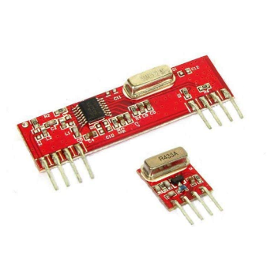R**F Transmitter and receiver**

RF Radio frequency communities paintings by means of developing electromagnetic waves on the supply and being able to accumulate the electromagnetic waves for a specific purpose. These electromagnetic waves propagate thru the air at a quick speed close to that of mild. The frequency of an electromagnetic sign is inversely proportional; the higher the frequency, the shorter the death.

Frequency is measured in Hertz (cycles per 2d), whilst radio frequencies are measured in kilohertz (kHz or thousand cycles consistent with 2nd), megahertz (MHz or million cycles in step with 2d), and gigahertz (GHz or billions of cycles according to 2d). Higher frequencies bring about shorter wavelengths. The latency of a 900 MHz tool is longer than that of a 2.Four GHz device.

In standard, longer signifiers pass further and circulate around and around things higher than shorter signifiers.

**GSM MODEM:**

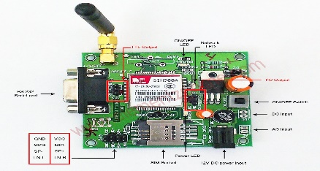

The Global System for Mobile Communications (GSM) is a globally general fashionable for virtual cellular communications. GSM is the name of a set created in 1982 to create a not unusual European cell fashionable that might offer specifications for a cell cellular machine running at 900 MHz. GSM affords tips, no longer requirements. The GSM specs define in element the functions and necessities of the tool, but do now not cover the hardware. The motive for this is to restriction builders as little as possible, at the same time as nevertheless permitting customers to buy device from special carriers. The GSM network is split into 3 foremost systems: Switching System (SS), Base Station System (BSS), and Operation and Support System (OSS). The predominant components of a GSM community are shown within the determine beneath.

**Global Positioning System** (**GPS)**

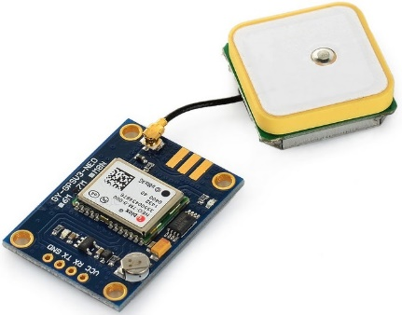

Different GPS modules are designed for exceptional applications. The modes are divided into households: the FGPMMOSLx and FGPMMOPAx collection (model variety shows x). The foremost distinction between the 2 households is the inclusion of a smart layer antenna. The PAx comes with a ceramic antenna, even as the SLx does no longer. These GPS modules are the best GPS video solution for great positioning, pace and accuracy, as well as brilliant consolation and tracking abilties in urban environments. GPS module from MediaTek Inc. It is powered by way of a chipset. GPS, the world's main company of digital media answers and the largest incorporated environmental organization.

**Motor Driver**

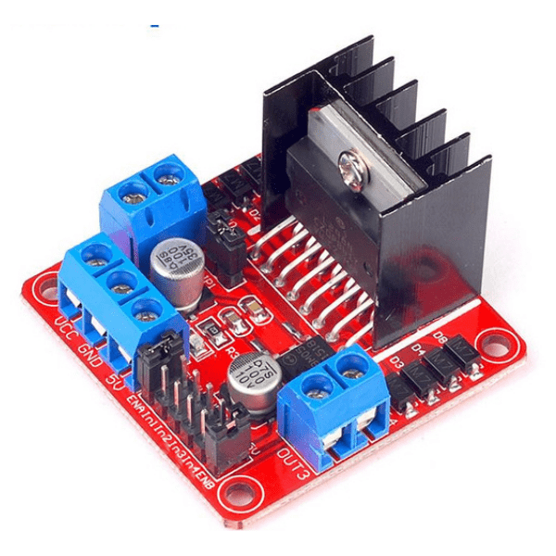

Motor drives act as an interface among the cars and the manage circuit. The motor requires a large amount of present day, while the controller circuit operates on low modern-day alerts. So the feature of the motor controller is to take a low modern manage signal after which convert it to a more potent signal which could force the motor. To control the robotic wirelessly via remote control, it's miles important to connect the cars to the wireless structures. Inclusive of Bluetooth, 2.4GHz RF module, etc. Here is a contrast of every motor driver on offer that will help you pick out a motor and motor motive force aggregate.

**Motors**

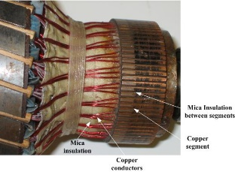

A DC motor is used to force a mechanical load. In this laboratory an independently excited dc generator substances the load. It controls the weight of the device by converting the excitation of the generator. As the excitation contemporary of the DC generator will increase, the burden on the DC motor increases and subsequently the armature current increases. DC cars have their very own function velocity-torque curves, as shown in fig. 9.1. Because the laboratory does no longer have the Golden Arm to measure the device, an opportunity DC motor idea should be used. One option is to devise shaft velocity versus armature current, in view that torque is without delay proportional to armature present day ( ) with a steady field current carried out to the motor. The shaft velocity is likewise a feature of the excitation cutting-edge in a DC motor, retaining the armature voltage regular because the excitation contemporary is immediately proportional to the axis of the direct flux generated inside the device.

**Conclusion**

The improvement and implementation of a vehicle collision avoidance system primarily based on an Arduino microcontroller is effectively done with the advantages of making sure the speed of the automobile in motion, in addition to making sure the safety of the automobile and its drivers and is greater reliable and tested. Something easy to work on. . This task additionally shows how the sensors can screen the speed of the car and also guard it in case of any malfunction and prevent damage to the automobile, and locate special situations of the car via giving exceptional inputs to the microcontroller.

**References**

[1] A.R. Kashyap and Mohankrishna K, “Vehicle Collision Avoidance with Dynamic Speed Governor”, International Journal of Innovations in Engineering and Technology (IJIET) ISSN: 2319 -1058 Volume.5, Issue.4 August 2015, pp.323-331.

[2] Muhammad Saqib, Sultan Daud Khan, Saleh Mohammad Basalamah, “Vehicle Speed Estimationusing Wireless Sensor Network”, INFOCOMP 2011: The First International Conference on Advanced Communications and Computation ISBN: 978-1- 61208-161-8.

[3] S Nagakishore Bhavanam and Vasujadevi M, “Automatic Speed Control and Accident Avoidance of Vehicle using Multisensors”, International Conference on Innovations in Electronics and Communication Engineering (ICIECE 2014), 18th & 19th July 2014, Guru Nanak Institutions, Hyderabad.

[4] Vivek Singhal and Dr. S. S. Jain, “Sensor based Vehicle Collision Avoidance Techniques using Geospatial Data”, Paper No. A_31, Twenty-Eighth National Conventional Engineers and National Seminar on Role of Infrastructure on Sustainable Development, the Institute of Engineers, IIT Campus, Roorkee, October 12-14, 2012.

[5] Suresh Babu Changalasetty, Lalitha Saroja Thota, Ahmad Said Badawy, Wade Ghribi J. Subhash Chandra Bose, Mohammad Shiblee, “Vehicle Monitoring System using PIC Microcontroller”, International Journal on Computer Science and Engineering (IJCSE) ISSN: 0975-3397 Vol.8 No.12 Dec 2016.

[6] Umar Zakir Abdul Hamid, Hairi Zamzuri, Pongsthorn Raksincharoensak, Mohd Azizi Abdul Rahman, “Analysis of Vehicle Collision Avoidance using Model Predictive Control with Threat Assessment ”, 23rd ITS World Congress, Melbourne, Australia Paper No. AP-TP0170