An Architecture Combining Blockchain, Docker and Cloud Storage for Improving Digital Processes in Cloud Manufacturing

**MS. R. DHARANI**

ASSISTANT PROFESSOR, DEPARTMENT OF COMPUTER SCIENCE

SRI KRISHNA ARTS AND SCIENCE COLLEGE

[dharnir@skasc.ac.in](mailto:dharnir@skasc.ac.in)

**S. SRIKARTHIKEYAN**

STUDENT

DEPARTMENT OF COMPUTER SCIENCE

SRI KRISHNA ARTS AND SCIENCE COLLEGE

[srikarthikeyan@gmail.com](mailto:srikarthikeyan@gmail.com)

***Abstract*— *The Blockchain has been given great attention in recent literature among emerging technologies in software architectures. More specifically, when verifiable transactions between untrusted parties are concerned in a safe and reliable environment, its peculiar decentralized and tamper-proof structure makes it suitable for a vast class of business domains, such as Cloud Manufacturing, which is a new paradigm in the industry based on cloud technologies. However, the stiffness of existing solutions, that are unable to provide and implement heterogeneous services in a Cloud environment, emphasizes the need of a standard framework to overcome this limit and improve collaboration. Firstly, this paper introduces a Blockchain based platform designed with Smart Contracts for improving digital processes in a manufacturing environment. The primary contribution is the integration of two popular cloud technologies within the Blockchain: Docker, a scalable platform to run applications in lightweight environments, and Cloud Storage. Each process available in the platform requires input files and produces output files by using cloud storage as are positron and it is delivered by the owner as a self-contained Docker image, whose digest is safely stored in the chain. Secondly, with the purpose of selecting the fastest node for each new process instance required by consumers, we introduce a task assignment problem based on a deep learning approach and past metrics. The proposed platform is applied to a real-world industrial case study regarding ophthalmic lenses manufacturing and the optimization of lens surface calculation.***

**KEYWORDS—** Cloud manufacturing, blockchains, software architecture, distributed ledger, smart contracts, computer architecture.

**INTRODUCTION**

Cloud computing has made significant changes to the way businesses operate today [1]. While enterprise spending on cloud infrastructure services was only 3.5 billion dollars in 2011, it was almost 130 billion dollars in 2020 [2]. The new paradigm of Cloud Manufacturing, which enables businesses to provide and receive services over the Internet through an intelligent service-oriented architecture, emerged as a result of the adoption of cloud technologies in the manufacturing sector [3].

Decentralization is a key factor in both cloud computing and cloud manufacturing, as distributed architectures improve services reliability, scalability, and performance when compared to traditional on-premise centralized approaches [3]. The associate editor coordinating the review of this manuscript In the same way, security is a big issue in these situations because cloud-based data can be hacked, changed, or stolen, and services' integrity could be badly hurt [4].

for more information. Blockchain, a secure ledger for storing transactions, is an important part of modern distributed architectures. Over the past ten years, a lot of research has been done on this revolutionary technology. Numerous business areas have adopted a system application: from common financial applications like cryptocurrencies to completely new areas like business and industry, the Internet of Things, governance, education, health, and privacy and security.

Most of these applications are typically built on Smart Contracts as their core component. A Smart Contract is basically an algorithm that is written and executed in the Blockchain itself to enforce a specific agreement between parties involved in transactions. [6] provides a comprehensive overview of smart contracts and the most common uses for them.

The application of blockchain technology in business and industry has received the most recent attention among all business domains [5]. A well-organized class of Industry 4.0 applications has already been implemented, as the taxonomy provided in [7] explains in detail. In addition, the authors talk about how Smart Contracts are being used in areas like the Internet of Things, supply chain, manufacturing, and energy. On the other hand, the authors of [8] discuss the difficulties and the current state of Blockchain in manufacturing, as well as the relevant research avenues for the near future.

In[9], specific manufacturing and engineering solutions are discussed. The reviewed applications are made for specific things like making the manufacturing process more efficient, keeping data valid, and making internal and external communications better.

[10] argues that the Blockchain is a tool that could be used by all management stakeholders of a product lifecycle by describing various purposes, such as making deals and sharing product information. From the manufacturing system and product life-cycle management points of view, the authors' work examines the most recent research in the field. The Blockchain is generally regarded as a tangible enabler for current Enterprise Resource Planning and Manufacturing Execution Systems solutions when it comes to sustainable manufacturing in Industry 4.0.

Manu Chain, a decentralized task execution model for Industrial-Internet-of-Things (IIoT) environments, is offered as an illustration of this kind of application in [11]. The dual-layer architecture of the proposed architecture is based on a permissioned Blockchain and Smart Contracts designed specifically for it. A Blockchain-based security service architecture for Cloud Manufacturing environments that facilitates authentication and privacy protection in decentralized 5G IIoT contexts was recently presented by the authors in [12].

[13] discusses collaborative business process management (BPM) in the Blockchain domain. The authors demonstrate in their systematic review that, among other topics, papers on the phases of process implementation and execution as well as process modeling are the most representative.

The translation of processes defined in accordance with the well-known Business Process Model and Notation (BPMN) into Smart Contracts is a common research topic in this setting [14]. Caterpillar, an open-source BPM system, is suggested in [15]. A BPMN to Smart Contract compiler is included in the solution to carry out the translation automatically.

In terms of cloud manufacturing, the current Blockchain-based solutions already meet some of the most important requirements, like security and decentralization. Additionally, when it comes to these features, the Blockchain is known to perform better than other distributed architectures. In addition, a unique feature of the Blockchain, such as the immutability of transactions, clearly increases their credibility in several business domains. At the same time, the absence of trusted third parties makes it easier to verify contents and increases the platform's reliability [5].

In addition, the advantages of utilizing Blockchain in such settings, particularly for additive manufacturing and 3D printing, are made clear in [16]. In this regard, the authors point out that protecting CAD model intellectual property and using Blockchain technology to license models and secure the manufacturing process are crucial issues in this setting. In addition, in [17], a concrete example of an Additive Manufacturing architecture based on Blockchain and Smart Contracts is proposed with the specific goals of enforcing agreements between design and 3D printing businesses and safeguarding design file intellectual property.

However, in the context of collaboration, it is frequently necessary for modern platforms to fulfill additional significant requirements. They must be adaptable and standardized for easy implementation. Most current solutions to the development of virtualization and servitization technology are still insufficient, as suggested in [1] and [3], and as a result, they do not meet those requirements.

Ophthalmic lenses and 3D-printed products are two examples of specific manufacturing processes that are the focus of this paper. Specific digital processes and computationally demanding tasks are required for these kinds of manufacturing procedures, which also raise standards, cybersecurity, and intellectual property preservation issues.

Different actors can effectively provide, update, and consume any kind of process delivered as a service thanks to cloud solutions and standardized frameworks. It is difficult to flexibly integrate generic software logic in such environments due to the absence of a standard framework, which has an impact on the server vitization process.

This work proposes a decentralized, distributed, cybersecure, and collaborative platform to enhance digital processes in Cloud Manufacturing environments, inspired by this unresolved issue. Smart Contracts and Ethereum, one of the most widely used Blockchain implementations, serve as the foundation for the proposed platform [18]. In addition, the platform works with a variety of actors, including Process Owner, Process Consumer, and Process Runner, to manage the process life cycle and efficiently carry out digital business processes.

The main contribution of the paper is to use Docker, Cloud Storage, and Deep Learning in the Manufacturing Sector, integrated with Blockchain, in order to solve the problem of standardizing the processes, ensuring flexibility and security, preserving intellectual property, and enabling scalability. This is in contrast to previous solutions, such as [17], which only consider Blockchain as an enabling technology. The following technologies take an innovative approach to meeting these needs.

First, we incorporate two well-known cloud technologies into the proposed Blockchain platform: Cloud Storage [20] and Docker [19]. As a container-based platform for running applications in isolated environments from lightweight, self-contained images, Docker outperforms traditional virtual machines in terms of performance, scalability, and portability

**BACKGROUND**

1. **Blockchain and Smart Contracts**

Blockchain is essentially a distributed ledger with a centralized architecture. Its primary function is to record transactions that are at least signed by the issuer and allow all nodes joining the peer-to-peer network to verify them without a central authority [5].

The ledger is made up of a chain of blocks, each of which stores a certain number of transactions, as the name suggests. Due to the inclusion of each block's Secure Hash Algorithm (SHA) SHA-256 in the header, the chain is guaranteed to be tamper-proof [24].

Every time a new block needs to be added to the chain, all nodes must come to some kind of agreement because the order in which the blocks are connected affects the history of transactions. In recent years, numerous consensus mechanisms have been investigated for this purpose [25].

During a transaction, it is also possible to enforce a particular agreement between two or more parties in a Blockchain. One or more Smart Contracts are utilized in this instance [26]. A Smart Contract is a small algorithm written in languages like Solidity [27] and Vyper [28] and executed when specific conditions are met. It is stored on the Blockchain.

1. **Dockers, Containers, And Cloud Storages**

Docker is a client-server platform that allows multiple applications to run on the same host in separate environments known as containers. In contrast to conventional virtual machines, containers make use of the kernel of the host operating system and do not require a hypervisor. The platform, on the other hand, provides full life-cycle management, with features like collecting metrics and actions like create, start, stop, and destroy.

A Docker image, which is a template built according to a list of instructions in a Dockerfile, serves as the foundation upon which each container is run. The image filesystem is expanded by one layer with each of these instructions. A single SHA-256 hash that takes into account all of an image's layers can be used to identify a unique fingerprint for each one. A registry, which is essentially a repository that allows users to pull or push images based on their permissions and to store multiple versions of a single image identified by various tags, is where Docker images are typically stored.

One of the most widely used cloud technologies, cloud storage is provided by major service providers like Microsoft and Amazon through their respective Azure Blob Storage platforms and S3 services. It is basically a cloud-based data storage service [20] that lets users store their files there.

C. TIME PREDICTION ALGORITHM AND DIGITAL PROCESSES In this work, a digital process is defined as a software task typically comprised of a computationally demanding algorithm. The task generates a certain number of output files that can be used in subsequent manufacturing process steps and requires one or more input files.

A Time Prediction Algorithm, or Process Runner, is a function we use to predict how long it will take to complete a task in a particular environment. A deep learning strategy that is based on an ArtificialNeuralNetwork (ANN) is introduced for this purpose. The metrics that were previously collected from process runners after each task execution are used to train the proposed ANN.

# **SYSTEM REQUIREMENTS**

**HARDWARE AND SOFTWARE SPECIFICATION**

* **Operating System**: Windows XP/11.
* **Coding Language**: Python & Embedded C
* **RAM** : 4GB
* **IDE**  : Arduino IDE, Android Studio&

Pycharm

* **Device**  : NodeMCU

**THE POSTED PLATFORM STRUCTURE**

In this section, we present a novel and practical strategy for implementing BPM on the Blockchain by utilizing the capabilities of two of the most widely used cloud technologies: Cloud storage alongside Docker. Despite the fact that this platform was created with manufacturing environments in mind, other applications are possible.

In the event that the process to be executed is a digital process, we recommend utilizing Docker in the process execution phase, based on Dumas' BPM life-cycle [29]. In addition, we use Blockchain and Smart Contracts for process implementation and monitoring and store process inputs and outputs in conventional cloud storage. Additionally, we present a fundamental task assignment problem that is based on predicting execution time using an ANN that has been trained with metrics from previous process runs.

Figure shows the proposed platform architecture. 1. A Consortium Blockchain based on Ethereum serves as the platform's core in the central scheme. It addresses two primary use cases: The process lifecycle is represented by Create Process and Consume Process, which are controlled by the Process Smart Contract.

We chose the Proof-of-Authority consensus algorithm because of the Blockchain's consortium nature [30]. More specifically, Create Process refers to the creation of a new process, whereas Consume Process explains the lifecycle of a single instance.

Additionally, four client applications for interacting with the Blockchain are provided: the Process Runner Application, which interacts with Docker-based process runners, the Permission Granting Application, which listens for events on the Process Smart Contract and orchestrates the permissions on the Cloud Storage, and the Data Mining Application, which collects metrics about previous instances and updates the ANN weights on a dedicated Oracle Smart Contract, are the primary use cases that are implemented by the Process Client Application.

**A. COMPONENTS AND USE CASES**

This subsection provides a comprehensive description of the platform's primary components. The platform is made up of five main entities that are related to the process life cycle:

1) Person in Charge of the Process: It stands for the entity that coded the algorithm and the process's core logic. Usually, an owner sends the platform a process that can be requested by multiple customers. The use case in question involves this entity:

Create Method: It is the act of starting the chain process. After packing the algorithm files and all of their dependencies into a Docker image, the Process Owner sends the image to a Docker registry and then runs the CreateProcess function.

2)Process Shopper: It stands for the business entity that needs to carry out an instance of the digital process.

3) Executioner: By running the associated image in a container, it provides the computational resources necessary to run the process instance.

4) Application for Permissions Granting (PGA): Permissions for Cloud Storage files are assigned and removed by this component.

The following use case involves these final three components:

Consume Method: A new instance of the process is first requested by the Process Consumer by calling the ProcessInstance function. The Smart Contract then assigns a Process Runner to the instance, and the process is then carried out. In order to store and retrieve instance inputs and outputs, both the Process Consumer and the Process Runner need to interact with Cloud Storage. As a result, the PGA plays its role by granting and removing the appropriate permissions.

5) A Method for Mining Data: It is the external component that regularly trains the execution time prediction ANN for each registered runner and each known process by collecting metrics from previous instances in the chain. It pushes FIGURE 1 at each training's conclusion. Use cases and platform architecture.

added the weights for each runner to the Blockchain-based Oracle Smart Contract.

1. **SMART CONTRACTS**

Two Smart Contracts written in the Solidity programming language underpin the entire process lifecycle:

1) PROCESS SMART CONTRACT It stores information regarding instances, runners, and processes. Additionally, it 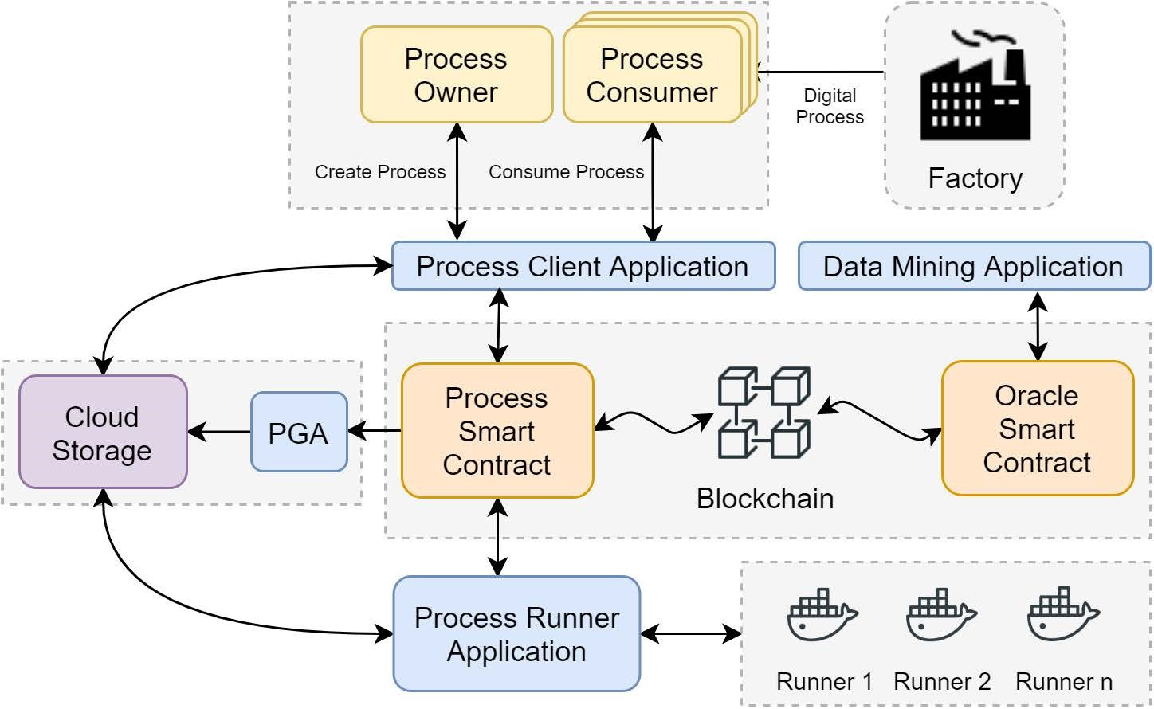provides the functions CreateProcess and ProcessInstance, which in the proposed platform represent the two primary Blockchain transactions. The process logic is effectively encoded in the Smart Contract and the Blockchain by the Process model, which includes the relevant Docker image name (optionally with its tag) and the docker SHA-256 digest that guarantees the execution's integrity. As a result, each time the Process Owner calls the Smart Contract's CreateProcess function, a new, distinct process is created that is identified by instance is given to the Process Runner, it can only use that image. Before running the instance, it must pull the necessary image from the remote registry if it keeps a different version in its local repository.

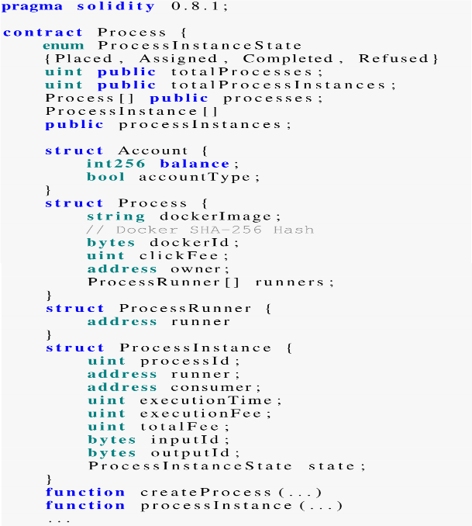The activity diagram for the Unified Modeling Language (UML) [31] shows the ProcessInstance function. 2. The customer stores the inputs in its area on the Cloud Storage when it requests a new process instance. The ProcessInstance function selects the fastest Process Runner simultaneously by predicting the execution time for each registered available runner using the Oracle Smart Contract's weights. Each runner is set to listen for events on the Smart Contract, so it learns about the task and performs an auxiliary function to decide whether or not to accept it. The PGA immediately grants it the necessary permissions to retrieve the instance inputs on cloud storage if it accepts. The process instance is run in a Docker container with the requested image once the inputs are available. The Smart Contract is notified at the conclusion of the execution, and the outputs are saved on Cloud Storage for the consumer to finally retrieve. On the other hand, the Smart Contract is notified if the first assigned runner declines, and the next fastest runners are attempted until either one of them accepts or there are no more runners available. The situation comes to an end in the latter scenario, and the customer is informed so that they can try again at a later time.

2) ORACLE SMART CONTRACT The calculated weights of each ANN trained on previous instance metrics are stored in the Oracle Smart Contract. Regular updates are made to the weights. C. CLIENT APPLICATIONS The components' interactions with the Blockchain and Smart Contracts are carried out by means of client applications that invoke Smart Contract functions and listen to chain events. The entire process is implemented in the Data Mining Application that is described in Section III-C.

We introduce four applications in this work:

1) Execute the Client Application: It uses the CreateProcess and ConsumeProcess use cases, as well as Cloud Storage, to store and retrieve instance inputs and outputs. It could also be connected to applications from third parties to exchange data and file

2) Process Runner Software: It uses the Consume Process use case and communicates with the Docker host to retrieve the

requested images from the registry and start the instance container for the process. In addition, it uses Cloud Storage to retrieve and store instance inputs and outputs.

3) Application for Permission to Grant: It assigns and revokes permission for consumers and runners on instance inputs and outputs and listens for chain events.

4) Application of Data Mining: By regularly querying the Process Smart Contract, it gathers metrics from previous instances. The day of the week and the time band (the hour of the day) are the inputs for each observation in the training dataset, and the actual running time in seconds is the output.

**CASES STUDY**

**Manufacturing of Ophthalmic Lenses**

In this section, we demonstrate how the proposed architecture is applied to the manufacturing of ophthalmic lenses. In point of fact, the production of ophthalmic lenses typically consists of single, distinct pieces, each of which is constructed using a TABLE 1. Details of the ANN dataset for time prediction.

unique prescription from a doctor. Additionally, complex optimization and a large amount of data are required for lens production. In contrast, cybersecurity concerns must be taken into consideration to safeguard ownership of the software for lens design and implementation. As a result, the chosen case study exemplifies the prerequisites for implementing the proposed technology and demonstrates the advantages of the Blockchain architecture.

The manufacturing of lenses typically consists of five steps that are performed in order: Calculation, which includes calculating the lens surface to be machined, Surfacing, Polishing, Coating, and Edging.

**A. LENS DESIGN SYSTEM A LDS** uses the patient's ophthalmic prescription as the basis for a mathematical calculation that generates the data that is sent to a CNC machine to create a surface on the back of a semi-finished lens. This process is referred to as a "job." The procedure was depicted

**Fig : System design for lenses**

The Vision Council of America, a US-based organization that includes nearly all relevant players, has published a standard that governs the exchange of data between machines and systems in the eye care industry. Data Communication Standard is the name of this standard, and the most recent version is 3.12.

A typical job input file, which includes prescription data and other relevant manufacturing parameters, is shown in Listing

Listing 2 shows that each parameter is identified by a record label followed by a record separator, which is always the "=" sign. File for LDS job input.

The LNAM label value determines the type of lens surface to be calculated and, in some cases, such as with progressive lenses, has a significant impact on the calculation time. In point of fact, whereas the freeform surface of progressive lenses necessitates the solution of a differential geometry problem, progressive lenses' spherical or toric shapes can be easily computed. Processing these problems takes several seconds because they are frequently computationally demanding.

The radius of the sphere or torus is all that is included in the output file, which is known as the LMS file, for conventional geometric shapes. The SDF file, on the other hand, is required for freeform surfaces and provides a square matrix-based description of the entire surface.

**B. IMPLEMENTATION** In this subsection, an LDS system implementation based on the presented architecture is proposed.

First, we identify the case study's participants as follows: The lens designer is the Process Owner, the lens manufacturer is the Process Consumer, and the surface calculator is the Process Runner.

In this case study, a Lens Designer uses his preferred programming language to implement its calculation algorithm. He then compiles the application along with all of its libraries and dependencies into a Docker image that is sent to a container registry.

Even though the Docker digest is included in the Process Smart Contract's model to encode the calculation logic, it only controls the process flow, so no particular modifications are required to support the particular case study.

As a result, using the CreateProcess and ConsumeProcess functions to request a new calculation and add a new lens design, respectively, is simple.

Furthermore, because we only need to collect input and output files on both the client and runner edges, the implementation of client applications does not necessitate any particular modifications to the proposed architecture.

However, in order for the CNC machine to retrieve the calculated surface, the Process Client Application must be connected to the lens manufacturer's information system.

Because we make use of the Amazon S3 service as our cloud storage, in order to store and retrieve files, both users and runners require accounts on those platforms.

**C. RUNNING TIME PREDICTION** The ANN Data Mining Application collects metrics from previous instances of lens calculation and trains a model for each process and runner to predict the running time of a single lens design instance on a runner at a particular time.

Unless other concurrent processes are running on the node and the available resources, such as CPU and memory, must be shared, the calculation time for a design is fairly stable in this particular context.

We use a single c5d.large node on Amazon Web Services with two Intel Xeon 3.6Ghz vCPUs and 4GB of RAM to simulate a real environment and evaluate the prediction method's efficacy. In order to evaluate the sample node's performance under various load conditions, we also select a progressive lens design and manually perform a set of 9143 calculations to obtain a reference value of running time in seconds in both busy and normal states. The calculation mean time is 15 seconds, with a standard deviation of 1.0 seconds, in the first busy case, which occurs when multiple intensive processes are running simultaneously on the node. In contrast, the mean calculation time in the second normal case, in which only one process is running at once, is 7 seconds, with a standard deviation of 0.5 seconds. Using calculated values and two normal distributions, we construct multiple random datasets with a total of 18200 samples collected at a rate of 200 samples per hour, Monday through Sunday, from 8:00 to 20:00.

In particular, we construct a first normal distribution for each day of the week by randomly selecting a two-hour period for the busy state condition:

X, where X1 is a random variable with a mean value of 15s and a standard deviation of 1s that represents the calculation time in the busy state condition.

A second normal distribution is then constructed:

X, where X2 is a random variable with a mean value of 7s and a standard deviation of 0.5s that represents the calculation time under normal conditions.

Finally, depending on the state, we randomly select 200 values per hour from either X1 or X2. Because we employ a normal distribution, almost 99.7% of the values that were sampled fall within the range [3, + 3].

The ANN shown in Table 1 is constructed after the dataset has been generated. The One-Hot encoding technique [33] is used to transform day of the week and hour of the day features into a single vector containing only 0 and 1 for each sample because a multilayer perceptron network requires numerical values as input. Figure shows the final network. 4 and is made up of twenty neurons in the input layer, twenty-one neurons in the hidden layer, and a single neuron in the output layer that is used to represent the time spent on the calculation.

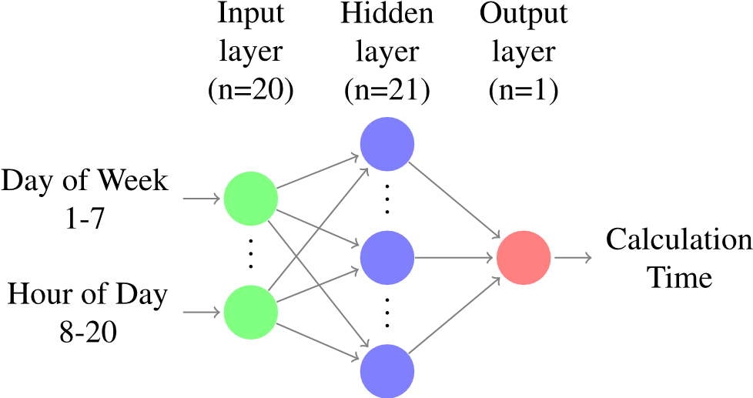

**Fig : Network infrastructure for MLP.**

The original dataset was divided into 80% training sets and 20% test sets. The network is trained with Mean Squared Error (MSE) as a loss function to minimize the average squared difference between the collected calculation time values and the predicted values because we are dealing with a regression problem. On the other hand, Rectified Linear Unit (ReLU), which is currently the default choice for many different kinds of neural networks because it frequently achieves better performance than other methods [34], is used as an activation function. Last but not least, the optimizer is the Adam algorithm [35]. As shown in Fig., the training process converges to MSE=0.38 for both training and test sets in less than ten epochs. 5.

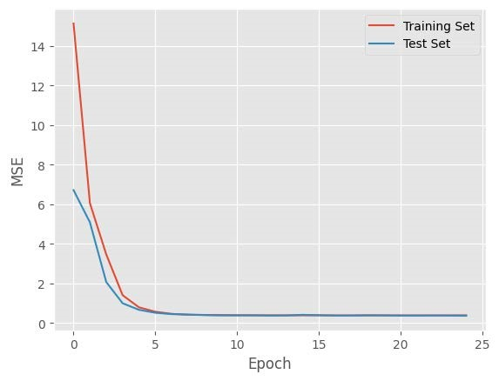

**Fig : MSE versus training epochs.**

We are able to predict the calculation time with sufficient accuracy for the purposes of this platform because the residual MSE=0.38 results in RMSE=0.61s. We predict the calculation time of the last 100 samples of the test set and plot both actual and predicted values in Fig. in order to clearly demonstrate the network's effectiveness after training. 6. Particularly, Figure 6 demonstrates that the proposed platform is able to select an alternative free node to calculate a specific lens design instance in the shortest amount of time by fully capturing the time band during which a particular node is busy.

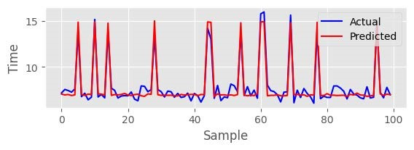

**Fig : The time prediction ANN's efficacy.**

DEBATE In this section, we examine how the proposed BPM platform stacks up against two different LDS design software: IOT, which is a single piece of software that must be installed on a calculation server used by a lens manufacturer; ProCrea is a client-server architecture that uses a centralized platform to provide calculation services.

The following are limitations of the aforementioned solutions:

• A lack of adaptability: Ten distinct single-vision and progressive lens designs are offered by the two manufacturers. The lens manufacturer's updates are the only thing that determines the availability of new designs. A lens designer cannot easily release a new design to the market without utilizing one of these older solutions.

• Each instance is dealt with one at a time in a queue: As a result, parallelizing calculations is impossible. The processing of huge queues takes a long time, affecting product lead times unavoidably.

• Reliability issues: In the case of IOT, if the local server failed, production would stop; In the case of ProCrea, the central platform's flaw would prevent on-premise customers from performing new calculations.

• A lack of safety: The local on-premise server or the centralized platform database stores the details and accounting of calculated jobs. There is no guarantee that these data will not be altered, lost, or damaged, compromising the integrity of financial transactions.

• Specific requirements: The ProCrea client software is based on Java and requires a particular Java Runtime Environment version. Local calculations are carried out by IOT, which is built on Microsoft.NET; Consequently, the amount of CPU and memory available on the on-premise server determines the calculation time.

The following enhancements can be achieved by incorporating an LDS system into the Blockchain platform that is being proposed.

1) COLLABORATION We offer a decentralized, shared platform on which a number of Lens Designers can distribute their algorithms as self-contained Docker images. As a result, providers of computational resources can sign up as calculators and offer their services. For all lens designs, the manufacturer uses the same client. As a result, it is simpler to incorporate new or updated designs because they do not necessitate significant environmental or structural reconfiguration.

2) PERFORMANCE The provided solution is fault-tolerant and distributed. In point of fact, the manufacturer is able to carry out a number of calculations simultaneously on various runners. As a result, reliability and computational time performance rise.

3) CYBERSECURITY Due to the Blockchain's tamper-proof nature, the fees paid to lens designers and surface calculators cannot be altered in their economic transactions. By implementing a specialized ERC-20 token, the Ethereum platform provides an additional option to conclude transactions directly on the chain .

4) COSTS: Both input and output files will be stored for a long time because the cloud storage service typically charges low prices. Data loss on the manufacturer's side is also prevented by this feature. In addition, the cost of executing transactions in Ethereum can be controlled and even eliminated when the Blockchain is implemented in a consortium fashion, as in the proposed platform.

However, there are some limitations to every Blockchain-based solution that must be investigated. For instance, in terms of scalability, the system's consensus algorithm determines the number of transactions performed per second. As a result, the consensus algorithm is scalable and does not require the time-consuming operations of mining-based algorithms because the adopted Blockchain is implemented in a consortium fashion. Additionally, from the perspective of transactional privacy, even though the Docker images and the file in the Cloud Storage area contain the core of the intellectual property, the contents of transactions are visible to all Blockchain users. As a result, the proposed system would benefit from the implementation of a complex Blockchain architecture like HyperLedger Fabric, which can restrict user access to transactions.

**V. CONCLUSION**

The Blockchain represents a fundamental shift in software architectures. Over the past ten years, there has been a growing interest in this technology, which has shown that it can be used for more than just financial applications like cryptocurrencies. It can also be used in business settings, specifically Cloud Manufacturing, to improve production process efficiency and reap the benefits of a decentralized approach and a tamper-proof ledger.

In this work, we integrate two of the most widely used cloud technologies into a novel blockchain-based platform for enhancing digital processes: Cloud storage alongside Docker. In particular, this platform runs process instances using input files stored in Cloud Storage in a distributed and flexible computational platform. Docker is typically used to run the software components of a typical Blockchain architecture. The differences and cooperation of Process Owner, Process Consumer, and Process Runner are the fundamentals of the proposed platform, which we identify and describe.

The main Smart Contract handles the process lifecycle, and a Docker image contains the individual processes' core logic, allowing any generic host to carry out a diverse set of tasks. Additionally, an ANN-implemented task assignment problem is presented with the intention of reducing instances execution times and thereby enhancing performance.

Finally, we present a case study of how this platform was implemented in the lens design systems and manufacturing environment of ophthalmic lenses.

Two outcomes provide insight. To begin, we demonstrate that the industrial process does not require any significant adjustments to implement the new platform. Second, we emphasize the advantages of switching from a static, centralized method to a flexible, distributed, secure, and collaborative platform where multiple lens designers can submit their calculation algorithms and where lens manufacturers can simultaneously run multiple calculations on registered calculators.

In order to address the task assignment issue and gain a deeper understanding of transactional privacy and intellectual property preservation, we intend to implement this architecture in a number of blockchain platforms, including Hyperledger Fabric.

**REFERENCES**

1. X. Xu, ‘‘From cloud computing to cloud manufacturing,’’ *Robot. Comput.Integr. Manuf.*, vol. 28, no. 1, pp. 75–86, Feb. 2012.
2. (May 2021). *Global Cloud and Data Center Spending 2020 | Statista*. Accessed: May 7, 2021. [Online]. Available: https://

www.statista.com/statistics/1114926/enterprise-spending-cloud-and-datacenters

1. M. K. Lim, W. Xiong, and Z. Lei, ‘‘Theory, supporting technology and application analysis of cloud manufacturing: A systematic and comprehensive literature review,’’ *Ind. Manage. Data Syst.*, vol. 120, no. 8, pp. 1585–1614, Jul. 2020.
2. C. Esposito, A. Castiglione, B. Martini, and K.-K.-R. Choo, ‘‘Cloud manufacturing: Security, privacy, and forensic concerns,’’ *IEEE Cloud Comput.*, vol. 3, no. 4, pp. 16–22, Jul. 2016.
3. F. Casino, T. Dasaklis, and C. Patsakis, ‘‘A systematic literature review of blockchain-based applications: Current status, classification and open issues,’’ *Telematics Inform.*, vol. 36, pp. 55–81, Mar. 2018.
4. S.Wang,L.Ouyang,Y.Yuan,X.Ni,X.Han,andF.-Y.Wang,‘‘Blockchainenabled smart contracts: Architecture, applications, and future trends,’’ *IEEE Trans. Syst., Man, Cybern., Syst.*, vol. 49, no. 11, pp. 2266–2277, Nov. 2019.
5. U. Bodkhe, S. Tanwar, K. Parekh, P. Khanpara, S. Tyagi, N. Kumar, and M. Alazab, ‘‘Blockchain for industry 4.0: A comprehensive review,’’ *IEEE Access*, vol. 8, pp. 79764–79800, 2020.
6. J. Leng, S. Ye, M. Zhou, J. L. Zhao, Q. Liu, W. Guo, W. Cao, and

L. Fu, ‘‘Blockchain-secured smart manufacturing in industry 4.0: A survey,’’ *IEEE Trans. Syst., Man, Cybern., Syst.*, vol. 51, no. 1, pp. 237–252, Jan. 2020.

1. J. E. Kasten, ‘‘Engineering and manufacturing on the blockchain: A systematic review,’’ *IEEE Eng. Manag. Rev.*, vol. 48, no. 1, pp. 31–47, Mar. 2020.
2. J. Leng, G. Ruan, P. Jiang, K. Xu, Q. Liu, X. Zhou, and C. Liu,

‘‘Blockchain-empowered sustainable manufacturing and product lifecycle management in industry 4.0: A survey,’’ *Renew. Sustain. Energy Rev.*, vol. 132, Oct. 2020, Art. no. 110112.

1. J. Leng, D. Yan, Q. Liu, K. Xu, J. Zhao, R. Shi, L. Wei, D. Zhang, and X. Chen, ‘‘ManuChain: Combining permissioned blockchain with a holistic optimization model as bi-level intelligence for smart manufacturing,’’ *IEEE Trans. Syst., Man, Cybern., Syst.*, vol. 50, no. 1, pp. 182–192, Jan. 2020.
2. T. Hewa, A. Braeken, M. Liyanage, and M. Ylianttila, ‘‘Fog computing and blockchain-based security service architecture for 5G industrial IoTenabled cloud manufacturing,’’ *IEEE Trans. Ind. Informat.*, vol. 18, no. 10, pp. 7174–7185, Oct. 2022.
3. J. A. Garcia-Garcia, N. Sanchez-Gomez, D. Lizcano, M. J. Escalona, and T. Wojdynski, ‘‘Using blockchain to improve collaborative business process management: Systematic literature review,’’ *IEEE Access*, vol. 8, pp. 142312–142336, 2020.
4. T. Allweyer, *BPMN 2.0: Introduction to the Standard for Business Process Modeling*. Norderstedt, Germany: Books on Demand, 2010.
5. O. López-Pintado, L. García-Bañuelos, M. Dumas, and I. Weber, ‘‘Caterpillar: A blockchain-based business process management system,’’ in *Proc. BPM*, 2017, pp. 1–5.
6. T. Ghimire, A. Joshi, S. Sen, C. Kapruan, U. Chadha, and S. K. Selvaraj, ‘‘Blockchain in additive manufacturing processes: Recent trends & its future possibilities,’’ *Mater. Today, Proc.*, vol. 50, pp. 2170–2180, Jan. 2022.
7. A. Haridas, A. A. Samad, D. Vysakh, and V. Pathari, ‘‘A blockchain-based platform for smart contracts and intellectual property protection for the additive manufacturing industry,’’ in *Proc. IEEE Int. Conf. Signal Process., Informat., Commun. Energy Syst. (SPICES)*, Mar. 2022, pp. 223–230.
8. (Jan. 2021). *Ethereum Development Documentation*. Accessed:

Jan. 21, 2021. [Online]. Available: https://ethereum.org/en/developers/ docs

1. (Jan. 2021). *Docker*. Accessed: Jan. 22, 2021. [Online]. Available: https://docs.docker.com/get-started/overview
2. W. Zeng, Y. Zhao, K. Ou, and W. Song, ‘‘Research on cloud storage architectureandkeytechnologies,’’in*Proc.2ndInt.Conf.Interact.Sci.Inf. Technol.,CultureHum.(ICIS)*,NewYork,NY,USA,2009,pp. 1044–1048.
3. C. Anderson,‘‘Docker [software engineering],’’*IEEE Softw.*, vol.32, no. 3,

p. 102, Apr. 2015.

1. A. Halty, R. Sánchez, V. Vázquez, V. Viana, P. Piñeyro, and D. A. Rossit, ‘‘Scheduling in cloud manufacturing systems: Recent systematic literature review,’’ *Math. Biosci. Eng.*, vol. 17, no. 6, pp. 7378–7397, 2020.
2. G. Volpe, A. M. Mangini, and M. P. Fanti, ‘‘An architecture for digital processes in manufacturing with blockchain, Docker and cloud storage,’’ in *Proc. IEEE17th Int. Conf. Autom.Sci. Eng. (CASE)*, Aug. 2021,pp. 39–44.
3. K. Christidis and M. Devetsikiotis, ‘‘Blockchains and smart contracts for the Internet of Things,’’ *IEEE Access*, vol. 4, pp. 2292–2303, 2016.
4. G.-T. Nguyen and K. Kim, ‘‘A survey about consensus algorithms used in blockchain,’’ *J. Inf. Process. Syst.*, vol. 14, no. 1, pp. 101–128, Feb. 2018.
5. R. Koulu, ‘‘Blockchains and online dispute resolution: Smart contracts as an alternative to enforcement,’’ *SCRIPTed-J. Law, Technol. Soc.*, vol. 13, no. 1, pp. 40–69, 2016.
6. (Jan. 2021). *Solidity Documentation*. Accessed: Feb. 22, 2021. [Online]. Available: https://docs.soliditylang.org/en/v0.8.1
7. (Feb. 2021). *Vyper Documentation*. Accessed: Feb. 22, 2021. [Online].

Available: https://vyper.readthedocs.io/en/stable

1. M. Dumas, M. La Rosa, J. Mendling, and H. A. Reijers, *Fundamentals of Business Process Management*. Berlin, Germany: Springer, 2013.
2. (Feb. 2021). I. Barinov, V. Baranov, and P. Khahulin. *POA Network Whitepaper*. Accessed: Feb. 21, 2021. [Online]. Available: https://github.com/poanetwork/wiki/wiki/POA-Network-Whitepaper
3. G. Booch, J. Rumbaugh, and I. Jacobson, *The Unified Modeling Language User Guide*. White Plains, NY, USA: Longman, 1999.
4. (Aug. 2019). *DCS—Data Communication Standard, V.3.12*. Accessed: May10,2021.[Online].Available:https://www.thevisioncouncil.org/sites/ default/files/DCS-v3_12_FINAL_v2.pdf
5. D. Harris and S. Harris, *Digital Design and Computer Architecture*, 2nd ed. Oxford, U.K.: Morgan Kaufmann, 2012.