# ONLINE DJ BOOKING MANAGEMENT

# Abhishek Chandel 1 Abhishek Yadav 2 Rahul Mahajan 3

1Dept. of Computer Science & Engg.,1Tha.Shiv Kumar Memorial Engg.College, Burhanpur(M.P.), India.

# ABSTRACT

# Depending on the type of event, and budget, it becomes difficult to find a perfect DJ for the event. An online booking system helps in finding DJs and booking in advance. Hence, Admin can add/remove/update any details related to the system, update charges & fees of the DJs, and other services, View/Confirm/Cancel booking orders placed by Users, and so on. Admin can manage & keep the records of the Users and their details.

# INTRODUCTION

# This is a Simple PHP entitled Online DJ Management System. This is a web-based application project that helps the DJ or Sound System Businesses an online platform where they can manage their clients' booking. This application has also a public website that allows the visitors to explore and browse the different events they provide service and their package information and pricing.

**Methodology**

**1.SDLC**

Software Development Life Cycle (SDLC) is a process used by the software industry to design, develop and test high quality softwares. The SDLC aims to produce a high-quality software that meets or exceeds customer expectations, reaches completion within times and cost estimates

.

SDLC is a process followed for a software project, within a software organization. It consists of a detailed plan describing how to develop, maintain, replace and alter or enhance specific software. The life cycle defines a methodology for improving the

quality of software and the overall development process..

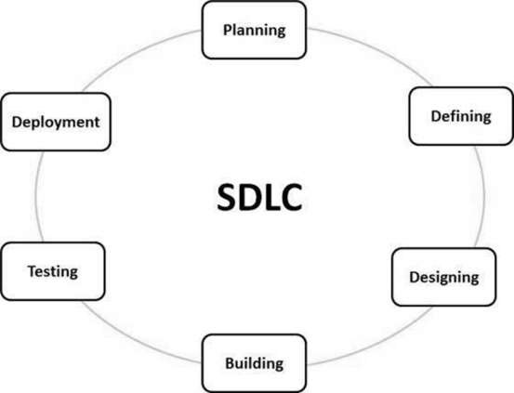

**Type of SDLC:-**

1. Waterfall Model
2. RAD Model
3. Spiral Model
4. Incremental Model
5. Iterative Model
6. Agile Model
7. V-Model

**a)Incremental Model**

Incremental Model is a process of software development where requirements divided into multiple standalone modules of the software development cycle. In this model, each module goes through the requirements, design, implementation and testing phases. Every subsequent release of the module adds function to the previous release. The process continues until the complete system achieved.

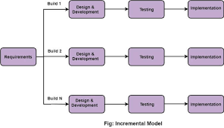

**IMPLEMENTATION**

**A. Technologies Used**

Various front-end and back-end technologies are available in this era of digitalization. The technologies used in this project are discussed briefly in the following sections.

**1.Front End Technologies**

***a) HTML***

It stands for Hypertext Markup Language, and it is the most widely used language to write Web Pages. Hypertext refers to the way in which Web pages (HTML documents) are linked together. Thus, the link available on a webpage is called Hypertext. As its name suggests, HTML is a Markup Language which means you use HTML to simply "mark-up" a text document with tags that tell a Web browser how to structure it to display (Musciano & Kennedy,1996). Originally, HTML was developed with the intent of defining the structure of documents like headings, paragraphs, lists, and so forth to facilitate the sharing of scientific information between researchers. Now, HTML is being widely used to format web pages with the help of different tags available in HTML language.

***b) CSS***

CSS (Powell, 2010) stands for Cascading Style Sheets. CSS describes how HTML elements are to be displayed on the screen, paper, or in other media. CSS saves a lot of work. It can control the layout of multiple web pages all at once.

**c)JavaScript/JQuery**

JavaScript (JS) is a high level, interpreted programming language. JavaScript has curly-bracket syntax, dynamic typing, prototype-based object-orientation, and first-class functions.

Alongside HTML and CSS, JavaScript is one of the core technologies of the World Wide Web (Flanagan, 2006). JavaScript enables interactive web pages and is an essential part of web applications. The vast majority of websites use it, and major web browsers have a dedicated JavaScript engine to execute it. JavaScript provides the facility to validate the form on the client-side so data processing will be faster than server-side validation

**d)BootStrap**

Bootstrap (Shenoy & Sossou, 2014) is a free and open-source CSS framework directed at responsive, mobile-first front-end web development. It contains CSS and (optionally) JavaScript-based design templates for

typography, forms, buttons, navigation, and other interface components.

To use bootstrap, we are required to either install in our system or use CDN. CDN is short for content delivery network. A CDN is a system of distributes servers that deliver pages and other web content to a user, based on the geographic locations of the user, the origin of the

webpage and the content delivery server

## User Manual

**a)Software Requirements:**

• Browser: Internet Explorer or Mozilla Firefox or Opera

• IDE : VS Code Studio

• Language : PHP

• Other Tech **:** HTML, CSS and JavaScript

• Operating system: Any Windows version/ MAC

**b)Hardware Requirements:**

• Processor: Intel Pentium IV or above

• Ram: 1GB or more

• Hard Disk: 40 GB or more

**c)Step to Run Project :**

**Step 1**:- Firstly start your laptop/pc .

**Step 2**:- Now install python setup for coding of PHP language .

**Step 3**:- After that install vs code .

**Step 4**:- XAMP for installing PHP .

**Step 5**:- In vs code we write coding for project . to run the project select brouser google chrome . Open one of the browser enter your url <http://127:0:0:1:9898> .

**RESULTS**

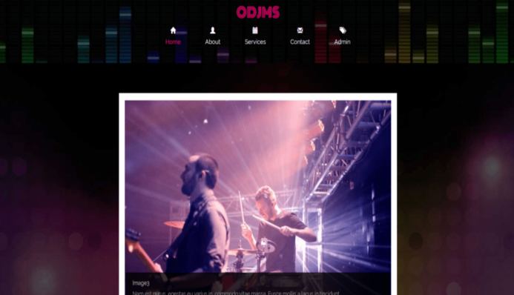

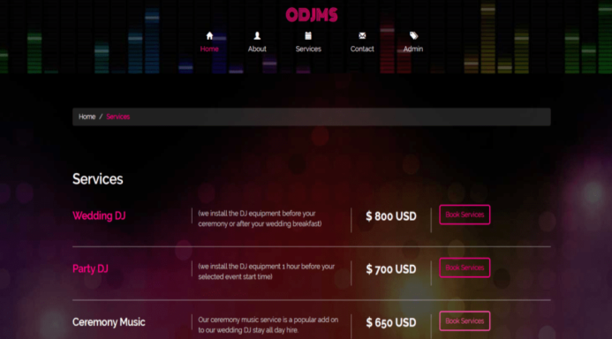

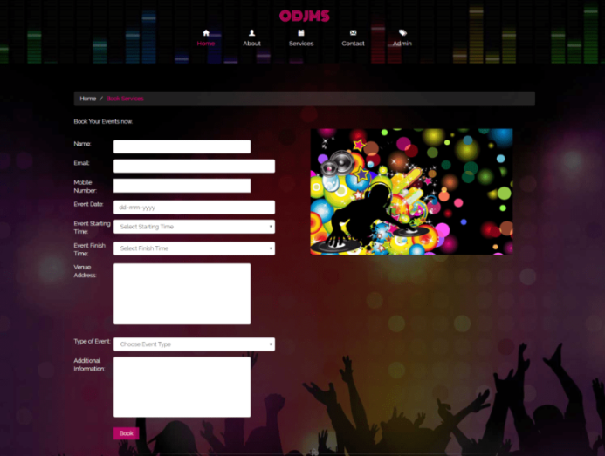

**CONCLUSION**

The “Online DJ Management System” was successfully designed and is tested for accuracy and quality. During this project we have accomplished all the objectives and this project meets the needs of the organization. The developed will be used in searching, retrieving and generating information for the concerned requests.

**REFERENCES**

**a) Websites**

1. [**www.w3schools.com**](http://www.w3schools.com)
2. [**www.geeksforgeeks.com**](http://www.geeksforgeeks.com)
3. **www.phpproject.com**
4. [**www.tutorialspoints.com**](http://www.tutorialspoints.com)
5. [**www.learnigpoints.com**](http://www.learnigpoints.com)
6. [**www.tutorialshub.com**](http://www.tutorialshub.com)
7. [**www.phpconcept.com**](http://www.phpconcept.com)
8. [**www.google.com**](http://www.google.com)
9. [**www.phplean.org**](http://www.phplean.org)
10. [**www.javatpoint.com**](http://www.javatpoint.com)

**b)Reference Research Paper**

[1] John Duckett ,HTML and CSS : Design and Build Websites,2015.

[2] Mastering HTML ,CSS & Javascript Web Publishing Paper back,2016.

[3]Elmasri Ramez ,Fundamental sofDatabase System, Seventh Edition,2017.

[4] RonaldJ. Leach, Introduction to Software Engineering,2017.

[5] CSeverance-IEEE Project Management journal,2018.

[6] MaccHills,PClint-IEEE

Software Evolution , 2018.

[7] PKyriakakis, A Chatzigeorgiou-IEEE PHP WebApplication,2019.

[8] SGupta , BBGupta – IEEE Journal of Computer Scienceand Technology , 2020 .

[9] JLiebowitz-IEEEITProjects,2020..

.