**Automation Number Plate Recognization with Optical Character Recognization**

**Banupriya A, Aarthi V, Elavarasan K, Mr. Arun R,**

Dept of Computer Science and Engineering,

Assistant Professor, Dept of Computer Science and Engineering,

Hindusthan Institute of Technology, Coimbatore, TamilNadu, INDIA

**Abstract-** Automatic Number Plate Recognition (ANPR) is an image processing technology which uses a number (license) plate to identify the vehicle. The objective is to design an efficient automatic authorized vehicle identification system by using the vehicle number plate. The system is implemented on the entrance for security control of a highly restricted area like military zones or area around top government offices e.g. Parliament, Supreme Court etc. The developed system first detects the vehicle and then captures the vehicle image. Vehicle number plate region is extracted using the image segmentation in an image. Optical character recognition technique is used for the character recognition. The resulting data is then used to compare with the records on a database so as to come up with the specific information like the vehicle’s owner, place of registration, address, etc. The system is implemented and simulated in Matlab, and it performance is tested on real image. It is observed from the experiment that the developed system successfully detects and recognizes the vehicle number plate on real images.Engine In most parts of the world, it has been established that breaking traffic laws is a significant factor in road accidents. It mostly happens in developing nations. Despite the laws governing traffic, a rising number of people continue to violate them. This is because the authorized authorities in various regions of the world do not properly enforce the rules. As a result, a mechanism must be created to help law enforcement authorities enforce these regulations in order to increase road safety and decrease accidents. This work makes use of a real-time embedded technology called a Vehicle Plate Number Recognition (VNPR) system to automatically identify license plate numbers. By utilizing the OpenCV open-source library, it offers a VPNR substitute. The system's primary goal is to employ image processing to identify automobiles that are breaking the law by their license plate numbers.

**I.INTRODUCTION**

The Automatic Number Plate Recognization (ANPR) was invented in 1976 at the Police Scientific Development Branch in the UK. However, it gained much interest during the last decade along with the improvement of digital camera and the increase in computational capacity. It is simply the ability to automatically extract and recognition a vehicle number plate’s characters from an image. In essence it consists of a camera or frame grabber that has the capability to grab an image,find the location of the number in the image and then extract the characters for character readable character. ANPR can be used in many areas from speed enforcement and tool collection to management of parking lots. It can be used to detect and prevent a wide range of criminal activities and for security control of highly restricted areas like military zones or area around top government offices. The system is computationally inexpensive compare to other ANPR systems. Besides Robustness, the earlier methods use either feature based approached usng edge detection or Hough transform which are computationally expensive or use artificial neural network which require large training data.The presented ANPR system is aimed to be light weighted so that it can be run real time and recognizes Sindh standard number plate under normal conditions. The ANPR system works in three steps , the first step is the detection and capturing a vehicle image, the second step is the detection and extraction of number plate in an image. The third section use image segementation technique to get individual character and optical character recognition (OCR) to recognize the individual character with the help of database stored for each and every alphanumeric character.

**II. RELATED STUDIES**

1. "License Plate Recognition System Based on Template Matching and Neural Networks" by Kadir Ozbek and Ozge Cakir, published in IEEE Transactions on Intelligent Transportation Systems.
2. "An Improved License Plate Recognition System Based on Deep Learning and Hybrid Features" by Wenqi Gao, Shuhui Wang, and Pengfei Xu, published in IEEE Access.
3. "Real-Time Automatic License Plate Recognition System Using Deep Learning and Connected Component Analysis" by Tamer Fares and Ibrahim Elfadel, published in IEEE Access.
4. "A Robust License Plate Recognition System Based on Character Segmentation and Convolutional Neural Network" by Ying Li and Qingqing Huang, published in Journal of Computers.
5. "An Accurate Automatic License Plate Recognition System Based on Deep Learning and Multiple Feature Extraction Techniques" by Reza Azmi, Farshid Boustani, and Ali Akbari, published in Journal of Intelligent Transportation Systems.
6. "A Novel Method for Automatic License Plate Recognition System using Edge Detection and Neural Networks" by R. Jayasree and M. G. Sumithra, published in International Journal of Engineering Research & Technology.
7. "An Efficient License Plate Recognition System Using Template Matching and OCR" by S. S. Deepak and S. Aravind, published in International Journal of Advanced Research in Computer Science and Software Engineering.
8. "A Novel License Plate Recognition System Based on Feature Extraction and Template Matching" by K. Saravanan and R. Kalaikumaran, published in International Journal of Computer Applications.
9. "License Plate Recognition System using Convolutional Neural Networks and Optical Character Recognition" by M. Tariq Sadiq, N. Ahmad, and M. Farhanullah, published in International Journal of Computer Applications.
10. "A License Plate Recognition System Based on Connected Component Analysis and Artificial Neural Network" by S. S. Deepak and S. Aravind, published in International Journal of Advanced Research in Computer Science and Software Engineering.

**III. METHODOLOGY**

**Data collection**: The first step in a license plate recognition project is to collect data that will be used to train and test the algorithms used in the project. This can involve capturing images of vehicles and their license plates under various conditions.

**Algorithm selection**: The next step is to select the algorithms that will be used for each stage of the license plate recognition process. This can involve choosing algorithms for image pre-processing, license plate detection, character segmentation, and character recognition.

**Training**: Once the algorithms have been selected, they need to be trained using the data collected in the first step. This can involve using techniques such as supervised learning or deep learning to train the algorithms to accurately recognize license plates and their characters.

**Testing**: After the algorithms have been trained, they need to be tested to ensure that they are working correctly and accurately recognizing license plates. This can involve using a separate set of test data to evaluate the performance of the algorithms.

**Deployment**: Once the algorithms have been trained and tested, they can be deployed in a real-world setting to recognize license plates in images or video streams.

**IV. EXPERIMENTAL RESULT:**

1. **Connect the sensor**: Connect the PIR sensor to the Raspberry Pi’s GPIO (General Purpose Input/Output) pins. The sensor will typically have three pins: VCC (power), GND (ground), and OUT (signal). Connect the VCC pin to a 3.3V or 5V pin on the Raspberry Pi, the GND pin to a ground pin, and the OUT pin to a GPIO pin that you will use to read the sensor’s output.
2. **Install necessary libraries**: Install any necessary libraries or packages for working with the PIR sensor on the Raspberry Pi. This may include libraries for reading the GPIO pins or for working with the specific sensor model you are using.
3. **Write code**: Write code to read the output of the PIR sensor and trigger an action when movement is detected. This may involve using Python or another programming language to read the state of the GPIO pin connected to the sensor’s OUT pin and trigger an action when it changes state.
4. **Test the sensor**: Test the sensor and your code to make sure everything is working correctly. You may need to adjust the sensitivity or other settings of the sensor to get it working correctly with your Raspberry Pi.

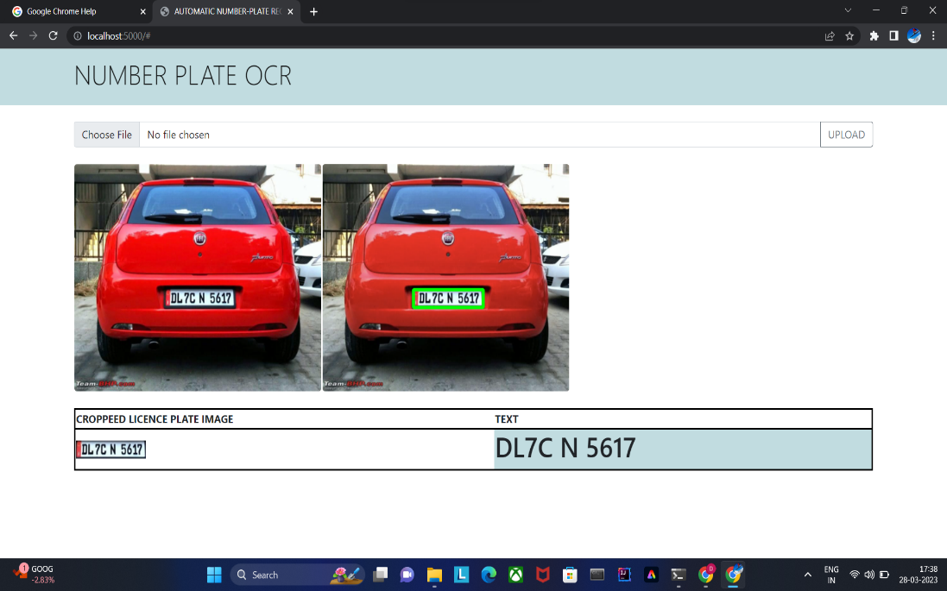

**WORKING**

1. **Image capture**: The first step in a license plate recognition project is to capture an image of the vehicle’s license plate. This can be done using a camera that is positioned to capture images of vehicles as they pass by.
2. **Pre-processing**: Once an image has been captured, it may need to be pre-processed to improve its quality and make it easier to analyze. This can involve steps such as cropping, resizing, and enhancing the contrast of the image.
3. **License plate detection**: The next step is to detect the license plate within the image. This can be done using various computer vision techniques such as edge detection, contour detection, or object detection algorithms.
4. **Character segmentation**: Once the license plate has been detected, the individual characters on the plate need to be segmented so that they can be recognized. This can involve using techniques such as connected component analysis or morphological operations to separate the characters from each other and from the background of the license plate.
5. **Character recognition**: The final step is to recognize the individual characters on the license plate. This can be done using optical character recognition (OCR) algorithms that are trained to recognize the specific font and character set used on license plates.
6. The output of a license plate recognition project is typically the text of the license plate, which can be used for various purposes such as identifying vehicles or tracking their movements.

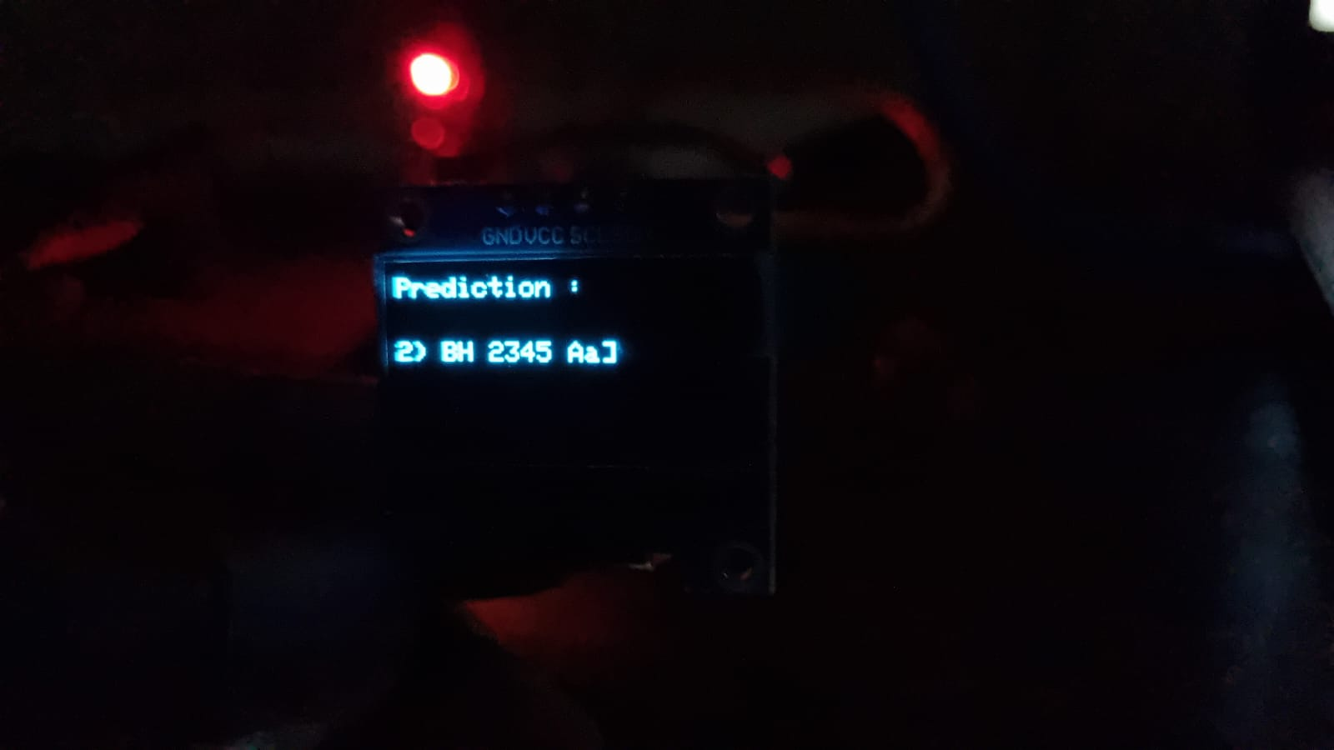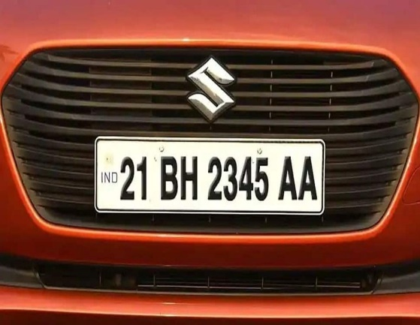

**V. CONCLUSION:**

To overcome the biggest issue in reducing the traffic law violation is the automatic number plate recognition of fast cars with web application. This system uses smart IR sensor to detect moving objects, camera to capture the image, extract the text from the image, and save the text on a web page. The major component selected to do the main work in the system is the Raspberry Pi. OpenCV was used together with python programming, for the character segmentation and recognition.

This was configured on the Raspberry Pi, including the required library that is required to make the hardware components of the system to work with the Raspberry Pi. Due to the calibration of the IR sensor, it is able to detect fast-moving cars and also able to log different cars at different times using a tag for each data it receives and having a unique saving sequence. The system is by far one of the cheapest means for the actualization of traffic management in a smart city

**REFERENCES**

[1] Thangallapally, S.K.; Maripeddi, R.; Banoth, V.K.; Naveen, C.; Satpute, V.R. E-Security System for Vehicle Number Tracking at Parking Lot (Application for VNIT Gate Security). In Proceedings of the 2018 IEEE International Students’ Conference on Electrical, Electronics and Computer Science (SCEECS), Bhopal, India, 24–25 February 2018.

[2] R. Panahi and I. Gholampour, “Accurate detection and recognition of dirty vehicle plate numbers for high-speed applications,” IEEE Transactions on Intelligent Transportation Systems, vol. 18, no. 4, pp. 767–779, 2016.

[3] Jia, W.; Zhang, H.; He, X. Piccardi, M. Mean shift for accurate license plate localization. In Proceedings of the 2005 IEEE Intelligent Transportation Systems, Vienna, Austria, 16 September 2005; pp. 566–571.

[4] Anagnostopoulos, C.N.E.; Anagnostopoulos, I.E.; Loumos, V.; Kayafas, E. A license plate-recognition algorithm for intelligent transportation system applications. IEEE Trans. Intelligent Transp. Syst. 2006, 7, 377–392.

[5] Caner, H.; Gecim, H.S.; Alkar, A.Z. Efficient embedded neural-network-based license plate recognition system. IEEE Trans. Vehicle. Technology 2008, 57, 2675–2683.

[6] Chen, Z.X.; Liu, C.Y.; Chang, F.L.; Wang, G.Y. Automatic license-plate location and recognition based on feature salience. IEEE Trans. Vehicle Technology 2009, 58, 3781–3785.

[7] K. Sajjad, Automatic License Plate Recognition Using Python and OpenCV, Department of Computer Science and Engineering, MES College of Engineering, Kuttippuram, Kerala, 2010.

[8] A. Kumthekar, M. S. Owhal, M. S. Supekar, and M. B. Tupe, “Recognition of Vehicle Number Plate Using Raspberry Pi,” International Research Journal of Engineering and Technology, vol. 5, no. 4, pp. 391–394, 2018.

[9] J. Muñoz, M. Craft, M. Ahmadian, and S. Wrobel, “Multifunction LIDAR sensors for non-contact speed measurement in rail vehicles: Part I—system installation and implementation,” in Proceedings of the 2013 Joint Rail Conference, Philadelphia, PA, USA, April 2013.

[10] S.-L. Chang, L.-S. Chen, Y.-C. Chung, and S.-W. Chen, “Automatic license plate recognition,” IEEE Transactions on Intelligent Transportation Systems, vol. 5, no. 1, pp. 42–53, 2004.