**AIRBORNE RADAR USING IOT**

**Gokul Raj.S**

**Guided by M.RAMACHANDRAN M.E.,** **Asstiant Professor**

Gokul Raj.S, EEE, Sree Sowdambika College Of Engineering, Virudhunagar, Tamilnadu, India.

M.RAMACHANDRAN M.E.,, Asstiant Professor

, Sree Sowdambika College Of Engineering, Virudhunagar, Tamilnadu, India.

**ABSTRACT**

Radar is a long-range object detection system that uses radio waves to establish certain parameters of an object like its range, speed and position. Radar technology is used in aircrafts, missiles, marine, weather predictions and automobiles.Even though the title says Arduino Radar Project, technically the project is based on Sonar technology as it using an Ultrasonic Sensor to determine the presence of any object in a particular range.

1. **INTRODUCTION**
2. Radar system is an object detection or tracking system which uses radio waves to decide or get the range, height, heading, or speed of items or objects. Radar frameworks or system arrive in an assortment of sizes and have distinctive performance particulars. Some radars are utilized for aviation authority at air terminals and others are utilized for long range observation and early- cautioning frameworks. There are some ways to show radar working data. There are also some modified radar systems which have advance technology of handling the systems. These modified system are used at higher levels to get or extract the helpful or important data. The project works on the principle of radar echo effect of the transmitting signal. In this project we are using the ultrasonic sensor to operate by emitting a burst of sound waves in very rapid succession. These sound waves hit the intended target, bounce back to the sensor, and travel at known speed.
3. An ultrasonic sensor, radar is much less affected by temperature, improving consistency and accuracy. Servos are small but powerful motors that can be used in a multitude of products ranging from toy helicopters to robots. Arduino controls the servo motor for the direction of the ultrasonic sensor and it moves from 0 degree to 180 degree. Ultrasonic sensor transmits the signal in all directions and if any obstacle that is the target is detected then echo pulse sense. With the help of this echo pulse arduino program, find out the distance and direction angle of the target. The angle of rotation is displayed on a screen. Whenever an obstacle is detected, the buzzer turns on and it is also displayed in the display.
4. Our proposed system’s working principle is linked by the following components which are is ultra-sonic sensor connected to the microcontroller (we have chosen arduino) digital input and output pins. Then we have servo motor which is also connected to digital output and input pins. Our both main components ultra-sonic sensor and servo motor are connected simultaneously, so that when our servo motor rotates from 0 degree to 180 degree from extreme right to extreme left the motor will rotate nearby its axis. We utilize computer screen to demonstrate the data (distance and angle) through software called “processing development environment”.
5. **METHODOLOGY**

Arduino is a free open source microcontroller. Having input and output digital and analog pins, which enables it to get interfaced with different components. We have interfaced ultrasonic sensor which is like the heart of the radar. Then to display output lcd (16*2 module). It can be operated in read/write mode. For our purpose we have operated it at write mode. It has enable pin which indicates as acknowledgement.arduino is a free open source microcontroller. Having inputand output digital and analog pins, which enables it to get interfaced with different components. We have interfaced ultrasonic sensor which is like the heart of the radar. Then to display output lcd (16*2 module). It can be operated in read/write mode. For our purpose we have operated it at write mode. It has enable pin which indicates as acknowledgement.

Arduino controls the servo motor in angle between 0 to 180 degree therefore covering the radar range. On this servo motor we are mounting the ultrasonic sensor. The led’s and a buzzer is used for the indication of the obstacle.in order to testify the working of this system, after its designing, construction and programming we placed few objects in front of the ultrasonic sensor. As the motor started to rotate, our monitor started to display the output through processing ide. Hence, when the sensor crossed over the object it showed a red segment with the distance and angle where the object is paced.the first object was placed at the distance of 30.5cm measured through a rulerand the system measured the distance at 32cm.while the second object was placed at a distance of 20 cm and the system measured it as 21cm. Hence the calculated efficiency turned out to be 95%

#### **System overview:**

The above figure represents a brief overview of this radar system. Here, as it is shown the controller we are using is arduino; with the input ultrasonic sensor and the output is the servo motor which rotates 180 degrees. The microcontroller controls all the operations of this system, from rotation of the motors to the obstacle detection of the ultrasonic and representation of the result on the screen.

#### **System Block Diagram:**

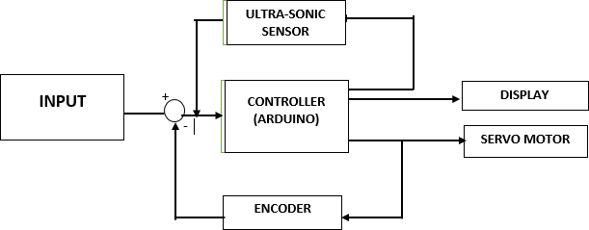

Fig 2.2 : Block Diagram of Radar System.

1. **WORKING**

The basic objective of our design is to ascertain the distance position and speed of the obstacle set at some distance from the sensor. Ultrasonic sensor sends the ultrasonic wave in various ways by rotating with help of servo motors. This wave goes in air and gets reflected back subsequent to striking some object. This wave is again detected by the sensor and its qualities is analyzed and output is shown in screen indicating parameters, for example, distance and position of object. Arduino IDE is utilized to compose code and transfer coding in Arduino and causes us to detect position or angle of servo motor and it is communicated through the serial port alongside the covered distance of the nearest object in its way. Output of all of this working is shown in the software called processing, it will display the input/output and the range of the object. Implementations of the sensors are done in such a way that ultra-sonicsensor is attached on top of the servo motor because it have to detect the object and its distance. Arduino (micro-controller) will control the ultra-sonic sensor and servo motor and also powered will be given to both of them through micro-controller.

1. **RESULTS AND DISCUSSION**

In this research paper we have mentioned that our system is designed consisting following components such as, a servo- motor, an ultra-sonic sensor and a micro-controller (Arduino). System’s objective is to track the distance and angle of the object and to represent this information graphically, means its output should be in graphical form which will be represented through processing software. We can have an idea of an efficiency of this radar by testing objects at different levels and observe how faster or smoothly it detectsan object that it finds in a way and gives us an expected range of the obstac

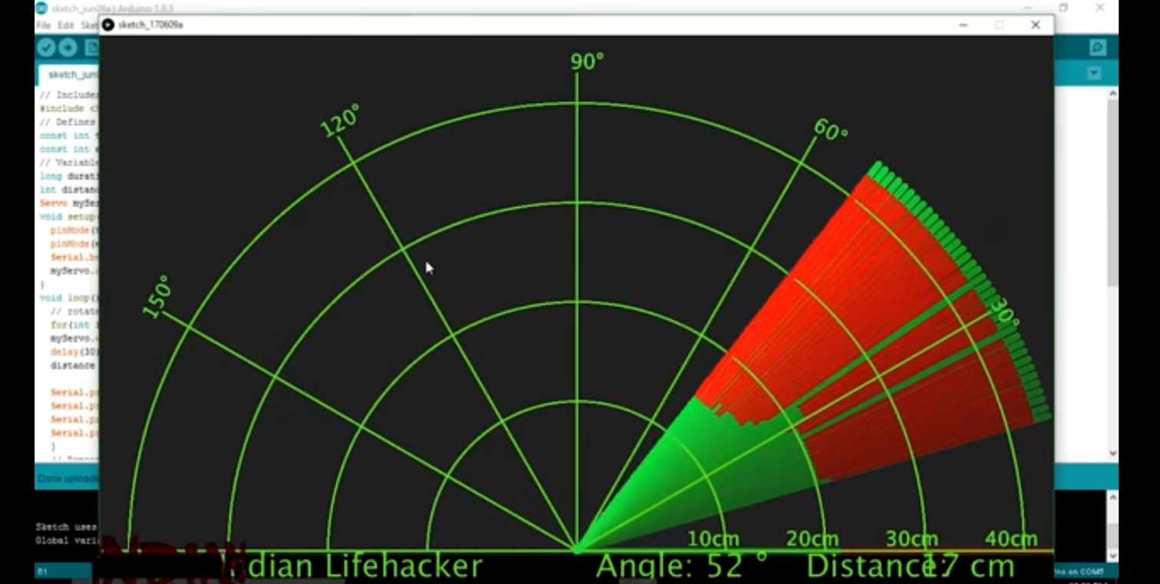

1. **CONCLUSION**

Numerous advanced control methods gave designers to have more commandover different advanced applications. In our paper, the recommended mapping method of whole system is assessed on small principles or scale. The field that we have chosen for our design “Radar System” is a very vast field and future scope of this technology is very high. We have tremendous applications in which radar system have been implemented or used . There is a lot of future scope of this design because of its security capacity. It can be used in many applications. This framework can also be developed or modifiedaccording to the rising needs and demand .As we have designed a short range radar therefore our research was specified and limited. This system can only detect objects from 0 to 180 degrees only because the servo motor that we have used can rotate only to this range. So, due to this limitation our design cannot be applied to places or areas for obstacle detection on a larger scale. Usage of a 360 degrees rotating servo motor can make the system more efficient. We look forward to modify this system and enhance our research work by using a fully 360 degrees rotating servo and a higher ranged ultrasonic sensor. We can further add features tothis system i.e. making it mobile, mounting an alarm system to it which turns on when obstacle is detected. Further modifications could be an obstacle avoiding robot with surveillance system

**ACKNOWLEDGEMENTS**

First and foremost, we thank **GOD** whose blessings have bestowed on us the will power and confidence to carry out our project successfully.

Next we thank **Our Parents** who provided full support for us with their prayers and wishes.We express our sincere thanks to **Dr. K. ARULMOZHI,M.Tech., Ph.D.,** Principal, Sree Sowdambika College of Engineering, Aruppukottai for providing all the necessary facilities for us.We are extremely grateful thank to our Head of the Department **Dr.R. SIVASANGARI,M.E.,Ph.D,** professor of EEE . I wish to express my deep sense of gratitude to my internal project guid, Mr. **M.RAMACHANDRAN M.E.,** Assistant professor,Department of EEE for his able guidance continuous encouragement and moral support throughout the project work.I would like to express my heartfeld thanks to our department **FACULTY** **MEMBERS** Of our college.

**REFERENCES**

1. Ahman Emmanuel Onoja, Abdusalaam Maryam Oluwadamilola, Lukman Adewale AJAO-“Embedded System Based Radio Detection and Ranging (RADAR) System Using Arduino and Ultra-Sonic Sensor”

American Journal of Embedded Systems and Applications 2017

1. Shreyes Mehta, Shashank Tiwari-“RADAR SYSTEM USING ARDUINO AND ULTRASONIC SENSOR” IJNRD, Volume 3, Issue 4 April 2018
2. Antonio Tedeschi ; Stefano Calcaterra , Francesco Benedetto- “ Ultrasonic radar System (URAS): Arduino and Virtual Reality for a Light- Free Mapping of Indoor Environments” IEEE Sensors Journal Volume: 17 ,

Issue: 14 , July15, 15 2017

1. Kiruthikamani.G, Saranya.B, Pandiyan.P-“Intelligent Driver Monitoring and Vehicle Control System” IJSRD - International Journal for Scientific Research & Development| Vol. 5, Issue 09, 2017
2. Mohanad Mahdi Abdulkareem,Qusay Adil Mohammed ,Muhanned Mahmood Shakir-“A Short Range Radar System“Rangefinder””
3. Harshad D. Lajurkar, Rushikesh D. Malokar, Akash N. Karmore- “ Currency Recognition Blind Walking Stick” IJIRST –International Journal for Innovative Research in Science & Technology,Volume 4 ,Issue 7

,December 2017

1. Srijan Dubey,Supragya Tiwari, Simit Roy -“ IMPLEMENTATION OF RADAR USING ULTRASONIC SENSOR” Indian J.Sci.Res. 2017
2. Anuj Dutt (Author), 2014, Arduino based RADAR System, Munich, GRIN Verlag.
3. T H Nasution, E C Siagian, K Tanjung, Soeharwinto-“Design of river height and speed monitoring system by using Arduino” 10th International Conference Numerical Analysis in Engineering 2018
4. Syed M Taha Saquib, Sarmad Hameed, Syed M Usman Ali, Raza Jafri, Imran Amin-“Wireless Control of Miniaturized Mobile Vehicle for Indoor Surveillance” ICSICCST 2013 IOP Conf. Series: Materials Science and Engineering
5. Sami ur Rahman, Sana Ullah and Sehat Ullah-“ Obstacle Detection in Indoor Environment for Visually Impaired Using Mobile Camera”CCISP 7017, IOP Conf. Series: Journal of Physics: Conf. Series 2018
6. Syed M Taha Saquib, Sarmad Hameed, Syed M Usman Ali, Raza Jafri, Imran Amin-“Wireless Control of Miniaturized Mobile Vehicle for Indoor Surveillance” ICSICCST 2013 IOP Conf. Series: Materials Science and Engineering
7. Sami ur Rahman, Sana Ullah and Sehat Ullah-“ Obstacle Detection in Indoor Environment for Visually Impaired Using Mobile Camera”CCISP 7017, IOP Conf. Series: Journal of Physics: Conf. Series 2018