**Age and Gender Prediction Using Deep Learning**

**Dr.S.SATHIYA, SNEKA.S, SOWMIYA.M, TAMILSELVI.K.B,VAISHNAVI.M**

Associate Professor, Department of Computer Science & Engineering, Vivekanandha College of Technology for Women, Namakkal, Tamil Nadu, India

UG Scholars, Department of Computer Science & Engineering, Vivekanandha College of Technology for Women, Namakkal,Tamil Nadu, India

**ABSTRACT:** The last decade or two has witnessed a boom of images. With the increasing ubiquity of cameras and with the advent of selfies, the number of facial images available in the world has sky rocketed. Consequently, there has been a growing interest in automatic age and gender predict using facial images. Feature extraction involves extracting relevant features from the facial images, such as facial landmarks, texture, and color information. These features can be used to train machine learning models to predict age and gender. Model training involves using machine learning algorithms such as linear regression, neural networks, and support vector machines (SVMs) to create a model that can predict age and gender from the extracted features.We in this paper focus on this challenging problem. Specifically, this paper focuses on age estimation, age classification and gender classification from still facial images of an individual. We train different models for each problem and we also draw comparisons between build-ing a custom CNN (Convolutional Neural Network) architecture and using various CNN architectures as feature extractors, namely openCV-trained on VGGFace, Res-Net50 and SE-ResNet50 pre-trained on VGGFace2 dataset and training over those ex-tracted features. We also provide baseline performance of various machine learning algorithms on the feature extraction which gave us the best results.

1. INTRODUCTION

1.1. GENERAL

Facial Analysis has gained tremendous popularity in the field of computer innovation in recent years. A person's face contains characteristics that determine their age, gender, emotion, and ethnicity. It is considered that Gender and Age are top-tier classifications that are helpful for real-world applications in security and surveillance systems, ECMS (Electronic Customer Management Systems), Biometrics, Human-Computer Interaction, entertainment, and Forensic Art.

There are still a few issues in gender and age grouping that remain unresolved. Despite the progress being made by the computer vision community with the continuous development and improvement of new techniques, age, and gender predictions of unfiltered real-life faces square measure nevertheless to satisfy the wants of commercial and real-world applications. Over the few years, a lot of routes suggested solving the grouping problem. Most of those routes are handcrafted which results in undesirable performance on the age and gender predictions of unconstrained in-the-wild image.

These traditional hand-engineered routes relied on the distinct dimensions of facial features and face signifiers which cannot handle diverse degrees of disparity perceived in these exigent ungoverned imaging stipulations. Images in this category might differ due to a few disparities in appearance, noise, pose, and lighting may affect the manually designed computer vision routes to at par grouping of age and gender images. Over the past few years, a variety of approaches are instructed to resolve the grouping drawback.

Most of those routes are manually constructed, which results in subpar performance on the age and gender predictions of unconstrained in-the-wild images. Tradition hand engineered routes were relying on facial characteristics and signifiers that do not have the capacity to deal with differences in degrees of disparity perceived in these ungoverned, exigent imaging conditions .Images in this category may differ due to minor differences in appearance, noise, pose, and lighting that affect the route manually designed for grouping images by age and gender.In this section, we briefly review the age and gender classification literature and describe both the early methods and thosethat are most related to our proposed method, focusing on age and gender classification of face images from unconstrained real-world environments.

Almost all the early methods for age andgender classification were handcrafted. Based on constrained images that weretaken under controlled imaging conditions,they manually engineered facial features from faces. The ratios between the different dimensions of facial features are determined by these features. Geometric features successfully distinguish babies from adults, but are unable to distinguish between young adults and senior adults. There fore,Lanitis proposed an Active Appearance Model based estimation method that incorporates both spatial and texture features. As a result, it is not suitable for the unconstrained imaging conditions associated with real-world face images, which are subject to variations in illumination, expression,poses, etc. From 2007, most of the approaches also employed manuallydesigned features for the estimation task: Gabor, Spatially Flexible Patches (SFP), Local Binary Patterns (LBP), and Biologically Inspired Features (BIF).

In recent years, classification and regression methods have been employed to classify the ageand gender of facial images according to those features. Classification methods in use Support Vector Machine based methods for age and gender classification. Several regression methods can be implemented to predict age and gender, including linearregression, support vector regression(SVR),Canonical Correlation Analysis (CCA), and partial least squares (PLS). Dileep and Danti also developed a method that utilized feedforward neural networks and a 3-sigma control limits the approach to classify people’s age into children, middle-aged adults, and old-aged adults.

However, allthese methods are only suitable and effective on constrained imaging conditions; they cannot handle the unconstrained nature of real-world images and, therefore, cannot be relied onto achieve respectable performance on the images which are common in practical applications. The main objective of this project is to create a system that can be used to predict the age and gender of people in real-time or from pre-recorded media. The system will utilize image or video processing techniques to extract relevant features from the facial images, such as facial landmarks, texture, and color information. These features will be used to train machine learning models to predict age and gender.

The project can have a wide range of applications, such as security and surveillance, marketing, entertainment, and healthcare. For example, a security system could use this technology to identify individuals that might pose a threat based on their age and gender. A marketing campaign could use this technology to classify their potential customers based on their age and gender to ensure that they are targeting the right audience. The project needs to ensure that it takes into account ethical and privacy concerns, such as data privacy, data bias

**II.SYSTEM ANALYSIS**

**EXISTING SYSTEM**

This project is to implement a real-time face recognition system using deep learning. This as it proceeds from the assumption that there is only limited images available to learn from Algorithms should be evaluated based on accuracy. Humans are capable of determining an individual’s age and gender relatively easily using facial attributes.

**DISADVANTAGES OF EXISTING SYSTEM**

* Pose
* Facial expression
* Imaging condition
* Age
* Face size
* Different facial features
* Illumination

**PROPOSED SYSTEM**

It is an OpenCV module. A pre-trained Tensorflow model can be used. This is, however, a deep neural network that may be utilised with a pre-trained model to infer. Support for several frames such as Cafe, Tensorflow, Darknet and PyTorch is provided by Open cv.

**ADVANTAGES OF PROPOSED SYSTEM**

**1.** **Higher Accuracy:** Deep learning algorithms are known to have high accuracy rates as they can learn from millions of data points. This means that the system will be able to predict age and gender with high accuracy rates.

**2. Real-time processing:** Deep learning algorithms can process data in real-time, making it possible to predict age and gender from live videos or images. This could be useful in applications such as security and surveillance systems.

**3. Robustness:** Deep learning algorithms are very robust and can handle variations in the input data. This means that the system will be able to handle images of varying quality, such as images taken under different lighting conditions.

**4. Scalability:** The proposed system can be scaled to handle large datasets and can be used to make predictions on millions of images or videos. This means that it could be used in applications such as marketing campaigns, where a large number of images need to be analyzed.

**5. Automatic feature extraction:** One of the biggest advantages of deep learning algorithms is their ability to automatically extract relevant features from images. This means that the system will not require manual feature extraction, which can be time-consuming and error-prone.

**6. Continuous learning:** Deep learning algorithms can continuously learn and adapt to new data. This means that the system will be able to improve over time with the inclusion of new data.

**III.SYSTEM ARCHITECTURE**

**SYSTEM ARCHITECTURE**

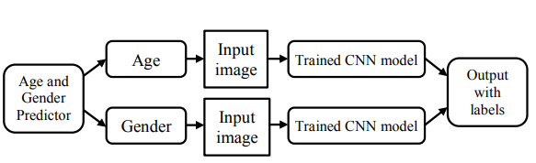

**Figure: 3.1 System Architecture**

**DATA FLOW DIAGRAM**

1. The DFD is also called as bubble chart. It is a simple graphical formalism that can be used to represent a system in terms of input data to the system, various processing carried out on this data, and the output data is generated by this system.
2. The data flow diagram (DFD) is one of the most important modeling tools. It is used to model the system components. These components are the system process, the data used by the process, an external entity that interacts with the system and the information flows in the system.
3. DFD shows how the information moves through the system and how it is modified by a series of transformations. It is a graphical technique that depicts information flow and the transformations that are applied as data moves from input to output.
4. DFD is also known as bubble chart. A DFD may be used to represent a system at any level of abstraction. DFD may be partitioned into levels that represent increasing information flow and functional detail.
5. Entities: An entity is an external object or person that interacts with the system. It is represented by a rectangle in a DFD.

**UML DIAGRAMS**

* UML stands for Unified Modeling Language. UML is a standardized general-purpose modeling language in the field of object-oriented software engineering. The standard is managed, and was created by, the Object Management Group.
* The goal is for UML to become a common language for creating models of object oriented computer software. In its current form UML is comprised of two major components: a Meta-model and a notation. In the future, some form of method or process may also be added to; or associated with, UML.
* The Unified Modeling Language is a standard language for specifying, Visualization, Constructing and documenting the artifacts of software system, as well as for business modeling and other non-software systems.
* The UML represents a collection of best engineering practices that have proven successful in the modeling of large and complex systems.
* The UML is a very important part of developing objects oriented software and the software development process. The UML uses mostly graphical notations to express the design of software projects.

**RESULTS**



Figure 1

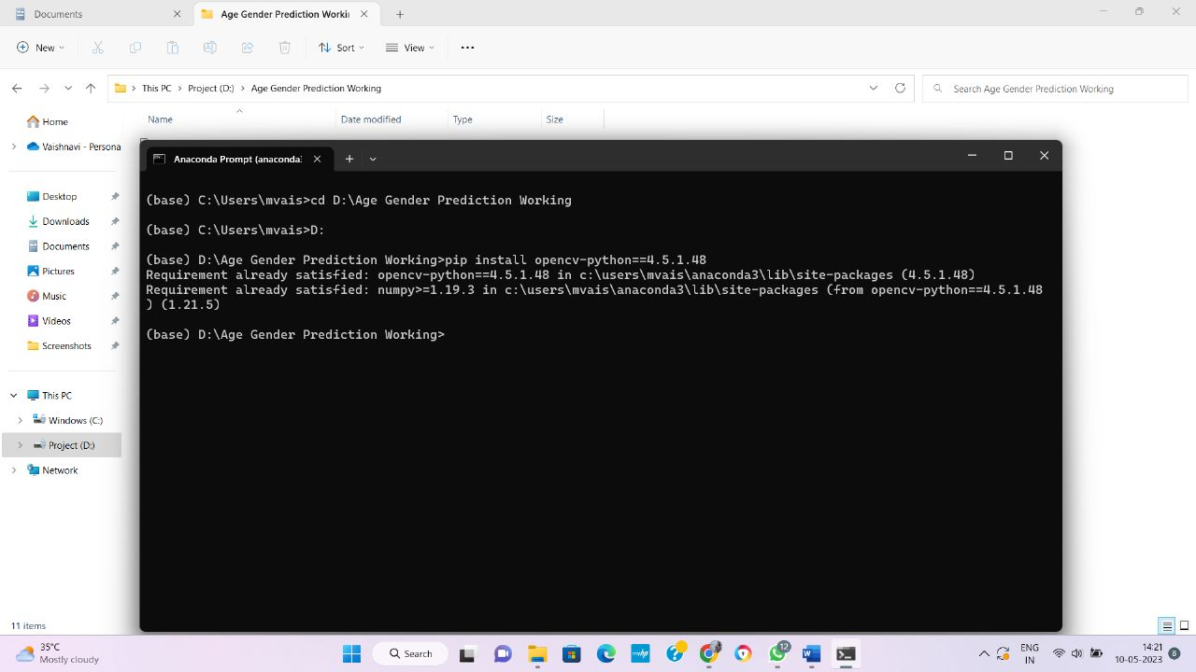

**Figure 2**

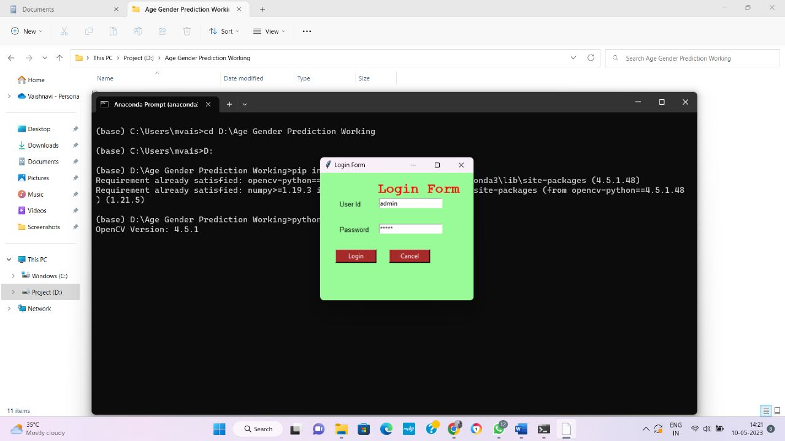

**Figure 3**

**CONCLUSION**

We assess the design of the CNN for good performance in this project. Age estimates and gender estimates via the convolutive Neural Network are the suggested approach of this research. The pre-trained CNN model was utilised to extract the features from the picture. Accuracy was 76 percent correspondingly in the results analysis for age and gender predictions using the caffe model. The model was designed in python language. Real time and static detection of the face have been performed. In a single picture, the system can recognise numerous faces

**FUTURE ENHANCEMENTS**

An AI software program application that is used to locate the age and gender of users who passes through based on line face analyses and automatically starts off evolved playing commercials based totallyon the centered audience. An Android app that determines your age from your photographs using facial popularity. it may bet your age and gender alongside that also can locate multiplefaces in a photo and estimate the age of each face.

**REFERENCES**

[1] D. Michael, and D. Perrett, “Perception of age in adult Caucasian male faces: Computer graphic manipulation of shape and colour information,”in Proc. Roy. Soc. London B, Biol. Sci., pp. 4352–4360, Jul. 2017.

[2] T. Park, M. Liu, T. Wang, and J.-Y. Zhu, “Semantic image synthesis with spatially-adaptive normalization,” in Proc. IEEE/CVF Conf. Comput. Vis.Pattern Recognit. (CVPR), Jun. 2019, pp. 2337-2346.

[3] P. Zhu, R. Abdal, Y. Qin, and P. Wonka, “Sean: Image synthesis with semantic region-adaptive normalization,” in Proc. IEEE/CVF Conf.Comput. Vis. Pattern Recognit. (CVPR), Jun. 2020, pp. 5104-5113.

[4] Z. Tan, D. Chen, Q. Chu, et al. “Efficient Semantic Image Synthesis via Class-Adaptive Normalizations,” IEEE Trans. Pattern Anal. Mach. Intell.(TPAMI) 2021.

[5] Y. Alharbi, and P. Wonka., “Disentangled image generation through structured noise injection,” in Proc. IEEE/CVF Conf. Comput. Vis. Pattern Recognit. (CVPR), Jun. 2020, pp. 5134-5142

[6] V. Carletti, A. S. Greco, G. Percannella, M. Vento, and I. Fellow, “Age from faces in the deeplearning revolution,” IEEE Transactions on Pattern Analysis and Machine Intelligence, p. 1,2019.

[7] B. Bin Gao, H. Y. Zhou, J. Wu, and X. Geng, “Age estimation using expectation of label distribution learning,” in Proceedings of the Twenty-Seventh International JointConference on ArtificialIntelligence, pp. 712–718,Stockholm, Sweden, July 2018.

[8] R. C. Malli, M. Aygun, and H. K. Ekenel, “Apparent age estimation using ensemble of deep learning models,” in Proceedings of the IEEEComputer Society Conference on Computer Vision and Pattern Recognition Workshops, pp. 714– 721,Las Vegas,NV, USA,June 2016.

[9] G. Antipov, M. Baccouche, S. A. Berrani, and J. L. Dugelay, “Effective training of convolutionalneural networks for facebased gender and age prediction,”Pattern Recognition, vol. 72, pp. 15–26, 2017.

[10] J. G¨unther, P. M. Pilarski, G. Helfrich, H. Shen, and K. Diepold, “First steps towards an intelligent laser welding Scientific World Journal architectureusing deep neural networks and reinforcement learning,” Procedia Technology, vol. 15, pp. 474–483,2014.

[11] C. Szegedy, W. Liu, Y. Jia et al., “Going deeper with convolutions,” in Proceedings of the IEEEConference on Computer Vision and Pattern Recognition (CVPR), pp. 1–9, Boston, MA, USA, June 2015.

[12] J. Huang, B. Li, J. Zhu, and J. Chen, “Ageclassification with deep learning face representation,” Multimedia Toolsand Applications, vol. 76, no. 19, pp. 20231–20247, 2017.