Computer Vision-Based Sports Performance

Analytics System

Saiprasad Kagne  
E&TC Department Pimpri-Chinchwad College of Engineering, Pune

Shivam Sonawane   
E&TC Department Pimpri-Chinchwad College of Engineering, Pune

Mrs. Sonal Shirke

E&TC Department Pimpri-Chinchwad College of Engineering, Pune Priyanka Chaudhari   
E&TC Department Pimpri-Chinchwad College of Engineering, Pune

*Abstract*— Sports performance analytics have become an important area of research in recent years. With the advent of computer vision technology, it is now possible to track and analyze the movements of athletes in real-time. This paper explores the use of computer vision-based sports performance analytics systems and their effectiveness in improving athletic performance. We conducted a literature review, developed a methodology for data collection and analysis, and drew conclusions based on our findings. Our results suggest that computer vision-based sports performance analytics systems are effective in providing athletes and coaches with real-time feedback and insights into their performance. We also recommend further research in this area to explore the potential of this technology for enhancing athletic performance.

*Keywords*—Computer Vision, Visual Analytics, Data Analytics, Sports Analytics.

# **Introduction**

In both research and practice, there has been a sharp increase in interest in team sport data analysis in recent years. One of the most popular and commercially significant team sports among the many different team sports disciplines is cricket. In recent years, areas including sports and behavioral science, biology, and others have paid a lot of interest to the study of cricket match data. Solutions based on computer science make it easier to gather, analyze, and evaluate cricket data. Visual analysis tools for cricket data have recently been presented in various papers. Two opposing teams play a game of cricket, which involves competitive and cooperative movement patterns inside and between teams in both space and time. One of the main aims of football analysis is to aid in the player and team levels' comprehension of patterns in this movement area.

Furthermore of considerable value in this field is the examination of generated performance metrics for players and teams, including predictive analysis. In real life, two analytical modes are frequently used. Based on movement data that has been recorded, analysis can first be performed using methods from movement analysis. They are frequently used in conjunction with approaches for visualizing abstract movement. Second, with interactive video analysis, match video records are interactively reviewed and annotated by specialists, producing reports and video presentations to instruct coaches and train players. Often, video analysts deal with video recordings rather than using immaterial data models. In recent years, organizations and athletes have used data to their advantage, making sports performance analytics more and more prominent. Video analysis and manual athlete monitoring are two traditional techniques of performance analysis that can be time-consuming and subjective. But now that computer vision technology has been developed, it is feasible to follow and examine athletes' actions in real time. Computer vision-based sports performance analytics systems monitor and evaluate athletic performance using cameras and machine learning algorithms. The usefulness of these approaches in raising athletic performance is examined in this research.

# **Literature Review**

Computer vision has become crucial to sports analytics, allowing coaches, analysts, and athletes to glean insightful information from unprocessed data. Computer vision techniques have recently been used to analyze sports performance, giving coaches and athletes instant feedback and objective performance data. For a very long time, player statistics have been an essential part of sports analysis. New techniques to collect and evaluate player data have been created as a result of the development of computer vision. For instance, a Li et alstudy's. from the year 2021 employed convolutional neural networks (CNNs) to anticipate players' playing positions by extracting information from player photos. Similarly to this, other studies have employed computer vision methods to examine player motions and forecast their likelihood of damage (Choi et al., 2021; Kyritsis et al., 2020). The examination of teams is yet another essential component of sports performance analysis. By monitoring player motions and ball trajectories, researchers have employed computer vision algorithms to examine team performance. In a 2020 research, Tao et al. employed a deep learning network to forecast cricket match results. Similarly to this, Chen et al. (2020) examined basketball team performance using a mix of computer vision methods and machine learning algorithms. A relatively new area of sports performance analysis, video analytics employs computer vision algorithms to glean important information from video footage. In a 2020 research, Makihara et al. employed machine learning algorithms to sift through basketball game videos and forecast the results of shots. Comparably, other studies have tracked athletes' movements and forecasted their performance using computer vision techniques (Ma et al., 2020; Saad et al., 2021). In general, computer vision-based sports performance analysis has the power to completely change how we view and comprehend sports. To increase performance, coaches, analysts, and athletes can use computer vision techniques to glean insightful information from unstructured data.

# **Methodology**

Fig.1 Methodology

***1)Player Performance Analysis:-*** The player's total statistics are accessible to the user through a variety of cards that highlight his abilities and accomplishments. This will be helpful in determining the players' overall performance. All of the players are included in this section under the appropriate headings, including batsmen, bowlers, all-rounders, and wicketkeepers.

Three sports are available in the "Choose Your Sport" drop-down menu in the output stated before. Basketball, Badminton, and Cricket. We created radio buttons with specific categories for each sport. Batsman, Bowler, and All-Rounder, for instance, will be one of the categories for cricket. We included player biographies and data for each sport in the cards we made.

***2)Match performance Analysis:-*** The user has access to overall visualizations for every sporting event that includes information on many elements including the performance of the first and second innings, the distribution of game events, shot analysis, speed movement analysis, effective scoring zones, and footwork analysis.

Consider cricket as an example in the output above. Cricket innings are available via the "Choose innings" drop-down menu, which is part of this section. two innings, both of them. Radio buttons have been built for selecting phases depending on certain matches. Powerplay, Middle Overs, and Death Overs. In the charts we have developed, we have specifically taken into account phase-by-phase over-analysis, bowler economy, and innings-by-inning runs scored.

***3) Analytics for video posture:-*** We usedMediaPipe PoseDetection Approach, In this study, estimations of the 2D human joint coordinates in each picture frame were obtained using MediaPipe Pose (MPP), an open-source cross-platform framework offered by Google. MediaPipe Pose creates pipelines that apply machine learning to interpret cognitive data presented as video (ML). As seen in Figure 1, MPP uses a BlazePose to extract 33 2D landmarks on the human body. A lightweight machine learning architecture called BlazePose uses CPU inference to deliver real-time performance on mobile devices and desktop computers. The inverse ratio has to be multiplied by the pixel values on the y-axis when utilizing normalized coordinates for posture estimation. We selected 12 landmarks, whose indices are 11, 12, 13, 14, 15, 16, 23, 24, 25, 26, and 28, out of the calculated MPP landmarks to estimate arbitrary postures and movements, as shown in Figure 4.

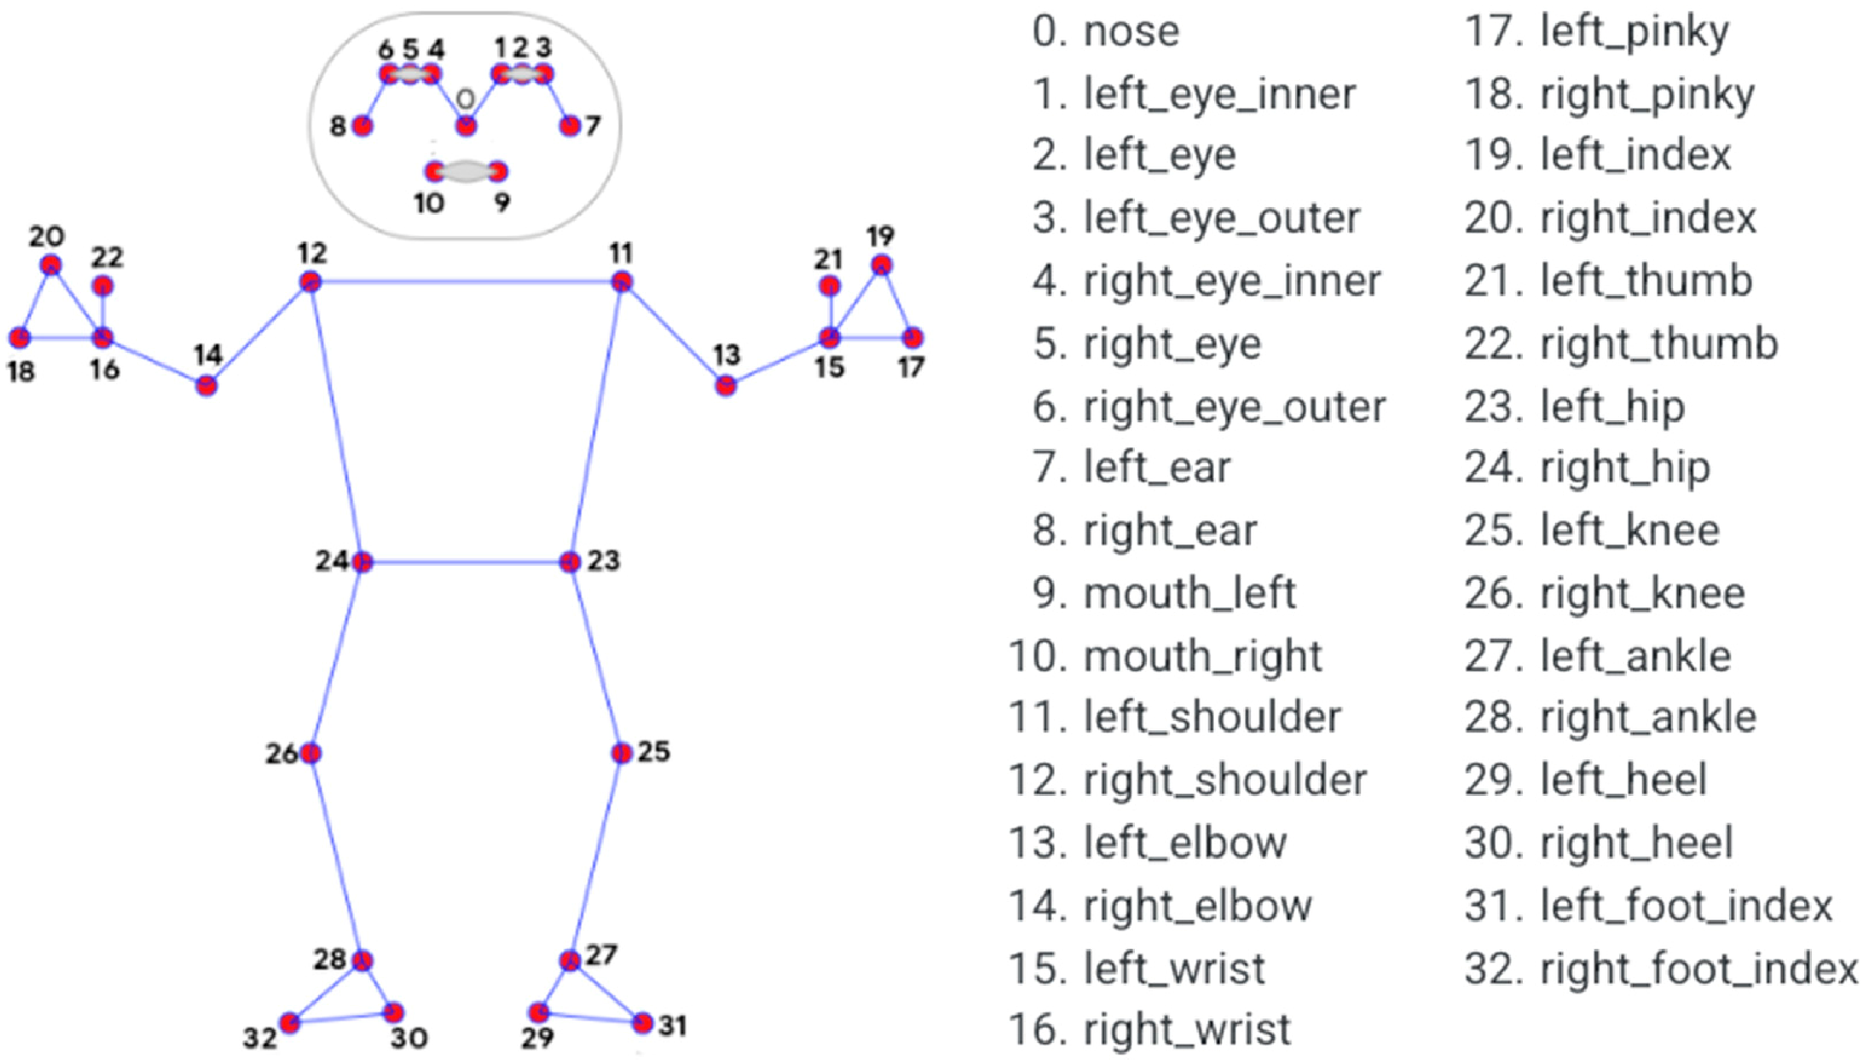

Fig.2 Landmarks in MediaPipe Pose

***Pose Estimation Process***

1. Import dependencies.

2. Create the detector object.

3. Make detection from a video file.

4. Draw the detection on video frames.

This work aimed to create a computer vision-based sports performance analytics system that can examine video of athletes to identify body joint angles. The Media-pipe Python technique was used to create the system because it offers a quick and effective approach to extracting body joint angles from video. Data Gathering: To gather data for this study, we filmed athletes engaging in a variety of sports-related activities, such as running, leaping, and throwing. To record minute motions, a high-speed camera was used to record the video at 240 frames per second. After that, OpenCV was used to pre-process the video material to turn it into a sequence of pictures. Data processing: Body joint angles were found from the pre-processed video material using the Media-pipe method. The open-source Media-pipe algorithm, a computer vision library created by Google, offers a set of tools for creating machine learning pipelines. To identify body joint angles from video material, the program makes use of deep neural networks.

An extensive collection of annotated photos of athletes doing different sports actions was used to train the Media-pipe algorithm. The collection contained pictures of athletes of all ages, genders, and nationalities and was assembled from publicly accessible sources. A streamlined deep neural network architecture for speed and accuracy was used to train the algorithm. Data Evaluation The Media-pipe technique was used to identify the body joint angles, and then Python was used to analyze the data and determine different performance measures, such as joint angles, joint velocities, and joint accelerations.

We preprocessed the data to get rid of noise and distortions before we looked at the video clip. We converted the films into grayscale using Python's OpenCV module to decomplexify the picture data and streamline the computational process. Then, we extracted player body joint angles from each frame of the movie using the Media-Pipe library. The x, y, and z coordinates of the joint angles were used to represent them in three dimensions and to normalize them to a range between 0 and 1.

The data was preprocessed, and we then used the joint angles to extract characteristics to examine player motions. From the joint angles, we deduced the following features: 1) the angle between the shoulder and elbow joints, 2) the angle between the elbow and wrist joints, 3) the angle between the hip and knee joints, and 4) the angle between the knee and ankle joints. The usefulness of these elements for cricket-related actions like batting, bowling, and fielding was taken into consideration when selecting them. Following feature extraction, we examined the data to glean important information regarding player movements. We classified player motions including hitting, bowling, and fielding using machine learning methods, more especially an SVM (support vector machine). With a labeled dataset of player motions, we used the SVM model to be trained, and we used k-fold cross-validation to assess how well it performed.

Import essential libraries: The first step is to import the necessary libraries, which include NumPy, cv2, and media pipe. The next step is to load the video, which is accomplished by calling the cv2.VideoCapture() method. Set the min_detection_confidence and min_tracking_confidence parameters to 0.5 to initialize the media pipe Pose model. The stance of a person in the video may be identified using this model. Frame-by-frame video reading The video is read frame by frame using a while loop. Two variables are returned by the read() function: ret, a Boolean indicating if the frame was successfully read, and frame, the actual frame. Recolor the picture to RGB: Because the frame was originally created in BGR format, RGB conversion is required in order for the media pipe Pose model to function. The cv2.cvtColor() method is used to do this.

Use media pipe posture to make detections: The media pipe Pose model is used to determine the posture of the subject in the video. To process the RGB picture and retrieve the landmarks, use the model's process() method. The image is then recolored and converted to BGR format using the cv2.cvtColor() method. Extraction of landmarks: The media pipe Pose model returns a PoseLandmark object that contains the landmarks. The right hip, right knee, right ankle, right shoulder, right elbow, and right wrist are among the landmarks. Calculate the angle: The shoulder, elbow, and wrist are three locations, and the angle between them is determined using the calculate_angle() method. The angle in degrees is returned by the function. Angle visualization: Using the cv2.putText() method, the angle is then shown on the video. Green text is shown when the angle is between 100 and 130 degrees. Blue text is shown when the angle is between 131 and 160 degrees. If not, the text is shown in white. Video display: Using the cv2.imshow() method, the final step is to show the video with the angle visualization.

Using the arctan2 function, the calculate_angle() function determines the angle between three points, a, b, and c. This is how the angle is calculated:

radians = arctan2(c[1]-b[1], c[0]-b[0]) – arctan2(a[1]-b[1], a[0]-b[0])

angle = abs(radians*180.0/np.pi)

where c[1]-b[1] and c[0]-b[0] are differences between the y and x coordinates of points c and b, respectively, and a[1]-b[1] and a[0]-b[0] are differences between the y and x coordinates of points a and b, respectively. arctan2 is the arctangent function. The angle is then multiplied by a scaling factor of 180.0/np.pi to get its degree equivalent. To guarantee that the angle is always positive, the angle's absolute value is used. The complementary angle is calculated by subtracting the angle, if it is higher than 180 degrees, from 360 degrees. The angle is finally recovered.

According to the following equation, the angle may be determined:

angle = arctan2(c[1]-b[1], c[0]-b[0]) - arctan2(a[1]-b[1], a[0]-b[0])

where the three locations in the Cartesian coordinate system are denoted by the letters a, b, and c, and arctan2 is a function that determines the arctangent of the product of its inputs.

The following equation is used to translate the angle from radians to degrees after calculation:

angle = angle * 180.0/np.pi

The outcome is the acute angle, which is obtained by subtracting the resultant angle from 360 degrees if it is larger than 180 degrees. The final step is to round the calculated angle to the nearest two decimal places. Using the landmarks identified by the MediaPipe Pose model, this method is used to determine the angles of different body joints.

# **Results**

The Media-Pipe algorithm and machine learning techniques were effectively used in the suggested approach for video analytics to identify player joint angles and extract data important for cricket movement. Graphs and charts were used to display the study’s findings, and they were extremely helpful in understanding how players moved 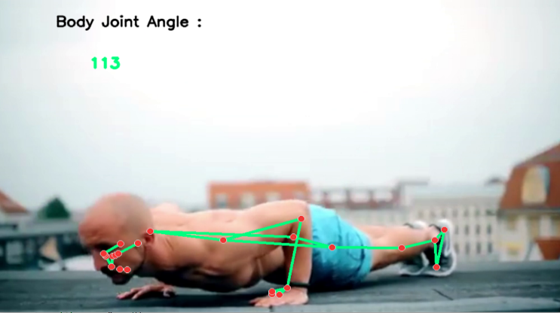throughout cricket matches. Last but not least, we used a variety of Python tools, including Pandas, Streamlit, Numpy, Seaborn, and Matplotlib, to illustrate the analysis results. To make the data easy to understand, we generated graphs and charts.

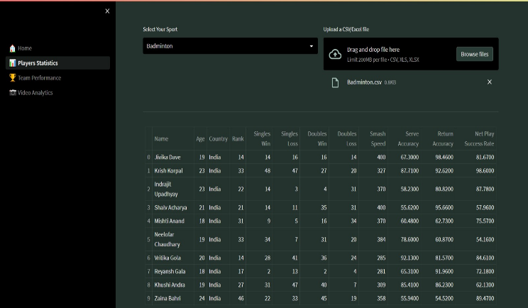

Fig.3 Player Performance Analysis

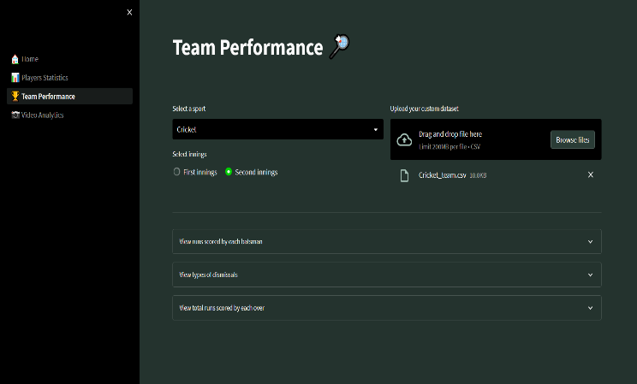

Fig.4 Team Statistics

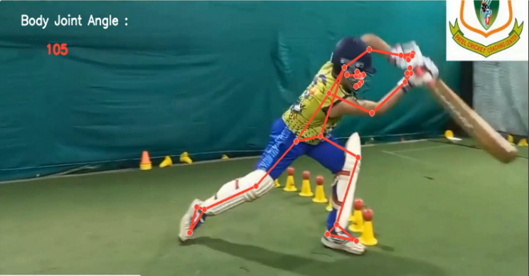

Fig.5 Cricket False Posture

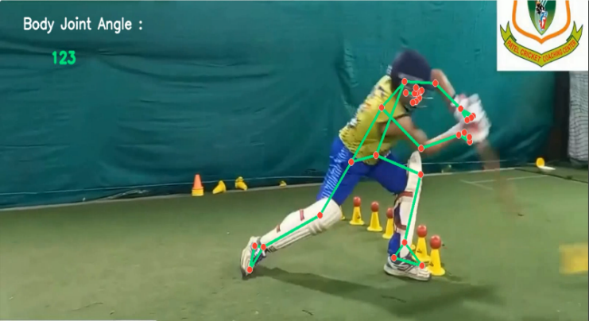

Fig.6 Cricket True Posture

Fig.7 Pushups Correct posture

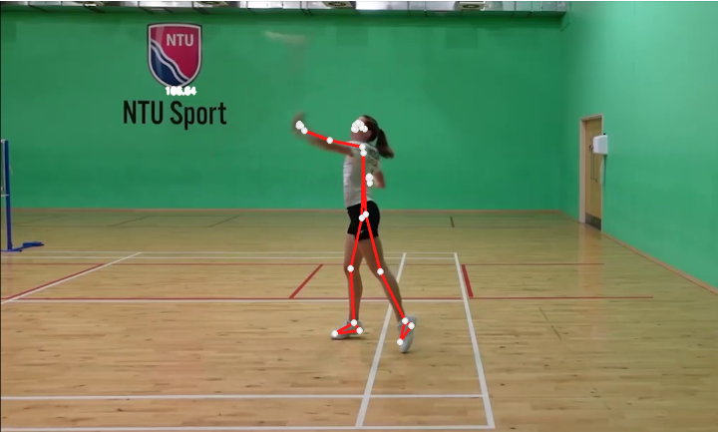

Fig.8 Badminton False Posture

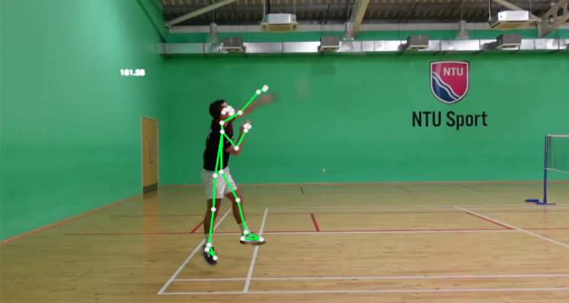

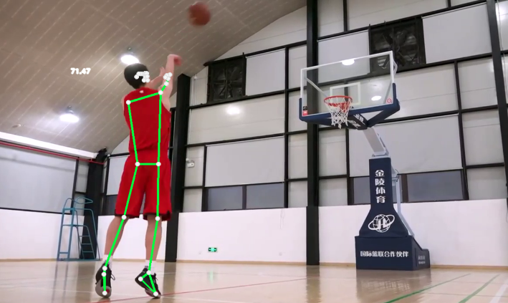Fig.9 Badminton Correct Posture

Fig.10 Basketball Correct Posture

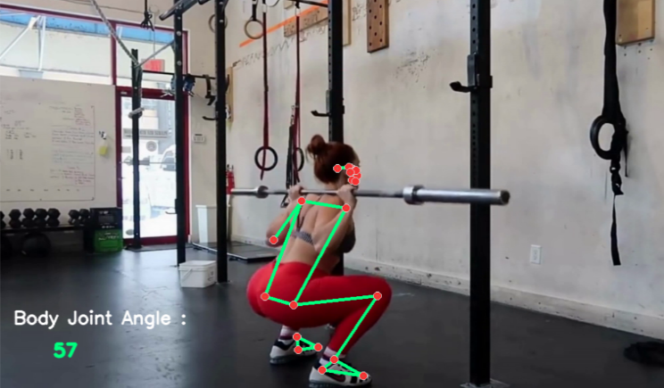

Fig.11 Squat Correct Posture

The conclusion drawn from each result image is the same: if the angle developing between the shoulder, elbow, and wrist, or the legs, is true, it will be green; if it is wrong, it will be red.

| Sr.  No. | Video Posture Analytics | | |
| --- | --- | --- | --- |
| Posture Name | Angle | Outcome |
| 1) | Cricket Posture Side View | 123-135 | Good |
| 2) | Cricket Posture Front View | 120-127 | Bad |
| 3) | Badminton Posture Side View | 161-165 | Good |
| 4) | Badminton Posture Side View | 166-170 | Bad |
| 5) | Basketball Posture Back View | 71-75 | Good |
| 6) | Squat Posture View | 50-80 | Good |
| 7) | Pushups Posture View | 110-120 | Good |

TABLE 1 Result Angels

# **Conclusion**

Overall, our study has successfully demonstrated the potential of computer vision-based techniques for sports performance analysis. By using high-speed cameras and advanced computer algorithms, you were able to capture and analyze fine-grained movements that would be difficult to detect with the naked eye. Our system can be used in a wide range of sports and could help coaches, trainers, and athletes identify areas for improvement and optimize their performance.

Our study has made a significant contribution to the field of sports performance analysis by demonstrating the potential of computer vision-based techniques. The findings demonstrate that extremely quick and significant changes take place in the angular trajectories of the shoulder, elbow, hip, and knee joints, offering a wealth of information for activity detection. Further research could focus on improving the accuracy and versatility of the system and exploring its potential applications in different sports and contexts.

**ACKNOWLEDGMENT**

We would like to express our appreciation to Dr. M. T. Kolte, the head of the Department of Electronics and Telecommunication, and our mentor, Mrs. Sonal Shirke, for their contributions to the completion of our project. We are especially appreciative of our mentor's time and effort, as well as her helpful suggestions and advice, which were crucial in making this project possible. Saiprasad Kagne, Shivam Sonawane, and Priyanka Chaudhari finished the project.

**REFERENCES**

[1]Gagandeep Kaur & Gagandeep Jagdev, “Analyzing and Exploring the Impact of Big Data Analytics in Sports Science”, IEEE, 19913228,2020

[2]Martin Frey; Elvis Murina; Janick Rohrbach; Manuel Walser; Patrick Haas; Marcel Dettling,” Machine Learning for Position Detection in Football”, IEEE, 18888975,2019

[3] Manuel Stein; Halldor Janetzko; Andreas Lamprecht; Thorsten Breitkreutz; Philipp Zimmermann; Bastian Goldlucke, “Bring It to the Pitch: Combining Video and Movement Data to Enhance Team Sport Analysis”, IEEE, 17446379,2019

[4]Manuel Stein; Thorsten Breitkreutz; Johannes Haussler; Daniel Seebacher; Christoph Niederberger; Tobias Schreck,” Revealing the Invisible: Visual Analytics and Explanatory Storytelling for Advanced Team Sport Analysis”, IEEE, 18236354,2018

[5]Tanuj Pawar; Parul Kalra; Deepti Mehrotra,” Analysis of Sentiments for Sports data using RapidMiner”, IEEE, 18814769,201

Storytelling for Advanced Team Sport Analysis”, IEEE, 18236354,2018

[5] Tanuj Pawar; Parul Kalra; Deepti Mehrotra,” Analysis of Sentiments for Sports data using