**COMMUNITY PARTICIPATION FRAMEWORK IN THE PHILIPPINE ENVIRONMENTAL IMPACT STATEMENT (EIS) SYSTEM**

**Kirk Edja B. Accion**

**ORCID Number: 0009-0003-1981-3677**

Master of Science in Development Administration (MSDA), Major in Urban and Environmental Planning, Graduate School of College of Development Management (CDM), University of Southeastern Philippines (USEP) Davao City, Davao Del Sur, Philippines

**ABSTRACT**

This study was conducted to examine and define the various dimensions of community participation within the Philippine Environmental Impact Statement (EIS) System among residents of the Davao Region. The study utilized a data reduction process using Exploratory Factor Analysis (EFA). To gather data, a total of 150 respondents residing in the Davao Region were conveniently chosen to answer a survey instrument consisting of 30 items. The questionnaire, validated by an examiner, was used as the data collection research instrument. The rotated component matrix discarded three items out of the original 30. After data reduction analysis, it was revealed that there are five dimensions of community participation within the Philippine EIS System among residents of Davao City, Philippines. These dimensions are *Perceptions of Community Empowerment and Recognition*, *Enhancing Community Engagement and Effectiveness*, *Transparency and Accessibility*, *Community Centered Approach and Collaboration*, and *Valuing Community Input and Providing Adequate Opportunities.* Considering these dimensions in policy-making would greatly motivate more citizens to participate in the Philippine EIS System.

**Keywords:** Framework, Community Participation, Philippine Environmental Impact Statement (EIS) System, Presidential Decree (PD) 1586, Exploratory Factor Analysis

1. **INTRODUCTION**

The Philippine Environmental Impact Statement (EIS) System, established under Presidential Decree (PD) 1586, is a crucial environmental management tool in the Philippines. Enacted in 1978, PD 1586 was designed to address concerns regarding the detrimental environmental impacts of development projects. The EIS system functions as a regulatory framework that mandates assessing, monitoring, and managing potential environmental impacts arising from proposed projects. Under the EIS system, project proponents are required to submit an Environmental Impact Statement, a comprehensive document that outlines the potential environmental impacts of the project on air, water, land, and socioeconomic aspects. The assessment also identifies appropriate mitigation measures and outlines the plan for public consultation and participation. The primary objective of the EIS system is to ensure sustainable development by integrating environmental considerations into decision-making processes. It seeks to strike a balance between economic development and environmental protection, recognizing the interconnectedness between human activities and the natural environment. (*Presidential Decree No, 1586, s. 1978 or An Act Establishing An Environmental Impact Statement System, Including Other Environmental Management Related Measures.* retrieved from https://www.officialgazette.gov.ph/1978/06/11/presidential-decree-no-1586-s-1978/).

Community participation in the Philippine Environmental Impact Statement (EIS) system is crucial to ensure that affected communities have a meaningful voice in environmental decision-making processes. However, the current state of community participation within the Philippine EIS system presents several challenges (Cooper et al., 2000). Although efforts have been made to involve communities in the decision-making process, there are instances where community input is limited or disregarded, resulting in potential conflicts, dissatisfaction, and a lack of trust among stakeholders (Gera, 2016). This situation highlights the need for a comprehensive examination of the existing community participation framework and its effectiveness. Currently, there is no established framework in the Philippines to assess the extent of community involvement in the Philippine EIS System.

The problem lies in the inadequate implementation and varying levels of community participation within the Philippine EIS system. While the importance of community engagement is widely acknowledged, the extent to which communities are actively involved and their voices are considered in the decision-making process remains inconsistent (Berry et al., 2019). This lack of consistent and meaningful community participation poses a significant challenge to sustainable development and environmental justice in the Philippines (Balzac, 2014). Addressing this problem is crucial as it directly affects the well-being of affected communities and the sustainable management of natural resources. Meaningful community participation ensures that environmental decisions consider local knowledge, concerns, and aspirations, leading to more informed and inclusive decision-making processes (National Research Council, 2008). It fosters a sense of ownership, empowerment, and accountability among community members, promoting social equity and environmental sustainability (Beierle, 1998; Charnley et al., 2005; Abelson et al., 2003).

Research conducted by (Richardson et al., 2019) highlights the importance of community participation in environmental decision-making, emphasizing its role in fostering social cohesion and enhancing the legitimacy of environmental governance processes. Their study found that involving communities in decision-making increases trust and cooperation among stakeholders, resulting in more effective and equitable environmental outcomes. Similarly, the findings of a study by (Depoe et al., 2020) underscore the need for effective community participation in addressing environmental conflicts and promoting sustainable development. They found that meaningful community engagement can help mitigate conflicts, enhance communication, and ensure that development projects align with the needs and values of local communities. These studies, among others, reinforce the significance of investigating and improving the community participation framework within the Philippine EIS system.

1. **OBJECTIVE OF THE STUDY**

The research aims to examine and define the various dimensions of community participation within the Philippine Environmental Impact Statement (EIS) System among residents of Davao City, Philippines. These identified aspects will then be analyzed in-depth to develop a comprehensive framework.

1. **METHODOLOGY**

This research was carried out in the Davao Region, with a total of 150 residents selected as participants for the study. The researcher utilized web-based applications to conduct the survey online, a method that has been recently validated by (Torrentira, 2020) for surveying. The survey questionnaire underwent examination and validation by experts in the field. To assess the interrelationships among variables, the degree of partial correlations was analyzed using the Kaiser-Meyer-Olkin measure of sampling adequacy. The Exploratory Factor Analysis (EFA) was employed to identify the underlying factors of the observed variables, as it is commonly used for this purpose (Auerswald & Moshagen, 2019). A scree plot was utilized to represent and identify the factors visually. These factors were further analyzed through content analysis techniques to develop the framework. The correlation matrix's structure was tested using Bartlett's test of sphericity to determine its validity.

1. **RESULTS AND DISCUSSION**

This section shows the analysis and interpretation of the gathered data.

**4.1 KMO and Bartlett's Test**

Table 1 presents the results of the Kaiser-Meyer-Olkin (KMO) Measure of Sampling Adequacy and Bartlett’s Test of Sphericity. The KMO score of .843 indicates that the samples exhibit strong correlations, making them suitable for factor analysis. In addition, the Bartlett’s test of Sphericity yielded a value of 2924.084 and a significance level of less than .0001, which indicates that the data is appropriate for the community participation framework in the Philippine Environmental Impact Statement (EIS) system. Furthermore, rejecting the null hypothesis based on Bartlett's test of Sphericity implies that there is indeed a community participation framework in the Philippine EIS System.

**Table 1.** KMO and Barlett’s Test

| Kaiser-Meyer-Olkin Measure of Sampling Adequacy. | | .843 |
| --- | --- | --- |
| Bartlett's Test of Sphericity | Approx. Chi-Square | 2924.084 |
| df | 435 |
| Sig. | .000 |

**4.2 Scree Plot**

In Figure 1, a graphical representation is presented, showing the relationship between the total variance and Eigenvalues across all factors. The Scree Plot, which depicts a declining trend of Eigenvalues, serves as a means to assess the significance of each component. This plot is particularly useful in determining the optimal number of factors to retain, as it identifies the inflection point where the curve starts to flatten. In this study, the curve begins to flatten at the seventh component, indicating the presence of Eigenvalues below 1. Any dimension with items falling below the minimum threshold will be eliminated. Consequently, based on the analysis, only 5 dimensions were retained.

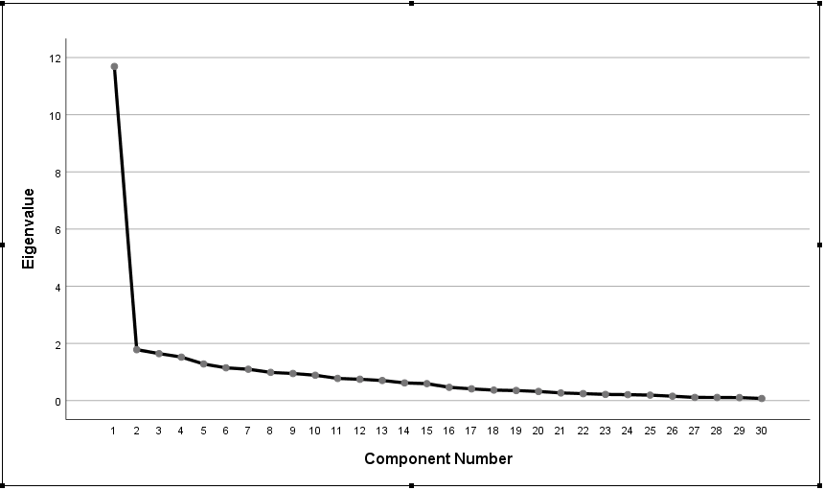

**Figure 1:** Scree Plot

**Rotated Component Matrix**

Table 2 presents the aspects of community participation within the Philippine Environmental Impact Statement (EIS) System among residents of Davao City, Philippines. Attributes such as "Perceptions of Community Empowerment and Recognition," which encompasses the variables related to community members' views on the value and acknowledgment of their contributions, support for local leadership development and decision-making, provision of resources and support for community engagement, and clarity in understanding roles and responsibilities within the Philippine EIS System (Chavis et al., 1990; Fraser et al., 2006).

The findings reveal that community members strongly perceive that the Philippine EIS System values and acknowledges their contributions (0.705). Additionally, the system is seen as effective in promoting open and honest communication between communities and decision-makers (0.694), supporting the development of local leadership and decision-making (0.643), and promoting sustainable development for communities (0.623). Community members also have favorable perceptions regarding the provision of resources and support for community engagement (0.584), recognition of cultural and traditional knowledge (0.568), and clarity in understanding roles and responsibilities (0.531).  
  
These results highlight the significance of community empowerment and recognition within the Philippine EIS System. When communities feel valued and acknowledged, experience open communication, and have access to resources and support, they are more likely to actively engage in decision-making processes. The promotion of sustainable development and the recognition of cultural knowledge contribute to an inclusive and holistic approach to environmental governance (Cavaye, 2001; Stone, 2015).

**Table 2.** Rotated component matrix with grouped attributes of Perceptions of Community Empowerment and Recognition

| Dimension | Attributes | Loading |
| --- | --- | --- |
| Perceptions of Community Empowerment and Recognition | Item 29 - Community members feel that the Philippine EIS System values and acknowledges their contributions. | 0.705 |
| Item 26 - The Philippine EIS System promotes open and honest communication between communities and decision-makers. | 0.694 |
| Item 19 - The Philippine EIS System supports the development of local leadership and decision-making. | 0.643 |
| Item 30 - The Philippine EIS System promotes sustainable development for communities. | 0.623 |
| Item 28 - The Philippine EIS System provides resources and support for community engagement | 0.584 |
| Item 27 - The Philippine EIS System values the cultural and traditional knowledge of communities. | 0.568 |
| Item 18 - Community members clearly understand their roles and responsibilities in the Philippine EIS System. | 0.531 |

Table 3 presents the aspects of community participation within the Philippine Environmental Impact Statement (EIS) System among residents of Davao City, Philippines. Attributes such as "Enhancing Community Engagement and Effectiveness," which encompasses variables related to the facilitation of dialogue between communities and decision-makers, the perceived effectiveness of the system in promoting community participation, the opportunity for community members to monitor and evaluate its effectiveness, responsiveness to community needs and concerns, empowerment of communities in decision-making processes, encouragement of active involvement from community members, and the provision of adequate opportunities for community participation (Drazkiewicz et al., 2015; Shandas et al., 2008).

The results indicate that the Philippine EIS System is perceived to significantly facilitate dialogue between communities and decision-makers (0.744). Furthermore, respondents expressed a strong belief in the system's effectiveness in promoting community participation (0.671) and recognized the opportunity it provides for community members to monitor and evaluate its effectiveness (0.630). The system was also perceived as being flexible and responsive to community needs and concerns (0.580), empowering communities in decision-making processes (0.567), encouraging active involvement from community members (0.525), and providing adequate opportunities for community participation (0.516).

These findings highlight the importance of enhancing community engagement and effectiveness within the Philippine EIS System. By fostering dialogue, promoting community participation, and providing opportunities for monitoring and evaluation, the system can effectively respond to community needs and concerns. Additionally, empowering communities and encouraging active involvement contribute to more inclusive and participatory decision-making processes, ultimately strengthening the overall effectiveness of the system (Bierle, 1999; Chen et al., 2015).

**Table 3.** Rotated component matrix with grouped attributes of Enhancing Community Engagement and Effectiveness

| Dimension | Attributes | Loading |
| --- | --- | --- |
| Enhancing Community Engagement and Effectiveness | Item 10 - Philippine EIS System facilitates dialogue between communities and decision-makers. | 0.744 |
| Item 1 - I feel that the Philippine EIS System is effective in promoting community participation. | 0.671 |
| Item 24 - The Philippine EIS System allows community members to monitor and evaluate its effectiveness. | 0.630 |
| Item 23 - The Philippine EIS System is flexible and responsive to community needs and concerns. | 0.580 |
| Item 11 - The Philippine EIS System empowers communities to participate in decision-making processes. | 0.567 |
| Item 3 - The Philippine EIS System encourages active involvement from community members. | 0.525 |
| Item 2 -The Philippine EIS System provides adequate opportunities for communities to be involved in decision-making processes. | 0.516 |

Table 4 presents the aspects of community participation within the Philippine Environmental Impact Statement (EIS) System among residents of Davao City, Philippines. Attributes such as "Transparency and Accessibility" which encompass variables related to the transparency of decision-making processes, the meaningful contribution of community members to the system, the provision of clear channels for community feedback, and ensuring access to relevant information for community members (Kaplan-Hallam et al., 2018; Cañizares-Espada et al., (2021).

The results reveal that the Philippine EIS System is perceived to be highly transparent in its decision-making processes (0.796). Community members also reported that they could contribute to the system in meaningful ways (0.788), indicating a sense of empowerment and active involvement. Furthermore, the system was perceived to provide clear channels for community feedback (0.706), demonstrating a commitment to incorporating community input. Additionally, the system is acknowledged for ensuring that community members have access to relevant information (0.597), emphasizing the importance of transparency and inclusivity.

These findings underscore the significance of transparency and accessibility within the Philippine EIS System. By maintaining transparency in decision-making processes, empowering community members to contribute, and providing clear channels for feedback, the system can foster trust, enhance collaboration, and ensure community voices are heard. Furthermore, ensuring access to relevant information promotes informed decision-making and equitable participation (Petrescu-Mag et al., 2014; Marantz et al., (2022).

**Table 4.** Rotated component matrix with grouped attributes of Transparency and Accessibility

| Dimension | Attributes | Loading |
| --- | --- | --- |
| Transparency and Accessibility | Item 7 - The Philippine EIS System is transparent in its decision-making processes. | 0.796 |
| Item 6 - Community members can contribute to the Philippine EIS System in meaningful ways. | 0.788 |
| Item 8 - The Philippine EIS System provides clear channels for community feedback. | 0.706 |
| Item 5 - The Philippine EIS System ensures that community members have access to relevant information. | 0.597 |

Table 5 presents the aspects of community participation within the Philippine Environmental Impact Statement (EIS) System among residents of Davao City, Philippines. Attributes such as "Community Centered Approach and Collaboration," which encompasses variables that assess the extent to which the EIS system prioritizes the needs and interests of communities, community members' feelings of respect and value within the system, the promotion of social justice and equity for communities, and the encouragement of collaboration and cooperation among community members (Reilly, 1998; Hermans et al. 2007).

The results indicate that the Philippine EIS System is highly regarded for prioritizing the needs and interests of communities, with a score of 0.782. Furthermore, community members reported feeling respected and valued by the EIS System, as reflected by a score of 0.681. The EIS System was found to promote social justice and equity for communities, scoring 0.617. This highlights the system's focus on addressing disparities and ensuring fairness in environmental decision-making. Collaboration and cooperation among community members, as indicated by a score of 0.556.

The findings emphasize the importance of adopting a community-centered approach and promoting collaboration within the Philippine EIS System. By prioritizing community needs, valuing community members, promoting social justice, and encouraging collaboration, the system can foster a sense of ownership, equity, and active involvement, leading to more effective and sustainable environmental governance (Paci, 2018; Gruber, 2010).

**Table 5.** Rotated component matrix with grouped attributes of Community Centered Approach and Collaboration

| Dimension | Attributes | Loading |
| --- | --- | --- |
| Community Centered Approach and Collaboration | Item 13 - The Philippine EIS System prioritizes the needs and interests of communities. | 0.782 |
| Item 12 - Community members feel respected and valued by the Philippine EIS System. | 0.681 |
| Item 14 - The Philippine EIS System promotes social justice and equity for communities. | 0.617 |
| Item 15 - The Philippine EIS System encourages collaboration and cooperation among community members. | 0.556 |

Table 6 presents the aspects of community participation within the Philippine Environmental Impact Statement (EIS) System among residents of Davao City, Philippines. Attributes such as "Community Centered Approach and Collaboration," which encompasses variables related to the proactive engagement of the EIS system with communities, the recognition and value placed on community input and opinions, the provision of sufficient opportunities for community involvement in decision-making processes, and the effectiveness of the system in promoting community participation (Van der Ryn et al., 2013; Rydin, 2000).

The results indicate that the Philippine EIS System takes a proactive approach to engage with communities, receiving a score of 0.713. Perceived to value the input and opinions of community members, with a score of 0.692. The Philippine EIS System provides adequate opportunities for communities to be involved in decision-making processes, scoring 0.601. Community participants reported a moderate level of perception regarding the effectiveness of the Philippine EIS System in promoting community participation, with a score of 0.500.

These findings underscore the importance of valuing community input and providing adequate opportunities within the Philippine EIS System. By proactively engaging with communities, valuing their input and opinions, and ensuring their meaningful participation, the system can foster a sense of ownership, legitimacy, and effectiveness. It is crucial for the EIS System to continue enhancing community engagement processes and promoting active community participation in order to achieve sustainable and inclusive environmental governance (Waddell, 2002; Pearson et al., 2010).

**Table 6.** Rotated component matrix with grouped attributes of Valuing Community Input and Providing Adequate Opportunities

| Dimension | Attributes | Loading |
| --- | --- | --- |
| Valuing Community Input and Providing Adequate Opportunities | Item 17 - The Philippine EIS System takes a proactive approach to engage with communities. | 0.713 |
| Item 4 - The Philippine EIS System values the input and opinions of community members. | 0.692 |
| Item 2 - The Philippine EIS System provides adequate opportunities for communities to be involved in decision-making processes. | 0.601 |
| Item 1 - I feel that the Philippine EIS System is effective in promoting community participation. | 0.500 |

1. **STUDY FRAMEWORK**

Presented in Figure 2 is the framework developed based on the findings. The researchers identified five key dimensions within the Community Participation Framework in the Philippine EIS System. These dimensions include

* **Perceptions of Community Empowerment and Recognition:** This dimension focuses on community members' perceptions of their empowerment and the recognition of their contributions within the Philippine EIS System. It encompasses aspects such as community members' sense of value, acknowledgment of their involvement, and support for their leadership development and decision-making.
* **Enhancing Community Engagement and Effectiveness:** This dimension highlights the importance of actively involving communities in decision-making processes and improving the effectiveness of their participation. It involves creating mechanisms and platforms that facilitate meaningful engagement, ensuring that community voices are heard and taken into account in environmental decision-making.
* **Transparency and Accessibility:** This dimension emphasizes the significance of transparent and accessible information within the Philippine EIS System. It focuses on providing communities with clear, accurate, and easily understandable information about development projects and their potential environmental impacts. Transparent communication and accessible data empower communities to make informed decisions and actively participate in the decision-making process.
* **Community-Centered Approach and Collaboration:** This dimension promotes a community-centered approach to environmental decision-making. It recognizes the importance of collaboration among various stakeholders, including community members, government agencies, and project proponents. A collaborative approach fosters trust, inclusivity, and shared responsibility, enabling effective decision-making that aligns with the needs and aspirations of the community.
* **Valuing Community Input and Providing Adequate Opportunities:** This dimension emphasizes the value of community input within the Philippine EIS System. It advocates for recognizing and valuing the knowledge, perspectives, and concerns of community members. It also emphasizes the need to provide adequate opportunities for community participation and engagement, ensuring that their voices are actively sought and considered in decision-making processes.

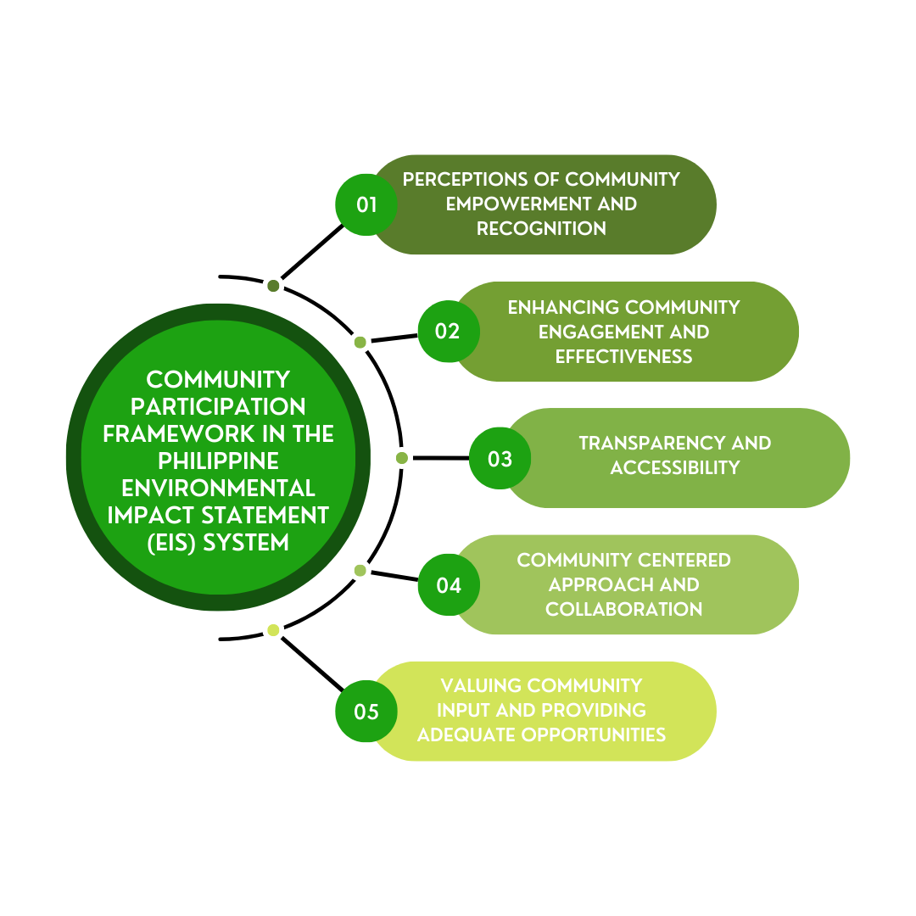

**Figure 2**: Community Participation Framework in the Philippine EIS System

1. **CONCLUSION**

Based on the findings, the researchers concluded that five dimensions relating to the Community Participation Framework in the Philippine EIS System, namely Perceptions of Community Empowerment and Recognition, Enhancing Community Engagement and Effectiveness, Transparency and Accessibility, Community Centered Approach and Collaboration, and Valuing Community Input and Providing Adequate Opportunities.

Considering these dimensions in policy-making is crucial as it will greatly motivate more citizens to actively participate in the Philippine Environmental Impact Statement (EIS) System. By integrating these dimensions into the decision-making process, policymakers can enhance community engagement, improve transparency and accessibility, foster collaboration, and demonstrate the value placed on community input. This, in turn, will contribute to more inclusive and effective environmental governance and increase the overall participation of citizens in shaping environmental policies and decisions.

1. **REFERENCES**
2. Cooper, L. M., & Elliott, J. A. (2000). Public participation and social acceptability in the Philippine EIA process. Journal of Environmental Assessment Policy and Management, 2(03), 339-367.
3. Gera, W. (2016). Public participation in environmental governance in the Philippines: The challenge of consolidation in engaging the state. Land Use Policy, 52, 501-510.
4. Berry, L. H., Koski, J., Verkuijl, C., Strambo, C., & Piggot, G. (2019). Making space: How public participation shapes environmental decision-making. Stockholm Environment Institute..
5. Balzac, J. M. (2014). Public Engagement" Reach In, Reach Out": Pursuing Environmental Justice by Empowering Communities to Meaningfully Participate in the Decision-Making Processes of Brownfields Redevelopment and Superfund Cleanups. Florida A & M University Law Review, 9(2), 5.
6. Beierle, T. C. (1998). Public participation in environmental decisions: an evaluation framework using social goals (No. 1318-2016-103451).
7. National Research Council. (2008). Public participation in environmental assessment and decision making. National Academies Press.
8. Charnley, S., & Engelbert, B. (2005). Evaluating public participation in environmental decision-making: EPA's superfund community involvement program. Journal of environmental management, 77(3), 165-182.
9. Abelson, J., Forest, P. G., Eyles, J., Smith, P., Martin, E., & Gauvin, F. P. (2003). Deliberations about deliberative methods: issues in the design and evaluation of public participation processes. Social science & medicine, 57(2), 239-251.
10. Richardson, B. J., & Razzaque, J. (2006). Public participation in environmental decision-making. Environmental law for sustainability, 6, 165-194.
11. Depoe, S. P., Delicath, J. W., & Elsenbeer, M. F. A. (Eds.). (2004). Communication and public participation in environmental decision making. Suny press.
12. Moises Jr, C. (2020). Online data collection as adaptation in conducting quantitative and qualitative research during the COVID-19 pandemic. European Journal of Education Studies, 7(11).
13. Auerswald, M., & Moshagen, M. (2019). How to determine the number of factors to retain in exploratory factor analysis: A comparison of extraction methods under realistis. Psycholc conditionogical methods, 24(4), 468
14. Chavis, D. M., & Wandersman, A. (1990). Sense of community in the urban environment: A catalyst for participation and community development. American journal of community psychology, 18(1), 55-81.
15. Fraser, E. D., Dougill, A. J., Mabee, W. E., Reed, M., & McAlpine, P. (2006). Bottom up and top down: Analysis of participatory processes for sustainability indicator identification as a pathway to community empowerment and sustainable environmental management. Journal of environmental management, 78(2), 114-127.
16. Cavaye, J. (2001). Rural Community Development: New Challenges and Endudring Dilemmas. Journal of Regional Analysis & Policy, 31(1), 109-124.
17. Stone, M. T. (2015). Community empowerment through community-based tourism: The case of Chobe Enclave Conservation Trust in Botswana. Institutional arrangements for conservation, development and tourism in eastern and southern Africa: A dynamic perspective, 81-100.
18. Drazkiewicz, A., Challies, E., & Newig, J. (2015). Public participation and local environmental planning: Testing factors influencing decision quality and implementation in four case studies from Germany. Land use policy, 46, 211-222.
19. Shandas, V., & Messer, W. B. (2008). Fostering green communities through civic engagement: community-based environmental stewardship in the Portland area. Journal of the American Planning Association, 74(4), 408-418.
20. Beierle, T. C., & Konisky, D. M. (1999). Public participation in environmental planning in the Great Lakes region (No. 1318-2016-103136).
21. Chen, M., Qian, X., & Zhang, L. (2015). Public participation in environmental management in China: status quo and mode innovation. Environmental Management, 55, 523-535.
22. Kaplan‐Hallam, M., & Bennett, N. J. (2018). Adaptive social impact management for conservation and environmental management. Conservation Biology, 32(2), 304-314.
23. Cañizares-Espada, M., Muñoz-Colomina, C. I., Pérez-Estébanez, R., & Urquía-Grande, E. (2021). Transparency and accessibility in municipalities: The case of social services in Spain. Central European Journal of Public Policy, 15(1), 31-54.
24. Petrescu-Mag, R. M., Oroian, I. G., Drăgan, A. A., & Petrescu-Mag, I. V. (2014). Access to environmental information, a key tool for ensuring eco-transparency: Proactive disclosure as reflected in Romanian legislation. Advances in Environmental Sciences, 6(1), 76-90.
25. Marantz, N. J., & Ulibarri, N. (2022). The tensions of transparency in urban and environmental planning. Journal of Planning Education and Research, 42(3), 401-412.
26. Reilly, T. (1998). Communities in conflict: Resolving differences through collaborative efforts in environmental planning and human service delivery. J. Soc. & Soc. Welfare, 25, 115.
27. Hermans, C., Erickson, J., Noordewier, T., Sheldon, A., & Kline, M. (2007). Collaborative environmental planning in river management: An application of multicriteria decision analysis in the White River Watershed in Vermont. Journal of Environmental Management, 84(4), 534-546.
28. Paci, F., Squicciarini, A., & Zannone, N. (2018). Survey on access control for community-centered collaborative systems. ACM Computing Surveys (CSUR), 51(1), 1-38.
29. Gruber, J. S. (2010). Key principles of community-based natural resource management: a synthesis and interpretation of identified effective approaches for managing the commons. Environmental management, 45, 52-66.
30. Van der Ryn, S., & Cowan, S. (2013). Ecological design. Island press.
31. Rydin, Y., & Pennington, M. (2000). Public participation and local environmental planning: the collective action problem and the potential of social capital. Local environment, 5(2), 153-169.
32. Waddell, P. (2002). UrbanSim: Modeling urban development for land use, transportation, and environmental planning. Journal of the American planning association, 68(3), 297-314.
33. Pearson, D. M., & Gorman, J. T. (2010). Exploring the relevance of a landscape ecological paradigm for sustainable landscapes and livelihoods: a case-application from the Northern Territory Australia. Landscape Ecology, 25, 1169-1183.