The Car Rental System

## 1st Rohit Donde, 2nd Ananta Chaudhari, 3rd Shruti Kapse, 4th Vaishnavi Ghuge

1st Computer Engineering, SPPU/LoGMIEER, and Nashik

# ABSTRACT

The Car Rental Services project aims to develop an innovative and user-friendly platform that provides efficient and convenient car rental services to individuals and businesses. With the increasing demand for flexible transportation options, this project seeks to bridge the gap between car owners and customers, offering a seamless rental experience.The platform will be designed to streamline the process of renting a car, eliminating the traditional complexities associated with paperwork and communication. Users will have access to a comprehensive database of available vehicles, allowing them to search, compare, and select the most suitable car based on their preferences, location, and budget.

**Keywords:** — **Interactive Display, Client / Server , Car Rental Service , Android, Customer Ingagement, php Language Processing, phpMyAdmin.**

# I . INTRODUCTION

The In recent years, the advancement in technology has brought about significant changes in the way we interact with computers. One of the most innovative developments in this area is gesture sensor technology. This technology enables users to interact with their computer or other electronic devices using hand gestures instead of traditional input methods like keyboards and mice. Gesture sensor technology has great potential for revolutionizing the way we interact with computers, especially in virtual environments. This research paper focuses on the use of gesture sensor technology for UI control on virtual mouse. The virtual mouse is a popular tool used in virtual environments, but it is often limited by the traditional input methods. The integration of gesture sensor technology can enhance the usability and functionality of virtual mouse, making it a more intuitive and natural way of interacting with virtual environments. this research paper aims to contribute to the existing literature on gesture sensor technology and its application to virtual environments.

# II . LITERATURE REVIEW

This paper will introduce a special kind of logistics management problem which exists in the car rental industry. Revenue management conception has been used for reference in the car rental industry to develop booking, pricing and inventory strategies. In order to get a high degree of customer satisfaction and optimize vehicle fleet utilization, logistics managers in the car rental business approximately adopt three decision-making steps: namely, pool segmentation, strategic fleet planning and tactical fleet planning. Optimizing resource deployment and reducing the logistics cost are the targets of logistics management in enterprise. We will review the existing literature on the car rental logistics problem and identify some gaps in current research. This sort of research is prospective and useful for future development of the car rental industry.

.

# PROBLEM STATEMENT

Inefficient Booking Process: The existing booking process is cumbersome and time-consuming. Customers often have to wait in long queues or make multiple phone calls to reserve a car. This results in delays and inconvenience for both the customers and the rental company.

Limited Vehicle Availability: The car rental system struggles to efficiently manage its fleet of vehicles. As a result, there is often a shortage of available cars during peak demand periods, leading to customer dissatisfaction and lost business opportunities.

Lack of Transparency: Customers often face difficulties in accessing relevant information about car availability, pricing, and rental policies. The lack of transparency leads to confusion and frustration among customers, impacting their overall experience and trust in the rental service.

Inadequate Vehicle Maintenance: The current system lacks an effective mechanism for tracking and scheduling vehicle maintenance. As a result, cars may be rented out without proper inspection and maintenance, leading to potential breakdowns and accidents that compromise customer safety and increase operational costs.

# OBJECTIVES

* 1. Rent on cars.
  2. Secure payment. 3] Best market rate.

# SYSTEM ARCHITECTURE

This project traverses a lot of areas ranging from business concept to computing field, and required to perform several researches to be able to achieve the project objectives. The area covers include:

Car rental industry: This includes study on how the car rental business is being done, process involved and opportunity that exist for improvement.

PHP and Android Technology used for the development of the application. General customers as well as the company’s staff will be able to use the system effectively.

Android-platform means that the system will be available for access 24/7 except when there is a temporary server issue which is expected to be minimal.

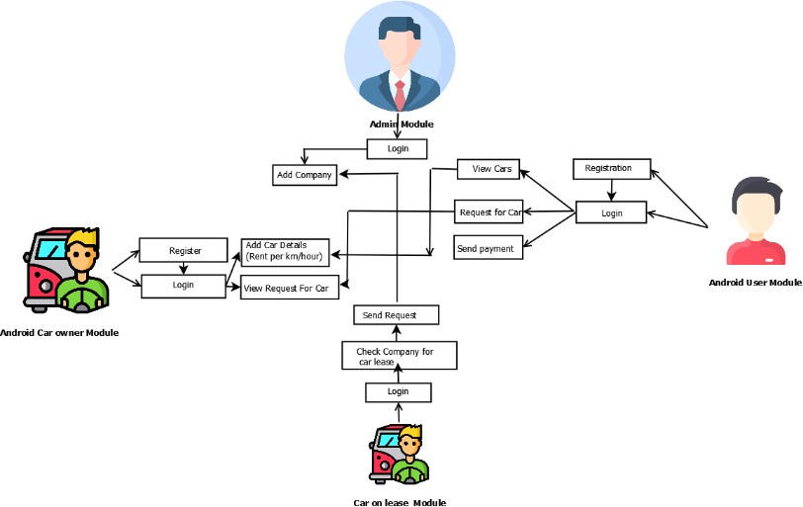

# METHODOOGY

[1]Requirements Gathering: The first step is to gather the requirements for the car rental system. This involves understanding the needs of the business or organization operating the system, as well as the expectations of the customers using the system. This includes identifying the desired features, functionality, and any specific constraints or limitations. [2]System Design: Once the requirements are gathered, the next step is to design the system architecture and user interface. This includes defining the various components of the system, such as the database structure, application modules, and user interfaces for customers and administrators. The design should align with the requirements and ensure a user-friendly experience.

1. **RESULT AND SCREENSHOT**

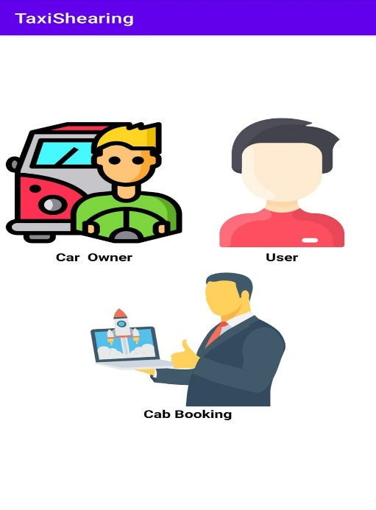 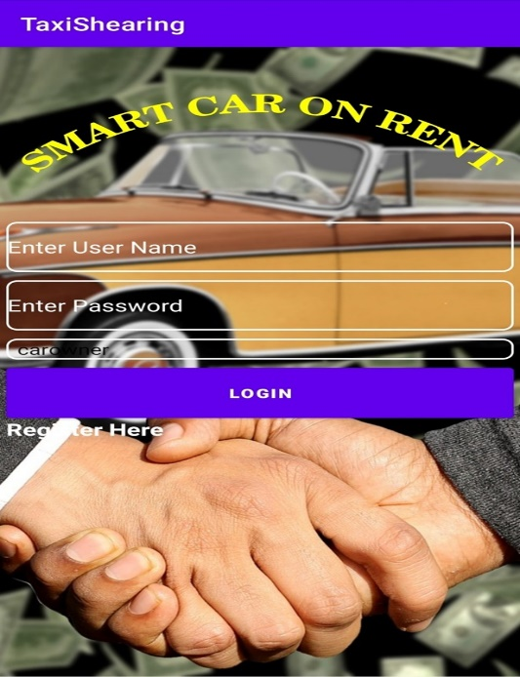    
Fig 1 :home page Fig2: login page Fig 3: dashboard

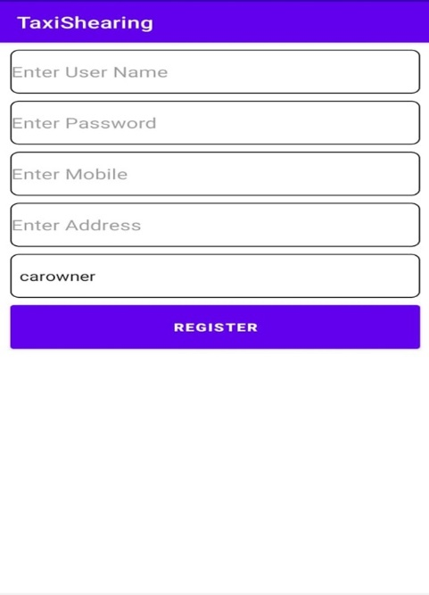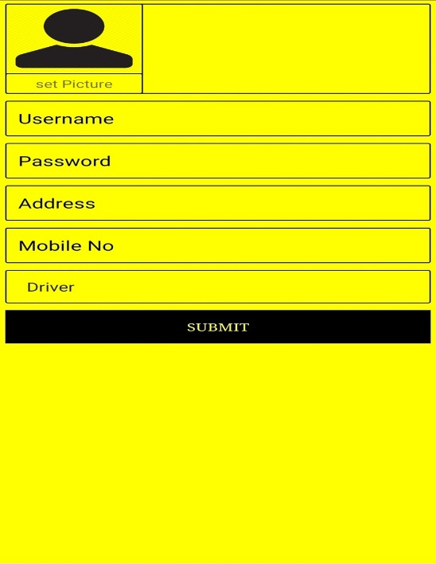 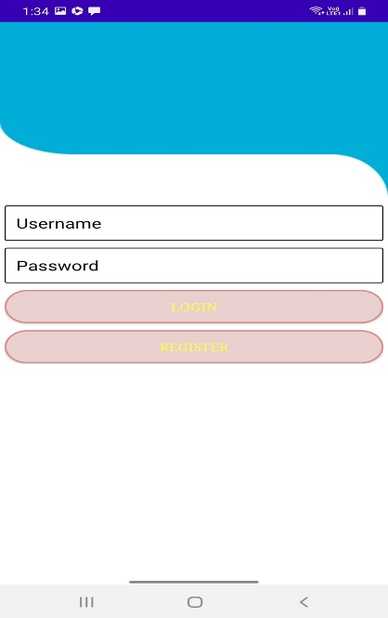

Fig 4:Taxi share Fig 5 :Profile page Fig 6: User login

# APPLICATIONS

1. User Registration and Authentication:

Allow users to create accounts and log in securely.

Implement authentication mechanisms to ensure secure access.

1. Vehicle Inventory Management:

Maintain a database of available vehicles, including details like make, model, year, mileage, and availability status.

Implement search and filtering options for users to find suitable vehicles based on their preferences.

1. Reservation and Booking:

Provide a reservation system for users to select a vehicle, specify rental dates and times, and make bookings. Manage conflicts and avoid double-bookings by checking vehicle availability.

1. Pricing and Payment:

Calculate rental prices based on factors such as vehicle type, rental duration, mileage, and additional services (e.g., insurance).

Support various payment methods, including credit/debit cards, online wallets, or cash payments.

1. Customer Management:

Store customer information, including contact details, identification, and reservation history.

Enable customers to view and manage their reservations, modify bookings, and check rental history.

1. Administrative Dashboard:

Provide an administrative interface for staff to manage the car rental system.

Allow administrators to add, update, or remove vehicles from the inventory, manage user accounts, and generate reports.

1. **CONCLUSION**

Firstly, the car rental services project has provided convenient and flexible access to a wide selection of vehicles, allowing customers to choose the most suitable option for their specific needs. This has resulted in increased mobility and freedom for individuals, enabling them to travel conveniently and comfortably without the hassle of vehicle ownership

# REFERENCES

1. R. S. Pressman, Software Engineering (3rd Ed.): A Practitioner’s Approach. New York, NY, USA: McGraw-Hill, Inc., 1992.
2. P. Kulkarni, Knowledge Innovation Strategy. Pune: Bloomsbury Publication, 2015.
3. P. Sinha, Electronic Health Record. IEEE Press Wiley.
4. McKinsey, “Big data: The next frontier for innovation, competition, and pro- ductivity,” tech. rep.
5. “Digital competition[:http://www.](http://www.mckinsey.com/insights)m[ckinsey.com/insights.](http://www.mckinsey.com/insights)”