Automated Face Mask Detection System: A System Featured with Machine Learning and Image Processing

***Agni Rakshit1, Anirban Karmakar1, Pritam Mukherjee1, Sanchari Neogi1, Avishikta Layek1, Soumallya Dey1, Subir Gupta1\****

***1Department of Master of Computer Application, Dr. B. C. Roy Engineering College, Durgapur, West Bengal 713206, India.***

# ABSTRACT

The word Expression itself is recounting that it is wont to intend something. The word “express” is concealed inside. Well, the documented meaning of an expression is a kind of looking that we can see in the face of someone which delineates an emotion of any distinct type. In other words, to convey one’s feelings, the way is being utilized is known as expression. According to surveys and researches, human being uses 55-57% of body language to express their feelings, 7% of tones or tonal variations, and the rest amount is with words. Besides being an astonishing thing, it’s a verity. And the facial expression is a slice of body language. There is an adequate amount quantity of paper breathed in the fields of psychology, medicine, and other domains which are the corroboration of the extensive use of expressions. Customarily, we can see that humans respond in any sort of stimulation by using facial expressions. So, it’s that much salient in our daily life. But sporadically, human expressions are not that conspicuous to be recognized and, in this case, it is quite obligatory to detect the facial expressions properly. For this reason, facial expression detection should be automated. This proposed system dispenses an authentic facial expression detection system. The paper blends machine learning and image processing. This report says that seeing the face will understand and display the actual expression is being recorded in the camera. This paper is introducing features with a success rate of 90%.

# INTRODUCTION

The worldwide pandemic of coronavirus disease has changed the picture of living daily life and a drastic change has come in the graph of social, economic, healthcare as well as technological sectors[1][2]. On one side, people have lost their dears as the disease didn’t give mercy to them, on the other hand, the situation has become a strict teacher to all of us and taught us how to maintain healthy habits. The daily lifestyle has been changed up to a certain percentage, starting from the technical field to social areas[3][4]. If we took a look at previous few years, we could see that there was no such popularity of online classes, there were no such uses of sanitizers personally, no one was getting so much frightened after seeing a person sneezing publicly (though sneezing publicly without using handkerchief is not a good habit). But now all these things have become a habit and seem very natural to us. After long research and discussions, the experts, doctors, and scientists have proposed a guideline through which people can prevent the virus from trespassing into their body, as no such vaccines and medicines has been invented (a few months back) which can provide a protective shield to human being from this virus. The WHO has issued and approved the guidelines and advice as well as urged the citizens of earth to maintain all of them so that they can avoid the disease up to a certain percentage[5]. One of those guidelines is, wearing a proper mask appropriately. We were habituated to see the doctors, wearing masks during operations. But who knew this, that one day it will be a daily life friend to all of us? Yes, it has happened. A few days ago, we had only protection, not prevention. The vaccination program is in rapid progress everywhere[6]. But it doesn’t mean at all that we will forget the mask and sanitizer after getting vaccinated. So, wearing a mask, obviously in a proper manner is mandatory. Unfortunately, in India, it can be seen that a large amount of people is not

following the guidelines. Besides that, they are not even appropriately wearing a mask. Sometimes in the chin, it’s hanging from the ear, etc. It’s indeed surprising that they are not at all aware of the necessity of proper mask-wearing. Some of them have no fear of this virus and have been taken very lightly. But though they have accepted it as inevitable, it may harmful for others. It’s not at all a good practice and there is a chance of spreading COVID 19[7][8][9]. After a huge gap of almost one year, the working sectors are getting reopened and the period of work from home is coming almost to the end. So, an essential gathering will happen eventually. And it’s quite impossible for a human being to monitor all the candidates all the time whether they have worn a mask or not, and if yes then if it is in a proper way or not. And that is why the system has been proposed. Like a CCTV camera or a biometric attendance recording machine or a face detector, there is a need for such a system that can monitor whether a mask has been worn properly or not. And working sector’s management should take an initiative to make it a mandatory rule and implement the same to maintain the strictness. This is the reason that why researches are going on in this particular domain. This face mask detector can be a beneficial invention for the globe.

Here, during research, we found various machine learning-based algorithms and methods. Where machine learning is used in different domains like image processing, material science, wather forcasting, etc[10][11][12][13]. In face masking detection researchers have introduced it previously. Some of them are as follows: (a) Mobilenet V2: it is a convolutional neural network architecture that performs well especially at mobile systems or gadgets. Based on a reverse residual model, it works. And in this case, the connection that is known as residual takes place betwixt the bottleneck layers. (b) KNN: it is known as the K nearest neighbor algorithm[14][15][16]. It is present exclusively in statistics. One of the indispensable algorithms it is. It is used to resize an image. It starts from a one- pixel grid and comes to an end in another specific image pixel grid. It has a bi-directional function ability. (c) Sequential model: it is a theory that elaborates the co-operativity of protein subunits[17]. It is also known as the KNF model. It denotes the presence of 2 states of conformation[18][19].

# METHODOLOGY

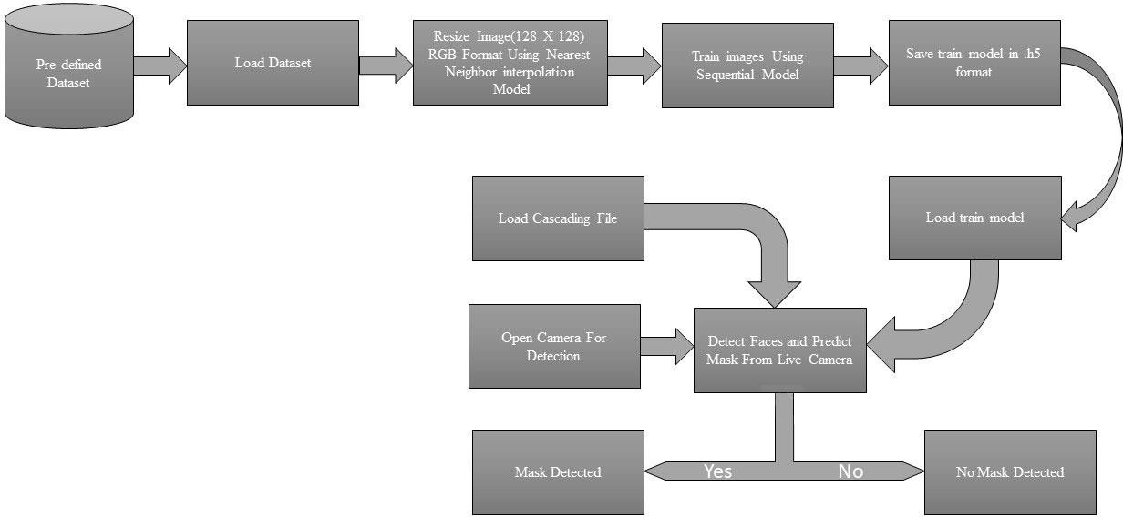

***Figure 1: Methodology diagram of Face Mask Detection***

The term methodology denotes the methodical view of the proposed system. Here, we will discuss the workflow and the procedure of the proposed system. Besides that, we will roam at a glance to the abstract view of this report too. We have collected some datasets here; those are purely RGB images or color images. Point to be noted that, these images have been taken arbitrarily. Among those images, some are with masks whereas some of them are without the mask. Some other points that are

needed to mention are that the facial expression, haziness of the image, size of the image, typeset of the image, all these are immaterial in this dataset. Due to the size of the image (as it is an RGB image, so it is too high), it may take more time in training. So, that is the reason that we have kept the image snot in a total higher form but in a measured form as 128 X 128. The moral of the story, we have cropped the image and this has been done by using the inter nearest interpolation algorithm. Then we will divide the entire dataset into 1:1 or 50-50 ratios. For this particular demo or trial model or experimental case, we are using 1000 images. These are a combination of with and without the mask. After that, we are directly training our model using the training image dataset. Simply, 50% of the dataset is used for training and the rest 50% are used for testing purposes. So, it’s time to enter the 50% image into the training dataset. Here we train the model using the sequential model. After that, we prepare our prophecy model or the predicted model. Rest 50% images we are used for testing the training accuracy, the cause of training, and the exact prediction as well. Here a very vital point that should be essentially highlighted is “threshold value”. It is playing a key role here. After the use of the sequential model, at the end of that phase, we have tried to find out the threshold value. If the mean of the image pixel is above the threshold value, then it will be denoted as without mask, else it will represent with the mask. The methodology diagram we have shown in Figure 1 and the pseudocode of the same is being explained in Figure 2.

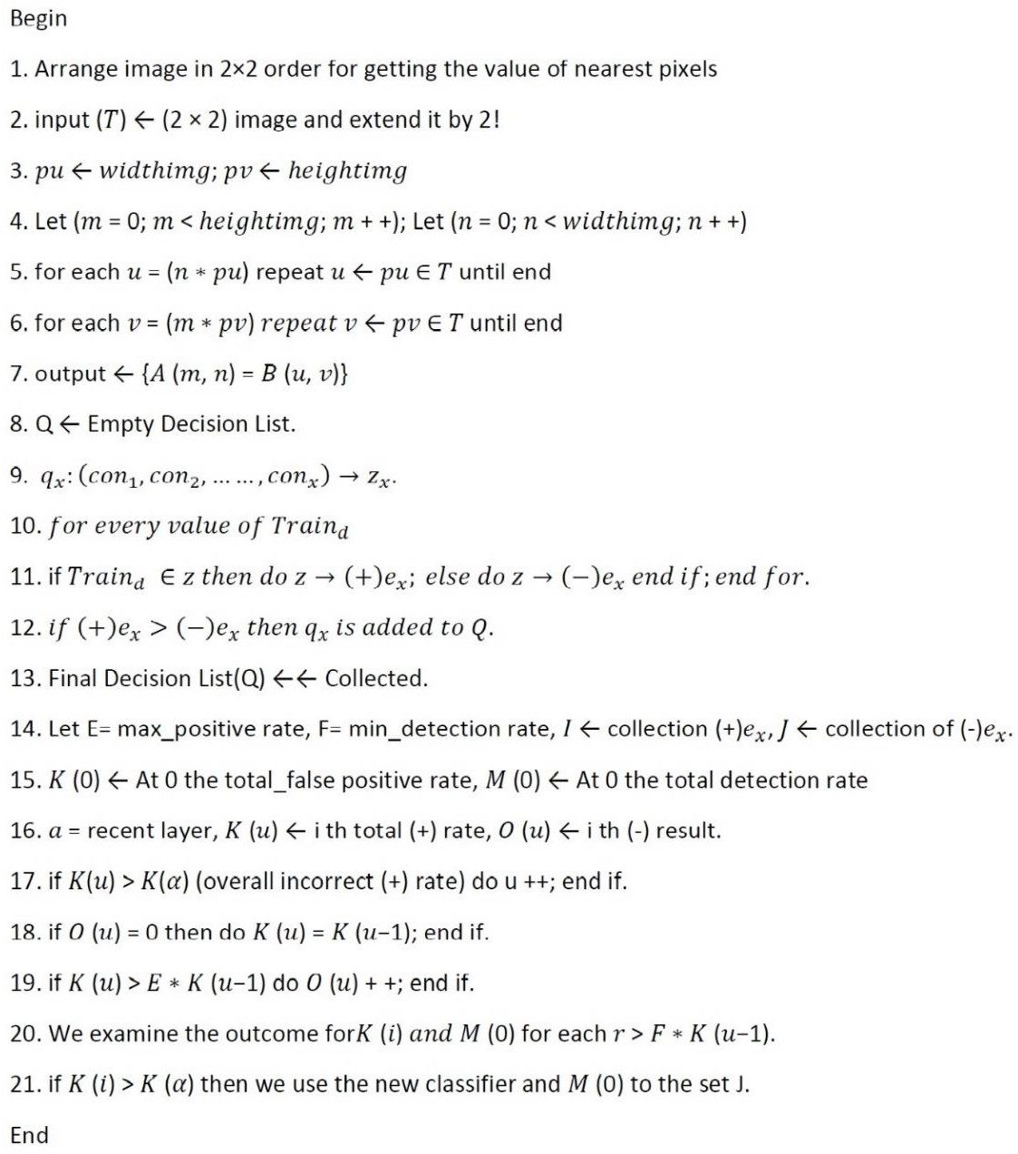

***Figure 2: Pseudo Code of Methodology***

# RESULT ANALYSIS

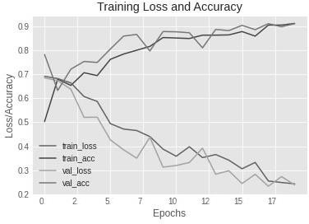

***Figure 3: Training Loss and Accuracy***

Now coming to the final section is the result analysis part. Here the section has been divided into two zones. One is the coding accuracy and the other is the result accuracy. First, let’s have a look at the abstract view. It comprises the procedure that the user will observe during the process will run. When the system will start, it will eventually start the camera and the face will be captured (recorded) here. After that, the face will be examined by using some specific algorithms and methods, finally, the prediction and detection will be generated whether the person has worn the mask properly or not, as well as if the person has a mask on his face or not. Coming to the next part, that is, the coding analysis part. Here, it has been described through the faces where masks are present and absent.

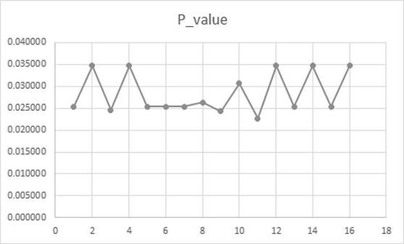

***Figure 4: Chi-Square Test On Resulted Dataset***

After that, the training loss and accuracy will be seen in Figure 3 and here it has been seen that the training data that is the 50% accumulated data where it has been indulged into the training dataset to train, the graph is shown in Figure 3. The graph has composed of epochs and the loss/accuracy. We can see the variations here that the training dataset is displaying the accuracy or loss rate depending on the epoch. In Figure 3, we can see the loss rate according to the value of the loss. It denotes the

deterioration of the loss depending on the value loss. In Figure 3 we can also see the accuracy rate according to the value of accuracy. It denotes the deterioration of the accuracy depending on the value accuracy. Finally, the prophecy and the recognized detection will take place at the end and it has been mentioned in Figure 4.It represents the detection result that comes as the ultimate inference where the proposed system is showing the percentage of proper masking as well as the presence or absence of a mask in a face. All the cases and graphs are the outcome of 15 times trial run.

# CONCLUSION

The face mask has become an indispensable and extensively used thing and it is being used by human beings each and everywhere. Previously we were not quite accustomed to it. But the recurrent waves of covid 19 have made enforcement utilize a mask and properly as well. The WHO has declared wearing the mask as an essential thing to carry, to use, and to keep. Repeated awareness programs are spreading in social media, television, radio, and even in mobile caller tunes also. But unfortunately, some people don’t have any to this disease as well as don’t have any concern to their health, safely and safely of others too. This is the reason to develop such detector as unlock phase has already started and in some working sectors rapidly works are going on. Workers, employees are going to the working places and it is not possible to observe all of them manually. So, we have tried to implement the detection system at the very beginning level. Though it brings the accuracy and the satisfactory level result, it has been proposed. Further, some other higher methods, algorithms, and procedures will be applied to make the system more strengthful, accurate, and prominent. Overall, the system is running accurately and successfully and it can detect with accuracy.

# REFERENCES

1. S. Dabbaghchian, M. P. Ghaemmaghami, and A. Aghagolzadeh, “Feature extraction using discrete cosine transform and discrimination power analysis with a face recognition

technology,” *Pattern Recognit.*, vol. 43, no. 4, pp. 1431–1440, 2010, doi: 10.1016/j.patcog.2009.11.001.

1. B. Varshini, H. Yogesh, S. D. Pasha, M. Suhail, V. Madhumitha, and A. Sasi, “IoT-Enabled smart doors for monitoring body temperature and face mask detection,” *Glob. Transitions Proc.*, vol. 2, no. 2, pp. 246–254, 2021, doi: 10.1016/j.gltp.2021.08.071.
2. M. Res, C. Ruts, C. R. Hospital, M. Sciences, I. E. Committee, and S. Crh-smims, “Prevalence of,” no. May, pp. 517–520, 2018, doi: 10.4103/ijmr.IJMR.
3. A. K. Ghosh, S. Panda, A. Das, U. Dey, and S. Gupta, “Machine Learning-Based Data Science Model for Examination for Corona Virus Second Stage Spread Rate : A Contextual

Investigation Utilizing West Bengal Dataset Till 15th May 2021,” *Eng. Technol. J. Res. Innov.*, vol. III, no. Ii, pp. 35–39, 2021.

1. N. Sharma, R. Sharma, and N. Jindal, “Machine Learning and Deep Learning Applications-A Vision,” *Glob. Transitions Proc.*, vol. 2, no. 1, pp. 24–28, Jun. 2021, doi: 10.1016/j.gltp.2021.01.004.
2. H. B. Sharma, S. Panigrahi, A. K. Sarmah, and B. K. Dubey, “Jo ur na l P re of,” *Sci. Total Environ.*, p. 135907, 2019, doi: 10.1016/j.aca.2021.338884.
3. W. Bo, Z. Ahmad, A. R. A. Alanzi, A. I. Al-Omari, E. H. Hafez, and S. F. Abdelwahab, “The current COVID-19 pandemic in China: An overview and corona data analysis,” *Alexandria Eng. J.*, Jun. 2021, doi: 10.1016/j.aej.2021.06.025.
4. R. K. Rajeesh, A. M, B. E, S. J. P. J, K. A, and P. S, “Detection and monitoring of the asymptotic COVID-19 patients using IoT devices and sensors,” *Int. J. Pervasive Comput. Commun.*, 2020, doi: 10.1108/IJPCC-08-2020-0107.
5. A. Narin, C. Kaya, and Z. Pamuk, “Automatic detection of coronavirus disease (COVID-19) using X-ray images and deep convolutional neural networks,” *Pattern Anal. Appl.*, 2021, doi: 10.1007/s10044-021-00984-y.
6. S. Gupta, J. Sarkar, A. Banerjee, N. R. Bandyopadhyay, and S. Ganguly, “Grain Boundary Detection and Phase Segmentation of SEM Ferrite–Pearlite Microstructure Using SLIC and Skeletonization,” *J. Inst. Eng. Ser. D*, vol. 100, no. 2, pp. 203–210, Oct. 2019, doi: 10.1007/s40033-019-00194-1.
7. S. Gupta, J. Sarkar, M. Kundu, N. R. Bandyopadhyay, and S. Ganguly, “Automatic recognition of SEM microstructure and phases of steel using LBP and random decision forest operator,” *Measurement*, vol. 151, no. xxxx, p. 107224, Feb. 2020, doi: 10.1016/j.measurement.2019.107224.
8. S. Gupta *et al.*, “Modelling the steel microstructure knowledge for in-silico recognition of phases using machine learning,” *Mater. Chem. Phys.*, vol. 252, no. May, p. 123286, Sep. 2020, doi: 10.1016/j.matchemphys.2020.123286.
9. S. Gupta, “Chan-Vese segmentation of SEM ferritepearlite microstructure and prediction of grain boundary,” *Int. J. Innov. Technol. Explor. Eng.*, vol. 8, no. 10, pp. 1495–1498, Aug. 2019, doi: 10.35940/ijitee.A1024.0881019.
10. J. Wang and M. Wang, “Review of the emotional feature extraction and classification using EEG signals,” *Cogn. Robot.*, vol. 1, no. December 2020, pp. 29–40, 2021, doi: 10.1016/j.cogr.2021.04.001.
11. H. Taneja and S. Kaur, “An ensemble classification model for fake feedback detection using proposed labeled CloudArmor dataset,” *Comput. Electr. Eng.*, vol. 93, no. May, p. 107217, 2021, doi: 10.1016/j.compeleceng.2021.107217.
12. S. Vishwakarma, V. Sharma, and A. Tiwari, “An Intrusion Detection System using KNN-ACO Algorithm,” *Int. J. Comput. Appl.*, vol. 171, no. 10, pp. 18–23, Aug. 2017, doi: 10.5120/ijca2017914079.
13. B. Kamiński, M. Jakubczyk, and P. Szufel, “A framework for sensitivity analysis of decision

trees,” *Cent. Eur. J. Oper. Res.*, vol. 26, no. 1, pp. 135–159, 2018, doi: 10.1007/s10100-017- 0479-6.

1. P. P. Rebouças Filho *et al.*, “New approach to evaluate a non-grain oriented electrical steel

electromagnetic performance using photomicrographic analysis via digital image processing,”

*J. Mater. Res. Technol.*, vol. 8, no. 1, pp. 112–126, 2019, doi: 10.1016/j.jmrt.2017.09.007.

1. E. Menahem, A. Shabtai, L. Rokach, and Y. Elovici, “Improving malware detection by applying multi-inducer ensemble,” *Comput. Stat. Data Anal.*, vol. 53, no. 4, pp. 1483–1494, 2009, doi: 10.1016/j.csda.2008.10.015.