**Implementing Pulse Width Modulation to Achieve Low-Cost, Automatic, and Energy-Efficient Emergency Lighting**

*1Thiyagarajan, Graduateship / Associate Membership, Electrical and Electronics Engineering, Indian Institute of Industry Interaction Education and Research, india*

*2Murugu Nachippan, Assistant Professor, Indian Institute of Industry Interaction Education and Research, Inda*

*3Tamilarasan, Project Coordinator, Indian Institute of Industry Interaction Education and Research, India*

**Abstract**

Pulse Width Modulation (PWM) is a modulation technique that involves encoding information by varying the width or duration of pulses within a signal. It is used to regulate the power output to devices such as motors, LEDs, and audio speakers. PWM signals can be produced through microcontrollers, Digital Signal Processors (DSPs), or specialized PWM generator Integrated Circuits (ICs). It offers numerous benefits such as streamlined power management, uncomplicated execution, and harmonious integration with digital platforms. The utilization of pulse width modulation (PWM) resulted in a reduction of approximately 14.28% in power consumption when compared to a circuit that did not employ PWM.

Keywords: Pulse Width Modulation, LED, Power management Power consumption

**1. Introduction**

The escalating need to conserve electricity is propelled by a multitude of factors, encompassing ecological apprehensions, escalating energy expenses, and the necessity for sustainable energy methodologies. The factors encompassing environmental awareness, escalating energy expenses, energy dependability, sustainable growth, technological progress, monetary encouragements, and corporate ethical obligations are noteworthy. In response to the increasing need for energy conservation, individuals can adopt uncomplicated measures such as deactivating lights when not in use, utilising energy-efficient appliances, optimising heating and cooling systems, and implementing intelligent energy management tactics. Governments, utility companies, and organisations have the potential to significantly contribute to the promotion of energy conservation programmes, provision of incentives, and investment in renewable energy sources. The occurrence of power supply failures can result in noteworthy challenges and disruptions for individuals, enterprises, and societies. The aforementioned factors encompass the disturbance of regular routines, decreased efficiency, breakdown of communication channels, apprehensions regarding safety, impact on physical and mental health, economic ramifications, and impairment of infrastructure. In order to address the challenges and disruptions arising from power outages, it is imperative for governmental bodies, utility providers, and individuals to adopt pre-emptive strategies such as allocating resources towards robust power infrastructure, deploying contingency power arrangements, advocating for energy-efficient and conservation practises, and instituting efficient communication protocols to disseminate prompt updates and support during power disruptions. The implementation of these measures can potentially alleviate the challenges and disruptions resulting from power outages. The system is engineered to identify instances of power failure originating from the primary power source and subsequently initiate an automatic transition to a secondary power supply, such as a reserve generator or a battery-based energy storage system. In the event of a power outage, the switch is triggered and facilitates the connection of an alternative power source to the electrical infrastructure, thereby ensuring continuous power supply. Upon the restoration of mains power, the switch is capable of detecting the resumption of power and subsequently initiates an automatic transition back to the mains supply, thereby deactivating the alternative power source. The aforementioned system guarantees a smooth and uninterrupted switch from the primary power source to the secondary power source, thereby reducing any potential disturbances and ensuring a constant supply of electricity. It is imperative for lighting professionals to possess a comprehensive understanding of LED lighting controls to prevent substandard designs and subsequent customer discontent, thereby mitigating unfavourable outcomes[1].The authors suggest the development of a ubiquitous lighting control mechanism, referred to as the Pervasive Adaptive Resourceful Smart Lighting and Alerting Device, which utilises the Arduino UNO R3 platform. The system operates in two distinct modes, namely light control and alert mode, which are facilitated by the implementation of perceptive light automation and buzzer activation algorithms. The efficacy of the proposed model has been demonstrated for both incandescent and LED light bulbs[2].The present study outlines the design, development, and testing of a solar-powered smart emergency light suitable for deployment in diverse settings, including residential, industrial, agricultural, and commercial environments. The system exhibits a lack of operational expenses and a modest initial investment, and can be recharged through both solar power and AC electrical infrastructure. The testing is conducted in a live environment[3].The objective of this study is to mitigate energy usage and ensure safety for individuals in critical circumstances. Automated street lights equipped with brightness control and finger scanner-based security systems have been implemented[4].The emergence of nearly zero energy buildings (NZEBs) represents a significant milestone in the field of building construction. The present study aims to examine the significance of technologies, systems, and solutions in enhancing energy efficiency, optimising occupant comfort, and minimising reliance on the grid and municipal potable water supply. Innovative approaches encompass a distinctive glazing mechanism, energy-conserving methodologies, water conservation strategies, and a CCHP microgrid for integrated cooling, heating, and power generation[5].The present study aimed to design and implement a high-performance LED driver circuit utilising Pulse Width Modulation (PWM) technique. The circuit exhibits a higher level of luminosity in comparison to halogen bulbs, while simultaneously consuming less than fifty percent of the power. The integration of LED technology into vehicle headlights is imperative due to its superior characteristics such as extended lifespan, enhanced light output, and heightened efficiency in comparison to other bulb technologies. The enhancement in efficiency will aid in the reduction of energy consumption by vehicles, resulting in an increase in miles per gallon (MPG) and effective range. LED headlights are expected to have a significant impact on the future of automobiles[6].The present study examines the potential of intentional electromagnetic interference (IEMI) as a means of disrupting or manipulating a particular category of commonly employed actuators that rely on pulse width modulation (PWM). The present study entails the development and experimental validation of a theoretical framework concerning False Actuation Injection (FAI), utilising IEMI waveforms characterised by specific frequencies and modulations[7].The objective of this project is to develop an intelligent streetlight infrastructure and a system for detecting and preventing accidents on highways, with the aim of mitigating energy consumption and reducing the incidence of accidents. Light Emitting Diodes (LEDs) are employed for object detection and to regulate the intensity of LEDs to a higher level. Meanwhile, Infrared (IR) sensors are utilised for object detection and to adjust the intensity of LEDs to a higher level. An alert mechanism is employed to notify the rescue team in the event of an incident, while an alcohol detector is utilised to consistently monitor the concentration of alcohol in the bloodstream[8].The objective of this study is to design an intelligent LED lighting system that can be operated through handheld Android devices using remote control applications. The system employs ZigBee standard wireless data communication and a self-adaptive weighted data fusion algorithm for processing sensed data. The system exhibits the capability of remote control and activation of self-learning mode through a singular handheld device utilising Wi-Fi transmission[9].This project aims to develop most power efficient and user friendly product and to reduce power consumption by using a low-cost, automatic white LED based emergency lamp using PWM.

**2. Features of Energy-Efficient Emergency Lighting**

The circuit under consideration is a basic one with minimal complexity. The components exhibit high availability and affordability. The device is designed to activate upon detection of a power outage and deactivate upon restoration of mains power. Additionally, it possesses a dedicated battery charger that ceases charging automatically upon reaching full charge. The attribute of convenience renders our daily routines more facile and user-friendly. The low energy consumption of the product results in increased economic benefits for the consumer.

**2.1 Advantage**

* One advantage of LED bulbs is their efficiency, as they produce more light per watt compared to incandescent bulbs.
* The property of emitting a desired colour without the need for colour filters is referred to as colour.
* The dimensions of the object in question are notably diminutive. The light exhibits a rapid on/off response time.
* Cycling may be subject to frequent on-off cycling.
* The lighting system has the capability to be dimmed through the use of Pulse Width Modulation (PWM).
* The failure mode of incandescent bulbs is characterized by a gradual decrease in luminosity over time, as opposed to an abrupt cessation of function. This phenomenon is commonly referred to as "slow failure."
* The product exhibits a prolonged and advantageous lifespan. In contrast to fluorescent lamps, light-emitting diodes (LEDs) are devoid of mercury, thereby mitigating the issue of toxicity.

**2.2 Disadvantages**

* The present cost is relatively higher.
* The performance of the system is significantly influenced by the temperature at which it operates.
* The utilisation of cool white LEDs may pose a health hazard to the eyes.

**3. Circuit Diagram**

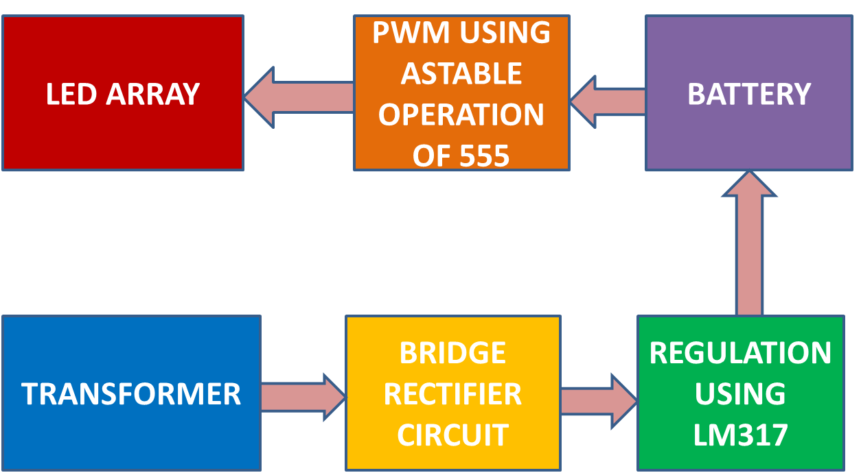

Fig.1. Layout of Circuit with PWM

**4. Fabrication**

The circuit has three sections:

**4.1 Power supply section**

The component of the charging device that accommodates the electrical power source: A transformer exhibiting a step-down function with a voltage output of 9V and a current output of 500mA. The function of the bridge rectifier is to rectify the electrical output of the transformer. The LM317 is a device utilized for voltage regulation. In the event of an electrical power disruption, the battery system activates to furnish the requisite power supply. A Zener diode is a semiconductor device that exhibits a unique electrical behaviour, whereby it transitions from a non-conducting state to a conducting state when the voltage across it exceeds a certain threshold value, known as the Zener voltage. This characteristic makes it useful in voltage regulation and protection applications.

* 1. **555 timer section**

In the 555 timer section, the LED section can be regulated using Pulse Width Modulation (PWM).

* 1. **LED driver section**

Incorporate the BD 140 component into the construction. A configuration of 12 white Light Emitting Diodes (LEDs) that are connected in parallel. The LED section illuminates in the event of a power outage. The 555 was utilized to achieve a consistent operation, resulting in the blinking of the device. The phenomenon of persistence of vision causes the appearance of full-time ON.

**Results and Discussion**

The key difference from PWM is that the power delivered to the load is continuously adjusted rather than being switched on and off rapidly. Keep in mind that the specific circuit configuration may vary depending on the desired application and the type of load being controlled. The circuit without PWM consumed more power than circuit with PWM.

Table 1: Power Consumed of Circuit without PWM and Circuit with PWM

|  |  |  |
| --- | --- | --- |
| Parameters | Circuit without PWM | Circuit with PWM |
| Voltage | 2.96 V | 2.74V |
| Current | 2.7 mA | 2.5mA |
| Power consumed | 7.992mW | 6.85 mW |
| Total power consumed | .095904 W | .0822 W |
| ***Percentage decrease*** | | 14.28 % |

Fig.2.Comparison of performance of LED, Fluorescent and Incandescent lamp

**5. Conclusion**

The project was determined to be innovative in enhancing daily life. The device introduces a novel aesthetic to conventional lighting fixtures. The implementation of Pulse Width Modulation (PWM) facilitates the mitigation of energy loss. The circuit's implementation cost is relatively low, which is a notable benefit of utilising it. Except cost, LED performs best in all aspects such as efficiency, luminous intensity and life span compared to fluorescent and incandescent lamp. Power consumed for circuit with PWM was reduced around 14.28% compared to circuit without PWM.

**Reference**

[1] A. Huang, “Basics of LED Lighting Control,” pp. 1–15, 2015.

[2] P. Adaptive, R. Smart, and S. Incandescent, “Pervasive Adaptive Resourceful Smart Lighting Supporting Incandescent and LED Light Bulbs,” pp. 1–20, 2019.

[3] S. Narasimha and R. S. Surender, “Design and development of smart emergency light,” *Telkomnika (Telecommunication Comput. Electron. Control.*, vol. 18, no. 1, pp. 358–364, 2020, doi: 10.12928/telkomnika.v18i1.13934.

[4] N. Vinothkumar, V. K. Subhash, T. Viswanathan, and S. P. S, “Intelligent Street Light Controller with Security System Fig. 1. Block diagram of proposed system,” no. 2, pp. 296–299, 2018.

[5] G. Habash, D. Chapotchkine, P. Fisher, A. Rancourt, R. Habash, and W. Norris, “Sustainable Design of a Nearly Zero Energy Building Facilitated by a Smart Microgrid,” *J. Renew. Energy*, vol. 2014, no. May 2010, pp. 1–11, 2014, doi: 10.1155/2014/725850.

[6] B. Cavanagh, N. K. Goodale, M. Janiga, S. Bitar, and J. McNeill, “Efficient Pulse Width Modulation LED Headlight Driver,” pp. 1–81, 2015.

[7] G. Y. Dayanikli, S. Sinha, D. Muniraj, R. M. Gerdes, M. Farhood, and M. Mina, “Physical-Layer Attacks Against Pulse Width Modulation-Controlled Actuators,” *Proc. 31st USENIX Secur. Symp. Secur. 2022*, pp. 953–970, 2022.

[8] R. Ranjan, “Smart Street Light on Highway with Energy Conservation and Accident Prevention,” *Int. J. Res. Appl. Sci. Eng. Technol.*, vol. 10, no. 7, pp. 549–557, 2022, doi: 10.22214/ijraset.2022.45326.

[9] W. T. Sung and J. S. Lin, “Design and implementation of a smart LED lighting system using a self adaptive weighted data fusion algorithm,” *Sensors (Switzerland)*, vol. 13, no. 12, pp. 16915–16939, 2013, doi: 10.3390/s131216915.