**DEVELOPMENT OF FIREFIGHTING ROBOT TO USE IN HAZARDOUS SITUATION**

*1Gireesh Kumar, Graduateship / Associate Membership, Mechanical and Automation Engineering, Indian Institute of Industry Interaction Education and Research, India*

*2Murugu Nachippan, Assistant Professor, Indian Institute of Industry Interaction Education and Research, India*

*3Tamilarasan, Project Coordinator, Indian Institute of Industry Interaction Education and Research, India*

**Abstract**

This innovative project lets users wirelessly control a firefighting robot with a water tank and spray gun. The robotic vehicle and water pump are controlled by an RF remote and RF receive-based microcontroller circuit. The receiver circuit receives commands from the RF remote. Receiver circuit decodes data commands. It sends it to the microcontroller. The microprocessor then instructs the vehicle motors to move in the specified direction. The water pump motor and pump direction motor spray water on user demand. The operator can operate the robot and extinguish the fire from a safe distance. The remote controls the robot within 8 metres.

Keywords: Firefighting robot, Microcontroller, Rf remote, Rf receiver

**1. Introduction**

A person who works as a fire extinguisher has a dangerous job that frequently puts their life in danger as they search for fires and put them out. Fires can cost lives and money. Explosives, smoke, and high temperatures can make firefighting difficult. Firefighters are also in danger. Firefighting robots can help in such situations. IOT powers this firefighting robot. Fire Extinguishing Robot will sense and move to a little flame to extinguish it. Firefighter delays can have serious repercussions. Fire Extinguishing robots monitor and extinguish fires immediately. The goal of this project is to provide a technical answer to the previously indicated difficulty. A mechanical device that is capable of carrying out an intricate sequence of activities automatically is known as a robot. In particular, a robot is one that can be programmed by a computer. A firefighting robot is a robotic device that may be operated autonomously or by remote control and is designed to aid firefighters in putting out fires and other potentially dangerous circumstances. These robots were designed from the ground up to carry out labour that is either perilous for humans or difficult for them to accomplish, such as going into burning buildings, finding and extinguishing fires, and carrying out search and rescue operations. A robot is a piece of machinery that mimics the appearance of a human being and is capable of performing a wide range of difficult activities. There is a diverse range of robots available, including those with a stationary base, mobile robots, underwater robots, humanoid robots, space robots, medicine robots, and others. A proposal for a fire extinguishing robot is presented in this study. This particular robot is outfitted with a single flame sensor that can detect the presence of fire in its surroundings and send the relevant signals to the microcontroller in order to activate the pump that sprinkles water on the flames in an effort to put them out. Robots designed for combating fires are outfitted with a variety of features, including ruggedized tracks or wheels, sensors for detecting and extinguishing fires, remote operation and autonomy, the capacity to manipulate objects and integrate tools, communication and mapping capabilities, resistance to heat, a small size and portability, and human-robot collaboration. They are built to endure the high heat and severe conditions that are common during firefighting operations. They are also available in a variety of sizes, ranging from compact and manoeuvrable models to bigger units that are able to carry heavy equipment or payloads. In addition to this, they are able to offer help, collect data, and carry out other duties that lessen the danger to human life. Firefighting robots need to be able to classify fire, smoke, and their thermal reflections to assess local conditions, decide a proper heading, and autonomously navigate toward a fire. Long-wavelength infrared camera images were used to capture the scene. Bayesian classifier and genetic algorithm optimization were used to find the best solution.[1]The project aims to develop a robotic vehicle capable of detecting and extinguishing fire automatically. It consists of a gas sensor, gear motor, relay driver, and Bluetooth module. When the sensor detects fire, the robot stops and starts a pump and sprinkler to extinguish it. Control is achieved using Arduino and Android mobile. [2]The proposed vehicle is able to detect fire and extinguish it automatically using gas and temperature sensors. It contains gear motors and motor driver to control the movement of the robot. It has a water jet spray capable of sprinkling water and obstacle avoiding capability. Communication between the mobile phone and robot will take place through Bluetooth. Android controlled robot can be used in everyday life.[3]Swarm robotics is the coordination of multiple robots as a system that consists of a large number of physical robots. Firefighting robots use water or chemicals to extinguish the fire, and can be used indoors and in places where water cannot be used. They can be used in buildings, warehouses, luxurious hotels and showrooms, where perishable or valuable items could be damaged by water or chemicals.[4]The purpose of this project is to design an automatic fire Fighting robot that can move, find the flame, and extinguish the fire, controlled by a microcontroller (Arduino).[5]This project presents a design and enforcement of a firefighting device that moves towards the fire and pumps out gas to extinguish the fire. It explains how to interface ARM7 with different components, making it useful for accompanying fire fighters and preventing outbreaks. [6]The project aims to design a firefighting robot that is small, powerful and versatile. It is designed with the help of NODE MCU board and can be controlled manually or automatically with the help of IOT. The robot overcomes obstacles and moves into the direction where it is obstacle. [7]QRob is a fire-fighting robot that can be controlled from a distance. It has advantageous features such as the ability to detect location of fire automatically, a compact body and lightweight structure, an ultrasonic sensor, and the ability to avoid hitting obstacles or surrounding objects. It can be used in small entrances and small spaces, and can sense smokes and fire accurately in a short time. [8]Disaster response, especially fire-fighting and rescue, is highly risky for firefighters. Existing robots are large and heavy, so we propose a novel hose type robot that can detect the fire in the area and automatically turn on the pump. An ultrasonic sensor is used to navigate through the area and detect the movement of humans, sending a buzzer alert to the security system. With the help of robot, we can fight under difficult conditions. [9]Firefighting is an important and dangerous occupation, and technology has improved to make it more efficient. This project is designing a firefighting robot using an Android app and sensors to sense fire. The app has buttons for controlling the movement of the robot and live video streaming to provide navigation. The robot will reach the location and spray water to extinguish the fire.[10]Firefighting is an important and dangerous occupation, and technology has improved to make it more efficient. This project is designing a firefighting robot using an Android app and sensors to sense fire. The app has buttons for controlling the movement of the robot and live video streaming to provide navigation. The robot will reach the location and spray water to extinguish the fire. [11]Fire extinguishing is an extremely dangerous undertaking and can lead to death. Robotics is the rising answer to ensure the safety of the environment and human lives. Fire extinguishing robots can be used to reduce the blunders and constraints faced by people during the extinguishing process. [12]The proposed project aims to develop an Arduino controlled fire fighter robot that can be used to extinguish the fire remotely. The vehicle consists of a water tank and pump, an Infrared receiver, an Arduino Uno microcontroller board, Android, a sprinkler, Bluetooth communication, and a wireless camera.[13]This paper presents fire detection and extinguishment using autonomous robots, as well as an assessment of several fire-fighting robots. It provides an overview of current research efforts to make fire-fighting robots smarter, less expensive and more efficient, including the use of cutting-edge sensors and wireless communication standards. [14]Firefighters are responsible for extinguishing fires in hazardous environments, such as nuclear power plants, gas stations, oil rigs, and narrow places. Technological advancements can be used to assist in firefighting operations, such as the development of a multi-purpose fire extinguishing robot. This robot can assist in carrying out fire extinguishing operations as well as reconnaissance missions. [15] The primary objective of the project is to build the firefighting robot and enables users to wirelessly control a firefighting robot with a water tank and spray gun from a safe distance.

**Materials and Methods**

**8051 Microcontroller**

Intel first introduced the 8051 microcontroller architecture in the early 1980s, and it quickly became one of the company's most successful and widely adopted products. It is based on the Von Neumann architecture, which integrates data memory and programme memory into a single space. It has a single-chip CPU with an ALU, control unit, and register set, memory, I/O ports, timers and counters, serial communication interfaces, interrupt-based programming, and a condensed instruction set. Additionally, it has memory that can store a large amount of data. For developers, the availability of development tools and compilers for programming the 8051 microcontroller makes it simpler to write, debug, and test their embedded software.

**Robotic Chassis**

The mechanical framework or structure that composes the body or foundation of a robot is referred to as the robotic chassis. It is what decides the robot's physical qualities, its mobility, and its overall functionality. One of the most prevalent kinds of chassis, wheeled chassis grant the robot the ability to move about by means of the wheels themselves. They can have two wheels, four wheels, or even more complicated arrangements than that, depending on the amount of wheels they are equipped with. Applications that require the robot to move on flat or slightly uneven surfaces are good candidates for wheeled chassis.

**Water Tank**

Water tanks are receptacles that are utilised for the purpose of storing and holding water in a variety of contexts, including residential, commercial, industrial, and agricultural operations. The primary purpose that they serve is to store water for later use, which ensures a stable supply of water in regions that have restricted access to municipal water sources or during periods of water shortage. They can also be used during times when there is an abundance of water.

**Spray Tube**

A spray tube is a component that can be used to discharge water or other substances that put out fires into a fire. In most cases, it takes the form of a lengthy tube in the cylindrical shape, and it is constructed out of materials that are resistant to heat, corrosion, and mechanical stress. Along its length, it is fitted with one or more nozzles that are capable of directing the flow of the liquid being dispensed in a regulated manner. In order to modify the flow rate and pressure of the water or agent that is being released, flow control systems are utilised. In order to maximise the usefulness of the robot in putting out the fire, it may articulate its joints and move freely around the area.

**Pump**

Firefighting robots' water or fire-suppressing agent delivery systems require pumps. It pressurises water or agent to battle fires. A firefighting robot's pump provides the pressure and flow rate needed to fight flames.

**RF Tx Rx**

RF Tx Rx devices transmit and receive radio signals for wireless communication. The transmitter turns electrical signals into radio frequency signals, while the receiver catches and demodulates them. Wireless communication using RF Tx Rx devices is common. Local restrictions determine frequency bands. RF Tx Rx devices modulate carrier signals to encode information. Transmit power, antenna design, ambient conditions, and interference sources affect range and signal strength. Antennas transmit and receive radio signals. Encryption can secure communication.

**RF Encoder IC and RF Decoder IC**

RF Encoder ICs (Integrated Circuits) convert digital data into RF signals for wireless communication. Telemetry, remote control, and wireless sensors use it. RF Decoder ICs (Integrated Circuits) receive and decode radio frequency (RF) signals into digital data. Modulation technique, data rate, channel count, and system compatibility determine the best RF Decoder IC.

**Resistors**

Resistors restrict the flow of electric current in a circuit, while capacitors store and release electrical energy in the form of an electric field. They are used for controlling current flow, voltage division, biasing components, and limiting current to protect other components. Transistors are essential components in modern electronics, used in amplifiers, digital logic circuits, power control, and signal processing.

**Cables and Connectors**

Cables and connectors provide the physical interface for data, power, and audio/video connections between electronic devices.

**Diodes**

Diodes block current in one direction but allow it in the other. A p-n junction is created by doping silicon or germanium. The diode is "on" when a forward voltage is supplied. The diode is "off" when reverse voltage is applied.

**PCB and Breadboards**

Electronic circuit prototyping and construction use breadboards and PCBs. PCBs are flat non-conductive boards with a thin copper covering on one or both sides. They enable board design, wiring, soldering, and manufacturing. Breadboards increase signal integrity, noise, and thermal management, whereas PCBs are compact, reliable, and repeatable. Breadboards are reusable electronic circuit platforms. They have a plastic board with grid-patterned holes that are internally joined to form electrical connections. They are great for rapid development and experimentation but lack signal integrity and stability.

**Light Emitting Diode**

The passage of an electric current through an LED causes it to emit light, which confers several advantages over more conventional sources.

**Push Buttons and Switch**

Push buttons are mechanical switches that are activated by applying force to them, connecting a button or actuator to a set of contacts.Switches are mechanical devices used to control the flow of electricity in a circuit.

**IC**

Integrated Circuits (ICs) are compact electronic devices made of numerous electronic components atop a semiconductor substrate. They are tiny and efficient electronic circuit builders that execute specific operations or difficult electronic activities.

**Circuit Diagram**

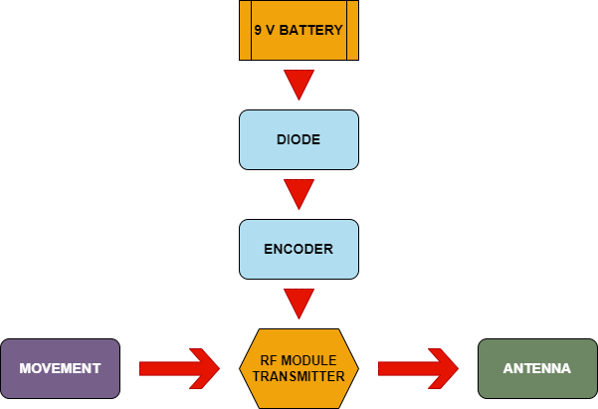

Fig.1. Circuit diagram of Transmitter operation

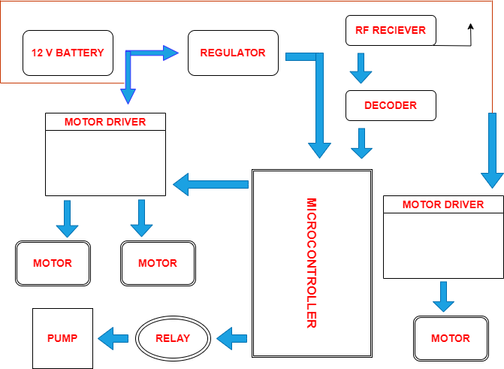

Fig.2. Circuit diagram for motor and pump operation

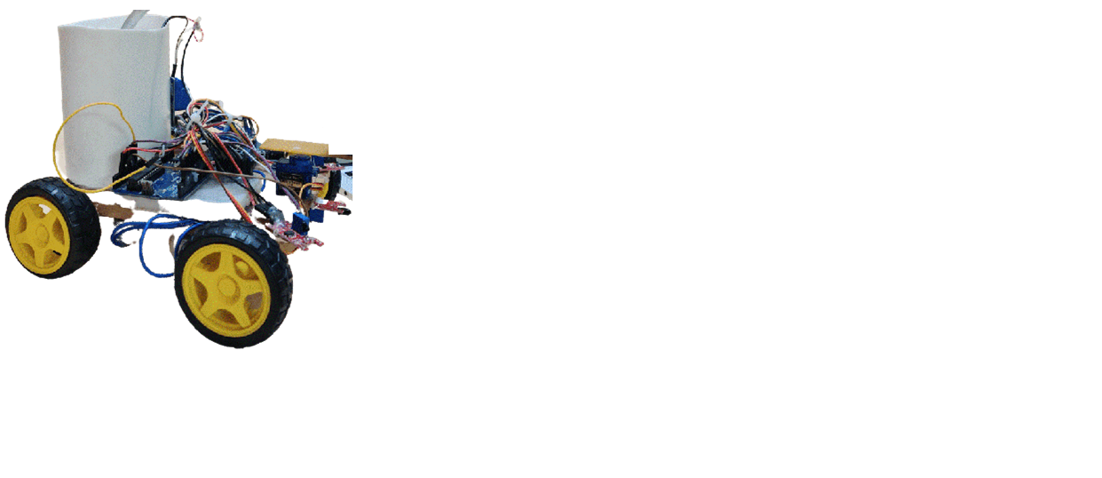

Fig.3. Prototype model of Firefighting robot

**Results and Discussions**

The fire-controlled extinguishing robot that can pinpoint the location of a fire and put out the blaze by activating sprinklers and pumps in response to the alarm. In order to provide the motors that are a part of the project with high voltage and high current, the motor driver board is put to use. The turning of the wheel is accomplished with the help of a straightforward DC motor, and the water that is poured into the flame is moved with the assistance of a pump. A firefighting robot is the primary focus of this project. The robot is designed to search for and put out flames in affected parts of the environment. Because of fire's concentrated effect on plant growth, it makes room for the emergence of new plant species. The number of fires that need to be put out would decrease as a result of this method, which would also boost the firefighters' efficiency.

**Conclusions**

The project's concluded that fire detection and response system without human intervention. Mobile agents may be used for activities that include the sensing of an external stimuli and reacting to the input, even if the reaction entails a considerable amount of mechanical operations, according to the development of sensor networks and the maturation of robotics, which suggests that mobile agents may be used for these types of tasks. The fight against fire is an obvious choice for such automation, and the implementation of the system is urgently needed. The first version of the robot that fights fires was cleverly conceived and built, with provisions made for its integration with a wide variety of sensors. The infrared light that is created by the fire is detected by the prototype using a photo diode, and a signal is then sent to the controller. We plan to expand our work by providing a keypad that can be programmed to allow manipulation of the robot. our will allow the robot to travel in the desired direction with the assistance of the motor driver module, and it will also allow the water tank to be rotated at 180 degrees with the assistance of the servo. This future work will also investigate the possibility of using a long distance sensor in conjunction with the appropriate technology in order to achieve better and more rapid results.

**References**

[1] J. H. Kim, S. Jo, and B. Y. Lattimer, “Feature Selection for Intelligent Firefighting Robot Classification of Fire, Smoke, and Thermal Reflections Using Thermal Infrared Images,” *J. Sensors*, vol. 2016, 2016, doi: 10.1155/2016/8410731.

[2] B. Sonal and G. Ujwala, “Android Controlled Fire Fighting Robot,” *Int. J. Comput. Eng. Appl.*, vol. XII, no. march 18, pp. 1–9, 2017.

[3] K. Kadam, A. Bidkar, V. Pimpale, D. Doke, and R. Patil, “Fire Fighting Robot,” *Int. J. Eng. Comput. Sci.*, vol. 7, no. 01, pp. 23383–23485, 2018, doi: 10.18535/ijecs/v7i1.02.

[4] O. Bhongale, K. Pal, P. Lingawar, and N. Hiwarkhade, “Fire Fighting Robot Using,” vol. 2, no. 12, pp. 4481–4486, 2018.

[5] S. D L, “Fire Fighting Robot,” *Int. J. Res. Appl. Sci. Eng. Technol.*, vol. 7, no. 5, pp. 3101–3105, 2019, doi: 10.22214/ijraset.2019.5512.

[6] A. K. Srivastava, K. K. Singh, K. V. Tripathi, J. D. Nath, K. Bhati, and Imamuddin, “Fire Fighting Robot,” *Invertis J. Sci. Technol.*, vol. 12, no. 2, p. 29, 2019, doi: 10.5958/2454-762x.2019.00006.4.

[7] N. Muthukumaran, A. Professor, and U. Scholar, “Design and Analysis the Fire Fighting Robot,” *Int. J. Emerg. Technol. Innov. Eng.*, vol. 5, no. 9, pp. 2394–6598, 2019, [Online]. Available: https://ssrn.com/abstract=3446709.

[8] M. Aliff, M. Yusof, N. S. Sani, and A. Zainal, “Development of fire fighting robot (QRob),” *Int. J. Adv. Comput. Sci. Appl.*, vol. 10, no. 1, pp. 142–147, 2019, doi: 10.14569/IJACSA.2019.0100118.

[9] A. M. K. Tabish Patel, Faizan Mistry, Aarif Nadaf, Owais Patel, “Autonomous Fire Fighting Robot,” *Int. J. Glob. Technol. Initiat.*, vol. 7, no. 1, pp. D31–D35, 2019.

[10] A. M. M. Sumitra Motade1, Aditi Suresh Bidwai 2, Komal Jaysing Kale3 and Assistant, “FIRE FIGHTING ROBOT USING ANDROID APPLICATION.pdf,” vol. 4, no. 11, pp. 9–12, 2020.

[11] S. Chitti, P. Ramchandar Rao, C. Padmaja, and D. Raghava Kumari, “Fire Detection and Direction Control of Fire Fighting Robot,” *IOP Conf. Ser. Mater. Sci. Eng.*, vol. 981, no. 3, 2020, doi: 10.1088/1757-899X/981/3/032016.

[12] D. Itole, P. Kumbhar, C. Kharche, and V. Lonari, “Fire Fighting Robot,” *Int. Res. J. Innov. Eng. Technol.*, vol. 05, no. 05, pp. 95–97, 2021, doi: 10.47001/irjiet/2021.505017.

[13] “RF CONTROLLED FIRE FIGHTING ROBOT WITH HIGH,” vol. 13, no. 07, pp. 1634–1641, 2022.

[14] K. Krishnan, M. Meghana, N. Mallasure, and S. Sindhu, “A Review on Fire Fighting Robot,” pp. 3623–3626, 2022.

[15] R. Dawale, P. Dudhe, S. Borate, A. Deshmukh, and M. Sugat Pawar, “Design and Development of Fire Extinguisher Robot,” *Int. J. Technol. Eng. Arts Math. Sci.*, vol. 1, no. 2, pp. 27–30, 2022, doi: 10.21275/SR21705175854.