TIMETABLE GENERATOR SYSTEM

Sahil Sameer Suriya1, Sayyam K Nahar2, Mr Deepak KR3

Student, Department of BCA1, 2

Assistant Professor, Department of BCA3

BMS College of Commerce and Management, Bangalore, Karnataka

**Abstract:** Creating and managing college schedules can be a complex and time-consuming task, involving numerous courses, professors, classrooms, and student preferences. To address these challenges, colleges are increasingly turning to technological solutions. In this article, we introduce the Timetable Generator System, a powerful software application designed to automate and optimize the process of generating college timetables. By leveraging advanced algorithms and intelligent scheduling techniques, this system streamlines the scheduling process, improves efficiency, and enhances the overall college experience for students, faculty, and administrators

**Keywords:** Time management, Add subjects, Add teachers, Add students, Conflict resolution, User-friendly interface

# INTRODUCTION

Timetable creation is a critical aspect of college administration, influencing student enrollment, faculty workload, and efficient utilization of resources. The Timetable Generator System offers an innovative approach to simplify and enhance the process, ensuring optimal scheduling for courses, faculty availability, and student preferences**.**

**Automated Course Scheduling:** The Timetable Generator System automates the course scheduling process by intelligently assigning courses to available time slots and classrooms. It takes into account various factors such as course prerequisites, faculty availability, room capacity, and student preferences. By automating this traditionally manual task, colleges can save significant time and effort while ensuring an optimized and conflict-free schedule.

**Optimization and Conflict Resolution:** The system employs advanced algorithms to optimize the timetable by minimizing conflicts, such as overlapping classes or resource clashes. It considers various constraints, including room availability, faculty preferences, and course requirements, to generate conflict-free schedule that meet the needs of both students and faculty

**Real-time Schedule Updates:** The Timetable Generator System provides real-time schedule updates, ensuring that any changes or adjustments are reflected immediately. This feature enables students, faculty, and administrators to stay informed and adapt to schedule modifications promptly. It reduces confusion and enhances communication by providing up-to-date information to all.

# LITERATURE REVIEW

1. Automated timetable generation using multiple context reasoning for university models.

Author: Dipti Srinivasan, Tian Hou Seow, Jian Xin Xu

“Dipti Srinivasan, Tian Hou Seow and Jian Xin Xu” proposed that finding a feasible lecture/tutorial timetable in a large university department is a challenging problem faced continually in educational establishments. This paper presents an evolutionary algorithm (EA) based approach to solve a heavily constrained university timetabling problem. The approach uses a problem specific chromosome representation. Heuristics and context-based reasoning have been used for obtaining feasible timetables in a reasonable computing time. An intelligent adaptive mutation scheme has been employed for speeding up the convergence. But this system is difficult to implement since it considers entire university problem and evolutionary algorithm.

1. University Time Table Scheduling using Genetic Artificial Immune Network.

Author: Antariksha Bhaduri

Antariksha Bhaduri in their article proposed that Scheduling is one of the important tasks encountered in real life situations. Various scheduling problems are present, like personnel scheduling, production scheduling, education time table scheduling etc. Educational time table scheduling is a difficult task because of the many constraints that are needed to be satisfied in order to get a feasible solution. Education time table scheduling problem is known to be NP Hard. Hence, evolutionary techniques have been used to solve the time table scheduling problem. Methodologies like Genetic Algorithms, Evolutionary Algorithms etc. have been used with mixed success. In this paper, we have reviewed the problem of educational time table scheduling and solving it with Genetic Algorithm. We have further solved the problem with a mimetic hybrid algorithm, Genetic Artificial Immune Network and compare the result with that obtained from GA.

1. A mimetic algorithm for university course timetabling problem.

Author: Sadaf N. Jat, Shengxiang Yang

“Shengxiang Yang, Member, IEEE, and Sadaf Naseem Jat” proposed that The university course timetabling problem (UCTP) is a combinatorial optimization problem, in which a set of events has to be scheduled into time slots and located into suitable rooms. The design of course timetables for academic institutions is a very difficult task because it is an NP-hard problem. This paper investigates genetic algorithms (GAs) with a guided search strategy and local search (LS) techniques for the UCTP. The guided search strategy which is used here is to create offspring into the population based on a data structure that stores information extracted from good individuals of previous generations. The LS techniques use their exploitive search ability to improve the search efficiency of the proposed GAs and the quality of individuals. The proposed GAs is tested on two sets of benchmark problems in comparison with a set of state-of the- art methods from the literature. The experimental results show that the proposed GAs is able to produce promising results for the UCTP

Wikipedia also gave a definition as;

A school timetable is a table for coordinating these four elements:

* Teachers
* Students
* Subjects
* Time slots or Periods

# METHODOLOGY

The methodology for developing a timetable generator system involves several steps. Here's a general outline of the methodology:

1. **Requirements Gathering:** Understand the specific requirements of the college, including the number of courses, departments, classrooms, faculty availability, student schedules, and any other constraints that need to be considered.
2. **Data Collection:** Gather all the necessary data, such as course schedules, faculty availability and any other relevant information. This data can be collected manually or through an automated process if the college already maintains a digital database.
3. **Design the Data Model:** Design a suitable data model to represent the various entities involved, such as courses, departments, classrooms, faculty, and students. Determine the relationships and attributes required to store the necessary information.
4. **Implement the Timetable Generator:** Develop the software system that will generate the college timetable based on the defined requirements, data model, and selected algorithm. This involves writing code to process the data, apply the constraints, and generate feasible timetables.
5. **Validation and Testing:** Test the system with sample data and real-world scenarios to ensure that it produces valid and optimized timetables. Identify any issues or conflicts that may arise and refine the system accordingly.
6. **User Interface Development:** Design and develop a user-friendly interface that allows college administrators or faculty members to input data, configure constraints, and view generated timetables. The interface should provide options for manual adjustments and allow users to review and finalize the generated timetable.
7. **Maintenance and Upgrades:** Regularly maintain and update the system as per the changing requirements and constraints of the college. Incorporate feedback from users and make improvements to enhance the functionality and performance of the system.

# FLOW CHART

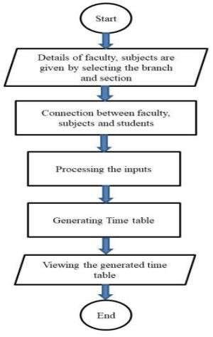

# USE CASE DIAGRAM

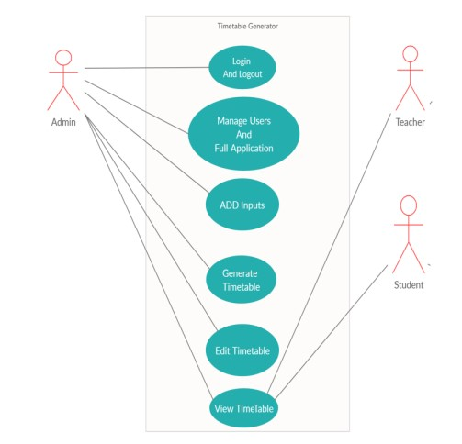

# SYSTEM DESIGN

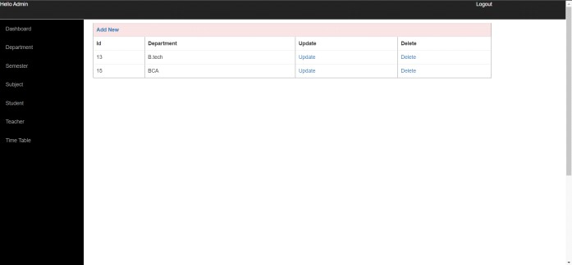

Admin Panel to add department

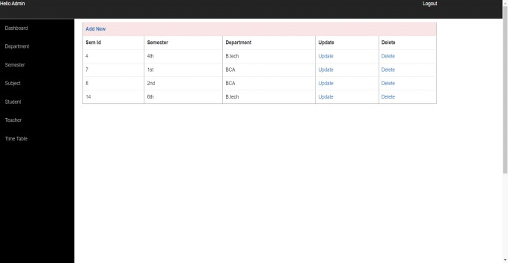

Admin Panel to add semester

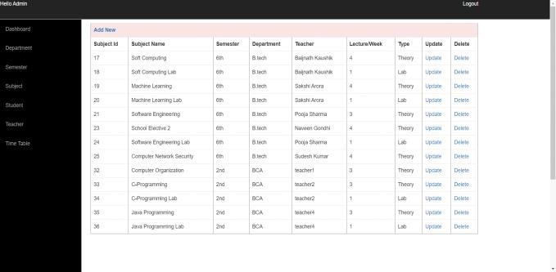

Admin Panel to add subjects

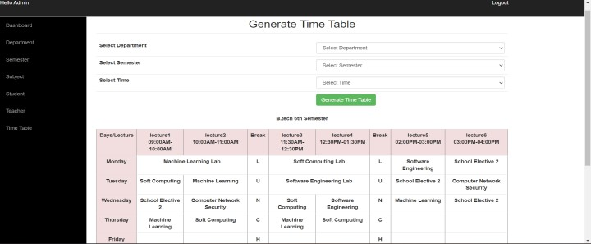

Admin Panel to generate timetable

# CONCLUSION

The Timetable Generator System revolutionizes the process of college schedule creation and management, bringing efficiency, optimization, and flexibility to the forefront. By automating scheduling tasks, integrating student preferences, and optimizing resource utilization, colleges can provide a smoother and more personalized experience for students, faculty,

# REFERENCES

1. Dipti Shrinivasan “Automated time table generation using multiple context reasoning for university modules” Published in: evolutionary computation, 2002. cec '02. proceedings of the 2002 congress on (volume:2).
2. D. Srinivasan, Tian Hou Seow, Jian Xin Xu, “Automated time table generation using multiple context reasoning for university modules”, Proceedings of the 2002 Congress on Evolutionary Computation. CEC'02 (Cat. No.02TH8600) published by IEEE in 07 August 2002

[3]Bhaduri a “University timetable scheduling using genetic algorithm”. Advances in Recent Technologies in Communication and Computing, 2009. ARTCom '09. International Conference. [4]Adithya R Pai, Ashwitha S, Raksha Shetty, Prof. Geethalaxmi, “Automatic timetable generator”, International Journal of Computer Engineering and Applications, Volume XII, Issue II, www.ijcea.com ISSN 2321-3469, Feb. 18