ONLINE EVENT MANAGEMENT SYSTEM FOR STDUIO
R. Ramakrishnan1, M.Jagan2 ,M.E Madhan kumar3
1 Associate professor, Department of Master Computer Application, Sri Manakula Vinayagar
Engineering College, Pondicherry-605 107.India
ramakrishnanmca@smvec.ac.in
2PG Student, Department of Master Computer Application, Sri Manakula Vinayagar
Engineering College, Pondicherry-605 107.India
jaganeditz@gmail.com
3 PG Student, Department of Master Computer Application, Sri Manakula Vinayagar
Engineering College, Pondicherry-605 107.India
madhankumarme7@gmail.com

ABSTRACT
The Online Event Management System for Studios is a comprehensive platform designed to simplify the process of planning and executing events in a studio setting. This innovative system leverages digital technologies to offer studio owners and event organizers a seamless and efficient solution for managing all aspects of event organization, from pre-event planning to post-event analysis. The system's key features include an intuitive user interface that allows event organizers to create and customize event profiles, manage guest lists, schedule studio bookings, and coordinate with vendors and staff. Through the platform, event organizers can seamlessly communicate with clients, track event progress, and generate comprehensive reports, enhancing overall event productivity.
The Online Event Management System for Studios also incorporates integrated financial management tools, enabling users to generate invoices, process payments, and track expenses. This feature eliminates the need for manual bookkeeping, reduces administrative tasks, and ensures accurate financial records for each event.
Keywords: user interface, create and update event, event list, employee list and customer list.
I INTRODUCTION
In Studios, whether they cater to photography, videography, or audio production, often serve as venues for various events such as photo shoots, video productions, workshops, and more. To meet the growing needs of studio owners and event organizers, the Online Event Management System for Studios has emerged as a game-changing solution. The Online Event Management System for Studios is a comprehensive and user-friendly platform designed to streamline the entire event planning and execution process. By harnessing the power of online technology, this system revolutionizes how studios manage and organize events, ensuring a seamless and hassle-free experience for both studio owners and other studio employee.
With this system, studio owners and another studio employee can effortlessly create event profiles, manage customer lists, and schedule studio bookings, all from a single, intuitive interface. This eliminates the need for disjointed communication channels and facilitates seamless collaboration between all stakeholders involved in the event planning process. Additionally, the system allows for efficient coordination with different vendors, ensuring that everyone is on the same page and well-informed throughout the event journey.

2.EXISTING SYSTEM
The existing system for an event management system in a studio can vary depending on the specific studio and its requirements for maintaining by hand written books or short note in notepad it made by manual. The existing system likely includes a booking and scheduling module to manage the availability of the studio and its resources (such as equipment, staff, and locations) for different events. This module may allow users to check availability, make bookings, and view existing reservations. The existing system for event management in a studio environment may involve a combination of manual processes, spreadsheets, and generic event management tools.

3.PROBLEM IDENTIFICATION
The existing system may lack an efficient booking and scheduling process, leading to double bookings, conflicts, or difficulties in managing the studio's availability. This can result in confusion, delays, and dissatisfaction among clients and staff. If the current system lacks robust communication and collaboration features, it can hinder effective coordination among event organizers, studio staff, and clients. This can lead to miscommunication, delays in decision-making, and a lack of clarity regarding event details. If the system relies heavily on manual processes, such as manual data entry, paper-based documentation, or manual invoice generation, it can be time-consuming, error-prone, and inefficient. This can lead to delays, inaccuracies, and increased administrative burden.
4. PROPOSED SYSTEM
The proposed system is an integrated and comprehensive event management system designed specifically for studios. It aims to address the identified problems and provide a centralized platform that streamlines the entire event planning and execution process.
5.SCREEN SHORT WITH MODULE EXPLANATION
HOME PAGE

The home page has two logins, which are the Employee login and the Admin Login.

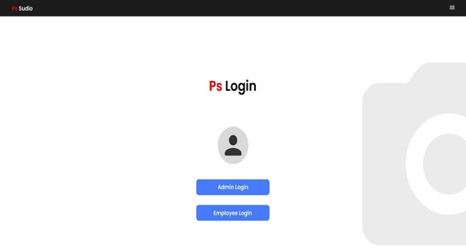

Figure 1: Home page

6.EMPLOYEE MODULE

The employee who working in the studio has unique ID and password to login their page. The Employee can Login, view notification, view events, send feedback and send queries.

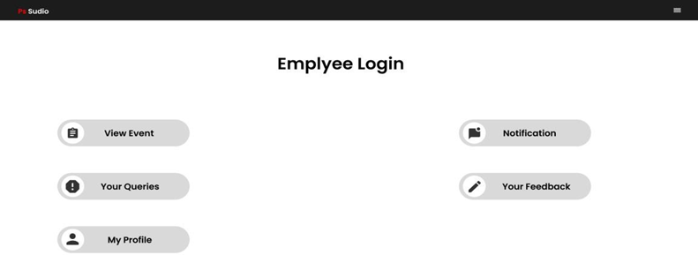
Figure 2: Employee module
View Event List:

The Event list is used to view the events with the Event ID, Name, Phone no, Event name, Package, Venue, Advance amount, additional information to the Employee. So, that the employee can easily view the details of a user.

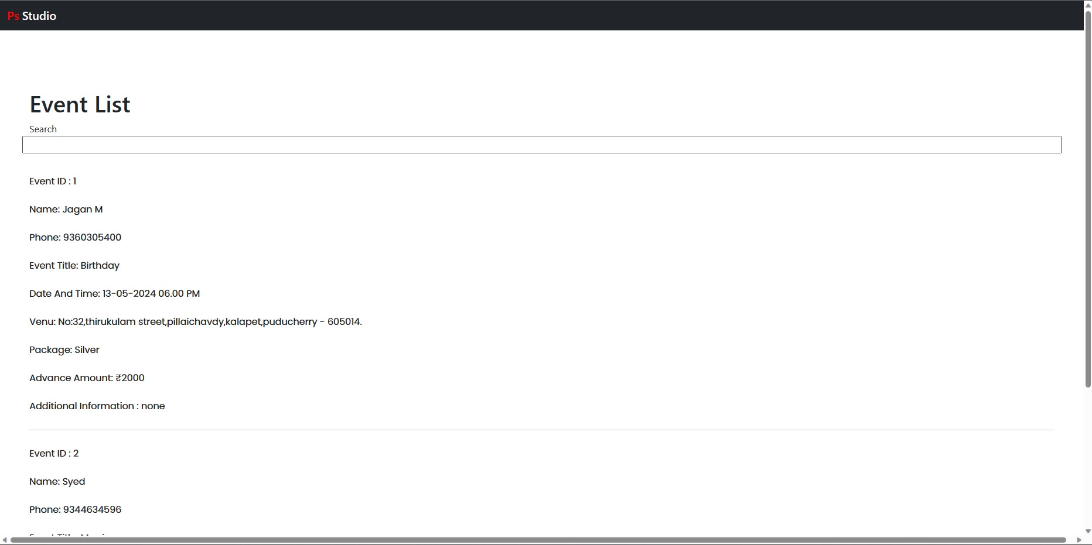
Figure 3: Event List

Post Query:
The Post Query is used to post your doubts, give suggestion and your ideas to the admin and admin will view your queries. This Post Queries contain three fields which are the e-mail, user ID and the query text area.

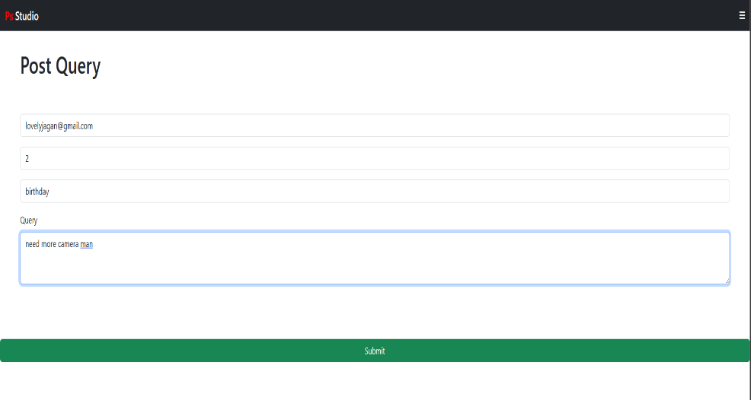

Figure 4: Post Query
Your Query:
The Queries module is a component of a project that involves interacting with a database or processing user inputs. It handles the task of receiving queries or requests from users or external systems and executing the necessary actions to provide the desired results.
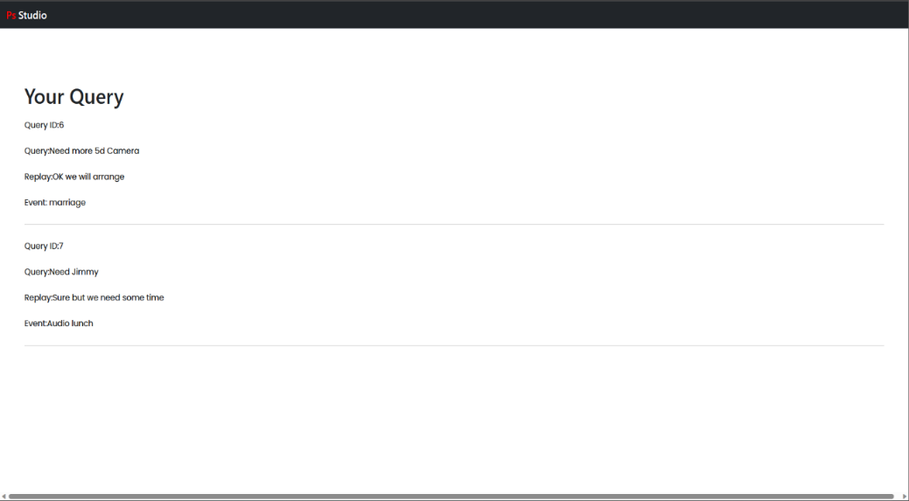

Figure 5: Your Query
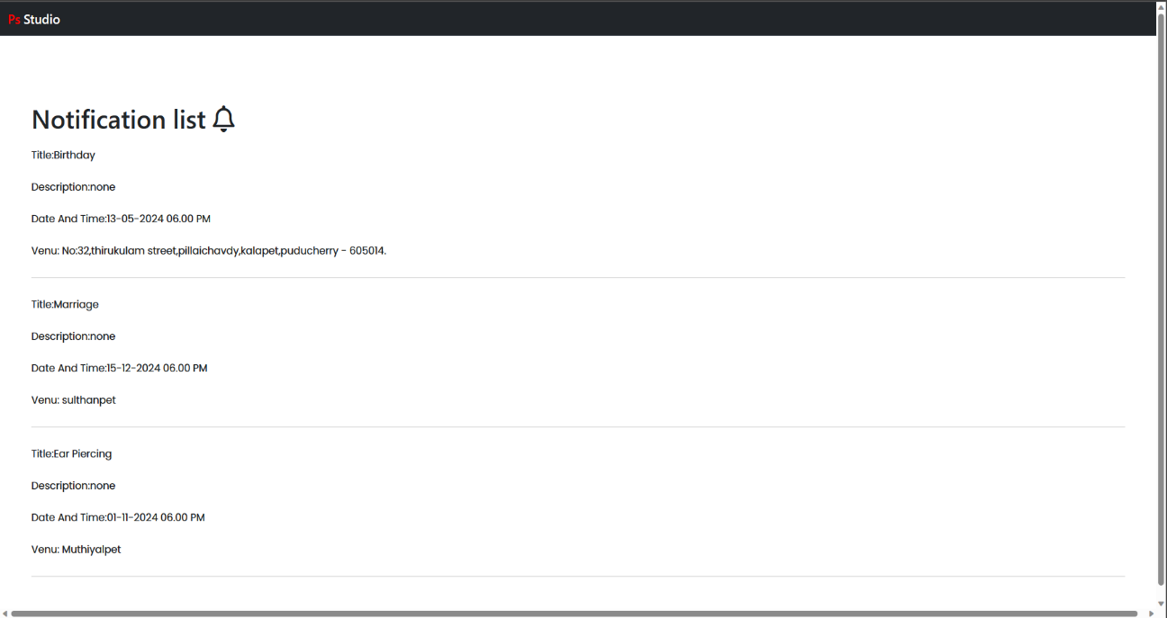
View Notification: The Event Notification which was send by the admin, the employee gets received the notification and view the notification. The notification of the event name, date, time and venue which will show through the display.

Figure 6: View Notification
7.ADMIN MODULE
The admin who can create, update the events, update the user details, Admin will create the notification of an events details and send to their employees, view feedback and view queries raised by the employees.
The admin modules include login, create user, update event, create user, user details, create notification, view notification, view feedback and view queries.

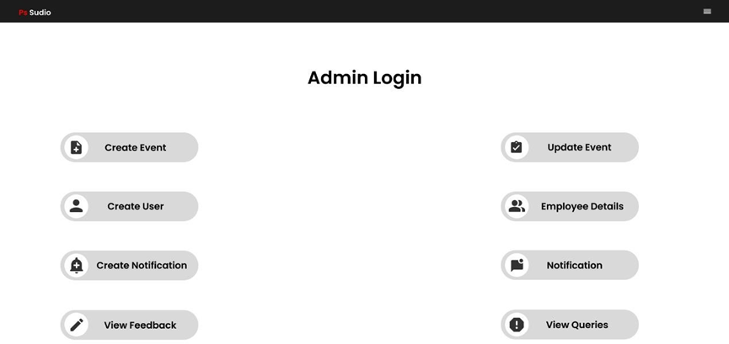

Figure 7: Admin module

Answer The Query
Admin is used to answer the query that employee posted in the web site

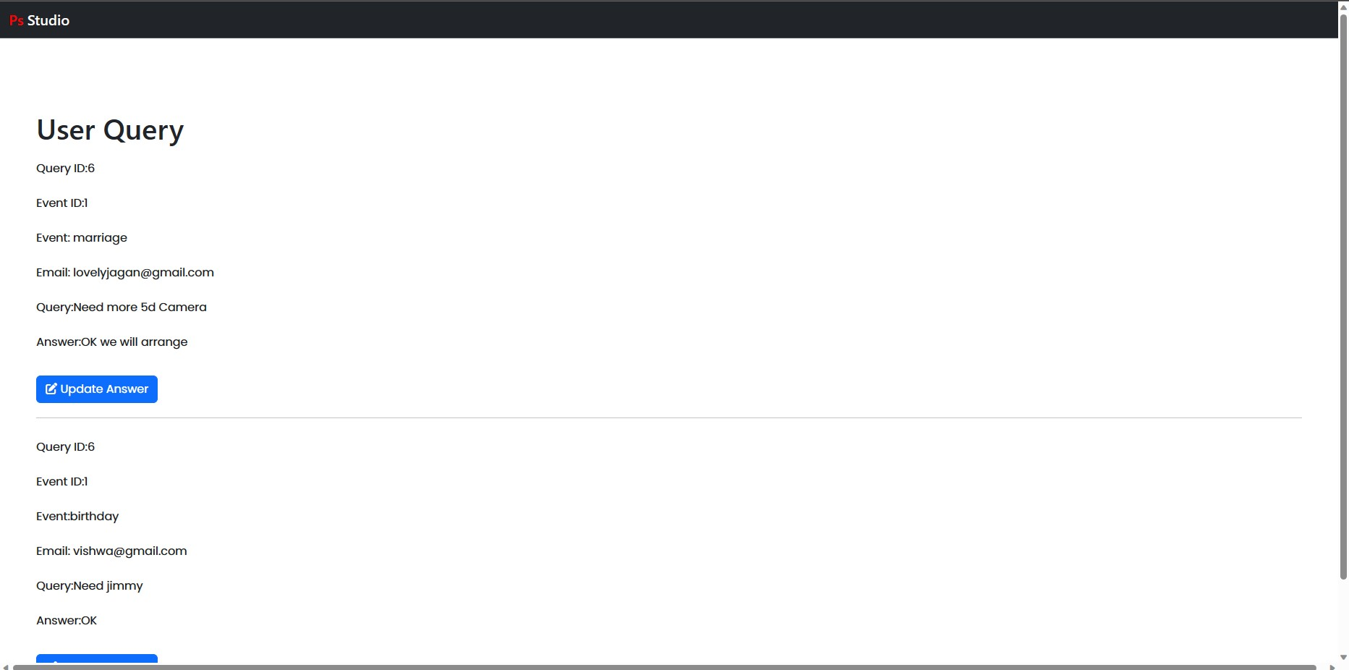
Figure 8: Answer the Query

Create Event
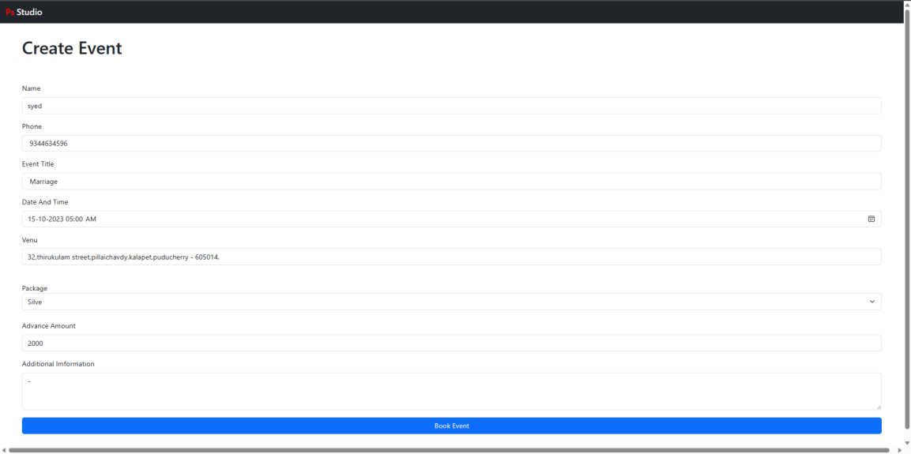
The admin has to create the new event list of a customer and enter the customer details like name, phone no, event title, date and time, address, package and advance amount.

Figure 9: create event
Event List

The event list of an admin module will show the entire event list of an customer and the admin will update the event list through the edit option. Once the event was end or the customer will cancel the event, then admin will use the delete button to delete the particular event from the database.
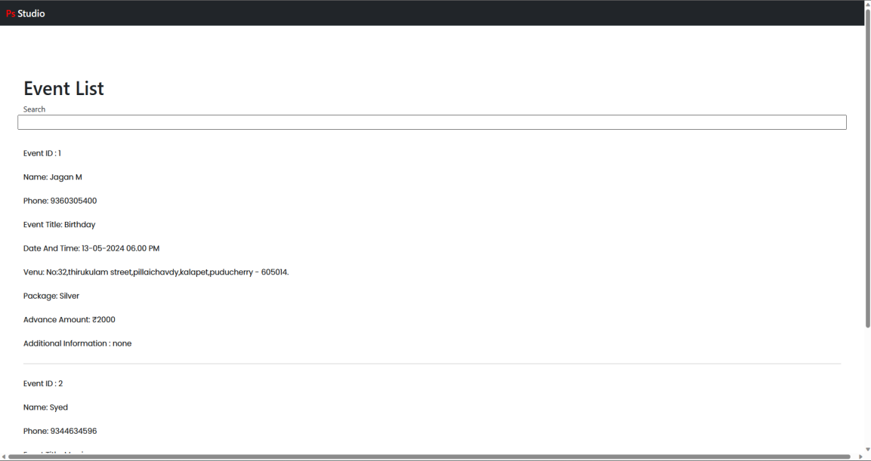

Figure 10: Event List
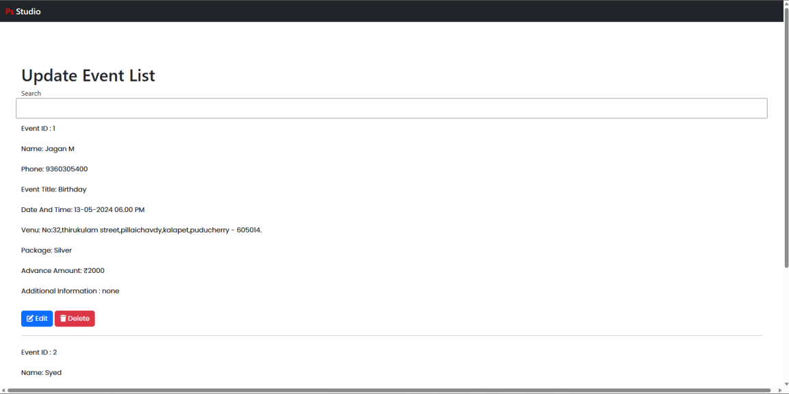

Figure 11: Update Event List
Send and Update Notification
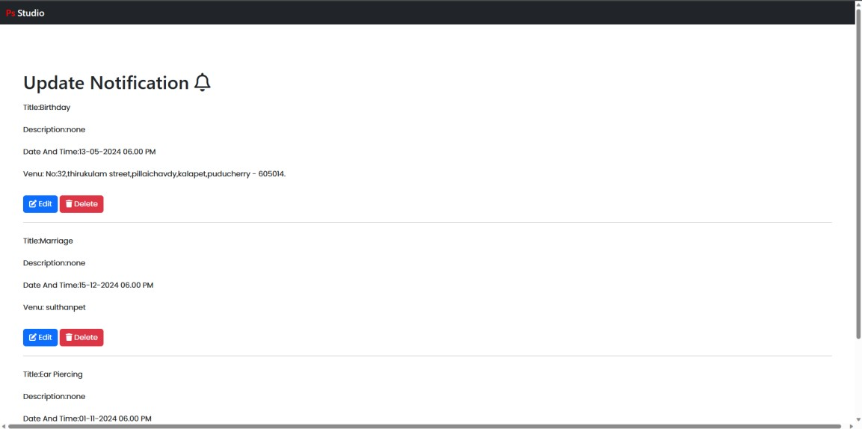
The admin will send the notification of the event name, time, date and venue to the employee for a reminder of an event dates and update the notification through the edit option to remember the event date to the employee. And delete the notification through the delete option once the event was ended.

Figure 13: Update notification

DATA DESIGN
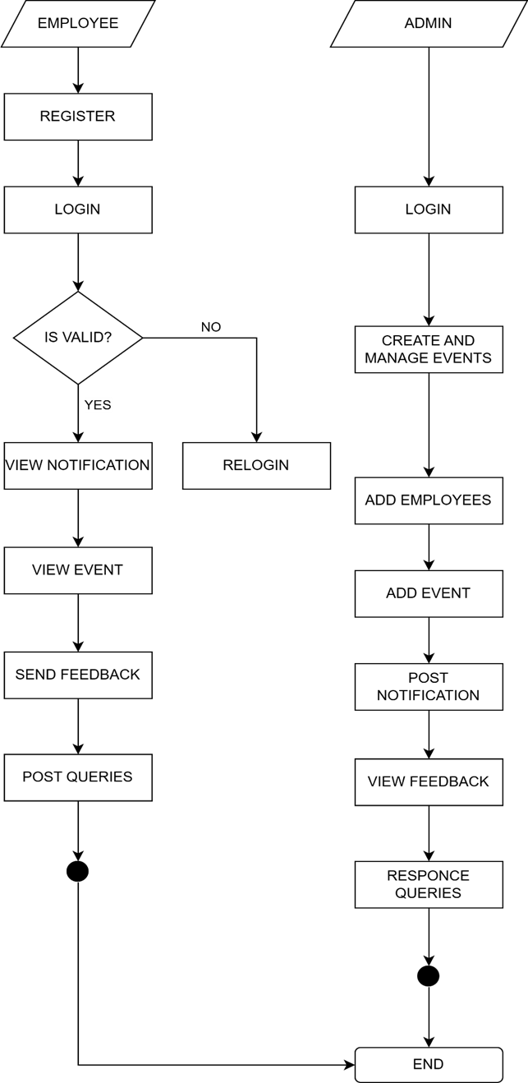
Figure 14: Data Design
8.TECHNOLOGY USED
IDE:
VISUAL STUDIO CODE
Visual Studio Code( VS Code) is a featherlight source law editor developed by Microsoft. It's designed to give a rich and customizable coding terrain while being presto, effective, andcross-platform. VS Code supports a wide range of programming languages and offers multitudinous features and extensions that enhance productivity for inventors. VS Code is available for all platform icing a harmonious experience across different operating systems. The editor's stoner interface is largely customizable, allowing inventors to epitomize their coding terrain with themes, icons, and settings to suit their preferences. it also known as IntelliSense, which offers suggestions for law particles, function autographs, and variable names as you type. It helps speed up development and reduce typos. VS Code includes an intertwined terminal, allowing inventors to execute commands and scripts without leaving the editor. It supports both the command advisement and shell surroundings. The editor is largely extensible, enabling inventors to install a wide range of extensions to enhance their workflow. It provides visual diff tools, source law operation, and flawless integration with depositories similar as GitHub. The editor includes a important debugging interface that supports colorful programming languages. It uses to inventors allow to set breakpoints, check variables, and step through their law to find and fix issues. VS Code supports task robotization through the integrated task runner. It provides interface inventors to define and execute or erecting systems without leaving the editor. VS Code offers Live Share, a point that enables cooperative rendering sessions. It allows multiple stoner or inventor to work together in real- time, participating their editor defenses, outstations, and debugging sessions.
9.HTML FRAMWORK
HTML frameworks are sets of pre-written code and libraries that provide developers with a structured and efficient way to build real-tine applications. These frameworks offer a collection of ready-to-use HTML, CSS, and JavaScript components that simplify the development process and ensure consistency across different projects. One popular HTML framework is Bootstrap. Bootstrap is an framework developed by Twitter. It provides a responsive grid system, CSS styling for typography and forms, and a wide range of pre-designed user interface (UI) components such as buttons, navigation bars, and modals. Bootstrap is known for its ease of use and customization options, making it a favourite among developers looking to quickly prototype or build visually appealing websites.
CSS
Cascading Style Sheets, or CSS, is a fundamental technology used for styling and presenting web pages. It works in conjunction with HTML and allows developers to control the layout, appearance, and behaviour of elements on a webpage. CSS provides a powerful set of tools and properties that enable precise control over the visual aspects of a website, including colours, fonts, spacing, and positioning. CSS operates on a rule-based system, where selectors target specific HTML elements, and declarations within the rules define how those elements should be styled. Selectors can target by their tag name based on elements, class, ID, or other attributes, allowing for granular control over individual or groups of elements. Declarations consist of property-value pairs that define the desired styles, such as setting the font size, background colour, or border radius.
MYSQL
MySQL is a popular open- source relational database operation system( RDBMS) that's extensively used for managing and storing structured data. It was originally developed by a Swedish company called MySQL AB, innovated by Michael Wideners, and is now possessed by Oracle Corporation. As an RDBMS, MySQL allows druggies to produce, organize, and manipulate databases using a structured query language known as SQL( Structured Query Language). SQL is a standardized language used for managing relational databases and performing colorful operations similar as querying, fitting , streamlining, and deleting data. MySQL offers a robust and scalable platform for storing and reacquiring data efficiently. It provides features similar asmulti-user access, data security, data integrity, and sale support. also, it supports colorful storehouse machines, including Inorb, Misa, and others, which offer different capabilities and performance characteristics.
PHP
PHP, which stands for Hypertext Preprocessor, is a popular garçon- side scripting language used for web development. It's known for its ease of use, versatility, and wide relinquishment in the assiduity. PHP allows inventors to produce dynamic web runners, interact with databases, handle form cessions, and perform a variety of garçon- side tasks. One of PHP's crucial strengths is its integration with HTML, making it flawless to bed PHP law directly within HTML lines. This allows inventors to mix dynamic and stationary content, enabling the creation of interactive web runners. PHP also supports a vast array of erected- in functions and libraries that grease common web development tasks, similar as train running, database connectivity, and data manipulation. PHP is extensively supported by colorful web waiters and operating systems, making it a protean choice for web development. It can be used to make small particular websites, large- scale enterprise operations, content operation systems( CMS),e-commerce platforms, and more. PHP fabrics like Laravel, Symfony, and CodeIgniter give fresh structure and features to streamline development and enhance law association.
Angular Js:
AngularJS is a important JavaScript- grounded open- source frame developed and maintained by Google. It's designed to simplify the development of dynamic and single- runner operations( gyms). AngularJS follows the Model- View- Controller( MVC) architectural pattern, which promotes a clear separation of enterprises and enhances law maintainability. One of the crucial features of AngularJS is its two- way data list. It allows automatic synchronization of data between the model and the view, barring the need for homemade updates. This simplifies the development process and improves productivity. also, AngularJS provides a rich set of directives that extend HTML's capabilities, enabling inventors to produce applicable factors and fluently manipulate the DOM( Document Object Model). Another significant aspect of AngularJS is reliance injection. It allows inventors to define and fit dependences into their factors, making the law modular and largely testable. This promotes law reusability and maintainability, as factors can be fluently shifted or replaced without impacting the rest of the operation.
10.Future Enhancement
Virtual Reality (VR) Integration: Explore the integration of virtual reality technology to provide an immersive experience for attendees. VR can allow participants to explore virtual event spaces, interact with 3D content, and engage with presenters and fellow attendees in a more interactive and engaging manner. Artificial Intelligence (AI) and Chatbots: Incorporate AI-powered chatbots to handle common attendee inquiries and provide real-time assistance. Chatbots can help answer questions, provide event information, guide attendees through the registration process, and offer personalized recommendations based on attendees' preferences. Live Streaming and On-Demand Content: Enhance the streaming capabilities of your online event management system to support high-quality live streaming of studio events. Additionally, consider providing on-demand access to recorded sessions or exclusive content for attendees who may have missed the live event or want to revisit specific sessions. Multi-language Support: Consider adding multi-language support to your event management system to cater to a global audience. This can involve providing event content, registration forms, and communication in multiple languages, ensuring inclusivity and accessibility for attendees from diverse backgrounds.
Conclusion
Start by defining your specific needs and goals for the online event management system. Consider factors such as the types of events you plan to host, the number of participants expected, registration and ticketing processes, event scheduling, payment integration, attendee management, and reporting requirements. Look for a reliable and feature-rich online event management platform that aligns with your requirements. Evaluate platforms based on their capabilities for event registration, ticketing, customization options, integration with other systems (e.g., website, payment gateways), attendee communication features, reporting and analytics, and user experience.
Regularly gather feedback from event participants and internal stakeholders to identify areas for improvement. Keep an eye on industry trends and advancements in event management technology to stay up to date with new features and tools that can enhance your online event management system.
REFERENCE
Lung-Chuang Wang, “Enhancing construction quality inspection and management using RFID technology”, Journal Automation in Construction, Elsevier, pp. 468-469, 2008.
2) Fauzan Saeed, Mustafa Rashid, "Integrating Classical Encryption with Modern Technique", IJCSNS International Journal of Computer Science and Network Security, VOL.10 No.5, May 2010.
3) Kullaprapa Navanugraha, Pornanong Pongpaibool, Chalee Vorakulpipat, Nuttapong Sanglerdsinlapachai, Nutvadee Wongtosrad, Siwaruk Siwamogsatham, “The Deployment ofthe Auto-ID System in a Conference”, PICMET, IEEE, pp.1-7, 2010
4) L. McCathie and K. Michael, “Is it the End of Barcodes in Supply Chain Management?”, Proceedings of the Collaborative Electronic Commerce Technology and Research Conference LatAm, 2005.
5) Cristian CIUREA, "Implementing an Encryption Algorithm in Collaborative Multi cash Service desk Application", Open Source Science Journal, Vol. 2, No. 3, 2010.
6) Paul M. Swamidass, “Bar Code Users and Their Performance”, White Paper, UNOVA Inc., 1998.
7) Roozbeh Derakhshan, Maria E. Orlowska and Xue Li, “RFID Data Management: Challenges and Opportunities”, IEEE International Conference on RFID, 2007
8) Zebra Technologies, “It‟s All In The Wrist: Improving Patient Safety With Barcode Wristbands”, White Paper, Zebra Technologies, 2013.
9) Arthorne, J.; Laffra, C. Official eclipse 3.0 FAQs, Addison – Wesley Professional,2004.
10) Thomas, O. Reference Model Management, In Kelley, G. (Ed.), Selected Readings on Information Technology Management: Contemporary Issues, Hershey, New York, 2008.

