# Wireless notice board using Bluetooth and

WIFI module

K.Sravanthi ***Vignan”s institute of information technology***

B.V.V.Yeswanth

### *Vignan”s Institute of* Information Technology

T. Dinesh swamy

### *Vignan”s Institute of* Information Technology

B.Arundhati

### *Vignan”s institute of* information technology

M.Varaprasad

### *Vignan”s Institute of* Information Technology

K.sujitha

### *Vignan”s Institute of* Information Technology

S.S.Ramakrishna

### *Vignan”s Institute of* Information Technology

***Abstract—* Due to the process of exploring things over the society to get to know what is happening in the world, the things are getting at most immediate on not getting any delay. To get reach over all the surrounding purposes to get out of the optimal problems to an optimal solution the message has been passed which is more reliable and also the way of passing out the message from the mobile phone through a application to make it possible to visible in a notice board. To pass the messages through the mobile phone and the messages to be displayed on a notice board this purpose of actually creating the application of wireless notice board. This can be used and reached all over the places like malls,hospitals,theatres and many places to get to know what is actually happening over the society and things can be worked out easily.**

***Keywords:* Arduino UNO; Switch Mode Power Supply (SMPS); SMPS board**

1. **INTRODUCTION**

The Today's world is increasingly dominated by mobile phones and related technologies. Over the areas of communication and embedded system”s, people are being exposed to a wider range of technical topics on a regular basis. Cell phone use has grown dramatically during the previous 15 years. The development of networking technologies has helped to create and grow highly dense networks. Landlines are now rarely used because the general public prefers to communicate while moving about. Many sheets of paper are utilised and then discarded by organisations. This, in turn, causes extensive deforestation, contributing to the Global Warming. Small innovations and moves on using the technology for everyday reasons would have a negative impact on the environmental challenges we are currently concerned about. This paper's proposal system has various

future applications in many of the education institutions and also organizations, criminal prevention, traffic management, trains, advertisings, and so on. This application's user friendliness, extensive A wider variety and faster means of transmitting information are valuable assets. Using the presented methods, we can imperatively improve the security system.

1. **RELATEDWORK**

Informing the public with a WIFI-enabled wireless notice board that is of electronic notice display board. This would allow us to send any message practically instantaneously and without delay simply by sending an SMS, which is better and more reliable than the old traditional technique of posting the message on the notice board.

This proposed WIFI technology can be atmost used in a variety of public places, shopping malls, or huge constructed buildings to increase security, raise awareness in emergency situations, and prevent various hazards. Using several AT instructions, the message is displayed on the display board. WIFI technology is used to control the display board and communicate information via a message supplied by an authenticated user.

The primary goal of the work is to designate the SMS-driven automatic system of the display board that can replace the currently employed programmable electronic device. The transmitter and receiver parts can describe the full method. The WIFI or BLUETOOTH module receives a message from the authorised mobile phone and retrieves the message from the mobile.

WIFI and Bluetooth module is controlled by the microcontroller and displayed on the MATRIX display board. Serial to parallel communication is used throughout the process, from the WIFI module to the microcontroller and over the matrix. In addition, an LCD display acknowledgement.

1. **PROPOSED MODEL**

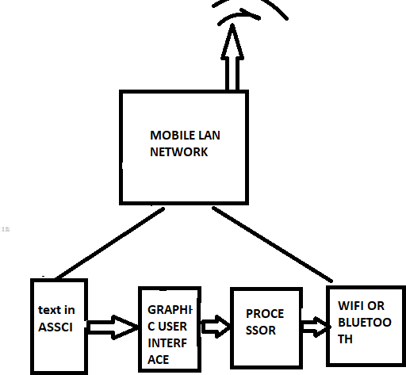

## CONNECTING LED DISPLAY WITH THE MICRO CONTROLLER

An LED matrix is an arrangement of LEDs that is made up of the positive (anode) and negative (cathode) terminals of each LED in the same column and row, respectively.LED matrix is formed by connecting the positive terminal (anode) of each LED in the same column and the negative terminal (cathode) of each LED in the same row. It should be noted that this can be done in the opposite direction, with the positive terminal that has been connected to maximum number of rows and also some

_ve terminals that are connected to many of the columns. An LED dot matrix is displaying and (the name "dot" refers to utmost circular lense in front to many LEDs) and can also contain multiple LEDs of different colours behind the each dot in the matrix. A color of Red, Green, and Blue LED, for example, is hidden behind each dot in the matrix used in this project.

If the switching is carried out quickly enough, there won't be any visible flicker, and the LED matrix display will seem to have all of its LEDs turned on simultaneously. The Persistence of Vision theory, which argues that the retina of the human eye retains an image for around a tenth of a second, explains why this works. An LED matrix must therefore be regulated with extreme precision, with the column data being sent out at the same rate while the rows are sequentially scanned at a rate greater than about 40Hz (to be caution). A microcontroller is the most efficient tool for carrying out this kind of control.

Protieus as utmost an language which is interpreted, meaning that programmes are put into memory before being pre dot compiled and executed. Because there are many built-in functions, execution. Performance is typically quite good and frequently on par programmes

1. **BLUETOOTH FUNCTIONING**

Arduino and Android use a separate Bluetooth device. It’s indistinguished from the series monitor and is utilized within the same kind way by Arduino as another serial device. For the Android, it's simply another type of Bluetooth device to couple with it, the fact that it's connected to an Arduino is irrelevant. This specifically means

:

1. The pairing does not involve Arduino. It just provides power and would not be required if another source of power was available.
2. As a result, the pairing is been successfully restricted to bluetooth and does not confirm connection with the Arduino.
3. Similarly, Bluetooth serial connectivity with Arduino does not ensurecommunication.

## 5. ESP8266

The ESP8266 WiFi Module is a integrated self contained system-on- a-chip (SOC that includes an integrated TCP and IP protocol stack and may provide the following features:

Your microcontroller may connect to the WIFI network. The ESP8266 may run a software application or offload all Wi-Fi networking capabilities to another programme processor. Each of the ESP8266 modules is pre-programmed with the AT Instruction set applications, meaning that you simply need to link it to your Arduino device and receive nearly the same wireless connection as a Wi-Fi Shield.

The ESP8266 transmitter module is a low-cost board with a large and expanding user base. This module has enough onboard in addition processing and storage capability to communicate with sensors as well as other specific to an likely application devices via its general- purpose interrupts (GPIOs), while requiring very little development and unloading during runtime. due to its elevated state As a result of the substantial degree of inside the chip integration, it demands relatively minimal auxiliary circuitry, namely the front side section, which has been developed to take up No Circuit space as feasible is used. The embedded system ESP8266 features APSD for applications using VoIP and Wifi cohabitation layouts, and it has a self-calibrated RF capability that enables it to perform in all operational conditions without the need for extra RF components. The ESP8266 seem to be in limitless supply.

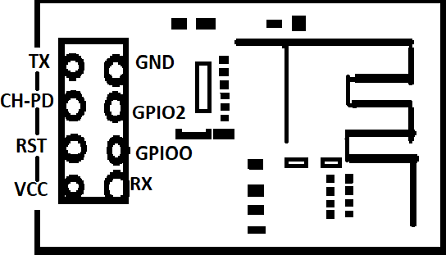

## 6. DISPLAY ROLLING SCREEN

*Rolling Exhibition:*

There now will be four 8 cross 8 LED displays that will continously displaying in notice board.

Benefits:

1. Use the Wi-Fi module to broadcast wireless messages.
2. Because the system makes use of mobile technology and wireless connection, it is less expensive.
3. The system is simple to operate; a mobile module is used to convey messages or information, which is then displayed on an LED dot matrix.
4. Backuping the data can be kept on the device that can be accesible.
5. It is eventually possible to communicate in real time. Applications:

1. Posting Notices in Public Places. 2 . Smart Cities in airports.

1. Smart Colleges in the bus station and also in the Railway Station.

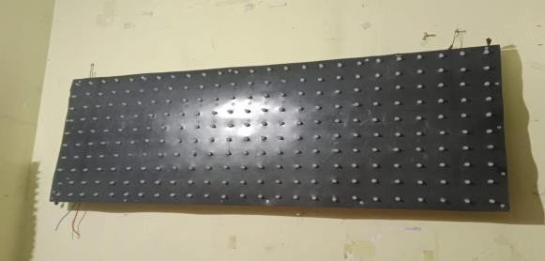

## Existing system:

Existing System: Currently, the notice/advertisement boards are administered manually. Putting up notices the notice board and is a time taking and consuming operation. This wastes a lot of resources such as the paper, printer ink, and even the manpower, as well as time pupose. Because the current power system is based on WIFI based delivering comments through an announcement board requires the integration of a mobile phone with a SIM card of an ESP8266.

The existing system also provides WIFI worldwide roaming capability, so we may send messages to receivers from anywhere in the globe, which is why additional charges are required.

"Developing the Simple and very low Cost WIFI base Notice Board" by Niraj Khira et al. The suggested system employs either Bluetooth or Wi-Fi-based wireless technology.

## NOTICE BOARD METHODOLOGY

"Large Screen Wireless Notice Display System" deals with wireless message receipt and display utilizing Raspberry Pi in order to improve the usability of electronic notice boards.

Almost every output revolution is been supported. This paper describes a method for incorporating message into Hyper text transfer protocol script. It stands apart from other notice boards due to features like changeable text size, colour, and backdrop colour.

This technology overcomes the screen size, which is a fundamental restriction of other methods.

The project "Electronic notice board giving the multiple outputs over the display" intends to iterate on the outcomes of a project focused on producing a wireless electronical notice board that allows users to controls the information display within a defined range on numerous displays. The notice board will show us the total and required information that’s transmitting to it via serial communication protocol from a central controlling device.

## PROJECT OUPUT

Because no message is communicated to the WIFI module when this power(p) is turned on and all the other modules are maintained to be ready, the notice board display the preprogrammed incredible type message is seen . To realise the desired digital notice board on a cloud platform, we developed the concept shown below as a prototype. It includes a NodeMcu with a built-in Wi-Fi Module. With the use of an LED matrix and a cell phone, the suggested notion is examined. You may use LUA script to programme the ESP8266 modules thanks to the NodeMCU firmware. It resembles how Arduino is programmed quite a bit. You can control the ESP8266 GPIOs, connect to Wi-Fi, turn it into a web server, and do a lot more with just a few lines of code. The Controller will connect to the internet via a WiFi module. The user's smartphone will use the internet to send the notice. That notification will be retrieved from the internet and shown by the NodeMcu..

## CONCLUSION

The proposed system obtains the message, stores it, and verifies it. Following that, it is shown on the LED board. In retail centres, train stations, and other public locations, LED boards are used to display messages. displaying advertisements for businesses, educational institutions, government agencies, and organisations that control traffic in smart cities and other public utility areas. The cost of printing and photocopying is also decreased because a large number of people can receive information in a short amount of time. Faster data transfer is possible, and it's almost easy to install and to use and make maintainence. It provides an effective way of receiving wireless technology-based auto notifications as well as displaying messages on the notice board. Users can so quickly get important messages or information.

## REFRENCES:

1. Andrea Goldsmith.,(2012); "Wireless communications," IEEE journal on communications, [www.iee.org,](http://www.iee.org/) Vol.2, No.4.
2. "Wireless Digital Notice Board Using GSM Technology" by Ramachandra K. Gaurav and Rohit Jagtap, published in International Research Journal of Engineering and Technology (IRJET) in 2015.
3. "Review on Electronic Notice Board" by Darshika Morey, Mamta Taikar, Rageeni Waghmare, and Vivek Ghumde, published in the International Research Journal of Engineering and Technology (IRJET) in 2018.

[4]V. K. Garg (1998), "Principles and Applications of GSM", pp 424-438.

[5]"KEYBOARDDRIVENELECTRONICNOTICEBOARD,

" Ritu Singh1, Samrah Manzoor2, Reena Anamika