**“Determination of Favipiravir in Bulk and Pharmaceutical Formula by Spectroscopic Method using Phenol Red Reagent”**

**Prof. Jitendra D. More*, Prof. Suryawanshi C.P., Prof. Amit P. Sinhal, Prof. Namita Jadhav.**

**OBVS’s Prof. Ravindra Nikam College of Pharmacy, Gondur,**

**Dhule-424002, Maharashtra, India.**

**Abstract:**

Establishing a spectrophotometric method to quantitatively assess the quantity of Favipiravir in both its pure form and pharmaceutical formulations was the main goal of this study. Using the reagent Phenol red. In this approach, Favipiravir and Phenol Red reagent interacted to produce a yellow-colored chromagen. Acetonitrile was used as the solvent, and a colored complex was found at a 475-476 nm wavelength. The International Council for Harmonization (ICH) requirements were followed throughout the validation of the created approach. The correlation coefficient for the data, which showed a strong linear association between the concentration ranges of 10–50 g/ml, was 0.9995. The devised approach also showed outstanding accuracy, precision, specificity, and sensitivity. This technique may easily be used to measure the concentration of Favipiravir in both bulk samples and pharmaceutical dosage forms for routine analytical purposes.

**Keywords:** Favipiravir, Spectroscopic Method, Phenol Red, Method Development, Validation etc.

**Author for Correspondence:**

Prof. Jitendra Devchand More,

Department of Pharmaceutical Chemistry and QA,

Faculty of Pharmacy, KBC NMU,

Email: [meet2jiten95@gmail.com](mailto:meet2jiten95@gmail.com)

**Introduction:**

An antiviral medication called Favipiravir (Figure 1) was created to treat different viral diseases including influenza and COVID-19.1, 2 it has the chemical name 6-fluoro-3-hydroxypyrazine-2-carboxamide and the chemical formula C5H4FN3O2 as well as a molecular weight of 157.104 g/mol. It is a colourless powder with a pKa value of 5.1, is soluble in organic solvents, and is very marginally soluble in water. It is an organic substance that falls within the class 2 of Pyrazine carboxamides. The anti-viral medication Favipiravir works by blocking the RNA dependent RNA polymerase enzyme, preventing viral transcription and replication.3, 4

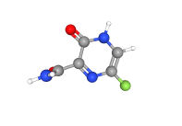

**Figure 1: Molecular Formula of Favipiravir.**

The literature review revealed that estimating techniques for Favipiravir formulations have been established. The devised techniques comprised spectroscopic techniques including ultraviolet spectroscopic techniques (5–10) and visible spectrophotometric techniques11, Fourier transform infrared spectroscopic (FTIR) method12, spectrofluorimetric method 13, thin layer chromatography (TLC) 14, RP-HPLC methods15, LC-MS/MS methods 16, LC-MS/MS methods17, UPLC-MS/MS methods18, LC-MS/MS methods19, LC-MS/MS methods20, and electrical methods such as voltametric methods. 23, 24, 45 However, it was clear that just one technique, using methyl orange and methyl red reagents in spectroscopy, had been devised for the determination of Favipiravir in pharmaceutical formulation. As a result, the present work aims to evaluate a technique for estimating Favipiravir in bulk and in pharmaceutical formulation utilizing spectroscopic method and the Phenol Red reagent.

**Materials and Methods:**

**Reagents and chemicals:**

Working standards for Favipiravir were received as a gift sample from Hetero laboratories in Hyderabad. We bought the Favipiravir pills (Favihope 400 Tab) from a nearby drugstore. All of the solvents required for the method's development came from Merck in Mumbai, India. Additionally, 9 all of the chemicals used for the method's development were of the AR grade and came from Sigma Aldrich in Maharashtra, India.

**Instruments-:**

The estimate of Favipiravir in pharmaceutical formulations was done using a Uv/Vis double beam spectrophotometer. UV Prob. software was used to regulate every parameter. Other tools used in the investigation included a sonicator and an ultrasonic bath scale for weighing. **Preparation of standard and sample solutions:**

Favipiravir working standard, correctly weighed at 100 mg, was made to dissolve in 100 ml of acetonitrile solvent, creating a 1000 g/ml concentration. In order to achieve a concentration of 100 g/ml, 10 ml of the stock solution were collected and diluted with 100 ml of distilled water. To achieve a concentration of 30 g/ml, a mixture of 3 ml of the aforementioned solution and 1 ml of the Phenol Red reagent was diluted to 10 ml with distilled water.

20 Favihope 400 pills were precisely weighed, and an average weight was determined. Favipiravir 100 mg equivalent weight was prepared to dissolve in 100 ml of acetonitrile solvent. An ultrasonic bath sonicator was used to sonicate the stock solution for 30 minutes. The solution was then filtered, and 10 milliliters of the filtrate were made into 100 milliliters of distilled water. Finally, 10ml of distilled water was used to dilute 3ml of the aforementioned solution and 1ml of the Phenol Red reagent.

**Method validation:**

**Linearity:**

By creating several dilutions in the concentration ranges of 10–50 g/ml and measuring their absorbance, the linearity of this approach was assessed. Between the concentration and absorbance data, a graph was drawn.

**Precision:**

Precision investigations were conducted intraday and between days to calculate the % RSD. Six duplicates of a solution containing 30 g/ml were made, and their absorbance was measured immediately (for intraday precision studies) and over two days (for interday precision studies).

**Accuracy:**

By using the standard addition procedure, solutions at the three levels of 50%, 100%, and 150% were created, and their absorbance was recorded. Three degrees of percentage recovery were computed from these numbers.

**Specificity:**

A blank solution was made and monitored to assess the method's specificity.

**Results:**

Figure 2 displays the conventional drug's UV-visible spectrum.

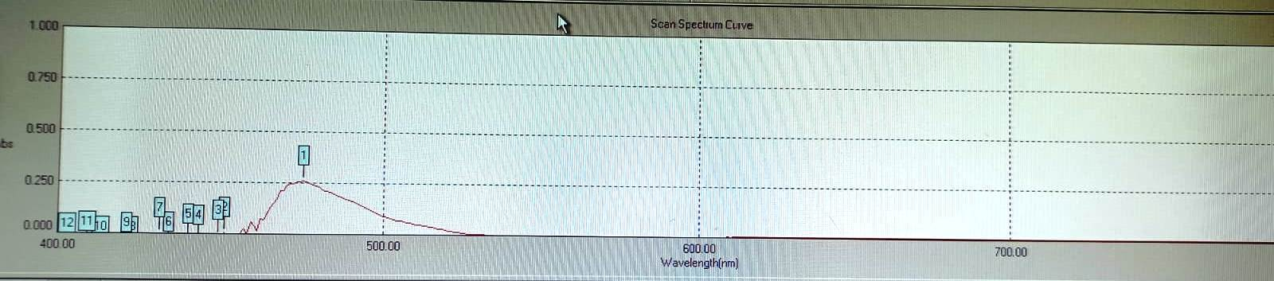

**Figure 2:**

**UV-Visible spectrum of Favipiravir**

The UV-Visible spectrophotometer was used to measure and record the absorbance of the prepared standard solutions and sample solutions. The results are shown in table 1.

**Table 1:**

**Optical Characteristics**

|  |  |  |
| --- | --- | --- |
| **S. No** | **Parameters** | **Results** |
| 1. | Absorption maximum | 475- 476nm |
| 2. | Linearity range | 10-50μg/ml |
| 3. | Regression equation | y = 0.0135x + 0.0073 |
| 4. | Slope | 0.0135 |
| 5. | Intercept | 0.0073 |
| 6. | Correlation coefficient (r) | 0.9994 |
| 7. | Molar extinction coefficient (L.mol-1 cm-1) | 2246 |
| 8. | Sandell’s sensitivity (μg/cm2 – 0.001 absorbance units | 0.068 |
| 9. | Accuracy (% recovery) | 99.85% - 100.33% |
| 10. | Precision (Intra-day) % RSD  (Inter-day) % RSD | 0.35  0.27 |
| 11. | LOD | 1.61 |
| 12. | LOQ | 4.86 |
| 13. | Standard error | 0.0066 |

A linearity graph was plotted by taking concentration on x-axis and absorbance values on y-axis as shown in figure 3 and results were summarised in table 2.

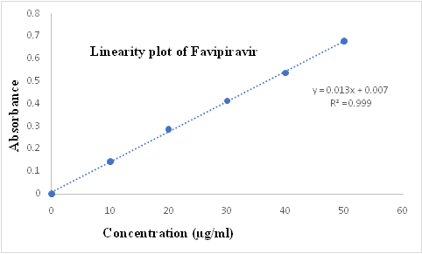

**Figure 3: Linearity plot of Favipiravir**

**Table 2: Results of linearity:**

|  |  |  |
| --- | --- | --- |
| **S. No.** | **Concentration (μg/ml)** | **Absorbance** |
| 1 | 10 | 0.142 |
| 2 | 20 | 0.287 |
| 3 | 30 | 0.412 |
| 4 | 40 | 0.537 |
| 5 | 50 | 0.679 |
| Regression coefficient (r2) | | 0.9992 |
| Correlation coefficient (r) | | 0.9995 |

The results for precision were presented in table 3a and 3b.

**Table 3a: Intra-day precision results:**

|  |  |  |
| --- | --- | --- |
| **Sample number** | **Sample absorbance** | **% Assay** |
| 1 | 0.412 | 99.60 |
| 2 | 0.415 | 99.84 |
| 3 | 0.412 | 99.12 |
| 4 | 0.414 | 100.08 |
| 5 | 0.414 | 99.60 |
| 6 | 0.413 | 99.36 |
| Average | 0.413 | 99.60 |
| % RSD | 0.34 | 0.34 |

**Table 3b:Inter-day precision results:**

|  |  |  |
| --- | --- | --- |
| **Sample number** | **Sample absorbance** | **% assay** |
| 1 | 0.416 | 99.60 |
| 2 | 0.415 | 99.36 |
| 3 | 0.418 | 100.08 |
| 4 | 0.417 | 99.84 |
| 5 | 0.417 | 99.84 |
| 6 | 0.418 | 100.08 |
| Average | 0.417 | 99.80 |
| % RSD | 0.28 | 0.28 |

The accuracy results were summarised in table 4.

**Table 4: Accuracy results:**

|  |  |  |  |  |  |
| --- | --- | --- | --- | --- | --- |
| **Sample No.** | **Level (in %)** | **Amount of Favipiravir added (mg)** | **Amount of Favipiravir found (mg)** | **% Recovery** | **Mean % Recovery** |
| 1 | 50 | 50.00 | 49.93 | 99.84 | 99.84 |
| 2 | 50 | 50.00 | 50.17 | 100.32 |
| 3 | 50 | 50.00 | 49.69 | 99.36 |
| 1 | 100 | 100.00 | 100.09 | 100.08 | 100.08 |
| 2 | 100 | 100.00 | 99.85 | 99.84 |
| 3 | 100 | 100.00 | 100.33 | 100.32 |
| 1 | 150 | 150.00 | 150.50 | 100.32 | 100.32 |
| 2 | 150 | 150.00 | 150.74 | 100.48 |
| 3 | 150 | 150.00 | 150.25 | 100.16 |

The blank spectrum was shown in figure 4.

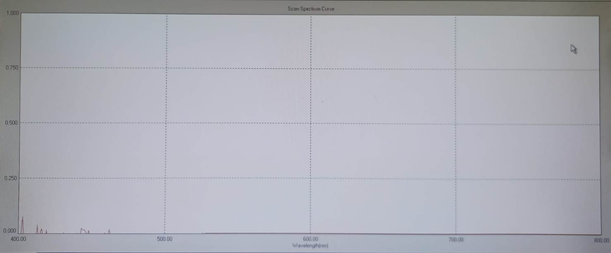

**Figure 4: Blank Spectrum**

**Discussion:**

The purpose of this study was to create and verify a simple, novel spectrophotometric method for Favipiravir in pharmaceutical formulations and bulk form using Phenol Red as reagent. **Solubility studies:**

In order to develop this method, it was necessary to conduct solubility tests on the reference drug Favipiravir, which included dissolving the drug in a variety of solvents including methanol, acetonitrile, water, 0.1N HCl, and 0.1N NaOH.

**Selection of solvent:**

According to the aforementioned solubility experiments, the medication is completely soluble in both methanol and acetonitrile. Acetonitrile solvent was utilized to prepare solutions for further research.

**Selection of ion pair reagent:**

Several reagents, including phenol red, phenol red, and thymol blue, were utilized. Phenol Red formed a transparent solution when these reagents were added separately to a standard solution. For this reason, it was chosen to act as an ion pair reagent.

**Selection of detection wavelength:**

The wavelength for the measurement was detected by scanning a reference solution with a concentration of 10 g/ml from 400 to 800 nm in a UV-Visible spectrophotometer. Maximum absorbance was measured at 475 nm, and this wavelength was used for further analysis.

Serial dilutions were made in the range of 10-50 g/ml, and their absorbance was measured to establish the method's linearity. Concentration and absorbance readings were then displayed on a graph. A value of 0.9995 for the correlation coefficient was calculated from the data shown on the graph.

In intraday precision experiments, the % RSD was 0.34, whereas in interday precision studies, it was 0.28.

The method's efficacy was evaluated by determining the percentage of recovery. The results showed a recovery rate of 99.84%-100.32%, proving the efficacy of the technique used.

When comparing the UV-Visible spectra of the standard solution and the blank solution, the absence of interference in the blank spectrum confirms the method's specificity.

The approach was shown to be sensitive, with a limit of detection of 1.60 ng/ml and a limit of quantification of 4.85 ng/ml.

**Conclusion:**

Validation according to ICH requirements was performed on a simple, innovative spectrophotometric approach for the measurement of Favipiravir in bulk and pharmaceutical dose form using Phenol Red reagent. The devised procedure was proven to be reliable, exact, linear, targeted, and sensitive. This established approach is suitable for regular analysis and quality control in formulations requiring the estimate of Favipiravir.

**Acknowledgment:**

Prof. Chandrakant P. Suryawanshi, of Prof. Ravindra Nikam College of Pharmacy in Gondur- Dhule, has been an invaluable mentor to me, and I'd want to thank him for all he's done. The research facilities used for this study were generously provided by Prof. Ravindra Nikam College of Pharmacy in Gondur-Dhule, for which I am eternally thankful. Gondur-Dhule and Prof. Amit P. Sinhal, Prof. Namita Jadhav both of the Prof. Ravindra Nikam College of Pharmacy, have been tremendous sources of encouragement and guidance for me.

**Funding:**

None

**Conflict of Interest:**

The authors declare no conflict of interest.

**References:**

1. Shiraki K, Daikoku T. Favipiravir, an anti-influenza drug against life threatening RNA virus infections. Pharmacol Ther. 2020; 209:107512.
2. Du YX, Chen XP. Favipiravir: Pharmacokinetics and concerns about clinical trials for 2019-nCoV infection. Clin Pharmacol Ther. 2020; 108(2):242-247.
3. Pilkington Victoria, Pepperrell Toby, Hill Andrew. A review of the safety of Favipiravir-a potential treatment in the COVID-19 pandemic. J Virus Erad. 2020; 6(2):45-51.
4. Hayden FG, Shindo N. Influenza virus polymerase inhibitors in clinical development. Curr Opin Infect Dis. 2019; 32(2):176-86.
5. Pritee RA, Mirza Shaihed Baig. Analytical method development and validation of Favipiravir in bulk and tablet formulation. Int J Pharm Res. 2022; 26(1):52-64.
6. Ibrahim Bulduk. Comparison of HPLC and UV Spectrophotometric methods for quantification of Favipiravir in pharmaceutical formulations. Iran J Pharm Res. 2021; 20(3):57-65.
7. Sayyed Nazifa Sabir Ali, Lajporiya Mobina, Manjra Mehfuza, Patel Seema, Aejaz Ahmed, GJ Khan. Analytical method development and validation and forced degradation stability indicating studies of Favipiravir by RP-HPLC and UV in bulk and pharmaceutical dosage form. J Pharm Res Int. 2021; 33(48B):254-271.
8. Santosh VG, Hanmant AB. Development and validation of UV-Spectrophotometric method for estimation of Favipiravir. Int J Pharm Res. 2022; 24(4):172-179.
9. Jeevana Jyothi B, Venkata Kavya R. Ultraviolet spectrophotometric method development for estimation of new antiviral repurposing drug Favipiravir. Asian J Pharm Clin Res. 2021; 14(7):67-69.
10. Itigimatha N, Chadchan KS, Yallur BC, Hadagali MD. New Analytical Methods for the Determination of New Anti-Viral Drug Favipiravir: A Potential Therapeutic Drug against Covid-19 Virus, in Bulk and Dosage Forms. Pharm Chem J. 2023; 56(10):1419-1425.
11. Wrushali A Panchale, Sonam B Bisen, Jagdish V Manwar, Ravindra L Bakal, Tejaswini V Tidke, Mitali N Paithankar, et al. Development of visible spectrophotometric methods for the analysis of Favipiravir in pure drug and tablet formulation. GSC Biol Pharm Sci. 2022; 20(02):184-195.
12. Nithila P, Raghavendrababu N, Padmavathi Y, Neena G, Sushma K, Poojitha A. New FTIR method development and validation for quantitative analysis of Favipiravir in bulk and pharmaceutical dosage forms. Int J Curr Pharm Res. 2022; 14(5):25-29.
13. Safa M Megahed, Ahmed A Habib, Sherin F Hammad, Amira H Kamal. Experimental design approach for development of spectrofluorimetric method for determination of Favipiravir; a potential therapeutic agent against COVID-19 virus: Application to spiked human plasma. Spectrochim Acta A Mol Biomol Spectrosc. 2021; 249:119241.
14. Ibraam EM, Heba E, Fathalla B, Adel EI. Green micellar solvent free HPLC and spectrofluorimetric determination of Favipiravir as one of COVID-19 antiviral regimens. Microchem J. 2021; 165:106189.
15. Pallavi VD, Kamalkishor GB. Bioanalytical method development and validation for the determination of Favipiravir in spiked human plasma by using RP-HPLC. J Pharm Res Int. 2021; 33(47A):275-281.
16. Duygu Taskin. Development and validation of a rapid HPLC-DAD method for determination of Favipiravir in pharmaceutical formulation. Clin Exp Health Sci. 2022; 12:648-652.
17. Komarov TN, Karnakova PK, Archakova OA, Shchelgacheva DS, Bagaeva NS, Shohin IE, et al. Determination of Favipiravir in human plasma by HPLC-UV. Drug Dev Regist. 2022; 11(3):220–229.
18. Hailat M, Al-Ani I, Zakareia Z, Al-Shdefat R, Al-Meanazel O, Anwer MK, et al. Development and Validation of HPLC-DAD Method for the Determination of Favipiravir and Studying the Impact of Vitamin C on the Pharmacokinetics of COVID-19 Antiviral Drug Favipiravir. Separations 2022; 9:303.
19. Hailat M, Al-Ani I, Hamad M, Zakareia Z, Abu Dayyih W. Development and Validation of a Method for Quantification of Favipiravir as COVID-19 Management in Spiked Human Plasma*.* Molecules. 2021; 26(13):3789.
20. Vishal Bansi Ghune, Amit Suryakant Tapkir. Method development and validation of Favipiravir by RP-HPLC. Innov J Med Sci. 2022; 6(2):13-19.