## **Experimental on Study on Enhancing Strength in Flyash Aggregate Concrete**

**Meniga naveen kumar Reddy1 and K .Shammad basha 2**

1PG student in SVR Engineering College, Nandyal, Andhra Pradesh, India

2Assistant Professor in SVR Engineering College, Nandyal, Andhra Pradesh, India

**ABSTRACT**

Fly ash is a residue left after burning of coal in thermal power stations and need suitable disposal system so that it does not become hazardous and injurious to human life and environment. Besides the use of fly ash as partial replacement material, its use as aggregate in concrete can pave the way for large scale use of fine aggregate. Most of the previous research works were done by using conventional fine and coarse aggregates in concrete. In this research work, the fine and coarse aggregates were completely replaced by fly ash aggregates in concrete.The properties of fly ash fine aggregates and fly ash coarse aggregates were determined. The aggregate crushing value and aggregate impact value of fly ash coarse aggregates were also determined.

**Keywords:** Enhancing Strength, Flyash, Aggregate ,Compressive strength

1. **INTRODUCTION**

Concrete is the most adaptable man-made building material in the world, and it is widely employed in all different kinds of construction activity. Concrete can be found everywhere. The attributes of concrete's constituents, the quantities of the mix, the manner of compaction, and other controls during putting, compaction, and curing all have an effect on the substance's strength, durability, and other features. The advancements in concrete technology have made it possible to build concrete that is strong, long-lasting, and uniform by optimising the proportions of the mix and the craftsmanship, which enables one to get the most out of the locally available resources. The use of supplemental cementing materials, mineral admixtures, or component replacements has been one of the most important focal points of study in the field of concrete. The utilisation of waste products from industrial processes that have a pozzolanic nature and may be made to develop cementitious qualities can partly increase a material's strength and durability while also contributing to the preservation of the natural environment. In most areas of the nation, there is a growing level of concern over the environmental effects that are caused by the extraction of river sand and crushed stone aggregate. Researchers strongly advise that lightweight concrete should be produced using alternative aggregates wherever possible.

One of the drawbacks of using traditional concrete is that it tends to have a rather high self-weight. Concrete typically has a density in the range of 2200 to 2600 kg/m3, depending on the mix. The substantial amount of its own weight makes it an inefficient choice as a building material. In order to produce concrete of the desired density to suit the application, the self weight of structural and non-structural members needs to be reduced. This allows for economies of scale to be achieved in the design of supporting structural elements, which in turn leads to the development of lightweight concrete (Ramamurthy et al 2008).

The most essential quality of light weight concrete is its low heat conductivity, which is a quality that becomes better as the density of the material gets lower (Ramazan Demirboga et al 2003). Lightweight concrete is a high performance material because of its decreased bulk while maintaining acceptable strength, increased thermal and acoustic insulation qualities, and lower energy consumption throughout the building process. Even though lightweight concrete cannot always replace regular concrete due to its strength potential, it does have its own benefits, such as reduced dead load, and thus economical structures and enhanced seismic resistance, high sound absorption, high thermal insulation, and good fire resistance. Additionally, lightweight concrete has its own advantages, such as good fire resistance. (Tommy et al 2004). The term "lightweight concrete" refers to a kind of concrete that, in comparison to traditional concrete, has been reduced in weight by modifying either the material composition or the manufacturing process. Concrete with lightweight aggregates is produced by exchanging the typical material aggregate with lightweight aggregates during the manufacturing process of concrete.

1. **METHODOLOGY**

**2.1 Cement**

Ordinary Portland Cement of 43 grade confirming to IS: 8112-1989 was used for the present experimental investigation. Its specific gravity is 3.15. The cement was tested as per the procedure given in Indian Standards

**2.2 Fine Aggregate**

Natural river sand with fraction passing through 4.74 mm sieve and retained on 600µ sieve was used and tested as per IS:2386. The fineness modulus of sand is 2.68 with a specific gravity of 2.66.

**2.3 Coarse Aggregate**

Hard broken granite stone (HBG) coarse aggregates confirming to graded aggregate of size 20 mm as per IS:383-1970. Its specific gravity is 2.71.

**2.4 Water**

Potable tap water available in the laboratory with pH value of 7.0 ± 1 and confirming to the requirements of IS: 456-2000 was used for mixing concrete and curing the specimens as well.

**2.5 Fly Ash**

Fly ash (Class F) obtained from Mettur Thermal Power Station (MTPS) was used in the experimental work.

**2.6 Fly ash Aggregates**

he class F fly ash was used in the formation of fly ash aggregates. The details are presented in this chapter.

1. **RESULTS AND DISCUSSION**

**3.1 Compressive Strength**

The development of the control concrete's strength, in comparison to its strength after 28 days, is 16 percent, 40 percent, 69 percent, 85 percent, 108 percent, and 120 percent, respectively, for 1, 3, 7, 14, 56, and 90 days. These numbers are in order from lowest to highest. When compared to its strength after 28 days, the compressive strength of concrete containing fly ash aggregates and made with a cement-to-fly-ash ratio of 20:80 was found to increase by 13 percent, 38 percent, 75 percent, 92 percent, 107 percent, and 114 percent, respectively. This strength gain was seen in the concrete's ability to withstand compression over the course of 1, 3, 7, 14, and 90 days. When the strength gain of fly ash aggregate concrete at 28 days is compared to that of fly ash aggregates obtained from cement fly ash proportion 22.5:77.5, the results are 23 percent, 42 percent, 69 percent, 85 percent, 109 percent, and 126 percent, respectively, at the ages of 1, 3, 7, 14, 56, and 90 days.

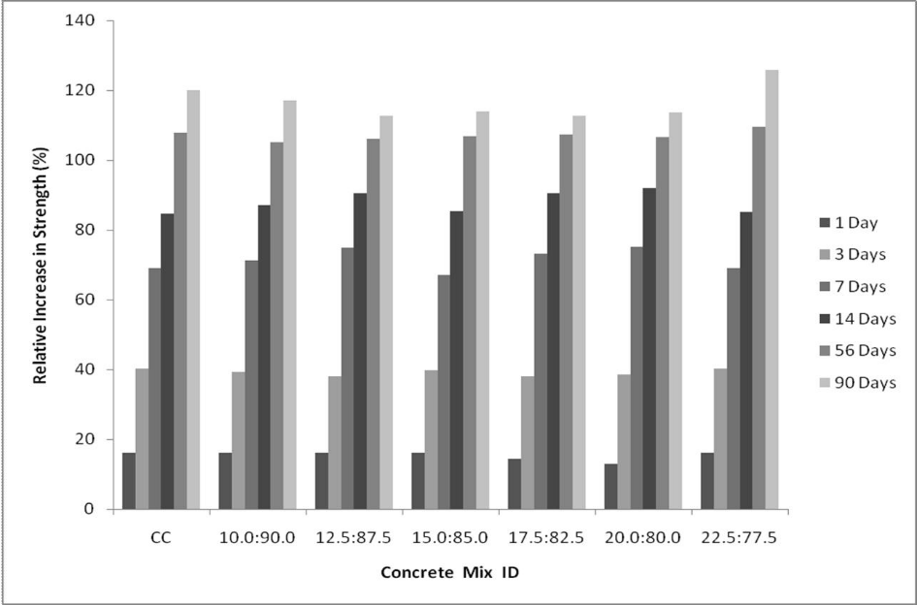

Figure 1Compressive strength after 28 days for FAAC and CC, compared to the compressive strength after the same amount of time for CC.

**3.2 Split Tensile Strength**

The breaking tensile strength of fly ash aggregate concrete mixes after 7 days and after 28 days of ageing respectively. In comparison to control concrete, the fly ash aggregate concrete exhibited an increase in split tensile strength of 12 percent and 15 percent, respectively, at the ages of 7 days and 28 days. The fly ash aggregate concrete was made with fly ash aggregate that was made from cement fly ash proportion 15:85.

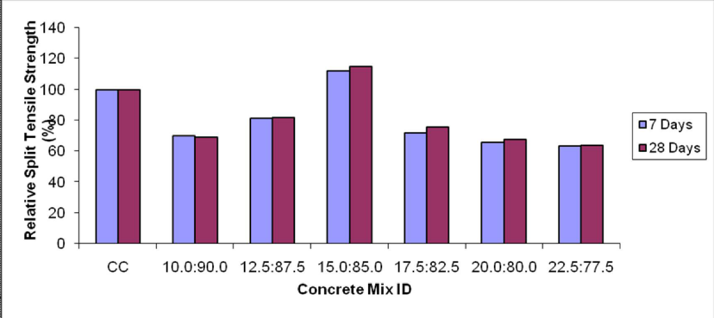

Figure 2 shows a comparison of the split tensile strength of fly ash aggregate concrete with that of control concrete at various periods after curing the concrete.

**3.3 Flexural Strength Test**

The flexural strength of fly ash aggregate concrete after 7 days and after 28 days of ageing respectively. The fly ash aggregate concrete, which contained fly ash aggregate and was made from cement and fly ash in the proportion of 15:85, demonstrated an increase in flexural strength that was 11 percent higher at the age of 7 days and 16 percent higher at the age of 28 days than the control concrete specimen. At the age of curing in 7 days, the cement fly ash proportions 10:90, 12.5:87.5, 17.5:82.5, 20:80, and 22.5:77.5 showed a reduction in flexural strength of 17 percent, 9 percent, 11 percent, 15 percent, and 20 percent, respectively. At the age of curing in 28 days, these proportions showed a reduction in flexural strength of 18 percent, 11 percent, 14 percent, 18 percent, and 23 percent, respectively.

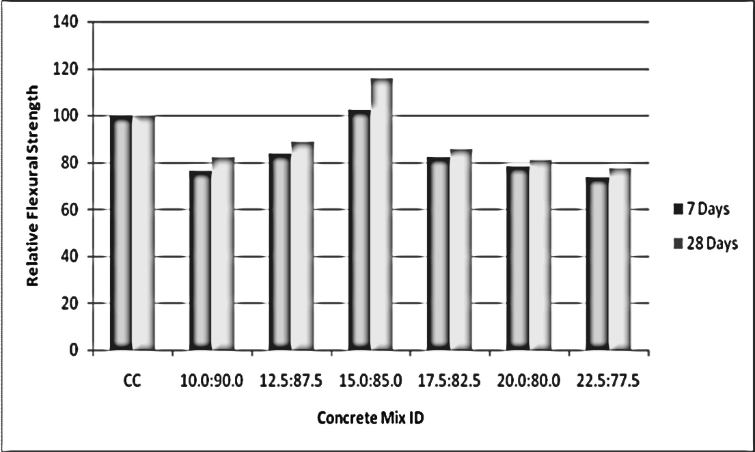

Figure 3 Comparison of the flexural strength of fly ash aggregate concrete with that of control concrete at several ages after curing

1. **CONCLUSION**
2. The studies were carried out on concrete made using fly ash aggregate. At a variety of ages, the features of fly ash aggregate concrete's strength were investigated. The fly ash aggregate concrete in question had varying ratios of cement to fly ash. The use of fly ash aggregates had a significant positive impact on the increased strength and durability of the concrete.
3. The major purpose of this study was to investigate the mechanical characteristics of FAAC at a variety of ages and with a range of amounts of cement fly ash. The compressive strength, split tensile strength, and flexural strength have all been investigated, and a conclusion on the link between the compressive strength and the other two strengths has also been reached. At several ages of concrete, researchers looked at how fly ash aggregates affected the properties of the finished product. The following are the inferences that may be drawn from the experimental investigations:
4. The compressive strength of FAA with a cement fly ash percentage of 15:85 is greater than that of control concrete at all ages, including one day, three days, seven days, fourteen days, twenty-eight days, fifty-six days, and ninety days. It should be highlighted that the rise in fly ash content that occurs throughout the production of FAA demonstrates an ascending pattern of compressive strength up to this level at all ages. According to the findings, the ratio of 15:85 cement to fly ash should be used to achieve the best possible formation of FAA. Because of its high pozzalanic character, fly ash forms a more densely packed C-S-H gel when combined with cement, which is the fundamental reason why the compressive strength is mostly dependent on the proportion of fly ash.
5. **REFERENCES**
6. Geotechnical Engineering”, ASCE Geo Congress, pp. 9-12, 2004.
7. Behra, J.P., Nayak, D.B., Ray, H.S. and Sarangi, B. “Light weight concrete with sintered fly ash aggregate: A study on partial replacement to normal Granite aggregate”, IE(I) Journal – CV, Vol. 85, pp. 84-87, 2004.
8. Beth Brueggen, Thomas H.K. Kang and Chris Ramseyer, “Experimental and SEM Analyses of Ground FlyAsh in Concrete”, International Journal of Concrete and Structures and Materials, Vol. 4, pp. 51-54, 2010.
9. Byung-wan Jo, Seung–Kook and Jong–bin Park, “Properties of concrete made with alkali activated fly ash light weight aggregate” Journal of cement and concrete composites Vol-29 pp 128-135, 2007.
10. Byung-wan Jo, Seung-kook Park and Jong-bin Park, “Properties of concrete made with alkali-activated fly ash lightweight aggregate”, Journal of Cement and Concrete Composites, pp. 1-8, 2006.
11. Carolos Videla and Patricia Martinez, “Sustainable concrete construction with fly ash light weight aggregates”, Proceedings of Conference, COBRA, pp. 1-11, 2001.
12. Carolyne Namagga and Rcbecca A. Atadero, “Optimization of fly ash in concrete”, World of Coal Ash Conference, Conference Proceedings, pp. 1-6, 2009.
13. Celik Ozyildirim, “Durability of structural light weight concrete”, Proceedings of LWC Bridges workshop, pp. 1-14, 2009.
14. Chen, H.J., Yen, T. and Huang, T.P. “Determination of the dividing strength in lightweight aggregate concrete, Cement and Concrete Composites, Vol. 21, pp. 29-37, 1999.
15. Daniel Rypl and Tomas Bym, “Modeling of concrete microstructure for the assessment of the percolation threshold of interfacial transition zone”, 5th European Congress on Computational Methods in Applied Sciences and Engineering, 2008.