**STUDY OF GEOPOLYMER CONCRETE WITH POLYPROPYLENE FIBRE**

**J. Jeyaseela1, A. Dhanalakshmi2, P. Aarthi3**

1Assistant Professor, Civil Engineering, P.S.R Engineering College, Sivakasi, Tamil Nadu, India

2 Research Scholar, Civil Engineering, P.S.R Engineering College, Sivakasi, Tamil Nadu, India

3M.E Student, Civil Engineering, P.S.R Engineering College, Sivakasi, Tamil Nadu, India

**ABSTRACT**

One of the main wastes produced by thermal power plants is fly ash. Early on, it had an issue with treatment and disposal. Researchers discovered a practical way to substitute fly ash for cement in calculated qualities. Currently, the replacement proportion has been rising. In this experiment, fly ash was used as the main binder instead of cement to evaluate the performance of concrete. Because it reduces carbon dioxide emissions more than high calcium fly ash, low calcium fly ash is favoured as a source material. In this project, the binders sodium hydroxide and sodium silicate solution are alkaline liquids. In the process of geopolymerization, it is employed. Testing of a mix proportion for geopolymer concrete was done for various grades of concrete. Geopolymer concrete's compressive and tensile strengths have been investigated and contrasted with OPC. In comparison to using simply alkaline hydroxides, reactions happen more quickly when the alkaline liquid also contains soluble silicate, such as sodium or potassium silicate.

**Keywords:** Geopolymer, Alkaline liquid Sodium hydroxide sodium silicate and polypropylene fibre.

1. **INTRODUCTION**

**1.1 General**

Only water is used more frequently worldwide than concrete. Traditionally, the main binder for creating concrete has been ordinary Portland cement (OPC). It is generally recognized that the manufacture of OPC has environmental consequences. As a result of the calcinations of limestone and the combustion of fossil fuels, approximately one ton of carbon dioxide is released for every ton of OPC produced. OPC production also uses less energy than steel and aluminum production combined. On the other hand, the widespread availability of fly ash presents an opportunity to use this coal-burning byproduct in place of OPC to make concrete.

In 1978, Davidovits (1999) postulated that source materials of geological origin or by-product materials like fly ash and rice husk ash may form binders by a polymeric reaction of alkaline liquids with the silicon and aluminum. He referred to these adhesives as geopolymers. According to Palomo et al. (1999), pozzolans such blast furnace slag may be activated using alkaline liquids to generate a binder, completely replacing the need for OPC in concrete. The silicon and calcium in the blast furnace slag are the primary components in this strategy that need to be activated. The major binder created as a result of the hydration process is a C-S-H gel.

* 1. **Fly ash-based Geopolymer concrete**

Instead of Portland or any hydraulic cement paste, low-calcium (ASTM Class F) fly ash-based geopolymer is utilized in this work as the binder to create concrete. With or without the use of admixtures, the loose coarse aggregates, fine aggregate, and other unreacted components are joined by the fly ash-based geopolymer paste to create the geopolymer concrete. The conventional concrete manufacturing techniques are used to create geopolymer concrete. In geopolymer concrete, the aggregates make up roughly 75–80% of the bulk, similar to OPC concrete. The geopolymer paste that binds the aggregates and other unreacted ingredients is created when the silicon and aluminum in the low-calcium (ASTM Class F) fly ash react with an alkaline liquid made of sodium silicate and sodium hydroxide solutions.

1. **LITERATURE REVIEW**

**Fareed Ahmed Memon et al. (2011)** Higher compressive strength is the outcome of the geopolymerization process being improved with more curing time. With longer cure times, a rise in compressive strength was seen. The specimens' compressive strength was at its peak after 96 hours of curing; however, the rise in strength after 48 hours was not appreciably larger. When the curing temperature was raised from 60°C to 70°C, the compressive strength of concrete improved; however, when the curing temperature was raised above 70°C, the compressive strength of self-compacting geopolymer concrete dropped.

**R.Kumuta et al. (2011)** There are two drawbacks to geopolymer concrete (GPC mix), including a long setting time and the need for heat curing to make it stronger. By substituting 10% of the fly ash in the GPC mix with OPC, these two drawbacks were removed, creating Geopolymer Concrete Composite (GPCC mix). By substituting 10% of the fly ash in the GPC mix with OPC, the compressive strength, split tensile strength, and flexural strength were all increased relative to the GPC mix by 73%, 128%, and 17%, respectively. The mechanical properties of Geopolymer Concrete Composites were improved by the addition of steel fibers. Steel fiber reinforced Geopolymer concrete composites have higher compressive strength, split tensile strength, and flexural strength as the percentage volume fraction increases from 0.25 to 0.75. Steel fibers added at a volume fraction of 0.25 increased the compressive strength.

**H. Mohammed et al. (2010)** All concrete must have compressive strength, which is also a function of curing temperature and time. The compressive strength increases together with the curing time and temperature. Concrete can achieve a compressive strength of between 400 and 500 kg/cm2 by curing at temperatures between 60 and 90 oC for a period of 24 to 72 hours (Chanh et al., 2008). Additionally, the amount of fly ash fine particles (less than 43 m) in a geopolymer had a significant impact on the material's compressive strength.As fly ash particles increased, the compressive strength increased as well. As a result, the kind and concentration of the activators had a major role in the alkali activation reaction. The sodium silicates and activator solution (n = 1.5; 10% Na2O) yielded the highest compressive strength. Because it contains dissolved and partially polymerized silicon, which readily reacts, incorporates into reaction products, and considerably improves the properties of mortar, sodium silicate is the most suitable alkaline activator.

**S.Thokchom et al. (2010)** Alkalis that migrated from the specimen to the solution are responsible for the significant pH increase in exposure solutions. The solution holding the specimen with the highest Na2O concentration experienced the greatest pH increase, which indicating that more alkalis migrated from these specimens.When exposed to a magnesium sulphate solution, a geopolymer mortar specimen increases weight, and this gain is correlated with the specimen's Na2O content. Extremely little weight gain was observed in the specimens, with the specimen with the least Na2O level showing the most weight rise. Throughout the exposure time, there were some variations in residual compressive strength. The specimen with the highest Na2O level maintained its maximal strength of 89.7% after 24 weeks of exposure. Higher alkali content geopolymer mortar specimens performed better than those made with lower alkali content.

**K.Naveen Kumar Reddy et al. (2010)** discovered that sodium hydroxide and sodium silicate solution are used as a combined alkali activator to create geopolymer concrete, which is made from low lime fly ash. With increased molarity of NaOH solution, a rise in compressive strength of these concrete samples is seen. For the samples that were cured at 60°C, the workability of concrete diminishes as the molarity of the NaOH solution increases. Higher sodium hydroxide solution concentrations (between 10 M and 16 M) reduce the workability of geopolymer concrete and increase compressive strength. For a specific concentration of NaOH solution, the compressive strength of the concrete gradually increases with time. High-range water reduction admixtures containing 1.5% fly ash (by mass) had little effect on the compressive strength of cured concrete, but they did make fresh geopolymer concrete easier to work with.

1. **METHODOLOGY**

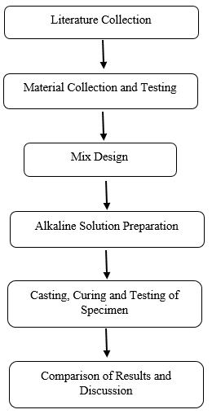

**Figure 1:** Methodology

**3.1 Materials Used**

* Fly ash

• Fine aggregate: Natural river sand

• Coarse aggregate

• Water: Ordinary portable water

• Polypropylene fibers

• Mineral admixtures: sodium hydroxide and sodium silicate solution.

* 1. **Fly Ash**

Fly ash with high fineness, low carbon content, and strong reactivity should be used. Fly ash has the same properties as natural soils in terms of specific gravity, particle size, compaction characteristics, permeability coefficient, shear strength parameters, and consolidation parameters. These parameters are determined in a manner similar to how those soils are determined. It was discovered that the fly ash's quality met the standards for fly ash.

**Table 1.** Fly Ash Properties

|  |  |  |
| --- | --- | --- |
| SN. | Fly Ash | Values |
| 1 | Specific Gravity | 2.23 |
| 2 | Fineness m3/kg | 320 |
| 3 | Bulk Density | 0.53% |

* 1. **Water**

All of this investigation's specimens were cast using portable water.

* 1. **Fine Aggregate**

Sand is typically found mixed in varying gradations of fineness at different zones and is either a round or angular grain. The IS2386 procedures are used to evaluate the characteristics of fine aggregate. The four river sand zones are used to create the mortar cubes. Even though it has impurities, it needs to be thoroughly cleaned and sieved so that the mortar won't harm the building. Properties of fine aggregate.

**Table 2.** Properties of fine aggregate

|  |  |  |
| --- | --- | --- |
| SN. | Fine Aggrgate | Values |
| 1 | Fineness Modulus | 3.47 |
| 2 | Specific Gravity | 2.623 |
| 3 | Water Absorption | 1.1% |

* 1. **Course Aggregate**

Broken crushed stone that was free of clay, weeds, and other organic materials was used as the coarse aggregate since it is non-porous. The capacity to absorb water is less than 1%.the qualities of which are kept on a 19 mm filter and whose size passes through a 26 mm sieve.

**Table 3.** Properties of fine aggregate

|  |  |  |
| --- | --- | --- |
| SN. | Coarse Aggregate | Values |
| 1 | Fineness Modulus | 7.32 |
| 2 | Specific Gravity | 2.63 |
| 3 | Water Absorption | 0.59% |

* 1. **Sodium Hydroxide**

Typically, flakes and pellets of sodium hydroxides are accessible in solid form. The purity of the product has a major impact on how much sodium hydroxide costs. Since the primary procedure of our Polypropylene Fibre Reinforced Geopolymer Concrete is to activate the Sodium Silicate, it is advised to utilize the purest material possible, up to a purity of 94% to 96%, in order to keep costs down. The sodium hydroxide pellets were used in this experiment. The physical and chemical characteristics are listed by the manufacturer for solid sodium hydroxide are as follows.

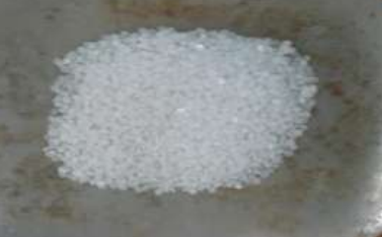

**Figure 1:** Sodium Hydroxide pellets

**Table 4.** Physical Properties of Sodium Hydroxide

|  |  |  |
| --- | --- | --- |
| SN. | Sodium Hydroxide | Values |
| 1 | Colour | Colour Less |
| 2 | Specific Gravity | 2.11 |
| 3 | PH | 13.7 |

**Table 5.** Chemical Properties of Sodium Hydroxide

|  |  |  |
| --- | --- | --- |
| SN. | Chemical Compounds | Values |
| 1 | Assay | 97% |
| 2 | Carbonate(Na2co3) | 2% |
| 3 | Chloride(Cl) | 0.01% |
| 4 | Sulphate(so2) | 0.05% |
| 5 | Lead(pb) | 0.001% |
| 6 | Iron(Fe) | 0.001% |
| 7 | Potassium(K) | 0.01% |
| 8 | Zinc(Zn) | 0.02% |

* 1. **Sodium Silicate**

Sodium silicate, which comes in liquid (gel) form, is also known as water glass or liquid glass. To create the polypropylene fiber reinforced geopolymer concrete in this, sodium silicate is employed. Following is a list of the physical and chemical characteristics of silicates according to their manufacturing.

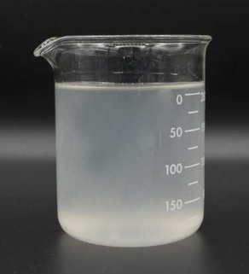

**Figure 2:** Sodium Silicate Solution

* 1. **Polypropylene Fibre**

In this investigation, polypropylene fibers are used an average diameter of 10 μm, a length of 18mm.

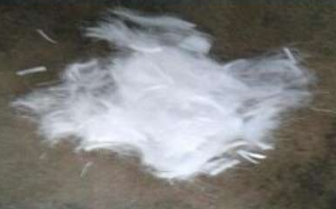

**Figure 3:** Polypropylene Fibre

**Table 4.** Properties of Polypropylene Fibre

|  |  |  |
| --- | --- | --- |
| SN. | Specifications | Values |
| 1 | Aspect ratio | 1800 |
| 2 | Tensile strength (Mpa) | 2.5x103 |
| 3 | Elasticity modulus (Mpa) | 8x103 |
| 4 | Specific gravity (g/cm3) | 8 |

* 1. **Mixing, Drying and Curing**

The aggregate, sand, and fly ash were dry mixed for three minutes before being added to the geopolymer concrete made from fly ash. the liquid component of the mixture, which includes the sodium hydroxide solution, the sodium silicate solution, and any additional water. Fresh geopolymer concrete made of fly ash was dark in color and in appearance, glossy. Using the traditional slump test, the fresh concrete's workability was evaluated. Three equal layers of freshly laid concrete were compacted in cylinder steel molds using 25 hand strokes per layer.

* 1. **Mix Proportion**

The mass ratio of 0.4 to 2.5 between sodium silicate solution and sodium hydroxide solution. Because the sodium silicate solution is significantly less expensive than the sodium hydroxide solution, this ratio was set at 2.5 for the majority of the mixes.

Sodium hydroxide (NaOH) solutions with molarities between 8M and 16M.

A mass-to-activator solution fly ash ratio of between 0.3 and 0.4.

Amounting to roughly 75 to 80% by mass of the overall combination is coarse and fine aggregate.

Additional water (if required).

1. **RESULT AND DISCUSSION**

The results of compressive strength, tensile strength, and load deflection tests are done for both geopolymer concrete and conventional concrete of M 25 grade. The compressive strength of geopolymer concrete made from fly ash is higher than that of ordinary concrete thanks to higher sodium hydroxide solution content (measured in molar terms).

* 1. **Compressive Strength**

One of concrete's key characteristics is its compressive strength. Sized concrete cubes with and without fly ash, 150mmx150mmx150mm were cast. The specimens were demolded and put through water cure after 24 hours. Samples were taken after 28 days of curing, allowed to dry, and then tested for compressive strength.

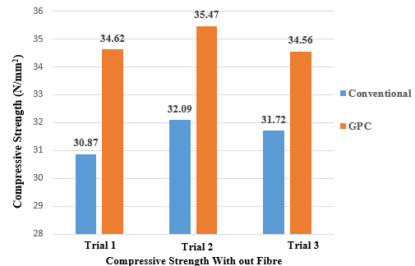 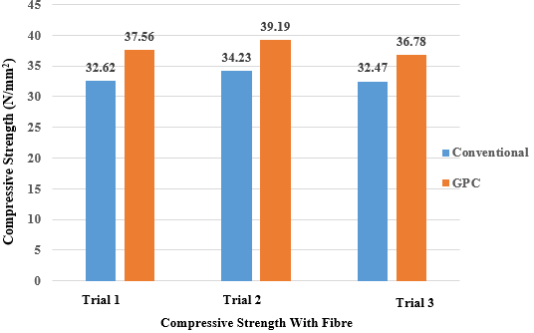

**Figure 4:** Comparison of Compressive strength without and with fibre

* 1. **Split Tensile Strength**

By applying a lateral compressive force to the cylinder, split tensile strength is an indirect method of determining the tensile strength of concrete. Cylinders with a diameter of 150 mm and a length of 300 mm were cast both with and without fly ash. The specimens were demolded and put under water to cure after 24 hours. Specimens were taken after 28 days of curing, allowed to dry, and tested in a universal testing equipment by laying the specimen horizontally.

Split tensile strength, fsp = 2P/π bd

Where, P = Load applied to the specimen in N

b = Breadth of the specimen in mm

d = Depth of the specimen in mm

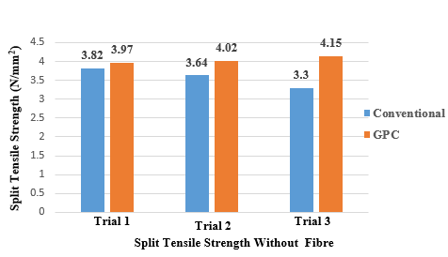 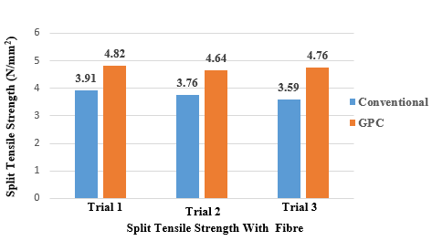

**Figure 5:** Comparison of Split Tensile strength without and with fibre

1. **CONCLUSION**

* Geopolymer concrete without fibres has a 10.63% higher compressive strength than conventional concrete.
* The Geopolymer concrete's split tensile strength is 11.58% higher than conventional concrete's, compared to neither material's split tensile strength.
* Comparing Geopolymer Concrete with Fibres to Conventional Concrete, Compressive Strength has risen by 10.70%.
* Geopolymer concrete with fibres has a 13.62% higher split tensile strength than conventional concrete.
* With its qualities, geopolymer concrete creates a material that is on par with or superior to conventional cements.
* Excellent compressive strength and suitability for structural applications can be found in low-calcium fly ash-based geopolymer concrete.

1. **REFERENCES**

[1] BehzadKalantari, Arun Prasad and Bujang B. K. Huat, (2011) “Use of cement, Polypropylene fibers and optimum moisture content values to strengthen peat” International Journal of Physical Sciences Vol. 7(8), pp. 1276 – 1285.

[2] Deotale.R.S, Sathawane S. H, Narde A.R, (2005)”Effect of Partial Replacement of Cement by Fly Ash, Rice Husk Ash with Using Steel Fiber in Concrete”, Vol 3 ,pp 6.

[3] Fareed, Ahmed,Memon, Muhd, Fadhil, Nuruddin, Samuel, Demieand, (2011) ”Effect of Curing Conditions on Strength of fly ash-based Self Compacting Geopolymer Concrete, International Journal of Civil and Environmental Engineering Vol 3 , pp 3.

[4] Františekškvára, tomášjílek, lubomírkopecký, (2005) “Geopolymer materials based on fly ash”, International journal, Vol 4, pp 2-5.

[5] Fareed,Ahmed,Memon,Muhd,Fadhil,Nuruddin,Samuel,Demieand, (2011) “Effect of Curing Conditions on Strength of fly ash-based Self Compacting Geopolymer Concrete”, International Journal of Civil and Environmental Engineering Vol 3, pp 3.

[6] Mohd Mustafa Al Bakri, Mohammed.H, Kamarudin.H, KhairulNiza.I and Zarina (2004) “Review on fly ash-based geopolymer concrete without Portland Cement”, Journal of Engineering and Technology Research Vol. 3(1), pp. 1-4.

[7] Mandal.S and Majumdar.D, (2007) “Study on the Alkali Activated Fly Ash Mortar”, the Open Civil Engineering Journal, Vol 3,pp 98-101.

[8] Siva KondaReddy.B, Varaprasad.J and Naveen Kumar Reddy.K, (2009), “Strength and workability of low lime fly-ash based geopolymer concrete”, Indian Journal of Science and Technology Vol.3,pp 12.

[9] Sreevidya.V, Anuradha.T, Dinakar.D, Dr.venkatasubramani.T, (2005)”Acid resistance of fly ash based geopolymer mortar under ambient curing and heat curing” ,International Journal of Engineering Science and Technology Vol 3 pp 6.

[10] Thokchom.S, Ghosh.P and Ghosh.S, (2011) “Performance of Fly ash Based Geopolymer Mortars in Sulphate Solution”, Journal of Engineering Science and Technology Review Vol 3 (1), pp 36-40.

[11] VijayaRangan.B, DodySumajouw, SteenieWallah, wantoroHardjitoDj, (2006),”Reinforced low-calcium fly ash-based geopolymer concrete beams and columns”, Journal of Engineering Science and Technology Vol 4,pp16-17.

[12] Vijai.K, Kumuthaa.V and Vishnu ramb T.B, (2003) “Effect of inclusion of steel fibres on the properties of geopolymer concrete composites”, International journal, Vol 7, pp 1-5.