**A STUDY ON EFFECTIVENESS ON EMPLOYEE ENGAGEMENT IN IT SECTOR**

S Divya and Praveen S V

MBA student Jerusalem College of Engineering, Chennai

Assistant Professor and Department of MBA, Jerusalem College of Engineering, Chennai

**ABSTRACT:**

Employee engagement has emerged as a critical factor for organizational success and competitive advantage, especially in dynamic and fast-paced sectors like Information Technology (IT). This study aims to explore and analyze the effectiveness of employee engagement strategies within the IT sector and their impact on employee performance, job satisfaction, and overall organizational outcomes**.** To undertake this investigation, data was gathered from a diverse sample of 99 respondents representing various segments of society, including employees, private sector workers and business professionals. These respondents were invited to provide their assessments on a range of statements. These statements pertained to factors such as their current brand usage, pricing considerations, available features, brand expectations, satisfaction levels, and accrued benefits. The data amassed was meticulously organized, coded, and subsequently subjected to thorough analysis using statistical tools like Regression analysis & correlation assessments, and frequency tabulations, all facilitated by SPSS software.

**Keywords**: employee engagement, IT sector, job satisfaction, organizational outcomes, engagement strategies, workforce productivity, innovation, turnover rates

**INTRODUCTION**

In today's rapidly evolving business landscape, the Information Technology (IT) sector plays a pivotal role in driving innovation, enhancing operational efficiency, and enabling digital transformation across industries. As technology continues to advance, organizations within the IT sector are increasingly recognizing the critical importance of employee engagement in sustaining competitive advantage and achieving long-term success. Employee engagement, characterized by a deep emotional connection and commitment to one's work and organization, has been linked to improved performance, higher levels of job satisfaction, and reduced turnover rates. This study aims to develop into the effectiveness of employee engagement strategies within the IT sector. By examining the factors that influence employee engagement and the impact of engagement on individual, team, and organizational levels, this research intends to contribute valuable insights that can guide HR professionals, managers, and organizational leaders in implementing strategies that promote a more engaged and productive workforce.

**REVIEW OF LITERATURE**

. In the study conducted by Anton Vorina, Miro Simonic ,Maria Vlasova (2017), Employee engagement is often defined as the emotional commitment an employee has towards their organization, leading them to invest more effort and contribute positively. The dimensions of engagement commonly include cognitive, emotional, and behavioral aspects. This commitment is crucial in the IT sector where innovation, problem-solving, and collaboration are essential. In the study related to aspects of Job satisfaction and work engagement by Yalabik Z.Y,Rayton,Rapti A (2017), the result was that considering all the aspects of job satisfaction, satisfaction on the work alone was a crucial factor that operates all the dimensions of job engagement that is vigor, absorption and dedication.

The study by "Gaëtane Caesens, Florence Stinglhamber and Gaylord Luypaert (2014) " by keeping task engagement , work holism and wellbeing as independent variables resulted that the relationship among perceived stress and perceived organizational support was mediated by job engagement and work holism mediated the relationship among perceived stress,co-worker support and sleep problems. A study relating to the effects of overload of work on "job satisfaction and employee engagement and performance by Sobi Ali , Yasir Aftab Farooqi (2014) shows a positive relation amongst the variables .An analysis on positive impact of opinion count on the job satisfaction by Tariq Malik(2013) shows that the member’s opinion count will be having a positive influence on job. Duncan, Halley M. Pontes and Mark D. Griffiths"(2013) showed that the effect of organizational identification on job satisfaction is transferred by job engagement and commitment. Another study conducted by C.Barnes and E.Collier (2013) showed that the service climate, affective commitment and job satisfaction influence the work engagement and this would have a subsequent impact on the adaptability and career commitment. A study conducted by Suzanne Benn, Stephen T.T. Teo,Andrew Martin (2013)" relating Environmental initiatives and Employee Engagement shows that when employees take part in environmental initiatives, it is contributing to high level of employee engagement and lesser tendency to quit. satisfaction. Further effects in team communication for job satisfaction is mediated by opinion count.

**METHODOLOGY**

The primary objective of this To study the effectiveness of employee engagement at IT Sector This study has been conducted to check consumer behavior and their purchase decision towards mobile phones. This research is intended to describe and analyses consumer’s preference between different brands of Smartphone. Descriptive research design is used in the study. Descriptive research includes surveys, finding and enquires. Descriptive research methods can be used in multiple ways and for various reasons. This design can be identified by characteristics, data trends, conduct comparisons, validate existing conditions and conduct research at different time periods. The limitations of the study is respondents are reluctant to response in all cases and since small size of 99 respondents are taken so it is difficult of draw inferences about the population from this sample size. Primary data is collected by providing questionnaire to friends, relatives & colleagues, through emails, WhatsApp, etc. Secondary data is collected by analyzing through websites, vlogs, etc.

**ANALYSIS**

1. **PERCENTAGE ANALYSIS FOR AGE VARIABLE**

**TABLE 1 CHART 1**

|  |  |  |
| --- | --- | --- |
| **PARTICULARS** | **FREQUENCY** | **PERCENTAGE** |
| 21-30 | 43 | 43.4 |
| 31-40 | 30 | 30.3 |
| 41-50 | 21 | 21.2 |
| ABOVE 50 | 5 | 5.1 |
| TOTAL | 99 | 100% |

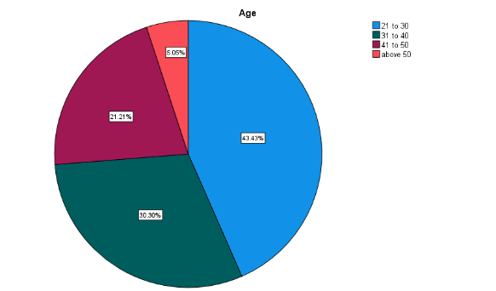

**INFERENCE**

From the above result it is observed that out of 99 respondents 43% are 21-30, , 30% are 31-40, 21% are 41-50 and 5% are above 50.

**2. PERCENTAGE ANALYSIS FOR GENDER VARIABLE**

**TABLE 2 CHART 2**

|  |  |  |
| --- | --- | --- |
| **PARTICULARS** | **FREQUENCY** | **PERCENTAGE** |
| MALE | 37 | 37.4% |
| FEMALE | 62 | 62.6% |
| TOTAL | 99 | 100% |

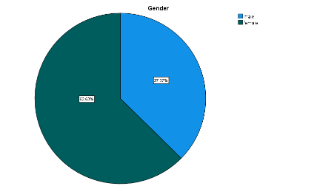

**INFERENCE**

From the above data it is found that out of 99 respondents 37% are male and 62& are females.

**3. PERCENTAGE ANALYSIS FOR EDUCATION QUALIFICATION VARIABLE**

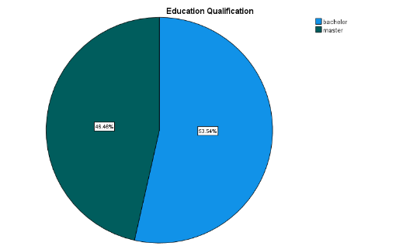 **TABLE 3 CHART 3**

|  |  |  |
| --- | --- | --- |
| **PARTICULARS** | **FREQUENCY** | **PERCENTAGE** |
| BACHELOR | 53 | 53.5% |
| MASTER | 46 | 46.5% |
| TOTAL | 99 | 100% |

**INFERENCE**

From the above result it is found that out of 99 respondents Bachelor-53% & Master-46%.

**4. PERCENTAGE ANALYSIS FOR ARE YOU TO MAINTIAN WORKLIFE BALANCE**

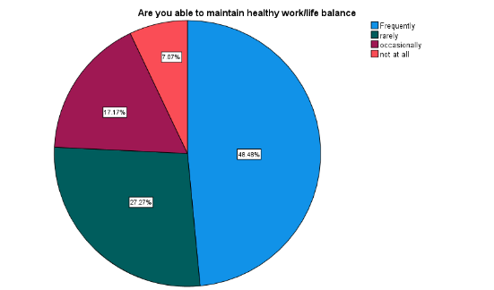 **TABLE 4 CHART 4**

|  |  |  |
| --- | --- | --- |
| **PARTICULARS** | **FREQUENCY** | **PERCENTAGE** |
| FREQUENTLY | 48 | 5% |
| RARELY | 27 | 26% |
| OCCASIONALLY | 17 | 20% |
| NOT AT ALL | 7 | 27% |
| TOTAL | 99 | 100% |

**INFERENCE**

From the above table and chart it is analyzed that out of 99 respondents Frequently- 5%, Rarely- 26%, Occasionally-17%, Not at all-27%.

**5. PERCENTAGE ANALYSIS FOR PERFORMANCE BY THE PROJECT HEAD AND THE TEAM MEMBERS**

**TABLE 5 CHART 5**

|  |  |  |
| --- | --- | --- |
| **PARTICULARS** | **FREQUENCY** | **PERCENTAGE** |
| HIGHLY SATISFIED | 32 | 32% |
| SATISFIED | 53 | 53% |
| NEITHER SATISFIED OR NOT SATISFIED | 14 | 14% |
| TOTAL | 99 | 100% |

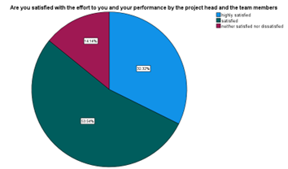

**INFERENCE**

From the above table and chart it is analyzed that out of 99 respondents Highly satisfied-32%,

Satisfied-53% & Neither satisfied or not satisfied-14%.

**REGRESSION ANALYSIS**

To find efforts to you performance by the project head and the team members

**NULL HYPOTHESIS:**

**H0:** There is no efforts to you performance by the project head and the team members.

**ALTERNATIVE HYPOTHESIS:**

**H1:** There is a efforts to you performance by the project head and the team members.

**TABLE 6**

|  |  |  |  |  |  |  |
| --- | --- | --- | --- | --- | --- | --- |
| Model | | Unstandardized Coefficients | | Standardized Coefficients | t | Sig. |
| B | Std. Error | Beta |
| 1 | (Constant) | 1.392 | 0.213 |  | 6.542 | <.001 |
| Are you satisfied with the effort to you and your performance by the project head and the team members | 0.406 | 0.110 | 0.351 | 3.691 | <.001 |

**INFERENCE**

From the test it is found that the significance value the significance value is <.001 which is higher than the table value 6.542, the Null hypothesis was accepted. That is There is relationship between factors of organic products and price of organic products of consumers.

**CORRELATION ANALYSIS**

To find the relationship between do you feel motivated when completely your daily task & are you been rewarded for tasking risk at work.

**NULL HYPOTHESIS:**

**H0:** There is no relationship between do you feel motivated when completely your daily task & are you been rewarded for tasking risk at work.

**ALTERNATIVE HYPOTHESIS:**

**H1:** There is a relationship between do you feel motivated when completely your daily task & are you been rewarded for tasking risk at work.

|  |  |  |  |
| --- | --- | --- | --- |
| **Correlations** | | | |
|  | | Do you feel motivated when completing your daily tasks | Have you been rewarded for taking risks at work |
| Do you feel motivated when completing your daily tasks | Pearson Correlation | 1 | .237* |
| Sig. (2-tailed) |  | .018 |
| N | 99 | 99 |
| Have you been rewarded for taking risks at work | Pearson Correlation | .237* | 1 |
| Sig. (2-tailed) | .018 |  |
| N | 99 | 99 |
| *. Correlation is significant at the 0.05 level (2-tailed). | | | |

INFERENCE

From the test it is found that the significance value is .237 which is higher than table value 0.1,the null hypothesis was rejected , that there is no significance between do you feel motivated when completely your daily task & are you been rewarded for tasking risk at work.

**FINDINGS**

According to the study, 99 respondents 43% are 21-30, , 30% are 31-40, 21% are 41-50 and 5% are above 50. According to the study37% are male and 62& are females. According to the study, Bachelor-53% & Master-46%. According to the study, 54% are very satisfied, 29% are somewhat satisfied, 14% are neutral and 3% are somewhat dissatisfied with their current smartphone. According to the study Frequently- 5%, Rarely- 26%, Occasionally-17%, Not at all-27%., from the test it is found that the significance value is .198 which is higher than the table value 0.5, the Null hypothesis was accepted. That is There is relationship between income and smart phone upgradation. According to the study value the significance value is <.001 which is higher than the table value 6.542, the Null hypothesis was accepted. That is There is relationship between factors of organic products and price of organic products of consumers., from the above result it is found that the significance value (0.004) is less than the table value (0.5). Therefore, the null hypothesis was rejected. That is, there is an association between. That is, there is no significant difference between the significance value is .237 which is higher than table value 0.1, the null hypothesis was rejected . that there is no signific between do you feel motivated when completely your daily task & are you been rewarded for tasking risk at work.

**SUGGESTION**

In recent years, the IT sector has witnessed unprecedented growth and transformation, making it a dynamic and competitive industry. Amidst this rapid evolution, the concept of employee engagement has gained significant attention as a critical factor influencing the overall success of organizations operating within this sector. Employee engagement refers to the emotional commitment and alignment that employees have towards their organization. It goes beyond mere job satisfaction, delving into the realm of personal investment and active participation in the company's goals and values. In the IT sector, where innovation, collaboration, and adaptability are paramount, fostering a high level of employee engagement becomes increasingly crucial. Numerous studies have highlighted the positive correlation between employee engagement and various organizational outcomes. Engaged employees are more likely to exhibit higher levels of productivity, creativity, and innovation. They tend to be more resilient in the face of challenges, contributing to a more agile and responsive work environment—a crucial trait in the ever-evolving landscape of the IT industry. Moreover , engaged employees tend to demonstrate a stronger sense of loyalty and commitment to their organizations. This translates into reduced turnover rates, which can be particularly significant in an industry characterized by competitive talent acquisition and retention. Additionally, a workforce that is deeply engaged often leads to better customer satisfaction, as employees are more likely to go the extra mile to deliver exceptional products and services**.**

**REFERENCES**

1.Agarwal, R. and T.W. Ferratt (2002). Enduring practices for managing IT professionals, Communications of the ACM,45(9),73- 79.

2.Barnad,C.(2001). Functions of executive (Cambridge: Harvard University press,1938).

3.Beck,S., Why associates leave and strategies to keep them, American Layer Medical LP,5(2),23- 27.

4.Clarke, K.F.(2001). What business are going to attract and retain employees-becoming an employer of choice, Employee benefit Journal, 34-37.

5.Corporate Leadership Council (2007). Improving employee performance in economic downtime,(Corporate Executive board, Washington, DC).

6.Deovsek, D.(2008). Creating highly engaged and committed employees starts at the top and ends at the bottom line, Credit union national Association Inc.