**“A STUDY ON IMPACT OF HEALTH AND SAFETY MEASYRES AT FITWEL TOOLSAND FORGING PRIVATE LIMITED.TUMAKURU”.**

**Prof DR. GRACE HEMALATHA.**

**ASSOCIATE PROFESSOR.**

Shridevi Institute of Engineering and Technology

Department of MBA

E-mail: Graceprabhu2000@gmail.com

SUPRITHA WESLEY

Shridevi Institute of Engineering and Technology

2nd Year MBA

E-mail: [suprithawesley@gmail.com](mailto:suprithawesley@gmail.com)

TUMKURU-572106

**ABSTRACT:**

In today's dynamic industrial landscape, prioritizing the well-being and security of employees within organizations has become paramount. This abstract highlights the comprehensive study conducted to analyse the tangible impacts resulting from the implementation of health and safety measures at Fitwel Tools and Forging Private Limited, located in Tumakuru.

The research delves into the multifaceted dimensions of this study, encompassing an array of health and safety measures implemented within the organization. By examining the organizational framework, safety protocols, training initiatives, and employee perceptions, this study seeks to uncover the interplay between these measures and the overall well-being of the workforce. Utilizing a mixed-methods approach, the research collected quantitative data through surveys and qualitative insights through interviews with employees across various levels. The study meticulously analyses the data to ascertain the extent to which health and safety measures have influenced accident reduction, employee morale, productivity, and the overall organizational environment.

**INTRODUCTION:**

In the realm of modern industry, ensuring the safety and well-being of the workforce has emerged as a paramount concern for organizations striving to attain operational excellence. Fitwel Tools and Forging Private Limited, situated in the industrially vibrant city of Tumakuru, stands as a prominent player in the forging sector. This forging enterprise is not only recognized for its precision engineering and production capabilities but also for its unwavering commitment to the health and safety of its employees.

Established with a mission to deliver precision-crafted components that power diverse industries, Fitwel Tools and Forging Private Limited has, over the years, cultivated a reputation for manufacturing excellence. Its state-of-the-art facilities, coupled with a team of skilled artisans, engineers, and technicians, enable the production of superior-quality forged products that meet the stringent demands of modern engineering applications.

The inherently robust forging process demands a meticulous blend of artistry and engineering precision, resulting in components that exhibit exceptional strength, durability, and performance. Fitwel Tools and Forging Private Limited has consistently demonstrated its expertise in this arena, producing components that underpin critical machinery across sectors such as automotive, aerospace, energy, and beyond.

In tandem with its commitment to engineering prowess, the company places a paramount emphasis on the safety and well-being of its workforce. The forging environment, with its specialized machinery and intricate processes, necessitates a comprehensive approach to health and safety. Fitwel Tools and Forging Private Limited has recognized this imperative and has undertaken proactive measures to create a secure working environment that safeguards its employees from potential hazards.

**REVIEW OF LITRATURE:**

**1.Heinrich:**

The concept of ensuring health and safety within the workplace has evolved from being mere regulatory compliance to a strategic imperative for organizations. Heinrich's pioneering work in 1931 emphasized the causal relationship between accidents and underlying factors, laying the groundwork for modern safety management approaches (Heinrich, 1931). Since then, the importance of health and safety measures has been underscored by various scholars, recognizing their potential to prevent accidents, enhance employee well-being, and contribute to overall organizational success.

**2. Hinze and Appan:**

A growing body of literature has consistently shown a positive correlation between the implementation of health and safety measures and improved organizational performance. Hinze and Appan (2016) conducted a study in manufacturing firms, revealing that effective safety management led to reduced accidents, decreased downtime, and increased employee satisfaction. The Hierarchy of Controls framework, proposed by the Centers for Disease Control and Prevention (CDC, 2015), further emphasizes the significance of proactive hazard elimination to enhance productivity.

**3.Goldenhar et al:**

Employee attitudes and engagement play a pivotal role in the success of health and safety initiatives. Goldenhar et al. (2001) explored the role of organizational culture in shaping employee perceptions of safety. A positive safety culture, characterized by strong leadership support, open communication, and employee involvement, has been associated with greater compliance and a proactive approach to safety measures.

**STATEMENT OF THE PROBLEM:**

The overarching challenge addressed by this research pertains to striking a balance between employee well-being and organizational performance. Ensuring a safe working environment is not only a legal and ethical responsibility but also directly influences employee satisfaction, retention, and productivity. On the other hand, organizations need to remain operationally efficient and competitive. Achieving this equilibrium demands a comprehensive understanding of how occupational health and safety practices impact both employee experiences and the company's bottom line. Fitwell Forging Private Limited provides a unique opportunity to bridge this gap and contribute to the knowledge base. By investigating the extent to which health and safety practices are implemented, understood, and embraced within the organization, this research seeks to shed light on the potential challenges, successes, and lessons learned that can benefit not only the forging industry but also similar manufacturing sectors.

**OBJECTIVES OF THE STUDY:**

1. Investigating employees' understanding of health and safety within the workplace.
2. Assessing the implementation of health and safety measures at Fitwell Forging Private Limited.
3. Analysing the management's contribution to the implementation of health and safety measures.
4. Determining individuals' contentment with regard to health and safety measures.
5. Offering recommendations for enhancing health and safety within the organization.

Top of Form

**SCOPE OF THE STUDY:**

This research encompassed an examination of the health and safety policies at Fitwel Tools and Forgings Private Limited. The study emphasizes the crucial role that health and safety play in improving productivity, thereby contributing to the company's overall performance. The investigation into health and safety measures aims to provide insights that can lead to enhanced business operations. Moreover, the study delves into employees' perceptions of health and safety, seeking to evaluate their influence on the organization's effectiveness.

By identifying areas within Fitwel Tools and Forgings that require attention, strategies for boosting productivity can be identified and subsequently implemented to strengthen employee performance. Additionally, this research involves an assessment of employees' attitudes toward health and safety protocols and provisions, forming an integral aspect of the study.

**HYPOTHESIS:**

In this study conducted at Fitwel Forging Company, Tumakuru, the null hypothesis (H0) suggests that the working environment within the company is not up to the standards of safety and cleanliness. This hypothesis proposes that there might be deficiencies, shortcomings, or lapses in maintaining a secure and clean work environment for employees within the specific context of Fitwel Forging Company. Contrarily, the alternative hypothesis (H1) asserts that the working environment within Fitwel Forging Company is indeed safe and clean. This hypothesis suggests that the company has successfully implemented health and safety measures, as well as cleanliness protocols, to ensure the well-being of its employees and the hygienic state of the workplace.

The primary aim of this study is to empirically examine and evaluate the validity of these hypotheses. This may involve conducting thorough assessments, inspections, surveys, and data analysis to determine the actual state of the working environment within Fitwel Forging Company. The study seeks to provide evidence that supports one of the hypotheses over the other based on the collected data. The outcomes of this research will have practical implications for Fitwel Forging Company. Depending on the findings, the company might need to consider refining its health and safety practices, cleanliness protocols, or maintenance procedures to align with the desired standards and ensure the safety, well-being, and productivity of its workforce.

**RESEARCH METHODOLOGY:**

|  |  |
| --- | --- |
| Research Methodology | Descriptive research |
| Sampling technique | Random sampling |
| Data collection instrument | Questionnaire |
| Sampling size | 100 |
| Sampling area | Fitwel Tools and Forgings |
| Hypothesis testing | Non-Parametric test |

**DATA COLLECTION METHOD:**

The process of media sampling utilized questionnaires as a means of data collection, while employee data was acquired through individual interviews.

**LIMITATION OF THE PROPOSED RESEARCH STUDY:**

* Owing to the busy timetables of employees, the researcher was compelled to employ a restricted sample size when seeking viewpoints.
* The study's scope is confined to Fitwel Tools and Forgings Pvt. Ltd., thus impeding the generalizability of the findings to the wider industry.

**Table1: Illustrating the breakdown of respondents' gender distribution within the company.**

|  |  |  |
| --- | --- | --- |
| **Particulars** | **No of respondents** | **Percentage** |
| Male | 90 | 90 |
| Female | 10 | 10 |
| Transgender | 0 | 0 |
|  | **100** | **100** |

**Analysis:** Based on the information depicted in the table, it becomes apparent that 90% of the participants are male, whereas the remaining 10% are female.

**Table 2: Depicting the distribution of employees' ages within the company.**

|  |  |  |
| --- | --- | --- |
| **Particulars** | **No of respondents** | **Percentage** |
| 20-25 | 10 | 10 |
| 26-35 | 20 | 20 |
| 36-45 | 20 | 20 |
| Above 45 | 50 | 50 |
|  | **100** | **100** |

**Analysis:** Analysing the data presented in the table reveals that 50% of respondents are in the age category of above 45 years. Furthermore, 20% of participants are within the age range of 26 to 35, another 20% fall between 36 to 45 years, and an additional 10% of employees are situated in the age group of 20 to 25.

**Table:3: Portraying the levels of experience among the participants.**

|  |  |  |
| --- | --- | --- |
| **Particulars** | **No of respondents** | **Percentage** |
| Less than 1 year | 10 | 10 |
| 1-5 years | 20 | 20 |
| 6-10 years | 20 | 20 |
| <10 years | 50 | 50 |
|  | **100** | **100** |

**Analysis:** Based on the data presented in the provided table, it becomes evident that 50% of participants have amassed experience exceeding 10 years. Furthermore, 20% of respondents indicate having 1 to 5 years of experience, with an additional 20% showcasing 6 to 10 years of experience. Notably, 10% of participants have gained less than 1 year of experience within the organization.

**HYPOTHSIS:**

Hypothesis 1:

Null Hypothesis (H0): The working environment is not safe and clean.

Alternative Hypothesis (H1): The working environment is safe and clean.

|  |  |  |  |  |
| --- | --- | --- | --- | --- |
| PARTICULARS | RESPONDENTS | O-E | **(O-E)2** | **(O-E)2/E** |
| STRONGLY AGREE | 64 | 44 | 1936 | 96.8 |
| AGREE | 20 | 0 | 0 | 0 |
| NEUTRAL | 2 | -18 | 324 | 16.2 |
| DISAGREE | 2 | -18 | 324 | 16.2 |
| STRONGLY DISAGREE | 12 | -19 | 324 | 16.2 |
|  | 100 |  |  | 145.4 |

**E=100/5=20**

**Degree of freedom= (n-1)**

**=5-1=4**

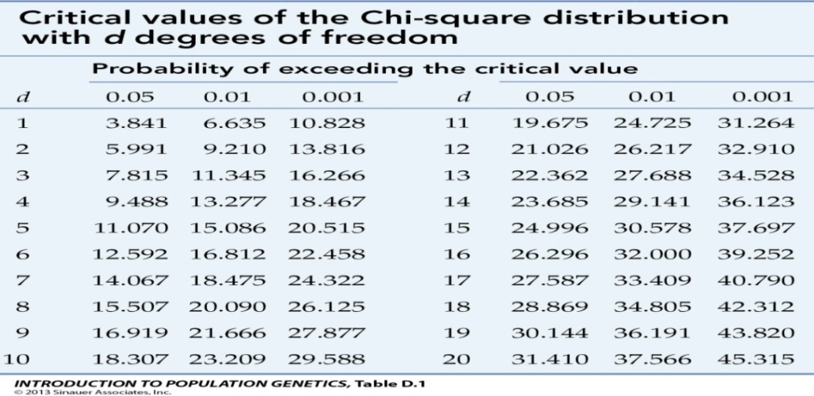

Having 5 degrees of freedom, the value corresponding to degree of freedom 4 from the provided table is 9.488. In contrast, the calculated value is 145.4. Given that the calculated value surpasses the tabulated value, the null hypothesis is refuted.

**CONCLUSION:**

Undertaking the study on the "Impact of Health and Safety Measures at Fitwel Tools and Forging" proved to be a highly rewarding endeavour. The research findings unveiled that Fitwel Tools and Forging aligns its health and safety protocols with the mandates outlined in the Factory Act of 1948. The results underscored a noteworthy level of employee awareness concerning the influence of workplace conditions on their well-being and safety. Significantly, the organization's dedication to health and safety was clearly evident through its effective management strategies. In summation, the collective effect of health and safety measures at Fitwel Forging Limited exhibited a positive influence, ultimately nurturing employee contentment.

**REFERENCES:**

**BOOKS:**

* K Aswathappa (2014); Human Resource Management (7th Edition); Mc Graw Hill Education.
* P. Subba Rao (2008); Essential of Human Resource Management and Industrial Relations (3rd Edition); Himalayan Publishing House.
* Carbonless copy paper, first invented in 1954; Graves Carol Gevecker; Matnoskigenevience m; Tardiffrobert g (2000)
* Dee W. Edigton Alyss b. Schuitz (2008) The health risk and workplace economic measures.

**WEBSITES:**

* [**www.fitweltoolsandforgings.com**](http://www.fitweltoolsandforgings.com)

Top of Form

Top of Form

Top of Form