Coal Mine Safety Monitoring and Alerting
System Powered By The Internet Of Things

DR.N. SAMBASIVA RAO, Mr. Gangisetty Devanand ,Vamsi Addagarla ,Gayathri Paila ,NagaTeja Methukumelli ,Lakshmi Siva Sri Ram Lakkoju
Professor & Head of the Department of Electrical & Electronics Engineering,,
NRI Institute of Technology(Autonomous), Vijayawada, India
nsraohodeee@gmail.com
Assistant Professor of the Department of Electrical & Electronics Engineering, NRI Institute of Technology(Autonomous),Vijayawada, India gdeva.eee@gmail.com
Department of Electrical & Electronics Engineering, NRI Institute of Technology(Autonomous),Vijayawada, India
aa234567addagarlavamsi@gmail.com
Department of Electrical & Electronics Engineering, NRI Institute of Technology(Autonomous),Vijayawada, India
pailag568@gmail.com
Department of Electrical & Electronics Engineering, NRI Institute of Technology(Autonomous),Vijayawada, India
methukumellinagateja9@gmail.com
Department of Electrical & Electronics Engineering, NRI Institute of Technology(Autonomous),Vijayawada, India
srirammsd5@gmail.com
ABSTRACT

The coal mining industry plays a vital role in fulfilling the energy demands of the world, but it is fraught with inherent risks to miners safety. The coal mining industry plays a vital role in fulfilling the energy demands of the world, but it is fraught with inherent risks to miners' safety. To address these challenges, this paper presents an innovative IoT-based Coal Mine Safety Monitoring System with Fire Alarm. The proposed system aims to enhance safety measures and prevent potential hazards by leveraging the power of Internet of Things (IoT) technology.
The study begins with an overview of the significance of coal mine safety and the relevance of IoT in industrial safety monitoring. A comprehensive literature review examines the limitations of existing safety systems and explores previous IoT- based solutions applied in industrial contexts.
The methodology section outlines the design and architecture of the proposed safety monitoring system. It details the selection and deployment strategy of various sensors, including gas sensors for detecting toxic gases, temperature sensors for monitoring environmental conditions, and humidity sensors for identifying moisture levels. Additionally, the fire alarm system integration and its working principle are elucidated.

Keywords— Coal Mining, Miners Safety, Internet Of Things (IOT), Sensors.

introduction
The coal mining industry has long been a cornerstone of global energy production, fueling the world's economic growth. However, the extraction of this invaluable resource comes with inherent risks to the safety and well- being of miners. Accidents, hazardous gas emissions, and fires pose serious threats, underscoring the urgent need for advanced safety monitoring and alerting systems in coal mines. In response to these challenges, this paper introduces an innovative IoT-based Coal Mine Safety Monitoring and Alerting System designed to enhance safety measures and mitigate potential hazards.
The advent of the Internet of Things (IoT) has revolutionized industries worldwide, offering unprecedented opportunities to gather, analyze, and act upon real-time data from interconnected devices. In the context of coal mine safety, IoT presents a transformative solution, enabling continuous monitoring of various parameters critical to identifying potential risks and responding proactively to ensure the well-being of miners.
This paper aims to present a comprehensive study on the development, implementation, and evaluation of the proposed IoT-based Coal Mine Safety Monitoring and Alerting System. By leveraging IoT technology, this system aims to revolutionize coal mine safety practices by providing mining companies with real-time insights into environmental conditions, gas concentrations, and fire occurrences within the mine.The paper proceeds with an in-depth analysis of existing safety monitoring practices in coal mines and highlights their limitations. It examines previous research and innovations that have utilized IoT in industrial safety contexts, drawing upon these insights to develop a robust, cost-effective, and scalable solution tailored specifically for coal mines. The methodology section outlines the architecture of the proposed system, detailing the selection and deployment strategy of various sensors and IoT devices. Gas sensors, temperature sensors, humidity sensors, and other vital components are carefully integrated to create a cohesive safety monitoring network. Furthermore, the implementation of an advanced fire alerting mechanism enhances the system's ability to detect and respond to fire incidents promptly.
The subsequent sections of the paper delve into the system's implementation and the results obtained from rigorous testing and validation. Performance metrics and data collected from the IoT-based Coal Mine Safety Monitoring and Alerting System are thoroughly analyzed to evaluate its efficacy in detecting and mitigating potential hazards.
In conclusion, the IoT-based Coal Mine Safety Monitoring and Alerting System holds immense promise in revolutionizing safety practices within coal mines. By leveraging IoT technology, this system empowers mining companies to make data-driven decisions, enhance the safety of their workforce, and minimize the occurrence of accidents, gas-related incidents, and fires. The findings and insights from this paper aim to contribute to the ongoing efforts in ensuring the well-being of coal miners, making significant strides towards safer and more efficient coal mining operations.

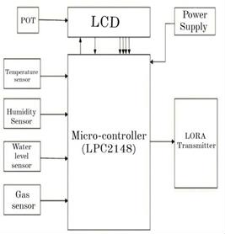
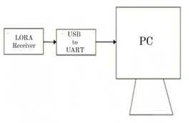
II. Block Diagrams

1(a) Transmitting part of monitoring section 1(b) Receiving part of monitoring section
Fig.1.Block Diagram of monitoring section (transmitting and receiving parts)

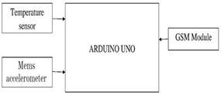
Fig.2.block Diagram of Alerting system
A few distinct parts make up this testing framework, including sheets (PIC board, LORA module, and USB interfacing board), LCDs (liquid crystal displays), several sensors, and other tiny electronic parts. This section provides a thorough analysis of each of these parts, along with their functioning principle. There are two sections: the area for monitoring and alerting. There are two sections in the checking segment:
Parts that are sent and recieved
Four sensors have been used in the transmitting side of the observation area to identify the various limitsSensors are used to monitor the situation in relation to the physical boundaries. The LCD and LORA transmitter are used to connect the sensors to the micro-regulator. POT is used to modify the LCD's brightness. The administrator of the control room and the excavator communicate remotely using a LORA transmitter and LORA recipient. This could be 2 kilometers away.
The upsides of each sensor are identified and sent to the micro-controller in this observation segment. The LCD (which displays the detected qualities) and the LORA transmitter receive these qualities from the micro-controller. These attributes are sent to the LORA recipient by the LORA transmitter. These attributes are sent to the PC by the LORA recipient via the USB/UART interface. .Through IOT, the received data will be consistently sent to the page. The Internet of Things supports remote monitoring and management of the current organizational structure. A GPRS-enabled IoT board is used in the system to display the information online. Using the IP address, the information can also be viewed on the permitted person's mobile device.
The excavator will be equipped with a band that includes a MEMS accelerometer sensor, a GSM module, and an Arduino uno for the warning segment. The following cases will contain an alarm that will be shipped off the excavator:
if a fall is detected by the accelerometer.
If the excavator's internal heat level increases specifically.
The GSM module will be used to send the alarm to the administrator in the control room.

List Of Components And Overview
The list of elements that are required to develop designing of I.O.T based coal mine safety monitoring and alarming system as shown in the below table[I].
TABLEI.LIST OF ELEMENTS THAT ARE REQUIRED
Component | Specification | Quantity
Microcontroller | LPC2148 | 1
LCD display | - | 1
Temperature sensor | LM35 | 1
Humidity sensor | HSM-20G | 1
Water level sensor | Magnetic reed | 1
Gas sensor | MQ-4 | 1
Lora wan | - | 1
Body temperature sensor | DSI8B20 | 1
MEMS accelerator | - | 1
GSM module | - | 1
ARDUINO NANO | - | 1

We will discuss briefly about the each and every component that is listed in the above table[I].In the below the every component should do it’s work properly in order to ensure the safety of the miners.

A.Microcontroller:
LPC2148 is the micro-controller used in the proposed system. Micro-controller is used to interface all the sensors and the module .
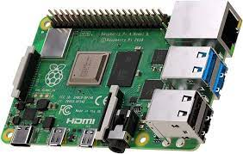
Fig.2.Microcontroller
B.LCD display:
LCD is utilized to show the detected qualities. LCD is a sort of level board show which involves fluid crystals in its essential type of activity .LCD-Liquid Crystal Display, have an enormous and fluctuating arrangement of purpose cases for shoppers and organizations ,as they can be regularly found in cell phones ,TVs ,PC screens and instrument boards.

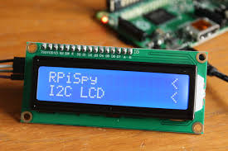
Fig.3.LCD Display
C.Temperature Sensor:

The temperature sensor in the suggested framework, the LM35, is used to measure the temperature inside coal mineshafts.

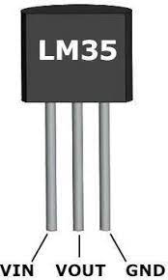

Fig.4.Temperature Sensor
D.Humidity Sensor:
The moistness sensor used in the suggested framework, the HSM-20G, is used to measure stickiness in the coal mineshaft.

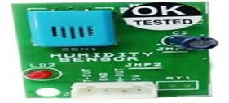

Fig.5.humidity sensor

E.Water level Sensor:
In the suggested system, a magnetic reed is used. The mine has a high water level if the reed is in the top position. The water level is low if the reed is lying flat.
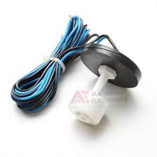

Fig.6.Water Level sensor

F.Gas Sensor:
Identifies the Changes in the concentration of hazardous gases are detected using MQ4.
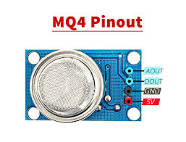
Fig.7. Gas sensor
G.Lora Wan:
The organization's framework and correspondence protocol are characterized by LoRaWAN. The long-range communication connection is maintained by the LoRa real layer. A LORA transmitter (located inside the mine) and a LORA receiver (located in the mine control room) have been used for the correspondence purpose.
H.Body Temperature Sensor:
The body temperature of the miner is measured using a popular digital temperature sensor called the DSI8B20.
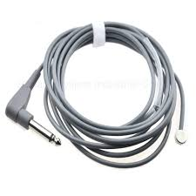
Fig.8.Body Temperature sensor

I.MEMS Accelerator:
MEMS accelerometers are low-range, highly sensitive instruments used for monitoring structures and detecting if Miners falls
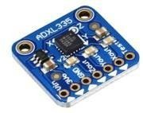
Fig.9.MEMS Accelerator

J.GSM Module:
A chip or circuit called a GSM module is used to organize communication between a mine manager and a digger.
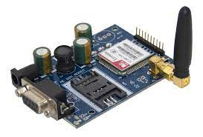
Fig.10.GSM Module

K. Arduino Nano:
The Arduino Nano is a low-cost, versatile, and user-friendly open source microcontroller board that can be integrated into a variety of electrical jobs. It is used to connect each of the modules in the warning segment.
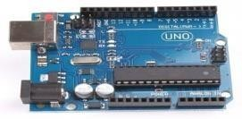

Fig.8. Solar Grass Cutter

Fig.11.Arduino Nano

IV. Circuit Diagram And Its Operation
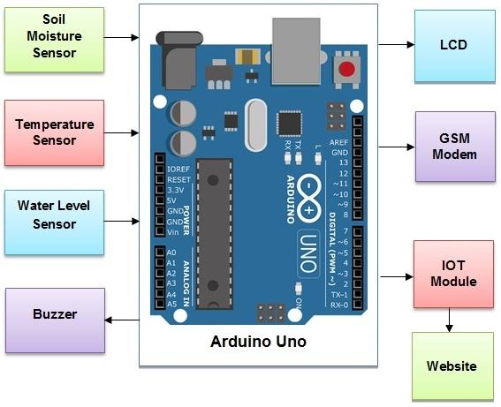

Fig.12.Basic circuit diagram of IOT based coal mine safety and alerting system
The transmitter module has temperature ,smoke/gas,water level sensors connected with it. It also carries an LCD display ,wifi module. All the sensor data is transmitted to remote IOT server regularly in a period of time .
Operation:
IOT Based Coal Mine Safety Monitoring project consists of two hardware modules, one transmitter, and one receiver. The
Main controller in both modules is an Arduino board.
Transmitter Module:
Transmitter module: It is installed inside the coal mine. The transmitter module contains the smoke sensor, temperature sensor, and methane sensor. The transmitter module also has an LCD. All the sensor data is displayed on the LCD display by Arduino. The RF transmitter present on the transmitter module sends the sensor data to the receiver module.
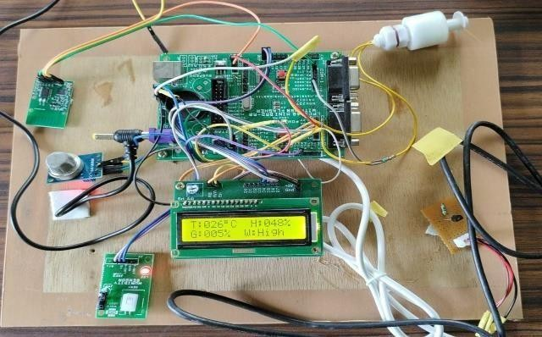
Fig.13.Transmitting Part-Sensors and LORA transmitted interfaced with the micro controller

Reciever Module:

It has an Arduino controller, LCD display, and an RF receiver. The RF receiver receives the sensor values from the RF transmitter on the transmitter module. The received sensor values are displayed on the LCD screen. The Arduino also sends the sensor data to the remote IOT server using the WiFi module every two minutes. If any of the sensor values exceeds a particular threshold level, the buzzer is turned on to notify the concerned personnel.

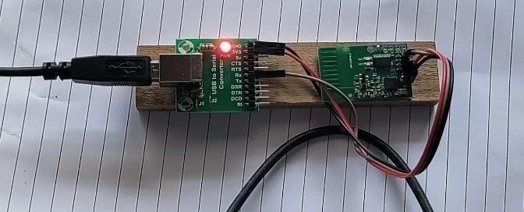
Fig.14.Recieving Part-Lora reciever

Alerting Module:

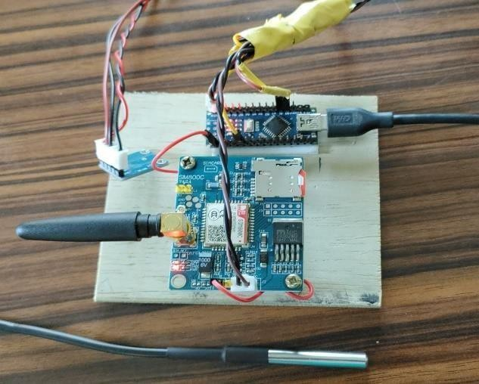

Fig.15.Alerting Module
The remote server has an IOT platform installed on it which displays the relevant data using the GUI which helps the users in monitoring and system control.

V. Result And Discussions
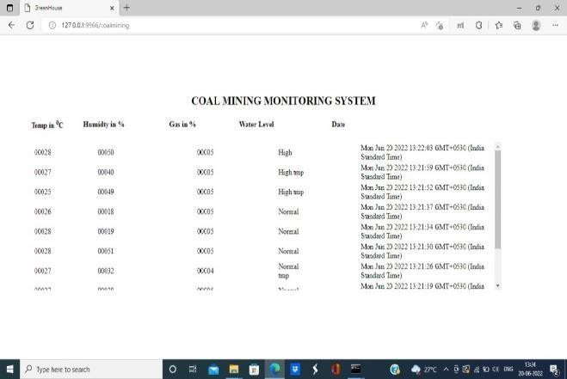

Fig.16.1.Values as recorded in PC

GRAPHS
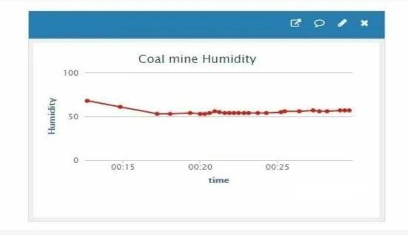
Fig.16.2.humidity v/s Time
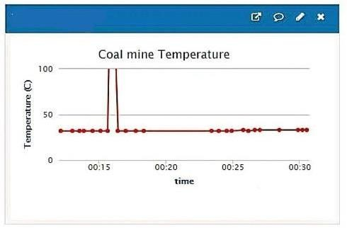

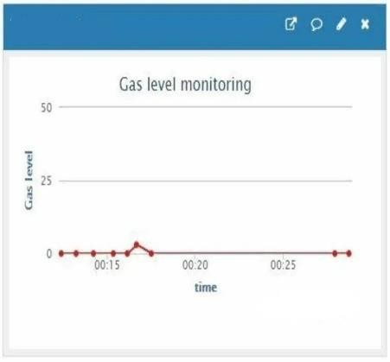
Fig.16.3.temperature v/s Time
Fig.16.4.Gas Level v/s Time

Applications ,Advantages of the IOT Based Coal Mine Safety Monitoring And Alerting System:
- The project is built from easily available and reasonably priced components. Therefore, the cost is reasonable and maintenance is easy.
- This project is crucial in the coal mining industry and is critical for the health and safety of the mine workers.
- The crucial parameters from inside the mine can be monitored from anywhere in the world by the supervisors and managers using the remote IOT platform. This can result in better management and improved production standards.
- This is a safety-critical project, therefore this system can be improved by making it fail-safe. We can implement the fail-safe operation using redundancy in the system. If one module fails then the parallel module will take over the operation.
VI.CONCLUSIONS
In conclusion, this IOT based coal mine safety monitoring and alerting system holds great promise in revolutionizing the safety landscape of coal mining operations. By harnessing the power of IOT and data-driven insights ,we can pave the way for safer working environments, thereby safeguarding the well being of miners and enhancing productivity in the coal mining industry. We hope this research serves as a foundation for further exploration and advancements in the field of mine safety , ultimately contributing to the betterment of the mining sector and the protection of human lives.

VII.Acknowledgment
It is highly acknowledged by the Department of Electrical and Electronics Engineering(EEE) at NRI Institute of Technology ,Agiripalli has provided assistance.

VIII.References
- S. Ingle, S. Salankar and S. Prasad, "To design and develop LoRa- based system for remote safety monitoring," 2022 10th International Conference on Emerging Trends in Engineering and Technology - Signal and Information Processing (ICETET-SIP-22), 2022, pp. 01-05.
- R. Hussain, F. M. Zakai and A. Iqbal, "Demystifying Mining Sustainab.ility Through Efficient And Low Cost IoT Based Safety Implementations," 2022 Global Conference on Wireless and Optical Technologies (GCWOT), 2022, pp. 1-6.Tao Liu, Bin Zhang, Jixing Jia Electromagnetic navigation system design of the
green house spraying robot IEEE(2014).
- T. Porselvi, S. G. CS, J. B, P. K and S. B. S, "IoT Based Coal Mine Safety and Health Monitoring System using LoRa WAN," 2021 3rd International Conference on Signal Processing and Communication (ICPSC), 2021, pp. 49-53.
- A. H. Soomro and M. T. Jilani, “Application of IoT and Artificial Neural Networks (ANN) for Monitoring of Underground Coal Mines,” 2020 International Conference on Information Science and Communication Technology (ICISCT), 2020,pp. 1-8.
- R. K. Kodali and S. Sahu, “IoT based Safety System for Coal Mines,” 2018 International Conference on Communication, Computing and Internet of Things (IC3IoT), 2018,pp. 147-150.
- U. Rai, K. Miglani, A. Saha, B. Sahoo and M. Vergin Raja Sarobin, “ReachOut Smart Safety Device,” 2018 6th Edition of International Conference on Wireless Networks & Embedded Systems (WECON), 2018,pp. 131-134.
- Mrs. shazia sulthana ,Madhukumari S ,Minali J Kunder ,Poornima Bajantri,Prapti K Yendigeri IOT based coal minig safety monitering and alerting system. 2022 july IJIRT volume 9 issuse 2 used for graphs

