Analyzing Convergence Rates of the Bisection Method for Root-Finding Using SCILAB

Dr.jyothi.G,K.Bhanu Priya,Dr.M.Dhana Lakshmi,Ch.Meghana*,M.Pujitha*,P.Swathi*

Lecturers,Department of Mathematics,Sri Durga Malleswara Siddhartha Mahila Kalasala, Vijayawada, A.P, India.

* Students, Mathematics,Sri Durga Malleswara Siddhartha Mahila Kalasala, Vijayawada, A.P, India.

ABSTRACT: Bisection method is the easiest method to find the root of an equation. In this paper, the software, SCILAB was used to find the root of the equation $x^{3}-2x-5=0$ in the interval [2,3] using the Bisection method. Also the study is aimed at analysing the rate of convergence of Bisection method of root-finding. The results are then compared based on the number of iterations. It was observed that the Bisection method converges at the 20th iteration. The root always converges, though very slow in converging.

KEYWORDS: Convergence, Roots, Iterations, Average, Opposite signs, Bisection Method and SCILAB Program code.

INTRODUCTION: Numerical analysis is one of the areas of mathematics and computer science that create analyses, and implements algorithms for solving numerically problems of continuous mathematics. There are many equations whose roots cannot be evaluated analytically by any methods. The approximate values of the roots of such equations can be found either by a graphical approach, or number of iterative methods or by a combination of both processes. In numerical methods of solving non-linear equations or root finding, the most popular methods are Bisection method, Newton’s method and Secant method. Several studies shown that many researchers are interested in the development and the application of Bisection method such as Muller method by Park and Hltotumatu (1987) and bisection-exclusion method by Yakoubsohn(2005).

Bisection method is based on Intermediate value theorem and it is an approximation method to find the roots of the given equation by repeatedly dividing the interval. The iterative sequence is continued until a desired stopping criterion is reached.

1.2 INTERMEDIATE VALUE THEOREM: If a function f(x) is continuous between a and b, and f(a) and f(b) are of opposite signs i.e., f(a)f(b)<0, then there exists at least one root for f(x)=0 between a and b.

PROCEDURE FOR BISECTION METHOD:

To find a root of the equation f(x)=0 lying in the interval (a, b), we shall determine a very small interval $(a_{1},b_{1})$ in which $f\left(a_{1}\right)f\left(b_{1}\right)<0$ if necessary, by using search bracket process.

Step 1: Let $x_{1}=\frac{a_{1}+b_{1}}{2}$.If $f\left(x_{1}\right)=0$ then $x_{1}$ is a root of the equation. If $f\left(x_{1}\right)≠0$ then either $f\left(a_{1}\right)f\left(x_{1}\right)<0$ or $f\left(b_{1}\right)f\left(x_{1}\right)<0$. If $f\left(a_{1}\right)f\left(x_{1}\right)<0$ then the root of the equation lies in $(a_{1},x_{1})$, otherwise the root of the equation lies in $(x_{1},b_{1})$. We rename the interval in which the root lies as

$(a_{2},b_{2})$ so that $b_{2}-a_{2}=\frac{1}{2}(b_{1}-a_{1})$.

Step 2: Let $x_{2}=\frac{a_{2}+b_{2}}{2}$. If $f\left(x_{2}\right)=0$ then $x_{2}$ is a root of f(x)=0. If $f\left(x_{2}\right)≠0$ and $f\left(x_{2}\right)f\left(a_{2}\right)<0$ then the root lies in $\left(a_{2},x_{2}\right)$.In which case we rename the interval as $(a_{3},b_{3})$, otherwise $(x_{2},b_{2})$ is renamed as $\left(a_{3},b_{3}\right)$ where

$b_{3}-a_{3}=\frac{1}{2}\left(b_{2}-a_{2}\right)=\frac{1}{2^{2}}(b_{1}-a_{1})$.

Step 3: Proceeding in this manner, we find $x_{n}=\frac{a_{n}+b_{n}}{2}$ which gives the nth

approximation of the root f(x)=0 and root lies in $(a_{n},b_{n})$ where

$b_{n}-a_{n}=\frac{1}{2^{n-1}}(b_{1}-a_{1})$.

Since the left end points $a_{1},a_{2},……,a_{n},…..$ form a monotonically increasing sequence which is bounded above and the right end points $b_{1},b_{2},……,b_{n},…..$ form a monotonically decreasing sequence which is bounded below, then there is a common limit $limit c=\lim_{n→∞}{a_{n}=\lim_{n→∞}{b_{n}}}$ such that f(c)=0 which means that c is a root of the equation f(x)=0.

1.4 SCILAB: SCILAB is capable of numerical computations, data analysis and plotting, system modeling and simulation, has graphical user interface capabilities and many many more.

From the programming language point of view SCILAB is an interpreted language. It contains a lot of already defined functions that can be used to resolve engineering and scientific problems. SCILAB is very versatile and can solve a vast type of mathematical and engineering problems. The best way to understand it’s capabilities is to look at the available functions.

The default [SCILAB installation](http://x-engineer.org/graduate-engineering/programming-languages/scilab/how-to-install-scilab-under-windows/) comes with a basic set of functions for:

* basic mathematical operators (addition, subtraction, multiplication, division, etc.)
* logical operations (AND, OR, NOT, etc.)
* these basic operators can be applied to various data types (booleans, integers, floating point, strings, etc.)
* matrix manipulation (transpose, product and sum of array elements, etc.)
* trigonometric functions (sine, cosine, tangent, cotangent, etc.)
* elementary functions (min, max, absolute value, etc.)
* user defined functions programming (conditionals and loops)
* 2-D and 3-D plotting (line and bar graphs, surface, etc.)
* I/O functions (files read and write)

2.1 STATEMENT OF THE PROBLEM:

Writing a SCILAB program code to find the real root of the equation

$x^{3}-2x-5=0$ in the interval [2,3] by using Bisection method performing 20iterations.

2.2 SCILAB PROGRAM CODE TO THE PROBLEM:

clc

a=input("enter lower limit")

b=input("enter upper limit")

k=input("enter no of iterations")

deff("[y]=f(x)","y=x^3-2*x-5")

if (f(a)*f(b)>0) then disp("wrong limits")

else

j=1

while(j<=k)

xm=(a+b)/2

printf("%f %f %f %f %f %f\n",a,b,xm,f(a),f(b),f(xm))

if (f(a)*f(b)<0) then b=xm

else a=xm

end

j=j+1

end

disp(xm,"approximate root in bisection method is ")

end

OUTPUT:

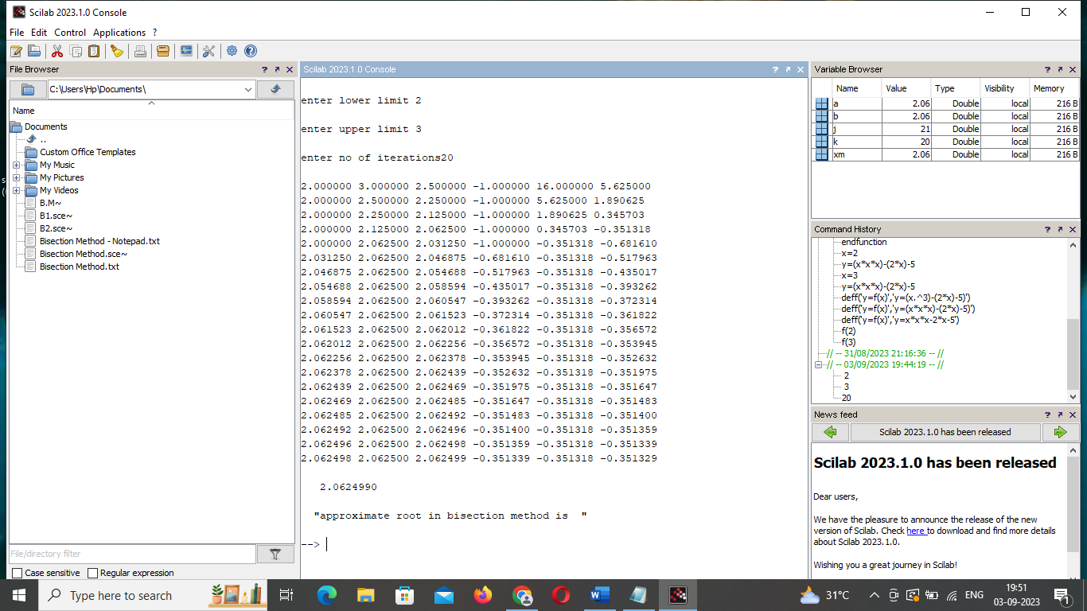

2.3 TABLE VALUES:

The Bisection method was applied to a single-variable function:

f (x) = $x^{3}-2x-5=0$ on [2,3], using the software, SCILAB. The calculations are presented in following table.

Iteration Data for Bisection Method

|  |  |  |  |  |
| --- | --- | --- | --- | --- |
| Steps | $$a_{m}$$ | $$b_{m}$$ | $$x_{m}$$ | $${f(x}_{m})$$ |
| 1 | 2.000000 | 3.000000 | 2.500000 | 5.625000 |
| 2 | 2.000000 | 2.500000 | 2.250000 | 1.890625 |
| 3 | 2.000000 | 2.250000 | 2.125000 | 0.345703 |
| 4 | 2.000000 | 2.125000 | 2.062500 | -0.351318 |
| 5 | 2.000000 | 2.062500 | 2.031250 | -0.681610 |
| 6 | 2.031250 | 2.062500 | 2.046875 | -0.517963 |
| 7 | 2.046875 | 2.062500 | 2.054688 | -0.435017 |
| 8 | 2.054688 | 2.062500 | 2.058594 | -0.393262 |
| 9 | 2.058594 | 2.062500 | 2.060547 | -0.372314 |
| 10 | 2.060547 | 2.062500 | 2.061523 | -0.361822 |
| 11 | 2.061523 | 2.062500 | 2.062012 | -0.356572 |
| 12 | 2.062012 | 2.062500 | 2.062256 | -0.353945 |
| 13 | 2.062256 | 2.062500 | 2.062378 | -0.352632 |
| 14 | 2.062378 | 2.062500 | 2.0624439 | -0.351975 |
| 15 | 2.062439 | 2.062500 | 2.062469 | -0.351647 |
| 16 | 2.062469 | 2.062500 | 2.0624485 | -0.351483 |
| 17 | 2.062485 | 2.062500 | 2.0624492 | -0.351400 |
| 18 | 2.062492 | 2.062500 | 2.062496 | -0.351359 |
| 19 | 2.062496 | 2.062500 | 2.062498 | -0.351339 |
| 20 | 2.062498 | 2.062500 | 2.062499 | -0.351329 |

2.4 RESULT: The table clearly shows the iteration data obtained for Bisection method with the aid of SCILAB. It was observed that using the Bisection method, the function, f (x) = $x^{3}-2x-5=0$ at the interval [2,3] converges to 2.062499 at the 20th iteration with error level of 0.000001.

2.5 ANALYSIS OF CONVERGENCE RATE OF BISECTION METHOD: Bisection method will always converge, and has the least convergence rate. It was also maintained that it converges linearly.

CONCLUSION: We implemented the function f (x) = $x^{3}-2x-5=0$ at [2,3] using Bisection method with the aid of the software, SCILAB. Based on result, we now concluded that the convergence of Bisection is certain, its rate of convergence is too slow.

REFERENCES:

Srivastava,R.B and Srivastava, S (2011), Comparison of Numerical Rate of Convergence of Bisection, Newton and Secant Methods. Journal of Chemical, Biological and Physical Sciences. Vol 2(1) pp 472- 479.

F.B. Hildebrand, Introduction to Numerical Analysis, 2nd Edition, McGraw-Hill, New York 1974.

C. Gerald, P.O. Wheatley, Applied Numerical Analysis, Addison-Wesley, Reading MA, 4th Edition, 1989.

R.L. Burden, J.D. Faires, Numerical Analysis, 5th Edition, PWS-Kent Pub. Co., Boston, 1993

K. Atkinson: An Introduction to Numerical Analysis, Wiley, (2nd ed.),

1989.

G. Dahlquist and A. Bjorck: Numerical Methods, Prentice Hall, 1974.

P. Deuflhard and A. Hohmann, Numerical Analysis in Modern Scientific Computing, 2nd ed., Springer, 2003.

8. W. Gautschi: Numerical Analysis: an introduction, Birkhauser, 1997.

9. A. Ralston and P. Rabinowitz: A First Course in Numerical Analysis,

McGraw-Hill, 1978.

10. E. Suli and D. Mayers: An Introduction to Numerical Analysis,

Cambridge, 2003.