# A STUDY ON EMPLOYEE MOTIVATION AT KARNATAKA SOAPS & DETERGENT LIMITED

1. **Dr. Ajatashatru Samal**

Head of the Department of MBA, Professor, Sri Venkateshwara College of Engineering

**Email id-** [**ajatashatru7@gmail.com**](mailto:ajatashatru7@gmail.com)

1. **Dr. ThiruLogaSundaram**

Associate Professor Department of MBA, Sri Venkateshwara College of Engineering

**Email id-** [**drthirulogan2014@gmail.com**](mailto:drthirulogan2014@gmail.com)

1. **Harshavardhan M**

Final year PG MBA Student, Dept of MBA, Sri Venkateshwara College of Engineering

**Email-id:** [**harsha1002911@gmail.com**](mailto:harsha1002911@gmail.com)

1. **Manoj R**

Final year PG MBA Student, Dept of MBA, Sri Venkateshwara College of Engineering

**Email-id:** [**manurebel449@gmail.com**](mailto:manurebel449@gmail.com)

# ABSTRACT

Employee Motivation is the key factor to help up the capacity of an association. In the globalization stage, each organization needs to continue itself in a furiously focused market. Representatives are the fundamental elements to show the business objectives into the real world. Subsequently, in the present world each association attempts to deal with its human asset office to keep its representatives inspired. In that specific circumstance, some of the administration speculations have been rehearsing by them. Business work or their presentation in the market can be assessed by surveying the degree of inspiration of representatives. Inspiration can assume a lead job to get the expert achievement in each budgetary year in a less exertion way.

**KEYWORDS:** Motivation, Employee Motivation, Rewarding, Drives & needs

# INTRODUCTION

Employee motivation ion is one of the most significant factors in the field of human asset the board. Capable and faithful employees are a base for effective organizations, and hence holding them is essential. Preparing new workers is tedious and requires more assets, in this way the more drawn out a representative remains with the organization, the better it is for the association.

# WHAT IS MOTIVATION

Motivation is a significant factor that urges people to give their best execution and help in arriving at big business objectives. Solid positive inspiration will empower the expanded yield of workers yet a negative inspiration will decrease their exhibition. A key component in work force the executives is motivation.

# Types of Motivation

1. **Intrinsic Motivation**

Intrinsic motivation is a type of motivation in which an individual is being motivated by internal desires. For example, let’s say an individual named Bob has define himself an objective to start shedding pounds and getting more beneficial. How about we likewise envision that Bob's motivation to seek after this way of wellness and wellbeing is to improve his wellbeing

in general and feel more joyful with his appearance. Since Bob's craving to change originates from inside, his inspiration is intrinsic.

# Extrinsic Motivation

Extrinsic motivation, on the other hand, is a type of motivation in which an individual is being motivated by external desires. Instead of being inspired by the need to look better and feel more beneficial, suppose that Bob was feeling pressure from his significant other to thin down and improve his physical make-up with the goal that she would be more pulled in to him. Since this weight originates all things considered this is an example of extrinsic motivation.

# Positive Motivation

In real sense, motivation means positive motivation. Positive motivation initiates individuals to do work in the most ideal way and to improve their presentation. Under this better offices and prizes are accommodated their better execution. Such rewards and offices might be money related and non-monetary.

# Negative Motivation

Negative motivation aims at controlling the negative endeavors of the work and tries to make a feeling of dread for the laborer, which he needs to languish over absence of good execution. It depends on the idea that if a laborer flops in accomplishing the ideal outcomes, he ought to be rebuffed.

# Reward-Based Motivation or Incentive Motivation

Incentive motivation or reward-based motivation is a type of motivation that is utilized when you or others know that they will be a reward once a certain goal is achieved. Since there will be something to anticipate toward the finish of an errand, individuals will regularly turn out to be increasingly resolved to oversee the undertaking with the goal that they can get whatever it is that has been guaranteed. The better the prize, the more grounded the inspiration will be !

# Fear-Based Motivation

The word “fear” carries a heavy negative meaning but when it comes to motivation, this is not necessarily the case. Anyone who is big on goal-setting and achievement knows that accountability plays a huge role in following through on goals. At the point when you become responsible either to somebody you care about or to the overall population, you make an inspiration for yourself that is established in the dread of disappointment. This dread encourages you to do your vision with the goal that you don't bomb before the individuals who know about your objective. Dread based inspiration is incredibly ground-breaking as long as the feelings of dread is sufficiently able to keep you from stopping.

# Achievement-Based Motivation

Titles, positions, and roles throughout jobs and other areas of our lives are very important to us. Those who are constantly driven to acquire these positions and earn titles for themselves are typically dealing with achievement-based motivation

# Theories used for the Employee Motivation for Improving Business Operation

**Maslow's Hierarchy of Needs**

Psychologist Abraham Maslow portrayed that in order to jump on the next level of psychological development, a person needs to satisfy himself or herself in all perspective, from where at present they existing, The characteristics of human life became satisfied when they can avail the psychological, safety, love, esteem and self - actualization process in their life span. Many organizations followed this theory to keep motivated their employees.

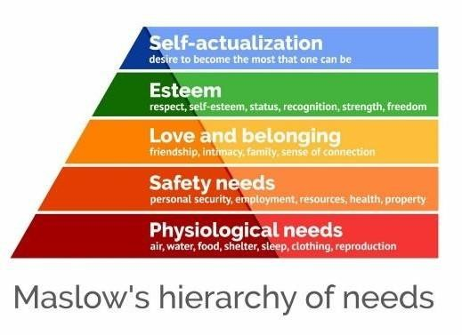

# Expectancy Theory

The expectancy theory proposes that employees’ behavior depends over the outcome the action. It suggests the aspects that when employees want hike in their salary increment they start working in longer hours. In this theory there have three main factors that are the expectancy, instrumentality and valence. In a workplace this theory can be executed by the authority, by giving reward to the employees for their good performance.

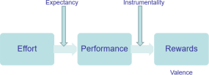

# Herzberg two Factor Theory

1. **Motivator factors:** The factors such like salary increment, good working environment motivate workers.
2. **Hygiene factors:** Those factors which can de-motivate the employees, such as company policies, salary deduction, Unhealthy relationship with managers and coworkers.

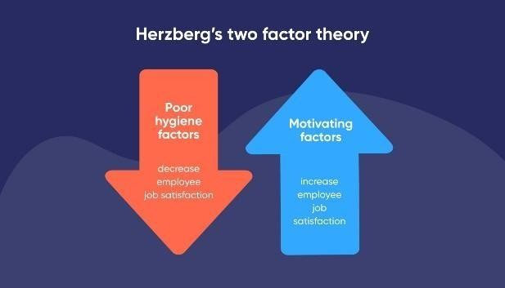

**OBJECTIVES OF STUDY**

1. To Evaluate the Effects of Motivation and satisfaction at workplace.
2. To Identify the Approaches used to Motivate Employees.
3. To Identify the Employee participation in decision making

**REVIEW OF LITERATURE**

* + **Setiyano Setiyano (The Impression of Workplace Discipline and Inspiration on Worker Performance), volume no. 2022, the year**

**.**

This article critically evaluates and employs research relevant to the scientific topic at hand. This study's research methodologies include subjective study and library research. The evaluation concludes by stating that the primary goal of this work remained to grow a premise concerning the probable links among various components, which may help as a platform for future research.

* + **Ronaldy Irfak (2005), volume no. 5, "Effect of Inspiration and Salaried Situations on Staff Productivity and Performance."**

The study's goal is to show how in (Orang Asli Programming (OAP)) app affects the government's capacity to precisely measure and analyze the well-being of Papuans in the area. Furthermore, by launching this app, it is wanted that the proportion of qualified applicants for future public service jobs in Sarmi Regency will help as a standard for future civil servant selections or appointments, particularly among the local Papuan people.

* **Eric Setiwan, volume no. 5 in the year of 2022, "Effect of Mutations and Permission on Desire & Their Effect on Work Satisfaction."**

The article dives into the importance of career transitions and breaks for employees, in particular those hired by agencies or enterprises with offices spread across Indonesia's archipelago. This significance is emphasized by the nation's geographical problems as fine as the country's uneven and insufficient transportation networks. The study, which is founded on library research, reveals a link between vacations, motivation, and job happiness.

# RESEARCH METHODS

The aim of the research was to find ways how to motivate the employees at KARNATAKA SOAPS & DETERGENT LIMITED. Considering the fact that Mind Science has more than 200 employees, and 100 it was reasonable to use the qualitative research methods instead of the quantitative, which suits more researches with large amounts of responses. The interview is one of the qualitative research methods and it can be structured, semi-structured, or unstructured. The structured interviews usually produce quantitative data, and with the unstructured interview the purpose is to gain more of observational data. Therefore, a semi- structured interview fit to the purpose of the research the best. The semi-structured interview usually contains predetermined open-ended questions, and additionally other questions that are originated during the interview.

# DATA COLLECTION

The interviews were implemented during three different days within a period of one week. The schedules for the interviews were planned together with the manager in order that there would be multiple interviews in one day, and the employees wouldn’t have to use their free time for it. Therefore, the interviews were supposed to take place during a certain part of a day when most employees were working at the same time.

# DATAANALYSIS

* + **illustrating “performance benefit in the organization”.**

|  |  |  |
| --- | --- | --- |
| Particulars | T0TAL RESP0NDENTS | RATIO |
| Once in six months | 34 | 34% |
| Once in one year | 17 | 17% |
| Once in a two year | 25 | 25% |
| Once in five year | 24 | 24% |

**ANALYSIS**

Rendering to the information from 100 respondents: 34% obtain a presentation windfall every six months, 17% receive it annually, 25% every 2 years, and 24% every 5 years.

* + **illustrating “performance benefit in the organization”.**

performance benefit

40%

30%

20%

10%

0%

once in 6 month once in one

month

once in two

month

once in six

month

**INTERPERTATION:**

The graph shows that the mainstream of those polled expect to accept a benefit for performance every six months.

* + **illustrating “kind of inspiration method used by organization”**

|  |  |  |
| --- | --- | --- |
| Factors | T0TAL RESP0NDENTS | RATIO |
| monetary | 10 | 10% |
| Nonmonetary | 50 | 50% |
| Non -technique | 30 | 30% |
| both | 10 | 10% |

**ANALYSIS:**

Among the 100 people who responded, 10% use monetary strategies, 50% use intangible methods, 30% use no technique at all, and 10% use a combination of the two.

* + **illustrating “kind of inspiration method used by organization**

|  |  |  |  |  |  |  |  |  |
| --- | --- | --- | --- | --- | --- | --- | --- | --- |
|  | | |  |  | | | | |
|  | | |  | | | | |
|  | | |  |  |  | | |
|  | | |  |  | | |
|  |  |  |  |  |  |  |

**INTERPRETATION:**

Chart Title

60%

50%

40%

30%

20%

10%

0%

monetary

non monetary

non technique

all

As illustrated in the chart above, the mainstream of respondents are of the opinion that the company employs financial incentives as a means to inspire its workers.

* + **illustrating showing “reimbursements providing by the association”**

|  |  |  |
| --- | --- | --- |
| Particulars | T0TAL RESP0NDENTS | RATIO |
| City passage allowance | 30 | 30% |
| Transport allowance | 15 | 15% |
| Maternity allowance | 11 | 11% |
| Dearness allowance | 10 | 10% |
| Household rent allowance | 0 | 0% |
| Project allowance | 20 | 20 |
| All | 14 | 14% |

**ANALYSIS:**

The table shows that the mainstream of defendants trust the business will pay municipal conveyance allowance.

* + **illustrating “benefits provided by the organization”**

benefits

35%

30%

25%

20%

15%

10%

5%

0%

city transport maternity dearness household project

all

passage allowance allowance allowance

allowance

rent

allowance

**INTERPREATATION:**

As depicted in the chart above, the mainstream of respondents state that the society offers employees with a transportation allowance

# FINDINGS

1. Since the research, 34% of participantsreceive a presentation incentiveonce a time.
2. From the research 50% of participants respondents are motivated with non- monetary techniques.
3. From the 30% of employee, the firm provides city transmission allowance to employees.

# SUGGESTION

* + Employees should receive feedback on their performances.
  + Employees must be trained motivated based on their peerformance.
  + Their should in no discrimination in training method among the employees

# CONCLUSION

Motivation is an important aspect within any organization and consequently ought to be overseen appropriately if high profitability in the association is normal. Authoritative administrators should in this manner target impacting positive representative directs through inspiring them to guarantee that they submit their endeavors towards hierarchical achievement. Certain inspirational speculations can assume a significant job in directing authoritative administrators through the representative inspiration process.

**REFERENCES BOOKS INTERNET**

**ARTICLES:**

Setiyano Setiyano(volume no.5, 2022 the year) Ronaldy Irfak (2005), volume no. 5

Eric Setiwan, volume no. 5 in the year of 2022