INVESTORS PERCEPTION TOWARDS DERIVATIVES INVESTMENT

#Dr Ch.Munendar Reddy
Abstract:
Derivatives have shifted the speculative trading to a more controlled environment. This paper analyses the perception of investors towards derivative trading. The study was conducted in Hyderabad to get an insight into the minds of investors to analyze their awareness and perception on investment in derivative instruments. The emergence of the market for derivative product, most notably Forwards, futures and options, can be traced back to the willingness of risk-averse economic agents to guard themselves against uncertainties arising out of Fluctuations in asset prices. By their very nature, the financial markets are marked by a very high degree of volatility. Through the use of derivative products, it is possible to partially or fully transfer price risks by locking – in asset prices, As Instruments of risk Management; these generally do not influence the fluctuations in the underlying asset prices. However, by locking in asset prices, derivative products minimize the impact of fluctuations in asset prices on the profitability and cash flow situation of risk – averse investors. A sound risk management system is integral to an efficient clearing and settlement system. NSE introduced for the first time in India, risk containment measures that were common internationally but were absent from the Indian securities markets. This paper deals with investor perception in derivatives investment in Hyderabad city and concern issue and challenges.
Key words: Income Surplus, Risk Factor, High Return, Interest Rates
Introduction:
“Derivative is a financial instrument whose value depends on (or derived from) the value of other, more basic underlying variables”. Financial derivatives are the innovative risk management products and financial services. Essentially, it is a future contract which is made between two parties and its value is derived from the original financial asset which may be Equity, Bonds or Foreign Exchange etc., differences or any others from of Security, and (b) a contract Which derives its value from the price, or index of prices, or underlying Securities.
---------------------------------------------------------------------------------------------------------------
#Associate Professor- MBA @ MRM Institute of Management, Chintapallyguda (V), ibrahimpatnam (M), R.R. Dist-501510, Telangana
Derivatives Trading in India are Legal and valid only if such contracts are traded on a recognized Stock exchange, thus precluding OTC derivatives.
Derivatives trading commenced in India in June 2000 after SEBI granted the approval to this effect in May 2000. SEBI permitted the derivative segment of two Stock exchanges, i.e. NSE and BSE, and their clearing house/ corporation to commerce trading and settlement in approved derivative contracts.
Derivatives are a very important financial instrument of the financial derivatives market as they help investors to hedge their risks, enable price discovery, and improve the liquidity of the underlying asset. There are different types of the derivatives market for derivative trading, namely; Options Derivatives, Future Derivatives, Index Derivatives. These financial derivatives are the financial contracts whose value is derived from their respective underlying asset. Further, there are various types of individuals with various investment goals to trade in the market, called Market Participants.
Each type of individual will have an objective to participate in the derivative market. Derivatives market participants can be divided into the following categories based on their trading motives:
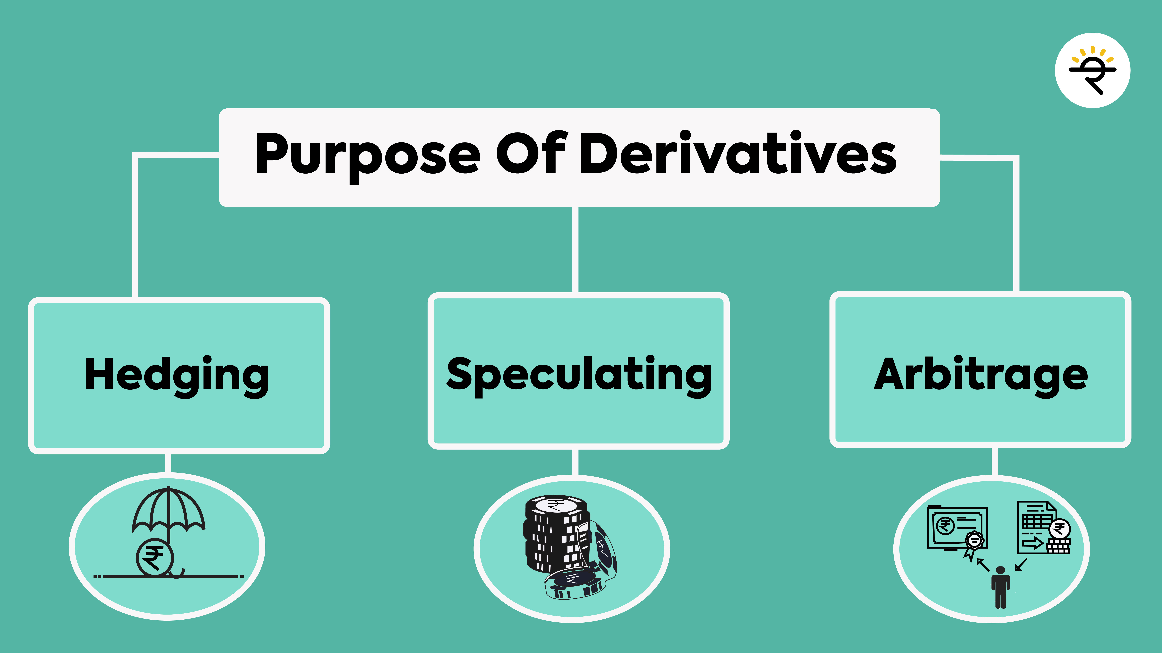
Source: Gopal Krishna (2019)

Hedgers
These are risk-averse traders in stock markets. Hedgers use derivatives, especially during market volatility. They aim at derivative markets to secure their investment portfolio against the market risk and price movements. They do this by assuming an opposite position in the derivatives market. In this way, they transfer the risk of loss to those others who are ready to take it (speculators). In return for the hedging available, they need to pay a premium to the risk-taker. This works in a way that - If you hold 100 shares of a company which is currently trading at a price of Rs.120. Your aim is to sell these shares after three months. However, you don’t want to make losses due to a fall in market price. At the same time, you don’t want to lose an opportunity to earn profits by selling them at a higher price in the future. In this situation, you can buy a put option by paying a nominal premium that will take care of both the above requirements.
Speculators
Speculators are the exact opposite of hedgers. These are the risk-takers of the market. Rather than protecting their portfolio, they aim at making higher gains in a shorter amount of time by taking risks in the derivatives market. Speculators take positions in the derivatives market without having a position in the underlying cash market. These positions are based upon their expectations of the price movement of the underlying assets. When they expect the market to go up, they may take a long position in these futures and when they expect the market to go down, they may take a short position in single stock futures.
This difference of perception and thought process helps them to make huge profits if the bets turn correct. In the above example, you bought a put option to secure yourself from a fall in stock prices. So on the other hand i.e. the speculator will bet that the stock price won’t fall. If the stock prices don’t fall, then you won’t exercise your put option. Hence, the speculator keeps the premium and makes a profit
Arbitrageurs
Arbitrageurs utilize low-risk market imperfections to make profits. They buy low-priced securities in one market and sell them at a higher price in another market at the same time. This is only possible when the same security is quoted at different prices in different markets. If an equity share is trading at Rs.1000 in the stock market and at Rs.1050 in the futures market. An arbitrageur would buy the stock at Rs 1000 in the stock market and sell it at Rs 1050 in the futures market. In this process, he/she earns a low-risk profit of Rs 50.

Literature:

Dr Venkatesh .R (2022) “The survival of business world in order to manage such risk, the new instruments have been developed in the financial markets, which are popularly known as financial derivatives at national and international financial market. Now there is a faster development in derivatives products as well as trading as they are very significant for every corporate and investor. The derivatives segment is to be handled by the SEBI. Derivatives segment is normal use by the trading purpose and other hand hedging purpose. In this research paper we have try to find the investors perception towards the derivatives market. Here we have found the popular strategy along with the all strategies also try to find the relation between the income and spent in the derivatives market. We have found out the psychology towards the derivatives instrument and then which problem facing the derivatives market by the investors.

Haritha (2021) The study determines that the investors preference reasons In the derivative investment is different in different Investment avenues. The investors preference reason in Derivative investments is depends upon the investment Objective such as Risk, Return, Safety and liquidity of the Investment. Most of the investors enter into the Forward Contract investments is Return, Future Contract investments Is Risk and Safety, Option Contract Investment is Future Needs and Investments in Swaps is Future Needs.
Gopal Krishna U M (2019) study explores that the Investors investment behavior and risk taking ability on various investment avenues. The study concludes the ability of risk behind the particular financial instruments in capital market.
D.V.Gakhar (2016) study on Impact on Volatility and Investor Perception explores that the investors awareness and investors investment decisions and risk taking ability on derivative instruments plays an important role in the development of trading activities in derivative market.
Y. Nagaraju (2014) conducted study on investors' perception towards derivative instruments and markets. The study concludes that before making of investment the investor should take effective measurements and determining the factors of risk for investment decision on particular financial instruments.
Dr. Babraju (2014) analysed the perception of investor towards derivatives as an investment avenue. He found that the derivatives are risk management tool that support in effective management of risk by various stockholders. Derivatives provide a chance to transfer risk from the one who wish to avoid it, to one who wish to agree it. India’s experience with the introduction of the equity derivatives market has been really encouraging and successful.
Methodology:
Objectives:
- To analyze the socio-economic profile of the investors and their investment characteristics.
- To find out the level of awareness of the investors towards financial derivatives.
- To analyze the investors’ perceptions regarding Equity derivatives.
Hypothesis:
H_{o1:} There is no significant relationship between age group of investor and level of awareness about derivative market
H_{o2:} There is no significant relationship between Educational Qualification of investor and level of awareness about derivative market
H_{o3:} There is no significant relationship between Marital Status of investor and level of awareness about derivative market

Data Collection:
The primary data is obtained by administering a structured questionnaire/ schedule to investors & stock broking companies in Hyderabad & Secunderabad region.
Sample Size:
A sample of 100 above profile responded opinion was collected with the help of a short questionnaire.

Influencing factor attracts to invest in Equity Derivative Market

Table 1: KMO and Bartlett's Test
Kaiser-Meyer-Olkin Measure of Sampling Adequacy. |  | .657
Bartlett's Test of Sphericity | Approx. Chi-Square | 2291.559
Bartlett's Test of Sphericity | df | 21
Bartlett's Test of Sphericity | Sig. | .000

The KMO value is 0.65 >0.6. Bartlett's Test of Sphericity indicates a measure of the multivariate normality of set of variables (Sig. value is less than 0.00 indicates multivariate normal and acceptable for factor analysis).

Table 1.2 : Communalities
 | Initial | Extraction
Low Risk | 1.000 | .490
Low Investment | 1.000 | .962
High Return | 1.000 | .962
High Liquidity | 1.000 | 1.000
Price discovery | 1.000 | 1.000
Less brokerage | 1.000 | .953
Sufficient time to square off | 1.000 | .953
Extraction Method: Principal Component Analysis.
The above table shows commonalities which indicate how much of the variance in the variables has been accounted for by the extracted factors. The item named “Low Risk factor” is removed further steps of factor analysis as its extraction value is less than 0.5 and rest of items has been accounted for further analysis.

Table 1.3: Total Variance Explained
Component | Initial Eigen values |  |  | Extraction Sums of Squared Loadings |  |  | Rotation Sums of Squared Loadings
Component | Total | % of Variance | Cumulative % | Total | % of Variance | Cumulative % | Total | % of Variance | Cumulative %
1 | 2.872 | 41.023 | 41.023 | 2.872 | 41.023 | 41.023 | 2.163 | 30.899 | 30.899
2 | 2.111 | 30.159 | 71.182 | 2.111 | 30.159 | 71.182 | 2.145 | 30.637 | 61.537
3 | 1.337 | 19.103 | 90.285 | 1.337 | 19.103 | 90.285 | 2.012 | 28.748 | 90.285
4 | .680 | 9.715 | 100.000
5 | 7.547  17 | 1.078  15 | 100.000
6 | -1.920  16 | -2.742  15 | 100.000
Extraction Method: Principal Component Analysis.

From the above table it is observed that 3 components or factors are having Eigen value more than 1, so only these 3 factors (value of component 1 = 2.872, component 2 = 2.111, and component 3 = 1.337) are considered for further analysis. Further, the extracted sum of squared holding % of variance depicts that the first factor accounts for 41.023% of the variance features from the stated observations, the second 30.15%, and the third 19.1%. Thus, 3 components are effective enough in representing all the characteristics or components highlighted by the stated 7 variables.

Table 1.4 : Component Matrixª
 | Component
 | 1 | 2 | 3
Low Investment |  | .910
High Return |  | .910
High Liquidity | .743 |  | .590
Price discovery | .743 |  | .590
Less brokerage | .840
Sufficient time to square off | .840
Extraction Method: Principal Component Analysis.
a. 3 components extracted.

The Table below shows the loadings (extracted values of each item under 3 variables) of the 7 variables on the 3 factors extracted. We have extracted 3 variables wherein the 6 items are divided into 3 variables according to the most important items which are similar responses in component 1 and simultaneously in components 2, and 3. The gap (empty spaces) on the table represents loadings that are less than 0.5, this makes reading the table easier. We suppressed all loadings less than 0.5.

H_{o1:} There is no significant relationship between age group of investor and level of awareness about derivative market.

Table 2 : Chi-Square Tests
 | Value | df | Asymp. Sig. (2-sided)
Pearson Chi-Square | 119.557ª | 6 | .000
Likelihood Ratio | 157.589 | 6 | .000
Linear-by-Linear Association | 1.727 | 1 | .189
N of Valid Cases | 500
a. 0 cells (.0%) have expected count less than 5. The minimum expected count is 11.20.

From the above table it is observed that Chi Squared test value is 119.55, p = 0.00 (<0.05), so null hypothesis shall be rejected. We can conclude that there is statistically significant relationship among age group of investor and level of awareness about derivative market.

H_{o2:} There is no significant relationship between Educational Qualification of investor and level of awareness about derivative market.

Table 3: Chi-Square Tests
 | Value | df | Asymp. Sig. (2-sided)
Pearson Chi-Square | 366.799ª | 15 | .000
Likelihood Ratio | 442.087 | 15 | .000
Linear-by-Linear Association | 8.456 | 1 | .004
N of Valid Cases | 500
a. 2 cells (8.3%) have expected count less than 5. The minimum expected count is 3.00.

From the above table it is observed that Chi Squared test value is 366.79, p = 0.00 (<0.05), so null hypothesis shall be rejected. We can conclude that there is statistically significant relationship among Educational Qualification of investor and level of awareness about derivative market.

H_{o3:} There is no significant relationship between Marital Status of investor and level of awareness about derivative market.

Table 4: Chi-Square Tests
 | Value | df | Asymp. Sig. (2-sided)
Pearson Chi-Square | 7.3998 | 2 | .116
Likelihood Ratio | 8.002 | 2 | .000
Linear-by-Linear Association | 10.238 | 1 | .000
N of Valid Cases | 500
a. 1 cell (16.7%) has expected count less than 5. The minimum expected count is 4.00.

From the above table it is observed that Chi Squared test value is 7.399, p = 0.116 (>0.05), so null hypothesis shall be accepted. We can conclude that there is no statistically significant relationship among Marital Status of investor and level of awareness about derivative market.

Results Discussion:

According to the results of this study, investor view of financial derivatives in India has changed in recent years, with investment in financial derivatives growing year after year. Investors' socioeconomic profiles (such as age, gender, income, and education, among other things) and investing patterns vary. Most investors believe that investing in derivatives is riskier than other avenues of investment. The majority of investors have discovered that liquidity and transparency are quite high in financial derivatives. The main disadvantages in derivatives market include volatility, large contract sizes, and a lack of flexibility; small investors are suffering a lot for investment in financial derivatives. Investing in financial derivatives entails both high risk and good return. As the derivative market provides a higher return by hedging interest rate and currency rate risk with maximum revenue. For their investments in financial derivatives, the majority of investors depend on third parties like brokers and social media. This is made possible by the market's significantly increased number of trading agents.
Most of the investors are not aware about the derivatives trading mechanisms. The investors mostly depend on professionals or experts and stock broker for trading in derivatives. There on the light of the above concerned authorities must take efforts to educate the investors. The main reason for the problems in the Futures and Options trading in the study is that lack of right information at the right time. This can be rectified by the authorities by providing necessary information through their online websites, Social media, National Seminars and so on.
The Stock Broking firms should provide mock trades, handouts and advices to create optimism among the investors. It is advisable to minimize the contract size because small investors cannot afford this much of huge premium. Investors felt that margin trading in derivative segment was the main barrier for investing, so the Institutions should work on this to reduce the margin.
References:
- BalaRaju. (2014). Derivatives usage by nonfinancial firms in emerging markets: The Peruvian case, Journal of Economics, Finance and Administrative science, pp-74-86.
- Divya Verma Gakhar (2012). Indian Derivatives Market: A Study of Impact on Volatility and Investor Perception. doi: 10.18178/ijssh.2016.6.12.7729.
- Dr. Y. Nagaraju, S. R. (2014). A Study on Investors' Perception Towards Derivative Instruments and Markets. International Journal of Research In Commerce, Economics & Management, 4 (7).
- Gopal Krishna U M (2019) Investors Perception towards Investment Avenues. International Journal of Recent Technology and Engineering 8(2), 1401-141110.
- Haritha (2021) “Investors Perception towards Investments in Derivatives” International Journal of Creative Research Thoughts (IJCRT), Volume 9, Issue 5 May 2021.
- Panchal, Nilam,(2022) Study on Investor's Perception Towards Trading In Equity Derivatives (February 18, 2022). Available at SSRN: https://ssrn.com/abstract=4296516
- R.Venkatesh (2022) “ Investors Perception towards Investments in Equity Derivatives in India “International Journal of Creative Research Thoughts, Volume 9, Issue 4 April 2022.

