**COMPARATIVE ANALYSIS OF THE MECHANICAL RESPONSE OF CEMENT AND THE LOCAL DYE RESIDUE, OR KATSI, ON STABILIZE LATERITE FOR THE PRODUCTION OF NBRRI CSEBS.**

**A.B. Shehu1*, A.A Bala 2 A. Zaid 3, J.M. Garba 4, I.Z. Ishaq5**

1234 Research Officers, Nigerian Building and Road Research Institute, Kano, Nigeria

5MSc student, Civil engineering Mewar University Chittorgarh, Rajasthan INDIA.

*E-mail of the corresponding author: [abshehudawaki1@gmail.com](mailto:abshehudawaki1@gmail.com)

**ABSTRACT**

With laterite samples from the Dantata and Sawoe barrow pit, Kano State, Nigeria, the study reports the results of an investigation into the use of cement admixed with Katsi to stabilize laterite in the production of NBRRI CSEBS (Compressed stabilized Earth Blocks). The natural soil used in the work is an A-2-6) soil according to the AASHTO soil classification system or CL in the Unified Soil Classification System. The plastic limit and CBR of the soil generally increase with increase in katsi content. The MDD of the lateritic soil increases with increases in the MDD from 2.07 to 2.08 g/cm3 at 0 to 5.0. but falls short of 5% katsi content. As the katsi concentration rises, the lateritic soil's OMC and CBR rise aswell. By weight replacement levels, the stabilizing agents were introduced at 2.5%, 5%, 7%, 5%, and 10%. The blocks' abrasion resistance, water absorption capacity, and compressive strengths were evaluated. The average dry compressive strength at 28 days was 1.63 N/mm2, 2.60 N/mm2, 2.78 N/mm2, and 3.12 N/mm2, respectively, for cement stabilized blocks at 2.5%, 5%, 7.5%, and 10% stabilization, according to the results. In contrast, KATSI stabilized blocks had 0.92 N/mm2, 1.25 N/mm2, 1.15 N/mm2, and 0.94 N/mm2, respectively. According to the Nigeria Building and Road Research Institute (NBRRI, 2006), the minimum strength for the first 28 days shouldn't be less than 2N/mm2. This criterion was only met by cement stabilized blocks with stabilization levels of 10% and higher. However, up to 5% of each is sufficient for stabilization in order for katsi to function as an effective soil stabilizer. The impact of katsi on the compressive strength, shear strength, and permeability warrants more

Keywords **—** Mechanical Response, Local Dye Residue, Katsi, Laterite, NBRRI CSEBS.

1. **INTRODUCTION**

Solid waste management has recently dominated the environmental scene in developing countries, everyday nearly three thousand tons of solid waste is generated in each state thereby causing environmental degradation [1]. The management of solid waste is cumbersome as many sources of the solid waste exist. Some common sources of solid waste include waste from educational sectors, agricultural sector, industries, etc. In areas where local dying of clothes, skin, etc are carried out, “Katsi” are the major waste product. The term “Katsi” is the Hausa name used in referring to the by-product residue of indigo dyeing process which is predominately carried out in Hausa land. As the dye loses its effectiveness, a dense deposit known in Hausa language as “dagwalo” is formed at the bottom of the dye pit, this ‘dagwalo’ is left to stand in the pit for about two days and then the whole solution is removed from the pit leaving behind a dense deposit at the base. The deposit is scrapped and removed from the pit and left to dry out completely. It is further burnt with open fire until a light grey ash is formed; this is pounded into powdered ash which is called Katsi or dye residue. According to [2], about 2 to 3 head pans (46 to 69kg) of Katsi are produced from a dye pit in a circle of dying process with an average annual production of about 112 tons. Hence, it is on this bases, the research seek to address the effect of this solid waste (Katsi) pollution by utilizing it as stabilizing agent in soil.

1. **LITERATURE** **REVIEW**

**SOIL AND SOIL PROPERTIES**

**Soil**

“Soil is the layer of earth formed on the surface by weathering and the influence of all other environmental factors. The mineral and organic substances of soil are pervaded with air, water and life forms. Natural soil originates through the combined interaction of parent material (basis rock), climate, water, relief, topography, flora, and fauna. The conditions at each location produce different soil types with characteristic profiles and specific physical and chemical properties. Along with air, water, and sunlight, soil is the basis of life for plants and animals, including humans. Soil is used as a production base for agriculture and forest plantations. Soil is affected by human interventions, by being moved and removed, altered, and destroyed, such as by construction and industrial action [3].

The Geologist regards soil as the material in the relatively thin surface zone within which roots occur and all the rest of the crust is grouped under the term “rock” irrespective of its hardness. To the Engineer, soil is the ungraded or uncemented deposits of mineral and/or organic particles or fragments covering a large portion of the earth crust [4]. To the soil scientist, or pedologist, the word "soil" conveys a somewhat different meaning, but no generally accepted definition exists [5]. Hilgard (1914) defined soil as "the more or less loose and friable material in which, by means of their roots, plants may or do find a foothold and nourishment, as well as other conditions of growth." This is one of the many definitions that consider soil primarily as a means of plant production[6].

**Lateritic** **Soil**

Lateritic soils abound in most parts of the tropics. Such soils have over the years found wide applications in such areas as pavements, embankments, low-cost houses, etc. In some cases the properties of the soils in the immediate vicinity of the construction works may not meet the required specifications. The need thus arises to improve the properties of the available materials. Soil stabilization is a method used to improve soil strength, bearing capacity and durability under adverse moisture and stress conditions[7]. It refers particularly to the mixing of the parent soil with other soil, cement, lime, bituminous products, silicates and various other chemicals and natural or synthetic, organic and inorganic materials.

**Local Dye Residue (Katsi)**

The word Katsi originated from Hausa tradition as a name of the bye-product of the indigo dyeing which is predominantly practiced in Hausa land. The dyeing is carried out in a dyeing arena called „MARUNA‟, in a dye pit of about 2 to 2.5 meters deep, having a diameter of about 0.5 to 0.8 meter. The upper edge circumference and the inner of the pit is cemented. The materials that constitutes the dyeing constituents includes water, backs of an oak tree and ashes, water is poured into the pit and the back of oak tree with ashes burnt from woods are added to it and allowed to decay and rot in the water for about two weeks. Then it is stirred continuously, until a muddy mixture is formed. The stirring is done consecutively for two days, then the elements responsible for the coloring is added known as „shuni‟. The resultant product is used for the dyeing of locally woven cotton, giving it its deep indigo blue color. The quantity of shuni used depends on the required color shade. As the dyeing process continues, and the dye losses its effectiveness, a dense deposit known in Hausa as „dagwalo‟ is formed at the bottom of the dye pit. The residue is left to stand in the pit for about two days after which the whole solution is removed from the pit, leaving behind a dense deposit at the base. The dense deposit is scrapped and removed from the pit and left to dry out completely. Upon drying, it is fired until a light grey ash is formed. This is pounded into powdered ash, which is called katsi (dye residue) [8]. Traditionally, katsi is used for local rendering by mixing it with the soil, mostly mixed with other materials such as „gashin jima‟ and „dafara‟ to make water proof cement known as „laso‟. Katsi can be found mostly in the northern region where local dyeing is predominant, particularly Kano, Zaria, Jigawa among others [9].

**Soil Stabilization**

A number of stabilization methods have been identified by various authors. However some of the stabilization methods such as the chemical stabilization involve the use of a wide range of additives in order to achieve a desired result. [10] noted that stabilizers in use include manufactured ones such as Portland cement, lime, bitumen, gypsum, alkalis, sodium chloride, calcium chloride, polymers and the natural ones agricultural and industrial wastes. Other natural stabilizer earlier mentioned include natural oil and plant extracts, animal dung and crushed ant-hill materials, bird droppings and animal blood have been used for the manufacture of compressed stabilized earth building blocks. The waste materials generally consist of nitrogenous organic compounds which help to bind together soil grains. Cassava starch has also been scientifically established by [11] to impart stabilization characteristics to a wide range of soil types.

The recent trend in soil stabilization is to consider the beneficial reuse of waste products from industries. [12] reported the use of fly ash for soil stabilization, while [13a,13b]showed that phosphatic waste, a by–product from the production of superphosphate fertilizer, pulverized coal bottom ash and blast furnace slag can be effectively used to improve deficient lateritic soil and tropical black clay[13].

1. **MATERIAL AND EXPERIMENTATIONMETHODS**

**3.1 Materials**

**3.1.1 Lateritic soil**

The international society for soil mechanics and foundation Engineering (ISSMFE) Progress Report (1982/85) states that “a soil can be considered lateritic if it belong to horizon A or B of well drained profiles developed under buried tropical climates, its clay fraction are constituted essentially of the kaolmite group and of iron or aluminum hydrated oxides. These components are assembled in peculiar porous and highly stable aggregate structure”. Lateritic soil is a category of residual soil formed from the weathering of igneous rock under conditions of high temperature and high rainfall such as those typically occurring in tropical regions. Laterites are mostly reddish in colour, but not all reddish tropical soils are lateritic. The soil for this research was collected a burrow pit from deposit in Kano State.

**3.1.2 Katsi**

Katsi was collected from waste deposit in Kofar Mata where dying is extensively carried out. The waste was dried and burnt to about 700 oC in an incinerator to form a light grey ash. The Ash is pounded into powdered ash which is called Katsi or dye residue and sieved using sieve #200 (75µm mesh size).

**3.2 Material Preparation**

The lateritic soils were stabilized with Katsi at concentration levels of 0, 2.5, 5.0, 7.5 and 10 % respectively of weight of soil. The stabilized soil were used to conduct The laboratory tests conducted includes; particle size distribution (sieve analysis), Atterberg limit test, compaction test, and California bearing ratio test.

1. **RESULTS AND DISCUSSION**

The summary results of tests(particle size distribution, atterberg limit test, compaction test, and California bearing ratio) conducted in this study are reported in the subsequent section.

**4.1 Particle Size Distribution**

The particle size distribution obtained using the sieve analysis (dry sieving) and hydrometer analysis methods are presented in Figure 1. The soil is low plastic soil with 43.72 % passing 200 µm sieve. This value is more than the recommended limit (≤ 35 %) provided by FMWH (2012). Hence, the soil could be considered not suitable material for sub-base and base course in highway. In addition, the soil was classified as Clayey sand and A-6 (2) using USCS and AASHTO classification respectively.

Figure 1: Particle Size Distribution Curve of Lateritic Soil

**4.2 TheEffects of Katsi on the Consistency of Lateritic Soil**

The effects of katsi on the consistency of lateritic soil were assessed using liquid limit, plastic limit, plasticity index and shrinkage limit as presented in Figure 2.

Figure 2: Consistency of Lateritic Soil

Where;

LL = Liquid limit PL = Plastic limit PI = Plasticity index SL = Shrinkage limit

The liquid limit of the soil generally decreases with increase in katsicontent as shown in Figure 2. The liquid limits change could be due to the cation exchange reaction and occulation-aggregation of soil particles. The decreases in liquid limits of stabilized soil are 30, 29, 28, 28 and 27 % respectively for increasing katsi content in the order 0, 2.5, 5.0, 7.5 and 10 % in the soil. The gradual reduction of the liquid limit is evident for improvement of the soil. In addition, the liquid limit for the range of katsi content (0 – 10 %) satisfies the requirement of the FMWH (2012).

The plastic limit of the soil increases with addition of katsias shown in Figure 2 from 17 to 21 %. An increase in plastic limit results from aggregation and cementation of particles into larger size clusters. Another possible reason is the water trapped within intra-aggregate pores. The presence of intra-aggregate water increases apparent water content without really affecting the interaction between aggregates (*Gruber et al*, 2001). In addition, the increase in plastic limit could be attributed to the presence of presence of CaO which has being documented by different studies to be significantly responsible for the increase in plastic limit as a result of cation ion exchange of Ca2+ in the soil mixture (Adeyanju and Okeke, 2019).

The plasticity index of the soil generally decreases with increase in katsicontent as shown in Figure 2. The high percentage of CaO, has being documented by different studies to be significantly responsible for the improvement in plasticity index as a result of cation ion exchange of Ca2+ in the soil mixture. This reduces the affinity of the soil to water, as the soil minerals are modified (Adeyanju and Okeke, 2019). A reduction of the PI from 13 to 6%was observed for the katsi stabilized soil.

As shown in Figure 2, increase in katsi content decreases the shrinkage of the soil. The decrease in shrinkage with addition of katsi could be attributed to reduction of plasticity index. In addition, the decrease could also be attributed to the increased physico-chemical reaction or ion exchange between katsi and soil.

**4.3 The Effects of Katsi on the Compactionof Lateritic Soil**

The effect of katsi on the maximum dry density (MDD) of lateritic soil is presented in Figure 3. The figure shows that katsi increases the MDD from 2.07 to 2.08g/cm3 at 0 to 5.0 % addition respectively and reduces beyond 5.0 % addition of katsi to 1.83 g/cm3 at 10 %. The increase in MDD could be attributed to filler property of the fine particle of katsi. The decrease could be attributed to the effect of lower density katsi displacing a more dense soil.

The effect of katsi on the optimum moisture content (OMC) of lateritic soil is presented in Figure 4. The figure shows that the OMC from 11.2 to 15.39 % at 0 to 10.0 % addition respectively of katsi. The increase in OMC could be attributed to high content of CaOin katsi. The increments in OMC with increase in katsi could be attributed to the increased amount of water required in the system to adequately lubricate all the particles in the soil-katsi mixture. It could also be as a result of increasing surface area due to excess fine particle of katsi, thereby making the mixture to require more water for hydration process.

Figure 3: Maximum Dry Density of Katsi – Stabilized Lateritic Soil

Figure 4: Optimum Moisture Content of Katsi – Stabilized Lateritic Soil

**4.4 Effects of Katsi on the California Bearing Ratio of Lateritic Soil**

The variation of California bearing ratio(CBR) of katsi Stabilized Soil is presented in Figure 5.It was observed from the figure that CBR values recorded an increase as katsi content increase. The observed increase in the CBR was due to the formation of a crystalline phase of CSH, which contributes to strength gain. The present of katsi has increased the CBR value from 18 to 73 %. These values are greater than the 15 % minimum CBR value required for pavement subgrades(Nigerian General Specifications, 1997). However, at 5 % and beyond, the CBR values were more than 30 % as specified by the Federal Ministry of Works (2012). This implies that the soil could be useful sub-base and base material when stabilized with not less than 5 % katsi content. The increase in CBR value of the soil with addition of katsiis an indication of improvement of the strength properties of the soil.

Figure 5: California Bearing Ratio of Katsi – Stabilized Lateritic Soil

**4.5.1 Preparation of Laterite Samples for NBRRI CEBS**

The laterite samples were air–dried for seven days in a cool, dry place. Air drying was necessary to enhance grinding and sieving of the laterite. After drying, grinding was carried out using a punner and hammer to break the lumps present in the soil. Sieving was then done to remove over size materials from the laterite samples using a wire mesh screen with aperture of about 6mm in diameter as recommended by Oshodi (2004). Fine materials passing through the sieve were collected for use while those retained were discarded.

**4.5.2 Production of Lateritic Interlocking Blocks**

The interlocking blocks were produced using a locally fabricated steel mould of size 250x130x220mm (Figure 1). The production process comprises batching, mixing, casting and compaction of the blocks. The materials used for the production of lateritic interlocking blocks were measured by weight in accordance with the predetermined percentages of stabilization (0%, 2.5%, 5%, 7.5%, and 10%) and the optimum moisture contents determined from the field.

Tables 1 and 2 showed the batching information for laterite samples stabilized with cement and KATSI, respectively.

The mixing was done on an impermeable surface free of all harmful materials which could alter the properties of the mix. The required quantity of laterite sample was measured and spread using a shovel to a reasonably large surface area. Cement or KATSI was then spread evenly on the laterite and mixed thoroughly with the shovel. The dry mixture was spread again to receive water

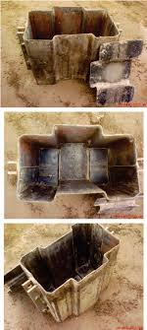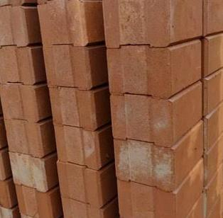

NBRRI CESBS BLOCK MOULD NBRRI CESBS BLOCK

**Table 1:** Batching Information for Laterite Samples Stabilized with Cement.

|  |  |  |  |  |
| --- | --- | --- | --- | --- |
| **Percentage** | **Laterite** | **Cement** | **Water** | **Water** |
| **Of** | **(kg)** | **(kg)** | **(kg)** | **Cement** |
| **stabilization** |  |  |  | **Ratio** |
| 0 | 215.00 | - | - | - |
| 2.5 | 201.56 | 13.4375 | 32.9225 | 2.45 |
| 5 | 188.125 | 26.875 | 65.84 | 2.45 |
| 7.5 | 174.69 | 40.3125 | 98.765 | 2.45 |
| 10 | 161.25 | 53.75 | 131.69 | 2.45 |

**Table 2:** Batching Information for Laterite Samples Stabilized with KATSI

|  |  |  |  |  |
| --- | --- | --- | --- | --- |
| **Percentage of** | **Laterite** | **KATSI** | **Water** | **Water** |
| **Stabilization (%)** | **(kg)** | **(kg)** | **(kg)** | **KATSI** |
|  |  |  |  | **Ratio** |
| 2.5 | 201.56 | 13.4375 | 32.9225 | 2.45 |
| 5 | 188.125 | 26.875 | 65.84 | 2.45 |
| 7.5 | 174.69 | 40.3125 | 98.765 | 2.45 |
| 10 | 161.25 | 53.75 | 131.69 | 2.45 |

**4.5.3 Curing of Lateritic Interlocking Blocks**

The blocks were first allowed to air dry under a shade made with polythene sheet for 24 hours. Thereafter, curing was continued by sprinkling water morning and evening and covering the blocks with polythene sheet for one week to prevent rapid drying out of the blocks which could lead to shrinkage cracking. The blocks were later stacked in rows and columns with maximum of five blocks in a column until, they were ready for strength and durability test (Figure 2).

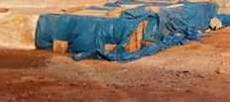

NBRRI CESBS FOR CURING

**4.6 Testing of Lateritic Interlocking Blocks**

The tests performed on the blocks are Durability, Water absorption and compressive strength. The durability of the blocks was determined through abrasive test. After the interlocking blocks have attained the specified age, two blocks were selected at random and weighed in the laboratory and their weight recorded. The blocks were placed on a smooth and firm surface and then wire-brushed to and fro on all the surfaces for 50 times, to and fro making a stroke. After brushing, the blocks were weighed again to determine the amount of material or particles abraded. This procedure was repeated for all blocks produced at various cement and KATSI contents and ages.

The water absorption was performed by randomly selecting two blocks from eachgroup at the specified age, and weighing them on a balance. These blocks were then immersed completely in water for 24 hours, after which they were removed and weighed again. The percentages of water absorbed by the blocks were estimated as follows:

Wa = Ws – Wd x 100 **(1)**

Wd

Where:

Wa = percentage moisture absorption

Ws = weight of soaked block

Wd = weight of dry block

Compressive strength test was carried out to determine the load bearing capacity of the blocks. Dry compressive strengths were determined. The blocks that have attained the ripe ages for strength test of 3, 7, 21, and 28 days were taken from the curing or stacking area to the laboratory, two hours before the test was conducted, to normalize the temperature and to make the block relatively dry or free from moisture. The weight of the each block was taken before being placed on the compression testing machine (Model: 50_C34A2, serial no:0294910) such that the top and bottom as moulded lie horizontally on a flat metal plate and the recessions filled with metal plate of the exact size to prevent sheaving of the block during testing. The block was then crushed and the corresponding failure load recorded. The crushing force was divided by the sectional area of the block to arrive at the compressive strength.

**4.7 Durability**

The abrasive test results at 28 days for cement and KATSI stabilized blocks are shown in Tables 3 and 4, respectively. It could be observed from the results that the resistance of the blocks to abrasion increases with the addition of both cement and KATSI as stabilizing agent. Laterite interlocking blocks without stabilization (The Control), recorded high percentage of materials abraded away in both cases. This is an indication that one form of stabilization or the other is required to enhance the durability of the blocks. However, cement stabilized blocks were of better resistance than KATSI stabilized blocks which is an indication of higher durability.

**4.8 Water Absorption**

The results of the water absorption tests are presented in Tables 5 and 6 for cement and KATSI stabilized blocks, respectively. Generally, the results indicate that water absorption decreases with increase in the percentage of stabilization. This is expected as the stabilizing agents (cement and KATSI) bond the laterite particles together thereby reducing the pores through which water could flow into the blocks. There was no result for the Control (0% stabilization) as the blocks were dissolved in the surrounding water.

**Table 3:** Result of Abrasive Test for Cement Stabilized Lateritic Interlocking Blocks.

|  |  |  |  |  |
| --- | --- | --- | --- | --- |
| **Cement** | **Mass** | **Mass** | **Abraded** | **Average** |
| **Stabilization** | **Before** | **After** | **Away** | **Abraded** |
| **(%)** | **Abrasion** | **Abrasion** | **(%)** | **away (%)** |
|  | **(kg)** | **(kg)** |  |  |
| 0 | 14.001 | 13.821 | 1.29 | 1.26 |
|  | 13.839 | 13.669 | 1.23 |  |
| 2.5 | 14.059 | 13.958 | 0.72 | 0.22 |
|  | 13.658 | 13.816 | -1.16 |  |
| 5 | 14.150 | 14.090 | 0.42 | 0.44 |
|  | 14.053 | 13.988 | 0.46 |  |
| 7.5 | 14.378 | 14.350 | 0.20 | 0.23 |
|  | 14.016 | 13.979 | 0.26 |  |
| 10 | 13.955 | 13.945 | 0.07 | 0.11 |
|  | 13.811 | 13.791 | 0.14 |  |

**Table 4:** Result of Abrasive for KATSI StabilizedLateritic Interlocking Blocks

|  |  |  |  |  |
| --- | --- | --- | --- | --- |
| **KATSI** | **Mass** | **Mass** | **Abraded** | **Average** |
| **Stabilization** | **Before** | **After** | **Away** | **Abraded** |
| **(%)** | **Abrasion** | **Abrasion** | **(%)** | **away (%)** |
|  | **(kg)** | **(kg)** |  |  |
| 0 | 14.001 | 13.821 | 1.29 | 1.26 |
|  | 13.839 | 13.669 | 1.23 |  |
| 2.5 | 13.619 | 13.739 | 0.88 | 0.98 |
|  | 13.870 | 13.720 | 1.08 |  |
| 5 | 13.830 | 13.935 | 0.76 | 0.86 |
|  | 13.544 | 13.674 | 0.96 |  |
| 7.5 | 13.820 | 13.720 | 0.75 | 0.78 |
|  | 13.760 | 13.650 | 0.80 |  |
| 10 | 13.010 | 12.960 | 0.38 | 0.35 |
|  | 12.940 | 12.900 | 0.31 |  |

The average water absorbed by cement stabilized blocks at 28days for 2.5, 5, 7.5,Band 10 % stabilization were 7.08%, 5.61%, 3.96%, and 2.90%, respectively while those of KATSI stabilized blocks were 11.17%, 8.79%, 6.28%, and 4.08%, respectively. These results showed that KATSI stabilized blocks were more permeable than cement stabilized blocks of similar percentage of stabilization. However the maximum water absorption of 12% as recommended by Nigerian Industrial Standard (2004) was satisfied by all blocks

**Table 5:** Result of Water Absorption Test for Cement Stabilized Interlocking Blocks.

|  |  |  |  |  |
| --- | --- | --- | --- | --- |
| **Cement** | **Dry** | **Wet** | **Water** | **Average** |
| **Stabilization** | **Mass** | **Mass** | **Absorbed** | **Water** |
| **(%)** | **(kg)** | **(kg)** | **(%)** | **absorbed (%)** |
| 2.5 | 14.108 | 15.094 | 6.99 | 7.08 |
|  | 14.321 | 15.347 | 7.16 |  |
| 5 | 14.005 | 14.805 | 5.71 | 5.61 |
|  | 14.145 | 14.925 | 5.51 |  |
| 7.5 | 13.903 | 14.396 | 3.55 | 3.96 |
|  | 13.726 | 14.326 | 4.37 |  |
| 10 | 13.190 | 13.570 | 2.88 | 2.90 |
|  | 13.365 | 13.755 | 2.92 |  |

**Table 6:** Result of Water Absorption Test for KATSI Stabilized Interlocking Blocks.

|  |  |  |  |  |
| --- | --- | --- | --- | --- |
| **Cement** | **Dry** | **Wet** | **Water** | **Average** |
| **Stabilization** | **Mass** | **Mass** | **Absorbed** | **Water** |
| **(%)** | **(kg)** | **(kg)** | **(%)** | **absorbed (%)** |
| 2.5 | 13.873 | 15.508 | 11.79 | 11.17 |
|  | 13.863 | 15.326 | 10.55 |  |
| 5 | 13.790 | 15.221 | 8.96 | 8.79 |
|  | 14.302 | 15.533 | 8.61 |  |
| 7.5 | 14.386 | 15.329 | 6.56 | 6.28 |
|  | 14.386 | 15.277 | 6.00 |  |
| 10 | 14.600 | 15.150 | 3.77 | 4.08 |
|  | 14.194 | 14.815 | 4.38 |  |

**4.9 Compressive Strengths**

The results of the compressive strengths are presented in Figures 3 and 4 for cement and KATSI stabilized blocks respectively. It can be observed from Figure 3 that the compressive strength of cement stabilized interlocking blocks increases as the percentage of stabilization increases. For KATSI stabilized blocks, Figure 4 showed that the compressive strength initially increases as the percentage of stabilization increases up to 5% stabilization and thereafter decreases as percentage of stabilization increases from 7.5% to 10%.

The compressive strength of unstabilized interlocking blocks (The control) varies from 0.37 N/mm2 to 1.48 N/mm2 as the curing age increases from 3 to 28 days. For cement stabilized interlocking blocks it varies from 0.64 N/mm2 to 1.63 N/mm2, 1.19 N/mm2 to 2.60 N/mm2, 1.25 N/mm2 to 2.78 N/mm2, and 1.98 N/mm2 to 3.12 N/mm2 for 2.5%, 5%, 7.5%, and 10% stabilization, respectively, during the same period.

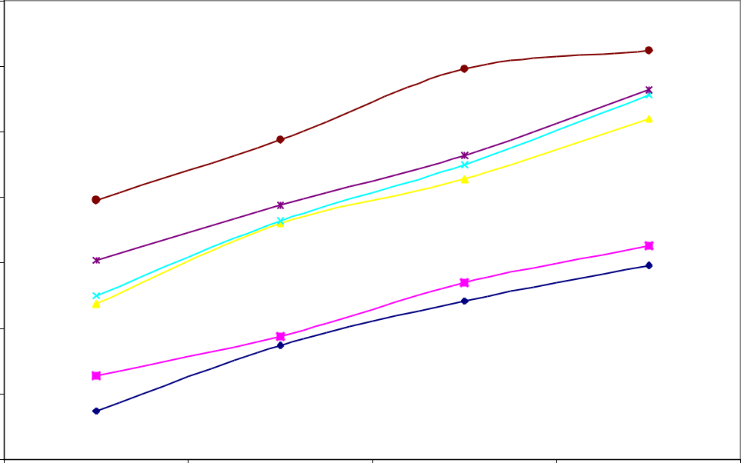

|  |  |  |  |  |
| --- | --- | --- | --- | --- |
| **2**  **Compressive Strength(N/mm2)** |  |  |  |  |
|  |  |  |
| 3.5 |  |  |  |
|  |  |  |  |
| 3.0 |  |  |  |
| 2.5 |  |  |  |
| 2.0 |  |  |  |
| 1.5 |  |  |  |
| 1.0 |  |  |  |
| 0.5 |  |  |  |
| 0 3 | 7 | 14 | 28 |

**Ages**

**Fig. 3: Compresive Strength of Cement Stabilized Lateritic Interlocking Blocks**

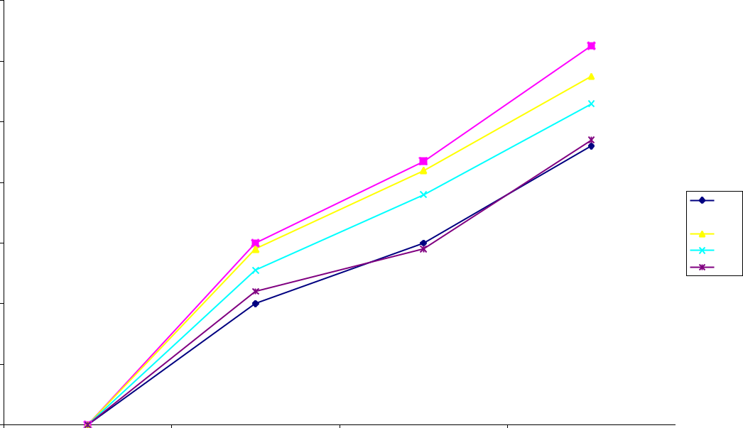

1.5 0%

1.0 8%

0.5

0

3 7 14 28**Ages**

**Figure 4: Compressive Strength of KATSI Stabilized Lateritic Interlocking Blocks.**

The compressive strength of KATSI stabilized interlocking blocks do not follow a regular pattern as discussed above. The 3 days strengths could not be determined as the cubes were very weak to be crushed. The compressive strength varies from 0.40 N/mm2 to 0.92 N/mm2, 0.60 N/mm2 to 1.25 N/mm2, 0.58 N/mm2 to 1.15N/mm2 and 0.44 N/mm2 to 0.94 N/mm2 for 2.5%, 5%, 7.5%, and 10% stabilization respectively as the curing age increases from 7 to 28 days. None of the blocks met the minimum requirements at 7 and 28 days as specified by the available codes. In fact, the compressive strength of the blocks was decreasing as the percentage stabilization go beyond 10%. This result indicated that KATSI stabilization is not suitable for laterite interlocking blocks due to the low clay content in the soil. According to Bell (1993), KATSI stabilization is suitable for soils with high clay contents.

1. **CONCLUSIONS AND RECOMMENDATIONS**

**Conclusions**

Base on the findings of the research on the performance katsi on lateritic, the following deductions were reached;

1. The liquid limit, shrinkage limits and Plasticity of the soil generally decreases with increase in katsi content.
2. The plastic limit and CBR of the soil generally increases with increase in katsi content.
3. The MDD of the lateritic soil increases with increases the MDD from 2.07 to 2.08 g/cm3 at 0 to 5.0 % addition respectively but decreases beyond 5 % katsi content.
4. The OMC and CBR of the lateritic soil increases with increasing katsi content.
5. The Durabilitytest results at 28 days for cement and KATSI stabilized blocks It could be observed from the results that the resistance of the blocks to abrasion increases with the addition of both cement and KATSI as stabilizing agent. Laterite interlocking blocks without stabilization (The Control), recorded high percentage of materials abraded away in both cases. This is an indication that one form of stabilization or the other is required to enhance the durability of the blocks. However, cement stabilized blocks were of better resistance than KATSI stabilized blocks which is an indication of higher durability.
6. Generally, the results indicate that water absorption increases with increase in the percentage of stabilization of KATSI. This is expected as the stabilizing agents (cement and KATSI) bond the laterite particles together thereby reducing the pores through which water could flow into the blocks. There was no result for the Control (0% stabilization) as the blocks were dissolved in the surrounding water. The average water absorbed by cement stabilized blocks at 28days for 2.5, 5, 7.5, and 10 % stabilization were 7.08%, 5.61%, 3.96%, and 2.90%, respectively while those of KATSI stabilized blocks were 11.17%, 8.79%, 6.28%, and 4.08%, respectively. These results showed that KATSI stabilized blocks were more permeable than cement stabilized blocks of similar percentage of stabilization. However the maximum water absorption of 12% as recommended by Nigerian Industrial Standard (2004) was satisfied by all blocks
7. The results of the compressive strengths for cement and KATSI stabilized blocks It can be observed that the compressive strength of cement stabilized interlocking blocks increases as the percentage of stabilization increases. For KATSI stabilized blocks, showed that the compressive strength initially increases as the percentage of stabilization increases up to 5% stabilization and thereafter decreases as percentage of stabilization increases from 7.5% to 10%.
8. The compressive strength of unstabilized interlocking blocks (The control) varies from 0.37 N/mm2 to 1.48 N/mm2 as the curing age increases from 3 to 28 days. For cement stabilized interlocking blocks it varies from 0.64 N/mm2 to 1.63 N/mm2, 1.19 N/mm2 to 2.60 N/mm2, 1.25 N/mm2 to 2.78 N/mm2, and 1.98 N/mm2 to 3.12 N/mm2 for 2.5%, 5%, 7.5%, and 10% stabilization, respectively, during the same period.
9. The compressive strength of KATSI stabilized interlocking blocks do not follow a regular pattern as discussed above. The 3 days strengths could not be determined as the cubes were very weak to be crushed. The compressive strength varies from 0.40 N/mm2 to 0.92 N/mm2, 0.60 N/mm2 to 1.25 N/mm2, 0.58 N/mm2 to 1.15N/mm2, and 0.44 N/mm2 to 0.94 N/mm2 for 2.5%, 5%, 7.5%, and 10% stabilization respectively as the curing age increases from 7 to 28 days. None of the blocks met the minimum requirements at 7 and 28 days as specified by the available codes. In fact, the compressive strength of the blocks was decreasing as the percentage stabilization go beyond 4%. This result indicated that KATSI stabilization is not suitable for laterite interlocking blocks due to the low clay content in the soil. According to Bell (1993), KATSI stabilization is suitable for soils with high clay contents.

**Recommendations**

Base on the above deductions of this the study, the following suggestions were made:

1. For an effective performance of katsi as soil stabilizer, up to 5 % each is adequate for stabilization.
2. Further study should be conducted on the effect of katsi on Unconfirmed compressive strength, shear strength and permeability.

**6. REFERENCES**

[1] Abdulrahman, H., Suleiman, A and Idi, M. A. (2016). Comparative Use of Cement and Katsi to Stabilize Laterite as a Liner in Containment Facility. International Journal of Scientific & Engineering Research, Volume 7, Issue 12, pp. 473 – 479.

[2] Ella O.B, (2004) The use of Katsi (Dye residue) as a pozzolana for partial replacement of cement and concrete, PhD. Thesis submitted to the Dept. of civil engineering A.B.U Zaria

[3] Ella, O. B. (2001), katsi as a pozzolana in mortar and concrete. , Ph. D. Thesis, Department of Civil Engineering Ahmadu Bello University, Zaria, Nigeria.

[4] Tawfiq, M. (2004). Retrieved from *SoilMechanics.*http//www.eng.fsu.edu/Tawfiq/ soilmech/lecture.html.

[5] Jenny, H. (1994). *Factors of Soil Formation;A System of Quantitative Pedology*. Constable and Company Jopte, J.S. (1936). *Pedology.* Rutgers University Press New Brunswick N.J.

[6] Hilgard, E.W. (1914). *Soils.* The Macmillan Company, New York. Houben, H and Guiland, H. (1994). *Earth Construction Technology.* GRA Terre, EAG, Paris. Hall C. (1977) Water movement in porous building materials unsaturated flow theory and its applications. Build Environ.Vol.12, 25-117.

[7] Ajayi, L.A. (1985). *The laterite and Laterite Soils in Nigeria.Geotechnical Practice in Nigeria.* Geotechnical Association Publication, Lagos, Nigeria.

[8] Haruna, I. (2017). Compressive Strength of Concrete Incorporating Rice Husk Ash and Local Dye Residue (Katsi) as Partial Replacement of Cement. Unpublished B. Eng. Final Year Project, A. T. B. U., Bauchi-Nigeria.

[9] Zubairu I.,Ibrahim, H., and Kabir, N. (2018), Investigation Into The Use Of Rice Husk Ash And Local Dye Residue (Katsi) As Partial Replacement For Cement *Globalscientificjournal Volume 6, Issue 6, June 2018, Online: ISSN 2320-9186 www.globalscientificjournal.com*

[10] Adam, E.A. and Agip, A.R.A. (2001). *Compressed Stabilized Block Manufacture In Sudan*.United Nations Education Scientific and Cultural Organization, pp 4-27.

[11] Khalil I.M (2005). *Soil Stabilization with Cassava Starch*, M.Sc Thesis, Department of Building, Faculty of Environmental Science, University of Jos, Nigeria.

[12] Phillips, T.P., Taylor, S.D., Sanni, L. and Akoroada, M.O. (2004). A Cassava Industrial Revolution in Nigeria: The potential of a New Industrial Crop. Food and Agriculture Organization.

[13a ] Osinubi K.J. (1998): “Influence of compaction delay on properties of cement stabilized lateritic soil” Nigerian Journal of Engrg., 6(1), 13-25.

[13b] Osinubi, K. J. (1998) “Stabilization of tropical black clay with cement and pulverized coal bottom ash admixture.” In: Advances in Unsaturated Geotechnics. Edited by Charles, D., Shackelford, Sandra L. Houston and Nien-Yin Cheng. ASCE Geotechnical Special Publication, No 99, pp 289-302.

AASHTO (1986). Standard Specification for Transportation Materials and Methods of Sampling and Testing 14th ed. *American Assoc. of States Highway and Transportation officials.*

ASTM (2006). Standards Practice for classification of soils for engineering purposes (Unified soil Classification system). Designation: D24287. West Conshohocken, United State.

BSI (1990). Methods of Test for soils for civil Engineering Purposes (BS 1377: Part 1-9). British standards institution, London.

.

BS1377 (1990). British Standard Methods of Test for Soils for Civil Engineering Purposes, *British Standards Institution, London.*