**Improving Device-to-Device Communication in LoRa Based Network Using Long - Short Term Memory Prediction Technique**

**1 Imo, F. U . , 2 Nwabueze, C. A & 2 Erukpe P. Aluhumile**

1 Nigerian Institute of Leather and Science Technology, Abuja, Nigeria

2 Department of Electrical/Electronic Engineering, ChukwuemekaOdumegwu Ojukwu University, Uli, Nigeria

1 imoudobi@gmail.com

**ABSTRACT**

Device to device communication has been on the research focus for a while as its prevalence in 5G and the incoming 6G could aid communication between two user equipment without the need for the base station in a cellular network. The effect of this is the reduction of pressure on the cellular network increasing the quality of service (QOS) as long as both devices communicating are in radio range while using radio technologies other than the cellular network. However, this promising technology can be considered less effective for mobile devices as they can move out of radio range, making it compulsory to switch back to the cellular network using the base station to relay the communication between them. Thus, resulting to the increased pressure on the communication network and reduced QOS. This switch in link can be avoided in some D2D communication that still requires human control by forecasting the dynamic Received Signal Strength Indicator (RSSI) which varies with respect to the distance between the devices. This forecast can aid prompt control decision to ensure that the devices are in communication range. To this end this research presents Improving Device-to-Device Communication in LoRa Based Network Using Long - Short Term Memory Prediction Technique This was achieved by simulating two devices 100m apart moving towards and apart from each other. The RSSI, the path loss and the distance between the nodes were logged. The RSSI was subdivided into train and test data. The train data was used to train an LSTM model and forecast was made using same model. It was observed that the forecast was following the same trend with the test data with RMSE of 4.848, 5.153 for each node when moving towards each other and RMSE of 4.68 and 4.17 when moving apart. The major contribution is to predict the future strength of path of a LoRa based D2D network using LSTM prediction technique. This will help user of the path to know whether it is safe to use the path for propagation or not.

**Keywords:** **Device - to - device communication, LoRa based network, Long-short term memory,** **Received signal strength indicator**

**1. INTRODUCTION**

Device discovery based on network influence involves the use of network functionality to locate the device intended for communication. This kind of device discovery is called Network Assisted Discovery. This, sometimes, could involve the use of the BS to aid device location identity (Rahim, Javed, and Ani, 2020). This technique which could mitigate collision (Ziadi and Asvadi, 2022), estimates the proximity or to locate devices in device to device (D2D) network ( Li and Tsai, 2018). Device to device (D2D) communication is a paradigm used to describe the technology that aids the communication between two or more UE’s with little or no use of the Base Station (BS) (Ziadi and Asvadi, 2022). Aside the use of network assisted device discovery, Rahim et al. (2020) highlighted the device discovery in which the base station was not involved. This kind of device discovery involved devices only. This is called distributed device discovery.

Distributed device discovery generally could be based on communication methods. One method involves the transmitting device sending broadcast randomly or receives a broadcast randomly at regular time intervals to discover devices within reach. This kind of distributed device discovery is called Randomized device discovery (Hayat, Ngah and Hashim, 2020). While another method could involve the transmission of beacon signal to a predetermined or a target device or the reception of beacon signal from a target device. This type of distributed device discovery which is not random in nature is called deterministic device discovery.

Succeeding the process of device discovery was D2D communication so as to aid the exchange of data. Communication in D2D could be on licensed or unlicensed spectrum (Kar and Sanyal, 2017). The licensed spectrum which was also known as in-band D2D communication involves the use of channels paid for. This however involved the use of the BS. This kind of communication was often discouraged except when needed for network expansion. Instead of it, the use of unlicensed spectrum which was also known as out-band D2D communication was highly encouraged so as to offload the cellular network. With this, the capacity of the network was increased. To achieve this, technologies like Bluetooth (BT), WI-FI direct, and LTE which operates within 2.4GHz ISM band or 3.8GHz mm wave spectrum has been used. According to Kar and Sanyal, (2017), BT which is characterized with data rate of 50mbps and range of 240m, Wi-Fi direct, having data rate of 250mbps and a range of 200m and LTE with data rate of 13.5mbps and range of 500m were suitable for low data rate communication characterized with short range. Therefore, they were suitable for D2D communication. This however was limited as the energy consumed during operation was often high and not suitable for long range communication. To combat this limitation, the Long Range (LoRa) radio technology was introduced (Moons et al., 2021). This technology which operates at low data rate, long range and low power was more suitable for D2D communication. To this end, this paper presents Improving Device-to-Device Communication in LoRa Based Network Using Long - Short Term Memory Prediction Technique.

**II. REVIEW OF RELATED WORKS**

The need for wireless communication for day to day activity is to attain a level of smartness in the execution of processes and decision making. In other words, for smart technology to be deployed, an integration of sensors and wireless communication module is necessary. This helps to harvest information of events of interest remotely. Aside this, the harvested information which could be large is stored in a central location for example the cloud which could be limitless in capacity. With this advantage, such technology has been used in the remote detection of forest fire (Lora et al., 2019), emergency health communication system (Sciullo et al., 2018), Unmanned Area Vehicle (UAV) (Hazwan et al., 2021) and smart farming (Escolar et al., 2019). According to Nurgaliyev and Saymbetov, (2020) and Kim, (2019), one form of communication modules used for this is IEEE.802.15.4 modules. These modules which include Bluetooth, Zigbee and WiFi were used to create a Local Area Network so as to capture behavioural patterns in a network. Although, they are good for high data rate transmission and reception because they are characterized by large bandwidth, however, the downside of its application is that they are meant for short distance communication (Kim, 2019; Nurgaliyev and Saymbetov, 2020). Aside this, the power consumed by these devices will generally reduce the life of sensor nodes in the network where they are used. To overcome these problems, Low power devices were developed for wide area networks. These devices include LoRa/LoRaWAN, NB-IoT, SIGFOX and Wi-SUN FAN (Escolar et al., 2019). Among all these LoRa/LoRaWAN is widely used today because of its efficient performance in ensuring wide range communication while using low power. This therefore infers that a LoRa Network is a network of wireless nodes which makes used of LoRa modules for communication.

**1.1. Characteristics of LoRa Network**

The LoRa Network is made up of a LoRa module at the physical layer which is the first layer of the Open Systems Interconnection (OSI) model. While, the LoRaWAN specification describes the media access control protocol at the second layer of the OSI model. The technology, operating in unlicensed Industrial, Scientific, and Medical (ISM) band, uses Chirp spread spectrum pulses to encode the data transmitted during modulation. According to Escolar et al. (2019), this device was operated within 863-870 MHz in Europe, 902-928 MHz in the United State, 915-928MHz in Australia and 470-510MHz in China. One of the advantages of using this technology was that LoRa divided the bands into different channels for uplink and down link. Also, it was affirmed by Escolar et al. (2019), that for LoRa modules, longer bandwidth, results to longer data rates and lower transmission time. Networks which used this technology were characterized with data rate which ranges from 0.3kbps to 27 kbps. This figure was as a result of a spreading factor (SF) ranging from 7 to 12. As shown in figure 2.1, with the use of LoRa WAN, devices can communicate directly with each other and with an internet connection. To communicate with the internet, the technology fosters communication with different gateways proving addressing and security.

there are applications which could be dynamic but could involve some level of control (Ioannou et al., 2022). This kind of D2D network application is seen in the control of drones or other forms of robots as shown in figure 2.4. Most times, one of the UEs like the downlink user equipment in this case, may be static while the upper link UE (the drone) is mobile. The drone may be a surveillance drone where the D2D communication is used for control of the drone and to receive video feeds of surveillance. As the drone moves away from the downlink UE, the channel used for D2D communication becomes less stable. This is evident in parameters such as Received Signal Strength Indicator (RSSI) among others which vary in magnitude. At points where the link is no more credible for communication, the base station can be used for relaying data automatically(Ioannou et al., 2022). This however, adds to the problem of cellular network overload which this research discourages. To avoid a handover, it is assumed that a fore knowledge based on a forecast on whether the mobile device will be within or without radius of coverage is needed to aid adequate control so as to avoid a handover. To achieve this, channel assessment is needed.

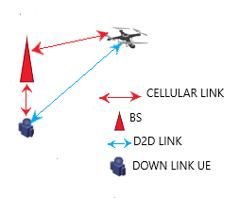

**Figure 1.: Application of D2D in Drone controls.**

**1.2 Review of Related Works**

In the quest to enhance communication for D2D in 5G/6G network, authors in Rattaro and Larroca (2020) used graph based machine learning method to know the state of the network. This was modelled as a link-prediction after which Random Dot Product Graph and Graph Neural Network was used to understand the state of the channel. To achieve this, the RSSI data set of Wi-Fi, one of the parameters that determined channel quality was used in this research. In the presentation, this helped to ensure better connectivity. The limitation of the work was that only instant channel quality was focused on. The knowledge of the channel so as to effectively stay within was not considered.

In an attempt to ensure better communication in a mobile D2D communication, researchers in Najla et al. (2020) proposed a power management scheme so as to limit interference in the case where channel gain between the BS and the UEs were known and when the channel gain between the D2D UEs were not known. To achieve this, DNN based supervised machine learning was used to determine the transmission power of individual devices in a pair. In other words, the channel gain of the BS was used to determine the transmission power of the UEs. In the presentation, it was proved that the knowledge of channel gain between devices in D2D communication may not be needed for power control which in turn helps to reduce interference. First the developed DNN power control scheme was used to investigate the relationship between the cellular and D2D channel gain. This relationship is then used to set the transmission power of UE. The limitation of the research work is that the method used still leveraged on the BS for information which was used for power control so as to limit interference. Furthermore, the consideration in this research was not loss of signal based on the increased distance between UEs.

To maintain quality of service (QoS) in a D2D network by ensuring effective communication, Wang et al. (2019) investigated and presented set of distributed resource allocation schemes that could aid out of coverage communication of D2D. In the presentation guidelines were provided on how to allocate D2D resources based on Modulation and Codding Schemes, Physical Resource Block (PBR) size and Time Resource Pattern. Furthermore, three distributed resource allocation schemes that selected PBR in the resource pool and adjust transmission power based on the available information about the network were presented. The first scheme which involved basic random allocation scheme allows user equipment’s to randomly select resource block from resource pool so as to transmit data at maximum power. The second which was Received Signal Strength based random allocation scheme enhanced the random scheme to reduce power consumption of the transmitting user equipment. While the third scheme developed was interference aware allocation. This scheme ensures effective allocation based on interference experience in the network.

Kim (2019) presented a new protocol which was an improvement on LoRa WAN. This was aimed towards overcoming the shortcomings of LoRa WAN in private network. To improve network coverage, Mesh protocol and a new multiple access scheme other than Aloha was developed.

In their work, Hazwan et al. (2021) presented review of real time deployment of an Unmanned Area Vehicle (UAV) based LoRa communication network. In the review, the focus was on the communication setup as shown in figure 2.5 and performance evaluation. According to the author, the communication network was characterized with low bit rate and therefore guarantees reliability in connection especially when it comes to long distance communication. Used in an IoT setup, the authors discussed LoRa based UAV which via sensors measured parameters of interest and communicated to the nearest LoRa gateway. In the gateway, protocol conversion was done. LoRa message was converted to message queuing telemetry transport protocol.

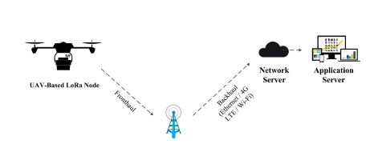

**Figure 1.2: Architecture of UAV-based Lora node (Hazwan et al., 2021).**

Gandortra and Jha (2016) carried out an extensive survey on device-to-device (D2D) communication including the plus points it offers; the key open issues associated with it like peer discovery, resource allocation etc., demanding special attention of the research community; some of its integrant technologies like millimetre wave D2D (mmWave), ultra dense networks (UDNs), cognitive D2D, handover procedure in D2D and its numerous use cases. Architecture aiming to fulfil all the subscriber demands in an optimal manner was proposed by the authors as shown in figure 2.6.

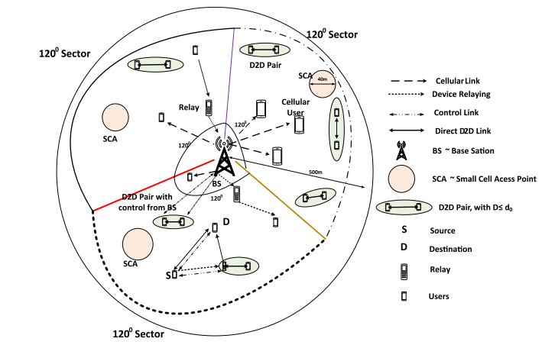

Figure 1.3: Architecture for D2D communication network in cellular network

(Gandortra and Jha, 2016).

**2. METHODOLOGY**

The D2D network structure considered in this work was a point-to-point network communication. Figure 3.1 shows that the network consists of two user equipment linked via wireless LoRa connection. The characteristic of the network is such that these UEs could be static and could be mobile. These results in the variation of the signal strength which may lead to loss of data packet sent especially when one UE wonders away from the coverage area. It should also be noted that since there is no check on the received signal strength, both equipment could continue communication which contributes to the depletion of their battery, reducing the life cycle of the nodes. The use of LSTM in the network communication will forecast the distance between both UE. This will ensure that there is no loss in communication since the motion can be controlled. In this work, three scenarios were considered. The first is when both UEs are static. The second scenario was when UE2 was moved away from UE1 and the last scenario was when UE2 was moved towards UE1.

**3. MODELING AND ANALYSIS**

**Work Flow**

Figure 3.2 shows the work flow adopted in this research. This began with the creation of the LoRa base D2D communication network. Afterwards, data of RSSI was generated. This data was feed into LSTM algorithm developed and the future distance forecasted. The accuracy of the forecast was determined via Root Mean Square Error (RMSE).



Figure 1. Work flow of the research work

**3.1. Simulation using MATLAB**

The simulation done with MATLAB was based on three scenarios. These scenarios are discussed in this section as follows:

**3.2. Mobile User Equipment in Static Position**

In this scenario, the two user equipment in D2D network are shown in figures 2.(a) and 2.(b), though may be mobile, it was assumed to be static in a constant position. This is because as shown in figure 2 (a) the two mobile UE a1 and b1, characterized with ground movement, though moved but, maintained the radius of communication. Similarly, figure 2 (b) illustrates a ground UE connected to a drone which moves from position 1 through to position 4. Even with these movements, the distance a, b, c and d are equal. In other words, $a=b=c=d$. With this, it is assumed that in all positions from 1 through to 4 is the same position.

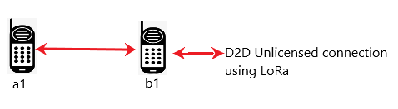  
(a)

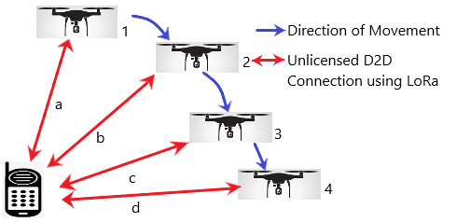

(b)

Figure 2: (a) Illustration of Physical connections between two UE in a D2D in a LoRa based network (b) Illustration of physical connection between two UE comprising of a drone and a control in a LoRa based network.

As shown in figure 4, for UE at point A to transmit to point B the power density (PD) is given in Equation (3.1).

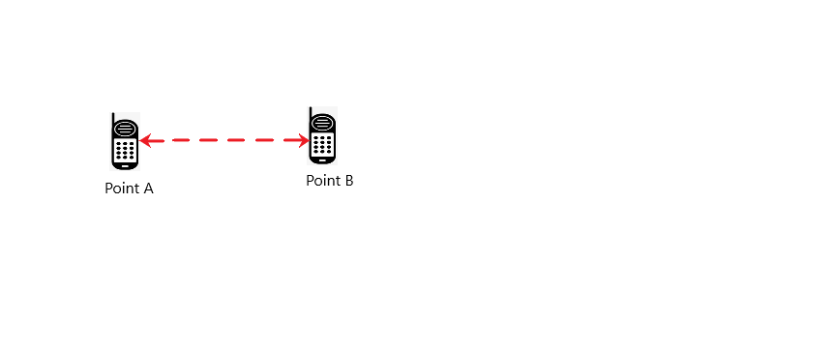

Figure 4: Illustration of wireless communication between D2D communications.

$$P_{D}=\frac{Power Recieved}{Surface area of the antenna of the LoRa module}$$

$P_{D}=\frac{P_{r}}{A}$ (3.1)

For an isotropic antenna,

$A=4πD^{2}$ (3.2)

Also, for effective communication, it is important to note that transmitted power $P_{t}$ is equal to received power $P_{r}$. Therefore the equation (3.1) can be rewritten as

$P_{D}=\frac{P_{t}}{A}=\frac{P_{t}}{{4πD}^{2}}$ (3.3)

where D is distance between the transmitter and the receiver. In reality, an isotropic antenna is not used but directional antenna. To consider such, the gain of the transmitting antenna $G_{t}$ was considered. Therefore PD is given as

$P_{D}= \frac{P_{t}G_{t}}{{4πD}^{2}}$ (3.4)

To calculate for the received signal in real situations, the receiving antenna signal depends on the effective aperture $(A_{e})$ which is mathematically defined as:

$A_{e}= \frac{P_{r}}{P_{D}}$ (3.5)

$P_{r}= A_{e}×P_{D}$ (3.6)

But $A_{e}α G_{r}$

where $G_{r}$ is the gain of the receiving antenna.

$A_{e}=\frac{λ^{2}}{4π}G_{r}$ (3.7)

where $λ$ is the wave length.

Remember that $P_{r}= A_{e}×P_{D}$ as stated in equation (6)

Therefore $P_{r}= \frac{P_{t}×G_{t}×G_{r}×λ^{2}}{{(4πD)}^{2}}$ (3.8)

Considering the loss L in the channel,

$P_{r}= \frac{P_{t}×G_{t}×G_{r}×λ^{2}}{{(4πD)}^{2}×L}$ (3.9)

Equation (3.9) is the free space equation between the two UE. From this equation, it can be inferred that the power of the received signal is inversely proportional to the losses in the channel. This is expressed as:

$P_{r} α \frac{1}{L}$

Also, the power of the received signal reduces as the square of the distance between the transmitter and receiver increases. This is expressed as

$P_{r} α \frac{1}{D^{2}}$

The free space path loss (FSPL) is defined as

$FSPL= \frac{P_{t}}{P_{r}}= \frac{{(4πD)}^{2}}{G_{t}×G_{r}×λ^{2}}$ (3.10)

$G_{t}= G_{r}=1$ (3.11)

$FSPL={(\frac{4πD}{λ})}^{2}= {(\frac{4πDf}{c})}^{2}$ (3.12)

Expressing it in decibels

$FSPL\left(dB\right)=20\log_{10}D+20\log_{10}f+20\log_{10}(\frac{4π}{c})$ (3.13)

Where f is the frequency of the spectrum and c is the velocity of the signal which is the velocity of light.

According to Shang et al. (2014), the received signal strength indicator (RSSI) can be expressed as

$RSSI= P_{t}-FSPL$ (3.14)

Also, the distance between the two UE is given as

$D= {10}^{(A-RSSI)/10n}$ (3.15)

Where A is the power of the received signal and n is the path loss index.

**3.3. Mobile User Equipment Moving away from Each Other**

In this scenario, the mobile UEs as shown in Figure .5 (a) and figures .5 (b) were seen to move away from each other. In figure 5 (a), the initial distance between the UEs was a. This was because the RSSI measured would be from UE a1 to UE b1. This is expressed as $RSSI=P_{t}-FSPL$. This same expression is presented in equation (3.14). As a result, the received signal strength was given as ${RSSI}_{0}$ and the path loss index was $n_{0}$. Therefore, the distance between the two UEs as expressed in equation (3.15) can be re written as.

$a= {10}^{(A_{0}-{RSSI}_{0})/10n_{0}}$ (3.16)

As UE b1 moved forward from position 1 to position 2, the total distance was a + b. Also, the new received signal power would be $A_{1}$, with new received signal strength indicator ${RSSI}_{1}$ and new path loss index would be $n_{1}$. This therefore suggested that if the UE b1 moved from position $0$ to $x$, the distance measured between UE a1 and UE b1 at point x would be given as

$a_{x}={10}^{(A_{x}-{RSSI}_{x})/10n_{x}}$ (3.17)

where x is the present position.

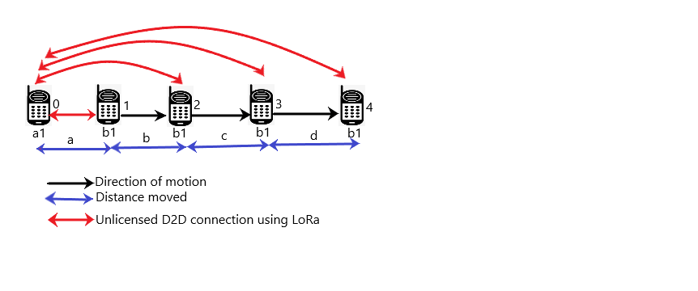

(a)

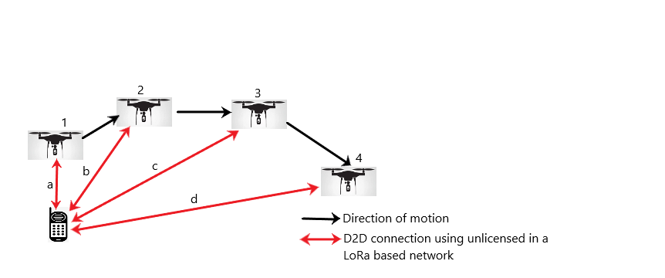

(b)

**Figure 5: (a) Illustration of D2D LoRa based connection between user equipment moving apart from one another (b) D2D LoRa based connection between user equipment and drone.**

**3.4 Mobile User Equipment Moving towards Each Other**

In this scenario, the focus was on a D2D network with mobile user equipment which constantly moved towards each other. As shown in figure 6, UE b1 was seen to move from position 4 to position 3 through to position 1. As a result of this movement, unlike scenario two where the power of received signal strength faded away, it is expected that the power of received signal strength increased as both UE a1 and b1 came close to one another. Consequently, the distance via the use of received signal strength indicator RSSI will be expressed as $a_{x}={10}^{(A_{x}-{RSSI}_{x})/10x}$. where $a_{x}$ is the distance between a1 and b1 at point x in space. $A_{x}$ is the power of the received signal, ${RSSI}_{x}$ is the received signgal strength indicator at position x and $n_{x}$ is the loss index at the point x.

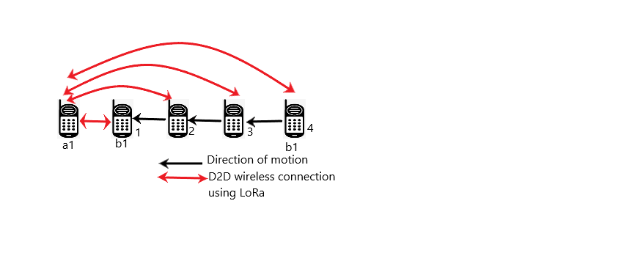

**Figure 6: Illustration of D2D network with the UE b1 moving from position 4 to position 1.**

**3.5 Long Short Term Memory (LSTM)**

Long-Term Short Memory is a form of Recurrent Neural Network (RNN) that ensures the extraction and retention of long term variable in past data gathered (Nguyen et al., 2021). RNN characterized with three gates which included control gate, input gate and forget gate, has more advantage over all method of forecasting (Muzaffar et al., 2019). Unlike the traditional neural network used to produce Y variable when an input X was used at the input of the neural network and afterwards, Y was never used again, RNN used the Y generated as the present X so as to forecast future Y. In other words, Y generated was not forgotten like the traditional neural network. As a result of this, RNN has to learn every past data which leads to a problem called the vanish problem. This means that because the recurrent network has to learn all past data, it tends to forget because the weight becomes too small for learning to occur. To solve this problem, LSTM was proposed as an improvement over RNN. The LSTM neural network overcomes the limitation of the RNN by propagating or forgetting information over a long and recurring training period. Furthermore, its ability to correlate between the previous and current information makes it suitable for time series data and achieve improved results. The basic architecture of LSTM model is a cell as shown in figure 3.7. The operation of this cell is presented as follows:

Let $x_{t}$ be the sequence vector where index $t=1, 2,……T$ where $T$ is the total time sample in the sequence. At time $t,$ the LSTM takes input sample from $x_{t}$, past state $a_{t-1}$ and past hidden state $h_{t-1}$**.** At the input of the cell, the forget gate is what determines what is to be omitted from $x_{t}$ and $h_{t-1}$. Note that the activation function could be a sigmoid or a rectified liner unit. The sigmoid which is often used at the input, output and forget gate is defined as:

$σ\left(z\right)=\frac{1}{{1+e}^{z}}$ (3.18)

Equation (3.18) gives a value between 0 and 1 for any input z. At this point, the sigmoid function determines whether the input vector is to be propagated (having values closer to 1) or to be forgotten (having values close to 0). As the training of LSTM is on-going, gradient computation which may lead to gradient vanish can occur if the gradient shrinks to zero. This however is solved with the choice of rectified liner unit function which is defined as $ρ\left(z\right)=max⁡(z,0)$. With this, computation is made faster impeding the gradient to varnish. However the decision made by the forget gate on which information to be propagated or omitted from $x_{t}$ and $h_{t-1}$ is what results to the output vector defined by Muzaffar et al. (2019):

$ɼ_{f}^{t}= σ(W_{fh}h_{t-1}+W_{fx}x_{t}+b_{f})$ (3.19) where $W_{fh}, W_{fx}$ are matrix weight, f is the forget gate and $b_{f }$ is the bias vector. Also, the resulting vector $ɼ_{f}^{ t}$ is the resultant vector at the forget gate.This resulting vector ($ɼ_{f}^{t}$) is what outputs 0 or 1 to determine what information is to be forgotten or propagated from cell state $a_{t-1}$ via element product expressed in Muzaffar et al. (2019) as:

$a_{t}= ɼ_{f}^{t}⊙ a_{t-1}+ ɼ_{i}^{t}⊙ ɼ_{g}^{t}$ (3.20)

where $ɼ_{i}^{t}$ and $ɼ_{g}^{t}$ are the resultant vector at the input gate and the input node. The application of sigmoid function at the input gate yields a resultant vector expressed as

$ɼ_{i}^{t}= σ(W_{ih}h_{t-1}+W_{ix}x_{t}+b_{i})$ (3.21) where $W_{ih}, W_{ix}$ are matrix weight at the input gate and $b_{i}$ is the bias of the input gate. The rectifier function applied at the input results to result vector expressed as

$ɼ_{g}^{t}= σ(W_{gh}h_{t-1}+W_{gx}x_{t}+b_{g})$ (3.22)

Where $W_{gh} and W_{gx}$ are matrix weights at the input node and $b_{g}$ is the bias of the input node

At this point the resultant elements $ɼ_{i}^{t}$ and $ɼ_{g}^{t}$ as represented in equation (3.19) contain new values to update $a_{t}$. Afterwards, the output gate passes the relevant values from updated $a_{t}$ to as a new hidden state $h_{t}$. This is achieved by passing the updated $a_{t}$ from the output gate through Rectified linear Unit (ReLU) function resulting to ρ($a_{t}$). Afterwards, the location of the updated cell state vector which holds the filtered values are decided by sigmoid function to yield the resultant element at the output gate expressed as

$ɼ_{o}^{t}= σ(W_{oh}h_{t-1}+W_{ox}x_{t}+b_{o})$ (3.23) Using the element wise product $ɼ_{o}^{t}$ and ρ($a_{t}$), new hidden state is finally expressed as

$h_{t}=ɼ_{o}^{t} ⊙ρ(a_{t})$ (3.24)

All these procedures are used to learn hidden features of the data used.

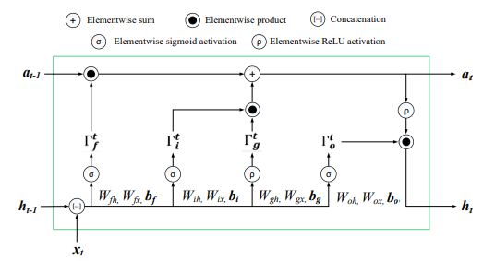

**Figure 7: Illustration of LSTM cell structure.(Singh et al., 2020)**

**3.6 Procedures in the application of LSTM**

The application of LSTM aids the prediction of the next series in the time series data. To achieve this, steps as shown in the figure 3.8 were applied. First the accumulated data is read or gathered so as to be formatted. The formatting also called data pre-processing or data preparation involves the mapping of all data points gathered into features (X) and target (Y).

If the time series data was generated as a univariate sequence such as [$a_{0}, a_{1}, a_{2}, a_{3}, a_{4}, a_{5}, a_{6}, a_{7}, a_{8}, a_{9}, a_{10},………..a_{n}$], the data would then be formatted into X and Y as shown in Table 1. As illustrated, $a_{0}, a_{1}, a_{2}$ is used to determine the next sequence which is $a_{3}$. The data input $a_{1}, a_{2}, a_{3}$ is used to predict $a_{4}$. Therefore, $a_{n-2}, a_{n-2}, a_{n-1}$ will be used to predict $a_{n}$.



**Figure .8: work flow of the process involved in prediction**

**Table 1: Format of the data to be trained in an LSTM model**

|  |  |
| --- | --- |
| X | Y |
| $$a_{0} , a_{1}, a_{2}$$ | $$a_{3}$$ |
| $$a_{1} , a_{2}, a_{3}$$ | $$a_{4}$$ |
| $$a_{2} , a_{3}, a_{4}$$ | $$a_{5}$$ |
| $$a_{3} , a_{4}, a_{5}$$ | $$a_{6}$$ |

**4. RESULTS AND DISCUSSION**

Figure 4.1 presents the distance between the two nodes. From the figure it is observed that initially, the distance between the nodes was 100m. However, as a result of the nodes moving towards each other, both nodes were together when time is 5 seconds. Afterwards, both continued to deviate from one another till they were 100m apart. As a result of this movement, it was observed that the RSSI of both nodes started increasing until it peaks in figure 4.2. As the nodes started moving apart, a decline in RSSI was noticed too. This movement also, was seen to affect the path loss as the loss declined as both nodes came close to one another and increased as they move away from each other.

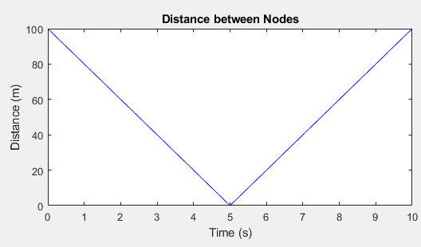

**Figure 4.1 Graphical illustration of the distance between the two nodes**

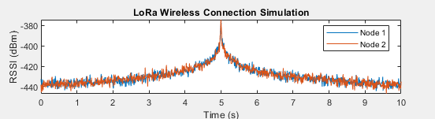

**Figure 4.2: Graphical illustration of the RSSI of both nodes with respect to time.**

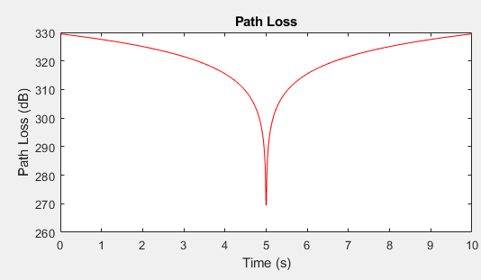

**Figure 4.3: The Path loss experience during communication as a result of motion.**

**4.2.1 Data Preparation**

Figures 4.4 and 4.5 show the data in graphical form being subdivided into RSSI data of both nodes plotted with respect to time as they move towards each other. Node 1 was denoted as red while node 2 was represented as blue. This was achieved after dropping unwanted columns in the data.

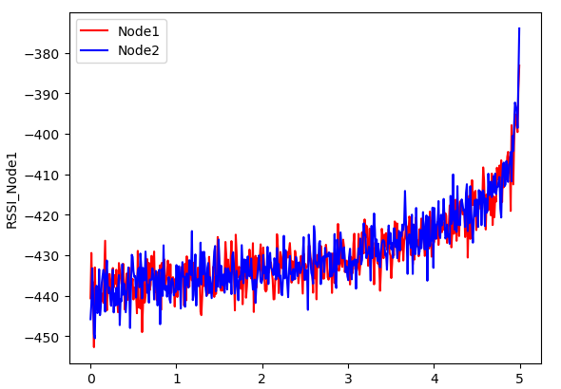

Figure 4.4: Graphical representations of the RSSI data with respect to time when the nodes were moving towards each other.

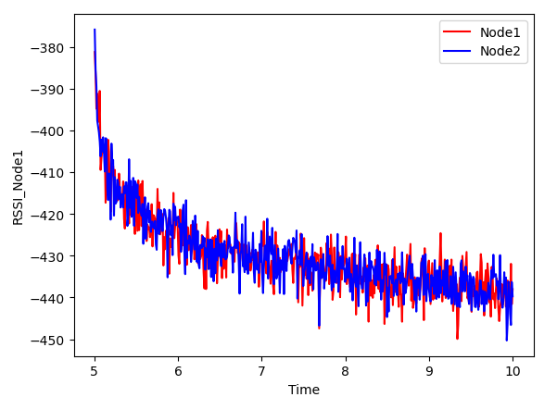

Figure 4.5 Graphical representations of the RSSI data with respect to time when the nodes were moving away each other.

Figure 4.6, figure 4.7, figure 4.8 and figure 4.9 presents graphical representations of each node increasing in RSSI and decreasing in RSSI as the move towards each other and move away from each other.

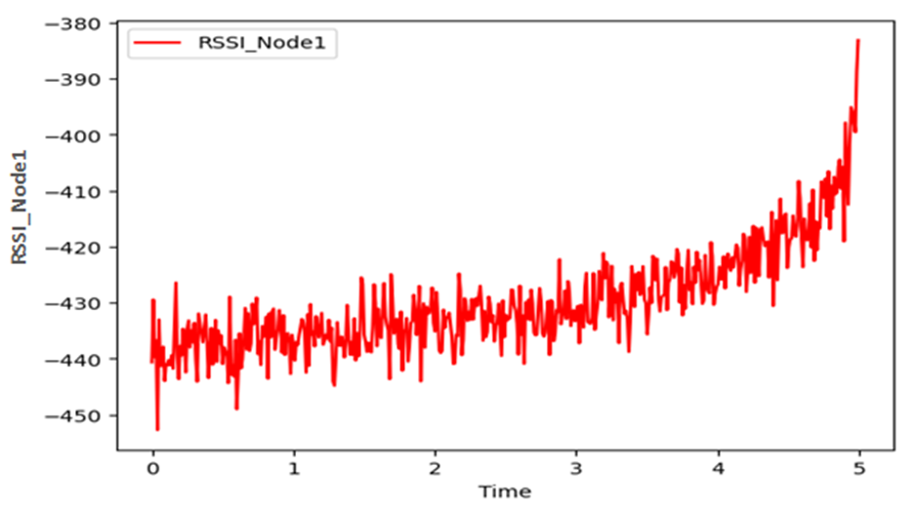

**Figure 4.6: Graphical representations of the RSSI data of node 1 with respect to time when nodes 1 approaches node 2.**

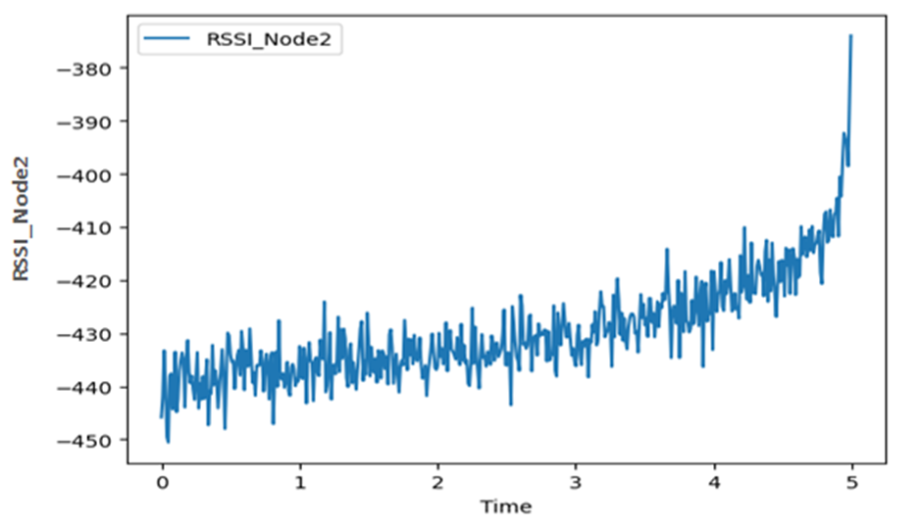

Figure 4.7: Graphical representations of the RSSI data of node 2 with respect to time when nodes 1 approaches node 2.

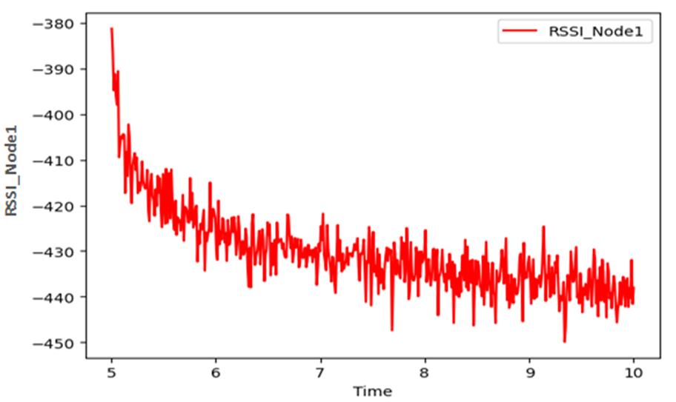

Figure 4.8: Graphical representations of the RSSI data of node 1 with respect to time when node 1 is moving away from node 2.

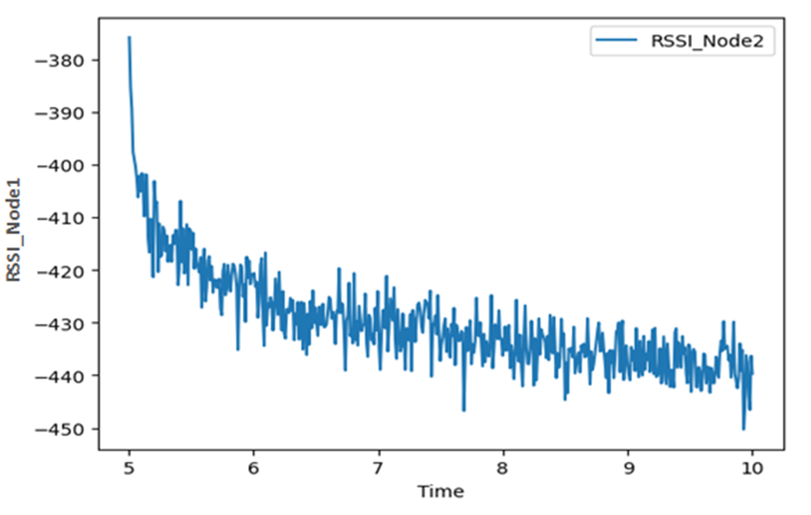

Figure 4.9: Graphical representations of the RSSI data of node 2 with respect to time when node 1 is moving away from node 2.

**5. CONCLUSION**

The results of the performances of the proposed system have been presented in mainly with respect to Received Signal Strength (RSSI) and the path loss in a D2D communication. The scenarios considered were when both nodes were moving towards one another and when the nodes were moving away from each other. Data of the RSSI was gathered and used to train an LSTM model and forecast was made using same model. It was observed that the forecast was following the same trend with the test data with RMSE of 4.848, 5.153 for each node when moving towards each other and RMSE of 4.68 and 4.17 when moving apart. This showed that the prediction algorithm was able to accurately predict signal strength for the propagation path. Thus, prior to data transmission, the user was able to know the received signal strength of the propagation path, which would help to know the safe path to be used for propagation.

The following are summary of the observations made from the simulation results:

i. The RSSI of devices in D2D communication increased as both nodes moved towards each other. This showed that the received signal strength would increase when distance between the nodes decreased.

ii. The RSSI of both devices in D2D communication decreased as they moved away from each other. This implied that as the distance of communication between nodes got wider, the signal strength of each user in the network dropped.

iii. As the nodes are apart and at equal distance to each other, it was observed that their individual RSSI was equal when they moved towards and away from each other.

iv. As nodes moved towards each other in D2D communication, path loss decreased.

v. The movement of nodes away from each other in D2D communication resulted in increase in path loss. The impact of the LSTM was that it helped in addressing increase in path loss before communication by providing the prior knowledge of the nature of the signal strength on the path of propagation via forecasting.

vi. The predicted data and the test data yielded almost the same performance regarding the trend in RSSI as both nodes move toward or away from each other in D2D communication. This showed that the LSTM prediction algorithm could provide near exact information of the nature of RSSI prior to using a path for propagation.

**6. REFERENCES**

(1) S..Escolar, F. Rinc, X. Toro, J . Villanueva,. M. J. Santofimia, D. Villa, , and C. L. Juan, (2019), "The PLATINO Experience : A LoRa-based Network of Energy-Harvesting Devices for Smart Farming," *2019 XXXIV Conference of Design of Circuit and Intergrated Systems IEEE*, 1–6.

(2) P. Gandotra, , and R. K. Jha, (2016), "Device-to-Device Communication in Cellular Networks: A Survey," *Journal of Network and Computer Applications,* http://dx.doi.org/10.1016/j.jnca.2016.06.004

(3) M. Hazwan, M . Ghazali,. K.. Teoh, and W. Rahiman, (2021), "A Systematic Review of Real-Time Deployments of UAV-Based LoRa Communication Network," *IEEE Access*, *9*, 124817–124830. https://doi.org/10.1109/ACCESS.2021.3110872

(4) I. Ioannou, C. Christophorou, V . Vassiliou,. and A. Pitsillides, (2020), "Performance Evaluation of Transmission Mode Selection in D2D communication, *In 2021 11th IFIP International Conference on New Technologies, Mobility and Security (NTMS)*, 1–7.

(5) I. Ioannou, C. Christophorou, V . Vassiliou,. and A. Pitsillides, (2020),. (2022), "Dynamic D2D Communication in 5G / 6G Using a Distributed AI Framework," *IEEE Access*, *10*, 62772–62799. https://doi.org/10.1109/ACCESS.2022.3182388

(6) U. N. Kar, and D. K.. Sanyal, (2017), "An overview of device-to-device communication in cellular networks. *ICT Express*, *4*(4), 203–208. https://doi.org/10.1016/j.icte.2017.08.002

(7) J. Y. Kim, (2019), "LoRa-based Mesh Network for IoT Applications," *In 2019 IEEE 5th World Forum on Internet of Things (WF-IoT)*, 533–536.

(8) C. Lora, , F. Detection, R. Vega-rodríguez, S. Sendra,. J. Lloret, P. Romero-díaz, and J. L Garcia-navas,. (2019), "Low Cost LoRa based Network for Forest Fire Detection," *In 2019 Sixth International Conference on Internet of Things: Management and Security (IOTSMS)*, 177–184.

(9) B. Moons, E.. Poorter, De, and H . Jeroen,. (2021), "Device Discovery and Context Registration in Static Context Header Compression Networks," *Information*, *12*(2), 83.

(10) S. Muzaffar, A. Afshari,. and S . Muzaffar,. (2019), "Short-Term Load Forecasts Using LSTM Networks," *Energy Procedia*, *158*, 2922–2927. https://doi.org/10.1016/j.egypro.2019.01.952

(11) M . Najla, S. Member, P. Mach, Z.. Becvar, and S . Member, (2020), "Deep Learning for Selection between RF and VLC Bands in Device-to-Device Communication," *IEEE Wireless Communication Letters*, *9*(10), 1763–1767. https://doi.org/10.1109/LWC.2020.3003786

(12) H . Nguyen, K. P. Tran , S.Thomassey, M. Hamad, H. Nguyen,. K. P. Tran, S. Thomassey, M. H. Forecasting, ,and A. Detection, (2021), "Forecasting and Anomaly Detection approaches using LSTM and LSTM Autoencoder techniques with the applications in Supply Chain Management," *International Journal of Management*, *57*, 102282.

(13) M . Nurgaliyev and A . Saymbetov, (2020), "Prediction of energy consumption for LoRa based wireless sensors network," *Wireless Networks*, *25*(6), 3507–3520. https://doi.org/10.1007/s11276-020-02276-5

(14) M. Rahim, M. A. Javed, and A. N. Alvi, (2020). "SDMA-based Distributed Device Discovery for D2D communication," *Turkish Journal of Electrical Engineering and Computer Sciences*, *28*(6), 3183 – 3192. https://doi.org/10.3906/elk-2002-113

(15) C. Rattaro, and F. Larroca, (2020), "Predicting Wireless RSSI Using Machine Learning on Graphs," *IEEE Wireless Communication Letters*, *9*(10), 1763–1767.

(16) F . Shang, W. Su, Q. Wang, H. Gao, and Q. Fu, (2014), "A Location Estimation Algorithm Based on RSSI Vector Similarity Degree," *International Journal of Distributed Sensor Networks*, *10*(8), 371350. https://doi.org/10.1155/2014/371350

(17) U. Singh, J. Determe, F . Horlin,. and P. De. Doncker, (2020), "Crowd Forecasting based on WiFi Sensors and LSTM Neural Networks," *IEEE Transactions on Instrumentation and Measurement*, *69*(9), 6121–6131. https://doi.org/10.1109/TIM.2020.2969588

(18) J. Wang, R. A Rouil,. and F. J. Cintron, (2019), "Distributed Resource Allocation Schemes for Out-of-Coverage D2D Communications," *IEEE Global Communications Conference(GLOBECOM)*, 1–10.

(19) K.. Ziadi, and R. Asvadi, (2022), "A Device-to-Device direct discovery algorithm to mitigate the collision caused by hidden users," *Physical Communication*, *52*(1), 101608.