MEAL - QUEST RECOMMENDATION SYSTEM

**ARSH GIBRAN TARIQ Anasuya Neharika Jonnalagadda MITRAA BALASUBRAMANIAN**

Dept. of Computer Science Dept. of Computer Science Dept. of Computer Science

and Engineering and Engineering and Engineering

SRM IST VDP SRM IST VDP SRM IST VDP

Chennai,India Chennai,India Chennai,India

**Abstract** — The Meal Quest and Recommendation System is designed to offer individuals customized meal plans based on their dietary needs and preferences. In today’s society people are concerned with their health and lifestyle choices. However, simply avoiding junk food and exercising is not enough; a balanced diet is crucial. To lead a healthy life, a balanced diet tailored to an individual's height, weight, age, and other factors is more essential. When coupled with physical activity, a proper diet can help achieve and maintain a healthy weight, reduce the risk of chronic diseases such as heart disease and cancer, and improving overall health. A balanced diet provides the necessary nutrients for the body to function optimally. Food calories are a measure of the energy stored in food, which the body utilizes it for various activities such as breathing, walking, and running. While the average person requires about 2,000 calories daily, calorie intake is dependent on physical characteristics like weight, height, age, and gender. As a result, one's food choices impact not just their current wellbeing but also their future health. Despite the growing need for such systems, there is a lack of state-of-the-art (SOTA) projects specifically focused on food or diet recommendation systems. Therefore, we propose a content-based recommendation system using machine learning to address this gap, offering personalized dietary advice to users.

**Keywords: Machine learning, Artificial Intelligence Recommendation systems, K-Nearest Neighbors.**

**1.INTRODUCTION**

The current way of living has caused a rise in unhealthy eating practices leading to various health concerns h problems and diseases, including heart attacks, gastrointestinal cancers, and deficiencies in vitamins and minerals Incorporating a well-balanced diet into fitness routine is essential for achieving desired results. To address this, a diet meal recommendation system has been developed. This system uses information provided by users, such as their age, gender, height, weight and working hours to recommend a balanced diet that meets their specific needs.

For people who wish to live a healthy lifestyle but lack the information and means to do so, the Meal Quest and Recommendation System will be a crucial tool. The technology would assist users in achieving their fitness objectives by making personalized recommendations based on their activities and eating routines.

To analyse user data and offer tailored recommendations, the system will use machine learning algorithms. Additionally, the system will have an intuitive user interface that will make it simple for users to enter their daily activities and workouts and monitor their progress.

**2.LITERATURE SURVEY**

Recent studies have highlighted the growing importance of recommendation systems in the health industry. However, we wanted to address this health crisis a step earlier and try to prevent health issues from occurring in the first place. We studied some of the papers with the same goal as us and came to the following conclusions as well as differences in our results and methodologies:

[1] Personalized Diet and Exercise Recommender System for Patients Suffering from Metabolic Syndrome and Obesity" by A. J. Silva et al. (2020): This study proposed a personalized diet and exercise recommender system for patients suffering from metabolic syndrome and obesity. The system used machine learning algorithms to analyse the patient's health data, such as medical history, age, and gender, to provide personalized recommendations for a healthy diet and exercise plan. patients suffering from metabolic syndrome and obesity. The system used machine learning algorithms to analyze the patient's health data, such as medical history, age, and gender, to provide personalized recommendations for a healthy diet and exercise plan. algorithms to analyze the patient's health data, such as medical history, age, and gender, to provide personalized recommendations for a healthy diet and exercise plan.

[2] Smart Diet Recommender System Based on Personal Health Data Analysis" by M. K. Rahman et al. (2018):

This study proposed a smart diet recommender system based on personal health data analysis. The system used

machine learning algorithms to analyse the user's health data, such as their age, gender, weight, and physical activity, to provide personalized recommendations for a healthy diet.

[3] 2021, e-Health Monitoring System with Diet and Fitness Recommendation using Machine Learning [2]. Published by IEEE. Proved to not be personalized enough. It used Decision Tree to give recommendations. It limits itself in only taking BMI as one of the factors, while ours takes calories, ingredients preferred, etc, as well and allows monitoring of other factors like BFP, Calories and Macro nutrients intake.

[4] Personalized nutrition: Moving from static to dynamic dietary recommendations" (M. Celis-Morales et al., 2019): This review article discusses the importance of personalized nutrition and the challenges associated with developing effective diet recommendation systems. The authors highlight the need for more accurate and reliable dietary assessment methods, as well as the use of machine learning and other advanced technologies to improve the precision of personalized recommendations.

[5] 2020, Cuisine Recommendation, Classification and Review Analysis using Supervised Learning was published by IEEE. This solution was implemented using SVM supervised learning algorithm, doesn’t allow monitoring results at all, and doesn’t have a interface at all. There is also very limited personalization for users.

**3.METHODOLOGY**

Our approach to calculate the user's daily caloric needs based on their weight, height, age, gender, and activity level, and recommends meals based on their calorie range. The system randomly selects items from different food groups (protein, fruit, vegetable, grains, etc.) and it removes the items that the user mentions allergic so that it ensures to provide a balanced meal plan for the user. The meal plan includes breakfast, lunch, dinner.

The system has three stages: the Information Collection Phase, the Learning Phase, and the Recommendation are categorized. In the Learning Phase, conclusions are drawn from the collected information. Finally, the Recommendation Phase provides a list of recommendations based on the user's physical aspects, preference, and Body Mass Index (BMI). This system aims to provide personalized and effective diet recommendations to improve the health and wellbeing of individuals.

**4.CHALLENGES FACED**

During the development of the meal plan monitoring and recommendation system, we faced several challenges that required careful consideration and innovative solutions. Some of the major challenges are described below

. •Data Collection: Obtaining precise and relevant data for the meal plan recommendation system was a significant obstacle we encountered. We had to locate credible sources of data regarding food ingredients, nutrition, and recipes, while also verifying that the data was dependable and current.

•Data Pre-processing: Prior to conducting analysis and modelling, the data gathered from different sources required substantial pre-processing. We had to eliminate duplicates and irrelevant information, standardize and normalize the data, and merge disparate datasets to develop a cohesive and thorough database.

• Feature selection: The selection of relevant features that can influence diet recommendations is another challenge. Relevant features may include the user's age, gender, weight, height, physical activity level, and medical history. Additionally, dietary restrictions, food preferences, and cultural background should also be considered.

• Personalization: Another challenge is to provide personalized recommendations that are tailored to the user's individual needs and preferences. The system needs to be able to adapt and learn from user feedback to improve the accuracy of recommendations over time.

•Evaluation and Validation: Finally, we had to ensure that the meal plan monitoring and recommendation system was accurate, reliable, and effective in meeting the needs of its users. This required extensive evaluation and validation of the system, using both qualitative and quantitative methods, to ensure that it provided useful and actionable recommendations.

**4.PROPOSED SYSTEM**

Personalization: Create custom profiles for dietary preferences, allergies, and fitness goals. Suggest meals based on user details and past choices. Recipe Variety: Provide a wide range of recipes and let users add and share their own. Nutritional Information: Show basic nutritional data for recipes and help users track their dietary goals. Dietary Options: Include filters for dietary needs like vegan, keto, or gluten-free. Engaging Features: Add challenges, rewards, and community interaction to keep users motivated and connected. Availability: Ensures high availability with redundant servers and cloud infrastructure, providing reliable access with minimal downtime.

**5.IMPLEMENTATION**

The system calculates the basal metabolic rate (BMR) of a person based on their weight, height, age, gender, and level of physical activity. It then suggests a sample meal plan based on the calculated BMR.

It consists of several input fields and a drop-down menu for the user to select their gender and physical activity

level. Once the user enters their information and clicks on the "Generate" button, the program calculates their BMR using the Harris-Benedict equation and suggests a sample meal plan based on the calculated BMR. The calculated caloric and nutrition requirement is then used to generate a diet plan based on the user calorie range

For the calorie range, the code generates a diet plan consisting of three meals using predefined lists of foods for each meal category. The food items for each meal category are chosen randomly using the randint () function, and the chosen food items are displayed on the browser. Overall, this program can be a useful tool for anyone looking to improve their diet and maintain a healthy lifestyle.

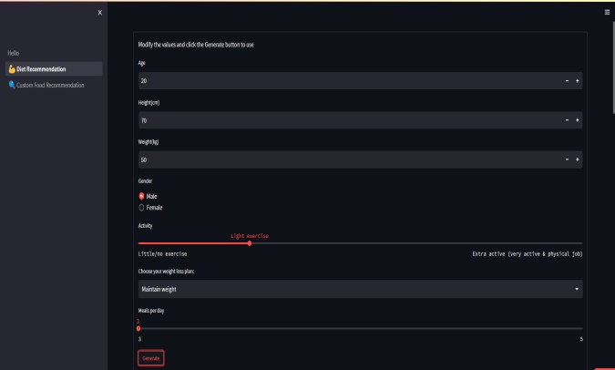

Fig 5.1 User Interface

**5.1 Modules and Tools used**

**• Python:** Python is a versatile programming language widely used to perform complex tasks in various applications, from web development to data analysis and automation. In web development, it plays a significant role by enabling dynamic and interactive functionalities such as data handling, backend services, and server-side logic. Python is often paired with frameworks like Django or Flask to build web applications. It is also popular for scripting, machine learning, artificial intelligence, and scientific computing due to its simplicity and readability.

**• FastAPI:** FastAPI is a cutting-edge web framework designed for building APIs with Python. Known for its high performance and ease of use, it allows developers to create APIs quickly, with production-ready features like automatic validation, serialization, and interactive documentation. FastAPI leverages Python's type hints to provide precise data validation and enhance code quality, making it ideal for asynchronous and real-time applications. It's particularly well-suited for building microservices, handling large-scale applications, and integrating with modern tech stacks. FastAPI excels in speed, scalability, and developer productivity, making it one of the top choices for building robust and fast web APIs.

**• Pandas:** pandas is an influential Python library used by data analysts and scientists to manipulate and analyze data. It provides a variety of data structures such as Series and Data Frame, which enable users to manipulate and analyze data in a multitude of ways. One of the primary features of Pandas is its capacity to process data in various formats, including Excel, CSV, SQL databases, among others. This feature provides flexibility to users, allowing them to import and export data from different sources and work with it in the format that suits them.

**• NumPy:** NumPy is a Python library extensively utilized in scientific computing, which offers powerful tools for working with multi-dimensional arrays and matrices. Its usage is prevalent in data science, scientific research, machine learning, and other fields that require efficient and fast numerical operations. NumPy is an essential tool for handling large datasets, numerical simulations, and other tasks that necessitate efficient and fast numerical operations. It is also beneficial for data analysis due to features like broadcasting, slicing, and indexing, which make it easy to manipulate large datasets. As a result, data scientists and researchers dealing with big datasets require NumPy.

**• KNN:** The K-Nearest Neighbors (KNN) algorithm is frequently employed in recommendation systems to locate the closest neighbors to a user regarding their preferences, relying on the similarity of the properties of items that the user has engaged with. This algorithm doesn't require any training and is based on memory. Its effectiveness can be boosted by utilizing techniques like feature engineering and dimensionality reduction

**• Scikit-learn 1.1.3:** Scikit-learn is a popular, easy-to-use machine learning library in Python. It provides simple and efficient tools for data mining, data analysis, and modeling. With a variety of algorithms available for tasks like classification, regression, clustering, and dimensionality reduction, scikit-learn is a go-to choice for both beginners and experienced practitioners. Version 1.1.3 of scikit-learn offers performance improvements and bug fixes, maintaining its robust support for model training and evaluation. It integrates well with other Python libraries like NumPy, SciPy, and pandas, making it a versatile tool for developing and implementing machine learning pipelines. •

**• Streamlit 1.16.0:** Streamlit is a Python framework for quickly building interactive web apps, especially for data science and machine learning. With its simple API, you can create apps with real-time data visualizations and interactive elements using minimal code, making it ideal for sharing insights and deploying models. Version 1.16.0 continues to offer easy, fast app development. •

**• BeautifulSoup :** BeautifulSoup: It is a wellknown Python library that is extensively used for web scraping and parsing of HTML and XML documents. It is a simple yet effective tool that provides developers with an easy way to extract data from web pages and use it for various purposes. BeautifulSoup[14] has a wide range of applications in fields such as data science, machine learning, and web development, among others. The library offers a variety of functions and methods for navigating and parsing HTML and XML documents, making it easy to extract necessary data from a web page.

**5.2 Frontend Development**

The front-end of the Meal Quest application is developed using Streamlit, an open-source Python framework. Streamlit simplifies creating web apps for data science and machine learning, integrating well withlibraries such as scikit-learn, NumPy, and pandas.

The application consists of three pages:

**• Hello.py** – A welcome page that introduces the project.

**• Diet Recommendation Page** – Users input their age, weight, height, and activity level to receive a personalized meal plan.

**• Custom Food Recommendation Page** – Users can further customize their diet based on specific nutritional preferences.

A sidebar enables easy navigation between these pages. The interface, developed with Streamlit, provides a simple and responsive design for a smooth user experience.

**5.3 Backend and Data Collection**

The back-end server is accountable for overseeing the exchange of information between the user interface and the database. It consists of various files such as serverside scripts composed in Python, and configuration files that establish the server settings. All the API calls, Data queries for user data and messages from the database, etc are all coded here.

Finding a suitable Recipe Dataset was a tough part of the process. We considered Food.com dataset from Kaggle, which had over 200k+ recipes along with their instructions, images and steps of preparation, and we continued to build our project with respect to this dataset, however this dataset later became a setback for our recommendation system since it didn‟t include any nutrient or calorie details, hence we ultimately went with “Epicurious - Recipes with Rating and Nutrition” from Kaggle.

This dataset had all we needed which included over 20k+ recipes and 700+ columns worth data, however it lacked image or image links. Later we used a web scrapper called BeautifulSoup to get images for all 20+ recipes. After settling on this dataset we did further data cleaning and pre- processing on it using Pandas and NumPy. Our dataset allowed us to know what type of recommendation system we will need to build, that is, content-based filtering, since we are using the contents of each recipe (like calorie, nutrition, etc.,) to recommend according to user preferences.

Data Analysis Modules: The generation of meal quest recommendations based on a user's nutritional goals and preferences is the responsibility of the data analysis modules. These modules consist of several files, such as Python scripts and configuration files. Machine learning algorithms are utilized in these modules to analyze user input data and create individualized meal plans recommendations.

**5.3 Flow Chart**

• User's will enter the necessary information like their age, gender, weight, working hours et

• The information will then go through the ML model.

• Then, it generates meal plans based on the person's caloric requirements.

• After analyzing all the data the system will calculate user's BMI and their current t state (total daily energy expenditure).

• The system will then recommend diet to the users into three categories (breakfast, lunch, dinner) based on the input

• The users can choose from multiple recommended items and make their diet plan.

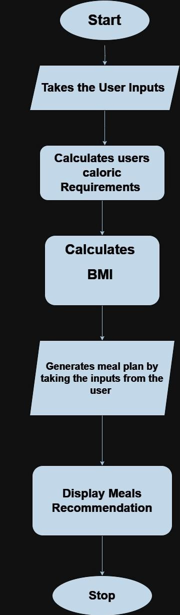

**Flow chart of meal quest diet recommendation**

**6.RESULTS AND DISCUSSION**

The Meal Plan Monitoring and recommendation System, titled “MEAL - QUEST” is a web application that is designed to help users in creating and monitoring their meal plans. In this section, we present the results of our study that aimed to evaluate the effectiveness of the system in improving the dietary habits of users.

Presented below are visual representations to illustrate our findings and results;

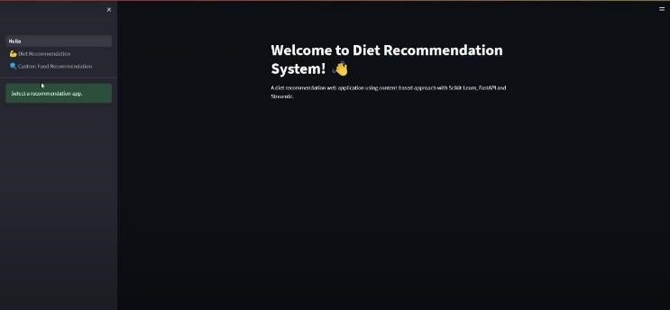

Fig 6.1 Home Page

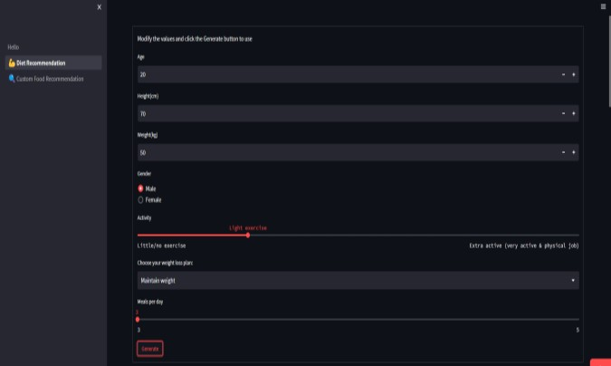

Fig 6.2 User Inputs

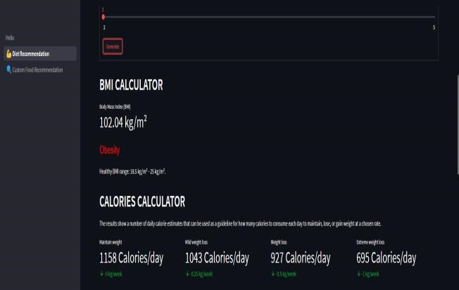

Fig 6.3 BMI CALCULATOR

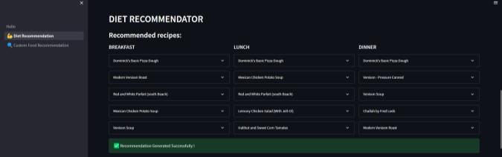

Fig 6.4 Meal Generator

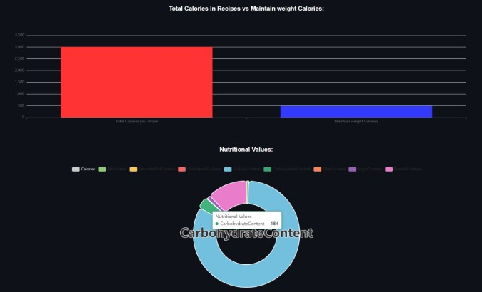

Fig 6.5 calories graph and nutritional values

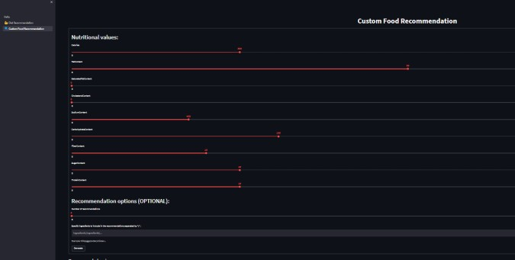

Fig 6.6 custom food recommendation

**7.CONCLUSION**

The Meal quest and Recommendation System proves to be a valuable tool for individuals aiming to achieve their fitness goals and maintain optimal health. By offering personalized meal plans based on factors such as gender, age, weight, height, and activity level, the system ensures a balanced diet that promotes overall well-being. It simplifies the process of creating tailored nutrition plans, saving both users and fitness professionals time and efforts. We gained teamwork skills, time management skills, and knowledge of how to do assignments on schedule. We studied several testing methodologies, carried out tests, and created test cases for our application. Each module of our application has passed satisfactory testing. Overall, this Meal quest recommendation system not only empowers individuals in their journey towards better health but also highlights the potential of technology in transforming dietary practices.

**8.REFERENCES**

[1] C. Lokuge and G. U. Ganegoda, “Implementation of a personalized and healthy meal recommender system in aid to achieve user fitness goals," 2021 International Research Conference on Smart Computing and Systems Engineering (SCSE), Colombo, Sri Lanka, pp. 84-93, 2021, doi: 10.1109/SCSE53661.2021.9568335.

[2] G. Agapito et al., "DIETOS: A recommender system for adaptive diet monitoring and personalized food suggestion," 2016 IEEE 12th International Conference on Wireless and Mobile Computing, Networking and Communications (WiMob), New York, NY, USA, pp.18,2016, doi:10.1109/WiMOB.2016.7763190.

[3] S. Pourramezan, H. Nezamabadi-pour, and N. Nematollahi. A personalized diet recommendation system for athletes based on the glycemic index. Health Inf. Sci. Syst., 8: 1-9, 2020.

[4] Vazquez, Hernan and Bergel, Alexandre and Vidal, Santiago and Diaz- Pace, Andres and Marcos, Claudia, “Slimming JavaScript Applications: an Approach for Removing Unused Functions from JavaScript Libraries,” Information and Software Technology, p. 107,2018, 10.1016/j.infsof.2018.10.009.

[5] A.J. Silva, F.S. Mesquita, F.M. Bastos-Filho, L.M. Fernandes, and E.A. Oliveira. Personalized Diet and Exercise Recommender System for Patients Suffering from Metabolic Syndrome and Obesity. J. Med. Syst., 44: 1-11, 2020.

[6] Vasilkov, Yurij and Gushina, Ludmila, “Analysis of the effectiveness and efficiency of management systems based on system analysis methodology,” International Journal for Quality Research, vol. 8, pp. 347-356,2014.

[7] van der Walt, Stéfanand Colbert, S. and Varoquaux, Gael, “The NumPy Array: A Structure for Efficient Numerical Computation,” Computing in Science and Engineering, vol 13, pp/. 22 – 30,2011, 10.1109/MCSE.2011.37

[8] Aslam, Fankaran Mohammed, HawaandLokhande, Prashant, “Efficient Way Of Web Development Using Python And Flask,” International Journal of Advanced Research in Computer Science, p. 6,2015

[9] T.H. Nguyen, T.N. Nguyen, N.T. Nguyen, and H.M. Nguyen. A personalized diet recommendation system based on the genetic algorithm. J. Ambient. Intell. Humaniz. Comput., 12: 129-141, 2021.