Survey Paper on Desktop AI Powered Virtual Assistant : J.A.R.V.I.S(Just A Rather Vary Intelligent System)

***1Shreyash Kindre , 2Sunil Magare , 3Aryan Pokale ,4Prem Shinde , 5Prof.Vijay Mohite***

***12345Zeal Polytechnic, Pune-41, India..***

# ABSTRACT

*Jarvis is “Just Rather Virtual Assistant System” which make easiest our life. In this project Jarvis is digital life assistant which uses only human communication means such twitter, instant message and voice to create two way connection between human and his apartment, controlling light and appliances assist in booking , notify him of breaking news, facebook notification and many more J.A.R.V.I.S. (Just a Rather Very Intelligent System) is a fictional character voiced by Paul Bettany in the Marvel Cinematic Universe (MCU) film franchise, based on the Marvel Comics characters Edwin Jarvis and H.O.M.E.R., respectively the household butler of the Stark family and another AI designed by Stark*

***Keywords:*** *Feature Extraction, Speech recognizer, Feature Matching…..*

# INTRODUCTION

Speech is an effective and natural way for people to interact with applications, complementing or even replacing the mouse, keyboard, controllers and gestures. A hand-free yet accurate way to communication with application, speech lets be productive and stay informed in a variety of situations where other interfaces will not. The recognition of speech is very interesting topic that is very useful in many applications and environments in our daily life survival. Speech recognizer is a machine which understands a human and their spoken word in some way and can act thereafter.

Almost all tasks are now digitalized in today's world. Voice searches have surpassed text searches. Web searches conducted via mobile devices have only recently surpassed those conducted via computer, and analysts predict that 50% of searches will be conducted via voice by 2024. Virtual assistants are turning out to be smarter than ever. Allow your intelligent assistant to handle your email. Detect intent, extract critical information, automate processes, and provide personalized responses. In recent years, several researchers have become interested in the recognition of human activities. The desktop's virtual assistant in Python is a software programme that assists you with day-to-day tasks such as showing the weather report, creating reminders, making shopping lists, and so onThis leads to the discussion about intelligent homes where this operation can made available for common man as well as for handicapped. According to this information presented so far one question comes naturally that is “How speech recognition is done?” To get knowledge of hoe speech recognition problem can be approached today, are view of some research high lights will be presented. The earlier attempt to devise systems for automatic speech recognition by machine were made in the 1950’s.

Here JARVIS boasts advanced security and privacy features, crucial for safeguarding user data. Employing robust cryptography and other security measures, it ensures data access and sharing only with user consent. The scalability of JARVIS caters to individuals, small businesses, and large enterprises alike, allowing customization to specific organizational needs. Its timesaving and productivity-enhancing capabilities streamline routine tasks, allowing users to focus on more critical responsibilities and stay organized.

# LITERATURE REVIEW

A literature review is a summary and evaluation of existing research on a specific topic. Its main purpose is to gather and combine what others have found, helping us understand what we already know and what still needs to be explored. To create a literature review, researchers look at different sources like books, articles, and studies written by others. This helps show how their work fits into the larger academic discussion.  
The review is usually organized by themes, trends, or timelines, making it easier for readers to understand. Besides just summarizing, a literature review also includes critical analysis, which means evaluating the strengths and weaknesses of the studies. This process highlights areas that need more research.

In conclusion, the literature review not only summarizes key findings but also suggests directions for future research, providing a comprehensive overview of the topic.

Intelligent Personal Assistants (IPA) area unit enforced and utilized in operative Systems, net of Things (IOT), and a spread of different systems. Several implementations of IPAs exist these days and corporations like Apple, Google and Microsoft all have their implementations as a serious feature in their operating systems and devices. With the employment of linguistic communication process (NLP), Machine Learning (ML), Artificial Intelligence (AI), and prediction models from these held in applied science (CS), further as theory and techniques from Human- Computer Interaction (HCI), IPAs are getting a lot of intelli-gent and relevant.

A survey on virtual assistant usage reveals key trends across various demographics and sectors. Research shows that younger generations, particularly Millennials and Gen Z, are the primary users, with over 70% of adults aged 18-29 regularly engaging with these technologies. As of 2022, about 50% of U.S. households own a smart speaker with a virtual assistant, indicating significant market penetration. Daily interactions with virtual assistants occur for approximately 30% of users, primarily for tasks like setting reminders. In the business realm, around 30% of companies have adopted virtual assistants to improve customer service

However, concerns regarding privacy and data security continue to challenge user trust and adoption rates. Looking ahead, the market for virtual assistants is poised for substantial growth, driven by advancements in AI and natural language processing.speech test integrated with voice.

# 

# PROBLEM STATEMENT

We are all well aware about Cortana, Siri, Google (AI) Assistant and many other virtual assistants which are designed to aid the tasks of users in Windows, Android and iOS platforms. But to our surprise, there’s no such virtual assistant available for the paradise of Developers i.e. Windows platform.

PURPOSE: This Software aims at developing a personal assistant for Windows-based systems. The main purpose of the software is to perform the tasks of the user at certain commands, provided in either of the ways, speech or text. It will ease most of the work of the user as a complete task can be done on a single command. Jarvis draws its inspiration from Virtual assistants like Cortana for Windows and Siri for iOS. Users can interact with the assistant either through voice commands or keyboard input.

**PRODUCT GOALS AND OBJECTIVES**:

Currently, the project aims to provide the Windows Users

with a Virtual Assistant that would not only aid in their daily routine tasks like searching the web, extracting weather data, vocabulary help and many others but also help in automation of various activities.

In the long run we aim to develop a complete server assistant, by automating the entire server management process - deployment, backups, auto scaling, logging, monitoring and make it smart enough to act as a replacement for a 6 general server administrator

**PRODUCT DESCRIPTION:** As a personal assistant, Jarvis assists the end-user with day-to-day activities like general human conversation, searching queries in various search engines like Google, Bing or Yahoo, searching for videos, retrieving images, live weather conditions, word meanings, searching for medicine details, health recommendations based on symptoms and reminding the user about the scheduled events and tasks. The user statements/commands are analysed with the help of ML.

# PROPOSED SYSTEM

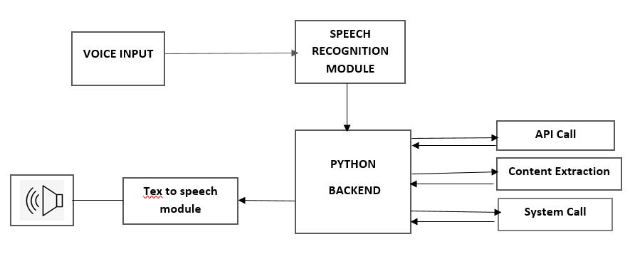

***FIG: BLOCK DIAGRAM OF VIRTUAL ASSISTANT USING PYTHON***

The above block diagram describes the steps undergone in the desktop’s virtual assistant using python. When the user provides a voice input as a command and speech recognition module takes the voice as an input and listen to the spoken words and identify them with its ability and converts spoken words into text. An API call is the method in which a requested data will be retrieved from the program by sending a request using client application and delivers it to the client webpage.

Content extraction extracts the related information from the webpage and avoids the irrelevant info like ads. Syscall, in which a computer program requests a service from the kernel of the operating system on which it is executed. API call, system call, content extraction is interconnected to the python backend and from python backend, the information is passed to the text to speech module which converts the text data into speech.

***The proposed system for JARVIS, a virtual assistant includes the following features and technologies like :***

*NLP (Natural Language processing) and Speech recognition (SR): JARVIS use this to interpret and respond Human commands

.

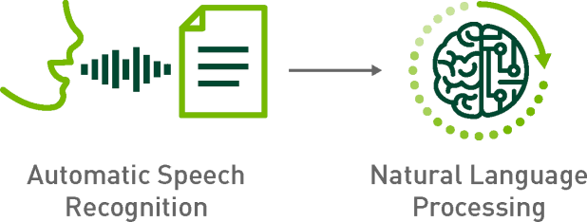

*Custom User Profiles (CUP) : JARVIS can give you

a better experience by using profiles made just for you. 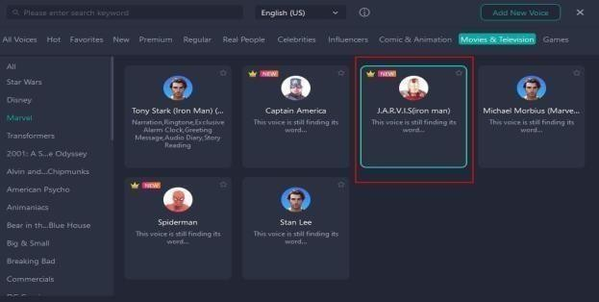

* Sentiment analysis and emotion recognition : JARVIS can better understand the user's needs and provide appropriate responses by using these features.

*

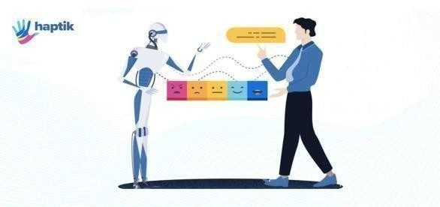

* Open-source libraries and APIs :

APIs stands for Application User Interfaces. In this the system is implemented using Python programming language and various open-source libraries and APIs.

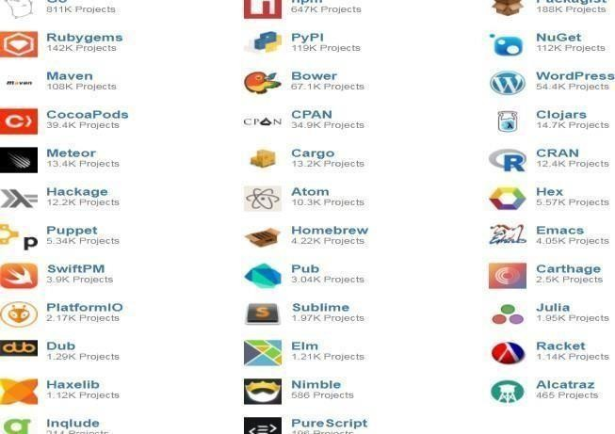

* Integration and APIs :

Integrating third-party services like Google and Amazon will enhance Jarvis's functionality, allowing seamless interaction with various platforms. An open API will enable developers to create custom integrations, fostering innovation and allowing users to tailor Jarvis to their specific needs. This approach promotes versatility and encourages a vibrant developer community.



# PROJECT SCOPE

The project scope for JARVIS involves developing an intelligent assistant designed to enhance user productivity and provide personalized experiences. The primary objectives include improving task management, delivering tailored recommendations based on user preferences, and facilitating easy access to information and resources. Key features will encompass user profiles for customized interactions, task management capabilities to create and track deadlines, information retrieval to answer queries, and integration with other tools such as calendars and emails for seamless functionality. The target audience includes individuals seeking productivity enhancements and teams requiring collaborative support. Deliverables will consist of a fully functional JARVIS application, user and developer documentation, and a post-launch support and maintenance plan. The project will be executed in defined phases—research, development, testing, and deployment—with specific timelines for each stage. Additionally, a budget will be established to cover development, marketing, and ongoing support costs. This comprehensive scope ensures all team members are aligned on the goals and deliverables of the project.

## 

## METHODOLOGIES

The JARVIS project was developed using a systematic approach which aims in creating a robust and efficient personal assistant system. The journey begins with a rigorous phase of requirements gathering, where the team meets with potential users and stakeholders to determine their requirements and expectations from the proposed system. Through interviews, surveys, and market research, a thorough grasp of required features and functionalities is gained, establishing the framework for the next steps.

With requirements in hand, the project enters the design and architecture phase. Intricate blueprints are created to outline the overall structure, components, and relationships of the JARVIS system. The emphasis is on scalability, modularity, and flexibility to support future enhancements and changes, ensuring that the system stays responsive to changing user needs and technological advances. Following the design process, great attention is paid to technology selection

The project team carefully assesses and selects the best programming languages, libraries, frameworks, and APIs for implementing capabilities like speech recognition, natural language processing, and online interface. This essential step establishes the groundwork for further implementation phase.

1. **Start:** The process begins with the user saying a command.

2. **Speak:** Jarvis hears the user's command and text is generated.

3. **User Command**: The text of the command is then analysed to determine what the user is asking or telling Jarvis to do.

4. **Check if command is valid (CMD Ok!!)**: Jarvis checks whether the command is something it understands and can do.

5. **Say NO again:** If the command is not valid, Jarvis says "NO" to the user and prompts them to try again.

6. **Execute command**: If the command is valid, Jarvis executes it. This could involve a wide range of actions, like setting an alarm, playing music, or providing information.

7. **End**: Once the command is executed, the process ends.

The below flowchart depict the whole operation of the Jarvis project:

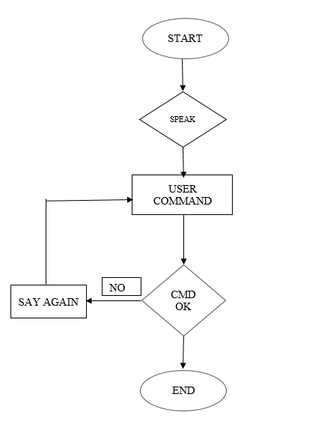

FIG : FLOWCHART

**CONCLUSION**

The JARVIS project's conclusion summarizes its successes, ramifications, and further directions. First and foremost, the project demonstrated the effective creation and implementation of an intelligent personal assistant system capable of comprehensive capability in speech recognition, natural language processing, and task automation. Through extensive testing and validation, as well as favourable user feedback, the

,JARVIS system has established itself as a remarkable tool for productivity and efficiency in a variety of settings. Furthermore, the efficiency of the JARVIS project demonstrates the larger importance of intelligent personal assistant systems in facilitating human- computer interaction and augmenting human

.capabilities.

As technology advances, such systems will play an increasingly important role in defining the digital world and improving daily living.

The JARVIS project demonstrates the feasibility and benefit of these technologies, paving the door for future innovation and exploration in this area those that in general does not correspond to any physical sense and filter bank analysis are perhaps the most widely used front-ends in state-of-the-art speech recognition systems. After testing, we confirming that all these functionalities are working properly.

## REFERENCES

1. *Vedant Kulkarni, Shreyas Kallurkar, Vipul Waikar, Saurabh Patil, - “Virtual Assistant Using Python”, Journal Of EmergingTechnologies and Innovative Research, 2022, ISSN-2349-5162.*
2. N Umapathi1*, G Karthick2, N Venkateswaran3, R Jegadeesan4, Dava Srinivas5 “*DESKTOP’S VIRTUAL ASSISTANT USING PYTHON”..*
3. *N Umapathi1* , G Karthick2 , N Venkateswaran3 , R Jegadeesan4 , Dava Srinivas5 “DESKTOP’S VIRTUAL ASSISTANT USING PYTHON”...*
4. *Amrita S. Tulshan(&) and Sudhir Namdeorao Dhage Survey on” Virtual Assistant: Google Assistant, Siri, Cortana, Alexa* “
5. *International Journal of Research Publication and Reviews,*