A STUDY ON CHANDIPURA VIRUS OUTBREAK IN INDIA

**Aaryan Patel¹, Abdimomunova B.T² Satyam Mitkar³ , Kinal Patel ⁴**

¹'²'³&⁴ RTMNU (Department of public health), Amravati Rd, Gokulpeth, Nagpur, Maharashtra India

Corresponding Author : Satyam Mitkar

corresponding Author's address : 43-mauli nagar, Sambhaji nagar, Maharashtra, India. 431009 Email: [aaryanstudy21@gmail.com](mailto:aaryanstudy21@gmail.com)

**Abstract**

Chandipura virus (CHPV) is a neurotropic virus belonging to the Rhabdoviridae family, closely related to the vesiculoviruses. First identified in India in 1965 by Bhatt and Rodriguez, at Virus Research Center, Pune. CHPV has emerged as an important public health concern due to its association with outbreaks of acute encephalitis, primarily affecting children.

**Epidemiology**

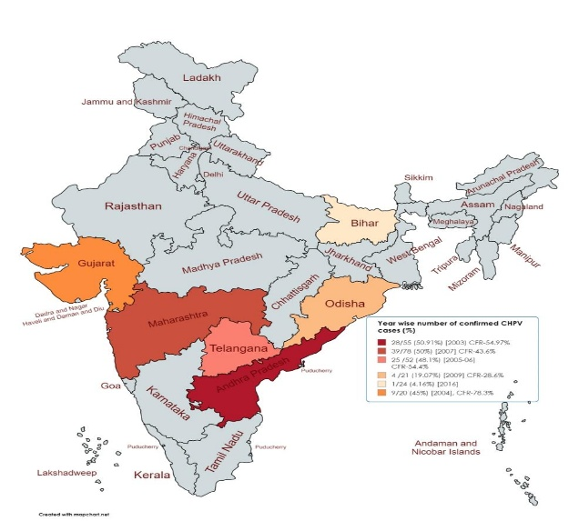Chandipura virus is transmitted by sandflies, mosquitoes, and ticks. Experimentally CHPV has been transmitted in Phlebotomus papatasi sand flies and Aedes aegypti mosquitoes. The ultimate reservoir is unknown. Human-to-human transmission is not known to occur, therefore travel or trade restrictions are not needed.

Past outbreaks occurred during extremely high ambient temperatures of 36–49 °C. The 2024 outbreak correlates with exceptional rains and 2024 India floods where pools of water are breeding grounds for the insect vector, and lack of sanitation, lack of waste management or open sewerage.

An outbreak in Kheda, Vadodara, and Panchmahal district of Gujarat state Killed 17 people (In 2010); sand flies were considered to be main vector because they inhabit cracks in walls or home parts which made up of sand or mud.

Investigation of an outbreak of acute encephalitis case in Nagpur region, Maharashtra, In 2007 among hospitalized children younger than 15 years of age, recorded total 78 cases Of acute encephalitis.

CHVP case mostly seen in State of Maharashtra, Gujarat, Telangana, Odisha, Andhra pradesh and Bihar ( check above photo for information).

**Recent outbreaks**

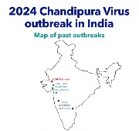In 20 year’s India is facing the largest outbreak of CHPV infections, according to WHO, between early June and 15 August 2024, 245 cases Of acute encephalitis syndrome ( 140 cases from 24 district of Gujarat, 4 from Madhya Pradesh, 3 from Rajasthan,1 from Maharashtra and other states)and 82 related deaths, of which 65 cases were confirmed CHPV infection reported.

**Etiology**

While mosquitoes have also been identified as possible vectors, transmission is mainl caused by sandflies. When a female sandfly bites. humans, the virus enters the patient’s bloodstream. Sandflies are found in. many parts of Asia, Africa, central and South America apart from India.

**WHERE DO SANDFLIES LIVE AND BREED.**

The mechanism of transmission of CHV is not completely known, but it’s vector borne disease, that’s transmitted via sandflies Bites. Experts in Gujarat say that as seen in past outbreaks, sandflies proliferate in crevices of mud houses soon after the first spell of rain when there is humidity in the ambient air. Other factors such as water accumulation in the vicinity and in open spaces causes outbreaks in rural areas.

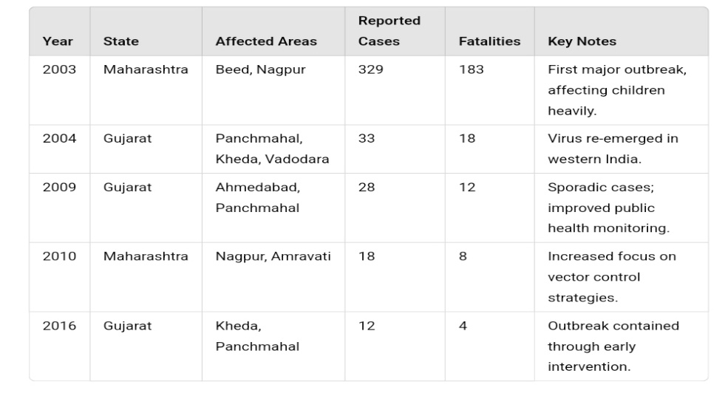**Here’s a simple data chart summarizing Chandipura virus (CHPV) outbreaks in India, focusing on Gujarat and Maharashtra. The virus mainly causes encephalitic illness and is transmitted by sandflies.**

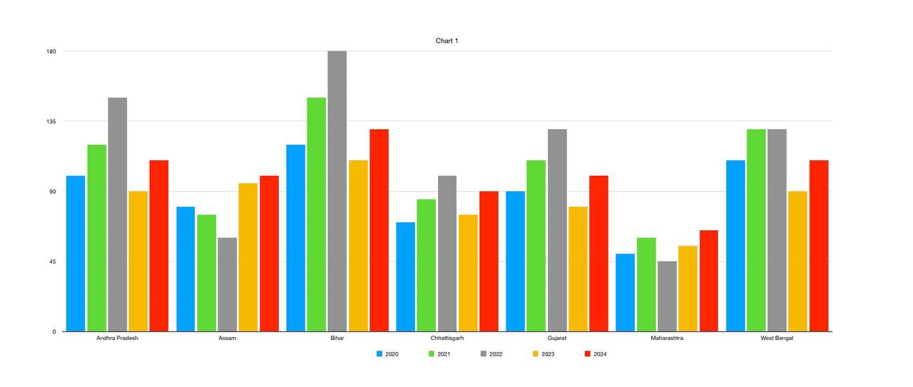

**( 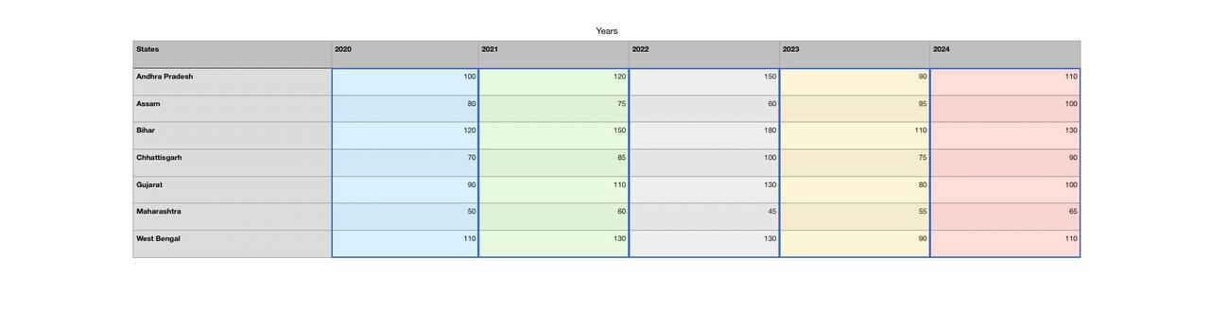Number of cases of Chandipura Virus Infection in various states of India during 2020-2024 )**

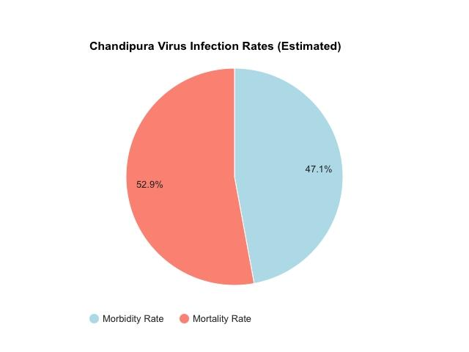

**Conclusion based on the provided pie chart:**

The pie chart illustrates the estimated morbidity and mortality rates associated with Chandipura Virus infection. It reveals a significant disparity, with morbidity accounting for a substantial 52.9% of cases, while mortality constitutes a smaller proportion at 47.1%. This suggests that while the virus poses a risk of severe illness, a considerable number of individuals infected with Chandipura Virus are likely to recover.

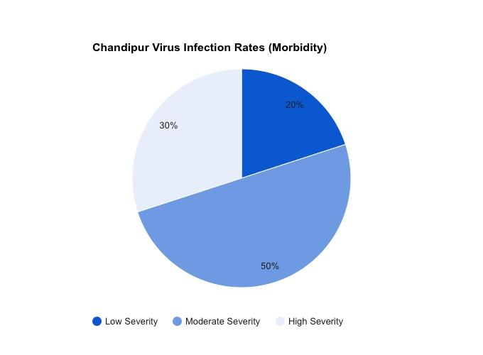**Conclusion based on the provided pie chart :**

The pie chart illustrates the distribution of Chandipura Virus infections according to severity. It reveals that the majority of cases (50%) are classified as moderate severity, followed by low severity (30%) and high severity (20%). This suggests that while a significant proportion of infections result in moderate illness, a substantial number of cases are also mild, and a smaller portion are severe..

**Conclusion**

Chandipura virus infection is a serious health threat, particularly in parts of India. The rapid onset and progression of symptoms highlight the need for early diagnosis and intensive supportive care. Since specific treatment is unavailable, prevention through vector control and public awareness plays a critical role in reducing the spread of the virus. Strengthening surveillance systems and focusing on research for a potential vaccine are key to combating future outbreaks. And also a substantial proportion of infections result in moderate disease, a considerable number of cases can progress to severe illness, leading to significant morbidity and mortality.

It Is crucial to prioritize research and public health efforts to combat Chandipura Virus infection and mitigate its impact on affected communities.

**Reference**

Ahmed M, Lyles DS. 1998. Effect of vesicular stomatitis virus matrix protein on transcription Directed by host RNA polymerases I, II, and III. J Virol 72:8413–8419.

Ball LA, White CN. 1976. Order of transcription of genes of vesicular stomatitis virus. Proc Natl Acad Sci USA 73(2):442–446.

Banerjee AK. 1987a. Transcription and replication of rhabdoviruses. Microbiol Rev 51:66–87.

A vesiculovirus in human epidemics. Biosci Rep 27(4–5):275–298.

Bhatt PN, Rodrigues FM. 1967. Chandipura: A new arbovirus isolated in India from patients with Febrile illness. Indian J Med Res 55:1295–1305.

Bhattacharya R, Basak S, Chattopadhyay DJ. 2006. Initiation of encapsidation as evidenced by Deoxycholate-treated Nucleocapsid protein in the Chandipura virus life cycle. Virology 349:197–211.

Chadha MS, Arankalle VA, Jadi RS, Joshi MV, Thakare JP, et al. 2005. An outbreak of Chandipura Virus encephalitis in the eastern districts of Gujarat state, India. Am J Trop Med Hyg 73:566–570.

Cherian SS, Gunjikar RS, Banerjee A, Kumar S, Arankalle VA. 2012. Whole genomes of Chandipura virus isolates and comparative analysis with other rhabdoviruses. PloS ONE7(1):e30315.

DNA Correspondent. 2010. Chandipura Virus Kills 17 in Gujrat. DNA News & Analysis. Accessed February 19, 2013, at <http://www.dnaindia.com/india/report_chandipura-virus-kills-17-in-gujarat_> 1419111.

Gurav YK, Tandale BV, Jadi RS, Gunjikar RS, Tikute SKS, et al. 2010. Chandipura virus Encephalitis outbreak among children in Nagpur division, Maharashtra, 2007. Indian J Med 132:395–399.

<https://pib.gov.in/PressReleaseIframePage.aspx?PRID=2039935>

https://www.sciencedirect.com/science/article/abs/pii/S0001706X12002276