**SPATIOTEMPORAL ANALYSIS OF NIGER DELTA OIL SPILL LEAK POINTS**

Okujagu Diepiriye Chenaboso1 and Odumah Clinton2

1&2Department of Geology, University of Port Harcourt, Nigeria

Corresponding Author’s Email: [diepiriye.okujagu@uniport.edu.ng](mailto:diepiriye.okujagu@uniport.edu.ng)

# ABSTRACT

In this research project leak points in the Niger Delta from 2011 to 2019 was considered. One thousand, two hundred and fifty two (1252) reports were downloaded from the Shell Petroleum Development Company (SPDC) website and incorporated into a Geographic Information System (GIS) interface. The result from the GIS, helped us to represent the data from the reports in a map. Results from this analysis shows that Rivers State has the highest number of leak points over this period accounting for 56.5%, Bayelsa State accounting for 18.6%, Delta State accounting for 11.9%, Abia State accounting for 8.5%, and Imo State with the least number of leak point accounting for 4.5% from 2011-2019. From the results also, It was observed that Crude oil theft (Bunkering) is the major leak point in Niger Delta, it accounts for over 50% of leak point in the region from 2011 to 2019. Corrosion, Hack Saw cut, well head failures, drilled hole and others are also very prominent. This study presents oil spill leak point in the niger delta region of Nigeria from 2011 to 2019 based on SPDC related oil spills covering the, impact area, spilling facilities and causative factors.

**Keywords:** Crude Oil Theft, Bunkering, Corrosion, Leak Points and Prominent, productions, environment.

**INTRODUCTION**

The production of oil and gas is basically the main economic activity in the Nigerian nation as it contribute 90% to its gross revenue. This dominant role has been badly punctured by the loss of crude through various leak point, which I believe have a equally contributes to the deterioration of our environment. The search for oil in Nigeria could be best dated back to the first decade of the last century though the first apparent discovery of which was in 1907 at Araromi in Ondo State. However, this endeavour did not last long and the company closed shop, when the First World War began in 1914. But oil was strom after in 1956 in Oloibiri in the Niger delta region. Chronics of its discoveries have only emerged recently half a century into exploration according to NNPC, 2016. This discovery was made when Shell-BP was the sole concessionaire off the Bight of Bonny. Leak point could be through natural processes (Natural surface flow, tectonic activity) or through human actions (Oil theft, vandalism and operational mishaps) (SPDC 2016). DPR forecast that 1.89 million barrels of petroleum were released into the environment in the Niger delta region between 1976 and 1996 out of a total of 2.4 million barrels spilled in 4,835 instances. Of which, 220 thousand cubic meters are the provision of approx., According to the report on the leak points, the UNDP says that there has been leakage of 6,817 between 1976 and 2001 which amounts to three million barrels of oil of which more than 70% was not recovered 69% of was occurred off-shore, a quarter was in swamp land and 6% onshore. This research work concludes that one inevitable risk associated with the exploration and production of oil and gas is oil leakage, which has in one way or the other affected the society in Niger Delta. However, it can be controlled, by studying the leak points and putting measures in place that helps to secure the pipelines from theft/bunkering, third party tampering and corrosion which seems to be the major cause of oil leaks. With the use GIS, it help to see the leak point data from a geographic perspective and to notice and detect notable trends that would be missed naturally from other studies.

**LITERATURE REVIEW**

Most research done on this region has been majorly based on oil spillage and the environmental, socio, economic impact. Among the few include a research done by Amnesty International early this year, 2013 respectively. They were based on wrong information obtained from the analyses of oil spillage in the Niger Delta as regards leakages. Such acts the report gives real life examples of circumstances that the cause of leakage were attributed to sabotage/crude oil theft. The human rights impacts are serious because if the leak point of a spill is wrongly attributed. it affects the compensation a community receives. They said that if the spill is classified as resulting from sabotage or theft, the community remains uncompensated, even if their farms and fishing grounds are destroyed. This is under a provision of Nigeria’s oil legislation which Amnesty International and the Centre for Environment, Human Rights and Development argue should be changed. Oil companies should bear the blame for any spillage regardless of sabotage or theft as the report concludes that oil majors have not done enough to guard against tampering with their pipeline infrastructure.

According to this report it shows that about 10% of oil spillage is as a result of sabotage and theft. From the available data, corrosion and operational failures as well are some of the causes of oil spills and regardless of the kind of leakage point, there is need to protect the flow stations in future leakages. According to mercy and okujagu (2020), they found that the rivers sate oil spillary, occurred predominantly on land and swamps Furthermore, they opined that the technical failures, sabotage and natural cause are some of the reasons for oil spills. Adati A. K. (2012) The Niger Delta being one of the biggest wetlands in Africa. Has lost the major of her ecosystem to oil spillages which have been in existence for decades. Which have described the area by; pollution of River, stream and forest which provides major income for most people inhabiting the area are that most of them are dependent on ecosystem services. And leaving them in deplorable state that they are, in poverty.As Osuagwu ES, Olaifa E. (2018) noted, due to constant oil spilling in the region, the hatchery in the coastal waters has been threatened and important fish species has been polluted which was the only source of earning for those indigenous people and possibly they had been left with no other means of surviving as well as their possible mass poisoning.

Dilanthi & Richard (2018) also supports the statement that the aspects of this zone are the worst impacted by oil spills in the world.d zones globally. Rather it leaves the affected communities looking for attention and justice for these environmental impacts through protest, agitation and violence, which results in promotion of resistivity within this region. Oteiva and Ndokiari (2018) examined the effect of crude oil spillage on the water surface of the lower Niger Delta; Sombro River. From chemical, physical and heavy metal concentration it is witnessed that the crude oil affects the river due to corrosion and damage of crude oil pipelines. (Illicit Still) The obtaining, storage or dealing in Jerry tanks and wooden barrels within the area to refine oil products to be used in the production of crude oil and its products for sale or transport. As some of the parameters exceed the initial state of the river, the ship is continuously cruising along a coastal river. Umar et al. (2019) constructed a spatial database to manage the impact of oil spill pollution of the water quality system of the Niger Delta. The findings also demonstrated that water surface in the Delta and Rivers State was more contaminated compared to Bayelsa State. This observed change was attributed to changes in the levels of metals that influenced the levels of salinity and ph within water sources; all the three states experienced high levels of these elements.

**METHODS AND MATERIALS**

The data used in this study comes from available SPDC JIV report including data from year 2011 to 2019. Applied methodology is described by Apata et al 2019.

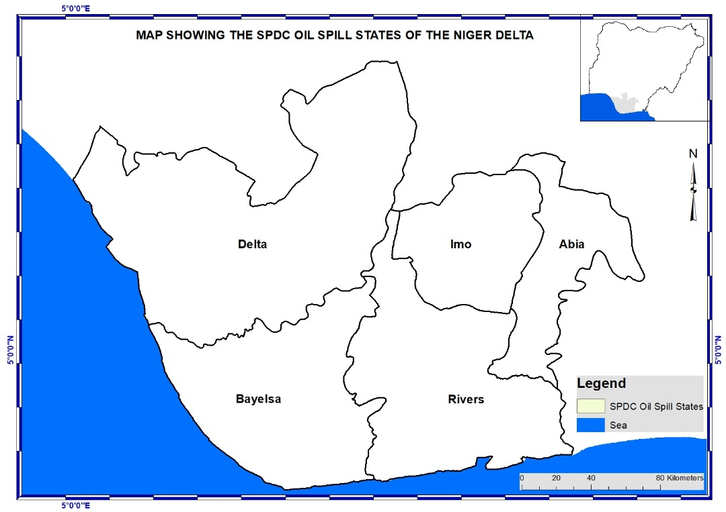**STUDY AREA**

**Figure 1: Showing Location map of the study area (After Mercy 2021)**

Niger Delta is the study area (fig 1). Based on survey (SPDC 2019), States affected by SPDC oil spill includes; parts of Rivers, Bayelsa, Delta, Abia, and Imo state. The Niger delta region consist of nine states and has more than 37million people representing about 22% of Nigeria’s population (Aaron, k.k 2005), the oil and gas resources of the niger delta volumes for 80% of the nation’s revenue, this region holds the oil wealth that made Nigeria the highest producer of Petroleum in Africa, and the sixth producer in the world (Yakubu 2008).

**RESULT AND ANALYSIS**

**Table 1: Summary of leak points from 2011-2019**

|  |  |  |  |  |  |  |  |  |  |  |  |
| --- | --- | --- | --- | --- | --- | --- | --- | --- | --- | --- | --- |
| Leak points | 2011 | 2012 | 2013 | 2014 | 2015 | 2016 | 2017 | 2018 | 2019 | Leak Point Total | % Change |
| Crude oil theft (bunkering) | 33 | 63 | 83 | 78 | 59 | 26 | 32 | 72 | 97 | 543 | **44.11** |
| Hack saw cut | 49 | 36 | 32 | 26 | 17 | 5 | 6 | 20 | 22 | 213 | **17.30** |
| Operational failures and other leak points | 46 | 40 | 15 | 21 | 29 | 19 | 18 | 8 | 5 | 201 | **16.33** |
| Corrosion (Internal and External) | 23 | 19 | 18 | 11 | 4 | 3 | 2 | 13 | 1 | 94 | **7.64** |
| Drilled Hole | 9 | 9 | 10 | 11 | 8 | 4 | 8 | 18 | 6 | 83 | **6.74** |
| Well head tampering | 3 | 3 | 0 | 6 | 3 | 5 | 4 | 4 | 0 | 28 | **2.27** |
| Missing pipeline/Flowline | 3 | 4 | 5 | 1 | 1 | 1 | 6 | 2 | 4 | 27 | **2.19** |
| Third party tampering with clamp | 1 | 5 | 6 | 2 | 2 | 4 | 1 | 3 | 2 | 26 | **2.11** |
| Explosive Tear Events | 2 | 2 | 2 | 3 | 2 | 3 | 0 | 2 | 0 | 16 | **1.30** |
| Yearly Total | **169** | **181** | **171** | **159** | **125** | **70** | **77** | **142** | **137** | **1231** | **100** |

Table 1 summarizes the distribution of leak points across various categories from 2011 to 2019. The total number of leak points exhibited annual fluctuations, with a peak of 181 incidents in 2012 and a minimum of 70 in 2016. Crude oil theft (bunkering) emerged as the most prevalent leak point type, accounting for 446 incidents (41%) throughout the period. Furthermore, it displayed the most substantial increase (44.11%) between 2011 and 2019. Hack saw cuts were the second most frequent type, with 191 occurrences (17%) and a moderate increase of 17.3% from 2011 to 2019. Operational failures and other leak points remained relatively consistent, averaging around 20 incidents annually. Conversely, leak points due to corrosion (internal and external) demonstrated a steady decline, decreasing from 23 in 2011 to just 1 in 2019. Drilled holes exhibited a moderate rise, increasing from 9 in 2011 to a peak of 18 in 2018, followed by a decrease to 6 in 2019. Wellhead tampering incidents were sporadic and relatively low, with a slight upward trend observed between 2013 and 2015. Missing pipelines/flowlines, third-party tampering with clamps, and explosive tear events remained infrequent and sporadic occurrences throughout the entire period.

**Table 2: Summary of states leak points from 2011-2019**

|  |  |  |  |  |  |  |  |  |  |  |  |
| --- | --- | --- | --- | --- | --- | --- | --- | --- | --- | --- | --- |
| States/Year | Oil Spill Leak Point Occurrences | | | | | | | | | Leak Point Total | % Change |
| **2011** | **2012** | **2013** | **2014** | **2015** | **2016** | **2017** | **2018** | **2019** |
| Rivers | 86 | 98 | 105 | 88 | 73 | 39 | 42 | 81 | 103 | **715** | **58.08** |
| Bayelsa | 33 | 25 | 25 | 47 | 35 | 15 | 10 | 27 | 17 | **234** | **19.01** |
| Delta | 36 | 29 | 19 | 20 | 13 | 7 | 9 | 12 | 5 | **150** | **12.19** |
| Abia | 8 | 20 | 15 | 3 | 4 | 4 | 10 | 14 | 2 | **80** | **6.50** |
| Imo | 6 | 9 | 7 | 1 | 0 | 5 | 6 | 8 | 10 | **52** | **4.22** |
| Yearly Total | **169** | **181** | **171** | **159** | **125** | **70** | **77** | **142** | **137** | **1231** | **100** |

Table 2 presents the distribution of oil spill leak points across five Nigerian states (Rivers, Bayelsa, Delta, Abia, and Imo) from 2011 to 2019. The data reveals a significant concentration of leak points in Rivers State, with 715 incidents (58%) recorded over the nine-year period. In contrast, Bayelsa, Delta, Abia, and Imo states reported considerably lower numbers of leak points. Interestingly, Rivers State witnessed a rise in oil spill leak points from 2011 to 2019, whereas Bayelsa and Delta states displayed a decline during the same timeframe.

# 2011 Oil Spill Leak Points

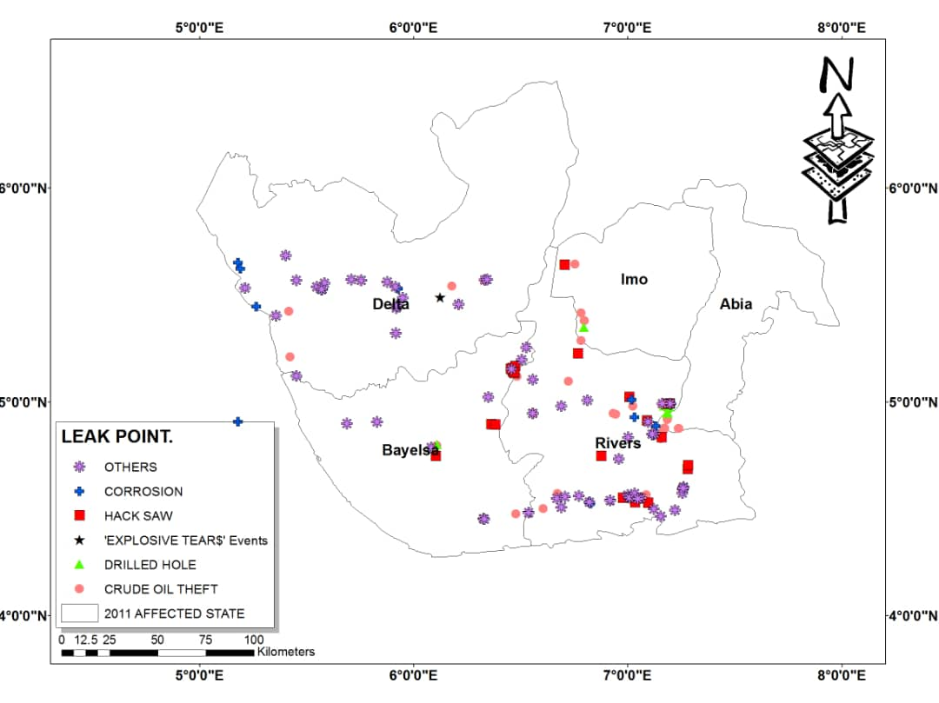

**Fig 2. A map showing the oil spill leak points in the Niger Delta in 2011**

# 2012 Oil Spill Leak Points

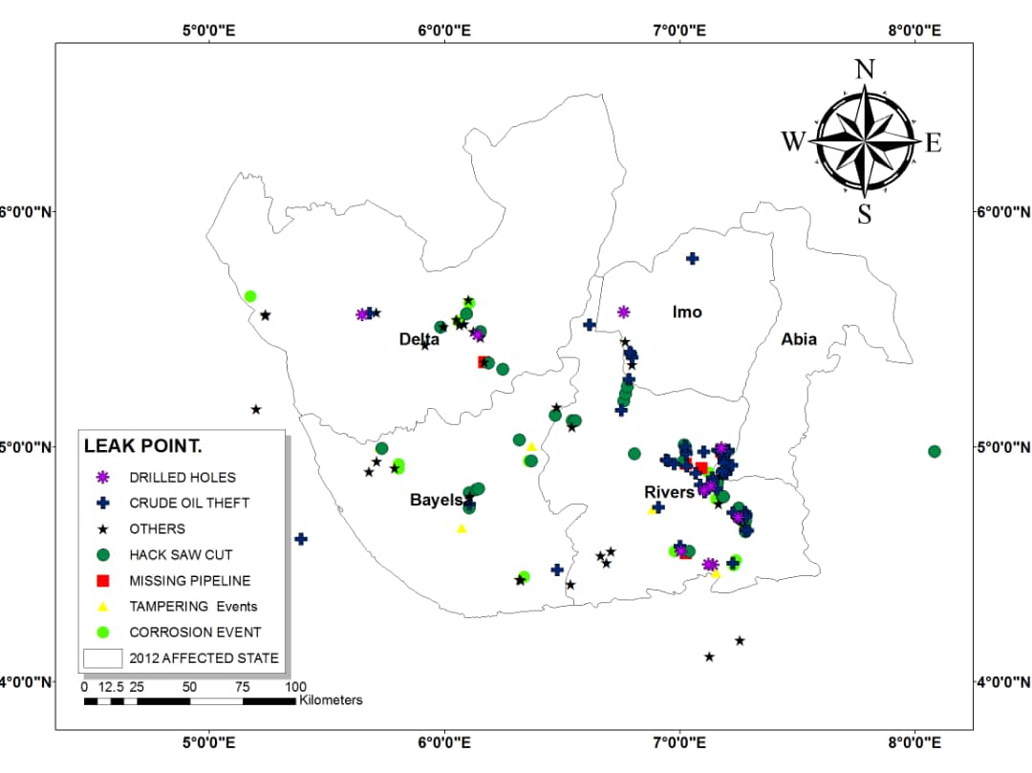

**Fig 3. A map showing the oil spill leak points in the Niger Delta in 2012**

# 2013 Oil Spill Leak Points

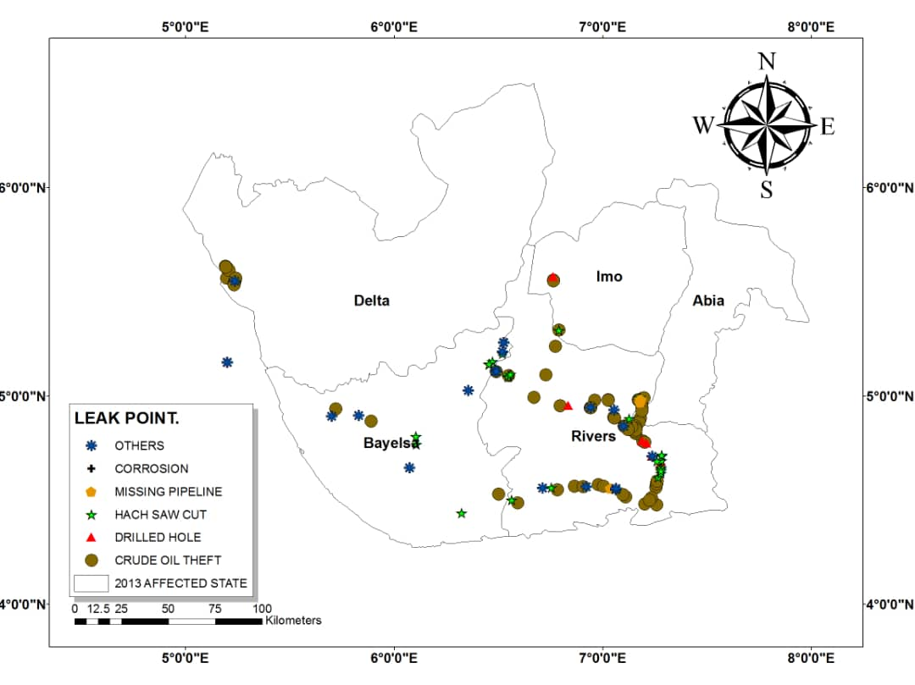

**Fig 4. A map showing the oil spill leak points in the Niger Delta in 2013**

# 2014 Oil Spill Leak Points

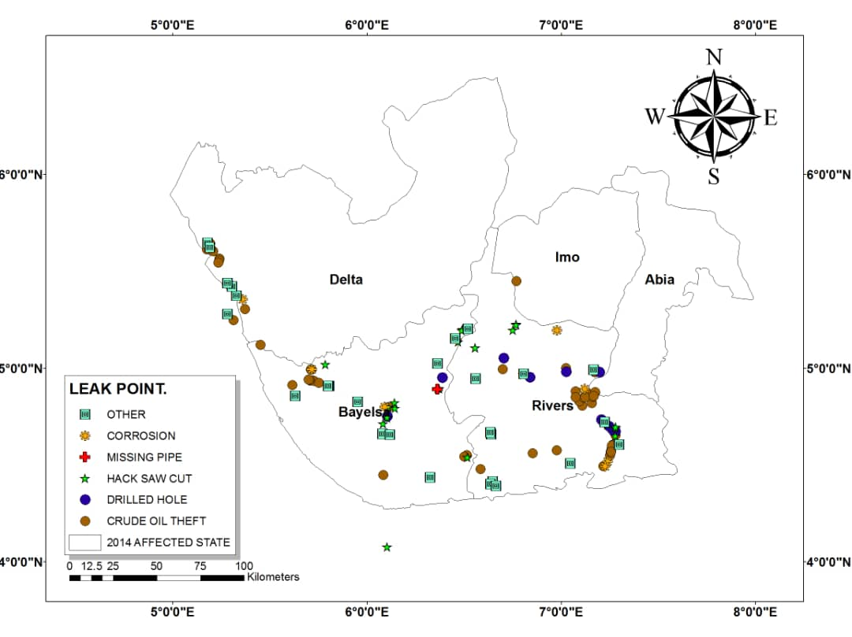

**Fig 5. A map showing the oil spill leak points in the Niger Delta in 2014**

# 2015 Oil Spill Leak Points

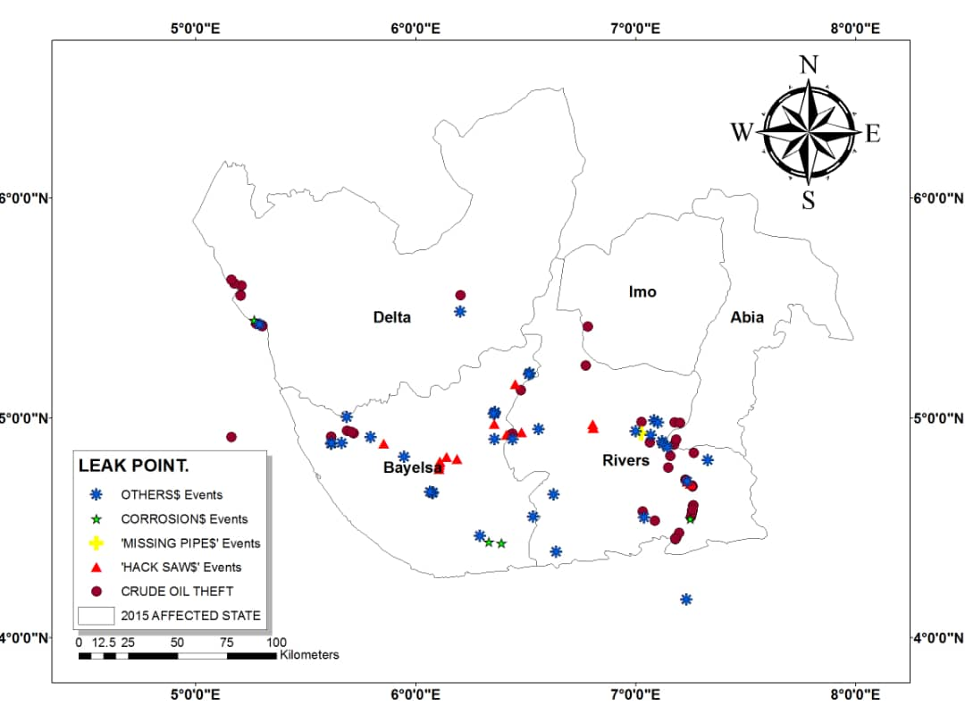

**Fig 6. A map showing the oil spill leak points in the Niger Delta in 2015**

# 2016 Oil Spill Leak Points

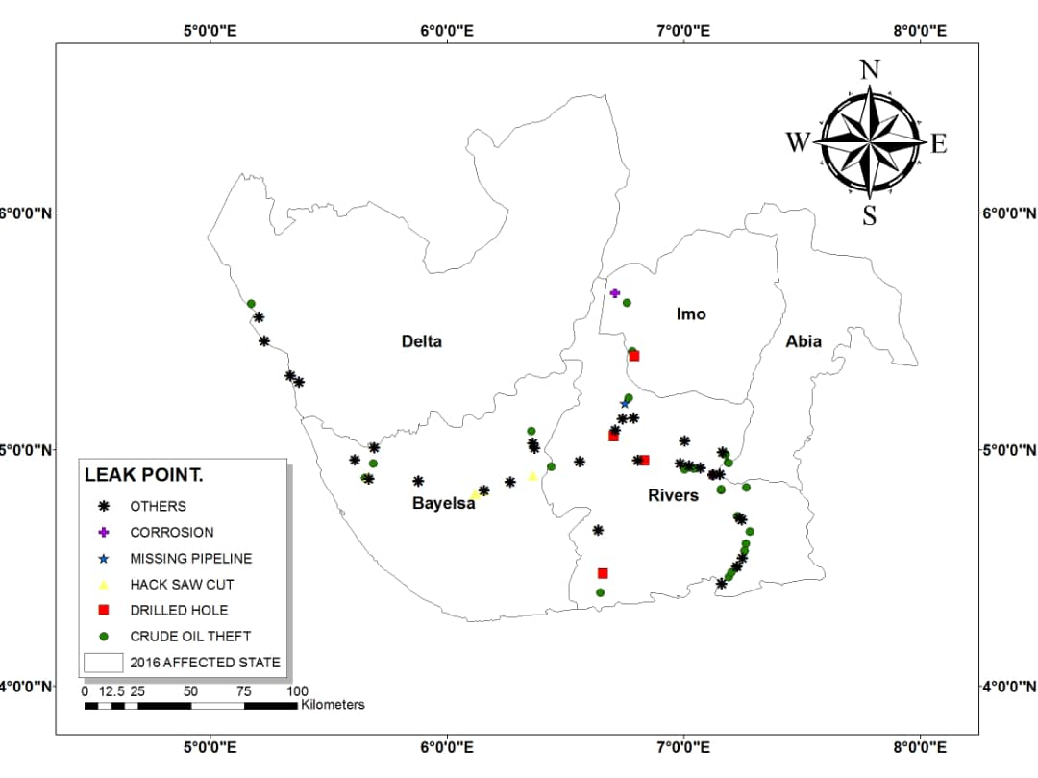

**Fig 7. A map showing the oil spill leak points in the Niger Delta in 2016**

# 

# 2017 Oil Spill Leak Points

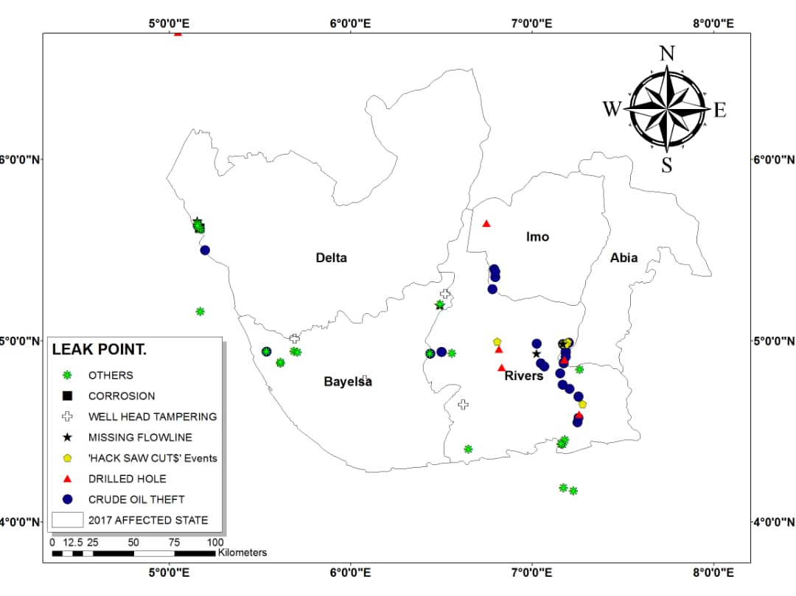

**Fig 8. A map showing the oil spill leak points in the Niger Delta in 2017**

# 2018 Oil Spill Leak Points

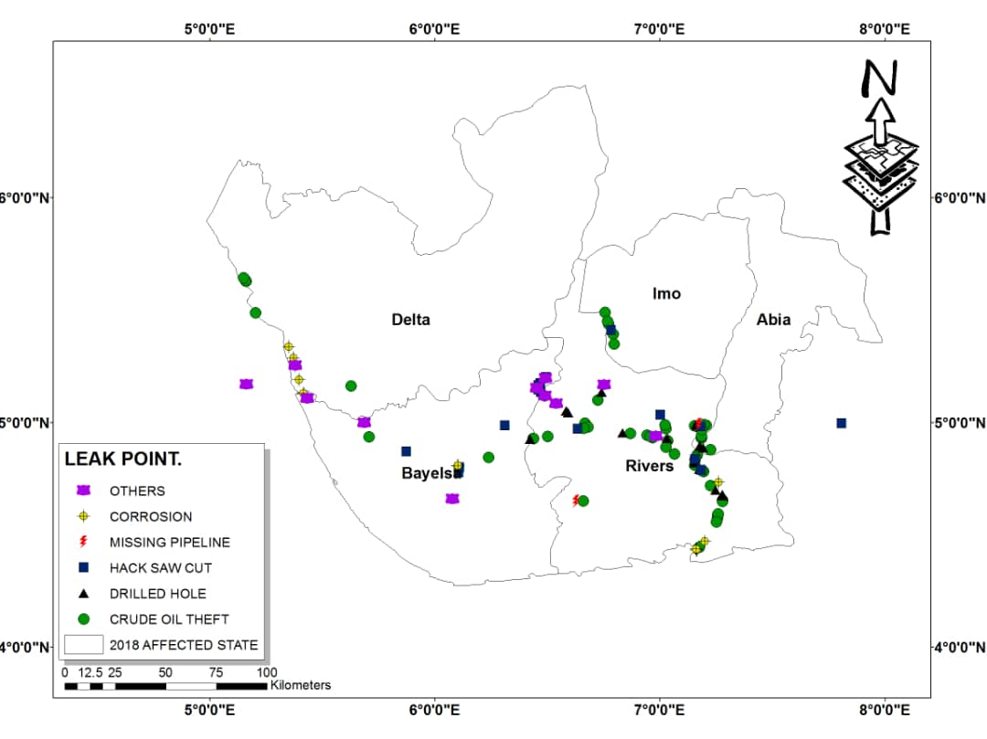

**Fig 9. A map showing the oil spill leak points in the Niger Delta in 2018**

# 

# 2019 Oil Spill Leak Points

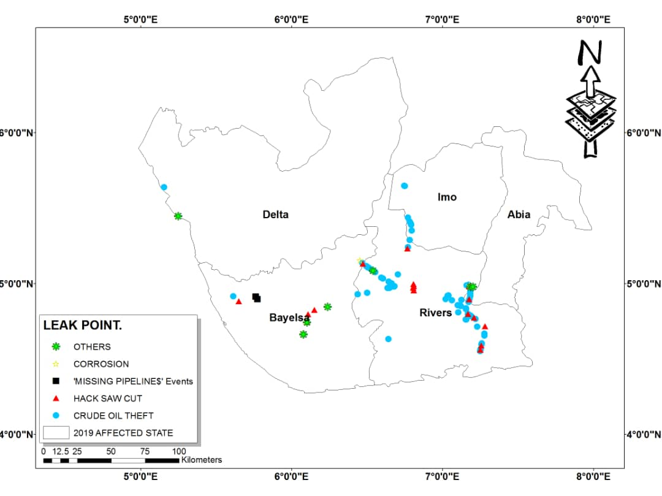

**Fig 10. A map showing the oil spill leak points in the Niger Delta in 2019**

# 

# DISCUSSION

**2011**

In 2011, Crude Oil Theft (Bunkering) had the highest number of leak points, accounting for 33 leak points (19.5% o). While Hack Saw Cut was the second most frequent cause of leaks with 49 leak points (29%). The remaining leak points fall under various categories, including: Operational failures and other leak points (46 leak points), Corrosion (Internal and External) (23 leak points), Drilled Holes (9 leak points), Wellhead Tampering (3 leak points), Missing Pipeline/Flowline (3 leak points), Third-party Tampering with Clamp (1 leak points), and Explosive Tear Events (2 leak points). These results show that intentional actions like crude oil theft and hack saw cuts were significant oil spill leak points in 2011. These combined for over 48% of all leak points. Corrosion, drilled holes, and other leak points collectively represent a substantial portion of the incidents in 2011. Table 2 shows the geographical distribution of leak points across Rivers, Bayelsa, Delta, Abia and Imo states in 2011. Rivers State with 86 leak points (58.08%), accounted for the highest number of incidents compared to other states. Following Rivers State, Delta state recorded (36 leak points) reported the next highest number of leak points while Bayelsa state recorded (33 leak points). Abia and Imo States, recorded considerably fewer leak points (8 and 6 incidents, respectively).

# 2012

In 2012, Crude oil theft (bunkering) remained a significant concern with 63 leak points, representing an increase of nearly 97% compared to 2011. This highlights the growing threat of oil theft within the Niger Delta region. Hack saw cuts showed a decrease from 2011 (36 leak points) and was the second most frequent leak point type. This implied that deliberate pipeline tampering continued to be a challenge. The remaining leak point’s fall under various categories, including: Operational failures and other leak points (40 leak points). Corrosion (internal and external) showed downward trend from 2011, with 19 leak points, suggesting potential improvements in pipeline maintenance practices. Drilled holes (9 leak points) and remained relatively stable compared to 2011. Wellhead tampering, missing pipeline/flowline, third-party tampering with clamp, and explosive tear eventsoccurred sporadically with a similar frequency to 2011. Table 2 shows the geographical distribution of leak points across Rivers, Bayelsa, Delta, Abia and Imo states in 2012. Rivers State recorded the highest number of leak points (98), representing a 14% increase compared to 2011, suggesting a potential rise in leak point occurrences within Rivers state. Bayelsa State witnessed a decrease in leak points from 2011 (33) to 2012 (25), showing a 24% decline. This is a contrasting trend compared to Rivers State. Similar to Bayelsa, Delta State also experienced a decrease in leak points from 2011 (36) to 2012 (29), reflecting a 19% reduction. Abia State displayed a significant increase in leak points from 2011 (8) to 2012 (20), representing a 150% rise. This is a noteworthy shift compared to the previous year. Imo State observed a moderate increase in leak points from 2011 (6) to 2012 (9), reflecting a 50% rise.

# 2013

In 2013, a total of 171 oil spill leak points was recorded, representing a slight decrease from 2012's 181 incidents, it's still a significant number. Crude Oil Theft (Bunkering) remained the primary cause, accounting for 83 incidents (48.5%). This represents a significant concern, highlighting the ongoing issue of intentional actions contributing to oil spills. Hack Saw Cut (32 incidents, 18.7%), Operational Failures and Other Leak Points (15 incidents), Corrosion (18 incidents), Drilled Holes (10 incidents), and Missing Pipeline/Flowline (5 incidents). Notably, Wellhead Tampering had zero reported incidents, while Third-party Tampering with Clamp had 6 incidents. Corrosion continues to show a gradual decline when compared with 2011 and 2012, potentially due to better pipeline maintenance practices. Operational Failures and Other Leak Points decrease in 2013 when compared to 2011 and 2012, suggesting potential improvements in pipeline maintenance or leak detection. Table 2 shows the geographical distribution of leak points across Rivers, Bayelsa, Delta, Abia and Imo states in 2013. Rivers State recorded the highest number of leak points (105, or 61% of the total). Other states included Delta (36 incidents), Bayelsa (21 incidents), Abia (5 incidents), and Imo (4 incidents). Rivers State's high incidence rate warrants attention to address underlying causes.

# 2014

In 2014, the total number of oil spill leak points across Nigeria reached 159, showing a slight decrease compared to previous years. Crude Oil Theft (Bunkering) remained the dominant cause, with 78 incidents, although this figure represents a decline from its peak in 2013. Despite the reduction, crude oil theft continues to be a major challenge, constituting a significant proportion of the leak points. Hack Saw Cut, another major cause of intentional oil spills, also saw a decrease in 2014, with 26 incidents reported. This reduction may be indicative of enhanced security measures or changing tactics in oil theft operations. Other types of leak points showed mixed trends in 2014. Operational failures and other leak points increased slightly, with 21 incidents compared to 2011. Corrosion incidents, both internal and external, continued their downward trend, with only 11 cases reported, possibly indicating better pipeline maintenance and preventive measures. Drilled holes increased to 11 incidents in 2014, while wellhead tampering saw a noticeable rise, with 6 incidents reported, compared to only 3 in 2011. Minor leak types, such as missing pipelines, third-party tampering with clamps, and explosive tear events, remained low and sporadic throughout 2014. Rivers State recorded the highest number of incidents, with 88 leak points in 2014. Although this figure shows a decline from previous years, it still far exceeds the numbers in other states. Bayelsa, Delta, Abia, and Imo saw a decrease in leak points, with Bayelsa experiencing a sharp drop from 47 incidents in 2013 to 20 in 2014. These trends suggest that while some areas have made progress, more attention is needed to address the high concentration of leak points in key regions like Rivers State.

# 

# 2015

In 2015, the total number of oil spill leak points in decreased to 125, reflecting a decline from the 159 incidents reported in 2014 and previous years. Despite this reduction, crude oil theft, also known as bunkering, remained the leading cause of oil leaks, with 59 incidents. While this figure is lower than the peak in 2013, it highlights the persistent challenge of illegal oil activities. Hack saw cuts, which had been a significant cause of leaks in previous years, also saw a decrease, with 17 incidents recorded in 2015, indicating a positive trend in reducing deliberate tampering. Other leak point types exhibited mixed trends in 2015. Operational failures and other leak points increased slightly, with 29 incidents, suggesting that despite improvements in some areas, operational issues continue to pose a risk. Corrosion, both internal and external, showed significant improvement, with only 4 incidents reported, indicating better maintenance of pipelines. Drilled holes remained consistent, with 8 incidents, while wellhead tampering, missing pipelines or flowlines, third-party tampering with clamps, and explosive tear events occurred infrequently, each with only a handful of incidents in 2015. Rivers State continued to dominate in terms of the number of leak points, recording 73 incidents, which accounted for 58.4% of the total in the country. Bayelsa State experienced a slight increase in incidents, reporting 35 leak points, while Delta State saw a reduction, with 13 leak points recorded. Abia and Imo States maintained a lower number of incidents, with Abia recording 4 leak points and Imo reporting none in 2015.

# 

# 2016

In 2016, there was a significant reduction in the total number of oil spill leak points, reaching the lowest point across the nine-year period (2011-2019). There were only 70 leak points recorded, reflecting a substantial decline of 42.86% compared to 2015, when 125 incidents occurred. Crude oil theft, or bunkering, remained the most frequent cause of leaks, though it also saw a sharp decrease in 2016, with only 26 incidents. This marked a 55.93% drop from the previous year. Other leak point types, including hack saw cuts, operational failures, corrosion, drilled holes, and wellhead tampering, followed a similar downward trend, suggesting that various forms of vandalism and operational issues were less prominent in 2016. Several potential factors could explain this significant drop in leak points. One possibility is the enhancement of security measures around pipelines, which may have acted as a deterrent against oil theft and sabotage. Additionally, increased efforts in maintenance and repair activities might have addressed pipeline vulnerabilities such as corrosion and operational failures. Another factor worth considering is whether there were changes in data reporting methodologies or collection processes in 2016, which could have influenced the recorded numbers. Rivers State, historically the area with the highest number of incidents from 2011, reported a sharp decline, with only 39 leak points compared to 105 in 2013. Bayelsa and Delta States also saw declines, with Bayelsa recording 15 leak points and Delta registering 7 incidents. While Abia State reported only 4 leak points, Imo State saw a major increase from 0 incidents in 2015 to 5 in 2016.

# 

# 2017

In 2017, crude oil theft remained a prominent concern, with 32 recorded leak points. While this reflects an increase from 26 incidents in 2016, it is notably lower than the peak of 97 incidents in 2019. Hack saw cuts, another significant cause of pipeline leaks, saw a minor rise in 2017, with six incidents, compared to five in 2016. However, this figure remains much lower than the 49 incidents reported in 2011. Operational failures and other miscellaneous leak points were responsible for 18 incidents in 2017, which is consistent with the typical range observed in 2016. Corrosion incidents, both internal and external, continued their decline, with only two incidents reported in 2017, likely indicating advancements in pipeline maintenance. Drilled holes increased moderately in 2017, contributing eight incidents, a rise from four in 2016. Wellhead tampering remained a low-frequency issue, with four incidents reported in 2017, while missing pipelines or flowlines contributed six incidents. Third-party tampering with clamps caused just one leak, and no explosive tear events were reported during the year. These observations highlight that while crude oil theft remains a pressing concern, other causes like corrosion and operational failures have seen a positive downward trend. Rivers State once again recorded the highest number of leak points, with 42 incidents in 2017. This represents a slight increase from the 39 incidents in 2016 but is still lower than the peak of 105 incidents in 2013. Bayelsa State, on the other hand, saw a significant decline, reporting only 10 incidents in 2017, the lowest figure recorded for the state during the 2011-2019 period. Delta State also experienced a reduction, with nine leak points in 2017, down from 13 in 2016. This decline in leak incidents in Bayelsa and Delta suggests a positive trend of improvement in these regions. However, the story was different for Abia and Imo States. Abia State saw a rise in leak points, with 10 incidents reported in 2017, up from four in 2016, while Imo State reported six incidents, an increase from five in 2016. Despite these increases, both states still recorded far fewer incidents than Rivers State, highlighting the regional disparities in oil spill causes and leak incidents. A total of 77 leak points were recorded in 2017, slightly higher than the 70 incidents recorded in 2016 but significantly lower than the peak of 181 incidents observed in 2012. This overall reduction in leak points suggests an improving national trend in pipeline safety and management, although year-to-year fluctuations persist. The continued decline in corrosion-related incidents reflects ongoing improvements in pipeline maintenance, while operational failures and other miscellaneous leak points remain areas of concern. The rise in crude oil theft in 2017, despite security measures, indicates that oil theft and vandalism continue to pose a major challenge to oil infrastructures in the states. In contrast, the reductions seen in Delta and Bayelsa States may be due to enhanced security efforts or localized maintenance activities, while the rise in leak points in Abia and Imo States could warrant further investigation to identify contributing factors and address vulnerabilities.

# 2018

In 2018, Nigeria witnessed a noticeable rise in oil spill leak points, totaling 142 incidents, which marked a slight increase compared to the yearly average of approximately 138 leak points. Crude oil theft (bunkering) continued to be the most frequent cause of leaks, contributing 72 incidents. Although crude oil theft was still the dominant leak point type, its rise was moderate compared to the overall increase in total leak points. An emerging concern in 2018 was the rise in drilled hole incidents, which saw 18 leak points, compared to an average of 9 incidents in previous years. This notable uptick requires further investigation to identify the root causes and prevent future occurrences. Hack saw cuts remained a steady source of leaks in 2018, with 20 recorded incidents, slightly higher than the overall average of 18. In contrast, operational failures and other leak points saw a significant decrease, with only 8 incidents in 2018, as opposed to the typical average of around 22. This reduction suggests improvements in pipeline maintenance and operations. Corrosion-related leak points, both internal and external, also showed a decline in 2018, with 13 incidents recorded, indicating potential advancements in pipeline protection against degradation. Other leak categories, such as wellhead tampering, missing pipelines, third-party tampering with clamps, and explosive tear events, remained relatively low, with only minor fluctuations in numbers compared to previous years, indicating that these causes were not significant contributors to overall leak points in 2018. Rivers State once again recorded the highest number of leak points in 2018, with 81 incidents, representing a substantial increase from the 42 leak points reported in 2017. This marked a concerning trend in the region, where oil spills have historically been concentrated. However, Table 2 does not provide a detailed breakdown of the specific leak types contributing to the incidents in Rivers State for each year. Other states, such as Bayelsa, reported 27 leak points, while Delta saw 12 incidents. Abia and Imo states followed with 14 and 8 leak points, respectively. The results for 2018 suggests that oil theft and vandalism remain persistent challenges, particularly in areas like Rivers State, while certain regions may be experiencing some progress in leak point reduction.

# 2019

In 2019, a total of 137 oil spill leak points was recorded with crude oil theft (bunkering) as the most significant cause of oil spill leak points, with 97 incidents. the rise in 2019 highlights the escalating nature of this issue. Hack saw cuts followed as the second most frequent cause of leak points, with 22 incidents, suggesting that vandalism and intentional breaches of pipelines remained a major concern in 2019, despite some fluctuations over the years. Other leak point types, such as operational failures and corrosion, showed notable changes compared to previous years. Operational failures and other types of leaks decreased significantly, with only 5 incidents in 2019, compared to 46 in 2011. This decline may indicate improvements in pipeline maintenance and operational protocols. Corrosion, both internal and external, also saw a substantial reduction, with just 1 leak point in 2019, down from 23 incidents in 2011. These improvements suggest that efforts to reduce corrosion and operational failures have been somewhat successful. However, occasional leak points from drilled holes, wellhead tampering, and other less common causes remained consistent with previous years, requiring continued attention. Rivers State again recorded the highest number of leak points in 2019, with 103 incidents. This marked an increase of 17 incidents from 2011, reaffirming Rivers State as a hotspot for oil spills. In contrast, Bayelsa State saw a significant reduction in leak points, dropping from 33 in 2011 to 17 in 2019, reflecting a nearly 50% improvement. Delta State experienced an even more dramatic decrease, with leak points plummeting from 36 in 2011 to just 5 in 2019, representing an over 80% decline. These improvements in Bayelsa and Delta States may be attributed to better security measures or successful intervention strategies. Abia State saw a small increase, with 2 leak points recorded in 2019 compared to 8 in 2011, while Imo State experienced a modest rise in incidents, from 6 in 2011 to 10 in 2019. This mixed performance across states underscores the importance of region-specific approaches to addressing oil spill leak points.

**CONCLUSIONS**

Leak points, representing breaches in oil pipeline infrastructure, are critical factors influencing the incidence and severity of oil spills. Analyzing their spatial distribution and underlying causes is crucial for developing effective oil spill prevention and mitigation strategies. This study investigated oil spill leak points across five states within the Nigerian Niger Delta region: Rivers, Bayelsa, Delta, Abia, and Imo. The analysis of leak points from 2011 to 2019, as shown in Table 1, reveals a total number of 1231 leak points. Crude oil theft (bunkering) consistently remained the dominant cause of leak points, with a total of 543 incidents over the nine-year period. This represents 44.11% of the total leak points, marking a steady increase in crude oil theft incidents, particularly rising from 33 incidents in 2011 to 97 incidents in 2019. Hack saw cuts were the second leading cause, contributing to 213 leak points (17.30%) over the period, although these incidents showed a decreasing trend overall, from 49 in 2011 to 22 in 2019. Operational failures and corrosion both saw noticeable declines over the years. Operational failures, which caused 46 leak points in 2011, dropped to just 5 by 2019, contributing 16.33% of the total leak points. Corrosion, both internal and external, was responsible for 94 leak points (7.64%), showing a significant reduction from 23 in 2011 to only 1 in 2019, likely due to improved pipeline maintenance. Other causes, such as drilled holes, wellhead tampering, missing pipelines, Third party tampering with clamp and Explosive Tear Events contributed smaller portions to the total, with drilled holes at 6.74%, wellhead tampering at 2.27%, missing pipelines at 2.19%, Third party tampering with clamp at 2.11% and Explosive Tear Events at 1.30%. Table 2 indicates the geographic distribution of leak points, with Rivers State consistently recording the highest number of incidents, totaling 715 leak points (58.08%) from 2011 to 2019. Bayelsa and Delta states followed, with 234 (19.01%) and 150 (12.19%) leak points, respectively, while Abia and Imo accounted for much fewer incidents.

In conclusion, the results suggests that the oil and gas industry in faces significant challenges in preventing oil spills, with crude oil theft being the primary culprit. The geographical concentration of these incidents in certain states highlights the need for continuous monitoring and analysis of leak point trends to inform effective strategies for prevention, mitigation and targeted interventions to address the underlying causes and mitigate the environmental and economic impacts of oil spills in the affected states.

**REFERENCES**

Adati, A. K. (2012). Oil exploration and spillage in the Niger Delta of Nigeria. Civil and Environmental Research, 2(3), 38-51.

Amnesty International. (2013). Amnesty International Report 2013: The State of the World's Human Rights (Report No. POL 10/001/2013).

Beka, F. T., & Oti, M. (1995). The distal offshore Niger Delta: Frontier prospects of a mature petroleum province. In M. N. Oti & G. Postma (Eds.), Geology of Deltas (pp. 237-241). A.A. Balkema.

Mercy, & Okujagu, D. C. (2020). Spatial temporal patterns of Rivers State SPDC related oil spill from 2010 to 2019. International Journal of Research in Engineering and Science (IJRES), 8(5), 54-68.

Mercy, (2021), Oil Spill Trend in Some Selected States of The Niger Delta Region From 2011-2019. Unpublished BSc Project, department of Geology.

Moses, A. D., Okujagu, D. C., & Beka, F. T. (2019). Geospatialization of spilling facility from SPDC 2015 oil spill reports of the Niger Delta region of Nigeria. Journal of Applied Geospatial Information, 3(1). <http://journal.polibatam.ac.id/index.php/JAGI>

NNPC. (2016). Industry history. NNPC Business Information. http://nnpcgroup.com/nnpcbusiness/businessinformation/oilgasinnigeria/industryhistory.aspx

Obaje, N. G. (2009). Geology and mineral resources of Nigeria [Lecture notes].

Osuagwu, E. S., & Olaifa, E. (2018). Effects of oil spills on fish production in the Niger Delta. PLOS ONE, 13(10).

Oshienemen, N. A., Dilanthi, A., & Richard, P. H. (2018). Evaluation of the impacts of oil spill disaster on communities and its influence on restiveness in Niger Delta, Nigeria. 7th International Conference on Building Resilience, 27–29 November 2017, Bangkok, Thailand.

Oteiva, F., & Ndokiari, B. (2018). The effect of crude oil spill on the surface water of the Lower Niger Delta (Sombriero River). Journal of Industrial and Environmental Chemistry, 2(2).

SPDC. (2016). Oil spill data. Shell Nigeria. http://www.shell.com.ng/environment-society/environment-tpkg/oil-spills.html

Umar, H. A., Abdul-Khanan, F. A., Ahmad, M. J., Sani, M. J., Abd-Rahman, M. Z., & Abdul-Rahman, A. (2019). Spatial database development for oil spills pollution affecting water quality system in Niger Delta. Photogrammetry, Remote Sensing and Spatial Information Sciences, XLII-4/W16.