**A STUDY ON IMAPCT OF REWARD SYSTEM OF EMPLOYEES IN IT SECTOR**

**Libica S1, S V Praveen2**

1Student, MBA, Jerusalem College of Engineering, Chennai, TamilNadu, India

2Asst. Prof., MBA, Jerusalem College of Engineering, Chennai, Tamilnadu, India

**ABSTRACT**

Performance appraisal (PA) is a crucial technique for improving the skills of employees and organisations. Organizations have implemented performance appraisal to monitor and supervise relationships, growth, and development of individuals and organisations to increase overall productivity and job satisfaction. The human resource department is tasked with employee recruitment, selection, and retention. The research will aim to establish the impact of performance appraisal fairness on the employees’ motivation in an organization. Motivation initiates, guides, and maintains an individual's goal-oriented behaviour. Employee retention is mostly determined by motivation. To inspire and retain employees, PA guidelines are used to assess workers, develop their competence, improve their performance, and issue awards. The sample size is 103. To achieve its objective, the study will adopt descriptive research. The research design used in this study is snowball technique. Chi-square, Annova and Correlation are the tools used in the study.

1. **INTRODUCTION**

**Reward system is defined as " An integration of policies procedures and practices by an organization for rewarding it's employees as per their performance , skills, competence and their market value. Reward system are central to the human resource Management operate. their purpose is to draw in gifted people, encourage them and retain people who have an improved work with the organization. Reward system have an immediate impact on the price facet of the organization's budget. Rewards are thought-about as a very important tool to ascertain the staff performance in each organization. Management use rewards for workers motivation. Thus we will say that effective reward system attract new workers for organization and encourage existing workers to perform high levels. Workers smart work is important to attain the particular goals and smart effort depends on rewards . The association and relationship between reward, motivation and job satisfaction of workers have abundant significance to success of each public and personal sectors. A reward system is very important for the worker performance. As worker performance are simpler to high reward system. Job performance is additionally a part of human resources management. Performance is Associate in Nursing what and for the organization succession and achieving the goals there's such a lot ever changing occurring within the faculty education within the world faculty has should relay on workers smart performance reverse thought-about as vital tool to ascertain the staff performance in every organization management use reward for workers motivation.**

1. **REVIEW OF LITERATURE**

**2.1 Ofelia Robescu and Alina-Georgiana Iancu(2016) says that the most important finding of the study is that a large part of employees agree that recognition motivates and influence the performance. In summary, recognition can be a powerful tool used to motivate employees. It is desired by employees and significantly increase their performance. Some suggests that social rewards, such as recognition may affect employee performance to the same level as payment.**

**2.2 Felista Ngozi Abasili, Abdu Ja’afaru Bambale(2017), investigate the direct relationship between reward and employee performance using the variables including salary, bonus, incentive, promotion, recognition, pension and gratuity as independent variables and performance as dependent variable. Employee performance and the level of job satisfaction and commitment to their job is a direct function of the compensation packages and reward system of the organization. Without appropriate compensative package, incentive system and motivational techniques put in place in the organization, it is most likely that workers will not be committed and their performance level will be underhand. Reward is central to the functioning of any employee-employer relationship and it is a matter that is closest to the heart of both the employee and the employer.**

**2.3 Yoko Kitakaji, Susumu Ohnuma(2018), examined whether rewards and mutual punishment increased noncooperation or motivation and regarded illegal industrial waste dumping as a social dilemma in which everyone bears the burden of the cost of illegal dumping, legal treatment is cooperative behavior, and illegal dumping is noncooperative behavior.**

**2.4 Zhen Zhang, Lianying Zhang, Aibin Li (2019) found that reward system as an effective tool to manage NPD (new product development) collaboration. Yet, our understanding about what types of rewards should be used for NPD collaboration is still unclear. This research examines the effects of reward interdependence and nonfinancial incentives on NPD collaboration, as well as the moderating roles of team size and deep-level heterogeneity**

1. **METHODOLOGY**

Research methodology refers to the systematic and organized approach used by researchers to conduct a study, gather data, analyze information, and draw valid conclusions. It outlines the techniques, procedures, tools, and strategies that researchers employ to address their research questions or objectives. The chosen research methodology depends on the nature of the study, the type of data required, and the scope of the research project.

* 1. **RESEARCH DESIGN**

A descriptive research design can use a wide variety of research methods to investigate one or more variables. Unlike in experimental research, the researcher does not control or manipulate any of the variables, but only observes and measures them.

**3.2 SAMPLING TECHNIQUE**

Snowball sampling, also defined as chain referral sampling is a non-probability sampling method where samples have unique characteristics. It is effective when investigating unknown and rare groups.

**3.3 Sample size**

A Sample of 103 respondents is taken in this study and the required data has been collected.

1. **ANALYSIS**

Percentage Analysis:

Simple percentage analysis refers to a special kind of rate. Percentage are used in making comparison between two or more series of data. A percentage is used to determine the relationship between the series of data. Formula: Percentage of Respondents = no of Respondents *100/total no of Respondents.

Regression analysis:

Regression analysis is a statistical technique used to examine the relationship between one or more independent variables (also known as predictor variables or features) and a dependent variable (also known as the outcome or response variable). The goal of regression analysis is to understand how changes in the independent variables are associated with changes in the dependent variable and to make predictions based on this relationship.

Correlation analysis:

Correlation refers to a statistical measure that describes the strength and direction of a relationship between two or more variables. It helps us understand how changes in one variable are associated with changes in another variable. Correlation does not imply causation; it simply indicates the degree to which two variables tend to move together or apart.

Chi-square analysis:

Chi-square analysis, also known as the chi-square test, is a statistical method used to determine if there is a significant association between two categorical variables. It's commonly employed to analyze the relationship between two variables when both are categorical.

Percentage analysis for gender of the respondent:

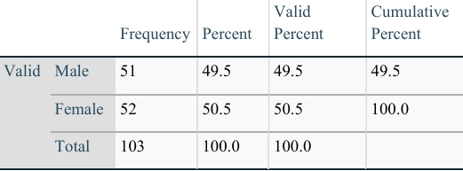

Inference: From the above table it is interpreted that 50.49% are female and 49.51% are male. Majority are female respondents.

REGRESSION:

To identify the significant relationship between superior and subordinates.

NULL HYPOTHESIS (H0): There is no significance difference between superior and subordinate.

ALTERNATIVE HYPOTHESIS (H1): There is significance difference between superior and subordinate.

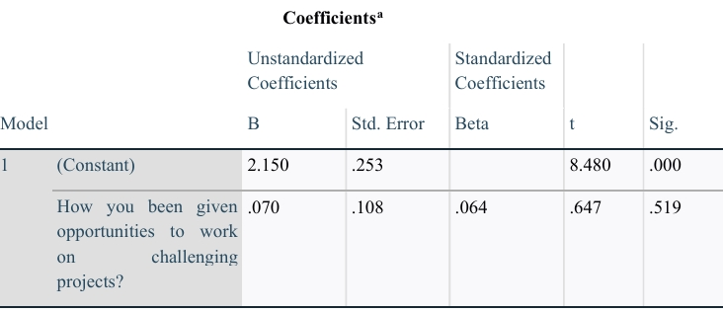

INFERENCE:

The significant value 0.000 is less than the table significant value (0.000).

CORRELATION

To find the feedback from PA system on effective.

NULL HYPOTHESIS (H0): There is no relationship between fairness of performance appraisal and frequency of performance appraisal.

ALTERNATIVE HYPOTHESIS (H1): There is relationship between fairness of performance appraisal and frequency of performance appraisal.

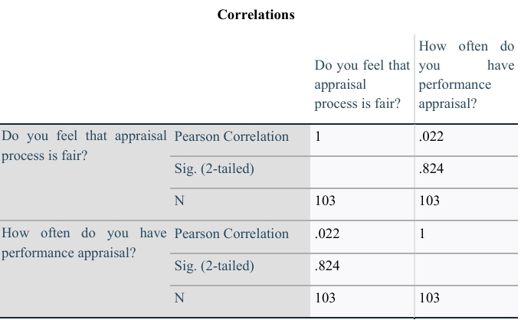

INFERENCE

The significant value 0.824 is less than the table significant value (0.824>0.05). H1 is rejected and H0 is accepted. Therefore, there is no relationship between fairness of performance appraisal and frequency of performance appraisal.

CHI SQUARE

To find the satisfaction level of employees towards PA system

NULL HYPOTHESIS (H0): There is no association difference between gender and overall satisfaction.

ALTERNATIVE HYPOTHESIS (H1): There is association difference between gender and overall satisfaction

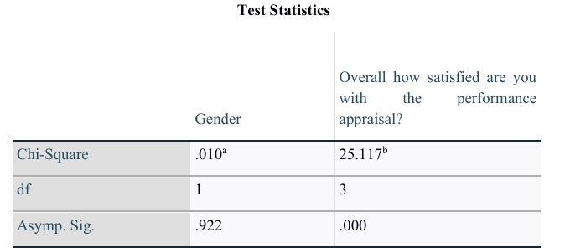

INFERENCE

The significant value 0.000 is less than the table significant value (0.000<0.05)

H0 is rejected and H1 is accepted.

Therefore, there is significance difference between gender and overall satisfaction.

1. **FINDINGS**

From the study, employees are satisfied through the reward system. Through the reward system performance of the employees increases. Most of the employee’s get to known about the reward system through superior. Many of the organizations were able to reduce turnover due to effective reward system. The study will also help the organization to increase the motivational level of employees and thus increases the performance. The best way to motivate employees is to give rewards so that they will remain back in the organization. From the study we found that employees prefer to non-monetary reward compared to monetary rewards. Monetary incentives that an employee earns as a result a good performance. These rewards are aligned with organization in the achievement of its goals.

1. **SUGGESTION**

Since the majority of respondents are female, consider tailoring certain engagement strategies or communication styles to resonate better with this demographic. With the majority of respondents falling in the 18-24 age group, you could focus on implementing programs, benefits, or initiatives that cater to the needs and preferences of this younger workforce segment. Given that most employees are unmarried, consider providing work-life balance initiatives and support that align with the needs of single individuals. The fact that a significant portion of employees are relatively new (less than 1 year experienced) highlights the importance of a comprehensive onboarding process to help them integrate smoothly into the organization. Though there is comfortable communication between the management and employees, study still indicates there is room for improvement in creating an opening and comfortable environment for communication so that there is transparency in the operational transaction . With the majority receiving feedback monthly, consider evaluating the impact of this feedback frequency on performance improvement and if it's driving the desired results.

1. **CONCLUSION**

The focus of this report explains the connection between reward systems, employment performance and development. This was extensively examined using secondary data, the development of this report has created an open ground for broad knowledge and many case studies were investigated. The development of this report resulted that, the management reward practice has a positive impact on employee performance and it is absolutely connected to employee performance. This report also established that, the application of reward systems in an organization has a direct relationship with motivation, both extrinsic, and intrinsic. Extrinsic motivation is best explained using financial rewards and intrinsic method is explained using non-financial rewards.

1. **REFERENCES**

1. Andrew, D.P. and Kent, A. (2007). The impact of perceived leadership behaviors on satisfaction commitment, and motivation. International Journal of Coaching Science, 1(1), pp.37-58.

2. Armstrong, M. (2013). A Handbook on Human Resource Management, London: KoganPage Publishers.

3. Boehm, J.K. and Lyubomirsky, S., (2008). Does happiness promote career success? Journal of career assessment, 16(1), pp.101-116.

4. Danish, R.Q. and Usman, A., (2010). Impact of reward and recognition on job satisfaction and motivation: An empirical study from Pakistan. International journal of business and management, 5(2), p.159.

5. Dewhurst, M., Guthridge, M. and Mohr, E., 2009. Motivating people: Getting beyond money.McKinsey Quarterly, 1(4), pp.12-15.