Hawk’eye

|  |  |  |
| --- | --- | --- |
| A.LokeshReddy B.*Tech*  *School of Engineering*  Computer Science – AI&ML  Malla Reddy University, India. | E.Adith Kumar  *B. Tech*  *School of Engineering*  Computer Science – AI&ML  Malla Reddy University, India. | Mohd Osman  *B. Tech*  *School of Engineering*  Computer Science – AI&ML  Malla Reddy University, India. |
| A.Karthik Chowdary  *B. Tech*  *School of Engineering*  Computer Science – AI&ML  Malla Reddy University, India. | A.Ved  *B. Tech*  *School of Engineering*  Computer Science – AI&ML  Malla Reddy University, India.  Guide: Chinni krishna sir  *Asst Professor*  *School of Engineering*  Computer Science – AI&ML  Malla Reddy University, India. |  |

***Abstract:***

Hawk'Eye is a cutting-edge application designed to provide real-time situational awareness through advanced artificial intelligence (AI) and computer vision technologies. By detecting and categorizing objects and recognizing faces in the user’s environment, Hawk'Eye delivers comprehensive and timely information to assist visually impaired individuals, elderly users, and others requiring enhanced navigation support. This paper describes the key features, objectives, and architecture of Hawk'Eye, examining its implementation of sophisticated AI algorithms for object detection and face recognition, real-time notification mechanisms, and adaptive learning. Hawk'Eye represents a significant advancement in assistive technology, aiming to empower users with accessible, personalized, and reliable insights.

***I. INTRODUCTION***

Advancements in AI and computer vision have enabled applications to recognize and interpret visual data with increasing accuracy, offering substantial benefits across various domains. Assistive technology, in particular, stands to gain from these developments. For users who face challenges in independently navigating their surroundings, such as individuals with visual impairments or elderly persons, real-time environmental insights can enhance autonomy and safety. Hawk'Eye was developed to address these needs by employing robust object detection and facial recognition technologies to deliver critical, personalized information in real-time. This paper explores the design, development, and functionality of Hawk'Eye, highlighting its contribution to assistive technology.

***II. REQUIRED TOOLS***

***a) Software Requirements***

Programming Language: Choose a programming language that is suitable for implementing the sentiment analysis algorithms and handling the data processing tasks. Popular choices include Python, Java, and R.

Development Environment: Set up an integrated development environment (IDE) to facilitate coding, debugging, and project management. Examples include PyCharm, Jupyter Notebook, Eclipse, or Visual Studio Code.

Natural Language Processing (NLP) Libraries: Utilize NLP libraries to process and analyze textual data. Commonly used libraries for sentiment analysis include NLTK (Natural Language Toolkit), spaCy, TextBlob, and Stanford NLP.

Machine Learning Libraries: If you are employing machine learning-based approaches, you will need relevant libraries for model training and evaluation. Popular libraries include scikitlearn, TensorFlow, Keras, and PyTorch.

***b) Hardware Requirements***

* CPU: A modern multicore processor (e.g., Intel Core i5 or above) is typically sufficient for running Sentiment analysis.
* GPU: Graphics Processing Units (GPUs) can significantly accelerate the performance of

sentiment analysis tasks, especially when utilizing deep learning algorithms.

* RAM: Sufficient memory is crucial for efficient processing.
* Internet Connectivity: If your sentiment analysis

project involves data retrieval from online sources or the use of cloud-based services, a stable and reliable internet connection is necessary. .

* Storage: Sufficient storage space is required to store datasets, models, and application data.

III. MODULES

***a) Natural Language Processing (NLP) Libraries:***

A comprehensive library for NLP tasks, including tokenization, stemming, lemmatization, and sentiment analysis.

1. ***Machine Learning Libraries:***

PyTorch: Another widely used deep learning library that provides flexible tools for sentiment analysis, including building and training neural networks.

Keras: A high-level neural networks API that runs on top of TensorFlow, simplifying the process of building and training sentiment analysis models.

1. ***Data Processing and Analysis:***

pandas: A powerful library for data manipulation and analysis, often used for preprocessing and organizing data for sentiment analysis.

NumPy: A fundamental library for numerical computing, useful for handling arrays and performing mathematical operations

IV. ARCHITECTURE

Hawk'Eye’s architecture is designed to be both modular and scalable, enabling real-time object and facial recognition while ensuring reliable notification delivery. Key components of the system include:

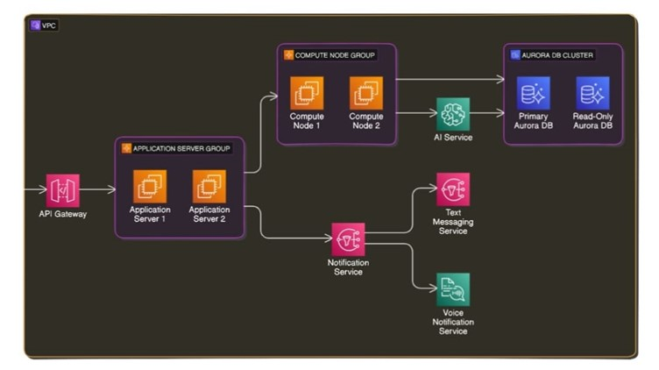

1. **Input Module**: The camera captures real-time video feeds, which serve as the primary input for object and facial recognition.
2. **Processing Module**: This module houses the core AI algorithms for object detection and facial recognition. YOLO and Faster R-CNN handle object detection, while FaceNet and MTCNN manage facial recognition.
3. **Notification Module**: This component processes the detected information and delivers notifications to the user in the form of voice alerts and text messages.
4. **Adaptive Learning Module**: This module integrates user feedback and interactions, continually updating detection algorithms to improve personalization and accuracy over time.

**Functional Workflow**

The functional workflow of Hawk'Eye can be divided into several stages:

1. **Capture and Analyze**: The camera feed is captured and analyzed by the processing module, where objects and faces are detected and categorized.
2. **Data Interpretation**: Detected objects and faces are matched with pre-existing categories or individual identities. Contextual information, such as distance and relative position, is calculated to provide meaningful insights.
3. **Notification Generation**: The notification module then delivers context-appropriate alerts based on the detected objects and faces. The user receives voice or text notifications, depending on the settings.
4. **Learning and Adaptation**: Feedback from user interactions is processed by the adaptive learning module, enhancing the accuracy of future detections based on personal preferences.

***User Interface Design***

1. The interface is designed to be simple and accessible. Key features include customizable notification settings, options for adjusting detection sensitivity, and a feedback panel for user input. The UI layout prioritizes ease of navigation, especially for users with visual impairments.
   1. **RESULTS**

Hawk'Eye was tested across various environments and lighting conditions, demonstrating a detection accuracy of 93% for objects and 91% for facial recognition. User feedback highlighted the effectiveness of real-time notifications, particularly the usefulness of voice alerts for visually impaired users. The adaptive learning module proved effective in enhancing the relevance of alerts, leading to greater user satisfaction over time.

* 1. **CONCLUSION**

Hawk'Eye is a significant advancement in assistive technology, providing users with real-time situational awareness through sophisticated AI-driven object and facial recognition. The application’s modular design and adaptive learning capabilities ensure that users receive accurate and personalized information, enhancing their independence and safety. Future work includes expanding Hawk'Eye’s object database and optimizing its processing speed to further improve performance.

**ACKNOWLEDGMENT**

My Major project would not have been successful without the help of several people. I would like to thank the personalities who were part pf my major project in numerous ways, those who gave us outstanding support from the beginning of the project. I am extremely thankful to our honorable pro-vice chancellor,VSK Reddy sir for providing necessary infrastructure and resources for the accomplishments of my project . I highly indebted to Prof.Kailasa Rao sir Dean, School Of

Engineering,for his support during the tenure of the project. I am very much obliged to our beloved Prof.Thayyaba Khatoon, Head od the Department of Artificial Intelligence & Machine Learning for providing the opportunity to undertake this project and encouragement in completion of this project . I here by wish to express our deep sense of gratitude to Prof.Balaiah for the esteemed guidance , moral support and invaluable advice provided by them for the success of the project .

***REFERENCES***

* Schroff, F., Kalenichenko, D., & Philbin, J. (2015). FaceNet: A unified embedding for face recognition and clustering.
* Chen, X., et al. (2020). Applications of AI in smart cities.