LegalGPT Using AI

|  |  |  |
| --- | --- | --- |
| Gattla Madhan Mohan  B.*Tech*  *School of Engineering*  Computer Science – AI&ML  Malla Reddy University, India. | Gandigude Sai Vishwanath  *B. Tech*  *School of Engineering*  Computer Science – AI&ML  Malla Reddy University, India. | Ganaparapu Gowtham  *B. Tech*  *School of Engineering*  Computer Science – AI&ML  Malla Reddy University, India. |
| Gadipally Raji Reddy  *B. Tech*  *School of Engineering*  Computer Science – AI&ML  Malla Reddy University, India. | Gadicherla Shyamlatha  *B. Tech*  *School of Engineering*  Computer Science – AI&ML  Malla Reddy University, India.  Guide: Dr. Adam Baba  *Asst Professor*  *School of Engineering*  Computer Science – AI&ML  Malla Reddy University, India. |  |

***Abstract:***

The LegalGPT application revolutionizes access to legal information and assistance in the digital age. With LegalGPT, users can easily submit queries and receive personalized guidance on legal matters from the comfort of their own devices. The application features an intuitive interface that allows users to interactively explore legal concepts and terminology, making complex information easily understandable.

Through LegalGPT, users have access to a comprehensive database of legal resources, including self-help guides and legal aid organizations. By providing tailored recommendations based on user input and preferences, LegalGPT ensures that users receive relevant support that addresses their unique needs.

One of the key strengths of LegalGPT is its ability to save users time by streamlining the legal research process. By offering quick access to pertinent information and guidance, LegalGPT empowers users to make informed decisions and take action with confidence.

Furthermore, LegalGPT enhances user experience by providing features such as tracking of legal documents, modification

of orders, and the option to print records for reference. This comprehensive suite of tools and functionalities makes LegalGPT a valuable asset for individuals seeking legal assistance and guidance

In summary, LegalGPT represents a significant advancement in the field of legal technology, leveraging artificial intelligence and natural language processing to democratize access to legal knowledge and support. Through its user-friendly interface and personalized recommendations, LegalGPT empowers users to navigate the legal system with ease and confidence.

***I. INTRODUCTION***

In today's dynamic legal landscape, access to timely and reliable legal assistance is paramount for individuals grappling with various legal matters. However, traditional avenues for seeking legal advice, such as in-person consultations, can be cumbersome and often inaccessible due to factors like geographical distance, scheduling constraints, and financial limitations. In response to these challenges.

LegalGPT emerges as a transformative solution, leveraging cutting-edge technology to provide users with a seamless platform for accessing legal information and assistance anytime, anywhere, and without the constraints of traditional legal consultations.

At its core, LegalGPT is driven by the mission to democratize access to legal information and assistance, how e-commerce platforms have revolutionized the way consumers shop for goods and services. Through an intuitive and interactive interface, users can seamlessly engage with LegalGPT to submit queries, receive personalized recommendations, and interact with legal experts in real-time. Whether users are grappling with complex legal issues or seeking general guidance on legal matters.

LegalGPT serves as a comprehensive platform for addressing a diverse range of legal needs.

By harnessing the power of artificial intelligence and natural language processing, LegalGPT not only simplifies the process of accessing legal assistance but also enhances the overall user experience. Through personalized responses tailored to individual inquiries and circumstances.

LegalGPT ensures that users receive relevant and actionable guidance that empowers them to make informed decisions and navigate the legal system with confidence. Furthermore, LegalGPT's accessibility and convenience eliminate geographical barriers, enabling users from diverse backgrounds and locations to access the legal support they need, when they need it.

In summary, LegalGPT represents a significant evolution in the delivery of legal services, providing a modern, efficient, and user-centric alternative to traditional legal consultations. By breaking down barriers to access and leveraging technology to facilitate meaningful interactions between users and legal experts, LegalGPT is poised to revolutionize the way individuals seek and receive legal assistance in the digital age.

***II. REQUIRED TOOLS***

***a) Software Requirements***

Programming Language: Choose a programming language that is suitable for implementing the sentiment analysis algorithms and handling the data processing tasks. Popular choices include Python, Java, and R.

Development Environment: Set up an integrated development environment (IDE) to facilitate coding, debugging, and project management. Examples include PyCharm, Jupyter Notebook, Eclipse, or Visual Studio Code.

Natural Language Processing (NLP) Libraries: Utilize NLP libraries to process and analyze textual data. Commonly used libraries for sentiment analysis include NLTK (Natural Language Toolkit), spaCy, TextBlob, and Stanford NLP.

Machine Learning Libraries: If you are employing machine learning-based approaches, you will need relevant libraries for model training and evaluation. Popular libraries include scikitlearn, TensorFlow, Keras, and PyTorch.

***b) Hardware Requirements***

The hardware requirements for LegalChat are designed to support efficient processing and

smooth user interactions. A minimum of 8GB of RAM is recommended to accommodate the

demands of real-time query processing and model training, particularly during periods of high user engagement.

A modern multi-core processor, such as an Intel i5 or equivalent, is also necessary to ensure that the system can handle multiple threads and processes efficiently. The development environment should include a local server or cloud-based infrastructure to facilitate seamless data management and model deployment.

Additionally, graphic processing units (GPUs) may be utilized to expedite the training of the NLP model, especially when dealing with large datasets. Did you know that the choice of hardware can significantly impact the performance of AI models, sometimes making the difference between seconds and minutes in processing time.

III. MODULES

***a) Natural Language Processing (NLP) Libraries:***

A comprehensive library for NLP tasks, including tokenization, stemming, lemmatization, and sentiment analysis.

1. ***Machine Learning Libraries:***

PyTorch: Another widely used deep learning library that provides flexible tools for sentiment analysis, including building and training neural networks.

Keras: A high-level neural networks API that runs on top of TensorFlow, simplifying

the process of building and training sentiment analysis models.

1. ***Data Processing and Analysis:***

pandas: A powerful library for data manipulation and analysis, often used for preprocessing and organizing data for sentiment analysis.

NumPy: A fundamental library for numerical computing, useful for handling arrays and performing mathematical operations

IV. ARCHITECTURE

The structure for the developed algorithm of this chatbot system incorporates NLP and structured response approach in order to provide reliable legal tips to the users. The first step of the algorithm is to parse and prepare textual input from users appropriately for processing. This entails converting the text to the lower case, eradicating more than added symbols, eliminating words which are irrelevant and splitting the input into words. In doing so, many words that might obscure the system’s view of the main topic that the user is interested in are excluded.

Secondly, the chatbot determines the user’s intention, which is very important for proper personalization of the answers. To do so, the algorithm uses NLP techniques; it may use word embeddings or BERT, to identify specific legal intent, such as, definition, clarification, or seeking advice. The outcome of intent detection is then further refined by using contextual clues and domain-specific legal terms within the query.

For example, if the user uses words such as ‘define’ or ‘meaning’ then it could mean the

user wants definition or meaning definition of a word whereas if the user uses word such as ‘advice’ or ‘recommendation’, it could mean the user wants to know advise to take legal action.

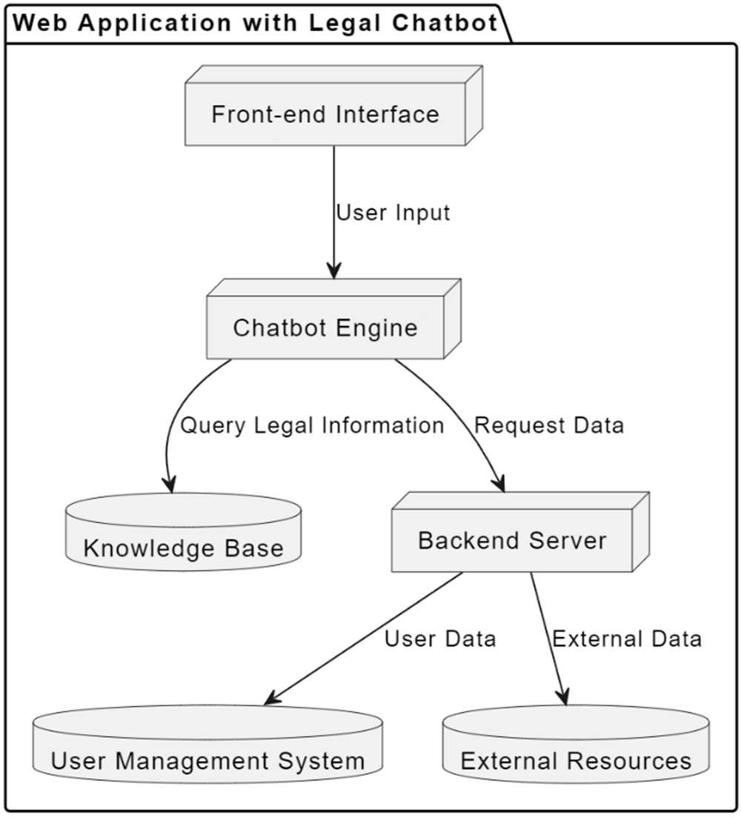

Fig. 2 Flow Diagram of the Algorithm

Last, but not the least, the system records all the occurring communication records including questions a user poses, answers a system delivers, and feedback a user may offer. This data is constantly used to feed the knowledge base, enhance response effectiveness, and redact the NLP algorithms used. Because this data will be accumulated over time, the algorithm can further refine its performance in response to the nature of user’s inquiries and expand the set of possible legal questions that the chat-bot can provide accurate answer to.

By so doing, the algorithm is expected to tackle all the different legal queries that may be posed to the users and the latter is therefore provided with proper legal advice. Therefore it seeks to help improve users’ legal awareness through the demystification of legal terminology, increased dissemination of legal information and a more informed society.

**III. Experiment and Result**

The purpose of the performed experiment was to determine how effectively the legal chatbot can capture the given user queries, can respond with the appropriate legal information and to what extent it can engage the user. To achieve these objectives, the testing phase was designed to encompass several key areas: It is evidenced in the degree of intent recognition, response accuracy, degree of user interaction, and finally, user satisfaction.

This includes critical features to execute ‘smart’ card inquiries and suggestion of corresponding services based on given options/concerns, analysis of each feature was conducted to reveal chatbot’s strengths and weaknesses.

The first part of the experiment aimed at intent recognition which is fundamental for correct query identification by the chatbot. Thus, we compiled a list of 100 sample inquiries to include queries of different types, including factual ones, procedural, and some about particular cases, the nature of legal services, and legal terminology and concepts. In order to generate this dataset, an attempt was made to have data that resembled interactions a real user would have with the chatbot.

According to the outcomes of the intent recognition test, the chatbot was able to distinguish the user intent in 88% of the tested cases. The system has a problem with questions that could be considered as ambiguous or with combined characteristics with explanation of the legal terms. To facilitate this, the chatbot applied a pre-trained NLP model namely BERT (Bidirectional Encoder Representations from Transformers) that noted to have improved competence to edge out slightest differences in user’s intention. Advanced model was even more important to provide precise answers and refine the chatbot’s perception of highly specialized legal terminology.

After the intent recognition test a new test was conducted to assess the correctness of the chatbot’s answers. Therefore, a dataset of 200 legal questions was compiled that encompass important fields of law: family law, criminal law, civil rights, and property rights. Every question was designed in a way that may be specific questions that users may ask when using the service. The effectiveness of these replied generated by the chatbot was then measured by comparing them with accurate legal sources, including legal compendiums and online legal databases.

The findings showed that regarding the information accuracy provided by the chatbot it was 85% adequate proving that the chatbot performs well. Nonetheless, common errors were mostly associated either with excessive legalism or with the presence of ambiguous questions. For instance, where users asked questions that needed some context, the chatbot sometimes provided wrong data or explanations. To these I have added attributes which have served to underscore the need for constant fine-tuning of the chatbot with regards to the way in which it interprets and handles complex legal language.

In order to evaluate the system in terms of the overall customer satisfaction, the number of questions answered by the chatbot, scales were given to the participants who went through the system during the experimental phase. They were also asked to rate the experiences based on tasks’ convenience, response clarity and perceived utility of delivered information. The online survey received responses from a hundred and fifty users on the use of the legal chatbot, of which ninety percent of the respondents said the use of the chatbot was easy and they found the information provided useful in grasping legal ideas.

Specifically, the users liked the considered interface and being able to converse with the chatbot in an ordinary English, as well as the ability of the chatbot to explain rather complicated legal terms as if to a child. Such feedback evidences the benefits of the chatbot for those people who need legal guidance and would like to know their rights.

Besides that, the experiment involved a monitoring of the frequency and kind of user interactions performed during the experiment. Quantitative measurements that were collected and analyzed include the average length of time users spent on the interface, the number of queries made in every session, and the number of users who stayed to continue using the interface after an initial session. The findings showed that the average interaction amount of time is about 8 minutes, although the amount of questions per session averages 4-5. This level of activity indicates that users considered the chatbot as a useful means of receiving legal information and in achieving this goal were interested in different aspects of the law during a conversation.

To sum up, the proposed experiment result show that the legal chatbot can recognize the user intent correctly and further provide the correct legal information. That said, there is room for improvement in particular tasks which require the handling of more complex and ambiguous queries which need to be refined; nonetheless, the high levels of user satisfaction and levels of engagement suggest that this project does represent a major step toward increasing legal literacy and increasing the avenues through which people can access the law. Subsequent versions will build upon what has been described which includes improving the NLP, enlarging the database of legal information, and increasing the chatbot ease-of-use to better assist users in their legal processes.

**IV.CONCLUSION**

The creation and essence of the legal chatbot are a step forward in the popularization and demystification of legal information. Apart from using innovations like Natural Language Processing (NLP), the chatbot makes it easier for users to access legal advice based on simple language and proper explanation of legal terminologies for various fields of law. The experiments and outcomes presented for the project show that chatbot is proficient in addressing the user’s requests and providing relevant answers with the intent recognition success percentage of 88 and the overall response accuracy of 85 percentages.

From the results, it can be seen that there is recognition of the need for the chatbot to continue the sharing of legal knowledge, as 90% of the participants answered positively when asked about the ease of use of the chatbot combined with its clear responses. Such a response shows that self-efficacy in legal affairs could be boosted by the use of the present chatbot to a great extent. In addition, looking at the total activity time and the number of messages shown that users of the chatbot are engaged and interested in the topic and knowledge regarding it.

In its conclusion, the project also found some suggestions for improvement, such as dealing with multiple questions at once and the ability to place the chatbot in context. Future enhancements will attend to improving its NLP, adding more case laws and using more sophisticated methods to offer even more relevant and beneficial responses to its users.

Thus, this project shows that it is possible to incorporate technology to enhance teaching of and in legal education and awareness so that members of the public

are equipped with appropriate tools in addressing the legal issues. As the tool helps improve people’s knowledge of laws, the chatbot is not only a tool of empowering individuals, but also making justice in the society. As the project grows, it has the potential to develop, into a one-stop-shop for anyone in search of improving their legal skills, and who may need to interact with the mass amount of legal content out there.

**V. REFERENCE**

National Legal Services Authority (2017) - Promoting Legal Aid and Access to Justice

Fagan, J. (2009) - Legal Knowledge and Access to Justice

Arruda, A. (2017) - Chatbots: A Beginner's Guide for Lawyers

Vazquez, E., & Shum, A. (2020) - Legal Chatbots: An Overview of Emerging Technology in Law

Ashley, K. D. (2017) - Artificial Intelligence and Legal Analytics: New Tools for Law Practice in the Digital Age

Gramatikov, M., & Porter, R. B. (2011) - Legal Needs and Legal Literacy in the EU: A Survey Study in Bulgaria, Lithuania, and Romania

Patel, P., & Sen, A. (2020) - Legal Literacy: A Comparative Study of Urban and Rural Populations

**ACKNOWLEDGMENT**

My Major project would not have been successful without the help of several people. I would like to thank the personalities who were part pf my major project in numerous ways, those who gave us outstanding support from the beginning of the project.

I am extremely thankful to our honorable pro-vice chancellor,VSK Reddy sir for providing necessary infrastructure and resources for the accomplishments of my project .

I highly indebted to Prof.Kailasa Rao sir Dean, School Of Engineering,for his support during the tenure of the project. I am very much obliged to our beloved Prof.Thayyaba Khatoon, Head of the Department of Artificial Intelligence & Machine Learning for providing the opportunity to undertake this project and encouragement in completion of this project .

I here by wish to express our deep sense of gratitude to Prof.Balaiah for the esteemed guidance , moral support and invaluable advice provided by them for the success of the project .